Determinants of Pension Participation and Gender Parity in India: Evidence from APY and NPS
Abstract
India operates two structurally distinct voluntary pension schemes—the Atal Pension Yojana (APY) and the National Pension System (NPS)—yet existing research assumes that standard determinants of participation operate uniformly across them. This paper tests that assumption using state-level data for 35 Indian states and Union Territories over 2019–20 to 2024–25. Cross-sectional OLS estimates, supported by reduced-form specifications, quantile regression, stacked interactions, and state–year fixed effects, show that determinants are scheme-contingent. Banking infrastructure is positively associated with NPS penetration (β = 1.094, p < 0.01) but not APY. Literacy is positively associated with female participation in NPS (β = 3.287, p < 0.05) but not APY. Per-capita income and female labour force participation show no robust associations. Gender outcomes diverge sharply: APY achieves near parity (GPI ≈ 1.0–1.2), while NPS remains male-dominated (GPI: 0.31–0.45). These results are consistent across specifications but are associative rather than causal. The findings show that identical structural conditions yield different participation outcomes depending on scheme design, challenging uniform models of financial inclusion.
Keywords: Atal Pension Yojana; National Pension System; Gender Parity Index; Pension Penetration; Financial Inclusion; OLS Regression; India
JEL Classification: G23; G53; H55; J16; I38; C21
1. Introduction
India’s two main voluntary pension schemes share a broad goal—extending retirement coverage beyond the formal sector—but little else. The National Pension System (NPS), a market-linked defined-contribution plan, requires subscribers to choose funds, manage contributions, and interact with registered financial intermediaries. The Atal Pension Yojana (APY), launched in 2015 and built into the Jan Dhan banking ecosystem, works through auto-debit: a fixed guaranteed pension deducted automatically, with enrolment often facilitated by self-help groups. By design, APY asks almost nothing of its subscribers; NPS asks quite a lot.
Participation in both schemes varies sharply across Indian states, and that variation is not well explained. The financial inclusion literature points to banking infrastructure density, income, and literacy as the usual suspects. But that literature was built mostly on single-product studies—it assumes, usually without saying so, that the same factors operate the same way across financial products. That assumption is questionable when two schemes differ as fundamentally as APY and NPS do. A factor that shapes NPS participation may be irrelevant for APY, or vice versa, when the schemes impose different access requirements and decision burdens on would-be subscribers.
This paper tests that directly. Do banking infrastructure, income, literacy, and female labour force participation predict pension uptake the same way across APY and NPS, or are their effects contingent on how each scheme works? The question matters both for explaining regional disparities and for designing policy. If the answer is that effects are scheme-specific, then a policy tool that works for one scheme may do nothing—or the wrong thing—for the other.
This is the first state-level regression evidence that standard determinants of pension participation operate differently across APY and NPS, and that access constraints are contingent on scheme design rather than fixed properties of a state’s infrastructure.
2. Review of Literature
2.1 Pension Coverage and Structural Constraints
Voluntary, contribution-based systems like NPS structurally exclude informal-sector workers because they lack auto-enrolment and distribution support; APY was designed to address these gaps through auto-debit and Jan Dhan integration (Sane and Thomas, 2015; Bhatia and Mahajan, 2022). Income, literacy, and banking access are established demand-side predictors of participation.
APY enrolment positively impacts formal retirement savings, with marginalised populations more likely to enrol (Rooj and Sengupta, 2025). This motivates examining what state-level conditions are associated with aggregate penetration.
2.2 Financial Infrastructure and Access
Branch density is the strongest predictor of cross-state financial inclusion variation in India (Sarma and Pais, 2011; Burgess and Pande, 2005), a pattern confirmed for 2000–2020 and aligned with the NPS penetration gradient documented here (Annemalla and Kasturi, 2025; Agarwala, Maity, and Sahu, 2024). However, none of this literature accounts for the fact that not all products require branch access equally. NPS requires a registered point of presence; APY enrols through existing Jan Dhan accounts and SHG facilitators. If that distinction holds, bank density should be associated with NPS participation but not APY. That is what H1 tests.

2.3 Gender Gaps in Pension Participation
Women’s underrepresentation in NPS reflects structural constraints: limited formal-sector employment, the gender wage gap, and constrained household financial autonomy (Mohanty and Behera, 2022). In India, only 9.8% of rural women are financially literate versus 28.3% of rural men (Bansal and Kaur, 2024). These barriers map directly onto the predictors tested here.
APY shows higher female participation, attributed to SHG integration and simplified enrolment (Bhatia and Mahajan, 2022; Duvendack, Sonne, and Garikipati, 2023). Whether this design has broken the link between formal employment and female enrolment is what H3 tests.
2.4 Literacy, Behaviour, and Pension Decisions
Financial literacy is a well-established predictor of retirement savings participation, particularly in schemes requiring active decision-making (Lusardi and Mitchell, 2014). In India, this association is driven largely by men and upper-wealth quintiles, and is amplified by digital financial literacy (Khandelwal, Vajjala, and Tagat, 2025; Pandey, Wadhawan, and Kiran, 2026). APY’s simplified structure reduces the literacy threshold; NPS’s market-linked design keeps it high.
Cross-country evidence confirms that literacy effects are conditioned by product complexity (Niu et al., 2020; Xu et al., 2023; Han et al., 2025; Luan et al., 2025; Oggero et al., 2023). Literacy matters most where schemes impose genuine cognitive demands—the condition that distinguishes NPS from APY. H4 tests this directly.
2.5 Research Gap
Banking infrastructure, income, literacy, and labour market conditions are established predictors of financial inclusion and pension uptake (Sarma and Pais, 2011; Gupte et al., 2012; Mohanty and Behera, 2022). APY and NPS are documented to differ in population served and determinants of uptake (Bhatia and Mahajan, 2022; Sane and Thomas, 2015; Verberi and Kaplan, 2025; Xia et al., 2025). What the literature lacks is a test of whether the same factors operate differently across both schemes in a unified framework. The question is not which factors matter—it is under what institutional conditions they matter.

2.6 Theoretical Framework
Two theoretical frameworks guide the analysis. Supply-side financial inclusion theory holds that access to financial products depends primarily on the physical availability of delivery infrastructure (Claessens, 2006; Sarma and Pais, 2011). Applied here: NPS requires a registered point of presence; APY enrols through existing Jan Dhan accounts. Branch density should therefore be associated with NPS uptake but not APY’s. H1 follows.
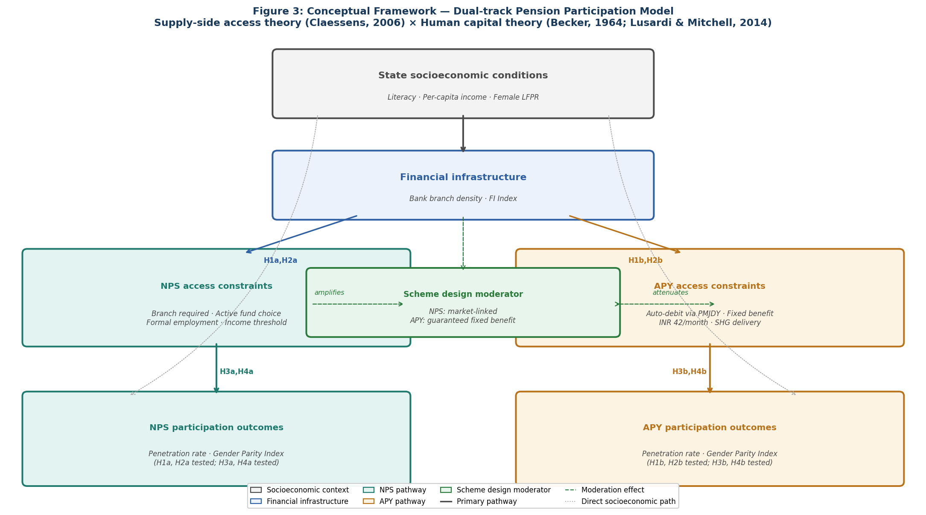
Figure 1: Conceptual Framework. State socioeconomic conditions → Financial infrastructure → Access constraints [scheme design moderates’ pathway] → Participation outcomes. Solid arrows represent hypothesised primary pathways; dashed arrows indicate scheme design moderation; dotted arrows represent direct socioeconomic effects. H labels indicate hypotheses tested at each pathway.
Source: Authors’ calculations.
Financial knowledge and literacy raise participation in schemes requiring active decision-making (Becker, 1964; Lusardi and Mitchell, 2014). NPS—requiring active fund selection and ongoing contribution management—creates a genuine knowledge barrier. APY, with a fixed guaranteed benefit and no investment decision, does not. H4 follows. Together, the frameworks generate scheme-specific predictions: identical structural conditions should produce different outcomes because the two schemes impose different demands on subscribers.
3. Hypotheses
Four testable hypotheses are derived from the reviewed literature. Each hypothesis explicitly distinguishes between APY and NPS based on their design differences.
H1a: Banking infrastructure density is positively associated with NPS penetration across Indian states.
H1b: The association between banking infrastructure density and APY penetration is statistically weaker than for NPS.
H2a: Per-capita income is positively associated with NPS penetration.
H2b: Per-capita income shows no significant association with APY penetration.
H3a: Female labour force participation rate is positively associated with female participation in NPS.
H3b: The association between female LFPR and female APY participation is weaker than for NPS.
H4a: State literacy rate is positively associated with female participation in NPS All Citizens.
H4b: State literacy rate shows no significant association with female APY participation.
4. Research Methodology
4.1 Research Design and Data Sources
This study uses cross-sectional data averaged over 2019–20 to 2024–25 for 35 Indian states and Union Territories. A cross-sectional design is used because key predictors (RBI FI Index, PLFS LFPR, Census literacy) lack consistent annual coverage across states; six-year averaging reduces year-to-year volatility.
Predictor variables are sourced from official databases and reflect the most recently available cross-sectional data at the time of analysis. These include bank branch density per 100,000 population (RBI Basic Statistical Returns 2022–23), female labour force participation rate (PLFS 2022–23), literacy rate (Census 2011, updated with NFHS-5 where differences exceed five percentage points), per-capita net State Domestic Product (MoSPI 2022–23), and the RBI Financial Inclusion Index (2022–23, composite scale 0–100). PLFS female LFPR estimates and MoSPI per-capita SDP figures for 2023–24 and 2024–25 were not publicly available for all states at the time of data compilation; the 2022–23 cross-section is therefore used for all predictors. This mismatch between the predictor reference year and the six-year outcome average (2019–20 to 2024–25) is consistent with standard practice in cross-sectional panel-averaged studies where structural predictors are measured at a single recent reference point.
4.2 Sample Construction and Outlier Treatment
The unit of analysis is the Indian state or Union Territory. Lakshadweep and Dadra and Nagar Haveli are excluded—both have populations below 100,000, making their penetration rates unreliable as regression outcomes. Sikkim is excluded as a structural outlier: its APY penetration of 8.13% sits more than three standard deviations above the national mean (0.89%, SD = 0.44%), driven by a small working-age population combined with high administrative coverage. Including it inflates leverage on the regression coefficients; results are robust to its inclusion (available on request), though coefficient stability is reduced. The final sample is N = 35.
With N = 35 and five predictors, statistical power is moderate; non-significant results should be read cautiously as they may reflect insufficient power.
4.3 Variable Definitions
Table 1: Variable definitions, operational measures, and data sources
Variable | Role | Operational Definition | Source
APY Penetration (%) | Dependent | APY subscribers / working-age population × 100 | PFRDA; Census 2011 projections
NPS Penetration (%) | Dependent | NPS (AC+Corp) subscribers / working-age population × 100 | PFRDA; Census 2011 projections
APY Female Share (%) | Dependent | Female APY subscribers / total APY subscribers × 100 | PFRDA gender-disaggregated data
NPS AC Female Share (%) | Dependent | Female NPS-AC subscribers / total × 100 | PFRDA gender-disaggregated data
Bank Density | Independent | Scheduled bank branches per 100,000 population | RBI Basic Statistical Returns 2022-23
Female LFPR (%) | Independent | Female workers as % of female population aged 15+ | PLFS Annual Report 2022-23
Literacy Rate (%) | Independent | % of population aged 7+ who can read and write | Census 2011; updated NFHS-5 (see footnote a)
ln(Per Capita Income) | Independent | Natural log of per capita net SDP (INR thousands) | MoSPI State Accounts 2022-23
FI Index | Control | RBI Financial Inclusion Index, scale 0-100 | RBI FI-Index 2022-23
Notes: FI Index is excluded from the reduced-form robustness specification (Models 1R–4R) due to high collinearity with bank density (r = 0.908). All outcome variables are averaged over 2019–20 to 2024–25. Predictor variables reflect 2022–23 values, the most recently available cross-sectional data for all states at the time of compilation; PLFS LFPR and MoSPI SDP figures for 2023–24 and 2024–25 were not publicly available for all states. Literacy rates are constructed using Census 2011 as the baseline, with harmonisation through threshold-based substitution: NFHS-5 (2019–21) estimates are used where differences exceed five percentage points, ensuring temporal relevance while maintaining cross-state comparability.
Source: Authors’ calculations.
ᵃ NFHS-5 (2019–21) literacy estimates are substituted for Census 2011 values in the following five states where the absolute difference exceeds five percentage points: Arunachal Pradesh (Census 65.4%, NFHS-5 71.2%, Δ = +5.8 pp), Assam (72.2% vs 78.2%, Δ = +6.0 pp), Ladakh (62.0% vs 68.0%, Δ = +6.0 pp), Telangana (66.5% vs 60.9%, Δ = −5.6 pp), and Tripura (87.2% vs 81.8%, Δ = −5.4 pp). For all remaining states, Census 2011 figures are used. Source for NFHS-5 figures: International Institute for Population Sciences (IIPS) and ICF (2021).
4.4 Analytical Framework
Four descriptive measures are constructed: (i) penetration rate $PR=\frac{\text{Subscribers}}{\text{Working-age Population}}×100$(ii) year-on-year growth $YoY=\frac{S_{t}-S_{t-1}}{S_{t-1}}×100$(iii) compound annual growth rate ${CAGR=\left(\frac{S_{2024-25}}{S_{2019-20}}\right)}^{1/5}-1$; and (iv) gender parity index $(GPI)=\frac{\text{Female Subscribers}}{\text{Male Subscribers}}$, where GPI denotes the female-to-male subscriber ratio (GPI = 1.0 indicates parity).
$$Yi​=β0​+β1​(BankDeni​)+β2​(FemLFPRi​)+β3​(Literacyi​)+β4​ln(PCIi​)+β5​(FIIndexi​)+ϵi​​$$
All predictors are z-scored before estimation so that coefficients are directly comparable across variables. OLS is the primary estimator; the remaining methods serve as robustness checks.
The NPS penetration model is heteroskedastic (Breusch–Pagan LM = 14.80, p = 0.011), so HC3-robust standard errors are computed as a check. VIFs flag high collinearity between bank density and the FI Index (r = 0.908; VIF = 11.92 in the full model), which motivates the reduced-form specification that drops the FI Index.
Spearman rank correlations provide a non-parametric check. Quantile regression (Koenker and Bassett, 1978) is estimated at Q10, Q25, Q50, Q75, and Q90 with 500-replication bootstrap standard errors (seed = 42) to confirm that associations hold across the full conditional distribution, not just at the mean.
Two additional specifications address the small sample directly. A stacked cross-section (N = 70) stacks APY and NPS as two observations per state and tests the APY–NPS bank density differential via a BankDen × Scheme interaction term with state-clustered standard errors. A state×year two-way fixed-effects panel (N = 210) uses annual bank density derived from RBI BSR national branch counts, with state and year fixed effects absorbing time-invariant heterogeneity and national trends. These are sensitivity checks; the primary evidence comes from the cross-sectional models.
As a further check on multicollinearity, PCA is applied to the three correlated development indicators (bank density, ln(PCI), FI Index). Results are in Appendix C.
All analyses are conducted in Python 3.11 (NumPy, SciPy, pandas).
4.5 Interpretation and Scope
Results are associational, not causal; the cross-sectional design and proxy variables preclude causal identification.
5. Results
5.1 State-Level Penetration of APY and NPS
Figure 2 shows average APY penetration across states over 2019–20 to 2024–25. Smaller states in the north-west and north-east shade darker; the large northern and central plains are lighter. Size matters more than geography: smaller states consistently outperform larger ones, regardless of region. Figure 3 shows NPS penetration, where the gradient is steeper and the coastal–interior divide is more pronounced.
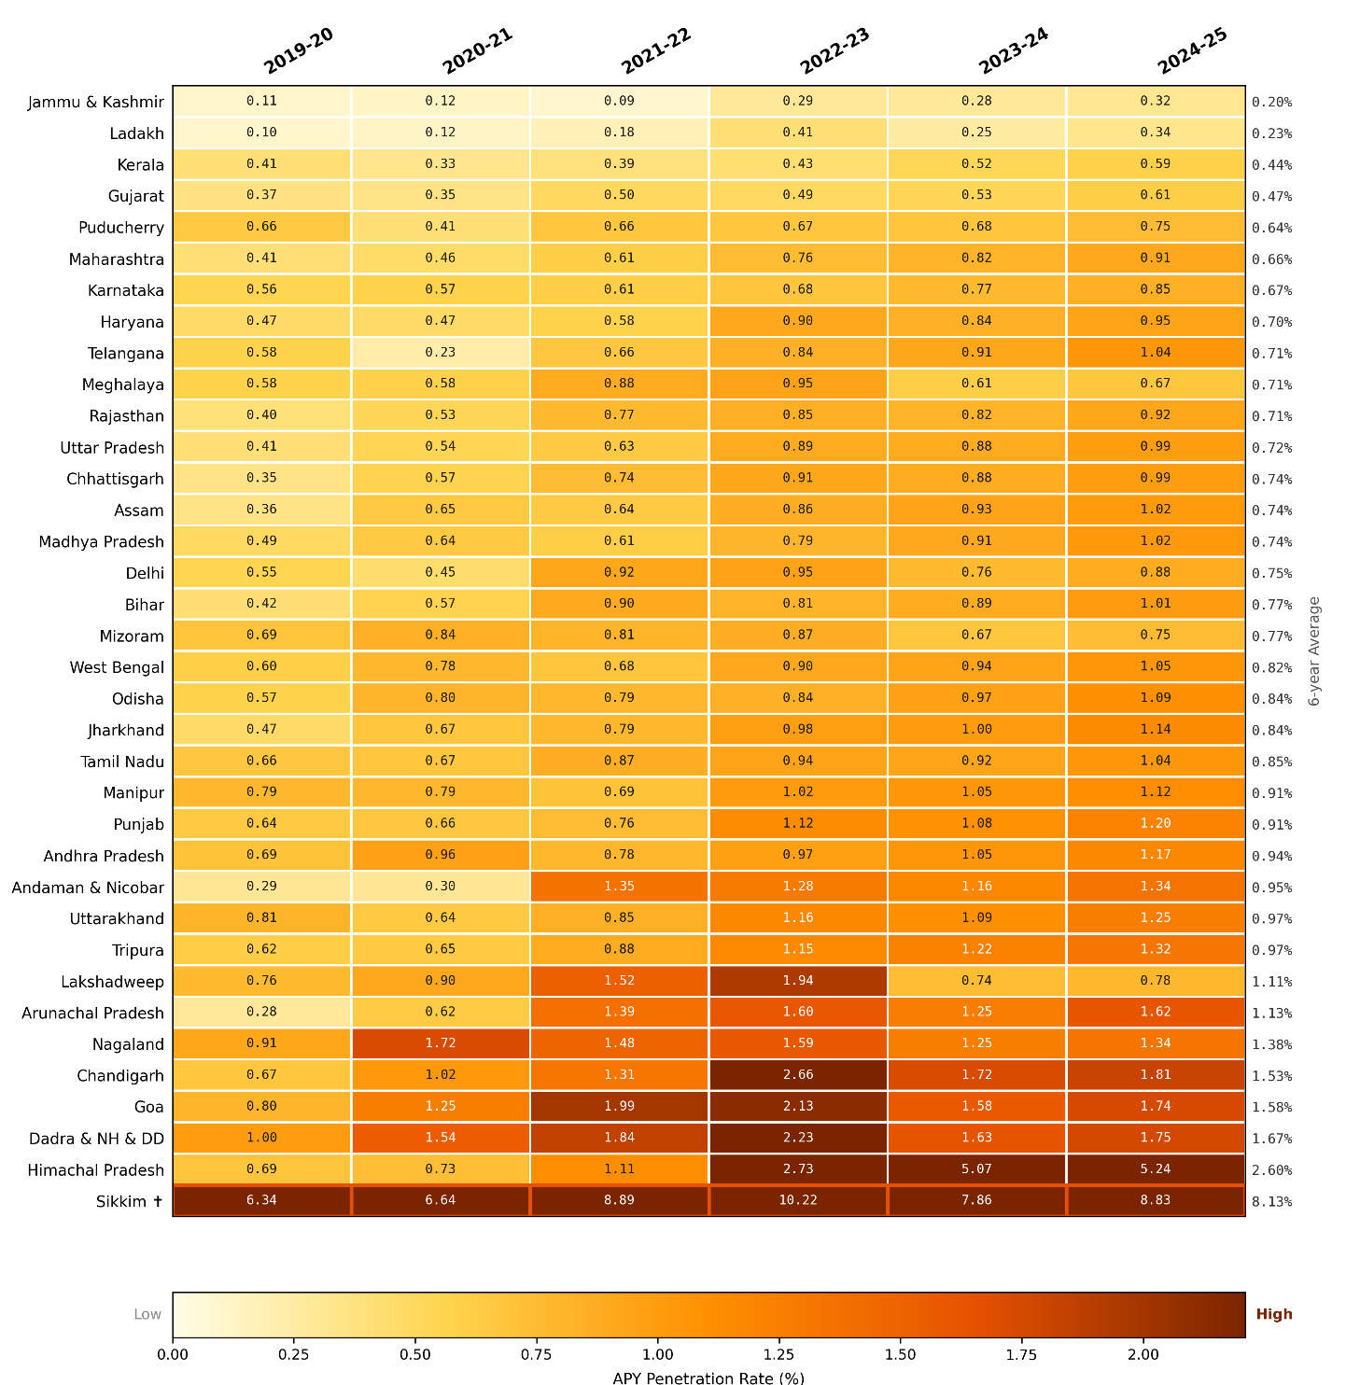Figure 2: State-wise Average APY Penetration Rate (%) India, 2019-20 to 2024-25. Penetration Rate = APY Subscribers ÷ Working-Age Population (18-60 yrs) × 100. Corrected data applied throughout.
Source: Authors' calculations based on PFRDA subscriber data and Census of India population projections.
APY averaged 0.89% nationally (excluding Sikkim), ranging from 0.20% to 2.60%. Smaller states consistently outperform larger ones; Kerala’s low rate (0.44%) reflects its higher-income profile.
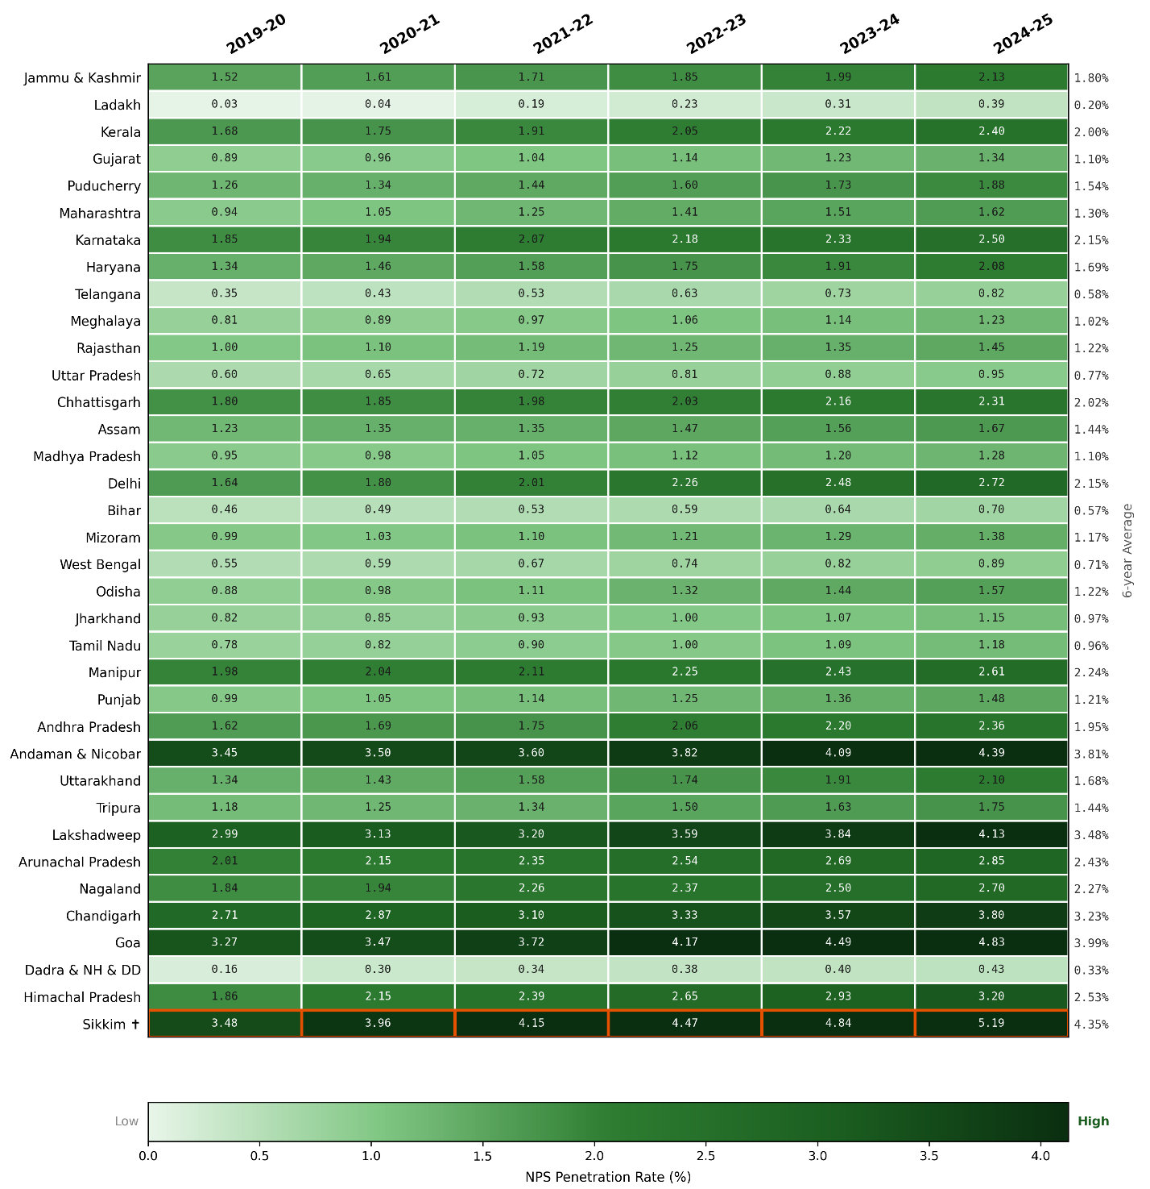Figure 3: State-wise Average NPS Penetration Rate (%) India, 2019-20 to 2024-25. NPS includes All Citizens and Corporate subscriber models only; Government and State employee subscribers are excluded.
Source: Authors' calculations based on PFRDA subscriber data and Census of India population projections.
NPS averaged 1.66% nationally with a steeper gradient; coastal and southern states lead while northern plains states record the lowest rates.
5.2 Year-on-Year Growth and CAGR
High CAGRs reflect low starting points. Himachal Pradesh (APY CAGR: 50%) and Arunachal Pradesh (42%) both began 2019–20 with very low enrolment; their rates look dramatic partly for that reason. The same applies to Ladakh (NPS CAGR: 65%). States worth paying attention to are those with both high CAGR and above-average absolute penetration—Himachal Pradesh for APY, Goa for NPS. That combination signals genuine momentum rather than statistical bounce from a low base.
5.3 OLS Regression Results
Model 3 (APY Female %) is included as a design-contrast check. Its non-significant F-statistic (F = 1.689, p = 0.17) is what the scheme-design argument predicts: APY’s auto-debit and SHG delivery decouple female participation from state-level socioeconomic conditions. That said, this null result cannot be distinguished from low statistical power (Adj. R² = 0.095; N = 35): it is consistent with the scheme-design hypothesis but should not be read as evidence against an association.
Table 2: OLS Estimates of State-Level Determinants of APY and NPS Penetration and Female Participation (N = 35; standardised β; Full Model (FI Index included; VIF = 11.92); see Table 4 for reduced-form results)
 | Model 1 APY Penetration | Model 2 NPS Penetration | Model 3 (APY Female %) | Model 4 NPS AC Female %
Bank Density | 0.266 (0.188) [p=0.167] | 1.094** (0.313) [p=0.002] | −1.251 (3.536) [p=0.726] | 0.598 (2.357) [p=0.652]
Female LFPR | 0.150† (0.081) [p=0.072] | 0.260† (0.134) [p=0.063] | 1.682 (1.482) [p=0.266] | 1.656 (1.012) [p=0.146]
Literacy Rate | 0.057 (0.105) [p=0.591] | 0.247 (0.175) [p=0.169] | 1.436 (1.939) [p=0.465] | 3.287* (1.319) [p=0.019]
ln(Per Capita Income) | 0.207 (0.153) [p=0.188] | 0.513† (0.255) [p=0.054] | −4.931 (2.945) [p=0.105] | −0.271 (1.924) [p=0.885]
FI Index | −0.363 (0.242) [p=0.145] | −1.245** (0.403) [p=0.004] | 2.261 (4.561) [p=0.624] | −0.276 (3.041) [p=0.655]
Constant | 0.897*** (0.070) [p<0.001] | 1.665*** (0.117) [p<0.001] | 47.533*** (1.331) [p<0.001] | 27.351*** (0.883) [p<0.001]
R² | 0.232 | 0.534 | 0.232 | 0.390
Adj. R² | 0.100 | 0.454 | 0.095 | 0.285
F-statistic | 1.752 | 6.648*** | 1.689 | 3.708*
N | 35 | 35 | 35 | 34
Notes: Standardised OLS coefficients (β) are reported with standard errors in parentheses and exact p-values in brackets, β (SE) [p]. Significance levels: *** p<0.001, ** p<0.01, * p<0.05, † p<0.10. Predictors are z-scored (zero mean, unit standard deviation). Sikkim is excluded as a structural outlier (APY > 3 SD above the mean). Variance Inflation Factors (VIF) in full models: Bank Density = 7.16; FI Index = 11.92. HC3-robust standard errors for Model 2 yield similar results (Bank Density SE = 0.293, p = 0.001). See Table 4 for reduced-form results.
Source: Authors’ calculations.
5.3.1 H1a and H1b Banking Infrastructure and Penetration
H1 is supported. Bank density is strongly associated with NPS penetration (β = 1.094, SE = 0.313, p = 0.002), though attenuated in reduced-form specifications (β = 0.422), but not APY (β = 0.266, p = 0.167). This null result is consistent with the scheme-design argument but cannot be distinguished from low statistical power (N = 35). Spearman correlations confirm the pattern: r = 0.480 for NPS (p = 0.003) versus r = 0.187 for APY (p = 0.281).
The large negative FI Index coefficient in Model 2 (β =− 1.245, p = 0.004) is a collinearity artefact, not a substantive finding. Bank density and the FI Index correlate at r = 0.908 (VIF = 11.92); when two predictors are that correlated, their coefficients partition shared variance and can flip sign (Belsley, Kuh, and Welsch, 1980). The reduced-form specification drops the FI Index, brings all VIFs below 4.0, and bank density retains its positive association with NPS penetration (β = 0.422, Table 4).

5.3.2 H2a and H2b Per-Capita Income and Penetration
Per-capita income approaches significance for NPS (β = 0.513, SE = 0.255, p = 0.054) but not for APY (β = 0.210, p = 0.188). The Spearman rank correlation confirms the direction (r = 0.437, p = 0.009). The OLS estimate disappears entirely in the reduced-form model (Table 4) once collinearity is addressed. Income shares variance with bank density and the FI Index (r > 0.80, Appendix B), suggesting it is proxying for correlated development indicators rather than exerting an independent effect. H2a is not treated as a robust finding. H2b—no APY income effect—is supported.

5.3.3 H3a and H3b Female LFPR and Gender Participation
H3 is not supported. Female LFPR is not significantly associated with either gender model: APY female share (β = 1.682, p = 0.266) or NPS AC female share (β = 1.656, p = 0.113). H3a and H3b are rejected at conventional thresholds.
The likely explanation is measurement mismatch. PLFS female LFPR is a total labour force measure—it counts all female workers as a share of the working-age female population, including those in the informal sector. NPS participation, by contrast, is structurally tied to formal wage employment: account opening requires a registered Point of Presence, contributions require a bank account, and the scheme targets salaried workers in the organised sector. The theoretical construct (formal female employment) and the available proxy (total LFPR) are different populations. This mismatch, rather than the absence of a genuine relationship, likely explains the null result for H3. Future research with state-level formal-sector female employment data could test this directly.
Shapiro–Wilk tests on residuals are consistent with OLS validity across models. Model 1 shows a marginal violation (W = 0.938, p = 0.049), but this does not affect inference given that all predictors are non-significant in that model.
5.3.4 H4a and H4b Literacy and NPS Female Participation
H4 is supported. Literacy rate is positively associated with NPS AC female share (β = 3.287, SE = 1.319, p = 0.019). The result is stable across specifications: the reduced-form coefficient is β = 2.956 (p = 0.026) and the Spearman correlation is r = 0.537 (p = 0.001). Kerala illustrates the pattern: with the highest state literacy rate (94.0%) and FI-Index score (79.2), female NPS participation rose from 34.4% to 54.6% over the study period—one of the few states to approach parity. Literacy here is best read as a proxy for financial capability, not general educational attainment. For APY, literacy shows no significant association with female participation (β = 1.436, p = 0.465): where there is no knowledge barrier, there is no literacy effect.
5.4 Spearman Rank Correlations
Table 3: Spearman Rank Correlations Between Socioeconomic Predictors and Pension Outcome Variables (N = 35)
Predictor | APY Penetration | NPS Penetration | APY Female % | NPS AC Female %
Bank Density | 0.187 | 0.480** | −0.227 | 0.426*
Female LFPR | −0.030 | 0.098 | 0.324† | 0.265
Literacy Rate | 0.285† | 0.465** | −0.063 | 0.537***
ln(Per Capita Income) | 0.198 | 0.437** | −0.308† | 0.395*
FI Index | 0.146 | 0.426* | −0.164 | 0.496**
Notes: Two-tailed Spearman rank correlations. Sample size: N = 35 (N = 34 for APY Female %). Significance levels: *** p<0.001, ** p<0.01, * p<0.05, † p<0.10.
Source: Authors’ calculations.
5.5 Robustness Check Reduced-Form Models Excluding the FI Index
The FI Index is excluded from the reduced-form specifications (r = 0.908 with bank density; VIF = 11.92). Table 4 reports Models 2R and 4R.
Table 4: Reduced-Form OLS Estimates Excluding FI Index (Robustness Check). N=35 for Model 2R; N=34 for Model 4R (Ladakh excluded as a structural zero on the gender outcome)
Variable | Model 2R NPS Penetration | Model 4R NPS AC Female % | VIF (M2R) | VIF (M4R)
Bank Density | 0.422 (0.254) | 0.323 (1.645) | 3.69 | 3.69
Female LFPR | 0.060 (0.133) | 1.281 (0.877) | 1.01 | 1.01
Literacy Rate | 0.154 (0.195) | 2.956* (1.258) | 2.18 | 2.18
ln(Per Capita Income) | 0.026 (0.228) | −0.281 (1.482) | 2.95 | 2.95
Constant | 1.665*** (0.132) | 27.351*** (0.871)
R² | 0.381 | 0.324
F-statistic | F(4,30)=4.62*** | F(4,29)=3.47**
Notes: Reduced-form specification excludes the FI Index. Standard errors are reported in parentheses. All variance inflation factors (VIF) are below 4.0. Significance levels: *** p<0.001, ** p<0.01, * p<0.05, † p<0.10. Key results—bank density for NPS penetration and literacy for NPS female participation—remain substantively unchanged relative to the full-model specification.
Source: Authors’ calculations.
The reduced-form results rule out multicollinearity as the explanation for the main findings. Literacy remains significant in Model 4R (β = 2.956, p = 0.026); bank density retains a positive association with NPS penetration (β = 0.422); all VIFs are below 4.0.

5.5.1 Quantile Regression Robustness
Quantile regression (Koenker and Bassett, 1978) was estimated at five percentiles (Q10–Q90) with bootstrap standard errors (500 replications, seed = 42) to test whether associations hold across the full conditional distribution.
Table 5a: Quantile Regression Estimates for NPS Penetration
Predictor | OLS β (SE) | Q10 | Q25 | Q50 | Q75 | Q90
 |  | β (SE) [sig] | β (SE) [sig] | β (SE) [sig] | β (SE) [sig] | β (SE) [sig]
Bank density | 1.094 (0.313) | 0.901 (0.500)† | 0.965 (0.478)* | 1.055 (0.389)** | 1.078 (0.364)** | 1.026 (0.534)†
Female LFPR | 0.260 (0.134) | 0.183 (0.185) | 0.198 (0.177) | 0.237 (0.168) | 0.270 (0.171) | 0.256 (0.203)
Literacy rate | 0.247 (0.175) | 0.190 (0.328) | 0.192 (0.305) | 0.209 (0.275) | 0.219 (0.248) | 0.262 (0.254)
ln(PCI) | 0.513 (0.255) | -0.056 (0.401) | 0.157 (0.528) | 0.640 (0.610) | 0.936 (0.393)* | 1.069 (0.442)*
FI Index | -1.245 (0.403) | -0.588 (0.605) | -0.806 (0.710) | -1.319 (0.742)† | -1.610 (0.510)** | -1.674 (0.616)**
Notes: Coefficients are standardised (β). Bootstrap standard errors in parentheses. *** p<0.001, ** p<0.01, * p<0.05, † p<0.10. OLS estimates shown for comparison. Source: Authors’ calculations.
Source: Authors’ calculations.

Table 5b: Quantile Regression Estimates for NPS AC Female Share
Predictor | OLS β (SE) | Q10 | Q25 | Q50 | Q75 | Q90
 |  | β (SE) [sig] | β (SE) [sig] | β (SE) [sig] | β (SE) [sig] | β (SE) [sig]
Bank density | 0.598 (2.357) | -0.297 (3.118) | 0.226 (3.245) | 0.318 (3.600) | 1.371 (3.676) | 2.849 (3.801)
Female LFPR | 1.656 (1.012) | -0.102 (1.552) | 0.486 (1.471) | 1.046 (1.620) | 2.218 (2.013) | 3.647 (2.147)†
Literacy rate | 3.287 (1.319) | 1.176 (2.910) | 1.209 (2.399) | 2.768 (2.198) | 4.122 (1.799)* | 4.185 (1.644)*
ln(PCI) | -0.271 (1.924) | -2.781 (2.915) | -1.781 (3.248) | -0.264 (3.471) | 1.162 (2.732) | 1.603 (2.324)
FI Index | -0.276 (3.041) | 4.787 (4.226) | 3.370 (3.878) | 0.781 (4.346) | -3.105 (4.449) | -5.445 (4.184)
Notes: Coefficients are standardised (β). Bootstrap standard errors in parentheses. OLS estimates are reported for comparison. Significance levels: *** p<0.001, ** p<0.01, * p<0.05, † p<0.10. N = 34.
Source: Authors’ calculations.
For NPS penetration (Table 5a), the bank density coefficient is stable across the full distribution (0.901 at Q10 to 1.078 at Q75), consistent with the OLS estimate of 1.094. The association is not driven by outliers. The increasingly negative FI Index at higher quantiles reinforces the decision not to interpret it substantively.
For NPS AC female share (Table 5b), the literacy coefficient rises from 1.176 at Q10 to 4.185 at Q90, suggesting the literacy–participation association is strongest in states that already have higher female enrolment. The FI Index sign reversal between Q10 (+4.787) and Q90 (−5.445) further confirms it should not be interpreted substantively.

5.5.2 Stacked Interaction and Panel Fixed-Effects Robustness

The BankDen×NPS interaction in the stacked specification (N = 70) is β = 0.411 (p = 0.0005), confirming the differential directly.
The two-way FE panel (N = 210) finds NPS BankDen β = 0.074 (clustered p < 0.001) versus APY β = 0.065 (p = 0.25, n.s.). The contrast holds within states over time.

Table 6: Stacked Interaction and Panel Fixed-Effects Robustness Results
 | Spec 1 Stacked N=70 | Spec 2a Panel NPS N=210 | Spec 2b Panel APY N=210
Bank density β (clustered SE) | 0.041 (0.179) n.s. | 0.0742 (0.0144) *** | 0.0645 (0.0549) n.s.
BankDen × NPS β (H1 direct test) | 0.411 (0.107) *** | absorbed by FE
Controls (lnPCI, Literacy, FemLFPR) | Yes (z-scored) | Absorbed by state FE | Absorbed by state FE
State fixed effects | No | Yes | Yes
Year fixed effects | No | Yes | Yes
SE clustering | By state (35) | By state (35) | By state (35)
N observations | 70 | 210 | 210
R² | 0.486 | 0.444 | 0.034
Notes: Coefficients reported as β with clustered standard errors in parentheses. Spec 1 is a stacked cross-sectional model (N = 70) with APY and NPS as separate observations per state; the BankDen × NPS term tests differential effects across schemes. Spec 2a and 2b are state×year two-way fixed-effects panel models (N = 210) with state and year fixed effects; time-invariant controls are absorbed by fixed effects. Standard errors are clustered at the state level. Significance levels: *** p<0.001, ** p<0.01, * p<0.05, † p<0.10.
Source: Authors’ calculations.
Across all three specifications, the direction of the bank density contrast is consistent (Table 6). The constructed nature of the annual bank density series limits strong inference from the panel alone, but it does not undermine the cross-sectional result.
6. Discussion and Limitations
The results show that the relationship between socioeconomic conditions and pension participation is contingent on scheme design. Banking infrastructure—commonly treated as a general determinant of financial inclusion—is strongly associated with NPS penetration but not APY. This difference reflects how access is structured: where enrolment requires interaction with formal financial institutions, infrastructure constraints remain binding; where enrolment is embedded in auto-debit and self-help group networks, those constraints are largely bypassed.
Literacy exhibits the same conditional pattern. Its positive association with female participation in NPS, and absence in APY, reflects differences in informational complexity. NPS requires active financial decision-making, while APY does not. Literacy therefore operates as a context-dependent determinant, relevant only where participation imposes cognitive demands. This challenges the assumption in much of the financial inclusion literature that literacy effects are uniform across products.
Per-capita income and female labour force participation do not show robust associations. This likely reflects measurement limitations rather than true absence of effect. Income is highly correlated with other development indicators, making its independent contribution difficult to isolate. Female LFPR, as measured by PLFS, captures total participation rather than formal employment, which is more directly linked to NPS enrolment.
These findings imply that structural determinants do not operate uniformly across financial products. The effectiveness of a given policy lever depends on how participation is structured within the scheme itself.
Three limitations qualify the analysis. First, the cross-sectional design and small sample (N = 35) limit statistical power and preclude causal inference; results should be interpreted as associations. Second, reverse causality cannot be fully ruled out, although the pre-treatment check using earlier bank density reduces this concern. Third, key variables are imperfect proxies: literacy reflects general rather than financial capability, and female LFPR does not isolate formal-sector employment. These limitations likely bias estimates toward zero, making significant results conservative.
7. Conclusion
We asked whether the same socioeconomic factors predict pension participation equally across APY and NPS, or whether scheme design conditions their effects. The answer is the latter. Bank density is associated with NPS penetration but not APY. Literacy is positively associated with female NPS participation but not APY. Per-capita income and female LFPR show no robust effects in either scheme. The same state-level conditions, two different outcomes—because the two schemes work differently.
For NPS, the relevant levers are branch access and financial literacy. For APY, outreach and enrolment strategies are more likely to move participation. A single uniform policy targeting both will underperform on at least one.
Financial inclusion is not a uniform process. The same infrastructure that opens NPS to more subscribers does not open APY, because APY was built to not need it. Ignoring that design difference—treating the two schemes as the same problem—risks misreading both the evidence and the policy options.
References
Agarwala, N., Maity, S., & Sahu, T. N. (2024). Efficiency of Indian banks in fostering financial inclusion: An emerging economy perspective. Journal of Financial Services Marketing, 29(2), 341–353. https://doi.org/10.1057/s41264-022-00203-7
Annemalla, R., & Kasturi, A. (2025). Financial inclusion among Indian states: An analysis through financial inclusion index. Global Business Review, 1–16. https://doi.org/10.1177/09726527251356954
Bansal, D., & Kaur, L. (2024). Financial literacy and gender gap: A study of Punjab state of India. Journal of Social and Economic Development, 26(1), 77–101. https://doi.org/10.1007/s40847-023-00253-0
Becker, G. S. (1964). Human Capital: A Theoretical and Empirical Analysis, with Special Reference to Education. New York: Columbia University Press.
Belsley, D. A., Kuh, E., & Welsch, R. E. (1980). Regression Diagnostics: Identifying Influential Data and Sources of Collinearity. New York: Wiley.
Bhatia, S., & Mahajan, P. (2022). Atal Pension Yojana: Coverage, challenges, and the road ahead. Economic and Political Weekly, 57(18), 38–46. https://www.epw.in/journal/2022/18
Burgess, R., & Pande, R. (2005). Do rural banks matter? Evidence from the Indian social banking experiment. American Economic Review, 95(3), 780–795. https://doi.org/10.1257/0002828054201242
Census of India. (2011). Population Census 2011 — State-wise Data. New Delhi: Office of the Registrar General and Census Commissioner, India. Available: https://censusindia.gov.in
Claessens, S. (2006). Access to financial services: A review of the issues and public policy objectives. World Bank Research Observer, 21(2), 207–240. https://doi.org/10.1093/wbro/lkl004
Cohen, J. (1988). Statistical Power Analysis for the Behavioral Sciences (2nd ed.). Hillsdale, NJ: Lawrence Erlbaum Associates.
Duvendack, M., Sonne, L., & Garikipati, S. (2023). Gender inclusivity of India’s digital financial revolution for attainment of SDGs: Macro achievements and the micro experiences of targeted initiatives. The European Journal of Development Research, 35, 1369–1391. https://doi.org/10.1057/s41287-023-00585-x
Gupte, R., Venkataramaiah, B., & Gupta, P. (2012). A computation of financial inclusion index for major states of India. Procedia — Social and Behavioral Sciences, 37, 133–149. https://doi.org/10.1016/j.sbspro.2012.03.281
Han, B., Liu, C., & Ling, W. (2025). Impact of financial literacy and awareness of children’s pension responsibilities on the willingness to purchase pension insurance. Finance Research Letters, 76, 107015. https://doi.org/10.1016/j.frl.2025.107015
International Institute for Population Sciences (IIPS) and ICF. (2021). National Family Health Survey (NFHS-5), 2019–21: India Report. Mumbai: IIPS. Available: https://www.nfhsiips.in
Khandelwal, A., Vajjala, A., & Tagat, A. (2025). Financial literacy and inclusion in India: Evidence from household-level data after demonetization. Journal of Emerging Market Finance, 24, 331–359. https://doi.org/10.1177/09726527251320228
Koenker, R., & Bassett, G. (1978). Regression quantiles. Econometrica, 46(1), 33–50. https://doi.org/10.2307/1913643
Kumar, I. (2024). Banking services and financial inclusion in India’s poorest regions. Journal of Banking Regulation, 25(2), 145–159. https://doi.org/10.1057/s41261-023-00224-9
Luan, D., Xu, B., & Chen, L. (2025). Financial pension security, digital literacy, and the well-being perception of the elderly population. Finance Research Letters, 107857. https://doi.org/10.1016/j.frl.2025.107857
Lusardi, A., & Mitchell, O. S. (2014). The economic importance of financial literacy: Theory and evidence. Journal of Economic Literature, 52(1), 5–44. https://doi.org/10.1257/jel.52.1.5
Marotta, G. (2020). Behind the success of dominated personal pension plans: Sales force and financial literacy factors. Journal of Pension Economics and Finance, 19(4), 532–547. https://doi.org/10.1017/S1474747219000209
Ministry of Labour and Employment. (2023). Periodic Labour Force Survey (PLFS) Annual Report 2022–23. New Delhi: Government of India. Available: https://mospi.gov.in/web/plfs/reports-notebooks
Ministry of Statistics and Programme Implementation (MoSPI). (2023). State-wise Per Capita Net State Domestic Product at Current Prices. New Delhi: Government of India. Available: https://mospi.gov.in/web/mospi/national-statistical-office
Mohanty, B. B., & Behera, D. K. (2022). Financial inclusion and gender gap in India. Economic and Political Weekly, 57(12), 44–51.
Niu, G., Zhou, Y., & Gan, H. (2020). Financial literacy and retirement preparation in China. Pacific-Basin Finance Journal, 59, 101262. https://doi.org/10.1016/j.pacfin.2020.101262
Oggero, N., Figari, F., Fornero, E., & Rossi, M. (2023). Support for pension reforms: What is the role of financial literacy and pension knowledge? Journal of Accounting and Public Policy, 42(4), 107096. https://doi.org/10.1016/j.jaccpubpol.2023.107096
Pandey, A., Wadhawan, N., & Kiran, R. (2026). Transforming digital financial inclusion into inclusive development: The critical role of financial literacy. Information Technology for Development, 32(1). https://doi.org/10.1080/02681102.2025.2462026
Pension Fund Regulatory and Development Authority (PFRDA). (2020–2025). Annual Reports 2019–20 to 2024–25. New Delhi: PFRDA. Available: https://www.pfrda.org.in/web/pfrda/research-publications/annual-reports
Preston, A., & Wright, R. E. (2023). Gender, financial literacy and pension savings. Economic Record, 99(324), 58–83. https://doi.org/10.1111/1475-4932.12708
Reserve Bank of India. (2021). Report on Financial Inclusion in India / Financial Inclusion Index. Mumbai: RBI. Available: https://rbi.org.in
Rooj, D., & Sengupta, R. (2025). Contributory pension scheme and formal retirement savings: Is there a trade-off? Evidence from India’s Atal Pension Yojana using copula regression methodology. Review of Economics of the Household, 23, 225–244. https://doi.org/10.1007/s11150-024-09705-w
Sane, R., & Thomas, S. (2015). In search of inclusion: Informal sector participation in a voluntary, defined contribution pension system. Journal of Development Studies, 51(10), 1409–1424. https://doi.org/10.1080/00220388.2015.1036040
Sarma, M., & Pais, J. (2011). Financial inclusion and development. Journal of International Development, 23(5), 613–628. https://doi.org/10.1002/jid.1698
Verberi, C., & Kaplan, M. (2025). The impact of personality, behavior, and geography on participation in the private pension system in Turkiye. Borsa Istanbul Review, 25(1), 149–162. https://doi.org/10.1016/j.bir.2024.12.010
Xia, C., He, Y., Heng, Y., Kang, K., Shenchen, H., Hao, Y., & Meng, Z. (2025). Pension system reform, financial security, and the well-being of the elderly population. International Review of Economics and Finance, 104241. https://doi.org/10.1016/j.iref.2025.104241
Xu, S., Ali, S. T., Yang, Z., & Li, Y. (2023). Effect of household’s financial literacy on pension decision making: Evidence from China’s new rural pension program. Kybernetes, 52(10), 4611–4644. https://doi.org/10.1108/K-03-2022-0321
Appendix A: Descriptive Statistics (N=35)
Table A1: Descriptive Statistics of Variables (N = 35)
Variable | N | Mean | SD | Min | Max
APY Penetration (%) | 35 | 0.89 | 0.44 | 0.20 | 2.60
NPS Penetration (%) | 35 | 1.66 | 0.93 | 0.20 | 3.99
APY Female Share (%) | 34 | 46.2 | 11.4 | 0.0 | 61.3
NPS AC Female Share (%) | 35 | 27.0 | 6.2 | 13.6 | 40.3
Bank Density (per 100k) | 35 | 16.1 | 8.2 | 6.1 | 38.1
Female LFPR (%) | 35 | 25.2 | 8.2 | 9.8 | 45.8
Literacy Rate (%) | 35 | 78.3 | 8.4 | 63.8 | 94.0
ln(Per Capita Income) | 35 | 5.01 | 0.43 | 3.85 | 6.22
FI Index (0-100) | 35 | 53.8 | 14.2 | 28.4 | 83.2
Notes: Sikkim is excluded as a structural outlier. APY Female Share (%) includes Ladakh (0.0%) due to the absence of gender-disaggregated APY data; Ladakh is excluded from Model 3 regression (N = 34). All statistics are based on state-level averages for 2019–20 to 2024–25.
Source: Authors’ calculations.

Appendix B: Pearson Correlation Matrix
Table B1: Pearson Correlation Matrix of Key Variables
 | APY | NPS | BankDen | FemLFPR | Literacy | PCI | FI-Idx
APY | 1.000 | 0.425 | 0.332 | 0.221 | 0.296 | 0.355 | 0.297
NPS | 0.425 | 1.000 | 0.601 | 0.069 | 0.521 | 0.539 | 0.460
BankDen | 0.332 | 0.601 | 1.000 | −0.013 | 0.727 | 0.805 | 0.908
FemLFPR | 0.221 | 0.069 | −0.013 | 1.000 | 0.053 | −0.103 | 0.172
Literacy | 0.296 | 0.521 | 0.727 | 0.053 | 1.000 | 0.603 | 0.727
PCI | 0.355 | 0.539 | 0.805 | −0.103 | 0.603 | 1.000 | 0.820
FI-Idx | 0.297 | 0.460 | 0.908 | 0.172 | 0.727 | 0.820 | 1.000
Notes: Entries represent Pearson correlation coefficients (r). Values greater than 0.80 indicate high collinearity. Strong correlations are observed among Bank Density, ln(Per Capita Income), and the FI Index, reflecting their role as related development indicators.
Source: Authors’ calculations.
Appendix C: Principal Components Analysis of Correlated Development Predictors
Bank density, ln(PCI), and the FI Index correlate at r > 0.80 across all three pairs (Appendix B), creating multicollinearity in the full five-predictor model (VIF up to 11.92 for FI Index). As a sensitivity check, PCA was applied to these three variables to extract a single composite dimension. PC1 explains 91.1% of their combined variance and loads positively on all three (BankDen: 0.5741; lnPCI: 0.5679; FI Index: 0.5898), suggesting they represent a common underlying dimension of state-level economic development.
Table C1: Principal Component Analysis (PCA) Loadings and Explained Variance
Variable | PC1 | PC2 | PC3
BankDen | 0.5741 | −0.6453 | −0.5039
lnPCI | 0.5679 | 0.7572 | −0.3226
FI Index | 0.5898 | −0.1010 | 0.8012
Eigenvalue | 2.8123 | 0.1995 | 0.0765
Variance explained (%) | 91.1 | 6.5 | 2.5
Cumulative (%) | 91.1 | 97.5 | 100.0
Notes: PCA is applied to Bank Density, ln(Per Capita Income), and the Financial Inclusion (FI) Index. The first principal component (PC1; eigenvalue = 2.81) explains 91.1% of the total variance and loads positively on all three variables. PC1 is used as a composite development indicator in the robustness analysis.
Source: Authors’ calculations.
Substituting PC1 for the three individual development predictors in a three-predictor model (PC1, Female LFPR, Literacy) returns results consistent with the main findings: PC1 is positively associated with NPS penetration (β = 0.332, p = 0.111), and literacy is significantly associated with NPS AC female share (β = 3.396, p = 0.012). The literacy finding is robust across the full model, reduced-form model, and PCA specification. The reduced-form model (Table 4) remains the preferred specification for H1a because it preserves the separable bank density signal rather than folding it into a composite index.

