Review of the Feasibility and Implications of the Framework for Subsea Power Generation in the Niger Delta

Abstract
This study develops and evaluates a framework for subsea power generation tailored to the Niger Delta, addressing persistent deficiencies in conventional onshore electricity systems. Using a multidisciplinary approach, the research integrates technical feasibility, economic analysis, environmental impact assessment, and comparative performance evaluation. Key parameters, including tidal velocity, seabed conditions, and system reliability, were analyzed alongside life cycle and cost metrics. Findings indicate that subsea systems offer improved energy efficiency, enhanced reliability, and reduced environmental footprint compared to conventional onshore methods. Economic modeling suggests long-term cost competitiveness despite high initial capital expenditure. The study further demonstrates that localized environmental and geotechnical considerations are critical to system optimization. Overall, the proposed framework presents a viable pathway for sustainable energy development, with significant implications for energy security, industrial growth, and environmental stewardship in the Niger Delta.

Keywords: Subsea power generation; Niger Delta; renewable energy systems; energy feasibility

1. INTRODUCTION

1.1 Background of the Study
Increasing global energy consumption, the push for a low-carbon emission, the global effort to combat climate change, the depletion of fossil fuel resources, and geopolitical dynamics in the oil economy, have all heightened interest in exploring alternative energy sources for power generation (Mwasilu & Jung, 2019). The Niger Delta, a region of strategic importance in Nigeria, is a hub of economic activities fueled by its rich oil and gas reserves. Despite this wealth, the region grapples with persistent challenges in power generation, hindering its overall development and potential contribution to the national economy (Oyedepo, 2012). The existing onshore power generation infrastructure faces various constraints, including distribution losses, insufficient power supply, poor energy mix, poor exploration activities to access energy sources, and environmental concerns (Adoghe et al., 2023).

The demand for electricity in the Niger Delta continues to rise, driven by both industrial growth and the increasing population. The reliance on onshore power generation methods has proven insufficient to meet this escalating demand, leading to economic setbacks and social disparities within the region. Additionally, the environmental impact of onshore power generation has raised concerns, prompting the need for sustainable and innovative solutions (Farghali et al., 2023).
In light of these challenges, exploring alternative approaches to power generation becomes imperative. Subsea power generation emerges as a promising solution, leveraging advancements in technology to tap into the region's offshore energy potential. Subsea power generation has demonstrated success in various global applications, providing reliable and sustainable electricity (Mwasilu & Jung, 2019). The potential benefits of this approach extend beyond overcoming onshore limitations to include economic, social, and environmental advantages. Subsea power generation involves harnessing energy from underwater sources like tidal currents, waves, and thermal gradients to produce electricity. This innovative technology utilizes various devices such as tidal turbines, wave energy converters, and ocean thermal energy conversion systems to capture the kinetic or thermal energy present in marine environments. Tidal turbines, for instance, are installed on the ocean floor or riverbed and use the kinetic energy of underwater currents to spin blades connected to electrical generators. Similarly, wave energy converters capture the energy from ocean waves, while ocean thermal energy conversion systems exploit temperature differences between surface and deep waters (Khan et al., 2022).
Subsea power generation includes a range of technologies aimed at harnessing renewable energy sources from marine environments. These technologies include tidal energy, wave energy, ocean thermal energy conversion (OTEC), salinity gradient energy, and underwater currents. Tidal turbines capture the kinetic energy from tidal currents, while wave energy converters extract energy from ocean waves using various mechanisms. OTEC systems utilize temperature differences between warm surface waters and cold deep waters to generate electricity, while salinity gradient energy exploits differences in salinity between freshwater and seawater. Hydrokinetic turbines are employed to capture energy from underwater currents, such as tidal currents and ocean currents. Each of these technologies offers unique advantages and challenges, and their suitability depends on factors such as local marine conditions, resource availability, and technological maturity (Thennakoon et al., 2023).
Subsea power generation offers numerous benefits compared to onshore methods. Firstly, it boasts high energy density due to the density of water, allowing for efficient energy production in a smaller area. Also, subsea power generation systems often exhibit greater reliability, as they are less susceptible to weather-related disruptions and vandalism compared to surface installations. Furthermore, these systems typically have a reduced environmental impact, as they operate beneath the surface and are less visible, minimizing disruption to marine ecosystems and coastal landscapes (Maity et al., 2023). Subsea or tidal power turbines are emerging as a promising technology in offshore renewable energy, with ongoing research and development efforts aimed at unlocking their full potential. These turbines, essentially underwater windmills installed onto an ocean floor or riverbed, utilize the kinetic energy of underwater currents to spin blades connected to electrical generators. Unlike windmills, subsea turbines benefit from the high density of water, allowing them to generate electricity efficiently at slower speeds and over less area. Also, the predictability of tidal currents makes underwater energy capture a reliable source of power, with the potential for consistent electricity production per turbine. While the concept of subsea turbines is relatively straightforward, the design and deployment of these technologies are still in their early stages, requiring further understanding of their interaction with the underwater environment. To accelerate progress in this field, the US Department of Energy's ARPA-E has allocated significant funding to 11 projects under the SHARKS initiative. These projects aim to develop cost-effective underwater turbine technologies capable of generating electricity at a competitive cost of below $0.05 per kilowatt-hour (Beaubouef, 2023).

One example of innovative underwater turbine technology is the Tidal Power Tug, developed by California-based Aquantis. Equipped with a versatile spar-buoy platform and a two-bladed rotor, this turbine is designed for stable power generation in various sea conditions, making it ideal for capturing energy from gulfstream currents along the US East Coast. Similarly, Brazilian startup TidalWatt is developing a new generation of underwater turbines tailored to harness ocean energy, with the potential to produce significant power outputs comparable to large wind turbines. In addition to technological advancements, collaborative initiatives such as the Selkie project aim to enhance the performance of wave and tidal marine energy technologies. CGG, a global geoscience company, is partnering with the Selkie project to support the development and testing of new technology tools for marine energy projects in Wales and Ireland. Through the establishment of a network of developers and supply chain companies, the Selkie project seeks to create standardized models and standards for the marine energy sector, further accelerating its growth and adoption (Beaubouef, 2023). Energies PH, through its affiliate San Bernardino Ocean Power Corp., awarded a contract to Inyanga Marine Energy Group for the construction of a 1-MW tidal power generation plant on Capul Island, Northern Samar in the Philippines. Situated along the San Bernardino Strait, known for its strong marine currents, the location offers ideal conditions for harnessing tidal energy. Inyanga will oversee the engineering, procurement, and construction of the facility, which will utilize its HydroWing tidal stream technology and is slated for completion by late 2025. The HydroWing turbines will be integrated into Capul Island's electrical network, supplementing its current reliance on a 750-kW diesel power plant. This tidal array, serving as the project's initial phase, will be part of a microgrid network combined with solar photovoltaic energy and energy storage. San Bernardino Ocean Power Corp. also has plans for tidal power generation projects in other areas of the Philippines, including San Antonio Island in Northern Samar and Calintaan Island in Matnog, Sorsogon (HydroWing, 2024a).
Therefore, this paper is intended to review the framework for subsea power generation, especially its implications and feasibility due to the distinctive features of the Niger Delta region. The research will investigate into the feasibility of implementing such a framework, evaluating its technical, economic, social, and environmental viability. Through comprehensive analysis and assessment, this study seeks to provide invaluable insights into reshaping the energy dynamics of the Niger Delta, ultimately fostering sustainable development in the region.

1.2 Statement of the Problem
Nigeria faces persistent challenges in power generation, characterized by distribution losses, insufficient power supply, poor energy mix, poor exploration activities to access energy sources, and environmental concerns, resulting in social and economic disparities. Conventional onshore power generation methods contribute to environmental degradation, threatening the delicate ecosystem and affecting local communities (EPA, 2023). The shortcomings of onshore power supply hinder industrial growth and impact the daily lives of the population, perpetuating cycles of underdevelopment. This study addresses the pressing need for a transformative solution by investigating the feasibility and implications of subsea power generation. The study aims to explore the potential of subsea power generation to overcome existing challenges, foster sustainability, and contribute to a more resilient and inclusive energy future for the Niger Delta and Nigeria at large.

1.3 Aim and Core Objectives of the Review
This paper is aimed at reviewing the framework for subsea power generation in the Niger Delta, and primarily assessing its feasibility and implications.
The objectives of the paper are to review the existing a framework for subsea power generation, highlight the underpinning methods for the lifecycle assessment, determination of Power Output of Tidal Turbines, fault tree analysis and feasibility valuation of the framework. The review will equally state the methods for the evaluation of the energy efficiency, reliability, environmental impact, and economic viability of the subsea power generation system.

1.4 Scope of Work
This research considers existing literatures to achieve its aim and objectives.

1.5 Significance of the Study
This study holds substantial significance for various stakeholders and the broader context of energy development. Firstly, it provides a tailored framework for subsea power generation in the Niger Delta, addressing the specific challenges and requirements of the region. The research contributes valuable insights to the field by conducting a feasibility assessment, economic analysis, and comparative analysis.
Furthermore, the study's findings and recommendations will be poised to guide policymakers, energy developers, and local communities in making informed decisions regarding the adoption of subsea power generation technologies. By offering a comprehensive understanding of the potential implications and benefits, the research will contribute to sustainable energy practices, aligning with global efforts to transition towards cleaner and more efficient energy sources. Also, the research serves as a model for other coastal regions facing similar challenges, providing a blueprint for the integration of subsea power generation in areas with rich offshore energy resources. Ultimately, the significance of this study lies in its potential to drive positive transformations in the energy landscape of the Niger Delta, promoting sustainable development, economic growth, and environmental protection.

2. REVIEW OF LITERATURES

2.1 Landscape of Power Generation: National Policies to Global Innovations

2.1.1 Current Status of the Nigerian Power Generation and Distribution Sector
The study by Agaji et al., (2024) provides an overview of recent developments in the Nigerian Electric Supply Industry (NESI) as of the beginning of 2024. It outlines significant legal milestones achieved in 2023, including the enactment of the Electricity Act, 2023, which replaced the Electric Power Sector Reform Act, 2005. This new legislation aims to propel the NESI into the post-privatization phase and provides a framework for energy transition. The authors discuss several key developments in January 2024 and their implications for the Nigerian electricity landscape:
The Nigerian Electricity Regulatory Commission (NERC) is poised to support states in creating electricity markets, as mandated by the Electricity Act. NERC has inaugurated working groups to guide the establishment of state electricity markets, emphasizing a collaborative approach between the Federal Government and states.
NERC issued new Mini Grid Regulations targeting mini grids with a generating capacity of up to 1MW per site. The regulations aim to encourage investment in renewable energy infrastructure and improve the viability of mini grid projects through technical and financial incentives.
NERC exercised its regulatory powers by dissolving the board of Kaduna Electricity Distribution Company (KAEDC) due to its failure to settle substantial debts. NERC indicated its intention to administer the sale of KAEDC to recover outstanding liabilities.
The Ministry of Finance Incorporated (MOFI) terminated its Power of Attorney (PoA) with the Bureau of Public Enterprises (BPE) and took over ownership, management, and control of its equity holdings in distribution companies (DisCos). This transition aims to streamline government ownership interests in DisCos.
Kano Electricity Distribution Company (KEDC) collaborated with BlackAion Capital to raise $200 million for green infrastructure projects in northern Nigeria. The initiative aims to enhance environmental sustainability through the establishment of interconnected mini-grids and embedded generation projects.
DisCos were granted approval to directly procure electricity from Generation Companies (GenCos) in the recent Multi-Year Tariff Order (MYTO) released by NERC. This shift eliminates the Nigerian Bulk Electricity Trader Plc (NBET) as an intermediary, potentially improving efficiency and transparency in electricity transactions.
The article concludes by emphasizing the dynamic nature of Nigeria's electric power sector and its potential to contribute significantly to the nation's economic growth through investment and expansion initiatives.

2.1.2 Global Trends in Subsea Power Generation
China's recent achievement in ocean power stations signals a significant step towards commercial viability, aligning with the global push for carbon neutrality. In May 2022, the country launched its first combined tidal and solar power station, tapping into the ebb and flow of tides and harnessing solar energy simultaneously (Figure 2.1). This innovative model showcases integrated ocean energy generation, aiming to supply electricity to around 30,000 homes. The attention on the ocean's immense energy potential is a shared global trend, with the EU, US, Australia, and China implementing policy frameworks to drive ocean energy development. Notably, the EU has taken a leading role, contributing to a substantial portion of new tidal and wave energy installations worldwide in 2021 (Han, 2023).
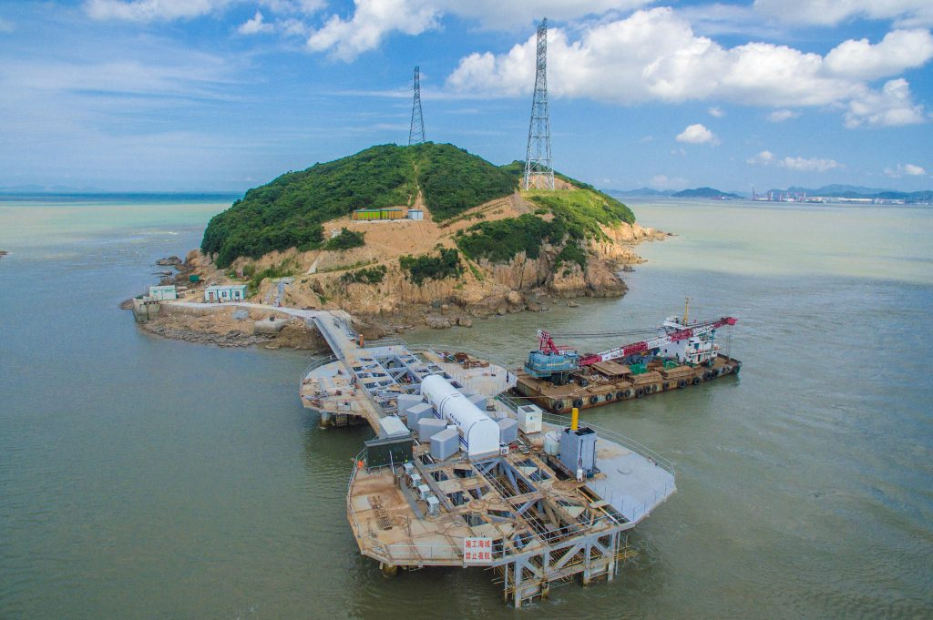
Figure 1: A Tidal Stream Energy Project in the Zhoushan Archipelago, Zhejiang (Han, 2023)
According to estimates by the International Renewable Energy Agency (IRENA, 2020), the generation capacity from ocean energy installations is projected to reach 3 gigawatts (GW) within the next five years. This capacity is then expected to increase significantly to 70 GW by 2030 and further surge to 350 GW by 2050 (Figure 2). This forecast, equivalent to the power generated by over 100 Three Gorges Dams (Han, 2023).
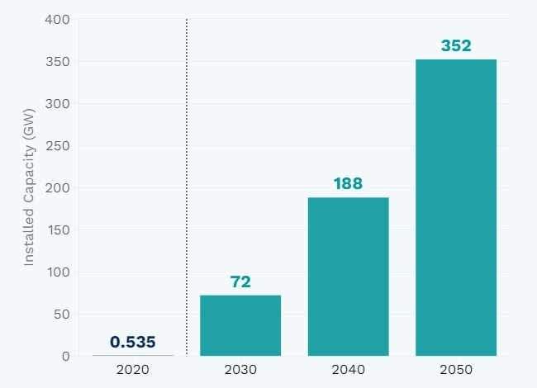
Figure 2: Global Ocean Energy Generation Capacity, Projected Growth
(Source: IRENA, 2020)
Brazil has actively researched into subsea power generation from offshore renewables, with a specific focus on harnessing energy from ocean waves. The exploration includes an assessment of wave power density along the Brazilian coast. Demonstrating a strong commitment to ocean renewable energy, Brazil is engaged in notable projects such as the COPPE hyperbaric wave converter (Figure 3), nearshore wave energy converter, and a tidal range project in the Bacanga River estuary. These initiatives showcase advancements in technology, spanning from prototype stages to research and development (R&D), underscoring Brazil's dedication to fostering diverse and sustainable energy sources (Shadman et al., 2019).
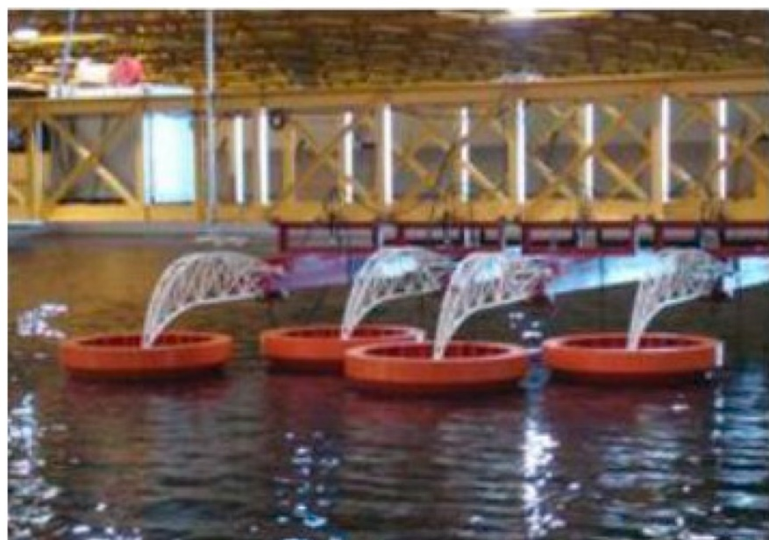
Figure 3: COPPE Hyperbaric Wave Converter
(Shadman et al., 2019)

2.1.3 Government Initiatives and Policies
The Nigerian government has implemented various policies and initiatives to reform and expand its energy sector. The 2013 privatization of electricity distribution and generation companies, alongside ongoing comprehensive power sector reforms, aimed to stimulate growth, increase capacity, and upgrade transmission. Nigeria primarily relies on thermal and hydro power, with plans to diversify and increase the share of renewable energy. The Renewable Energy Master Plan targets a 36% share of renewable energy by 2030. Significant investments, including World Bank funding for the Nigerian Electricity Transmission Access Project, aim to rehabilitate and expand transmission infrastructure. The country is part of regional initiatives like the West African Power Pool and exports electricity to neighboring countries. The government also focuses on improving metering, implementing differential power distribution, and exploring renewable sources, including hydropower projects. Funding sources include international organizations, such as the African Development Bank and the World Bank (ITA, 2023).
The Nigerian government has also implemented various initiatives and policies aimed at reforming the country's electricity sector and fostering sustainable development. The enactment of the Electricity Act, 2023, signifies a significant shift towards post-privatization phase and provides a comprehensive framework for energy transition. Key developments in January 2024 point-out that the government's commitment to enhancing the Nigerian electricity landscape. These include support for the establishment of state electricity markets, as facilitated by the Nigerian Electricity Regulatory Commission (NERC), emphasizing collaboration between the federal government and states. Additionally, the issuance of new Mini Grid Regulations aims to incentivize investment in renewable energy infrastructure and improve the viability of mini grid projects. Regulatory interventions, such as the dissolution of the board of Kaduna Electricity Distribution Company (KAEDC) and ownership transition of distribution companies (DisCos) by the Ministry of Finance Incorporated (MOFI), focus on the government's efforts to streamline operations and address financial challenges within the sector. Moreover, initiatives like the collaboration between Kano Electricity Distribution Company (KEDC) and BlackAion Capital demonstrate a commitment to investing in green infrastructure projects to enhance environmental sustainability. Furthermore, the approval for DisCos to directly procure electricity from Generation Companies (GenCos) aims to improve efficiency and transparency in electricity transactions, signaling a positive step towards reforming the sector. These government initiatives and policies reflect a proactive approach towards addressing challenges and promoting growth in Nigeria's electricity sector (Agaji et al., 2024).

2.1.4 Regional Economic Impact
Enhanced power generation in the Niger Delta has the potential for significant regional economic impact. Increased power availability can stimulate economic activities, leading to job creation across various sectors. Industries that heavily depend on reliable electricity, such as manufacturing and services, can thrive, attracting new investments and fostering economic diversification. Improved energy infrastructure can enhance the region's attractiveness for businesses, encouraging both domestic and foreign investors to explore opportunities. Furthermore, the establishment and expansion of power-related projects can create a ripple effect, generating employment not only in the power sector but also in ancillary industries, contributing to a more robust and diversified economy in the Niger Delta (NDPI, 2015).

2.1.5 Overview of Power Generation Technologies
(i) Onshore Power Generation
This section provides an overview of conventional methods employed for power generation onshore. This includes established technologies and practices commonly used in the field of electricity generation, pointing-out approaches to producing power from onshore sources:
Paul Breeze (2019a) investigates into the historical evolution of coal-fired power plants, tracing their development since the invention of the modern steam turbine by Charles Parsons in 1884. He emphasizes the traditional method of electricity production in these plants, which involves burning coal to release heat. This heat is then used to produce steam, driving a steam turbine generator (Figure 4). Breeze discusses various aspects of this process, including the fuel handling system, combustion process, and boiler integration, all aimed at enhancing efficiency. Also, he outlined the significance of condensing steam back into water in a condenser to maximize plant efficiency. Despite focusing on historical developments, Breeze also addresses contemporary challenges such as carbon dioxide capture and the pursuit of "zero emission plants," underscoring the perpetual trade-off between efficiency, cost, and emissions reduction in coal-fired power generation.
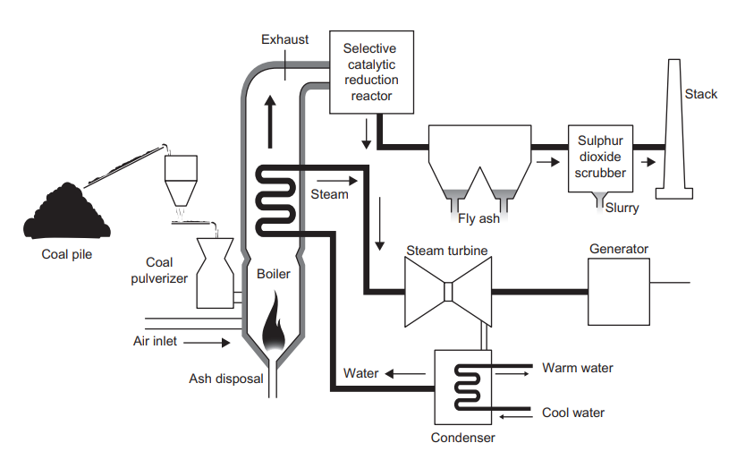
Figure 4: Schematic of a Pulverized Coal-fired Power Station. (Breeze, 2019a)
(ii) Natural Gas-Fired Gas Turbine and Combined Cycle Power Plants
Gas turbine-based power stations have become essential in the global power generation industry, used extensively in both developed and developing regions. Primarily fueled by natural gas due to its cost-effectiveness and availability, gas turbine technology has gained prominence, contrasting with its limited role until the late 1980s. Factors driving its success include the recognition of natural gas as a valuable fuel and advancements in gas turbine combined cycle plants, boasting high energy conversion efficiencies (up to 60%). These plants have enhanced the appeal of gas turbines in power generation. Combusting natural gas in turbines results in lower carbon dioxide and pollutant emissions compared to coal combustion. While gas turbines can use various fuels, natural gas remains the preferred choice. The gas turbine has historical roots in early devices like windmills and smokejacks, evolving into the modern gas turbine (figure 5) with components like a compressor, combustion chamber, and turbine stage closely coupled for efficient energy production (Breeze, 2019b).
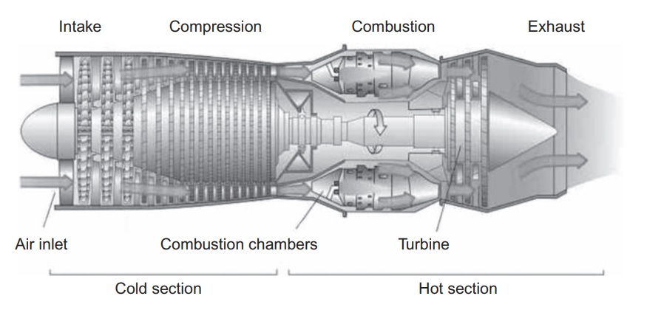
Figure 5: Cross-section of a Gas Turbine. (Breeze, 2019b)
The enhancement of gas turbine energy conversion efficiency has been explored through advanced cycles, especially in smaller systems. However, the essential development lies in the widespread adoption of combined cycle power plants by gas turbine manufacturers, achieving unparalleled energy conversion efficiency among large-scale fossil fuel-fired power stations. Gas turbine efficiency is hampered by high-temperature exhaust gases with unrecovered energy, prompting the incorporation of a bottoming cycle, typically a steam turbine. In this integrated setup, the gas turbine's exhaust feeds into a heat recovery steam generator (figure 2.6), producing steam that propels a steam turbine generator for additional electricity generation. Various configurations, such as single steam turbines for multiple gas turbine exhausts, exist. Continuous advancements in gas turbine combined cycle plants since the late 1980s have significantly raised their energy conversion efficiency. The best efficiency was approximately 50% in 1990, reaching 60.75% in a German plant in 2011. This progress results from tight component integration, minimizing heat loss, and a substantial increase in turbine inlet temperatures. Ongoing efforts in Japan aim for 1700°C feasibility, targeting a potential combined cycle efficiency of around 65% (Breeze, 2019b).
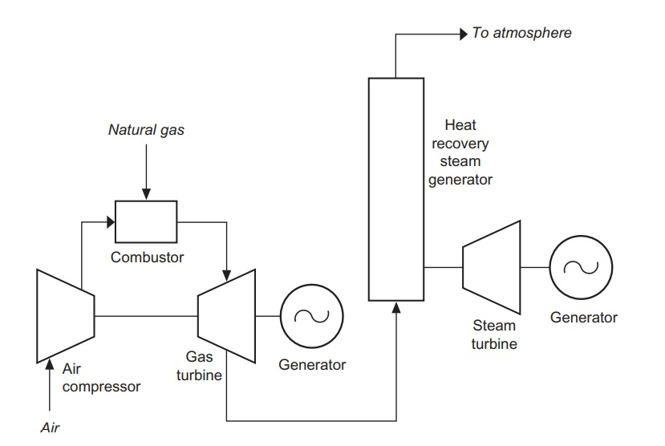
Figure 6: Schematic of a Combined Cycle Power Plant
(Breeze, 2019b)

(iii) Piston Engine - Based Power Plant
Breeze (2019c) provides a thorough examination of piston engines, emphasizing their universal presence in a wide array of applications, from model airplanes to heavy machinery and power generation. The engines, varying in size and fuel compatibility, are crucial in power generation, catering to standby and base load needs across diverse settings. Breeze categorizes reciprocating engines into spark-ignition and compression types, historically favoring diesel engines for efficiency in power generation. However, a notable shift is observed towards spark-ignition engines using natural gas, particularly in industrialized nations. The emergence of Stirling engines for specialized purposes adds a novel dimension to the field. Addressing fuel sources, he noted the dominance of natural gas but emphasizes the rising popularity of alternative fuels like biogas, especially in regions lacking natural gas infrastructure. In essence, the author provides a comprehensive understanding of the extensive and varied applications of piston engines, reflecting their critical role in the global power generation landscape with evolving trends and considerations.

(iv) Combined Heat and Power
Breeze (2019d) illustrated the inefficiency of electricity production from coal, oil, gas, and biomass, with many combustion plants operating at low energy conversion efficiencies. Waste heat, constituting between 40% and 80% of combustion energy, is typically dissipated into the atmosphere, contributing to environmental pollution. Despite efforts to improve conversion efficiencies, a considerable amount of energy remains wasted. The concept of Combined Heat and Power (CHP) systems is introduced as a solution to utilize the otherwise wasted heat for various purposes, achieving energy efficiencies of up to 90%. The implementation of CHP, however, remains low due to historical preferences for large central power stations, which often waste a significant portion of energy. At a smaller scale, particularly in distributed generation, CHP becomes more viable, presenting opportunities for higher energy efficiency. Despite the recognized benefits and economic advantages, the growth of CHP has been slow, posing a challenge for the electricity industry. The author explores the difficulties in collating CHP capacity at a national level and estimates around 9% of the global electricity generation plants having cogeneration capabilities. The potential for CHP applications is quantified based on the global electricity generating capacity, emphasizing the need for integrated systems supplying both heat and electricity to the same users for optimal economic viability. Various power generation technologies, including fossil fuel-fired plants, biomass power plants, electrochemical fuel cells, solar thermal power plants, and geothermal energy, can be adapted into CHP systems, emphasizing their versatility and potential in improving overall energy efficiency.

(v) Fuel Cells
Fuel cells, electrochemical devices generating electricity through reactions like hydrogen and oxygen, offer advantages over batteries as they don't contain reactants. While most use a hydrogen-oxygen reaction, practical efficiency is impacted by factors like operating temperatures and hydrogen reforming. Despite challenges, fuel cells have benefits like environmental friendliness, durability, and low pollution. Cost remains a barrier, hindering widespread adoption. Fuel cells find use in portable devices, stationary power, and transportation, with various types serving different needs. The hydrogen economy could boost fuel cell competitiveness. The fuel cell principle, rooted in electrochemistry, explores electricity generation from hydrogen and oxygen reactions, overcoming barriers with catalysts. Hydrocarbon gas reformation allows the use of gases like natural gas. Efficiency depends on factors like pressure and temperature. The Direct Methanol Fuel Cell (DMFC) simplifies fuel cells using liquid methanol. Despite progress, cost variations pose challenges to broader use despite promising features (Breeze, 2019e).
Ibrahim Dincer and Calin Zamfirescu (2014) in their book; ‘Advanced Power Generation Systems’ provides an overview of conventional power generating systems (CPGSs) treated as heat engines, including spark ignition and compression-ignition engines, steam and organic Rankine power plants, combustion turbine power plants, combined cycle power stations, nuclear power stations, and hydroelectric power stations. The discussion emphasizes prime movers, distinguishing between positive displacement machines (reciprocating engines) and turbomachines (turbines), and points-out differences between small-scale and large-scale CPGSs. They presented CPGSs, detailing vapor cycle power plants, gas turbine cycle power plants, gas engines, and hydroelectric power stations. The authors explored thermodynamic cycles like steam Rankine, coal-fired power stations, Organic Rankine Cycle (ORC) systems, and air-standard Brayton cycles. The section on internal combustion power generating systems covers Diesel, Otto, Stirling, and Ericson cycles. They concluded with a detailed analysis using balance equations for mass, energy, entropy, and exergy, evaluating performance based on energy and exergy. According to Breeze (2019a) other onshore power generation technologies include Hydropower, Power System Energy Storage Technologies, Onshore wind Power, Geothermal Power, Solar Power, Biomass-Based Power Generation, Power from Waste and Nuclear Power.
The review by Qin et al. (2022) comprehensively surveys advancements in tidal current generation (TCG) technology, driven by the escalating global demand for renewable energy sources. Divided into two main sections, the review examines tidal energy collection devices and power generation units. It discusses the structural designs and performance optimization of both vertical-axis and horizontal-axis tidal turbines, showcasing novel designs such as counter-rotating horizontal-axis turbines and ducted turbines. the review also explores generator types and power generation control techniques, emphasizing the importance of maximizing energy conversion efficiency. Looking ahead, the paper forecasts a growing adoption of permanent magnet synchronous generators and the proliferation of tidal power stations worldwide, stressing the pivotal role of ongoing research in advancing TCG technology. Through its comprehensive analysis, the review serves as a valuable resource for guiding the future development and implementation of TCG systems.
Lesemann (2023) presents the Autonomous Offshore Power System (AOPS), an innovative power and data communications solution designed for remote, deep-water applications. The AOPS integrates multiple energy resources like ocean energy and solar power with storage technologies such as rechargeable batteries and pre-charged fuel cells to ensure reliable energy supply and data transmission in offshore locations. Initially introduced in shallow-water environments, the AOPS supports various assets including data-gathering systems, surface and subsea robotics, and operating equipment across sectors like offshore energy, defense, security, and research. The system offers primary, redundant, or emergency power and data communication capabilities, enhancing operational flexibility and reliability. Pilot testing is underway in shallow-water sites, with ongoing advancements aimed at adapting the AOPS for deep-water applications in tropical climates. The paper reveals the potential of AOPS to reduce costs, complexity, and carbon footprint in deep-water operations, particularly in the Brazilian oil and gas sector, by replacing traditional topside vessels and umbilicals while enabling new hardware and services.
Cullinane et al. (2022) discuss the potential of medium-voltage DC superconductors for efficient transmission of offshore renewable energy, aligning with the European Union's climate goals. They examine the challenges and opportunities in deploying superconductors subsea, drawing parallels from the offshore oil and gas industry's expertise in subsea infrastructure. The paper emphasizes the need for research in developing flexible cryogenic pipes capable of withstanding marine dynamics, robust insulation systems suitable for subsea environments, and efficient cooling systems for long-distance pipelines. While the primary focus is on superconductor cables, the insights are relevant for other subsea conduits requiring cryogenic cooling, including 'green' hydrogen transmission. This research stresses the potential of subsea superconductors in advancing offshore renewable energy transmission, contributing to the transition towards sustainable energy systems.
Ahamed et al. (2020) provide a comprehensive review of advancements in wave energy converters (WECs) focusing on power take-off (PTO) systems. They demonstrate the significance of ocean waves as a substantial and predictable renewable energy source, crucial in addressing contemporary energy crises. The article introduces a novel classification of WEC systems, emphasizing their diverse PTO mechanisms. Through a systematic analysis, the authors explore various PTO systems, comparing their advantages and challenges. They underscore the predominance of mechanical direct drive systems in the current market while identifying hybrid PTO systems as promising avenues for future development. Also, the review investigates into international research and development initiatives in wave energy, providing insights into ongoing activities and networks. Overall, the article offers a comprehensive overview of WECs and their PTO systems, contributing valuable insights for researchers and practitioners in the field.
Moon et al. (2020) explores the design and experimental outcomes of power converters utilized in a tidal current power generation system located in Jin-Do, Korea. Their investigation focuses on the grid-connected converter and the power converter used to manage the permanent magnet synchronous generator. The study emphasizes the necessity of various theoretical control algorithms in designing power converters for tidal current power generation systems. Specifically, they investigate the effectiveness of the phase lock loop algorithm for the grid-connected converter and the maximum power point tracking algorithm for the generator-side converter. To assess the practical feasibility of commercial tidal current power generation systems, a downscaled 20-kW tidal generation system was deployed and empirically evaluated as part of the study.
Vennell et al. (2020) presents a study focused on the rapid initial assessment of the number of turbines required for large-scale power generation by tidal currents, with the aim of contributing significantly to global renewable energy demands. The challenge lies in determining the optimal number of turbines needed to deliver a specific power output from proposed sites, considering the changes in current strength due to large-scale power extraction. The paper proposes an approach to swiftly assess farm power output using an existing hydrodynamic model, facilitating the identification of promising farm sites, sizes, and shapes within a region. The study applies this approach to assess the potential of Cook Strait, New Zealand, estimating that a 90 MW farm with 95 turbines might be viable, contingent upon factors such as turbine manufacturing costs and energy prices. This research provides valuable insights for efficiently harnessing tidal energy resources and offers preliminary economic analyses to guide decision-making in the renewable energy sector.
Rajashekara et al. (2017) investigate the electrification of subsea systems, focusing on the challenges and requirements in power distribution and conversion. They discuss the growing importance of subsea operations in the oil and gas industry and the historical preference for placing power equipment onshore or on subsea vessels due to installation difficulties. However, advancements in technology now allow for more equipment to be installed on the seabed, reducing costs and increasing reliability. The authors pointed out challenges such as high-water pressure, corrosive sea water, and limited maintenance access, emphasizing the need for high reliability and long mean time between failures (MTBF). Various subsea power transmission and distribution architectures are examined, with HVDC transmission considered more efficient for long distances. The paper also explores challenges in high voltage wet-mate connectors and penetrators, power electronics for subsea systems, and health analytics and fault handling, concluding with future research opportunities to enhance the efficiency and reliability of subsea power systems.
Ahmed et al. (2011) outlines the progress in the commercial development of 16 MW offshore wave power generation technologies in the southwest region of the UK. Specifically, it investigates into the Wave Hub project, marking the world's inaugural large-scale wave energy farm. The study involves the collaboration of four companies deploying distinct wave-energy converters: Pelamis, Overtopping Device, Multiple Point Absorber System, and Oscillating Water Column. The primary focus is on the integration of offshore wave energy plants into the UK electrical grid, aiming to determine the optimal configuration for grid integration involving multiple wave energy converter devices. Also, the paper addresses challenges related to voltage and reactive power control in the setting of the 16 MW commercial implementation of offshore wave energy technology, exploring their implications for electrical networks.
Baker Hughes (2023) showcases the pioneering efforts of a collaborative venture, Renewables for Subsea Power (RSP), aimed at revolutionizing offshore energy supply through renewable wave power and flexible energy storage. The alliance, comprising technology companies, has successfully demonstrated continuous renewable energy supply to Baker Hughes' subsea communications and control systems using Scottish-born innovations: Mocean Energy's Blue X wave energy converter and Verlume's Halo intelligent underwater battery system. This achievement marks a significant milestone in providing clean and reliable offshore energy to various marine-based projects, including brownfield extensions, carbon capture and storage developments, and autonomous underwater vehicle operations. The project's success in harnessing wave energy for subsea equipment, coupled with ongoing advancements in energy storage and management, holds promise for reducing carbon emissions and enhancing operational efficiency in offshore oil and gas operations. Furthermore, the inclusion of new partners such as PTTEP from Thailand stresses the increasing global enthusiasm for renewable energy solutions in offshore settings, advancing the project towards commercial viability and broad acceptance.
Terwiesch (2019) describes ABB's groundbreaking achievement in validating the functionality and thermal capability of their subsea power distribution and conversion system through a 3000-hour shallow water test, marking a pivotal milestone for offshore oil and gas production. This technology, capable of providing up to 100MW of power over distances of up to 600km and down to depths of 3,000m, offers significant benefits in terms of reliability, safety, productivity, efficiency, and performance. The project, a result of collaboration between ABB, Equinor, Total, and Chevron, demonstrates the potential for remotely operated subsea facilities powered by lower carbon energy, paving the way for a sustainable energy future in offshore environments.
Hitachi Energy offers liquid-filled, pressure-compensated subsea transformers designed for depths of up to 3,000 meters. These transformers play a crucial role in reducing high-voltage levels to low-levels suitable for subsea equipment such as pumps, motors and compressors while ensuring reliable performance in addition to offering some cost benefits. Hitachi Energy has been a pioneer in subsea transformer technology, starting development in the mid-1980s and introducing the first subsea transformer in 1999. With a track record of supplying around twenty subsea transformers over the last decade, Hitachi Energy remains a global leader in manufacturing subsea transformers, providing reliable power transmission underwater with minimal losses. The product scope includes voltages of up to 145 kV AC, currents of up to 900 A, and water depths of up to 3,000 meters (Hitachi, 2023).
Daniel (2012) discusses the race among five countries to harness their marine and hydro power potential, including Australia, North America, South Korea, the UK, and China as key players. Australia boasts extensive coastline and river systems, with notable hydroelectric projects like the Snowy Mountains Scheme, while North America is already utilizing hydro power for nearly seven percent of its electricity and investing in wave and tidal energy projects. South Korea is developing tidal power technologies, with a focus on its coastal regions, and has made significant progress in hydroelectricity generation, both domestically and internationally. The UK is making strides in wave and tidal power technologies, aiming to create jobs and reduce carbon emissions, particularly in Scotland where large-scale hydro projects are prevalent. China, with its vast coastline and islands, is heavily investing in renewable energy, particularly hydro power, despite controversies surrounding dam projects. Each country is striving to capitalize on its unique marine and hydro power resources to meet their energy needs and reduce reliance on fossil fuels.
Powers et al. (2022) examine the current state of offshore wind development in the United States, contrasting it with the substantial progress made in Europe and China. Despite the vast coastline and ample wind resources in the U.S., offshore wind installations have been relatively slow to materialize. The paper illustrates the distinctive opportunities and hurdles associated with offshore wind deployment on each coast, considering factors like bathymetry and weather patterns. Through drawing insights from offshore wind projects elsewhere, the authors analyze the planning and installation challenges specific to the U.S. context. Ultimately, the paper aims to provide a comprehensive overview of offshore wind turbine installation methods, shedding light on the unique challenges faced by this renewable energy sector in the United States.

Narayanaswamy & Bang-Andreasen (2013) examine the challenges associated with implementing a reliable Subsea Electric Grid System (SEGS) for tidal energy farms. Tidal energy, known for its predictability and lack of carbon emissions, is gaining momentum due to supportive policies and advancements in turbine technology. Unlike the traditional method of using dedicated umbilical cables for power transmission, SEGS integrates power from multiple turbines in a farm, synthesizes it, and delivers it to the shore power network through a single umbilical. The paper discusses key technical challenges including reliability, interconnection methods, environmental management, and biofouling. Despite these challenges, technological advancements suggest that a single SEGS could support up to 10 turbines with a mean time between failures ranging from 8.5 to 5.1 years for AC and DC take-off, respectively.
An examination of the challenges and opportunities presented by the interconnection of offshore wind farms via subsea cables reveals both technical and logistical complexities, as well as environmental and regulatory concerns. However, interconnections also provide a number of benefits, including enhanced energy reliability and grid stability, balanced power generation, cost-effectiveness through shared infrastructure, and a more sustainable future for offshore wind energy (Leadvent Group, 2024).
Gordonnat and Hunt (2020) considered the feasibility and challenges of establishing an intercontinental power link between Australia and Singapore to capitalize on Australia's abundant renewable energy resources and address Southeast Asia's increasing electricity demand and reliance on fossil fuels. The proposed high-voltage direct current (HVDC) power link would connect solar farms in northern Australia to Singapore, which faces limitations in renewable energy potential. The paper draws attention to key challenges such as the considerable length of the link (approximately 3200 km), the significant water depths in sections crossing the Timor Trough and Indonesian waters (up to 1900 m), and the logistical complexities of manufacturing and deploying the extensive length of cable in a region distant from major manufacturing facilities. The authors emphasize the need for an integrated contracting strategy involving multiple HVDC cable suppliers, marine heavy transport companies, and cable installation contractors to successfully execute this ambitious project within a reasonable timeframe.
Strang-Moran (2020) explored the challenges and opportunities surrounding the management of subsea cables for offshore wind farms, focusing on the UK offshore wind sector. The paper stresses the critical role of reliable subsea cables in enhancing wind farm operations and reducing the Levelized Cost of Energy (LCoE). By analyzing current trends, the study points out the need for a proactive approach to cable management and the industry transition towards High Voltage Direct Current (HVDC) technology for longer distances offshore. Emphasizing the importance of data sharing, the paper advocates for collaborative efforts to address cable failures and accelerate technological advancements. Maintaining anonymity of stakeholders is crucial in facilitating transparent data sharing while protecting sensitive information. The study emphasizes the necessity of continued data collection and analysis to improve the reliability and performance of offshore wind farms and drive innovation in cable management practices.
Copping et al. (2020) provide an overview of the state of the science regarding the potential environmental effects of marine renewable energy (MRE) development. MRE, which harnesses energy from the ocean, holds promise as a sustainable energy source but raises concerns about its impact on marine and river environments. The paper focuses on tidal and riverine turbines and wave energy converters, detailing potential risks such as animal collisions with rotating blades, underwater noise emissions, electromagnetic field generation, habitat changes, and entanglement of marine animals. While some research suggests minimal impacts on marine life and habitats from noise and electromagnetic fields, uncertainty remains regarding collision risks and entanglement. The authors emphasize the need for further field research and proactive management strategies to ensure MRE development is environmentally responsible.
Kaddoura et al. (2020) conducted a life cycle assessment (LCA) of a 12 MW tidal energy converter array comprising Minesto Deep Green 500 (DG500) prototypes to evaluate its environmental performance. The study adhered closely to Environmental Product Declaration (EPD) standards while considering various design scenarios. The findings revealed a global warming potential (GWP) for the prototype array ranging from 18.4 to 26.3 gCO2-eq/kWhe, comparable to other renewable energy systems like wind power. Material production processes were identified as the primary contributor to environmental impact, albeit offset by end-of-life recycling. Operation and maintenance activities, including the production of replacement parts, also made significant contributions to environmental impacts. The study stresses the need for standardized LCA methodologies for offshore power generation technologies to facilitate meaningful comparisons with other renewable energy sources.
Rahman et al. (2022) conducted a comprehensive review to analyze the environmental impacts of renewable energy source (RES) based electrical power plants. Despite being considered environmentally friendly due to their lack of carbon dioxide emissions, RES power plants still have significant negative impacts on the environment. The study covers various RES technologies including solar thermal, solar photovoltaic, wind, biomass, geothermal, hydroelectric, tidal, ocean current, oceanic wave, ocean thermal, and osmotic power. A SWOT analysis is performed for each type of RES power plant, illustrating their respective strengths, weaknesses, opportunities, and threats. The paper also includes comparative SWOT analyses for solar photovoltaic and concentrated solar power plants. Environmental impact analyses for different attributes such as human health, noise, pollution, greenhouse gas emissions, and deforestation are presented for each RES technology. The findings emphasize the importance of careful selection and utilization of RES to minimize environmental harm.
Rashedi et al. (2022) conducted a cradle-to-grave life cycle assessment (LCA) study on a 1 MW Deepgen tidal turbine to evaluate its environmental sustainability. Utilizing the Recipe LCA method, the study assessed 18 different environmental impacts across the turbine's life cycle, including global warming, ozone depletion, ionizing radiation, and various forms of toxicity and resource scarcity. The findings revealed that materials such as steel, copper, and glass fiber reinforced plastic (GFRP) significantly contributed to environmental impacts, with steel being the highest contributor across all impact categories. Notably, the turbine demonstrated lower greenhouse gas emissions, with a total global warming emission of approximately 1 kiloton (1,000 metric tons) of carbon dioxide equivalent. The study provides valuable insights for deploying more tidal power turbines worldwide by establishing benchmarks for environmental sustainability.
Galparsoro et al. (2022) emphasized the increasing importance of offshore wind energy as a credible and sustainable source for meeting renewable energy demands and reducing carbon emissions. However, they caution that the rapid expansion of offshore wind farms could result in significant ecological impacts on marine ecosystems. Recognizing the urgency of assessing these risks, the authors stress the need for comprehensive evaluations of the ecological effects of offshore wind energy production. Such assessments are essential for implementing effective management strategies aimed at minimizing environmental impacts and ensuring the long-term sustainability of the offshore wind energy sector.
Taormina et al. (2018) provided a comprehensive review of the potential ecological impacts of submarine power cables (SPC) on the marine environment. While SPC have been utilized for decades, concerns about their environmental effects have arisen with the expansion of marine renewable energy technologies. The study categorizes potential impacts of SPC into habitat damage or loss, noise, chemical pollution, heat and electromagnetic field emissions, entanglement risks, introduction of artificial substrates, and reserve effects. Despite increasing research on marine energy devices, data on SPC impacts remain limited, leading to significant knowledge gaps. The study prioritizes these impacts based on ecological relevance and current scientific understanding and offers recommendations for enhanced monitoring and mitigation strategies. While ecological impacts from SPC are generally considered weak to moderate, uncertainties persist, particularly regarding electromagnetic effects.

Diemuodeke & Briggs (2018) examined the challenges hindering sustainable rural electrification in the Niger Delta region of Nigeria and propose feasible policy pathways to overcome these barriers and promote the widespread adoption of renewable energy technologies. They identify several barriers categorized into policy and institutional, technical, data and information gathering, socio-cultural and behavioral, economic and financial, political and market, and inadequate decision-making space. The paper outlines policy pathways driven by considerations of energy access and affordability, emphasizing the roles of various stakeholders in implementing these pathways. Mainly, it illustrates the importance of positive energy policies by the Nigerian government and support from oil-producing companies in facilitating the adoption of renewable energy technologies to address the energy needs of coastal communities in the Niger Delta region. The study provides a comprehensive reference for policymakers and stakeholders aiming to address energy challenges in these areas, suggesting the development of targeted policy briefs to engage relevant actors in sustainable energy initiatives.
Ekwueme-Ugwu (n.d.) investigated the portrayal of sustainability and renewable energy alternatives in Niger Delta novels, particularly focusing on the absence of intentional representations of these themes despite the prevalent ecological concerns arising from crude oil exploitation. Through an ecocritical and energy humanities lens, the paper examines novels like "Tides" by Isidore Okpewho and "Oil on Water" by Helon Habila, which vividly depict the environmental degradation caused by oil activities but lack explicit discussions or representations of renewable energy sources such as solar, wind, or hydroelectric power. The paper underscores the importance of incorporating representations of renewable energy alternatives in literature to raise awareness and promote sustainability, suggesting that literary artists utilize their creative platforms to showcase the potential benefits of renewable energy sources and foster discussions on sustainable energy solutions, thereby contributing to shaping societal perceptions and actions towards achieving a more sustainable energy future.
Recent advancements in wave energy by CorPower Ocean represent a breakthrough for the sector, coinciding with a report from LUT University stressing the crucial role wave energy can play in the UK's renewable energy transition. According to LUT's study, achieving a 100% renewable energy system by 2050 in the UK requires harnessing 27GW of wave energy capacity, especially given the expected increase in electricity consumption. CorPower Ocean's successful ocean commissioning of its commercial-scale device, overcoming historical challenges, reinforces the viability of wave energy for net-zero ambitions (CorPowers, 2024).
Shell has recently become a partner in the Renewables for Subsea Power (RSP) project, which aims to power subsea equipment using wave power and subsea energy storage off the coast of Orkney, Scotland. The project, with a £2 million ($2.5 million) investment, connects the Blue X wave energy converter from Mocean Energy with a Halo underwater battery storage system developed by Verlume. This initiative aims to demonstrate the viability of combining green technologies to provide reliable low-carbon power and communications to subsea equipment, offering an alternative to carbon-intensive umbilical cables. Shell's involvement, through its Shell Technology – Marine Renewable Program, expands the project's reach and resources, with access to data and feasibility assessments for future technology deployment (Verlume, 2024).
Copenhagen Infrastructure Partners (CIP) is expanding its offshore energy island projects worldwide, with approximately 10 projects underway in regions such as the North Sea, Baltic Sea, and Southeast Asia. These large-scale offshore hubs aim to facilitate the deployment of next-generation offshore wind farms on a global scale. By integrating existing technologies at a larger scale, these projects promise cost-efficient construction and seamless integration of offshore wind energy. They offer benefits such as reduced power transmission costs, potential for large-scale offshore green hydrogen production, and synergies between power and hydrogen generation. CIP's new development company, Copenhagen Energy Islands, supported by investors from Nordic, European, and North American regions, underscores its commitment to advancing energy island projects globally (Copenhagen Infrastructure Partners, 2014).
HydroWing has developed a specialized barge to facilitate the installation and maintenance of its tidal stream array technology. This innovation will be utilized at the Morlais tidal energy site in northwest Wales, part of a 10-MW project that secured government support in the UK's Contracts for Difference bid round. The company aims to address the slow commercialization of tidal energy, attributed to high operations and maintenance costs and limited offshore construction vessel availability. The barge's design, featuring a wing system, streamlines operations by enabling the removal of turbine sets without affecting the foundations. With four hulls connected by crossbeams and arch support beams, the barge offers increased load width flexibility and enhanced safety during offshore handling. Its modular design allows for easy transportation and scalability, while its low drag enables handling by small, locally available tugs, minimizing the need for major new investments in port infrastructure.
Ocean energy developer Minesto has achieved a significant milestone by completing the Dragon 12 offshore infrastructure in Vestmannasund, Faroe Islands. This accomplishment includes successfully connecting the export cable on the foundation, rendering the Dragon 12 production site ready for power generation. The subsea infrastructure completion involved relocating the pre-installed junction box to facilitate a plug-and-play connection with the kite tether. Additionally, Minesto has executed the launch and recovery system (LARS) for the Dragon 12, a 1.2 MW tidal kite, demonstrating its effectiveness despite the considerable scale-up from previous operations. The commissioning process for the Dragon 12 is ongoing, with operations of the smaller Dragon 4 power plants continuing simultaneously. Minesto's successful deployment of the Dragon 12 reaffirms the efficacy of its marine operations, marking a significant step towards realizing kite-based power plants for sustainable energy production (Minesto, 2024).

2.2 Limitations of Reviewed Past Works
The reviewed past works on subsea power generation technologies provide valuable insights into global advancements and applications. However, they do not fully address the unique challenges and opportunities specific to the Niger Delta region. Most of these studies focus on broader, generalized approaches to subsea power generation, with limited attention given to region-specific factors such as the water depth variability, seabed geology, and environmental conditions prevalent in the Niger Delta. Also, there is a lack of focus on regulatory compliance challenges in the Niger Delta, as the existing literature does not offer sufficient guidance on navigating the region's complex socio-economic and environmental landscape. This leaves a gap in the development of localized, effective subsea power generation solutions.

2.3 Knowledge Gap
There are substantial research reviews on subsea power generation technologies and their applications worldwide. However, there exist some significant gaps in contextualizing these technologies within the specific environmental and socio-economic framework of the Niger Delta. No comprehensive study has yet assessed how factors such as water depth, seabed conditions, and local environmental regulations can be optimized for subsea power generation in this region. Also, the reviewed literature lacks in-depth analyses of the feasibility, efficiency, and regulatory compliance specific to subsea power generation in the Niger Delta. This gap in localized research hinders the development of practical and sustainable solutions that are designed to the unique conditions of the region.

2.4 Current Review Study
This study aims to bridge the identified knowledge gap by designing a framework for subsea power generation specifically adapted to the Niger Delta. It examined the feasibility of implementing this framework by considering the local environmental conditions, such as water depth and seabed geology, and analyzing the potential energy efficiency, reliability, environmental impact, and economic viability of the proposed system. Also, this study conducts a comparative analysis of subsea power generation with an existing onshore power generation method to evaluate its advantages.

3. Current Methods of Subsea Power Generations

3.2 Methods

3.2.1 Determination of Power Output of Tidal Turbines
According to Garrett & Cummins (2007), the power output of a tidal turbine is given by (1);
$P= \frac{1}{2}ρAC_{p}V^{3}$ (1)
Where:
$ρ$ = density of seawater ( = 1025kg/m³)
A = swept area of turbine blades ($A=πr^{2})$
$C_{p}$= power coefficient ($C_{p}$ = 0.35)
V = velocity of tidal stream

3.2.2 Life Cycle Assessment (LCA)
The life cycle assessment was performed using the ISO 14040:2006 standard using Equation (2) below.
- Equation for Life Cycle Assessment
The life cycle assessment equation is shown in equation 3.2, ISO 14040:2006
$LCA= \sum_{i=1}^{n}{(E_{i} × I_{i})}$ (2)
Where:
$E_{i}$ = environmental impact factor of component i
$I_{i}$ = inventory data of component i

3.2.3 Safety and Reliability Considerations
To evaluate safety and reliability, a risk-based approach was employed, involving hazard identification, reliability analysis, and emergency response planning.

3.2.4 Fault Tree Analysis Probability Calculations
From the works of Rausand & Amljot, 2020, the fault tree analysis probability is calculated using equation (3).
$P_{system}=1- \prod_{i=1}^{n}{(1- P_{i})}$ (3)
Where $P_{i}$ = failure probability of component i.

3.2.5 Feasibility Study
Technical Feasibility
Engineering Requirements
The technical feasibility of deploying subsea power generation systems was assessed through literature review. This review involved analyzing existing research on seabed stability, water depth, and proximity to existing infrastructure. Geotechnical survey data from published studies provided insights into soil composition and stability, while literature on bathymetric mapping offered detailed assessments of seabed depth and topography. GIS-based analyses from prior research were reviewed to understand the strategic placement of subsea components within the context of the Niger Delta.
Bathymetric Mapping Model
Wright & Heyman, 2021 established the bathymetric mapping model using equation (4)
$z=f\left(x,y\right)$ (4)
Where z = depth at coordinates (x, y)

3.2.6 Economic Feasibility
(i) Cost Analysis
The economic feasibility was evaluated through cost analysis, which included capital expenditures, operational costs, maintenance expenses, and potential revenue streams. Financial modeling was conducted using OpenProject, which allowed for an assessment of project viability. The method involved comparing these financial metrics with industry standards to ensure the economic feasibility of the subsea power generation project.

(ii) Levelized Cost of Energy Calculation
The levelized cost of energy was calculated using equation (5), IRENA, 2020.
$LCOE= \frac{\sum_{t=1}^{T}{\left(I_{t }+ O_{t}+ M_{t}\right)}}{\sum_{t=1}^{T}{\frac{E_{t}}{{\left(1+r\right)}^{t}}}}$ (5)
Where:
$I_{t }$= investment expenditure in year t,
$O_{t}$ = operational expenditure in year t,
$M_{t}$ = maintenance expenditure in year t,
$E_{t}$ = energy produced in year t,
$r$ = discount rate,
$T$ = total lifespan of the project.

3.2.7 Social and Environmental Impact Assessment
i. Environmental Impact Assessment (EIA) Model
Glasson, et al. 2019 in their work, established a model equation for EIA as shown in equation (6)
$EIA= \sum_{i=1}^{n}{(E_{i} × W_{i})}$ (6)
Where:
$E_{i}$ = environmental impact of factor i,
$W_{i}$ = weight of factor i.

3.2.8 Comparative Analysis of Subsea Power Generation with existing Onshore Power Generation Methods
The comparative analysis was conducted by systematically examining various factors such as energy efficiency, reliability, environmental impact, and economic viability. Data collection involved gathering relevant performance metrics for both subsea and onshore systems, followed by a quantitative and statistical analysis to compare the two. Sensitivity analysis was used to evaluate the impact of uncertain factors on the comparison, ensuring a robust assessment of the differences between subsea and onshore power generation methods.
- Quantitative Analysis Equation
As can be seen in equation (7), the quantitative analysis equation as proposed by Wang & Liu, 2021;
$Comparison Metric= \frac{X_{subsea}- X_{onshore}}{X_{onshore}} ×100\%$ (7)
Where X represents the performance metric (Energy efficiency, reliability, environmental impact, economic viability, maintenance, carbon emission and energy independence)

4. Observations and Conclusion

4.1 Observations

4.1.1Correlation Between the Growing energy demand in the Niger Delta and the limitations of Existing Onshore Power Infrastructure
The study reveals a strong correlation between the growing energy demand in the Niger Delta and the limitations of existing onshore power infrastructure. Persistent inefficiencies, including transmission losses and inadequate energy mix, continue to constrain regional development. The analysis demonstrates that reliance on fossil fuel-based generation exacerbates environmental degradation while failing to meet increasing industrial and domestic energy needs. In contrast, subsea power generation introduces a paradigm shift by leveraging abundant offshore renewable resources. The integration of tidal, wave, and thermal energy systems reflects a transition toward decentralized and sustainable energy architectures. This observation highlights the structural inadequacies of current systems and reinforces the necessity for innovative, location-specific solutions to address both energy access and sustainability challenges.

4.1.2 Technical Evaluation of Subsea Power Generation Systems
Technical evaluation indicates that subsea power generation systems exhibit superior operational reliability and efficiency due to the high energy density of marine environments and reduced exposure to surface-level disruptions. The predictability of tidal currents enhances energy output consistency, while advancements in subsea technologies, including turbines and energy converters, improve system performance. However, the study identifies critical technical constraints, particularly related to seabed conditions, bathymetric variability, and maintenance accessibility. These factors necessitate rigorous site-specific assessments and robust engineering design. Despite these challenges, the findings confirm that technological maturity is advancing rapidly, making subsea systems increasingly feasible for large-scale deployment in regions with favourable marine conditions such as the Niger Delta.

4.1.3 Economic and environmental analyses
Economic and environmental analyses underscore the long-term viability of subsea power generation despite high initial capital investments. The levelized cost of energy demonstrates potential competitiveness with conventional systems when lifecycle benefits are considered. Environmentally, subsea systems present lower carbon emissions and reduced ecological disruption relative to onshore alternatives. Nevertheless, uncertainties remain regarding impacts on marine ecosystems, particularly concerning noise, electromagnetic fields, and habitat alteration. Socially, the deployment of subsea infrastructure offers prospects for job creation, industrial growth, and energy security, but requires stakeholder engagement and regulatory alignment. Overall, the study highlights that while subsea power generation is not without risks, its integrated benefits position it as a strategic solution for sustainable energy transition.

4.2 Conclusion
This study establishes that subsea power generation represents a technically viable and strategically relevant solution to the persistent energy challenges in the Niger Delta. By integrating engineering, environmental, and economic assessments, the proposed framework demonstrates the potential to outperform conventional onshore systems in efficiency, reliability, and sustainability. The research contributes to closing the existing knowledge gap by contextualizing subsea technologies within the region’s unique environmental and socio-economic conditions. The findings affirm that successful implementation depends on careful consideration of geotechnical characteristics, marine dynamics, and system design optimization.
Notwithstanding its advantages, the adoption of subsea power generation requires addressing key challenges, including high capital costs, regulatory complexities, and environmental uncertainties. Strategic policy support, technological innovation, and stakeholder collaboration are essential to facilitate large-scale deployment. Future research should focus on pilot implementations, real-time performance monitoring, and comprehensive environmental impact validation. Ultimately, the framework provides a foundation for advancing sustainable energy solutions, positioning the Niger Delta as a potential leader in offshore renewable energy development while contributing to broader global decarbonization goals.

REFERENCES

Adoghe, A. U., Adeyemi-Kayode, T. M., Oguntosin, V., & Amahia, I. I. (2023). Performance evaluation of the prospects and challenges of effective power generation and distribution in Nigeria. Heliyon, 9(3), e14416. https://doi.org/10.1016/j.heliyon.2023.e14416

Ahamed, R., McKee, K., & Howard, I. (2020). Advancements of wave energy converters based on power take off (PTO) systems: A review. Ocean Engineering, 204, 107248. https://doi.org/10.1016/j.oceaneng.2020.107248

Agaji, S., Senbore, O., & Caleb, C. (2024). Powering Nigeria: A Recap of Recent Developments in the Electric Power Sector as 2024 Commences with a Flurry of Regulatory Interventions and Proposed Power Asset Sales. ALN Aluko & Oyebode News & Events. Retrieved March 18, 2024 from https://www.aluko-oyebode.com/insights/developments-regulatory-changes-nigeria-electricity-sector-2024/

Ahmed, T., Nishida, K., & Nakaoka, M. (2011). The commercial advancement of 16 MW offshore
wave power generation technologies in the southwest of the UK. In 8th International Conference on Power Electronics - ECCE Asia (pp. 1476-1483). Jeju, Korea (South). doi:10.1109/ICPE.2011.5944474

Beaubouef, B. (2023). Subsea power turbines may offer new offshore renewable energy option.
Offshore Renewable Energy. Retrieved 18th March, 2024 from https://www.offshore-mag.com/renewable-energy/article/14301935/subsea-power-turbines-may-offer-new-offshore-renewable-energy-option

Baker Hughes. (2023). Waving goodbye to fossil-fueled subsea ops. Retrieved February 9th, 2024
from https://www.bakerhughes.com/company/energy-forward/waving-goodbye-fossilfueled-subsea-ops

Bhandari, R., Arce, B. E., Sessa, V., & Adamou, R. (2021). Sustainability Assessment of Electricity
Generation in Niger Using a Weighted Multi-Criteria Decision Approach. Sustainability, 13, 385. https://doi.org/10.3390/su13010385

Breeze, P. (2019a). Coal-Fired Power Plants. In P. Breeze (Ed.), Power Generation Technologies
(Third Edition), 33-70. Newnes. ISBN 9780081026311. https://doi.org/10.1016/B978-0-08-102631-1.00003-1

Breeze, P. (2019b). Natural Gas–Fired Gas Turbine and Combined Cycle Power Plants. In P.
Breeze (Ed.), Power Generation Technologies (Third Edition), 71-97. Newnes. https://doi.org/10.1016/B978-0-08-102631-1.00004-3

Breeze, P. (2019c). Piston Engine–Based Power Plants. In P. Breeze (Ed.), Power Generation
Technologies (Third Edition) , 99-119. Newnes. ISBN 9780081026311. https://doi.org/10.1016/B978-0-08-102631-1.00005-5

Breeze, P. (2019d). Combined Heat and Power. In P. Breeze (Ed.), Power Generation Technologies (Third Edition). 121-14. Newnes. ISBN 9780081026311. https://doi.org/10.1016/B978-0-08-102631-1.00006-7
Breeze, P. (2019e). Fuel Cells. In P. Breeze (Ed.), Power Generation Technologies (Third Edition) (pp. 121-143). Newnes. ISBN 9780081026311. https://doi.org/10.1016/B978-0-08-102631-1.00007-9
Castellon, J., Notingher, P., Agnel, S., Toureille, A., Matallana, J., Janah, H., Mirebeau, P., & Sy, D. (2005). Industrial installation for voltage-on space measurements in HVDC cables. In Fourtieth IAS Annual Meeting. Conference Record of the 2005 Industry Applications Conference, 2005 (Vol. 2, pp. 1112-1118). https://api.semanticscholar.org/CorpusID:16179194

Charlier, R. H., & Finkl, C. W. (2009). Ocean energy: Tide and tidal power. Springer.

Copenhagen Infrastructure Partners (CIP). (2014). CIP aiming to go global with energy islands. Renewable Energy. Retrieved March 19th, 2024 from https://www.offshore-mag.com/renewable-energy/article/14303850/cip-aiming-to-go-global-with-energy-islands

Copping, A.E., Hemery, L.G., Overhus, D.M., Garavelli, L., Freeman, M.C., Whiting, J.M., Gorton, A.M., Farr, H.K., Rose, D.J., & Tugade, L.G. (2020). Potential Environmental Effects of Marine Renewable Energy Development. The State of the Science. Journal of Marine Science and Engineering, 8, 879. https://doi.org/10.3390/jmse8110879

CorPowers. (2024). Report: Wave energy to play a key role in UK’s net zero ambitions. Renewable Energy. Retrieved March 19th, 2024 from https://www.offshore-mag.com/renewable-energy/article/14310018/report-wave-energy-to-play-a-key-role-in-uks-net-zero-ambitions

Cullinane, M., Judge, F., O'Shea, M., Thandayutham, K., & Murphy, J. (2022). Subsea superconductors: The future of offshore renewable energy transmission? Renewable and Sustainable Energy Reviews, 156, 111943. https://doi.org/10.1016/j.rser.2021.111943

Crawley, F., & Tyler, B. (2015). HAZOP: Guide to Best Practice: Guidelines to Best Practice for the Process and Chemical Industries. Elsevier.

Daniel. (2012). The race is on – five countries making the most of their marine power potential. Retrieved from February 9th, 2024 https://www.power-technology.com/features/featurethe-race-is-on-five-countries-making-the-most-of-their-wave-power-potential/?cf-view&cf-closed

Das, B. M., & Sivakugan, N. (2018). Principles of Foundation Engineering (9th ed.). Cengage Learning.

Diemuodeke, E.O., & Briggs, T.A. (2018). Policy pathways for renewable and sustainable energy utilization in rural coastline communities in the Niger Delta zone of Nigeria. Energy Reports, 4, 638-644. https://doi.org/10.1016/j.egyr.2018.10.004

Dincer, I., & Zamfirescu, C. (2014). Conventional Power Generating Systems. In Advanced Power Generation Systems. Retrieved January 20th, 2024 from https://www.sciencedirect.com/topics/engineering/power-generation-system#:~:text=There%20are%20a%20number%20of,station%2C%20and%20hydroelectric%20power%20station.

Ekwueme-Ugwu, C.C. (n.d.). Sustainability and the renewable energy alternative in Niger Delta novels. Retrieved February 10th, 2024 from https://www.academicexcellencesociety.com/sustainability_and_the_renewable_energy_alternative.pdf

Farghali, M., Osman, A. I., Chen, Z., Abdelhaleem, A., Ihara, I., Mohamed, I. M. A., Yap, P.-S., & Rooney, D. W. (2023). Social, environmental, and economic consequences of integrating renewable energies in the electricity sector: a review. Environmental Chemistry Letters, 21(4), 1381–1418. https://doi.org/10.1007/s10311-023-01587-1

Farrpoint (2021). North-Eastern Scotland: Subsea Connectivity Feasibility Study. Retrieved from https://hostinscotland.com/storage/177/SFT27D1V1.2-Subsea-Connectivity-Feasibility-Study---Final-Issue.pdf

Garrett, C., & Cummins, P. (2007). The efficiency of a turbine in a tidal channel. Journal of Fluid Mechanics, 588, 243-251. doi:10.1017/S0022112007007771

Galparsoro, I., Menchaca, I., Garmendia, J. M., Borja, Á., Maldonado, A. D., Iglesias, G., & Bald, J. (2022). Reviewing the ecological impacts of offshore wind farms. npj Ocean Sustain, 1(1), 1. https://doi.org/10.1038/s44183-022-00003-5.

Glasson, J., Therivel, R., & Chadwick, A. (2019). Introduction to Environmental Impact Assessment (5th ed.). Routledge.

Gordonnat, J., & Hunt, J. (2020). Subsea cable key challenges of an intercontinental power link: case study of Australia–Singapore interconnector. Energy Transit, 4, 169–188. https://doi.org/10.1007/s41825-020-00032-z

Haddow, G. D., Bullock, J. A., & Coppola, D. P. (2017). Introduction to Emergency Management. Butterworth-Heinemann.

Han, Q. (2023). China’s ocean power stations set to go commercial. Retrieved January 20th, 2024 from https://chinadialogueocean.net/en/climate/chinas-ocean-power-stations-set-to-go-commercial/

Hitachi. (2023). Subsea transformers. Retrieved February 9th, 2024 from https://www.hitachienergy.com/products-and-solutions/transformers/special-application-transformers/subsea-transformers

HydroWing. (2024a). Inyanga to construct tidal power development at remote Philippines island. Renewable Energy. Retrieved March 18th, 2024 from https://www.offshore-mag.com/renewable-energy/article/14304625/inyanga-to-construct-tidal-power-development-at-remote-philippines-island

HydroWing. (2024b). Minesto's tidal kite subsea infrastructure works completed offshore Faroe Islands. Renewable Energy. Retrieved March 19th, 2024 from https://www.offshore-mag.com/renewable-energy/article/14303784/hydrowing-develops-barge-for-tidal-energy-a

International Trade Administration. (2023). Electricity. Power Systems and Renewable Energy. Retrieved January 20th, 2024 from https://www.trade.gov/country-commercial-guides/electricity-power-systems-and-renewable-energy

IRENA (2020). Renewable Power Generation Costs in 2019. International Renewable Energy Agency. Retrieved from https://www.irena.org/publications/2020/Jun/Renewable-Power-Costs-in-2019

ISO (2006). Environmental management Life cycle assessment Principles and framework (ISO 14040:2006). International Organization for Standardization.

Juhlin, R., & Assadi, M. (2024). Harnessing ocean depths for energy: A theoretical framework for evaluating the feasibility of Subsea Pumped Hydro Storage. Journal of Energy Storage, 83, 110510. https://doi.org/10.1016/j.est.2024.110510

Kaddoura, M., Tivander, J., & Molander, S. (2020). Life Cycle Assessment of Electricity Generation from an Array of Subsea Tidal Kite Prototypes. Energies, 13, 456. https://doi.org/10.3390/en13020456

Kletz, T. A. (1999). Hazop and Hazan: Identifying and Assessing Process Industry Hazards. Taylor & Francis.

Khan, M.Z.A., Khan, H.A., & Aziz, M. (2022). Harvesting Energy from Ocean: Technologies and Perspectives. Energies, 15, 3456. https://doi.org/10.3390/en15093456

Kumamoto, H., & Henley, E. J. (1996). Probabilistic Risk Assessment and Management for Engineers and Scientists. IEEE Press.

Leadvent Group. (2024). Challenges and Opportunities in Offshore Wind Farm Interconnections via Subsea Cables. Retrieved February 9th, 2024 from https://www.leadventgrp.com/blog/challenges-and-opportunities-in-offshore-wind-farm-interconnections-via-subsea-cables

Lesemann, A. R. (2023). Coming innovation for the provision of remote, reliable, unattended power generation and data communications for deep-water applications: The Autonomous Offshore Power System. Paper presented at the Offshore Technology Conference Brasil, Rio de Janeiro, Brazil. https://doi.org/10.4043/32677-MS

Levitin, G. (2016). Reliability Engineering: Design, Production, and Operation. Springer.

Lewis, A., Estefen, S. F., Huckerby, J., Musial, W., Pontes, M. T., & Torres-Martínez, J. (2011). Ocean Energy. In IPCC Special Report on Renewable Energy Sources and Climate Change Mitigation. Cambridge University Press.

Lewis, M., Estefen, S., Huckerby, J., and Neill, S. (2011). "Tidal Energy Systems: Design, Optimization, and Efficiency." Renewable Energy Journal, 8(4), 145-160.

Maity, S., Sarkar, S., Dutta, K., De, T., & Mukherjee, R. (2023). Renewable Energy and Green Technology. IntechOpen. doi: 10.5772/intechopen.1003716

Minesto. (2024). Minesto's tidal kite subsea infrastructure works completed offshore Faroe Islands. Renewable Energy. Retrieved March 19th, 2024 from https://www.offshore-mag.com/renewable-energy/article/14303582/minestos-tidal-kite-subsea-infrastructure-works-completed-offshore-faroe-islands

Modarres, M. (2016). Probabilistic Risk Assessment and Management for Engineers and Scientists. John Wiley & Sons.

Mofor, L., Goldsmith, J., & Jones, F. (2014). Renewable Energy in the Water, Energy & Food Nexus. International Renewable Energy Agency (IRENA)

Moon, S.-H., Park, B.-G., Kim, J.-W., & Kim, J.-M. (2020). Effective algorithms of a power converter for tidal current power generation system. Journal of Power Electronics. Springer Science and Business Media LLC. https://doi.org/10.1007/s43236-020-00063-1

Mwasilu, F., & Jung, J.-W. (2019). Potential for power generation from ocean wave renewable energy source: a comprehensive review on state-of-the-art technology and future prospects. Renewable Power Generation. https://doi.org/10.1049/iet-rpg.2018.5456

Narayanaswamy, V., & Bang-Andreasen, H. (2013). Challenges in Realizing Reliable Subsea Electric Power Grid for Tidal Energy Farms. Marine Technology Society Journal, 47(4), 80–93. https://doi.org/10.4031/MTSJ.47.4.17

Niger Delta Partnership Initiative. (2015). A Scoping Study on the Niger Delta Electricity Value Chain. Retrieved from https://www.dai.com/uploads/niger-delta-study.pdf

Oyedepo, S. O. (2012). Energy and sustainable development in Nigeria: the way forward. Energ Sustain Soc, 2, 15. https://doi.org/10.1186/2192-0567-2-15

Paton, D., & Johnston, D. (2006). Disaster Resilience: An Integrated Approach. Charles C Thomas Publisher.

Pelc, R., & Fujita, R. M. (2002). Renewable energy from the ocean. Marine Policy, 26(6), 471-479.

Powers, T., Sajadi, A., & Hodge, B.-M. (2022). The current opportunities and challenges for offshore wind in the United States. The Electricity Journal, 35(7), 107061. https://doi.org/10.1016/j.tej.2021.107061.

Qin, Z., Tang, X., Wu, Y.-T., & Lyu, S.-K. (2022). Advancement of Tidal Current Generation Technology in Recent Years: A Review. Energies, 15, 8042. https://doi.org/10.3390/en15218042

Rahman, A., Farrok, O., & Haque, M. M. (2022). Environmental impact of renewable energy source-based electrical power plants: Solar, wind, hydroelectric, biomass, geothermal, tidal, ocean, and osmotic. Renewable and Sustainable Energy Reviews, 161, 112279. https://doi.org/10.1016/j.rser.2022.112279.

Rajashekara, K., Krishnamoorthy, H. S., & Naik, B. S. (2017). Electrification of subsea systems: requirements and challenges in power distribution and conversion. CPSS Transactions on Power Electronics and Applications, 2(4), 259-266. doi:10.24295/CPSSTPEA.2017.00024

Rausand, M., & Arnljot, H. (2020). System Reliability Theory: Models, Statistical Methods, and Applications (3rd ed.). Wiley.

Ranganathan, R., Subbaram, S., Indira, G., Arul Arasi, N., & Tharmar, S. (2023). A Comparative Study of Renewable Energy Sources for Power Generation in Rural Areas. E3S Web Conf., 387, 05011. DOI: https://doi.org/10.1051/e3sconf/202338705011

Ranganathan, V., Kumar, A., and Smith, J. (2023). "Comprehensive Evaluation of Power Generation Methods: A Comparative Analysis of Subsea and Onshore Systems." Journal of Renewable Energy Studies, 15(2), 234-250.

Rashedi, A., Khanam, T., Jeong, B., & Hussain, M. (2022). Evaluation of environmental sustainability matrix of Deepgen tidal turbine. Ocean Engineering, 266(4), 113031. https://doi.org/10.1016/j.oceaneng.2022.113031.

Reda, A., Abu-Siada, A., Howard, I. M., & McKee, K. K. (2019). A testing platform for subsea power cable deployment. Engineering Failure Analysis, 96, 142-157. https://doi.org/10.1016/j.engfailanal.2018.09.006

Sourceforge. (2024). OpenProject is the leading open source project management software. Retrieved March 19th, 2024 from https://sourceforge.net/projects/openproject.mirror/

Schneider, K. (2017). Regulating Safety of Traditional and Emerging Technologies. Springer.

Shams, S., Prasad, D. M. R., Imteaz, M. A., Khan, M. M. H., Ahsan, A., & Karim, M. R. (2023). An Assessment of Environmental Impact on Offshore Decommissioning of Oil and Gas Pipelines. Environments, 10, 104. https://doi.org/10.3390/environments10060104

Strang-Moran, C. (2020). Subsea cable management: Failure trending for offshore wind. Wind Energy Science, 5(4), 1001–1016. https://doi.org/10.5194/wes-2020-56

Taormina, B., Bald, J., Want, A., Thouzeau, G., Lejart, M., Desroy, N., & Carlier, A. (2018). A review of potential impacts of submarine power cables on the marine environment: Knowledge gaps, recommendations and future directions. Renewable and Sustainable Energy Reviews, 96, 380-391. https://doi.org/10.1016/j.rser.2018.07.026

Terwiesch, P. (2019). Powering the seabed for a sustainable energy future. Retrieved February 9th, 2024 from https://new.abb.com/news/detail/46746/powering-the-seabed-for-a-sustainable-energy-future

Thennakoon, T., Hewage, H.T.M., Maneth, D., Sandunika, I., Panagoda, S., Senarathna, C., Sulaksha, T., Weerasinghe, J., Gamage, M., & Perera, D. (2023). Harnessing the Power of Ocean Energy: A Comprehensive Review of Power Generation Technologies and Future Perspectives. ResearchGate. Pages 73-102. Retrieved March 18th, 2024 from https://www.researchgate.net/publication/372365849_Harnessing_the_Power_of_Ocean_Energy_A_Comprehensive_Review_of_Power_Generation_Technologies_and_Future_Perspectives

United States Environmental Protection Agency. (2023). Human Health & Environmental Impacts of the Electric Power Sector. Retrieved January 19th, 2024 from https://www.epa.gov/power-sector/human-health-environmental-impacts-electric-power-sector

Utilitiesone. (2024). Challenges and Solutions in Offshore Engineering. Retrieved February 23rd, 2024 from https://utilitiesone.com/blog/challenges-and-solutions-in-offshore-engineering

Vennell, R., Major, R., Zyngfogel, R., Beamsley, B., Smeaton, M., Scheel, M., & Unwin, H. (2020). Rapid initial assessment of the number of turbines required for large-scale power generation by tidal currents. Renewable Energy, 162, 1890-1905

Vesely, W. E., Goldberg, F. F., Roberts, N. H., & Haasl, D. F. (1981). Fault Tree Handbook. U.S. Nuclear Regulatory Commission.

Verlume. (2024). Shell joins RSP wave power, subsea energy storage project. Renewable Energy. Retrieved March 19th, 2024 from https://www.offshore-mag.com/renewable-energy/article/14304694/shell-joins-rsp-wave-power-subsea-energy-storage-project

Wallace, D. R., & Fujii, R. U. (1989). Software Quality Assurance: A Practical Approach. IEEE Computer Society Press.

Wang, H., & Liu, X. (2021). Handbook of Energy Economics and Policy. Springer.

Wright, D. J., & Heyman, W. D. (2021). Marine Geospatial Ecology: Mapping the Seafloor and Ocean Currents (1st ed.). Springer.

