IoT Based Health And Alcohol Monitoring And Safety Control System

Abstract:
This paper presents the design and implementation of an Internet of Things (IoT)-based Health and Alcohol Monitoring and Safety Control System aimed at enhancing safety in industrial, transportation, and other safety-critical environments. Accidents caused by alcohol consumption and abnormal health conditions pose significant risks, while traditional monitoring methods are often manual, inefficient, and lack real-time capabilities.
The proposed system integrates multiple sensors, including an MQ-3 alcohol sensor, heart rate sensor, blood pressure sensor, and DS18B20 temperature sensor, to continuously monitor physiological parameters of individuals. The collected data is processed using an ESP32 microcontroller, which analyzes sensor values and compares them with predefined safety thresholds to determine the user’s fitness for operation.
When abnormal conditions are detected, the system activates alert mechanisms such as a buzzer and LCD display notifications, and can restrict access to machinery or workplace environments. Furthermore, the system utilizes Wi-Fi connectivity to transmit real-time data to an IoT cloud platform, enabling remote monitoring, data logging, and safety analysis through web or mobile interfaces.
Experimental results demonstrate that the system accurately detects unsafe conditions and responds in real time, thereby reducing human error and improving overall safety. The proposed solution offers a reliable, scalable, and cost-effective approach for preventing accidents and enhancing safety monitoring in modern industrial applications.
Keywords: Alcohol sensor, Heart rate sensor, Blood pressure sensor, DS18B20 temperature sensor, ESP32 microcontroller
I.INTRODUCTION:
The rapid advancement of industrial automation and transportation systems has significantly increased the need for effective safety monitoring mechanisms in workplaces and safety-critical environments. Accidents caused by alcohol consumption, fatigue, and abnormal health conditions remain a major concern, leading to severe injuries, fatalities, and economic losses. Ensuring that individuals are physically fit and not under the influence of alcohol before operating machinery or performing critical tasks is therefore essential for maintaining operational safety.
Traditional safety monitoring approaches, such as manual alcohol testing and periodic medical examinations, are limited in their effectiveness. These methods are time-consuming, prone to human error, and incapable of providing continuous real-time monitoring. Furthermore, conventional systems rely on manual record-keeping, which makes data analysis and safety auditing inefficient and unreliable.
With the emergence of Internet of Things (IoT) technology, it has become possible to develop intelligent monitoring systems capable of real-time data acquisition, processing, and remote supervision. IoT-based systems utilize sensors, microcontrollers, and cloud platforms to continuously monitor physiological parameters and detect abnormal conditions, enabling automated alerts and data-driven decision-making.
In this context, the proposed system introduces an IoT-based Health and Alcohol Monitoring and Safety Control System that integrates multiple sensors, including an MQ-3 alcohol sensor, heart rate sensor, blood pressure sensor, and DS18B20 temperature sensor, with an ESP32 microcontroller. The system continuously monitors user conditions, processes sensor data, and compares it with predefined safety thresholds to identify unsafe situations.
.

II. PROPOSED METHODOLOGY
A. System Overview: The proposed system is an Internet of Things (IoT)-based Health and Alcohol Monitoring and Safety Control System designed to ensure safety in industrial and safety-critical environments. The system continuously monitors physiological parameters and alcohol levels of individuals before allowing them to operate machinery or access restricted areas.
The system integrates multiple sensors, a microcontroller, alert mechanisms, and IoT cloud connectivity to provide automated monitoring, real-time analysis, and remote supervision.
B. System Architecture: The architecture of the proposed system is divided into four major functional units: sensing unit, processing unit, output unit, and communication unit.
The sensing unit consists of an MQ-3 alcohol sensor, heart rate sensor, blood pressure sensor, and DS18B20 temperature sensor, which are used to collect real-time physiological data.
The processing unit is implemented using the ESP32 microcontroller, which receives sensor inputs, processes the data, and compares the values with predefined safety thresholds.
The output unit includes an LCD display and a buzzer. The LCD displays real-time sensor readings and system status, while the buzzer provides an audible alert when abnormal conditions are detected.
The communication unit utilizes the built-in Wi-Fi capability of the ESP32 to transmit sensor data to an IoT cloud platform for remote monitoring and data storage.
C. Working Principle: The system operates on a continuous monitoring and threshold-based decision-making approach. Initially, all sensors and modules are initialized when the system is powered.
The sensors continuously measure parameters such as alcohol concentration, heart rate, blood pressure, and body temperature. The ESP32 microcontroller reads and processes these values at regular intervals.
The processed data is compared with predefined safety thresholds. If all parameters are within safe limits, the system continues normal operation. However, if any parameter exceeds the threshold, the system identifies the condition as unsafe.
In such cases, the system activates the buzzer, displays warning messages on the LCD, and can restrict access to machinery or workplace environments to prevent accidents.
D. Hardware Implementation: The hardware implementation of the system includes the ESP32 microcontroller, MQ-3 alcohol sensor, heart rate sensor, blood pressure sensor, DS18B20 temperature sensor, LCD display, and buzzer.
The ESP32 acts as the central processing unit due to its high processing capability and built-in Wi-Fi connectivity. The MQ-3 sensor detects alcohol concentration in breath, while the heart rate and blood pressure sensors monitor vital health parameters. The DS18B20 sensor provides accurate digital temperature readings.
E. Software Implementation: The software for the proposed system is developed using Arduino IDE with Embedded C programming. The program performs continuous monitoring and control operations.
The software initializes all sensors and communication modules, reads sensor data, processes the values, and compares them with predefined thresholds. Based on the results, the system generates alerts and controls output devices.
F. IoT Integration: The IoT integration enables remote monitoring and data analysis. The ESP32 microcontroller connects to the internet using Wi-Fi and transmits sensor data to a cloud-based platform.
The cloud platform stores real-time data and provides visualization through dashboards, allowing supervisors to monitor the system remotely. This feature enhances system reliability and enables quick decision-making in case of abnormal conditions.

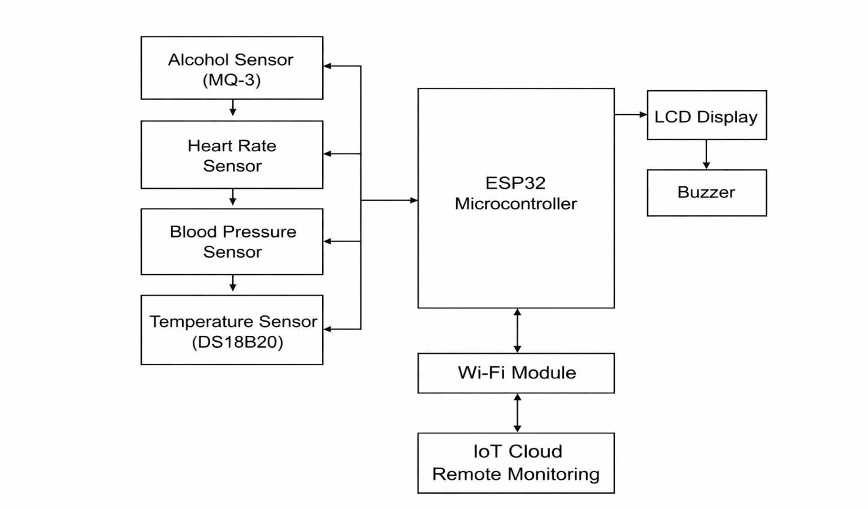
Figure:1 block diagram of the proposed IoT-based Health and Alcohol Monitoring and Safety Control System
The block diagram of the proposed IoT-based Health and Alcohol Monitoring and Safety Control System illustrates figure1 the interaction between various hardware and communication components. The system is designed to continuously monitor physiological parameters and detect unsafe conditions using a combination of sensors, processing units, and IoT connectivity.
G. Input Unit (Sensors)
The input unit consists of multiple sensors responsible for collecting real-time physiological data from the user. The MQ-3 alcohol sensor detects alcohol concentration in breath, while the heart rate sensor measures pulse rate. The blood pressure sensor monitors systolic and diastolic pressure, and the DS18B20 temperature sensor measures body temperature. These sensors generate analog or digital signals corresponding to the measured parameters.
H. Processing Unit (ESP32 Microcontroller)
The ESP32 microcontroller acts as the central processing unit of the system. It receives input signals from all sensors and processes the data using embedded algorithms. The microcontroller compares the measured values with predefined safety thresholds to determine whether the user is in a safe condition. Due to its high processing capability and built-in Wi-Fi module, ESP32 enables both local processing and cloud communication.
I. Output Unit (LCD Display and Buzzer)
The output unit consists of an LCD display and a buzzer. The LCD display provides real-time visualization of sensor readings, including alcohol level, heart rate, blood pressure, and temperature. The buzzer serves as an alert mechanism that is activated when any parameter exceeds the safe threshold value, thereby notifying users and supervisors of unsafe conditions.
J. Control Mechanism
The system includes a control mechanism that can restrict access to machinery or workplace environments when unsafe conditions are detected. This ensures that individuals under the influence of alcohol or with abnormal health parameters are prevented from performing critical operations.
K. Communication Unit (IoT Cloud Platform)
The communication unit utilizes the built-in Wi-Fi capability of the ESP32 to transmit sensor data to an IoT cloud platform. The cloud platform stores real-time data and provides remote access through dashboards or mobile applications. This enables supervisors to monitor system status, analyze historical data, and make informed decisions.
L. Power Supply Unit
The power supply unit provides regulated DC voltage to all system components. It ensures stable and reliable operation of sensors, microcontroller, and output devices.

III RESULTS AND DISCUSSION
A. Experimental Setup
The proposed IoT-based Health and Alcohol Monitoring and Safety Control System was implemented and tested under various operating conditions to evaluate its performance and reliability. The system integrates multiple sensors, including an MQ-3 alcohol sensor, heart rate sensor, blood pressure sensor, and DS18B20 temperature sensor, interfaced with an ESP32 microcontroller.
The experimental setup was designed to continuously monitor physiological parameters and detect unsafe conditions in real time. The collected data was displayed on an LCD module and transmitted to an IoT cloud platform for remote monitoring and analysis.
B. Experimental Results
The system was tested under different conditions to analyze its response to normal and abnormal parameters. The observed results are summarized as follows
Test Case | Alcohol Level | Heart Rate (BPM) | Temperature (°C) | Blood Pressure | System Status
1 | Normal | 72 | 36.5 | 118/78 | Safe
2 | Normal | 80 | 36.9 | 120/80 | Safe
3 | High | 75 | 36.7 | 122/82 | Alert
4 | Normal | 110 | 37.8 | 125/85 | Alert
5 | Normal | 85 | 36.8 | 118/76 | Safe
The results indicate that the system successfully distinguishes between safe and unsafe conditions based on predefined threshold values.
C. Performance Analysis
The performance of the proposed system was evaluated based on key parameters such as detection accuracy, response time, and real-time monitoring capability.The system accurately detected high alcohol levels and triggered alert mechanisms immediately. Abnormal physiological parameters such as elevated heart rate and body temperature were successfully identified. The ESP32 microcontroller ensured fast processing, enabling real-time monitoring and decision-making. Sensor readings were continuously updated and displayed on the LCD as well as transmitted to the IoT cloud platform.
D. Response Time Evaluation
Response time is a critical factor in safety monitoring systems. The proposed system demonstrated rapid response characteristics: Alerts were generated within a few seconds after detecting abnormal conditions. The buzzer and LCD display provided immediate notification to users. Data transmission to the IoT platform occurred with minimal delay. This fast response ensures that preventive actions can be taken in time to avoid potential hazards.
E. IoT Monitoring and Data Visualization
The integration of IoT technology enables real-time monitoring and data visualization through a cloud platform. The system provides the following features: Continuous data logging of physiological parameters Remote monitoring through web dashboards or mobile interfaces Visualization of data trends for analysis Storage of historical records for safety audits This capability enhances the efficiency of monitoring systems and allows supervisors to make informed decisions.
F. Discussion
The results demonstrate that the proposed system effectively integrates alcohol detection and health monitoring into a single platform. Compared to traditional monitoring systems, the proposed solution offers significant improvements in automation, accuracy, and real-time performance.
The integration of IoT enables remote monitoring and data management, which is not feasible in conventional systems. The system also reduces human intervention and minimizes the chances of error during monitoring.
However, certain limitations such as dependency on internet connectivity and sensor calibration requirements may affect system performance. These limitations can be addressed through improved sensor technologies and offline data handling mechanisms.
IV. Conclusion
This paper presented the design and implementation of an IoT-based Health and Alcohol Monitoring and Safety Control System aimed at improving safety in industrial and safety-critical environments. The proposed system integrates multiple sensors, including alcohol, heart rate, blood pressure, and temperature sensors, with an ESP32 microcontroller to enable continuous monitoring of physiological parameters.
The system effectively analyzes sensor data in real time and compares it with predefined safety thresholds to detect unsafe conditions. When abnormal parameters are identified, the system generates immediate alerts using a buzzer and LCD display, and can restrict access to machinery or operational environments. The integration of IoT technology allows real-time data transmission to a cloud platform, enabling remote monitoring, data logging, and analysis.
Experimental results demonstrate that the system provides accurate detection, fast response, and reliable performance. The proposed solution reduces human intervention, minimizes errors, and enhances workplace safety. Therefore, it can be effectively deployed in industries, transportation systems, and other environments where continuous safety monitoring is essential.
REFERENCES
[1] A. McEwen and H. Cassimally, Designing the Internet of Things, John Wiley & Sons, 2014.
[2] R. Kamal, Internet of Things: Architecture and Design Principles, McGraw-Hill Education, 2017.
[3] M. A. Mazidi, J. G. Mazidi, and R. D. McKinlay, The 8051 Microcontroller and Embedded Systems, Pearson Education, 2006.
[4] Espressif Systems, ESP32 Technical Reference Manual, 2020.
[5] Arduino, “Arduino Programming Guide,” [Online]. Available: https://www.arduino.cc
[6] Hanwei Electronics, “MQ-3 Alcohol Sensor Datasheet,” Zhengzhou Winsen Electronics Technology Co., Ltd.
[7] Maxim Integrated, “DS18B20 Digital Temperature Sensor Datasheet.”
[8] Pulse Sensor, “Pulse Sensor Amped – Heart Rate Sensor Documentation,” 2019.
[9] B. Gido et al., “Design and Implementation of an IoT-Based Health Monitoring System,” International Journal of Engineering Research and Technology (IJERT), 2018.
[10] S. Ali and M. Farooq, “Smart IoT-Based Workplace Safety Monitoring System,” International Journal of Smart Engineering and Systems, 2023.
[11] S. Kumar and R. Yadav, “IoT-Based Patient Health Monitoring System Using ESP32,” International Journal of Advanced Research in Computer Science and Engineering, 2021.
[12] H. Kim et al., “Smart Health Monitoring System Using IoT Technology,” IEEE Access, 2019.
[13] F. Zhao et al., “IoT-Based Real-Time Health Monitoring System,” IEEE Sensors Journal, 2020.

