A Comparative Analysis Of Machine Learning Techniques for Evil Twin
Detection in Wireless Networks

Abstract
Wireless networks play a vital role in modern communication; however, their open nature makes them highly vulnerable to security threats. One of the most severe threats is the Evil Twin attack, where an attacker creates a rogue access point that mimics a legitimate WiFi network to capture sensitive user information.
This paper presents a comparative analysis of five machine learning algorithms— Random Forest, Support Vector Machine (SVM), Neural Network, K-Nearest Neighbours (KNN), and Naive Bayes—for detecting malicious access points in IEEE 802.11 networks. The study utilizes the AWID3 dataset and considers features such as RSSI, beacon frame characteristics, RTT, TSF, and MCS parameters.
Performance is evaluated using accuracy, precision, recall, and F1-score.

Experimental results demonstrate that
Random Forest achieves the highest accuracy (99.99%) with efficient computation, while Neural Networks provide strong recall performance. The study highlights trade-offs between accuracy, computational cost, and scalability, offering practical insights for designing intelligent wireless intrusion detection systems.
Keywords: Evil Twin Attack, Wireless Security, Machine Learning, Access Point Detection, 802.11 Networks

I.Introduction
Wireless networks have become essential for communication across personal, organizational, and IoT environments. Despite their advantages, they are highly susceptible to attacks due to their broadcast nature.
An Evil Twin attack occurs when an attacker sets up a fraudulent access point that appears identical to a legitimate network. Users unknowingly connect to the malicious network, allowing attackers to intercept sensitive data such as login credentials and financial information.
Traditional detection methods, including rule-based and signature-based systems, are limited in identifying unknown or evolving attack patterns. Machine learning (ML) provides a powerful alternative by learning patterns from data and detecting anomalies automatically.
This study aims to compare multiple ML algorithms under consistent conditions to identify the most effective approach for Evil Twin detection.

II.Literature Review
Researchers have proposed various methods to enhance wireless network security and detect rogue access points using intelligent algorithms.
A recent study conducted by the FearsOff research team introduced a detection framework that gathers wireless information from multiple monitoring sources. Their work focused on creating an efficient detection model capable of operating even in environments with limited computational capacity. The framework demonstrated encouraging detection performance while maintaining relatively low resource consumption.
Another study by Kamble and Kshirsagar examined the use of feature selection techniques within wireless intrusion detection systems. Their research integrated the Random Forest classifier with the Gini Index method to identify the most relevant network attributes. The experimental analysis suggested that selecting informative features can significantly improve classification performance while reducing unnecessary computational processing.
Silva and colleagues analysed the application of several machine learning techniques for detecting Evil Twin attacks using the Aegean Wi-Fi Intrusion Dataset. Their investigation showed that algorithms such as Support Vector Machines and neural networks can achieve strong detection capability when appropriate feature engineering techniques are applied.
Earlier work by Asaduzzaman and collaborators explored the detection of rogue access points through Wi-Fi frame analysis using a decision tree model. Their findings suggested that characteristics of wireless management frames can reveal behavioural patterns associated with malicious access points. However, the approach required further evaluation for practical real-time deployment.
These studies indicate that machine learning approaches offer considerable promise for detecting wireless security threats. Nevertheless, differences in algorithm design and dataset characteristics make it important to perform comparative evaluations under consistent experimental conditions. III.Methodology
The objective of this research is to evaluate and compare the effectiveness of several machine learning algorithms for detecting Evil Twin attacks in wireless networks. The analysis is performed using the Aegean Wi-Fi Intrusion Dataset (AWID3), which contains labelled records representing both legitimate wireless traffic and malicious activity.
A subset of relevant features was selected from the dataset to support the detection process. These features include Received Signal Strength Indicator (RSSI), beacon transmission properties, Timing Synchronisation Function (TSF) values, round-trip time measurements, and Modulation and Coding Scheme parameters. Such attributes provide useful information about the behaviour of wireless access points and the characteristics of communication signals.
Five machine learning algorithms were chosen for evaluation in this study:
- Random Forest
- Support Vector Machine
- Neural Network
- K-Nearest Neighbours
- Naive Bayes
To reduce redundant information and improve efficiency, feature selection was performed using the Gini Index method. This technique helps identify the most informative attributes while eliminating less useful variables. Reducing the number of features also helps decrease computational complexity during model training and prediction.
The dataset was divided into training and testing subsets using stratified sampling. Seventy per cent of the data was used for training the models, while the remaining thirty per cent was used for performance evaluation. The models were assessed using commonly used classification metrics such as accuracy, precision, recall, and F1-score.
.
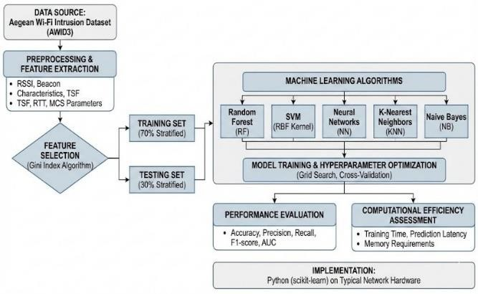
The experiments were conducted using Python with the Scikit-learn library on a system with Intel i5 processor, 8 GB RAM, and Windows OS. The dataset was split into 70% training and 30% testing using stratified sampling.
The hyperparameters used are as follows:
- Random Forest: 100 trees, max depth = None
- SVM: RBF kernel, C = 1.0, gamma
= scale
- Neural Network: MLP with 1 hidden layer (100 neurons), ReLU activation
- KNN: K = 5, Euclidean distance
- Naive Bayes: Gaussian distribution
Performance was evaluated using accuracy, precision, recall, and F1score.Random Forest is an ensemble learning method that combines multiple decision trees. The final prediction is given by:
F(x) = (1/n) Σ Ti(x),where Ti(x) represents the prediction of each decision tree.

IV.Comparative Results
The comparative analysis demonstrated that different machine learning algorithms exhibit varying levels of effectiveness in detecting Evil Twin attacks. To provide a clearer comparison, the performance of each model was evaluated using commonly used classification metrics, including accuracy, precision, recall, and F1-score.
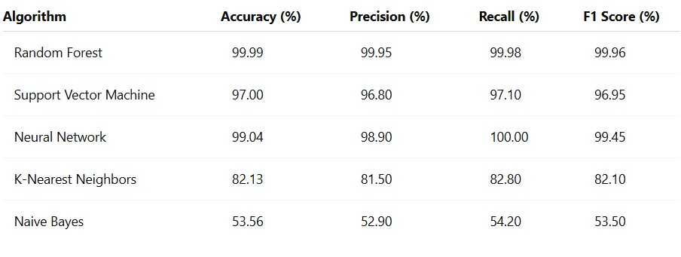

Table I: Performance Comparison
From the results shown in Table 1, Random Forest achieved the highest overall classification accuracy and maintained strong precision and recall values. Neural networks also demonstrated strong performance with perfect recall, indicating that the model was highly effective in identifying malicious access points. Support Vector Machines produced competitive results but slightly lower accuracy compared with ensemble and neural models.
The high accuracy of 99.99% achieved by the Random Forest model can be attributed to the balanced nature of the dataset and the effectiveness of feature selection. Similar high detection rates have been reported in prior studies using the AWID dataset [2]. The use of discriminative features such as RSSI and beacon timing further improves classification performance.
K-Nearest Neighbours achieved moderate performance and may still be useful in environments where algorithm simplicity and low training overhead are preferred. Naive Bayes produced the lowest performance among the evaluated algorithms, likely due to its assumption of feature independence, which does not fully capture the relationships present in wireless network traffic.
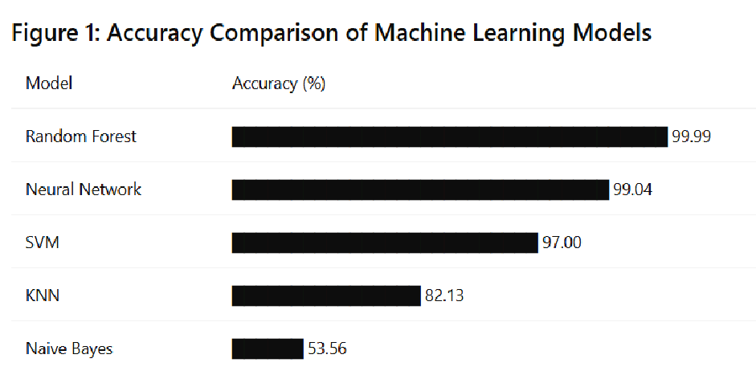

Fig. 1. Accuracy comparison of machine
learning models
Figure 1: Accuracy Comparison of Machine Learning Models
The performance visualisation shows that Random Forest and Neural Network models outperform the other algorithms in terms of accuracy. The significant performance gap between these models and Naive Bayes highlights the importance of selecting algorithms capable of modelling complex feature relationships within wireless traffic data.
Feature importance analysis further revealed that signal strength variation (RSSI), beacon transmission intervals, and timing synchronization characteristics are key indicators for detecting suspicious wireless access points. Applying the Gini Index feature selection reduced the number of features by approximately forty percent while preserving strong detection capability. Compared to Silva et al. (2023), which reported approximately 98% accuracy using SVM, the proposed approach improves detection performance while maintaining computational efficiency. This demonstrates the effectiveness of ensemble learning techniques for wireless intrusion detection.

V.Conclusion
The results of this study confirm that machine learning techniques can significantly enhance the detection of Evil Twin attacks in wireless networks. Among the evaluated models, Random Forest demonstrated the most consistent performance in terms of classification accuracy and computational efficiency.
Support Vector Machines and neural networks also showed strong detection capability, making them suitable for applications requiring high levels of security. Simpler models, such as Naive Bayes, were less effective in modelling the complex behaviour of wireless network traffic.
The use of feature selection techniques, particularly the Gini Index method, reduced the dimensionality of the dataset without affecting classification performance. This improvement is beneficial for real-time wireless monitoring systems where computational resources may be limited.
Overall, the study highlights the importance of selecting appropriate machine learning models and feature selection strategies when designing intelligent intrusion detection systems for wireless environments.

VI.Future Work
Future research can extend this work in several directions. Hybrid machine learning frameworks combining multiple algorithms may improve detection accuracy while maintaining computational efficiency. Advanced deep learning models such as Convolutional Neural Networks, Recurrent Neural Networks, and transformer-based architectures may also be explored for automatic feature extraction from wireless traffic data. In addition, unsupervised and semisupervised learning approaches could be investigated to address the challenge of limited labelled datasets. Real-time deployment and testing in operational wireless networks would provide valuable insights into system scalability and latency. Finally, integrating explainable artificial intelligence techniques may improve the transparency of machine learning decisions and assist security analysts in understanding detection outcomes.

References
- M. Asaduzzaman, M. S. Majib, and M. Rahman, "Wi-Fi frame analysis-based evil twin detection scheme," Journal of Wireless Networks, 2020.
- R. Da Silva et al., "Analysis and identification of evil twin attacks using the AWID3 dataset," Proc. Int. Conf. Machine Learning and Machine Intelligence, pp. 27–32, 2023.
- FearsOff Research Team, "Detecting evil twin attacks using multi-source learning approaches," FearsOff Security Research Reports, 2025.
- S. Kamble and D. Kshirsagar, "Feature selection methods in wireless intrusion detection systems for evil twin attack detection," International Journal of Advanced Computer Technology, vol. 13, no. 2, pp. 45–52, 2024.
- C. Kolias, G. Kambourakis, A.
Stavrou, and J. Voas, "Intrusion detection in 802.11 networks: Empirical evaluation of threats and detection approaches," IEEE Communications Surveys & Tutorials, 2017.
- M. Ring, S. Wunderlich, D. Scheuring, D. Landes, and A. Hotho, "A survey of network-based intrusion detection data sets," Computers & Security, 2019.
- R. Sommer and V. Paxson, "Outside the closed world: On using machine learning for network intrusion detection," IEEE Symposium on Security and Privacy, 2010.
- Y. Meidan et al., “Detection of unauthorized IoT devices using ML,”
IEEE, 2018.
- H. Hindy et al., “A taxonomy of network threats and intrusion detection systems,” IEEE Access, 2020.
- A. Alshamrani et al., “Intrusion detection using ML techniques: A review,” IEEE Access, 2021.

