RESEARCH PAPER
Lothal Dock hub of Maritime Trade, Commercial Institutions & Multimodal Transport Integration in the Indus Vally Civilization

ABSTRACT:
The National Maritime Heritage Complex can powerfully convey the story of Lothal Dock as a brilliant example of multimodal transport integration, showcasing the advanced capabilities of the Indus Valley Civilization to a global audience
Lothal functioned as a thriving port city and a key economic hub of the Indus Valley Civilization, showcasing remarkable urban planning, engineering prowess, and extensive trade networks that connected it to both inland regions and far-flung ancient civilizations with multimodal maritime connectivity
Lothal's dock was not merely a place for ships; it was the central node where maritime voyages converged with inland river networks and overland routes, forming a seamless, efficient system for trade and commerce. This integration allowed Lothal to serve as the gateway for goods flowing into and out of the vast Indus Valley Civilization.

Keywords:
Lothal Dock, Indus Valley Civilization, Multimodal Transport, Maritime Trade, Inland Waterways, Sabarmati River, Tidal Engineering, Harappan Port City, Trade Networks, Warehouse Logistics, Hydraulic Engineering, Gulf of Khambhat, Nal Corridor, Bead Industry, Urban Planning, Ancient Logistics, Maritime Connectivity, NMHC (National Maritime Heritage Complex), Hinterland Connectivity, Trade Facilitation

Introduction:
Lothal was prosperous port town which aided and flourished trade in beads, jewels, and shells reflects the city’s rich artistic legacy, with sophisticated metallurgy, pottery, and ornaments etc. The town was complex urban and commercial life reflecting heritage history of civilization. Lothal has fusion trade and expressed the maritime power of ancient Bharat.
The site is most famous dockyard showcasing remains of ancient economic strength, Harappan peoples sophisticated engineering, urban design, and maritime knowledge, making it a symbol of a possible invention. The developed connected with Sabarmati River basin exploring adoption of multimodal transport integration with efficient loading and unloading of cargo on ships.
Development of National Maritime Heritage Complex at Lothal may incorporate theme of trade facilitation of Lothal dock with distance region such as Mesopotamia, Egypt, and Persia. The engineers of Lothal dock researched the tidal motion and their effects on brick-built structures.
The NMHC encapsulates the multifaceted importance of Lothal in the context of the Indus Valley Civilization trade and business facilitations.
Lothal Dock Strategically Integrates Maritime Trade with Inland Waterways Transportation System and reflecting NMHC heritage with Inland Waterways systems incredibly connects vital link of expanding extensive trade networks and prosperity through maritime trade with extending last mile Inland Transportation. The site demonstrates hinterland connectivity and potentially showcased shorter overland trade routes.
Identified Research Areas:
NMHC strategic genius lay in its ability of Lothal to seamlessly integrate maritime trade with inland waterways, creating a highly efficient transportation system for the Indus Valley Civilization.
Lothal Dock: Strategically Integrates Maritime Trade with Inland Waterways
The famed Lothal dockyard can be showcased a NMHC that dock was not merely a port; it was a sophisticated hub designed to bridge the gap between long-distance sea trade and the extensive riverine networks of the Harappan hinterland.
    - Harnessing of Tidal Engineering for Trade: Showcasing of application of ancient tidal engineering for facilitating trade with docking of vessels at Lothal, the dock was strategically situated on an ancient course of the Sabarmati River, which provided direct access to the Arabian Sea via the Gulf of Khambhat. The high tidal amplitude of the Gulf was ingeniously harnessed. At high tide, ships could enter the dock through a sluice gate. This allowed for effective control of water levels within the basin, ensuring that even at low tide, there was enough water to keep vessels afloat for loading and unloading.
- Inland Waterways Connections: The Sabarmati River, which was likely more navigable in ancient times, acted as a crucial artery connecting Lothal to inland settlements. Recent studies, including those using satellite imagery and paleochannel analysis, have confirmed that the Sabarmati flowed directly alongside Lothal during the Harappan period. This riverine connection allowed goods brought by sea to be transported further inland, and raw materials from the interior to be brought to Lothal for export.
- Evidence suggests an important Inland Waterways route through the Nal Corridor. This narrow, low-lying region, connecting the Gulf of Khambhat to the Little Rann of Kutch, experienced seasonal flooding in the Harappan period. This made it a navigable pathway, providing a shorter and safer alternative to long sea voyages around the hazardous Saurashtra coast. Lothal was ideally positioned to benefit from this, linking south Gujarat with sites like Dholavira in the north.
- Warehouse Proximity: The large warehouse, strategically located adjacent to the dock, further emphasizes this integration. Goods could be efficiently transferred directly from ships to storage, and then presumably prepared for onward distribution via inland routes, or vice versa for exports.

- Engineering Marvel: The design of the dock, with its baked brick walls, sluice gate, and spill channel, demonstrates a remarkable understanding of hydraulics and engineering. This allowed for the efficient management of water flow, minimizing siltation and ensuring the dock's functionality over long periods.

Lothal Dock: A Hub for Multimodal Transport Integration in the Indus Valley Civilization
Lothal Dock as the nexus of a truly multimodal transport system. This is an excellent way to highlight its sophisticated role in ancient trade at NMHC
The transportation system of Lothal, and the broader was multi-modal, leveraging both land and water routes:
Water-based Transportation (Primary):
- Maritime Vessels: Large, sturdy boats and ships were used for sea trade, capable of traversing the Arabian Sea to Mesopotamia, Persia, and possibly beyond. Terracotta models of boats found at Lothal provide clues about their construction. These vessels would have been crucial for carrying bulk goods like timber, copper, and large quantities of beads and other finished products.
- Riverine Barges/Boats: Smaller, flatter-bottomed boats and barges would have been used for navigating the rivers (like the Sabarmati and other connected channels) and inland waterways. These would have been ideal for transporting goods to and from the hinterland, accessing sources of raw materials like semi-precious stones from the Aravalli hills and along the Narmada.
- Tidal Flow Utilization: The strategic design of the dock allowed for the effective use of tidal currents for ship movement, minimizing the need for constant manual propulsion when entering or leaving the harbour.
Land-based Transportation:
- Bullock Carts: While direct archaeological evidence of carts is limited to terracotta models, it is widely believed that bullock carts were the primary mode of land transport for heavier goods. These would have been used to transport goods from the immediate hinterland to the city's warehouses and potentially for shorter overland trade routes.
- Human Porterage: For lighter, more valuable goods, or in rugged terrain where carts were impractical, human porterage would have been employed.
- Well-laid Roads/Tracks: Although not as prominent as the water networks, the presence of well-planned streets within Lothal suggests a degree of internal land movement. For longer distances, compacted dirt tracks or established trade routes would have connected Lothal to other Harappan settlements not directly accessible by water.
Visual Element/Diagram Concept at NMHC for Showcasing
Imagine a central point labelled "Lothal Dock". Radiating outwards from this central point would be different coloured lines representing the various transport modes, clearly showing their connection at the dock.
- Centre: Lothal Dock (Gateway to Trade)
  - Image: A stylized representation of the dockyard with a ship inside.
  - Key Features: Sluice gate, warehouse, administrative buildings nearby.
- Arrow 1 (Thick Blue Line): Maritime Routes
  - Label: Deep Sea Trade & Coastal Shipping
  - Path: Extends from Lothal Dock, through the Gulf of Khambhat, into the Arabian Sea.
  - Connections: Arrows pointing towards Mesopotamia, Persian Gulf, Oman Peninsula, East Africa (potential).
  - Goods In (Examples): Copper, Gold, Tin, Incense, Steatite (raw).
  - Goods Out (Examples): Carnelian Beads, Ivory, Shell Products, Cotton textiles, Grains (as bulk cargo).
  - Vessels: Large seafaring ships, dhow-like vessels.
- Arrow 2 (Thinner Blue Line with Waves): Inland Waterways
  - Label: Riverine & Estuarine Networks
  - Path: Extends from Lothal Dock up the Sabarmati River (ancient course), branching to connect with other regional rivers or seasonally navigable channels.
  - Connections: Arrows pointing to Harappan sites in Gujarat (e.g., Rangpur, Rojdi), Sources of Semi-Precious Stones (Aravalli Hills), Timber Forests, Agricultural Plains.
  - Goods In (Examples): Raw Carnelian, Agate, Jasper, Timber, Agricultural produce, Limestone.
  - Goods Out (Examples): Finished goods from Lothal (beads, metal tools), imported luxury items from overseas.
  - Vessels: Smaller riverine boats, barges, rafts.
- Arrow 3 (Brown/Green Dashed Line): Land Routes
  - Label: Overland Caravans & Bullock Cart Trails
  - Path: Extends from Lothal Dock towards various inland regions, crossing flatter plains and connecting to other settlements not directly on major waterways.
  - Connections: Arrows pointing to Remote resource areas, Pastoral communities, Other regional Harappan settlements (e.g., in Kutch or deeper into Rajasthan/Malwa for specific resources).
  - Goods In (Examples): Specific minerals, animal products (wool, hides), specialized crafts from isolated communities.
  - Goods Out (Examples): Finished goods, redistributed imported items, necessities for local populations.
  - Means: Bullock carts, human porterage, pack animals.
Key Components & Their Role in Integration:
- The Dockyard's Design:
  - Tidal Engineering: Allowed deep-drafted sea vessels to access the dock even with fluctuating tides, linking directly to the main oceanic highways.
  - Proximity to River: The immediate connection to the Sabarmati River's ancient course meant that goods offloaded from sea vessels could be directly transferred to smaller riverine boats for inland distribution, or vice-versa.
- The Great Warehouse:
  - Centralized Storage: Its location adjacent to the dock emphasized its role as a crucial transit point. Goods from sea, river, or land could be stored, sorted, and prepared for their next leg of the journey, whether for local consumption, inland distribution, or overseas export.
  - Logistics Hub: Facilitated efficient management of goods, minimized handling, and protected valuable cargo.
- Specialized Craft Production (e.g., Bead Factory):
  - Value Addition at the Hub: Raw materials (e.g., carnelian from inland sources) arrived via river or land routes, were processed into high-value finished products (beads) within Lothal itself, and then exported via sea, making the dock a center for both trade and production.
- Standardized Weights and Measures & Seals:
  - Facilitating Transactions: These tools ensured fair trade across all modalities. Seals, impressed on goods, provided proof of origin and ownership, crucial for long-distance trade involving multiple transfers.

- Urban Planning & Infrastructure:
  - Internal Connectivity: Well-laid streets and designated areas within Lothal ensured smooth movement of goods from the dock/warehouse to workshops, markets, or local distribution points.
RESEARCH FINDINGS
Showcasing Lothal as a hub for multimodal transport integration at the National Maritime Heritage Complex (NMHC) in Lothal offers an incredible opportunity to bring ancient history to life. The key is to blend archaeological accuracy with engaging, interactive, and immersive experiences.
Here are various methods of showcasing Lothal's multimodal transport integration at the NMHC:
I. Immersive & Experiential Methods:
- Reconstructed Dockyard Experience (Core Exhibit):
  - Partial or Full-Scale Recreation: Recreate a section of the Lothal dockyard at its functional scale, with water. This would be the centrepiece.
  - Interactive Sluice Gate Model: Allow visitors to operate a model of the sluice gate system to understand how tides were managed.
  - Life-Sized Ship Replica: Place a full-scale replica of an Indus Valley boat (based on terracotta models) within the reconstructed dock, loaded with replica goods.
  - Soundscape: Recreate the sounds of a busy ancient port – creaking ropes, lapping water, distant calls of merchants, sounds of animals, and waves.
- Multimodal Journey Simulator/VR Experience:
  - "Journey of a Bead": A virtual reality (VR) or large-screen simulator ride where visitors "follow" a carnelian bead from its raw form (mined inland via land/river routes) to its processing at Lothal, its loading onto a sea-going vessel, and its journey across the Arabian Sea to Mesopotamia.
  - 360-Degree Projections: Project immersive scenes onto the walls of a circular room, showing different transport modes in action (river boats on the Sabarmati, bullock carts on land, sea vessels sailing the Gulf).
- Holographic Projections/Augmented Reality (AR):
  - Dynamic Trade Routes: Project a holographic map of ancient India and the Middle East, showing dynamic lines representing the flow of goods along maritime, riverine, and land routes, all converging at a glowing Lothal.
  - AR Overlay: Use AR apps on visitors' devices or museum-provided tablets. Pointing the device at a static model of the dock could bring the scene to life with animated ships, people, and goods moving.
- "Marketplace of Goods" Interactive Zone:
  - Touch-and-Feel Artifacts: Replicas of goods traded (beads, pottery, shells, metal tools) with tactile descriptions and information about their origin and destination.
  - Interactive Trade Game: A digital game where visitors act as merchants, making decisions about routes, goods, and risks, to understand the complexities of ancient trade.
  - Smell Stations: Introduce scents that might have been present in an ancient port (spices, timber, salt, even animal smells) to further immerse visitors.
II. Interpretive & Educational Methods:
- Large-Scale Dioramas & Models:
  - Panoramic Model of Lothal: A detailed, large-scale model showing Lothal's urban layout, including the dock, warehouse, bead factory, and connecting river/land pathways. Use different colored lighting to highlight the various transport arteries.
  - Cross-Sectional Dock Model: A detailed model showing the dock's engineering (sluice gate, brick lining, water levels, connection to the river).

- Interactive Digital Maps & Timelines:
  - Touchscreen Globe: A large digital globe where visitors can tap on ancient sites (Lothal, Mesopotamia, Oman) to see their connections, goods traded, and estimated journey times.
  - Integrated Timeline: A digital timeline that synchronizes with the map, showing key periods of trade activity and significant archaeological finds.
- Multimedia Presentations & Documentaries:
  - Short Films: High-quality documentaries or animated films explaining the science behind Lothal's dock, the types of boats used, and the daily life of traders.
  - Expert Interviews: Integrate snippets of archaeologists, historians, and maritime experts explaining the significance of Lothal's multimodal role.
- Artifact Displays with Context:
  - "Goods of Exchange": Display actual excavated artifacts (or high-quality replicas) found at Lothal, alongside artifacts from distant lands that were either imported to Lothal or exported from it (e.g., Indus seals found in Mesopotamia, Mesopotamian cylinder seals found at Lothal).
  - Material Tracing Exhibit: Use visual aids (maps, infographics) to explain how scientists trace the origins of materials (e.g., copper from Oman, lapis lazuli from Afghanistan) to demonstrate the vastness of the trade network.
- Infographics & Explanatory Panels:
  - Clear Visuals: Use compelling diagrams, flowcharts, and illustrations to simplify complex concepts of trade routes and transport logistics.
  - "How it Worked" Panels: Dedicated panels explaining the tidal system, the function of the warehouse, and the methods of inland transport.
III. Engaging & Hands-on Activities (Especially for Younger Audiences):
- "Build Your Own Boat" Station: A hands-on area where visitors can build simple models of Indus Valley boats, understanding their basic construction.
- "Pack the Warehouse" Game: A physical or digital game challenging visitors to efficiently pack a virtual warehouse with goods for different transport modes.
- Archaeological Dig Pit (Simulated): A sandpit where children can "excavate" replica artifacts related to trade, fostering a sense of discovery.
Overall Design Principles for NMHC Lothal:
- Storytelling: Weave a compelling narrative around Lothal as a dynamic, interconnected hub.
- Interactivity: Encourage active participation rather than passive viewing.
- Accessibility: Ensure information is understandable for all age groups and backgrounds.
- Authenticity: Ground all interpretations in the latest archaeological research and historical evidence.
- Modern Technology with Ancient Wisdom: Use cutting-edge technology to highlight the ancient ingenuity of the Harappans.
CONCLUSION
Lothal Prowess in Trade:
Lothal stands as a remarkable testament to the Indus Valley Civilization's advanced capabilities, particularly in the spheres of trade, urban planning, and hydraulic engineering. Its archaeological remains paint a vivid picture of a highly organized and commercially astute society.
Lothal was undeniably a major economic powerhouse and a vital hub in the Harappan trade network. Lothal positioned strategically near the Gulf of Khambhat, Lothal provided direct access to the Arabian Sea, making it a crucial link for maritime trade. It also connected to inland river systems (like the ancient course of the Sabarmati) that facilitated the movement of goods from the hinterlands.
Lothal's dockyard, is considered the world's earliest known artificial tidal dock. This impressive feat of engineering allowed ships to enter and exit, load and unload cargo, managing the powerful tidal fluctuations of the Gulf of Khambhat. Its design suggests a sophisticated understanding of marine engineering and hydraulics.
strategically located warehouse adjacent to the dock served as a central storage facility for incoming and outgoing goods. The discovery of numerous terracotta seals (some with impressions of cords or fabric) suggests they were used to mark and secure consignments, indicating a systematic approach to inventory and logistics.
Lothal was a prominent centre for the production of exquisite beads from semi-precious stones like carnelian, agate, and jasper. The presence of a bead factory with raw materials, unfinished beads, and specialized tools highlights a thriving industry geared towards both domestic consumption and export. Lothal's distinctive beads have been found in far-flung regions like Mesopotamia, demonstrating the reach of its trade networks.
The city also showed expertise in metallurgy, producing copper and bronze tools and ornaments. The abundance of high-quality chank shells from the nearby coast made Lothal a significant centre for shell-working, producing bangles and other shell artifacts.
wide array of goods including timber, copper (possibly from Oman/Arabian Peninsula), gold, lapis lazuli, cotton, grains, pottery, and various finished products.
Lothal Prowess in Urban Planning:
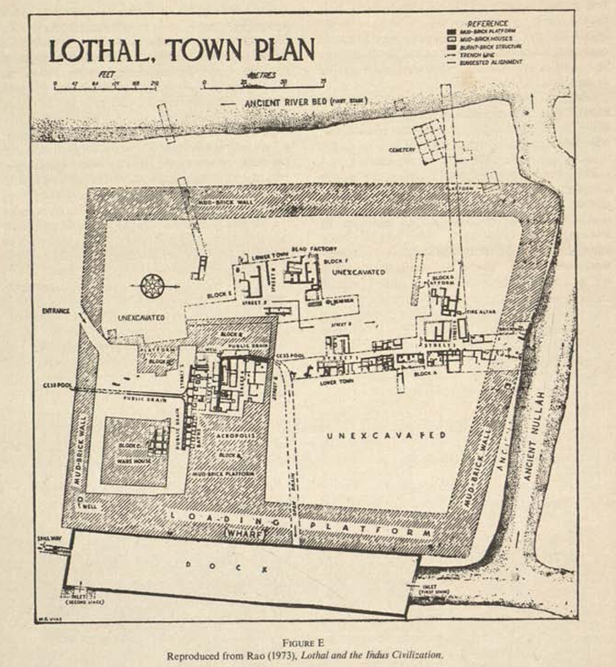
Lothal exemplifies the remarkable urban planning characteristic of the mature Harappan period. The city was meticulously planned with a clear division into an "Acropolis" (or Upper Town) and a "Lower Town." The entire settlement was enclosed by a massive brick wall, primarily for flood protection, but also providing a measure of security.
Lothal featured a grid pattern, with streets intersecting at right angles, indicating a pre-determined layout and organized growth.
The city was efficiently zoned, with distinct areas for residential dwellings, commercial activities (like shops along the main arterial street), industrial workshops (like the bead factory), and administrative/elite residences (in the Acropolis).
The widespread use of baked bricks for construction, particularly in the dock, drains, and some houses, points to durable and resilient infrastructure
The planning included well-defined public spaces and private residences, some with their own bathing platforms and wells

Lothal Prowess in Hydraulic Engineering:
The Tidal Dock - Lothal's survival and prosperity in a flood-prone region were largely due to its sophisticated understanding and application of hydraulic engineering.
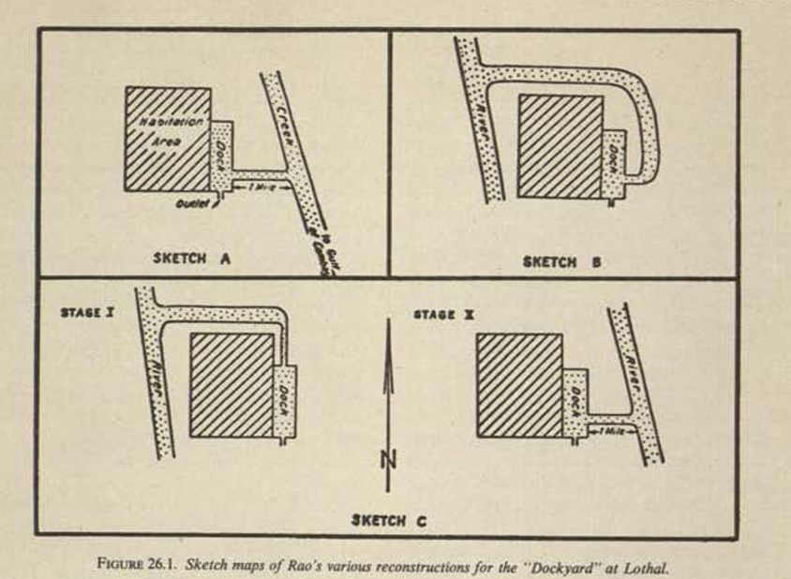
The dock is the prime example. Its construction required an intricate understanding of tidal forces, water pressure, and the properties of building materials (kiln-fired bricks, which were more resistant to water erosion). The presence of inlet and outlet channels and a possible sluice gate system allowed for the controlled entry and exit of ships, and for flushing out silt.
The Flood Protection Wall - The surrounding city wall, made of mud bricks and later reinforced, was primarily designed to protect the city from the annual sheet flooding and high-intensity flash floods that characterize the region. The city's elevation on an artificial mound further mitigated flood risks.
Advanced Drainage System - Lothal possessed an impressive, well-integrated drainage system, a hallmark of Harappan urban centers.
- Covered Drains: Kiln-fired brick drains, often covered, ran along the streets, collecting wastewater from individual houses.
- Sewerage Channels: These smaller drains connected to larger public sewers that effectively carried sullage and stormwater out of the town, preventing waterlogging and maintaining hygiene.
- Soak Pits: Some houses and areas had soak pots or cesspits, demonstrating a system for waste disposal and water management at the individual dwelling level.
- Well Systems: The presence of numerous wells provided a clean water supply for the inhabitants, separate from the drainage systems.

REFERENCES

- S.R. Rao, Author Book – Lothal & The Indus Civilization, Publisher – Archeological Survey of India

- NITI Aayog Library https://library.niti.gov.in/

- Sh. Dilip K Charkarbarti – Marg Foundation Magazine https://www.harappa.com/category/place-books/lothal

- Open Library Resources https://openlibrary.org/books/OL4247176M/Lothal_a_Harappan_port_town_(1955-62)

- https://www.exoticindiaart.com/book/details/lothal-harappan-port-town-1955-62-in-set-of-2-volumes-memoirs-no-78-old-and-rare-book-nal660/

- Sh. Possehl, Gregory L. Ed. - Central Archeological Library, Govt of India – Call no. 913.05471/Pos

- NCERT – Text Books - https://ncert.nic.in/textbook/pdf/kefa102.pdf

- NCERT - https://ncert.nic.in/textbook/pdf/lehs101.pdf

- UGC – Shodhganga - Ph.D. Thesis of Prakritik Mishra, P.K. University, Shivpuri, Madhya Pradesh
http://hdl.handle.net/10603/550568
https://shodhganga.inflibnet.ac.in/handle/10603/550568
- Economic Integration by Inland Water Transport Network at Varanasi ", International Journal of Emerging Technologies and Innovative Research (www.jetir.org | UGC and issn Approved), ISSN:2349-5162, Vol.6, Issue 5, page no. pp3102-3110, May-2019, Available at : http://www.jetir.org/papers/JETIR1905V29.pdf
- Integration of Inland Water Transport into the Multimodal National Transportation Grid for Economic Development of India", International Journal of Emerging Technologies and Innovative Research (www.jetir.org), ISSN:2349-5162, Vol.6, Issue 6, page no.972-983, June 2019, Available :http://www.jetir.org/papers/JETIR1906Y62.pdf
- Impact of Health on Economic Productivity, IJCSER | Vol 1 Issue 1 October 2013-March 2014 by Mr. Prakritik Mishra, Dr Anshu Tyagi, Dr Ravi Kant
Research Publish Journals - https://www.researchpublish.com/search

- International Journal of Management and Commerce Innovations ISSN 2348-7585 (Online) Vol. 3, Issue 1, pp: (477-481), Month: April 2015 - September 2015, Available at: www.researchpublish.com

END
***********

