MONITORING FOREST COVER CHANGE IN PROTECTED AREAS OF PANDAM NATIONAL PARK, NIGERIA USING SENTINEL-2 IMAGERY AND GOOGLE EARTH ENGINE

ABSTRACT

The high demand for certain wood species in China and other regions, including Nigeria, has exerted pressure on protected areas worldwide. Pandam National Park is among the forests affected by this demand, driven by the activities of illegal loggers operating locally in collusion with foreign wood merchants. This study was conducted to assess the status of vegetation cover in the protected area before the peak of devastation, at the peak, and after it. The objective is to quantify the spatial and temporal changes in forest cover using remote sensing and GIS techniques. The Google Earth Engine (GEE) cloud-based platform was used to analyze Sentinel-2 images from 2019, 2021, and 2023, focusing on land-cover changes during those periods. The results indicated that the Normalized Difference Vegetation Index (NDVI) was higher in 2019 (0.7436) than in 2021 (0.73), with a subsequent improvement in 2023 (0.80), based on the maximum and minimum NDVI values. The cumulative forest cover change to the 2019-2021 period indicated that 208.55 sq km of forest was changed to bare surface, more than the same change in 2021-2023, which had 195.62 sq km, a reduction in forest cover destruction of 12.93 sq km. The Federal Government of Nigeria (FGN) needs to strengthen the enforcement of forest protection laws and invest in regular monitoring using advanced geospatial technologies. Integrating communities in forest surveillance alongside forest guards and adopting sustainable resource-use practices can help prevent further forest degradation. The government should reafforest the park and make it a hub for tourism, rather than just upgrading it to a National Park.

Keywords: Illegal logging, Forest cover change, Protected areas, Sentinel-2, Google Earth Engine (GEE)

INTRODUCTION

Global forest cover has declined by 31% (4.06 billion ha) and continues to shrink. Since 1990, 420 million ha of forest, larger than India, have been lost, including 10 million ha between 2015 and 2020, roughly the size of Iceland (FAO, 2020). Selective logging has affected about 400 million ha in the tropics and 1 billion ha worldwide (Putz et al., 2022).
Africa’s tropical forests have become major hotspots for illegal logging due to their dense vegetation and high international demand for timber. This exploitation is largely driven by the Chinese market, which relies on small-scale loggers to supply high-value rosewood. China’s extensive rosewood industry, supported by state-backed financing and estimated to comprise 3,000 rosewood factories across 25 regions, is valued at $75 million and has intensified illegal extraction, making rosewood the most heavily smuggled wildlife product globally (Environmental Investigation Agency, 2019; Africa Centre for Strategic Studies, 2022).
Logging is degrading tropical forests at rates higher than deforestation, driving extensive rosewood exploitation in Nigeria’s Sudan and Guinea Savannah regions. Unsustainable legal and illegal logging, alongside unregulated resource extraction, have depleted protected forests, while market-driven selective logging often leads to broader forest clearing and damage to younger trees (ICIR, 2016; Pearson et al., 2017; da Silva & Rodgers, 2018; Okechalu et al., 2021).
Protected Areas (PAs) have expanded since the 1990s, with global commitments to protect 17% of land by 2020 under the Convention on Biological Diversity. By 2018, over 230,000 terrestrial PAs covered 14.9% of the Earth’s land surface and inland waters and protected only a small proportion of global tree cover (Lindsey et al., 2014; UNEP-WCMC, 2018).
International frameworks emphasize the establishment and management of protected areas as essential for biodiversity conservation and sustainable development. The Convention on Biological Diversity and the 2030 Sustainable Development Agenda, particularly SDGs 14 and 15, recognize protected areas as a central strategy for conservation. However, despite these commitments, the condition of protected areas continues to deteriorate as global biodiversity loss intensifies toward 2030 (UN, 1992; UNEP, 2016).
Empirical Studies
Studies in tropical Nigeria highlight threats to forest regions from illegal timber exploitation. Ahmed and Olaitan (2024) noted that the unlawful export of timber, often aided by tax and royalty relief, increases personal income for syndicates at the expense of national development, emphasizing the need for stricter laws and regulations.
Similarly, Bisong and Mfon (2022) reported in Southeast Nigeria that higher logging intensities correlate with greater damage to unlogged trees, reducing their population and increasing stand destruction, demonstrating that logging intensity is a key factor in collateral forest damage.
In southwestern Nigeria, timber exploitation studies documented the harvesting of 60 tree species in free areas and 57 species in reserves, with a total of 111,377 stems harvested, corresponding to an estimated timber volume of 295,089.67 m³. In Osun State, Olugbadieye et al., (2021) reported extensive timber harvesting in Shasha, Ago-Owu, and Ikeji-Ipetu Forest Reserves, where illegal logging and timber processing are highly prevalent, posing challenges to forest conservation.
Forest monitoring studies have shown that the Normalized Difference Vegetation Index (NDVI) and the Green Normalized Difference Vegetation Index (GNDVI) are highly reliable spectral indices for mapping and tracking changes in forest cover, with strong correlations and high validation accuracy (Warner et al., 2016). Similarly, at Pandam National Park in Nigeria, African Rosewood (Pterocarpus erinaceus) and other valuable tree species were heavily logged, highlighting the selective pressure on economically important trees (Mwansat & Da’an, 2017). Socio-economic assessments around Pandam National Park further revealed that wood businessmen account for 73% of tree cutting. In comparison, 93% of respondents attributed timber extraction to perceived government approval, highlighting the strong human and policy drivers of forest degradation (Habila et al., 2022).
Monitoring forest change using widely available remote sensing data has become essential for understanding forest degradation and associated environmental risks. Accurate and reliable information is critical for this process, and geospatial technologies provide effective tools for forest assessment. In this regard, Google Earth Engine offers a robust platform for efficient monitoring of forests and protected areas (Hu et al., 2021; Sharifi et al., 2022).
This study aims to assess the extent of illegal forest-cover change in protected areas and to inform improved policy enforcement and resource management.
Problem Statement
Logging activities in the Pandam National Park have led to forest cover loss and degradation, unauthorized deforestation, and illegal logging. As a result, truly undisturbed forest ecosystems are gradually disappearing, and young plants have been destroyed through indiscriminate felling of trees, thereby exposing a large expanse of bare surface in the study area (Mohammad & Adam, 2010; Gibson et al., 2011; Karamage et al., 2016; Mwansat et al., 2016; Nimmak et al., 2020; Da’an et al., 2020; Moisa et al., 2022).
MATERIALS AND METHODS

The Study Area
Pandam National Park, located in Qua’anpan Local Government Area, Plateau State, Nigeria, lies between latitude 8°35′ N and 8°55′ N and longitude 8°00′ E and 10°00′ E, covering 224 sq km. It is bounded on the East by Namu and Kayarda towns, to the West and North by the Dop River, and on the South by Aningo and Pandam towns (Figure 1). Originally owned and managed by the Plateau State Government through the Plateau State Tourism Corporation, it was formally converted to a National Park when Governor Caleb Mutfwang handed it over to the Federal Government, placing it under the Nigeria National Park Service. (Ezealor, 2002; Akosim et al., 2007; Da’an, 2020). The upgrade to a National Park was initiated by former Governor Simon Bako Lalong in 2021, but the park’s formal handover was officially completed by his successor, Governor Caleb Mutfwang, on September 16, 2025.
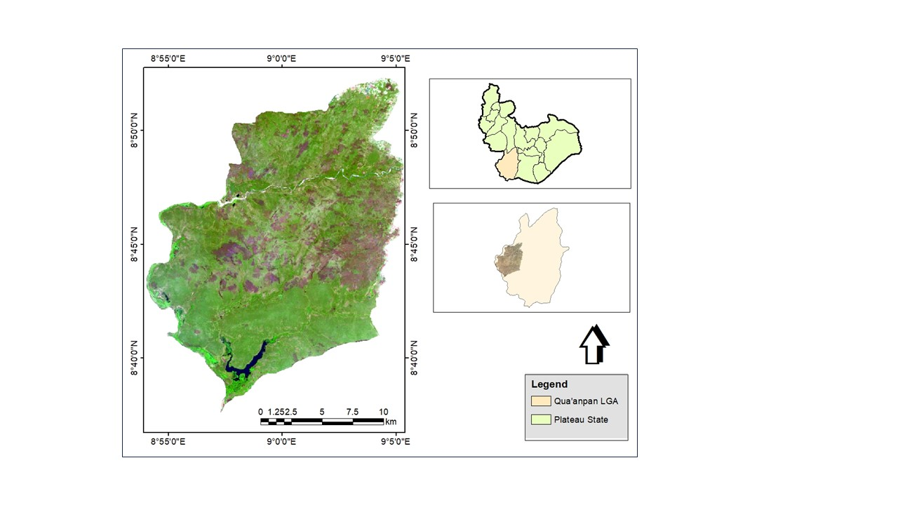
Figure 1: Plateau State showing the Study Area
Source: Author, 2024
Pandam National Park was gazette in 1972 and officially began operations on October 25, 1975, under Joseph Gomwalk, the then Military Governor of Benue–Plateau State. Parts of the game reserve were later converted into a park to protect its savanna wetlands and forests. Due to persistent conservation and security challenges, the Federal Government of Nigeria designated it as one of 10 new National Parks in 2020 to conserve biodiversity and reduce criminality in protected areas.
During the transition between the handover of the reserve and its full takeover by the Nigerian National Park Service, the area experienced widespread illegal logging and effectively became a no-man’s forest. Local resistance to the destruction was deflected to the Federal Government, while the reserve turned into a hotspot for illegal fishing, grazing, hunting, armed robbery, and kidnapping, resulting in damages to biodiversity and serious environmental consequences (Choji, 2023; Dakagan, 2023).
Climate
The Pandam area experiences a wet season from April to November and a dry season from December to March. Monthly mean rainfall ranges from 0.0 to 243.5 mm, with an annual total of about 1,000–1,500 mm. The area has an annual mean temperature of approximately 32 °C, while monthly mean temperatures vary from 25.8 °C in August to 35.7 °C in March (Ezealor, 2002; Akosim et al., 2007; Dami & Manu, 2008; Hudu & Ibrahim, 2021).
Relief and Drainage
Pandam National Park ranges in altitude from 175 to 315 m above sea level, sloping gradually southwards to form a basin that includes Pandam Lake, a 2 km² wetland complex. The Park is well drained, with the southern part fed by the Kurmi, Zurzurfa, and Dogon Ruwa streams flowing into Pandam Lake, while the northern and western areas are drained by the Dop and Li rivers and their tributaries (Ezealor, 2002; Akosim et al., 2007; Akosim et al., 2008).
Vegetation
Pandam National Park covers approximately 224 sq km of pristine savanna, wetlands, and forest, though it has been affected by various anthropogenic activities (Ezealor, 2002; Dami & Manu, 2008; Popoola et al., 2020).
Datasets
Remote sensing data
Sentinel-2 images from 2019, 2021, and 2023 were used for supervised classification at biennial intervals to assess land-cover changes in Pandam National Park. The years were selected to represent pre-peak timber exploitation (2019), peak timber exploitation (2021), and post-peak timber exploitation (2023). The targeted year 2019 marks when logging was progressively mild, but 2021 represents the most disastrous year within the window period of handover of the Park to the FGN, while 2023 marked when the Park was abandoned because the targeted trees were exhausted. Images were obtained via Google Earth Engine (GEE), which facilitated cloud-based processing and avoided challenges with data storage, network issues, and satellite downloads.
Secondary data
Administrative spatial data for Nigeria and Plateau State were obtained from GRID.3 to delineate the study area, with boundaries clearly defined using Google Satellite Hybrid imagery. The dataset, projected to WGS 1984, Zone 32N, was essential for accurate statistics following land-cover classification in the research area.
Validation
Classified maps of land cover were compared with high-resolution imagery in Google Earth Pro. This was necessary as a cost-effective alternative to complement ground truthing due to the insecurity in the park. The features validated were those classified among which are water bodies, vegetation, and bare surfaces. This was done to see if classified features matched visible reality.
Image Processing
Image preprocessing
Satellite images for 2019, 2021, and 2023 were selected with less than 10% cloud cover, mostly during the dry season, to ensure clear visibility of forest features and relevant variables for analysis before preprocessing. Google Earth Engine (GEE) was used to query and filter the Landsat images for the research region using ee.ImageCollection(), with a 10% cloud cover threshold and a date range specified. The NDVI derivation method was used to determine the NDVI. NDVI = (NIR - Red) / (NIR + Red) is the result of applying the normalizedDifference() function to the NIR and Red bands of the images.
The Google Earth Pro high-resolution imagery was used to verify landcover classes in Pandam National Park, to ensure spatial and temporal consistency with the Sentinel-2 acquisition dates. The validated reference data were divided into training and validation sets to train the Random Forest classifier in Google Earth Engine, thereby improving and strengthening the credibility of the forest cover change findings.
Land cover classification in Google Earth Engine (GEE)
Google Earth Engine (GEE) was used to perform land cover classification of vegetation, water bodies, and bare land, calculating the annual mean of pixels to create single images for each period. The web-based GEE platform enabled remote sensing analysis without downloading images, and classification of Sentinel-2 images for 2019, 2021, and 2023 revealed the spatial extent of environmental damage through statistical analysis (Ezealor, 2002; Akosim et al., 2007).
Random forest classification algorithm
Random Forest classification was used due to its high performance across diverse datasets, robustness to noise, and superior classification accuracy compared to other algorithms. Classification was done using training data and spectral indices (including NDVI) as input features. The Random Forest algorithm (ee.Classifier.randomForest()) was used to classify the land cover in the image collection.
Change detection
The study conducted change detection analysis on Pandam National Park by classifying Sentinel images from 2019, 2021, and 2023 and converting the resulting thematic maps into vector format. The vectors were intersected to identify transitions between feature classes over time, and the changes were visualized using bar graphs in MS Excel. The analysis revealed sizable forest cover change and highlighted the environmental impacts associated with land-use changes.
RESULTS
Forest Cover Sensitivity Using Spectral Index
The Normalized Difference Vegetation Index (NDVI) analysis for 2019, 2021, and 2023 shows variations in vegetation health and density over time, which were used to assess forest cover change. NDVI values range from +1 to −1, where values closer to +1 indicate dense, healthy vegetation, and values closer to −1 represent areas with little or no vegetation (such as bare land, degraded forest, and waterbody). By comparing the NDVI maps across the three years, areas showing a consistent reduction in NDVI values can be interpreted as zones experiencing progressive deforestation or forest disturbance, whereas stable or increasing NDVI values suggest vegetation recovery or regeneration.
The NDVI results show notable temporal changes in forest condition between 2019 and 2023. In 2019 (Fig. 2), the dominant high NDVI value (0.7436) indicates extensive healthy vegetation before major disturbance. By 2021 (Fig. 3), generally lower NDVI values across the forest reflect widespread vegetation loss and forest devastation, marking the peak period of degradation. In 2023 (Fig. 4), the increase in the highest NDVI value to 0.80 indicates partial vegetation recovery, particularly at lower levels. Overall, the results suggest a transition from healthy forest cover to degradation, with 2021 representing the height of vegetation loss, followed by signs of gradual recovery after the takeover by the National Park Service.
Land cover change follows the same pattern as NDVI: Bareground increased markedly from 13.49% in 2019 to 23.52% in 2021, then declined to 14.47% in 2023. Vegetation cover decreased substantially from 85.82% in 2019 to 75.91% in 2021, and increased to 81.92% in 2023 (Figures 5-8).
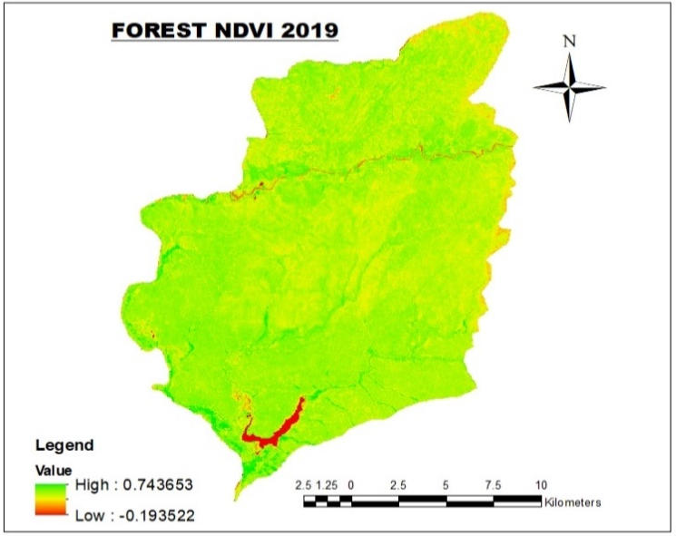
Figure 2: Forest Cover NDVI 2019

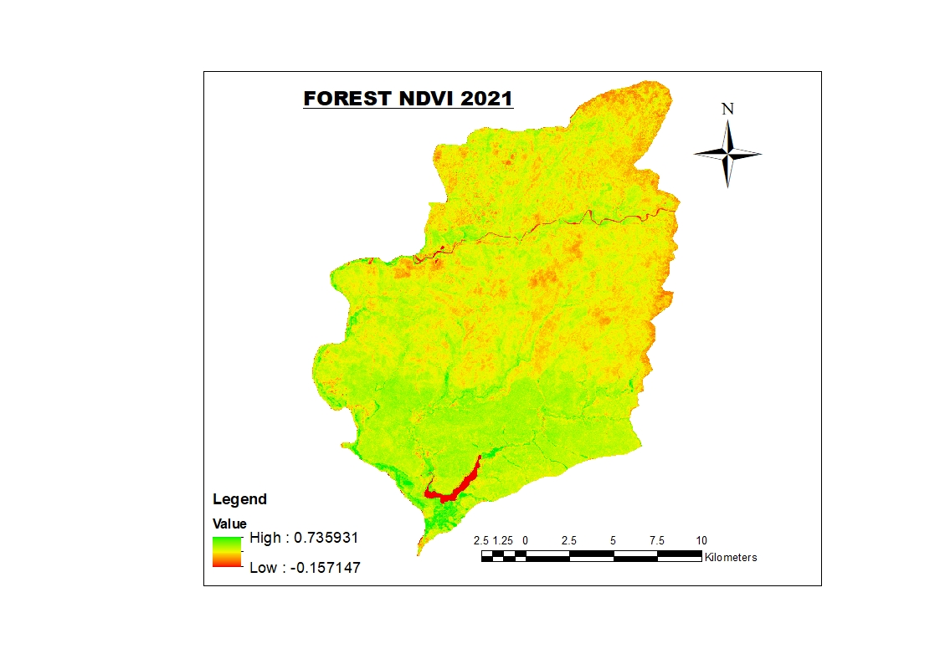
Figure 3: Forest Cover NDVI 2021
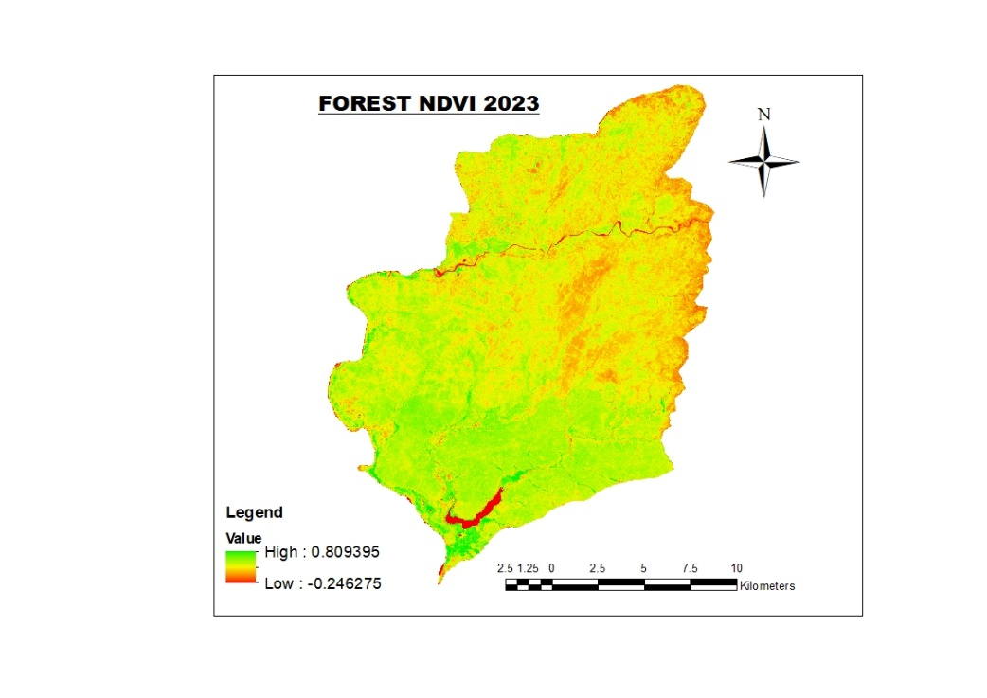
Figure 4: Forest Cover NDVI 2023

Figure 5: Forest Cover 2019-2023
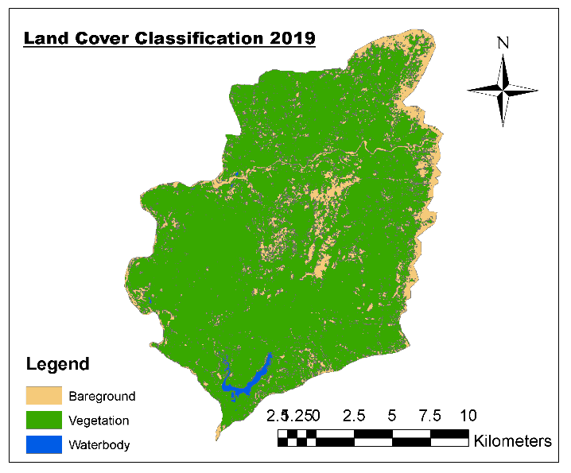
Figure 6: Forest Cover of 2019
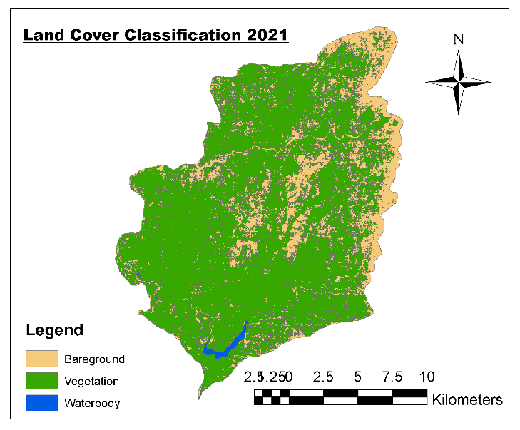
Figure 7: Forest Cover of 2021
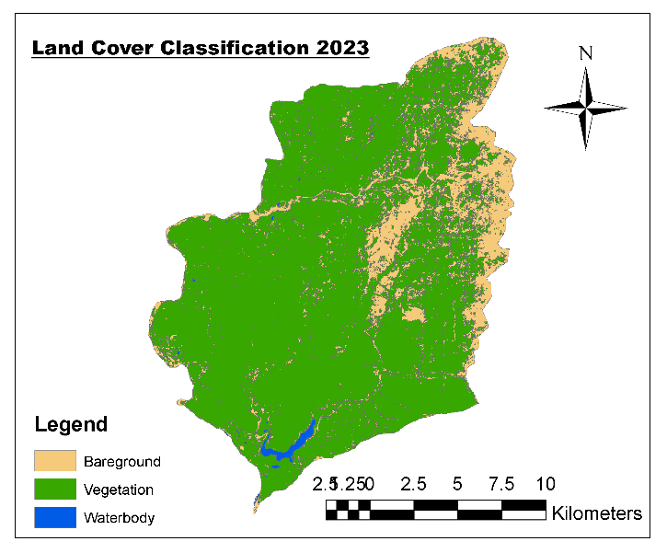
Figure 8: Forest Cover of 2023
Forest Transformation from 2019-2021 and 2021-2023
The biennial analysis highlights a pronounced transformation in forest condition across the study period. Between 2019 (pre-peak devastation) and 2021 (peak devastation) (Fig. 9), the forest experienced ruthless degradation, with large areas converted from vegetated cover to bare ground, marking the period of maximum forest loss. This extensive transformation reflects uncontrolled exploitation driven by intensive logging activities involving both local actors and foreign rosewood merchants, occurring in the absence of effective regulatory or community control.
The 2021–2023 period (Fig. 10) shows a clear departure from the earlier phase of degradation, as classified imagery reveals a notable conversion of bare surfaces to vegetated areas.

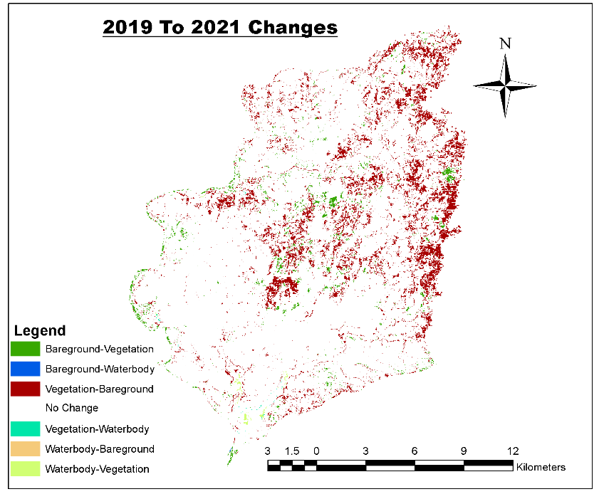
Figure 9: Forest transformation from 2019 – 2021 (Change Detection)
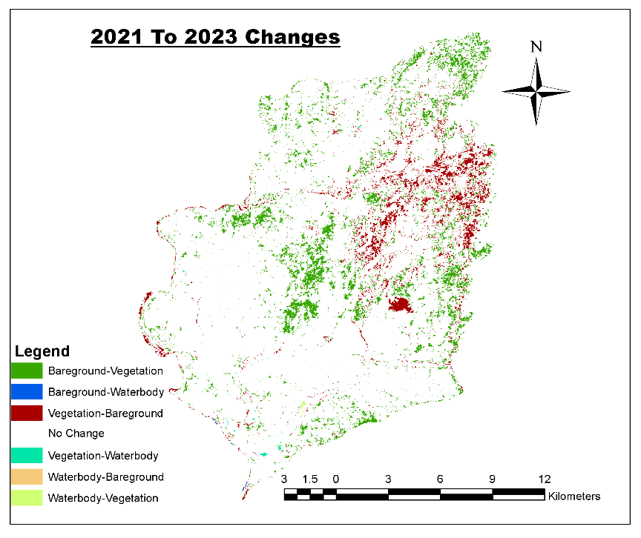
Figure 10: Forest transformation from 2021 - 2023 (Change Detection)

The cumulative forest cover change to the 2019-2021 period of peak destruction indicated that a larger area of forest (208.55 sq km) was converted to bare surface compared to the 2021–2023 period (195.62 sq km), which had a reduction in forest cover destruction of 12.93 sq km (Figs. 11 and 12), indicating that forest destruction was more intense during the earlier period. The comparatively lower magnitude of these conversions in the latter period suggests a decline in the rate and intensity of forest devastation after 2021, pointing to a gradual easing of destructive activities. However, despite this visible recovery, the regenerated secondary vegetation lacks the structural complexity and ecological functions of the original primary forest, indicating that full ecological restoration has not yet been achieved.

Figure 11: Changed Area from 2019-2021

Figure 12: Changed Area from 2021-2023

Accuracy Assessment
The Google Earth Pro imagery served as a reference dataset, and was used for evaluation by comparing classified values versus observed features in the imagery. This process provided an output in the Google Earth Engine with a confusion matrix.
[[0, 0, 0, 0] = 0 samples, no predictions.
[0, 13, 0, 0] = 13 samples, all correctly classified.
[0, 0, 17, 0] = 17 samples, all correctly classified.
[0, 0, 0, 17] = 17 samples, all correctly classified.

Kappa coefficient = 1
The overall accuracy = (13 +17+17) / (13 +17+17) = 47/47 = 1 = 100% accuracy.
DISCUSSION
The study used Sentinel-2 NDVI data from 2019, 2021, and 2023 to assess forest cover. The resulting spectral index trends clearly captured forest change over time, consistent with the findings of Warner et al., (2016), who used NDVI for mapping and monitoring forest cover.
The study found a shift from densely vegetated forests to sparsely forested areas primarily due to illegal timber extraction, aligning with the findings of Adekunle, Olagoke, & Ogundare (2013), Abugre & Kazaare (2010), Mwansat & Da’an (2017), and Olugbadieye et al., (2021). The targeting of choice species like the African rosewood leading to mortality of surrounding trees, and destruction of vegetation in the study area corroborates the findings of Bisong & Mfon (2022), and Namuene & Egbe (2022). The findings highlight that species-focused illegal logging accelerates forest sparsity and threatens future forest regeneration.
The transformation of vegetative areas to bareground in the study area is similar to the findings of Tobore et al., (2021), Afele et al., (2022) and Temgoua et al., (2022) who reported forest loss replaced by other land cover. The major driver of forest cover change in this study agrees with similar submission by Afele et al., (2022), who noted that logging was the second major driver of vegetation loss in forest reserves, after agricultural encroachment. This prompted an investigation into the pre-devastation, peak devastation, and post-devastation periods. The illegal logging during the invasion window, which targeted the forest's transition to a park, was the study's main focus.

CONCLUSION
The devastation of Pandam National Park during its transition to a National Park raises concerns and highlights the issues of federal ownership of natural resources, where illegal activities occur unchecked. The study highlights the dynamic nature of forests and the increasing pressure from anthropogenic factors. Findings demonstrate the effectiveness of remote sensing and GIS techniques in detecting spatial and temporal changes in forest cover, providing reliable data for conservation planning. Overall, consistent monitoring and collaborative governance remain essential for preserving the integrity of Pandam National Park. Proper attention to Pandam National Park in Qua’anpan LGA, Plateau State, is essential to ensure the transition enhances protection rather than enabling destruction.

Competing interests
Authors have declared that no competing interests exist.

DISCLAIMER (ARTIFICIAL INTELLIGENCE)
Authors hereby declare that NO generative AI technologies such as Large Language Models (ChatGPT, COPILOT, etc.) and text-to-image generators have been used during the writing or editing of this manuscript.

References

Ahmed, Y. A., & Olaitan, R. A. (2024). The Challenges of Deforestation and Management in Nigeria: Suggestions for Improvement. Ghana Journal of Geography 16 (1), 193-220.
Akosim, C., Kwaga, B. T. & Mamman, G. S. (2007). Flora Resources and Structure in Pandam Wildlife Park, Pandam, Plateau State, Nigeria. Agricultural Journal. 2(6): 740- 747.
Bisong, F. E., & Mfon, P. (2022). Effects of Logging on Stand Damage in the Rainforest of South-eastern Nigeria. West African Journal of Applied Ecology · September 2009.
Choji, I. D. (2023). Concern over unhindered exploitation of fauna and flora in Pandam National Park. https://www.environew.snigeria.com/concern-over-unhindered-exploitation-of-fauna-and-flora-in-pandam-national-park/ Accessed 26/06/2024.
Da’an, S. A., Jidangkat, M., Chaskda, A. A., & Mwansat, G. S. (2020). Livelihoods and biodiversity conservation: A survey of socioeconomic activities around Pandam Game Reserve, Plateau State, Nigeria. Journal of Applied Science and Environmental Management, 24(6), 979-983.
Dakagan, J, B. (2023). Kidnapping in Communities Adjoining Conserved Areas: The Case of Pandam Wildlife Park and Namu (Jepjan). The International Journal of Humanities & Social Studies, 11(5), 18-201.
Dakagan, J. B. (2025). The Complexity of Land Grabbing. Published by Insights Bathrobas, Jos, Plateau State, Nigeria.
Dami, F. D., & Manu, S. A. (2008). The Bird Species of Pandam Wildlife Park and the Surrounding Farmlands. Science World Journal Vol 3 (2007). www.scienceworld journal.com.
da Silva, A. M., & Rodgers, J. (2018). Deforestation across the World: Causes and Alternatives for Mitigating. International Journal of Environmental Science and Development 9(3), 67-73.
Ezealor, A. U ed. (2002). Critical Site for Biodiversity Conservation in Nigeria NCF, Lagos, Nigeria.
Fisher, R., Turner, K., & Morling, P. (2009). Defining and classifying ecosystem services for decision making, Ecol. Econ., 68, 643–653.
Gibson, L et al., (2011). “Primary forests are irreplaceable for sustaining tropical biodiversity,” Nature, 478, 378–383.
Nguyen, A., Kovyazin, V., & Pham, C. (2025). Application of Remote Sensing and GIS in Monitoring Forest Cover Changes in Vietnam Based on Natural Zoning. Land, 14(5), 1037.
Habila, M. T., Uzoma, A. C., Charles, I. C., & Olalekan, O. J. (2022). Socio-Economic Status and Activities of Neighboring Communities in Pandam Wildlife Park, Plateau State, Nigeria. IMCC Journal of Science, 2, 29-41.
Hudu A. B., & Ibrahim I. O. (2021). Socio-Economic Impact of Wildlife Management of Pandam Wildlife Park in Qua'anpan Local Government Area of Plateau State, Nigeria. Journal of Research in Forestry, Wildlife & Environment 13(4): 93 – 100.
ICIR (2016). How China Fuels Deforestation in Nigeria, West Africa. Retrieved on the 14th February 2017 from: http://www.icirnigeria.org/how-china-fuelsdeforestation-in-nigeria-west-africa/
Karamage, F., Shao, H., Chen, X., Ndayisaba, F., Nahayo, L., Kayiranga, A., & Zhang, C. (2016). Deforestation effects on soil erosion in the Lake Kivu Basin, DR Congo-Rwanda. Forests 7(11):281.
Lindsey, P. A., Nyirenda, V. R., Barnes, J. I., Becker, M. S., McRobb, R., Tambling, C. J., Taylor, W. A., Watson, F. G., & Sas-Rolfes, M. (2014). Underperformance of African protected area networks and the case for new conservation models: insights from Zambia. PLoS ONE 9, e94109.
Mohammad, A. G., & Adam, M. A. (2010). The impact of vegetative cover type on runoff and soil erosion under different land uses. CATENA 81(2):97–103. https://doi.org/10.1016/j.catena.2010.01.008.
Moisa, M. B., Dejene, I. N., Hirko, O., & Gemeda, D. O. (2022). Impact of deforestation on soil erosion in the highland areas of western Ethiopia using geospatial techniques: a case study of the upper anger watershed. Asia Pac J Reg Sci. https://doi.org/10.1007/s41685-022-00238-7.
Mwansat, G. S., Da'an, S. A., & Nwabueze, E. (2016). Seasonal responses of two faunal taxa to fire treatments in Yankari Game Reserve. FULafia Journal of Science & Technology 2 (2): 80- 85.
Mwansat, G. S., & Da’an, S. A. (2017). Halt The Deforestation in Pandam Wildlife Park. African Journal of Natural Sciences 20, 53-56.
Nimmak, S. P., & Onwuadiochi, I. C. (2020). Assessment of the socio-cultural and economic challenges of ecotourism industry in Pandam Game Reserve, Plateau State, Nigeria. IOSR Journal of Environmental Science, Toxicology and Food Technology. (IOSR-JESTFT), 14(6), 22 – 32.
Okechalu, A. A., Amonum, J. I., & Agbidye, F. S. (2021). Plant Diversity and Composition in Pandam Wildlife Park, Plateau State, Nigeria. Journal of Research in Forestry, Wildlife & Environment 13(2).
Olugbadieye, O. G., Daramola, J. O., Adesuyi, F. E., Akinbowale, A. S., & Adekunle, V. A. J. (2021). Rate of timber harvest and the effects of illegal activities on forest conservation in Southwestern Nigeria. Asian Journal of Forestry 5(1) 8-16.
Palmer, M. A. et al., (2004). Ecology for a crowded planet, Science, 304, 1252–1253.
Pearson, T. R. H., Brown, S., Murray, L., & Sidman, G. (2017). Greenhouse gas emissions from tropical forest degradation: An underestimated source. Carbon Balance and Management, 12. doi:10.1186/s13021-017-0072-2.
Popoola, A. S., Okechalu, S. O., Likita, M. S., Lapkat, L. G., Bako, A., Maikano, S., Ademola, T. O., & U. F. Yahaya (2020). Detection and Evaluation of Deforestation Trend in Pandam Game Reserve, Plateau State, Nigeria. African Scholar Journal of Agriculture and Agricultural Tech. (JAAT-1). 18(1).
Potapov, P. et al., (2008). Mapping the world's intact forest landscapes by remote sensing, Ecol. Soc., 13,51–66.
Putz, F. E., Romero, C., Sist, P., Schwartz, G., Thompson, I., Roopsind, R., Ruslandi, Medjibe, V. & Ellis, P. (2022). Sustained timber yield claims, considerations, and tradeoffs for selectively logged forests. PNAS Nexus 1: 1-7.
Sharifi, A., Mahdipour H., Moradi, E., & Tariq, A. (2022). Agricultural field extraction with deep learning algorithm and satellite imagery. J Indian Soc Remote Sens. 50(2):417–423.
Trifkovic, N., Rand, J., Rodriguez, P C., & Tarp, F. (2023). Economic and environmental upgrading after a policy reform: The case of timber value chain in Myanmar. Journal of Rural Studies 99, 20–34.
UNEP. Protected Planet Report 2016: Data, Maps & Figures (April 2016). Available online: https://www.protectedplanet.net/c/protected-planet-report-2016/protected-planet-report-2016--data- -maps-figures (accessed on 8 March 2019).
UNEP-WCMC. User Manual for the World Database on Protected Areas and World Database on Other Effective Area-Based Conservation Measures: 1.5; UNEP-WCMC: Cambridge, UK, 2018. Available online: http: //wcmc.io/WDPA_Manual (accessed on 31 December 2019).
Vries, F. T. et al., (20212). Land use alters the resistance and resilience of soil food webs to drought, Nature Climate Change, 2, 276–280.
Warner, T. A., Skowronski, N. S., & Gallagher, M. R. (2016). High spatial resolution burn severity mapping of the New Jersey Pine Barrens with WorldView-3near-infrared and shortwave infrared imagery. Int. J. Remote Sens. 38 (2), 598–616.

