Spatio-Temporal Changes in Crop Cultivation and Their Effects on Rural Livelihoods: A Case Study of Small-Scale Farmers in Belacoba Gram Panchayat, Jalpaiguri, West Bengal
ABSTRACT
In the progress of rural economic development, agriculture play an essential roll. Farming is the primary occupation of the people in this area. In the Jalpaiguri region past 10 years, following an evaluation on agriculture field. Mainly small-scale farmers sifting their crop pattern. Due to heavy market demand for tea, they are shifting their cultivation sight in to tea garden. That cause they have been facing financial growth in the last few years. The cause of this region growth rate is high in these years. The condition of this garden is good. And the farmer's life stander is standing in this session.
Keywords: Agricultural transition, Tea Garden, Small-Scale Farmers.
INTRODUCTION
India is pre-eminently a rural country. As per 2011 census report of India rural population is gutter than the urban population, of the 1.21 billion Indians, 833 million (68.84%) live in rural areas while 377 million stay in urban areas. In the rural area agriculture is the main source of income. Thet cause Agriculture’s play a biggest role in Indian rural economic development. India is a big agriculture sector. As this topic agriculture pattern changes are a biggest matter in India. That cause some agriculture products demand increase and demand for some items decrease.
Tea is biggest demanding product over the world. In this paper we discuss the agriculture pattern is shifting tea garden In Jalpaiguri areas and the cause and effect on rural family’s economic growth.
BACKGROUND INFORMATION
India is a one of the biggest tea production and tea product exporter in the world. This case study is mainly based on small scale tea farmer. This farmer is recently changing his cultivation type. Mostly farmer shift the farming type on tea. According to the 2011 census data 72.62% population is urban and 27.38% population is rural. This study area is under Bhelakoba gram panchayat. Bhelakoba has a total population of 17,215 peoples, out of which male population is 8,875 while female population is 8,340. There are about 3,911 houses in bhelakoba village. This study area is named Mohitnagar approx 608km. from Kolkata. Nearest popular railway station is Jalpaiguri road.
LITERATURE REVIEW
The literature reviewed highlights the complex relationship between changing agricultural practices and rural economic development. Nguyen and Tran (2012–2023) found a U-shaped link between landholding changes and household well-being in Vietnam, with gains seen in both land accumulation and exit from farming. Foster and Rosenzweig (2003) analyzed 30 years of data and concluded that while agricultural technical change may spur diversification and income growth, many farmers globally remain in poverty. McArthur and McCord (2017) emphasized the critical role of modern agronomic inputs like fertilizer and seeds in improving yields and driving structural economic shifts. Pender (1999) discussed how rural population growth affects agriculture and natural resources, noting that impacts vary depending on local institutions and responses. In the Indian context, Paria, Mishra, and Behera (2022) argued for a necessary transition in cropping patterns due to climate change and market shifts, identifying infrastructure, irrigation, and education as key drivers. Chand, Srivastava, and Singh (2017) observed a decline in agriculture's share of rural output and employment, highlighting the urgent need to shift a large portion of the rural workforce to non-farm sectors for balanced economic growth.

OBJECTIVES OF THE STUDY
Mainly this study has 3 major objectives.
- To analyzing the cause of crop pattern changes.
- To analyzing small-scale farmer economic.
- Identify the problem of their economic growth.
METHODOLOGY
The study primarily relies on primary data collected through questionnaire surveys and interviews with 345 randomly selected small-scale farmers from Mohitnagar village in Belacoba Gram Panchayat, Jalpaiguri, supported by secondary data sources such as Google Earth imagery, USGS Landsat 5, Landsat 8, Landsat 9. Field interactions aimed to understand farmers' socio-economic conditions and the factors driving changes in cropping patterns, complemented by insights from local agricultural officers. Geospatial data were used the creation of LULC. Data were processed through manual tabulation and analyzed statistically using percentages, with results presented through charts and diagrams. Software tools used include MS Word, MS Excel, QGIS, Google Earth Pro.
LOCATION
Mohitnagar village is under in Belacoba Gram Panchayet gram in Jalpaiguri district, west Bengal. The region located under 88°39’36’’E to 88°40’48’’E and 26°30’54’’ N to 26°32’6’’N. The elevation of 89 metres from mean sea level. It is also 606Km. away from Kolkata. Nearest popular railway station is Jalpaiguri road. Jalpaiguri district bounded with Darjeeling, Alipurduar and coochbehar district of west Bengal and also share with Bangladesh and Bhutan.
Map:1- Location Map
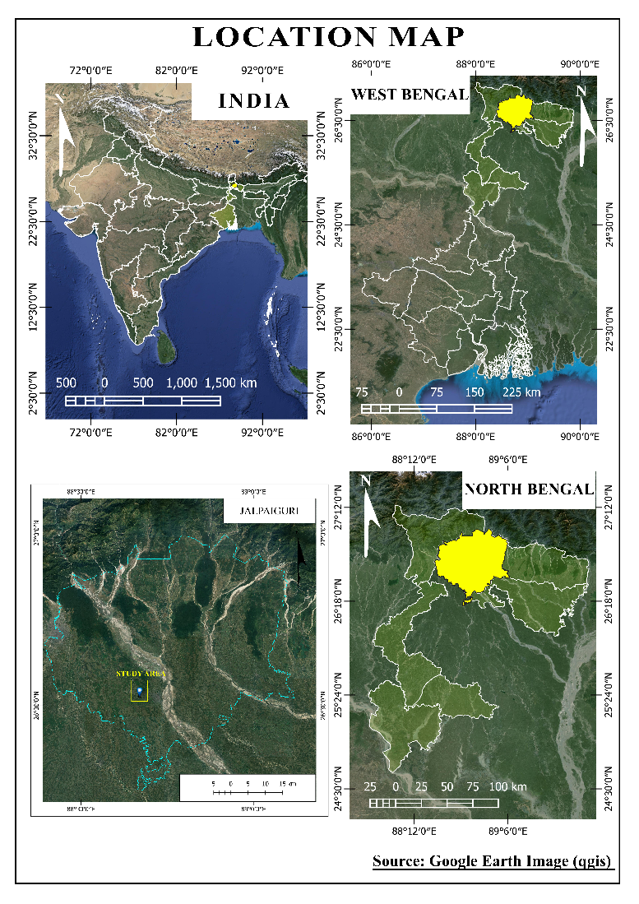
DISCUSSION
History of Jalpaiguri Tea Cultivation
Tea cultivation in Jalpaiguri, part of the fertile Dooars region in northern West Bengal, began in the late 19th century, inspired by the success of neighboring Assam and Darjeeling. The region’s ideal climatic conditions, including rich soil and ample rainfall, supported rapid expansion, led primarily by British planters who introduced modern agricultural practices. This growth attracted a large migrant labour force from Bihar, Jharkhand, and Chota Nagpur, forming the backbone of the industry. Post-independence, Indian entrepreneurs took over many estates, and government reforms improved labour welfare. Advancements in technology and cultivation methods further boosted productivity and quality. Today, Jalpaiguri’s tea industry stands as a symbol of resilience and sustainability, continuing to thrive globally through a focus on quality and fair-trade practices.
Visualizing Land Use Changes and Tea Dominance Over Three Decades in The Study Area (1995-2025):
Map:2- Land Use and Land Cover Map of The Study Area (1995–2025): Depicting Temporal Transformation Patterns
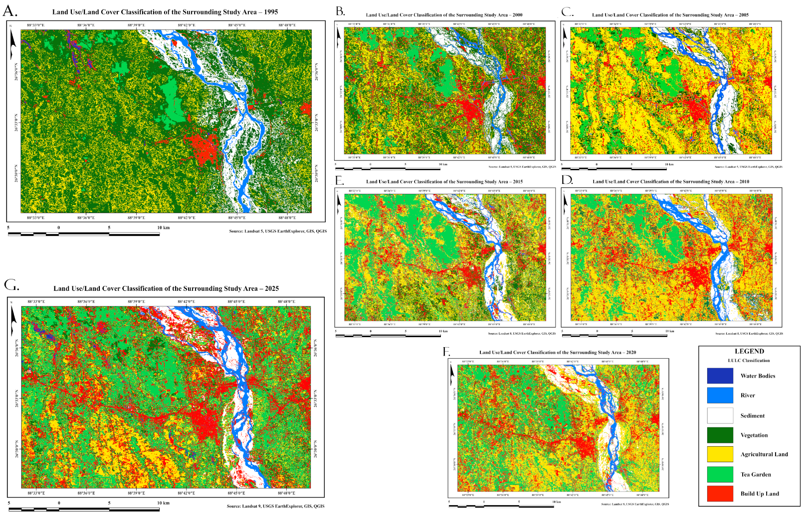
The Land Use and Land Cover (LULC) maps of the study area from 1995 to 2025 reveal significant transformations in agricultural land use, with a marked expansion of tea plantations over time. In 1995, the landscape was dominated by mixed cropping patterns including paddy, jute, and seasonal vegetables. However, by 2025, a substantial portion of this land has been converted into tea gardens, particularly in the Terai region of Jalpaiguri. This shift is evident through the increasing spatial coverage of areas classified as plantation crops in the LULC maps. The use of satellite imagery and GIS tools, such as Landsat data and Google Earth analysis, highlights both the pace and pattern of land conversion, indicating a clear trend toward mono-cropping of tea, driven by economic viability, market demand, and changing climatic conditions.
The Land Use and Land Cover (LULC) transformation in the study area over three decades reveals a significant two-phase land conversion process: first, natural vegetation was cleared and converted into agricultural land, followed by a transition from agriculture to tea gardens. This chain of transformation reflects the changing priorities in land use, driven by market demands, agricultural policy shifts, and local livelihood adaptations.
Table:1- 1995 To 2025 LULC Classes Area Coverage Data
Years | 1995 | 2000 | 2005 | 2010 | 2015 | 2020 | 2025
LULC Class | Area  Sq. Km | Area  Sq. Km | Area  Sq. Km | Area  Sq. Km | Area  Sq. Km | Area  Sq. Km | Area  Sq. Km
Water Bodies | 3.48 | 0.00 | 0.00 | 0.00 | 0.00 | 0.00 | 5.69
River | 16.45 | 13.69 | 23.67 | 28.18 | 25.69 | 21.71 | 24.32
Sediment | 57.77 | 35.48 | 46.43 | 37.41 | 29.93 | 31.95 | 32.94
Vegetation | 463.36 | 383.81 | 120.77 | 111.42 | 78.56 | 48.12 | 11.55
Agricultural Land | 122.81 | 89.49 | 319.94 | 292.17 | 112.50 | 58.51 | 45.22
Tea Garden | 16.47 | 74.44 | 80.10 | 112.48 | 324.70 | 406.82 | 440.79
Build Up Land | 21.23 | 104.66 | 110.66 | 119.93 | 130.19 | 134.45 | 141.06
Source: Secondary Data USGS Landsat 5,8,9 & QGIS

Between 1995 and 2025, the region underwent a profound transformation in Land Use and Land Cover (LULC), driven largely by the rapid expansion of tea cultivation, urban development, and a decline in natural and agricultural landscapes. The most significant change was observed in tea gardens, which grew dramatically from 16.47 sq. km to 440.79 sq. km—a rise of over 2576%—indicating a shift toward monoculture plantation driven by economic incentives. This expansion came at the cost of vegetation, which declined sharply by 451.81 sq. km (–97.5%), reflecting widespread deforestation and loss of biodiversity. Agricultural land also saw a complex shift—initially expanding to 319.94 sq. km in 2005, before contracting to just 45.22 sq. km by 2025, suggesting that farmland was gradually converted into tea gardens and built-up areas. Urbanization progressed steadily, with built-up land increasing from 21.23 to 141.06 sq. km, showing strong infrastructure growth.

Fig:1- Line Graph Showing Temporal Changes in Land Use and Land Cover (LULC) Classes From 1995 To 2025

Source: Secondary Data USGS Landsat 5,8,9 & Ms excel
Sediment zones decreased by 24.83 sq. km (–2.97%), potentially due to erosion control or channel stabilization. River areas showed fluctuations but expanded overall by 7.87 sq. km (+47.85%), possibly from hydrological shifts or improved mapping accuracy. Water bodies disappeared entirely from 2000 to 2020 but reappeared in 2025 with an area of 5.69 sq. km, hinting at new water management practices or seasonal surface water recovery. Overall, the data reveal a clear transformation from natural and agricultural landscapes to tea-dominated and urbanized land use, raising both economic opportunities and environmental concerns.
Table:2- 1995 To 2025 LULC Classes Increase & Decrease Calculation
LULC Class | 1995 (sq.km) | 2025 (sq.km) | Change (sq.km) | % Change | Trend
Tea Garden | 16.47 | 440.79 | +424.32 | +2576.32% | ⬆ Major Increase
Vegetation | 463.36 | 11.55 | –451.81 | –97.51% | ⬇ Major Decrease
Agricultural Land | 122.81 | 45.22 | –77.59 | –63.16% | ⬇ Decrease
Built-Up Land | 21.23 | 141.06 | +119.83 | +564.27% | ⬆ Increase
Sediment | 57.77 | 32.94 | –24.83 | –42.97% | ⬇ Decrease
River | 16.45 | 24.32 | +7.87 | +47.85% | ⬆ Increase
Water Bodies | 3.48 | 5.69 | +2.21 | +63.51% | ⬆ Increase
Source: Secondary Data USGS Landsat 5,8,9 & QGIS
The overall trend indicates a major conversion of vegetation and agricultural land into tea gardens and built-up areas. This shift underlines the region’s transition toward a plantation economy and urban expansion, but also flags serious concerns about environmental sustainability, ecosystem health, and food security. The land use dynamics reflect the intertwined forces of economic development, policy decisions, and climatic or hydrological changes.
LULC Changes (1995–2025): Focus on Vegetation–Agriculture–Tea Garden Transition
The Land Use and Land Cover (LULC) transformation in the study area over three decades reveals a significant two-phase land conversion process: first, natural vegetation was cleared and converted into agricultural land, followed by a transition from agriculture to tea gardens. This chain of transformation reflects the changing priorities in land use, driven by market demands, agricultural policy shifts, and local livelihood adaptations.
Stage 1: Vegetation to Agriculture Transition (1995–2005): Between 1995 and 2005, the region witnessed a drastic decline in vegetation cover, falling from 463.36 sq. km to 120.77 sq. km, a loss of over 340 sq. km. This dramatic drop indicates the widespread conversion of forested or naturally vegetated land into agricultural fields. At the same time, agricultural land increased significantly, from 122.81 sq. km to 319.94 sq. km. This suggests a period of aggressive land clearance, likely for short-term cultivation, cash crops, or to meet growing food demands. While tea gardens also began to expand (16.47 to 80.10 sq. km), the primary change in this phase was deforestation in favour of agriculture, not yet fully dominated by tea.
Stage 2: Agriculture to Tea Garden Expansion (2005–2015): The period from 2005 to 2015 marks the peak of agricultural land conversion into tea plantations. Agricultural land shrank from 319.94 sq. km to 112.50 sq. km, while tea garden area soared from 80.10 sq. km to 324.70 sq. km. This direct inverse relationship clearly shows that tea cultivation expanded at the cost of existing farmlands. The drop in vegetation also continued (to 78.56 sq. km), but the major transition now cantered on repurposing active agricultural land for long-term monoculture plantations. This stage highlights a strategic shift toward tea as a more profitable and sustainable land use choice in the region, replacing seasonal or food crop farming.
Stage 3: Tea Garden Consolidation and Dominance (2015–2025): By 2015, tea had already established itself as the dominant crop, and this trend continued through 2025. Tea gardens grew from 324.70 sq. km to 440.79 sq. km, further reducing agricultural land from 112.50 sq. km to just 45.22 sq. km. This final stage confirms that tea plantations replaced both traditional farming and any remaining fallow land. Vegetation was reduced to a minimal 11.55 sq. km, indicating near-total conversion of natural ecosystems. The dominance of tea in this phase reflects a consolidated shift in the land use economy, strongly tied to commercial agriculture and export-focused development. The primary change in this phase was deforestation in Favor of agriculture, not yet fully dominated by tea.
The land use transformation in Jalpaiguri between 1995 and 2025 follows a clear two-step process
Step 1: Massive deforestation and conversion of vegetation into agricultural land (1995–2005).
Step 2: Subsequent conversion of agricultural land into tea gardens (2005–2025).
This layered transformation reflects evolving land priorities—from subsistence agriculture to commercial monoculture—reshaping both the economy and the environment. While the shift has likely brought economic benefits and employment through the tea industry, it has also triggered loss of biodiversity, decline in traditional food production, and possible soil and water stress due to intensive monoculture practices. Understanding this pattern is essential for planning sustainable land use and balanced rural development in the future.

Four Major Pre-Tea Cultivation Farming Practices in Mohitnagar
Table:3 – Pre-Tea Cultivation Farming Practices
Rice | Vegetable | Fruit Garden | Mixed Farming
23 | 16 | 22 | 284
Data Source: Primary Survey

Fig:2- Pre-Tea Cultivation Farming Practices

Data Source: Primary Survey

Mixed Farming (82%):
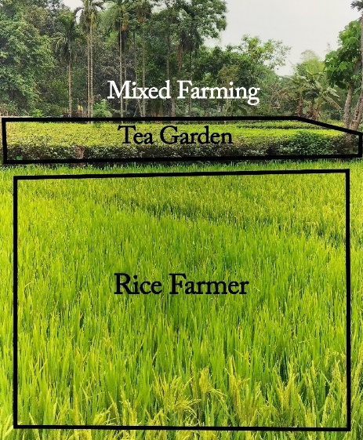
Photo: 1- Tea Gardens and Rice Farming by Same Farmar
The most dominant practice, mixed farming combined the cultivation of multiple crops with livestock rearing. This integrated system helped farmers diversify their income, optimize land use, and reduce dependency on a single crop, making it resilient to environmental and economic shocks.
Rice Cultivation (7%): Rice was a key monsoon-season crop grown in water-rich paddy fields. It played an essential role in the local diet and was cultivated using traditional wetland farming methods, depending heavily on seasonal rainfall for irrigation.
Fruit Gardens (6%): Farmers maintained orchards with trees like mango, guava, banana, and citrus fruits. These gardens required long-term care and investment but provided both nutritional and economic benefits to farm households.
Vegetable Farming (5%): Small-scale vegetable cultivation included leafy greens, root crops, and legumes. Often grown near homes, these plots supported household nutrition and market sales. Practices like crop rotation and intercropping helped maintain soil health and manage pests organically.
RESULT
Comparison Between Income rang 10 Years Ago and Now
Table:4 – Comparison Between Income Rents 10 Years Ago and Now
Income Range Now
Indian Rupees | <10000 | 10000-20000 | 20000-30000 | 30000-40000 | 40000-50000 | >50000
Person | 0 | 26 | 32 | 65 | 96 | 126
Income Range 10 Year Ago
Indian Rupees | <10000 | 10000-20000 | 20000-30000 | 30000-40000 | 40000-50000 | >50000
Person | 86 | 102 | 120 | 25 | 10 | 2
Data Source: Primary Survey
Over the past decade, the shift from traditional farming to tea cultivation in Mohitnagar has brought significant changes in income distribution among small-scale farmers. Previously, income levels were concentrated in the lower brackets, with 30% of farmers earning between ₹10,000–₹20,000 and 35% earning ₹20,000–₹30,000. Only a small percentage (7%) reached the ₹30,000–₹40,000 range, and even fewer (3%) earned between ₹40,000–₹50,000. A mere 1% of farmers earned more than ₹50,000, indicating that substantial income from traditional crops were rare and typically dependent on favorable market access, land size, or advanced techniques. These figures highlight the limited financial returns and vulnerability faced by traditional crop cultivators.
In contrast, the current income pattern under tea cultivation shows a marked improvement in economic outcomes. No farmers now fall below the ₹10,000 income level, and only 8% earn ₹10,000–₹20,000. The largest concentration (28%) lies in the ₹40,000–₹50,000 bracket, with 37% surpassing ₹50,000—a sharp contrast to the mere 1% from a decade ago. This growth reflects the profitability and scalability of tea cultivation in the region, supported by better market integration and the comparative
Fig:3- Comparison Between Income Range 10 Years Ago and Now

Data Source: Primary Survey
economic advantage of monoculture plantations. These changes illustrate how agricultural shifts have not only altered land use patterns but also enhanced rural income and economic resilience for a large portion of the farming population in Mohitnagar.
Comparison with Current Tea Cultivation:
The comparison between traditional farming and current tea cultivation in Mohitnagar clearly illustrates a significant shift in income distribution. Previously, the majority of farmers were concentrated in the lower income brackets, with most earning between ₹10,000–₹30,000, and only a small percentage exceeding ₹40,000. This reflects the limited profitability and challenges of traditional agriculture. In contrast, under tea cultivation, a substantial portion of cultivators—65%—now earn more than ₹40,000, with 37% earning over ₹50,000, indicating a remarkable economic upliftment. The transition to tea farming has resulted in a notable increase in income levels, with more farmers achieving higher financial stability and prosperity, driven by the commercial viability and scalability of tea as a cash crop.
Changing Pattern of Crop Cultivation Effaces on Small-Scale Farmers
Characteristics of Small-Scale Farmers of the area: Small-scale farmers in the region are characterized by limited land holdings, often less than a hectare to a few hectares, which shapes their farming choices and restricts the scale of mechanization. Their operations are largely labour-intensive, relying heavily on family labour and traditional methods. A hallmark of their agricultural strategy is mixed farming, where tea cultivation is combined with other food and cash crops like vegetables, fruits, and grains. Tea plays a central role in their economy, serving as a primary income source and connecting them to local and regional markets through sales to tea factories and cooperatives. Women are especially active in labour roles such as plucking, making tea farming a community-wide effort. Mixed farming not only offers economic diversification but also supports environmental sustainability through practices like crop rotation and intercropping. This approach helps maintain soil fertility, manage pests, and stabilize household income by reducing dependency on a single crop and buffering against market or climate shocks.
Changing Pattern of Crop Cultivation: From Traditional Farming to Tea Gardens: The shift from traditional farming to tea garden cultivation represents a significant transformation in agricultural practices for small-scale farmers. This change is driven by various factors, including economic incentives, market demands, and environmental considerations. Understanding the effects of this shift on small-scale farmers' economic growth is crucial for assessing its overall impact on the rural economy.
Traditional Farming Practices
Diverse Cropping Systems: Traditional farming typically involves the cultivation of a variety of crops, including staple foods like grains, vegetables, and legumes. This diversity helps ensure food security and provides a balanced diet for the community.
Cultural and Social Significance: Traditional farming practices are deeply embedded in the cultural and social fabric of rural communities. These practices are passed down through generations and contribute to the preservation of local heritage.
Sustainable Practices: Many traditional farming methods are sustainable, relying on natural fertilizers, crop rotation, and intercropping. These practices maintain soil health and biodiversity.
Transition to Tea Gardens
Economic Incentives: Tea cultivation offers higher potential profits compared to traditional crops. The global demand for tea and the establishment of processing factories creates lucrative opportunities for small-scale farmers.
Market Access: The integration of small-scale farmers into regional and international tea markets provides them with access to more stable and lucrative markets. This can lead to increased income and economic stability.
Employment Opportunities: Tea cultivation is labour-intensive, creating employment opportunities for both men and women. This shift can enhance household incomes and improve overall living standards.
Effects on Small-Scale Farmers Economic Growth
The transition from traditional farming to tea garden cultivation has significantly impacted the economic growth of small-scale farmers by increasing their income through higher profits from tea sales, enabling better investment in farming tools and practices. This income boost has improved their standard of living, offering enhanced access to education, healthcare, and housing. Additionally, tea cultivation promotes economic diversification, reducing reliance on a single crop and improving resilience. The increased earnings have also driven local infrastructure development—such as roads, storage, and irrigation—that benefits the broader community. Moreover, the shift demands new skills, encouraging farmers to engage in training and capacity-building programs that enhance productivity. While the opportunities are substantial, long-term success depends on sustainable practices, technical support, and efforts to preserve the region’s cultural and ecological balance.
Causes of Changing Pattern of Crop Cultivation
The transition from traditional farming to tea garden cultivation is driven by several key factors. These include high world market demand, nominal hard work, long-term benefits, high income rates, and the growth of living standards. Understanding these causes helps explain why many small-scale farmers are making this significant shift.
High World Market Demand
Global Popularity of Tea: Tea is one of the most widely consumed beverages in the world. The increasing global demand for tea has created lucrative market opportunities for producers, encouraging farmers to switch to tea cultivation.
Export Opportunities: The high demand in international markets offers farmers the chance to export their produce, often at higher prices than they would receive locally. This potential for higher earnings is a strong incentive for farmers to cultivate tea.
Stable Market Prices: Compared to many traditional crops, tea often enjoys more stable market prices. This stability provides farmers with a more predictable income, reducing the financial risks associated with farming.
Nominal Hard Work
Efficiency in Cultivation: Tea cultivation, while labour-intensive, involves repetitive and specialized tasks that can become more efficient over time. Farmers can develop expertise in tea farming, making the work more manageable and less physically demanding compared to the diverse tasks involved in traditional farming.
Use of Labour: The structured nature of tea farming allows for better organization and utilization of labour. This often means that family labour can be effectively used, with clear roles and responsibilities, reducing the overall burden on individual farmers.
Long-Term Benefits
Sustainable Income Source: Tea plants, once established, can produce leaves for many years. This provides farmers with a reliable and sustainable source of income over the long term, compared to annual crops that need to be replanted every season.
Soil Conservation: Tea gardens can help in soil conservation. The perennial nature of tea plants reduces soil erosion and improves soil health over time, contributing to long-term agricultural sustainability.
Infrastructure Development: The establishment of tea gardens often leads to improvements in local infrastructure, such as roads and irrigation systems, which benefit the broader community and contribute to long-term economic development.
High Income Rate
Increased Profit Margins: Tea cultivation generally offers higher profit margins compared to traditional crops. The ability to sell tea at higher prices, especially in international markets, significantly boosts farmers' incomes.
Economic Incentives: The promise of higher earnings from tea encourages farmers to invest in tea gardens. This investment is often seen as worthwhile given the substantial economic returns.
Financial Stability: Higher and more stable incomes from tea cultivation provide financial stability for farmers. This enables them to plan for the future, invest in their farms, and improve their overall economic situation.
Growth of Living Standards
Improved Living Conditions: With higher incomes from tea farming, farmers can afford better housing, healthcare, and education. This leads to an overall improvement in living standards and quality of life for farming families.
Access to Better Services: Increased earnings allow farmers to access better services, such as education for their children and healthcare for their families. This not only improves their immediate well-being but also enhances long-term prospects for the next generation.
Community Development: The economic growth driven by tea cultivation stimulates broader community development. Increased economic activity supports local businesses and services, leading to improved infrastructure and social services for the entire community.
Problem of Tea Cultivation in The Area:
Tea cultivation faces several challenges in areas like Jalpaiguri, exacerbated by market fluctuations, seasonal factors like heavy rains, and issues related to labour. Here's a breakdown of these problems and potential solutions.
Market Fluctuations: The tea market can be volatile, affecting prices and demand unpredictably. This product demand is worldwide some cases world market was down that effect on small-scale tea cultivator.
Seasonal Challenges (Rainfall): Heavy rains can disrupt harvesting, affect leaf quality, and lead to diseases. In case the rain water are block in tea garden, the tea plant will be destroyed.
Workers Issues: Labor shortages, disputes, or dissatisfaction can impact productivity and operational efficiency. Many time
Solutions
Encourage diversification of tea products (e.g., specialty teas) to reduce dependence on conventional markets. Conduct thorough market research to anticipate trends and adjust production accordingly. Secure long-term contracts with buyers to stabilize income streams.
Build or improve drainage systems and roads to mitigate waterlogging and ease transportation during rainy seasons. Implement practices like pruning and pest control to minimize damage caused by excessive rain.
Invest in training programs to enhance workers' skills and productivity. Ensure fair wages, good working conditions, and transparent communication to maintain a motivated workforce. Foster a supportive community environment to attract and retain workers.
Integrated Approach:
Technology Adoption: Utilize technology for weather forecasting, pest management, and efficient production practices.
Government Support: Advocate for policies that support the tea industry, such as subsidies for infrastructure development and market promotion.

CONCLUSION:
The tea cultivation sector in the region holds significant socio-economic importance, serving as a critical source of livelihood for thousands of workers and contributing meaningfully to the regional economy. However, the sector faces numerous challenges including fluctuating market demands, seasonal adversities, and persistent labour issues. Addressing these concerns requires a holistic and collaborative approach involving estate management, government agencies, and local communities. Such coordinated efforts are essential to building a more resilient and adaptable tea industry that can weather economic uncertainties while ensuring fair labour practices and sustainable production.
The comprehensive analysis of the dataset presented in this report reveals a promising trend of economic growth among tea garden workers, indicating that existing interventions have begun to bear fruit. This upward trajectory suggests that with continued focus on strategic planning, investment in infrastructure, skill development, and policy support, the sector can unlock further economic potential. Additionally, empowering workers through education, healthcare access, and social security schemes will foster a more inclusive and stable working environment.
Sustained improvement in the tea sector will not only benefit the direct stakeholders but also generate a ripple effect, contributing to the broader socio-economic development of this region. By nurturing innovation, strengthening institutional frameworks, and promoting sustainable agricultural practices, the tea industry can enhance its global competitiveness and secure long-term prosperity. Ultimately, the collective commitment to addressing these challenges today will lay the groundwork for a more equitable, productive, and thriving tea cultivation landscape in the years to come.

REFERENCES
- Nguyen. C. V., Tran. A. N. (2012-2023); “The role of crop land during economic development: Evidence from rural Vietnam”; European Review of Agricultural Economics Vol 41 (4) (2014) pp. 561–582 Advance Access Publication 30 October 2013.
- Andrew D. Foster, Mark R. Rosenzweig (2003); “Agricultural Productivity Growth, Rural Economic Diversity, and Economic Reforms: India, 1970-2000”; D. Gale Johnson Memorial Conference, October 25, 2003.
- John W. McArthur, Gordon C. McCord (2017); “Fertilizing growth: Agricultural inputs and their effects in economic development”; Journal of Development Economics 127 (2017) 133–152.
- Pender. J. (1999); “Rural Population Growth, Agricultural Change and Natural Resource Management in Developing Countries: A Review of Hypotheses and Some Evidence from Honduras”; International Food Policy Research Institute 2033 K Street, N.W. Washington, D.C. 20006 U.S.A.
- Paria. B., Mishra. P. And Behera. B (2022); “Climate change and transition in cropping patterns: District level evidence from West Bengal, India”; Department of Humanities and Social Sciences, Indian Institute of Technology Kharagpur, Kharagpur, 721302, India. -pp.1-11.
- Chand. R., Srivastava. S. K and Singh. J. (2017); “Changing Structure of Rural Economy of India Implications for Employment and Growth”; National Institution for Transforming India NITI Aayog, pp-26.
- Chand. R, Srivastava. S. K., Singh. J. (2017); “Changes in Rural Economy of India, 1971 to 2012”; Economic & Political Weekly, DECEMBER 30, 2017 pp-64.
- United States Geological Survey (USGS). (1995, April 25). Landsat 5 TM satellite image, Path 139, Row 042. Retrieved from USGS EarthExplorer.
- United States Geological Survey (USGS). (2000, December 2). Landsat 5 TM satellite image, Path 139, Row 042. Retrieved from USGS EarthExplorer.
- United States Geological Survey (USGS). (2005, November 14). Landsat 5 TM satellite image, Path 139, Row 042. Retrieved from USGS EarthExplorer.
- United States Geological Survey (USGS). (2010, December 14). Landsat 5 TM satellite image, Path 139, Row 042. Retrieved from USGS EarthExplorer.
- United States Geological Survey (USGS). (2015, February 11). Landsat 8 OLI satellite image, Path 139, Row 042. Retrieved from USGS EarthExplorer.
- United States Geological Survey (USGS). (2020, November 7). Landsat 8 OLI satellite image, Path 139, Row 042. Retrieved from USGS EarthExplorer.
- United States Geological Survey (USGS). (2025, April 3). Landsat 9 OLI satellite image, Path 139, Row 042. Retrieved from USGS EarthExplorer.

