Design and Implementation of an Expert System for Diagnosing Crop Diseases in Maize, Groundnut, and Millet
ABSTRACT
Agriculture is a cornerstone of economic growth and food security in Nigeria, particularly in rural states such as Yobe where maize, groundnut, and millet are staple crops. Despite their importance, productivity is severely constrained by crop diseases caused by fungi, bacteria, viruses, and pests. These diseases account for significant yield losses, threatening farmers’ livelihoods and national food security. Traditional diagnostic methods are often slow, costly, and inaccessible to smallholder farmers, who also face challenges of misdiagnosis due to limited technical expertise and inadequate extension services. Consequently, there is a pressing need for affordable, reliable, and accessible diagnostic tools that can empower farmers to make informed decisions. This study addresses these challenges by designing and implementing a rule-based Expert System for diagnosing common diseases in maize, groundnut, and millet. The system integrates a knowledge base of symptoms and diagnostic rules with an inference engine capable of simulating expert reasoning. Using iterative prototyping, the system was developed, tested, and refined to ensure accuracy and usability. By guiding farmers through symptom-based questioning and providing timely recommendations for disease management, the system reduces dependency on scarce agricultural experts and enhances decision-making in rural communities. The significance of this research lies in its contribution to food security, digital agriculture, and the application of Artificial Intelligence in solving real-world agricultural problems. Beyond its practical utility for farmers, the project also demonstrates the academic relevance of expert systems in computer science, showcasing how knowledge-based reasoning can be applied to critical domains. Ultimately, the system provides a localized, accessible, and intelligent solution to crop disease diagnosis, supporting sustainable agricultural productivity and resilience in Nigeria’s farming communities.
Keyword: agriculture, expert system, crop, diagnosing, & diseases.
INTRODUCTION
Agriculture is a fundamental contributor to the livelihood and economic growth of many developing countries, including Nigeria. In states such as Yobe, farming remains the dominant occupation, with crops like maize, groundnut, and millet being widely cultivated for food, income, and industrial use (FAO, 2021). These crops play a vital role in ensuring food security and supporting rural economies. However, one of the greatest challenges threatening their productivity is the prevalence of crop diseases caused by fungi, viruses, bacteria, and pests. Crop diseases account for significant post-harvest and field losses, thereby limiting farmers’ income and threatening national food security (Alakonya et al., 2018). In most rural farming communities, limited access to extension workers and modern diagnostic tools makes it difficult for farmers to identify and control diseases accurately (World Bank, 2020). Consequently, misdiagnosis and inappropriate treatment practices remain common, worsening yield losses.
Crop diseases in maize, groundnut, and millet are often caused by fungi, bacteria, viruses, and pests. Diagnosing these diseases accurately and early is critical for effective management. Unfortunately, many smallholder farmers lack the expertise and access to professional agricultural extension officers, leading to misdiagnosis and inappropriate treatment practices. With the growth of Artificial Intelligence (AI) and Expert Systems, computer-based tools can be developed to aid in disease detection, diagnosis, and recommendation of control measures. Such systems would empower farmers with knowledge, reduce dependency on scarce experts, and enhance food production. This study, therefore, seeks to develop an Expert System for the diagnosis of common diseases in maize, groundnut, and millet, providing users with timely and accurate recommendations for managing and controlling these diseases.
Advances in Artificial Intelligence (AI) and computer-based solutions have introduced Expert Systems as tools capable of simulating human reasoning in solving domain-specific problems. Expert systems have been widely applied in fields such as medicine, engineering, and increasingly in agriculture, where they can support farmers in diagnosing crop diseases and recommending effective treatments (Oladipo & Ajayi, 2019). Designing an Expert System for diagnosing common diseases in maize, groundnut, and millet will provide farmers with timely and reliable support, reduce dependency on scarce experts, and ultimately improve agricultural productivity.
Artificial Intelligence (AI) in Agriculture
Artificial Intelligence (AI) refers to the simulation of human intelligence processes by computer systems to perform tasks such as reasoning, learning, and decision-making (Russell & Norvig, 2021). In agriculture, AI is increasingly being used to enhance productivity, optimize resource use, and address complex challenges like pest and disease detection. AI models analyze large datasets of crop images, symptoms, and environmental parameters to predict diseases, recommend treatment options, and automate farm management decisions (Patil & Thorat, 2016).
AI-based agricultural tools, such as machine learning classifiers and expert systems, are helping farmers detect crop anomalies earlier and respond more effectively. For instance, image recognition systems powered by AI can classify leaf diseases based on visual symptoms, while expert systems can diagnose diseases based on farmers’ input of observed signs. By combining these technologies, decision-making becomes faster, more accurate, and less dependent on scarce agricultural experts.
Concept of Expert Systems
An expert system is a computer program designed to simulate the problem-solving ability of a human expert in a specific domain (Giarratano & Riley, 2020). It uses stored knowledge and inference rules to provide solutions, diagnoses, or recommendations. Expert systems are a branch of AI that focuses on reasoning using symbolic knowledge rather than numerical computation
Crop Disease Diagnosis
Crop disease diagnosis involves identifying the specific pathogen or condition responsible for the observed symptoms on plants. Accurate diagnosis is essential for selecting the appropriate control strategy and preventing the spread of disease. Traditional diagnostic methods rely on field observation or laboratory analysis, which can be time-consuming, costly, and inaccessible to smallholder farmers.
An expert system for crop disease diagnosis simplifies this process by guiding the user through a series of questions about crop symptoms such as leaf color, spots, wilting, or fungal growth and then matching responses with rules stored in its knowledge base. Once the system identifies a likely disease, it can also recommend management practices such as fungicide application, crop
Application of Expert Systems in Agriculture rotation
Expert systems have been successfully implemented across different domains of agriculture, including pest control, soil management, and irrigation scheduling. For instance, POMME (France) and DEXTER (USA) were among the early expert systems developed for crop management, capable of diagnosing apple scab and advising on disease control strategies (Oladipo & Ajayi, 2019). In Nigeria, several research efforts have adapted expert systems for local crops like rice, cassava, and maize, showing promise in reducing post-harvest losses and improving farmer productivity. By integrating these technologies, the proposed system in this study aims to address the diagnostic challenges facing farmers cultivating maize, groundnut, and millet providing an intelligent and locally relevant platform for disease management.
Decision Support System (DSS) Theory
Decision Support System theory emphasizes the use of computer-based tools to assist in making effective and timely decisions in uncertain or complex environments. It was proposed by Keen and Scott Morton (1978), who described DSS as systems designed to complement human judgment rather than replace it. In this research, the expert system acts as a Decision Support Tool for farmers and agricultural extension workers. It helps them analyze crop conditions and select appropriate disease management actions, thereby enhancing decision quality. The system’s output serves as an advisory aid, reducing dependence on limited agricultural experts and improving response time to outbreaks.
METHODOLOGY
The methodology for developing the Expert System for Crop Disease Diagnosis on Maize, Groundnut, and Millet (ESCDMM) is a hybrid mobile expert system implemented as an Desktop-focused C sharp application as presented in Figure 1. The system combines a traditional rule-based expert system (using forward chaining inference) for the interactive question-and-answer (Q&A) diagnostic mode with Google's Gemini API (leveraging its multimodal vision capabilities) for image-based diagnosis when users upload photos of affected plants. The development follows a design science research paradigm with iterative prototyping, ensuring the artifact addresses gaps in existing systems (e.g., limited multi-crop support, accessibility in rural areas). Key phases include requirements analysis, knowledge acquisition, hybrid architecture design, implementation using Visual Studio/C#, JSON, SQL and Gemini API, and rigorous evaluation.
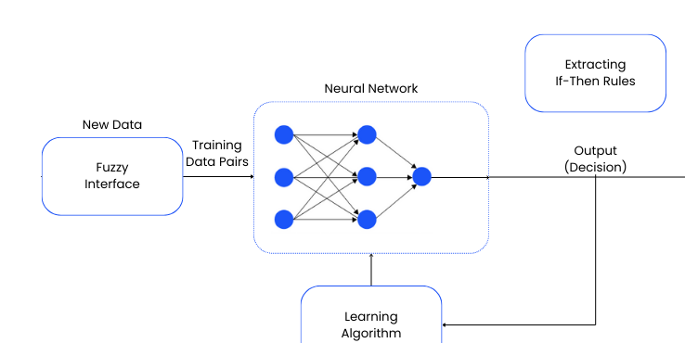
Figure 1: Hybrid Expert System Architecture Concept (Rule-based + AI Components)
The diagram illustrates the integration of symbolic rule-based reasoning with generative AI, similar to the ESCDDM hybrid design.
Research Design
The study uses a hybrid methodology: knowledge engineering for the rule-based component and agile software development for the mobile app. The expert system type is rule-based with forward chaining inference engine for the Q&A mode
Inference Engine Details
Primary Mode (Q&A): Forward chaining – starts with user-provided symptoms, progressively matches facts against IF-THEN rules in the knowledge base, and derives conclusions (disease diagnosis) as presented in Figure 2.
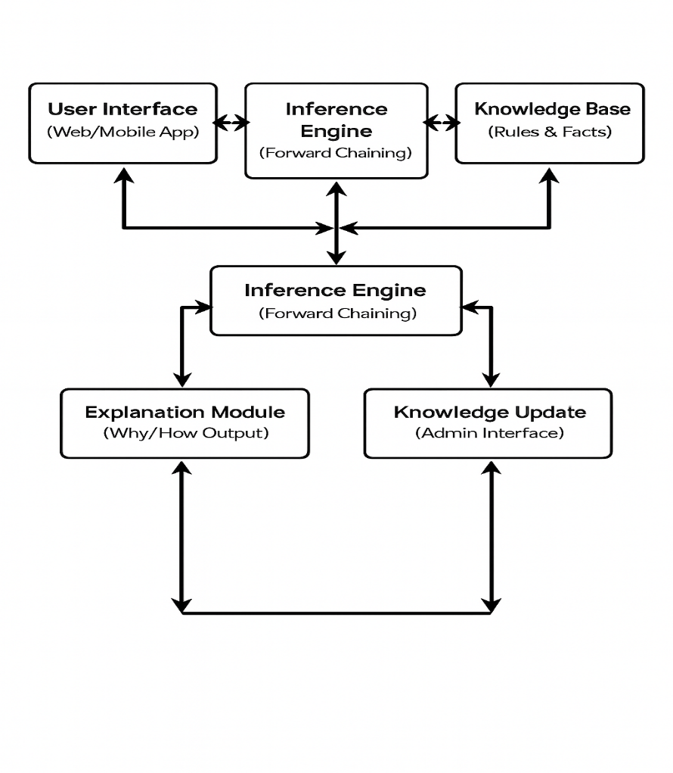
Figure 2: System Architecture Diagram
Description: The diagram shows bidirectional flow between components. Users interact via the interface, which queries the inference engine. The engine processes rules from the knowledge base and outputs diagnoses/explanations
RESULTS
Development Environment
The system was developed using a robust set of tools selected for their cross-platform capabilities and rapid prototyping features. The hardware and software specifications used during the development phase are as follows
Hardware Requirements
- Processor: Intel Core i5 (or equivalent) for development; ARM-based processors for mobile deployment.
- RAM: 8GB minimum (16GB recommended for running Visual studio, .NET framework 8).
- Desktop Devices: Windows, Linux (running Window 10.0 or higher) with a minimum 4gb RAM
Software Tools
- IDE: Visual Studio with C sharp and .NET extensions.
- Framework: MVC, Inference Engine, Bunifu
- Language: C# (for logic) and xml (Design).
- Backend/Database: Node and JSON for storing the rule-based knowledge base.
- Version Control: Git/GitHub
User Interface (UI) Design
The User Interface was designed with a focus on simplicity and accessibility for rural farmers as presented in Figure 3.
- Home Screen: Features large, distinct icons for the three target crops (Maize, Groundnut, Millet) and clear entry points for "Diagnose by Questions" or "Diagnose by Photo."
- Diagnosis Screen: A step-by-step wizard format prevents information overload.
- Result Screen: Displays the diagnosed disease in bold, followed by expandable sections for "Symptoms" and "Management/Treatment
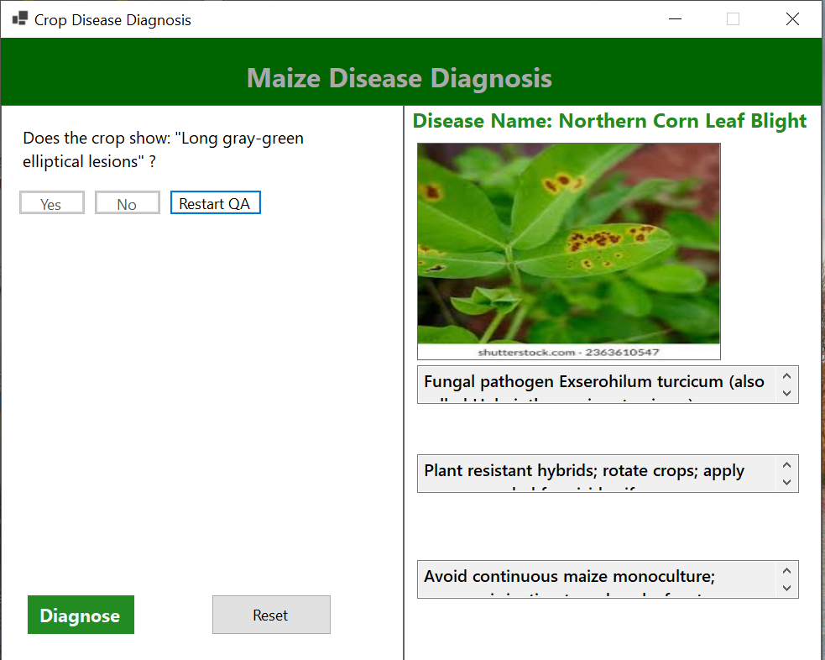
Figure 3: Maize Disease Diagnosis

CONCLUSION
The development of the ESCDMM (Expert System for Crop Disease Diagnosis on Maize, Groundnut, and Millet successfully demonstrates that Artificial Intelligence can be effectively democratized to support smallholder farmers. By combining the structured reliability of rule-based systems with the generative power of modern Large Language Models (LLMs) like Gemini, the system overcomes the limitations of previous single-crop or purely text-based systems. The study concludes that this hybrid expert system provides a viable, low-cost, and scalable alternative to traditional extension services. It empowers farmers with instant access to expert knowledge, thereby facilitating timely intervention, reducing yield losses, and contributing to the broader goal of food security in Nigeria.
RECOMMENDATION
Based on the findings and limitations of this study, the following recommendations are made:
- For Government & Agricultural Agencies: The Ministry of Agriculture should consider adopting and deploying such digital tools as a standard support mechanism for extension workers, equipping them with tablets containing the app to aid their field work.
- For Farmers: Farmers are encouraged to form cooperatives where at least one member has a smartphone, allowing the community to share the benefits of the diagnostic tool.
- Infrastructure Support: To maximize the effectiveness of the AI-vision component, efforts to improve rural internet connectivity should be prioritized by relevant stakeholders.
Contribution to Knowledge
This study contributes to the field of Computer Science and Agriculture by:
- Hybrid Architecture: Proposing and validating a novel architecture that integrates traditional symbolic AI (Rules) with modern Generative AI (Gemini) in a mobile context.
- Localized Knowledge Base: Creating a digitized, verified repository of disease symptoms and treatments specific to the Northern Nigerian agricultural context for Maize, Groundnut, and Millet.

REFERENCES
- FAO. (2021). World food and agriculture – Statistical yearbook 2021. Food and Agriculture Organization of the United Nations.
- Alakonya, A., et al. (2018). Crop diseases and post-harvest losses: Implications for farmers’ income and food security. Agricultural Systems. World Bank. (2020). Empowering smallholder farmers: Challenges in accessing extension services. Washington, DC: World Bank Group.
- Oladipo, O., & Ajayi, A. (2019). Development of a rule-based expert system for diagnosing maize leaf diseases using Python. Journal of Computer Science and Its Applications.
- Russell, S., & Norvig, P. (2021). Artificial intelligence: A modern approach (4th ed.). Pearson.
- Patil, J., & Thorat, S. (2016). Artificial intelligence in agriculture: Applications and challenges. International Journal of Computer Applications.
- Giarratano, J., & Riley, G. (2020). Expert systems: Principles and programming (5th ed.). Cengage Learning.
- Keen, P., & Scott Morton, M. (1978). Decision support systems: An organizational perspective. Addison-Wesley.

