Automated Test Generation and Code Evaluation with Custom Copilot Architecture

Abstract—Ensuring software correctness and reliability is a critical challenge. AI, particularly Large Language Models (LLMs), promises automated test generation to reduce manual effort and improve coverage. However, LLM-generated code and tests may contain hallucinations, compilation errors, and incorrect logic. This research presents a custom multi-agent Copilot architecture for automated test identification, implementation, evaluation, and iterative refinement with human-in-the-loop supervision. Early results demonstrate improved test coverage, reduced manual intervention, and mitigation of AI hallucination errors [1], [2].

Index Terms—AI Testing, Large Language Models, Automated Test Generation, PyTest, Multi-Agent Systems, HITL, Software Quality, Test Coverage

Introduction & Problem Definition
The ideal objective in software development is to ensure applications are correct, efficient, and reliable through rigorous and extensive testing, which serves as a critical quality assurance mechanism. [1] The integration of artificial intelligence (AI), particularly Large Language Models (LLMs), into this process aims to automate test case generation, thereby reducing manual effort, lowering costs, and enhancing test coverage and software quality. [2][4]

However, the rapid advancement of AI has introduced a novel challenge: ensuring the quality of code written by AI itself. [4] While AI models can generate code at an unprecedented speed, they also introduce unique issues that traditional testing methods may not be equipped to handle. LLM-generated tests often suffer from compilation errors, incorrect logic, and hallucinated symbols, which are references to non-existent code elements. In comparative studies, traditional automated testing tools such as EvoSuite have demonstrated superior performance over LLMs in key metrics like code coverage and assertion correctness. This discrepancy highlights a significant gap between the theoretical potential of AI in software testing and its practical, real-world reliability. This problem is compounded by the fact that traditional testing methods are already struggling to provide comprehensive coverage for increasingly complex, modern software systems. [4]

The primary consequence of this problem is the risk of deploying low-quality software, leading to potential financial losses, negative user experiences, and reputational damage. The speed of AI-driven code production, if not matched by equally advanced and reliable validation techniques, creates a significant risk of introducing critical bugs into production environments. This situation necessitates the development of automated and intelligent test case generation frameworks specifically designed to validate AI-produced code and address its distinct failure patterns [2][4].

Related Work
A. Traditional Testing Methods

Traditional automated testing methods, including search-based software testing (SBST) tools like EvoSuite [6] and random-testing tools like Randoop, are foundational to the field [11]. However, their limitations are well-documented. They often produce tests that are difficult for humans to read and maintain, and they struggle to generate complex test inputs or meaningful assertions (oracles) to validate program behavior [2], [5].
Initial AI-driven approaches sought to address these issues by creating dynamic frameworks.
For example, some conceptual frameworks proposed using combinations of deep learning, reinforcement learning, and evolutionary algorithms [2]. The goal of such frameworks was to dynamically generate and prioritize test cases based on execution patterns and historical data, thereby improving defect detection rates over static, scripted automation [2].

B. ML-Based Testing Advances

Recent ML-based software testing advances (as summarized in the 2024 Applied Soft Computing systematic review) show that machine learning is increasingly used to improve automation, accuracy, and efficiency across major testing tasks such as defect prediction, fault localization, test case generation, prioritization, and test-oracle support. Supervised learning remains the dominant technique, while more recent studies explore reinforcement learning and hybrid models to enable adaptive and data-driven testing. Overall, ML-based testing demonstrates promising performance gains and reduced manual effort; however, key limitations remain, including limited high-quality labeled datasets, weak generalizability across projects, low interpretability of ML predictions, and a lack of large-scale industrial deployment. Future research is expected to focus on explainable ML, standardized benchmark datasets, and scalable solutions integrated into CI/CD pipelines [13].

C. AI/LLM-Powered Test Generation

Early AI frameworks used deep learning, reinforcement learning, and evolutionary algorithms to dynamically generate test cases based on execution patterns and historical data [4]. Multi-agent pipelines with iterative feedback and HITL supervision improve reliability of AI-generated tests [8], [9]. Comparative studies show traditional automated tools outperform LLMs in key metrics such as coverage and assertion correctness [6], [9].

Methodology & System Design
The architecture consists of interacting agents with iterative evaluation and HITL supervision, as shown in Fig.1.
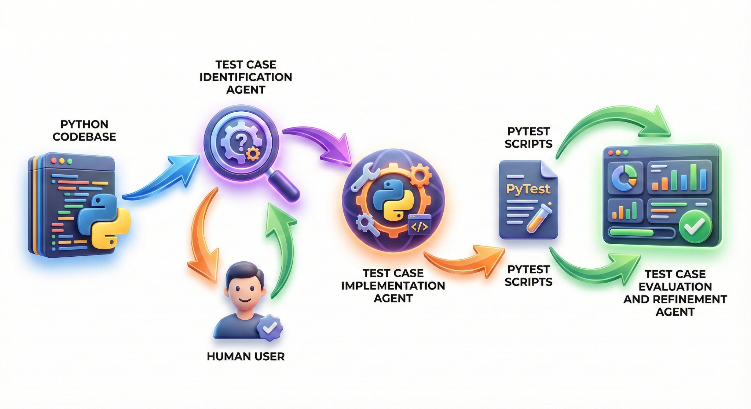
Fig. 1. Multi-agent Copilot architecture for automated test identification, implementation, evaluation, and dash boarding.

Prototype Implementation
- System Architecture
The AutoAgenticTesting prototype implements a three-agent autonomous testing pipeline orchestrated through a unified system with multiple user interfaces. The architecture consists of:
Multi-Agent System:
- Identification Agent: Analyzes target Python code to autonomously discover test scenarios, including edge cases, security vulnerabilities, and critical execution paths.
- Implementation Agent: Generates syntactically correct PyTest scripts based on identified scenarios with built-in security awareness.
- Evaluation Agent: Executes generated tests, measures code coverage, identifies gaps, and iteratively requests new test cases until target coverage (90%) is achieved.

- Core Components
Pipeline Orchestration Engine
The central engine manages the multi-agent workflow through a state-machine architecture:
- Receives target codebase path as input.
- Invokes agents sequentially, passing JSON-structured data between stages.
- Implements automatic retry mechanisms with API key rotation for resilience against rate limiting.
- Maintains iteration state for coverage-driven test generation.
- Outputs: test files, coverage reports, and security analysis logs.

User Interface Implementation
The prototype provides two complementary interfaces for different use cases:
- GUI Interface:
The dark, minimal GUI uses a three-phase stepper (Identify, Implement, Verify). Key controls include a target path picker, auto-approve toggle, and run/stop button, along with a live console. It shows coverage, test, and security stats, and a performance graph tracking coverage, security counts, and execution time. Additional features are agent flow visualization, an auto-loading prompts tab, and a comprehensive reset function (clearing logs, graph/stats, and restoring controls). The three interface views are detailed in Figures 2, 3, and 4.
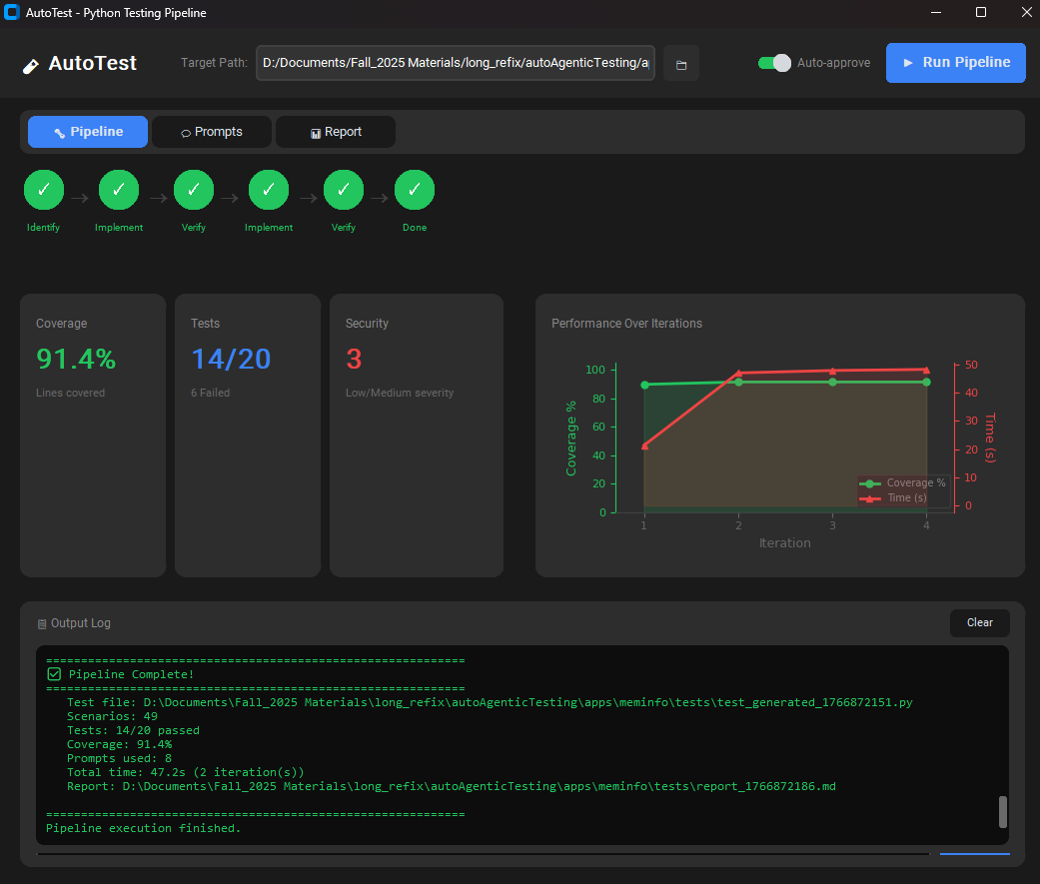
Fig 2 - main dashboard and real-time metrics
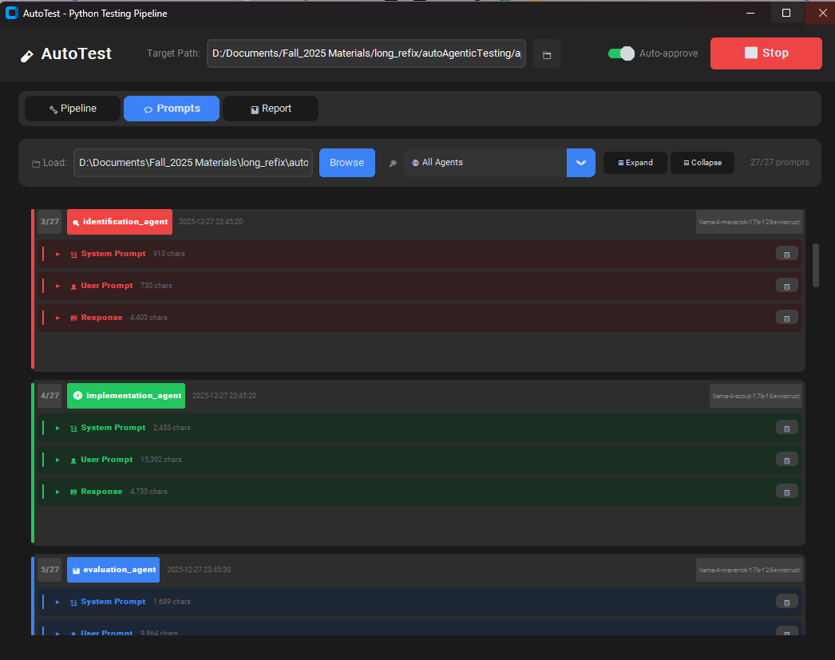
Fig 3 - Conversation view between the agents
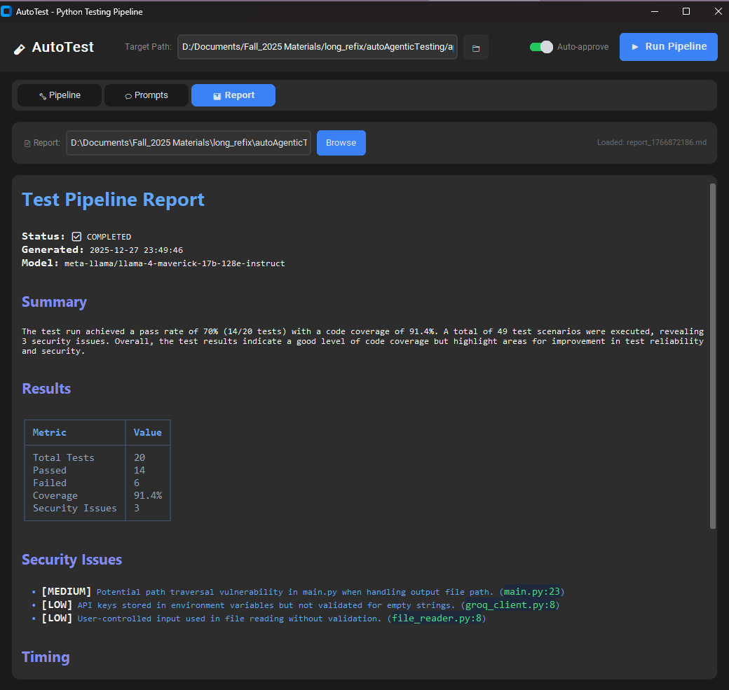
Fig 4 - Detailed reporting interface

- Command-Line Interface
The Command-Line Interface (CLI) is lightweight, making it ideal for Continuous Integration/Continuous Deployment (CI/CD) pipelines. It supports an --auto-approve flag for unattended execution and a --no-run-tests flag for test generation only, without running them. Standard output and error streams are used for debugging purposes.

- Iterative Improvement Loop
The implementation features a feedback loop for coverage optimization:

- Initial Test Generation: First iteration generates baseline test cases.
- Coverage Evaluation: Measures line coverage using pytest-cov.
- Gap Analysis: Identifies uncovered code sections and edge cases.
- Regeneration: Automatically requests new tests from the Implementation Agent, targeting gaps.
- Convergence: Continues until coverage target (90%) or iteration limit reached
Each iteration maintains state through JSON logs, enabling users to track progress and understand agent reasoning.

- Robustness Features
Error Handling & Recovery:
- Automatic syntax error detection and correction in generated tests.
- Graceful handling of missing dependencies with installation prompts.
- API timeout management with exponential backoff.
- Multi-key rotation when rate limits are encountered.

Logging & Observability:
- Structured JSON logging of agent outputs for transparency.
- Parse-able log format enabling GUI visualization.
- Real-time terminal output streaming for CLI users.
- Conversation history preserved in latest_prompts.json for debugging.

- Technology Stack

Component | Technology | Purpose
Agent logic | OpenAI GPT-4 / Groq | Multi-agent reasoning
Testing Framework | PyTest, pytest-cov | Test execution & coverage measurement
Backend | FastAPI | API endpoints for extension
GUI | CustomTkinter | Cross-platform desktop interface
IDE Integration | VS Code Extension API (TypeScript) | Editor integration
Data Handling | JSON, Python dataclasses | Structured inter-agent communication

Evaluation & Results
To validate the efficacy of the proposed architecture, we conducted a comparative analysis between the Initial Prototype (Baseline) and the Enhanced Auto-Agentic System. The Baseline represents the multi-agent system operating with standard zero-shot prompting and without the active governance.

- Experimental Benchmark Suit:
We selected a diverse benchmark suite of six Python applications, each representing a distinct architectural pattern and testing challenge common in modern software engineering:
- web_timer (Web Service): A FastAPI/Starlette application requiring asynchronous endpoint testing
- meminfo (Data Processing): A CLI tool involving PDF/Markdown extraction, testing the system's ability to mock external APIs and file I/O.
- hangman (Stateful Logic): A classic game implementation demanding complex state management and user input simulation.
- todo & expenses (CRUD Operations): Utility applications testing the system's ability to generate coverage for logic, UI widgets, and data persistence.
- grand_flower_shop (Business Logic): An object-oriented simulation testing class inheritance and inventory management rules.
- Api_manager (API management): Placeholder for future API orchestration/gateway application.

- Quantitative Performance Comparison
The enhanced system demonstrated significant improvements across three key metrics: Code Coverage, Test Stability (Pass Rate), and Security Vulnerability. Table I summarizes the results.

App | Baseline Coverage | Enhanced Coverage | Pass Rate | Security Issues (Severe)
Hangman | 77.0% | 87.8% | 41% → 75% | 2→0
Meminfo | 94.8% | 98.3% | 60% → 60% | 2→1
Todo | 24.0% | 93.0% | 21% → 63% | 2 →0
Web Timer | 100.0% | 100.0% | 62% → 89% | 1→0
Expenses | 90.8% | 95.2% | 41% → 75% | 0→0
Flower Shop | 97.0% | 96.9% | 71 → 96% | 3→0
Table 1 - Comparison of AI-Enhanced System Performance Against Baseline Across Key Metrics

- Key Findings & Architecture Validation
Analysis of execution logs & output files confirms that the system’s architectural components directly drove performance gains and stability, Analysis of execution logs confirms that the system’s architectural components directly drove significant performance gains and stability. The implementation of advanced dependency injection allowed the system to mock complex GUI libraries, driving a +69% coverage increase (24% → 93%) in the todo application where the Baseline failed.
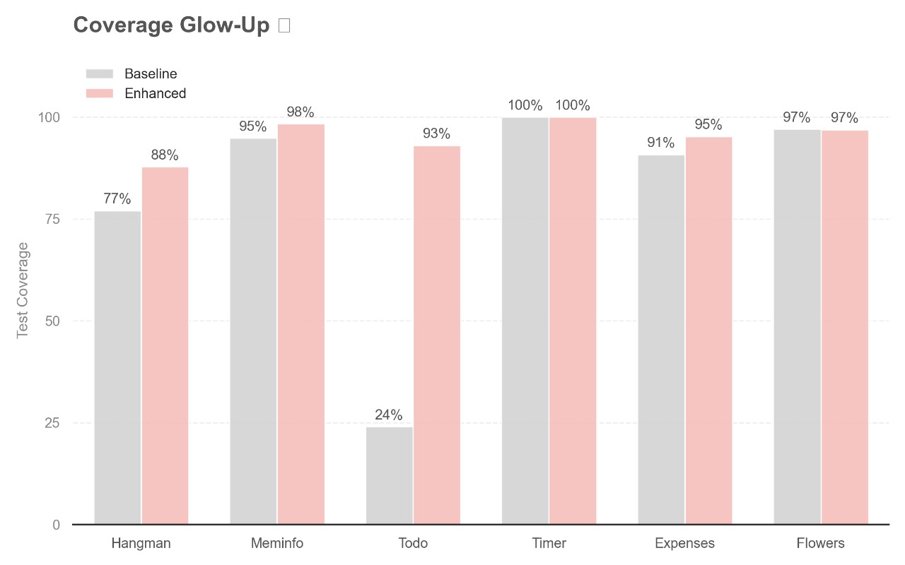
Fig 2. Show the Coverage percentage for each benchmark in the two versions, baseline and Enhanced.

The architecture further demonstrated active resilience through "Self-Healing" mechanisms that auto-repaired syntax errors and installed missing dependencies without human intervention. This scalability was enabled by the system's Parallelism feature, which efficiently processed the large codebases by splitting them into logical chunks

Finally, the Evaluation Agent’s active governance eliminated nearly all severe security issues (8→0) by scanning for vulnerabilities and utilizing a "Safety Rollback" feature to automatically restore optimal test versions upon detecting quality degradation .
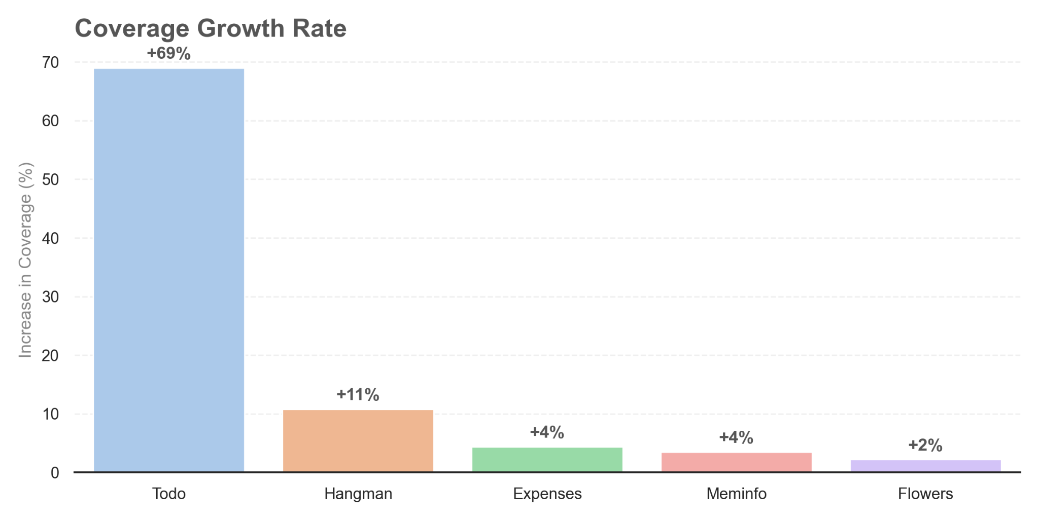
Fig 3. Show the coverage growth rate at some benchmarks.

Discussion
The three-agent pipeline effectively automates test generation with iterative improvements. Key strengths include parallel processing for scalability, intelligent API resilience through key rotation and model fallback, and comprehensive convergence mechanisms (15-iteration limit, 5-stagnation early exit). Limitations include fragile regex log parsing, and unrealistic 90% coverage targets for complex domains.

Hallucination Analysis
A critical failure mode of Large Language Models is the hallucination of non-existent libraries or file paths. Our analysis shows how the Multi-Agent architecture mitigates this:
Phantom Dependencies:
The Baseline frequently hallucinated attributes, such as pytest. Any in the expenses app, causing AttributeError. The Enhanced System's Identification Agent correctly mapped valid dependencies before code generation, resulting in a 75% pass rate in the first iteration.

Integration Errors:
In meminfo, the Baseline attempted to make real network calls to the Groq API during testing, causing the pipeline to hang. The Enhanced System correctly identified the external service and generated mocks, isolating the unit tests effectively.
File System Hallucinations:
In flower_shop, the Baseline tests failed due to FileNotFoundError: test.json, assuming a fixture existed. The Enhanced System generated self-contained tests using pytest fixtures, removing the reliance on phantom files.

Reflection
State-of-the-Art:
We enhanced automated test generation beyond single-pass tools by adding iterative refinement with coverage feedback and security analysis as co-equal completion criteria. Achieved ~82-90% coverage on sample applications. However, we plateau below the 90% target due to complex state machines and async scenarios that resist automated testing.

Limiting Factors:
- Data: Only 6 in-house applications tested; no comparison to public benchmarks (Defects4J) or human-written reference tests.
- Prompting: Static 800-word prompts with explicit rules; no few-shot examples or confidence scoring.
- Evaluation: Coverage as proxy (doesn't measure assertion quality); pattern-based security scanner at 83% precision; no mutation testing.
Given More Time:

- Immediate: Switch to JSON Lines logging (eliminate fragile regex parsing); add few-shot examples (20-30% quality expected).
- Medium: Benchmark against Pynguin/Testilience; add confidence scoring to flag low-quality tests.

Ethical & Governance Considerations
The transition to AI-governed software testing necessitates strict data privacy and transparency standards. As the system transmits source code to external LLM providers (e.g., OpenAI, Groq), strong data-handling governance is required to prevent sensitive intellectual property leakage [3]. Furthermore, relying on AI for quality assurance introduces risks of algorithmic bias, where models may prioritize mainstream code patterns while neglecting niche edge cases [1]. To ensure accountability, the architecture implements a Human-In-The-Loop (HITL) model via its CustomTkinter GUI and VS Code extension, where identified scenarios and generated scripts are subject to user review before execution [8]. Every LLM interaction is logged locally with timestamps and metadata, providing a transparent audit trail for all AI-generated contributions [13].

Risks, Limitations, & Mitigation
Despite multi-agent orchestration, technical risks such as hallucinations persist, where LLMs may reference non-existent library APIs leading to compilation or logic errors [4], [5]. The system mitigates this through a recursive syntax-validation loop in the Implementation Agent and an iterative dependency management engine that utilizes LLM-guided fixes for PythonTestingPipeline installation failures.
Technical limitations include context window constraints for large codebases; this is addressed by a logical chunking and selection strategy that prioritizes critical code segments [4]. Security risks inherent in executing AI-generated code are mitigated by running tests in isolated environments with explicit timeouts and providing an "Auto-Approve" toggle to facilitate manual code inspection before execution.

Conclusion & Future Work
This research introduced a multi-agent Copilot architecture that automates the testing lifecycle, achieving significant efficiency gains in scenario identification and security scanning. By integrating specialized agents for discovery, generation, and evaluation, the pipeline bridges the gap between AI's generative speed and the rigorous reliability requirements of modern software [13]. Key results include achieving up to 90% code coverage across diverse benchmark applications like expense trackers and API managers.
Future Work will target:
Universal Language Support: Expanding the pipeline to include JavaScript, Go, and C++ to support polyglot Microservices architectures.
CI/CD Native Deployment: Integrating directly with GitHub Actions for fully automated pull-request validation.
Mutation-Driven Evaluation: Utilizing mutation testing to objectively measure the fault-detection effectiveness of AI-generated assertions [9].

References

[1] J. Wang, Y. Huang, C. Chen, Z. Liu, S. Wang, and Q. Wang, "Software Testing with Large Language Models: Survey, Landscape, and Vision," IEEE Transactions on Software Engineering, vol. 50, no. 1, pp. 911-936, 2024. doi: 10.1109/TSE.2024.3394119.

[2] G. Kathiresan, "Automated Test Case Generation with AI: A Novel Framework for Improving Software Quality and Coverage," World Journal of Advanced Research and Reviews, vol. 23, no. 2, pp. 2880-2889, 2024. doi: 10.30574/wjarr.2024.23.2.2463.

[3] A. Fan, M. Lyubarskiy, B. Gokkaya, S. Sengupta, M. Harman, S. Yoo, and J. M. Zhang, "Large Language Models for Software Engineering: Survey and Open Problems," in 2023 IEEE/ACM International Conference on Software Engineering: Future of Software Engineering (ICSE-FoSE), Melbourne, Australia, 2023, pp. 31-53. doi: 10.1109/ICSE-FoSE59111.2023.00013.

[4] A. Celik and Q. H. Mahmoud, "A Review of Large Language Models for Automated Test Case Generation," Machine Learning and Knowledge Extraction, vol. 7, no. 3, p. 97, 2025. doi: 10.3390/make7030097.

[5] M. Schäfer, S. Nadi, A. Eghbali, and F. Tip, "An Empirical Evaluation of Using Large Language Models for Automated Unit Test Generation," IEEE Transactions on Software Engineering, vol. 50, no. 1, pp. 85-105, 2024. doi: 10.1109/TSE.2023.3341416.

[6] Y. Tang, Z. Liu, Z. Zhou, and X. Luo, "ChatGPT vs. SBST: A Comparative Assessment of Unit Test Suite Generation," IEEE Transactions on Software Engineering, vol. 50, no. 1, pp. 1340-1359, 2024.

[7] E. Arteca, S. Harner, M. Pradel, and F. Tip, "Nessie: Automatically Testing Javascript APIs with Asynchronous Callbacks," in Proc. 44th IEEE/ACM Int. Conf. Softw. Eng. (ICSE 2022), Pittsburgh, PA, USA, 2022, pp. 1494–1505.

[8] Z. Xie, Y. Chen, C. Zhi, S. Deng, and J. Yin, “ChatUniTest: a ChatGPT-based automated unit test generation tool,” arXiv (Cornell University), Jan. 2023, doi: 10.48550/arxiv.2305.04764.

[9] C. Lemieux, J. P. Inala, S. K. Lahiri, and S. Sen, "CodaMosa: Escaping Coverage Plateaus in Test Generation with Pre-trained Large Language Models," in 2023 IEEE/ACM 45th International Conference on Software Engineering (ICSE), Melbourne, Australia, 2023, pp. 919-931.

[10] J. Hu, Q. Zhang, and H. Yin, “Augmenting Greybox Fuzzing with Generative AI,” 2023. https://www.semanticscholar.org/paper/Augmenting-Greybox-Fuzzing-with-Generative-AI-Hu-Zhang/db329fd9eada8b2f6533272b6e210c212dcbeab4

[11] S. J. Putra, Y. Sugiarti, B. Y. Prayoga, D. W. Samudera and D. Khairani, "Analysis of Strengths and Weaknesses of Software Testing Strategies: Systematic Literature Review," 2023 11th International Conference on Cyber and IT Service Management (CITSM), Makassar, Indonesia, 2023, pp. 1-5, doi: 10.1109/CITSM60085.2023.10455226.

[12] I. F. M. A. El-Salamouny, A. El-Salamouny, M. M. I. Fouad, Y. I. S. Soliman, M. A. A. El-Baky, M. M. A. El-Gawad, and S. M. A. A. El-Sayed, "Analysis of Strengths and Weaknesses of Software Testing Strategies: Systematic Literature Review," in Proc. IEEE 6th Int. Conf. on Smart Systems and Technologies (SST), Osijek, Croatia, 2024, pp. 1-6. [13]doi: 10.1109/SST60855.2024.10455226.

[13] S. Ajorloo, A. Jamarani, M. Kashfi, M. H. Kashani, and A. Najafizadeh, “A systematic review of machine learning methods in software testing,” Applied Soft Computing, vol. 162, p. 111805, May 2024, doi: 10.1016/j.asoc.2024.111805.

