A General Mathematical Model for Phenotypic Ratios of n Linked Gene Pairs with Variable Recombination Frequency

Keywords: genetic linkage, recombination frequency, mathematical genetics, phenotypic ratios

Abstract
This paper proposes a generalized mathematical model describing recombination among n linked genes. Using a binomial probability framework, the model predicts the distribution of recombination events across multiple loci and connects these probabilities to observable phenotypic ratios in genetic crosses.

Introduction
Genes located on the same chromosome often show linkage, meaning they are inherited together more frequently than predicted by independent assortment. Recombination frequency (r) measures the probability that a crossover occurs between two loci during meiosis. When multiple genes are linked, predicting recombination outcomes requires a generalized mathematical approach.

Model Assumptions
Consider an organism heterozygous for n gene pairs: A1a1 A2a2 A3a3 ... Anan. Assumptions:
- Genes lie on the same chromosome.
- Adjacent loci share recombination frequency r.
- Recombination events occur independently.
- There are (n − 1) crossover intervals.

General Probability Model
Let k represent the number of recombination events among (n − 1) intervals. Equation (1)
P(k) = C(n − 1, k) (1 − r)^{(n} ⁻ ¹ ⁻ ^{k)} r^{k}

Expected Number of Recombination Events
For a binomial distribution the expected number of recombination events is: Equation (2)
E(k) = (n − 1) r

Generating Function Representation
Recombination probabilities can also be represented using a generating function: Equation (3)
G(x) = ((1 − r) + r x)^{(n} ⁻ ¹⁾

Example Calculation
Consider n = 3 linked genes with recombination frequency r = 0.2. There are (n − 1) = 2 recombination intervals.
Using Equation (1):
P(0) = (1 − r)²
= (0.8)²
= 0.64
P(1) = 2r(1 − r) = 2 × 0.2 × 0.8 = 0.32 P(2) = r²
= (0.2)²
= 0.04
Thus the probabilities of observing 0, 1, and 2 recombination events are 0.64, 0.32, and 0.04 respectively.

Application to Phenotypic Ratios
These recombination probabilities influence the distribution of parental and recombinant gametes in linkage experiments. Therefore, the model can help predict deviations from classical Mendelian ratios when multiple genes are linked.

Graphical Analysis

Figure 1: n = 2 genes.
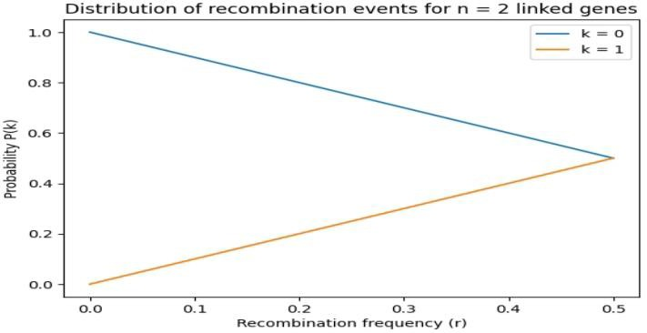

Figure 2: n = 3 genes.
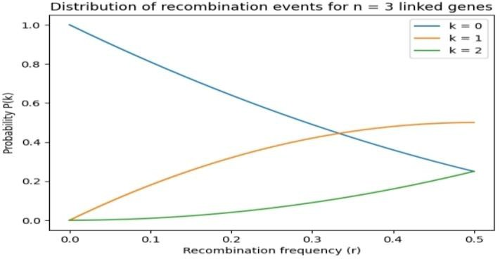

Figure 3: n = 4 genes.
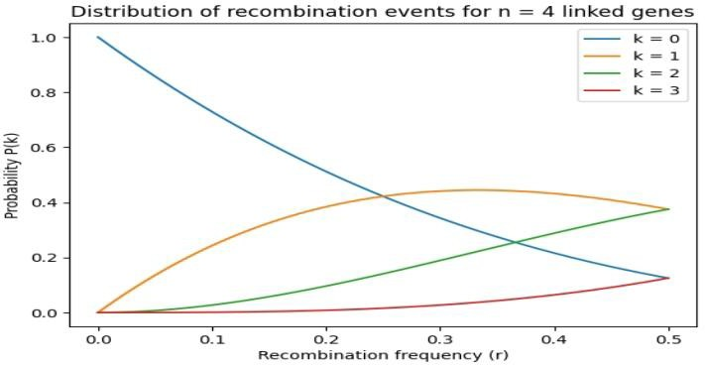

Conclusion
This study introduces a simple mathematical framework describing recombination among n linked genes. The model links recombination probability with phenotypic outcomes and provides a theoretical tool for studying linkage patterns in genetics.

References
- Mendel, G. Experiments on Plant Hybridization (1866).
- Griffiths et al. Introduction to Genetic Analysis.
- Hartl & Clark. Principles of Population Genetics.
- Pierce. Genetics: A Conceptual Approach.

