From Neolithic Origins to Modern China: The Historical and Cultural Development of Shandong Province

Abstract
This research report explores the historical and cultural development of Shandong Province, one of the most influential regions in Chinese civilization. From its Neolithic roots in the Houli, Dawenkou, and Longshan cultures to its central role in the rise of Confucian philosophy and imperial ritual traditions, Shandong has continuously shaped China’s intellectual and moral landscape. The study traces the province’s transformation across major historical periods including the Qi and Lu states, the imperial dynasties, and the modern reform era emphasizing how local heritage adapted to political and social change. Today, Shandong stands as both a symbol of China’s ancient legacy and a model for cultural preservation and innovation in the twenty first century. Also positioned on China’s eastern coast, Shandong’s fertile lands, waterways, and strategic location have shaped its role in agriculture, trade, and cultural innovation. Archaeological evidence highlights early settlements and societal complexity, while the province’s legacy as the birthplace of Confucius underscores its enduring influence on Chinese philosophy and governance. By examining historical records, material culture, and social transformations, this study illuminates how Shandong has both reflected and contributed to broader trends in China’s history. The research highlights the province as a lens through which to understand the continuity and change of Chinese civilization over millennia.
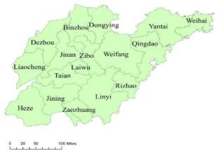

Figure 1: Shandong province map

Introduction

Shandong Province, located along China’s eastern seaboard and bordering the Yellow Sea, is a historic and cultural heartland. Known as the birthplace of Confucianism and home to Mount Tai, Shandong has long played a pivotal role in shaping Chinese civilization. Its history spans from early Neolithic settlements through imperial dynasties to modern reform and cultural revival, reflecting both continuity and transformation. This report examines Shandong’s historical trajectory and cultural development, highlighting its significance in the broader context of Chinese history. Shandong Province, perched on China’s eastern coast, has been a vital center of human civilization for thousands of years. From Neolithic settlements to modern urban development, its fertile lands, rivers, and coastline have shaped the lives of its inhabitants and influenced the wider history of China. Shandong is famously the birthplace of Confucius, whose ideas continue to resonate across the world, reflecting the province’s enduring cultural significance. This study explores Shandong’s journey through time, highlighting how its geography, society, and culture have contributed to China’s historical and cultural development.

Research Objectives

The principal objectives of this study are to:

- Examine the archaeological and Neolithic foundations of Shandong’s civilization.
- Trace the political, social, and cultural changes of Shandong during the imperial era.
- Analyze the impact of modernization, foreign contact, and reform between 1840 and 1949.
- Assess Shandong’s post-1949 economic and cultural renaissance.
- Demonstrate how Shandong’s local traditions contributed to the broader narrative of Chinese civilization.

Methodology
This research utilizes a multi-disciplinary historical methodology, combining:

- Archaeological Evidence: Excavation reports from Dawenkou and Longshan sites, which provide insights into Neolithic agriculture, pottery, and social hierarchy.
- Primary Historical Sources: Imperial chronicles, local gazetteers (difangzhi), and records from Confucian academies.
- Secondary Literature: Modern academic works on China’s population, economy, and cultural systems (e.g., Ho 1959; Pomeranz 1993; Elman 2000).
- Thematic and Chronological Analysis: Information is classified into key themes economic change, cultural development, political reform, and modernization to illustrate the evolution of Shandong’s historical identity.
- Comparative Interpretation: Data from multiple sources are cross-referenced to ensure accuracy and contextual depth.

Historical Overview
  - Prehistoric Foundations (c. 8500–2000 BC)

Shandong’s prehistory is marked by a remarkable continuity of human settlement, shaped by its fertile plains, river systems, and proximity to the Yellow Sea. Archaeological evidence indicates that as early as 8500 BC, hunter-gatherer communities inhabited the region, gradually transitioning to more sedentary, agricultural lifestyles. Sites such as Beixin and Dawenkou reveal early developments in millet cultivation, domestication of animals, pottery production, and social organization.(Zhao 2022)
By around 4000 BC, these Neolithic communities had developed complex settlements, with evidence of ritual practices, burial customs, and early craft specialization, suggesting emerging social hierarchies. The Longshan culture (c. 3000–2000 BC) further demonstrates advanced pottery techniques, fortified settlements, and increasing trade networks, laying the groundwork for later Bronze Age civilizations. Shandong’s prehistoric period thus reflects a dynamic process of adaptation, innovation, and cultural development, establishing the foundations for the province’s later historical prominence.

Archaeological evidence shows Shandong as one of East Asia’s earliest regions of human settlement. The Houli culture (c. 8500–7000 BC) marks the beginnings of millet cultivation and animal domestication. The Beixin culture (c. 5300–4100 BC) brought permanent villages, pottery, and burial practices, while the Dawenkou culture (c. 4100–2600 BC) demonstrated social hierarchies and ritualized graves. Finally, the Longshan culture (c. 2600–2000 BC) introduced fine black pottery and walled settlements, signaling the rise of proto-urban societies (Li, 2021; Zhang & Liu, 2020; Zhao, 2022).
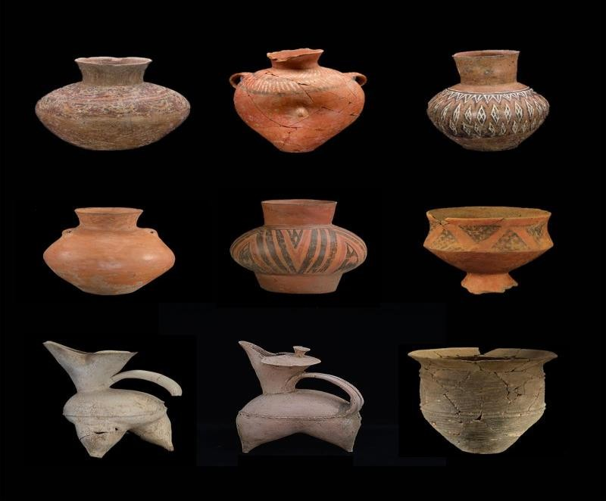
Figure 2: Artifacts from the Neolithic period (source: Shandong Museum)

Formation of Early States (c. 1600–221 BC)

By the late second millennium BC, Shandong had become a critical region in the broader trajectory of early Chinese state formation. Archaeological and historical evidence suggests that the province witnessed the rise of complex societies characterized by centralized authority, social hierarchy, and territorial expansion. During the Shang dynasty (c. 1600–1046 BC), Shandong fell within the sphere of influence of the central plains, as evidenced by oracle bone inscriptions and bronze artifacts discovered in sites such as Jinan and Qufu. The introduction of bronze metallurgy and ceremonial practices indicates the integration of Shandong communities into emerging state-level networks.

During the Shang and Zhou dynasties, Shandong was integrated into early state networks (Guo, 2019). The province later comprised the State of Qiin the north and the State of Lu in the south. The State of Lu was home to Confucius (551–479 BC), whose teachings on ethics, governance, and education remain foundational. The State of Qi, through institutions such as the Jixia Academy, became a hub of philosophical debate (Chen, 2020). Collectively, these developments shaped the region’s cultural identity, earning it the historical designation “Qilu”.In the later Zhou dynasty (c. 11th century BC–771 BC) and especially in the Spring & Autumn (770–476 BC) and Warring States (475–221 BC) periods, the region that is now Shandong was home to the prominent states of State of Qi and State of Lu. The State of Lu, in particular, is strongly associated with the philosopher Confucius (Kong Qiu, 孔丘) (c. 551–479 BC). His hometown was in Qufu in Shandong. Because of this lineage, Shandong is often called “Qilu” (齐鲁) combining Qi and Lu and regarded as a core region of early Han Chinese civilization. (Sun, 2018)

The subsequent Zhou dynasty (1046–256 BC) saw further consolidation of political structures. Shandong was divided among feudal states, including Qi, which became one of the most powerful and culturally influential during the spring and autumn (770–476 BC) and Warring States (475–221 BC) periods. Qi’s capital at Linzi became a center of administration, trade, and early philosophical thought, hosting scholars who contributed to Confucianism, Daoism, and legalist ideas. By the end of this period, Shandong had developed a pattern of urban settlements, fortified centers, and state-supported infrastructure, laying the groundwork for its enduring role in Chinese political and cultural life. The region’s early states exemplify the transition from Neolithic communities to fully organized polities, reflecting broader patterns of social complexity and statecraft in ancient China.(Sun, 2018)

Imperial Integration and Ritual Centrality (221 BC – 1911 AD)

With the unification of China under the Qin Dynasty (221–206 BCE), Shandong entered a new historical phase of centralized imperial administration. Over the next two millennia, the province evolved from a frontier of early Chinese civilization into a core region of imperial governance, religious ritual, and cultural identity. Its geographic location between the North China Plain and the Yellow Sea—made Shandong both a strategic hub for transportation and a symbolic center for imperial legitimacy. Under the Qin Dynasty, Shandong was fully incorporated into a unified Chinese empire. The Han dynasty elevated Mount Tai as the site of imperial sacrifices to Heaven and Earth, reinforcing the province’s spiritual significance (He, 2021). The Tang and Song

dynasties saw economic prosperity through the Grand Canal and the flourishing of Neo Confucianism. During the Ming and Qing dynasties, Confucian education, literary scholarship, and Mount Tai rituals further strengthened Shandong’s cultural and moral authority (Sun, 2018).

Qin and Han Dynasties: Incorporation and Development

Following Qin Shi Huang’s conquest of the Warring States, Shandong’s former territories once belonging to the states of Qi and Luwere reorganized into imperial commanders. The Qin standardized laws, currency, and script, integrating Shandong into a unified bureaucratic system. However, the province’s local identity, rooted in the traditions of Qi and Lu, remained resilient. Under the Han Dynasty (206 BCE–220 CE), Shandong’s role in the empire expanded significantly. The region became renowned for its salt and iron industries, particularly in the Liaocheng and Weifang areas. Coastal ports facilitated maritime exchange with Korea and Japan, laying the foundations for Shandong’s later commercial prominence. The Han period also saw the consolidation of Confucianism originating in Shandong as the ideological backbone of the state, elevating the province’s intellectual prestige.

Medieval Shandong: Trade, Religion, and Cultural Flourishing

During the Tang (618–907) and Song (960–1279) dynasties, Shandong enjoyed economic vitality and cultural prominence. The Grand Canal extended during the Sui and Tang periods, connected Shandong’s inland cities such as Jining and Linyi to the empire’s economic heartlands. This made the province a key artery in north-south trade, facilitating the transport of grain and goods to the imperial capitals. Culturally, Shandong became a locus for both Confucian revival and Buddhist expansion. Mount Tai (Taishan), the most sacred of China’s “Five Great Mountains,” emerged as a focal point of imperial ritual. Tang emperors such as Xuanzong and Xuanzong (different reigns) performed the Feng and Shan sacrifices at Mount Tai, acts that symbolized the emperor’s divine mandate to rule. These rituals reinforced Shandong’s status as a cosmic and political center a place where Heaven and Earth were symbolically united through imperial authority. (Wang 2019)

Late Imperial Shandong: Prosperity and Turbulence
The Ming (1368–1644) and Qing (1644–1911) dynasties brought both prosperity and challenges to Shandong. The province’s fertile plains supported dense agricultural populations, and cities such as Jinan became administrative and commercial hubs. The Qing administration expanded irrigation networks and promoted Confucian education, establishing numerous academies that continued the Lu tradition of moral scholarship. Yet Shandong was also vulnerable to natural and social upheavals. Recurrent Yellow River floods devastated farmland, leading to famine and displacement. In the 19th century, the province became a flashpoint for rebellion and foreign intrusion. The Boxer Rebellion (1899–1901), which began partly in western Shandong, reflected deep social grievances against both imperial decline and foreign imperialism.

During the late imperial period spanning the Ming (1368–1644) and Qing (1644–1911) dynasties Shandong Province occupied a position of both strategic and cultural importance within the Chinese empire. As the birthplace of Confucius and Mencius, Shandong was venerated as the

Spiritual heartland of traditional Chinese civilization, yet beneath this image of moral and scholarly authority laid a complex reality marked by economic expansion, administrative reform, environmental vulnerability, and recurrent social unrest. The province’s late imperial history was thus defined by the coexistence of prosperity and turbulence a microcosm of the broader challenges facing the waning dynastic order. (Wang 2019)

Economic Prosperity and Agricultural Strength
  - Agricultural Expansion, Shandong’s economic base during the Ming and early Qing periods rested firmly on agriculture. The province’s North China Plain provided fertile soils that supported large-scale cultivation of millet, wheat, and cotton. The introduction of new crops, such as sweet potatoes and maize during the Ming period, enhanced food security and population growth. The Grand Canal, which linked Shandong’s waterways with the imperial capital and southern grain-producing regions, further integrated the province into the national economy. Towns along the canal such as Jining and Linqing became bustling centers of trade and logistics, supplying grain to the north and distributing southern goods inland.
  - Commercial and Handicraft Development, as agricultural output expanded, Shandong witnessed a growing commercialization of rural life. Market towns multiplied, and handicraft industries particularly textiles, ceramics, and paper-making flourished. The salt trade, centered on Shandong’s coastal areas and salt pans, became a major source of wealth, involving powerful merchant guilds and officials. By the 18th century, Shandong’s economy had achieved significant diversification, contributing to the broader prosperity of the Qing Empire under the Kangxi (1661–1722) and Qianlong (1736–1796) emperors. The province’s abundance earned it the nickname “Land of Qi and Lu”, invoking its ancient states and suggesting both cultural and economic richness.

Early Trade Networks and Market Towns

During the spring and autumn (770–476 BCE) and Warring States (475–221 BCE) periods, the State of Qi, centered in Linzi (modern Zibo), emerged as one of the wealthiest and most commercially advanced polities in ancient China. Historical sources describe Linzi as a bustling metropolis with thousands of merchants, artisans, and traders. The state’s prosperity was underpinned by its control of salt, iron, and textile production, as well as its openness to innovation factors that made Qi a model of economic management. In the Han and Tang dynasties, Shandong’s cities became hubs connecting inland agricultural zones to coastal ports. Market towns flourished along transportation arteries, linking rural producers with regional trade networks. The Grand Canal, completed in the Sui and Tang periods, further integrated Shandong into the national economy by connecting it to the capital region and the lower Yangtze River.

Handicraft Production and Artisanal Culture
Handicrafts formed a vital part of Shandong’s traditional economy, blending artistry, technical skill, and local resources.

- Textiles: Shandong was renowned for producing silk, cotton, and hemp fabrics, often dyed in distinctive local styles. Weaving and embroidery developed into major cottage industries, particularly in regions around Weifang and Jining.
- Ceramics and Pottery: Since Neolithic times, Shandong artisans had mastered pottery- making. During the Song and Ming dynasties, kilns in areas such as Zibo and Yishui produced fine ceramics and glazed wares that were traded widely across northern China.
- Metalwork and Lacquerware: The province also produced fine bronze, iron, and lacquer objects, used both for ritual purposes and daily life. Artisans in Qufu, Zoucheng, and Yantai became famous for their craftsmanship, often combining practical design with decorative motifs reflecting Confucian and folk symbolism.
- Paper-cutting and Folk Art: In more recent centuries, Shandong’s distinctive folk arts such as Weifang kite-making, Yangjiabu New Year woodblock prints, and paper-cutting traditions have become iconic symbols of the province’s artistic vitality and cultural identity..

Maritime and Coastal Trade

Shandong’s coastline along the Yellow Sea and Bohai Gulf facilitated both domestic and foreign trade. Ports such as Yantai, Weihai, and later Qingdao connected the province to Korea, Japan, and beyond. During the Ming dynasty, Shandong’s maritime commerce expanded through fishing, salt production, and ship building. In the late 19th and early 20th centuries, the German concession at Qingdao transformed the city into a modern port and industrial center. Western- style breweries, textile mills, and shipyards were introduced, laying the foundation for Shandong’s later industrialization. Qingdao’s rise illustrated the intersection of traditional craftsmanship and modern commercial enterprise, signaling the province’s transition into global trade networks.

Modern Industrial Growth and the Legacy of Craft

Today, Shandong continues to balance its traditional handicraft heritage with large-scale industrial and commercial development. Cities such as Zibo and Weifang remain known for ceramics and folk crafts, while Qingdao, Yantai, and Jinan lead in manufacturing, electronics, and finance. The province actively promotes cultural industries reviving traditional crafts as both heritage tourism and high-value creative products.

Confucian Orthodoxy and Cultural Prestige
As the homeland of Confucius, Shandong occupied an unparalleled position in China’s moral geography, the imperial state drew upon this symbolism to reinforce its legitimacy. Emperors from the Ming and Qing dynasties regularly conducted pilgrimages to Mount Tai (泰山), the sacred peak symbolizing the harmony between heaven and earth and the right to rule. The Confucian temples and academies in Qufu the ancestral seat of the Kong family were maintained and expanded by imperial patronage. During the Qing period, the Kong lineage was granted hereditary titles and continued to oversee the Confucian shrines, which became both pilgrimage destinations and educational institutions. Shandong’s scholarly elite played a crucial role in the imperial examination system. The province produced numerous jinshi (advanced scholars) who

entered official service, perpetuating a local tradition of bureaucratic excellence. This cultural prestige reinforced Shandong’s reputation as a moral and intellectual center, even as the social fabric beneath it began to strain.

Environmental Challenges and Population Pressures

Despite its prosperity, Shandong’s agrarian success made it vulnerable to environmental instability. The province’s proximity to the Yellow River (Huang He) exposed it to frequent floods and course changes. In 1642, during the late Ming collapse, Yellow River flooding devastated vast tracts of farmland. The river’s periodic shifts between the northern and southern channels during the Qing further caused displacement, famine, and economic disruption. Meanwhile, Shandong’s population expanded rapidly from the 17th to the 19th centuries, placing immense pressure on available land. The combination of demographic growth, land fragmentation, and official neglect led to rising rural inequality and widespread tenant farming. Local disputes over land and water rights often erupted into violence, signaling the limits of imperial administration in maintaining stability.

Ritual and Identity

Throughout the imperial period, ritual centrality defined Shandong’s symbolic importance. The Temple and Cemetery of Confucius in Qufu and the Mount Tai complex were not merely religious sites but also ideological pillars of dynastic rule. Emperors and scholars alike undertook pilgrimages to Shandong to affirm their connection to China’s moral and cosmic order. The continuity of these rituals, across dynasties and political upheavals, illustrates how Shandong functioned as a ritual heartland of the Chinese empire a living embodiment of the Confucian worldview that linked governance, morality, and Heaven’s will.
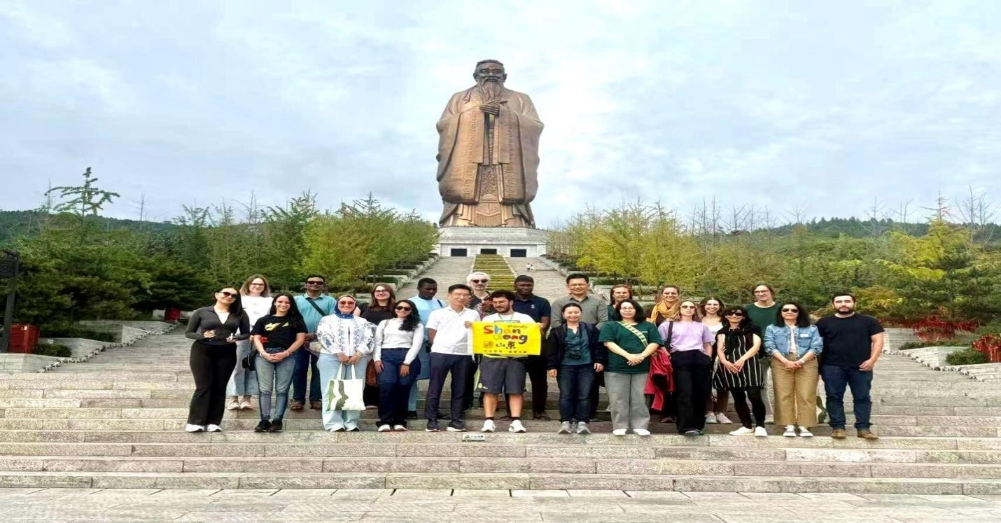
Figure 3: The young sinologists at Qufu, during the visit and learning about ritual and identity

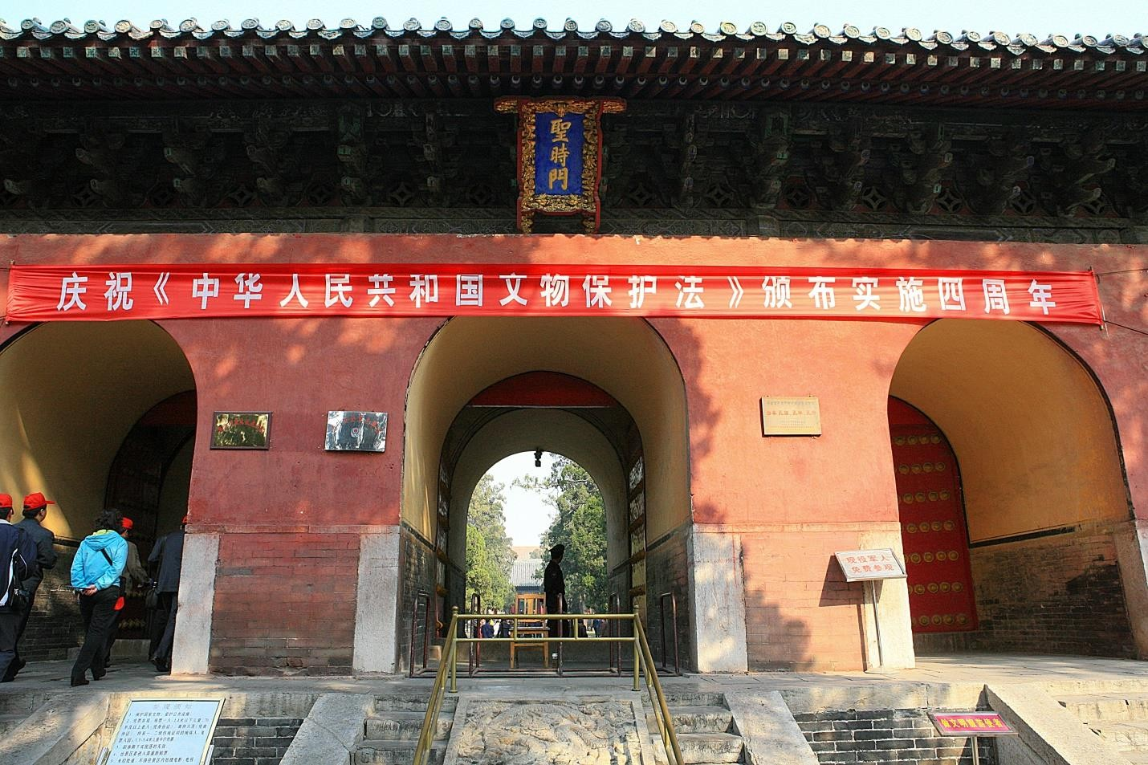
Figure 4: Temple and Cemetery of Confucius and the Kong Family Mansion in Qufu

Modern Transformation (1840–1949)
Shandong experienced foreign influence during the late Qing, including the German lease of Qingdao (1898–1914) and later Japanese involvement (Peng, 2017). The Republican era introduced social and intellectual reforms, exemplified by the May Fourth Movement (1919), which challenged traditional Confucian values and promoted modernization (Wang, 2019). Despite these upheavals, Confucian heritage continued to inform local cultural practices.(Chen & Fang 2018)

The Late Qing Era and Foreign Encroachment (1840–1895)

The mid-19th century marked the beginning of Shandong’s modern transformation, as the Opium Wars and ensuing “Century of Humiliation” exposed China and Shandong in particular to Western imperialism and internal upheaval.

      - Economic and Social Conditions: Before foreign intrusion, Shandong was largely agrarian, characterized by dense rural settlements and a strong Confucian gentry system. Frequent floods from the Yellow River and population pressure, however, led to widespread poverty and social unrest.
      - Impact of the Opium Wars: Although the province was not directly attacked, foreign trade and missionary activity expanded along the coast after China’s defeat. Western

religious missions established schools, hospitals, and churches, particularly in coastal areas such as Yantai and Qingdao. Taiping Rebellion and Local Uprisings: During the mid-19th century, Shandong suffered from banditry and peasant uprisings linked to the broader national instability. The Qing government relied heavily on local militia (xiangyong) and Confucian scholars to maintain order. (Chen & Fang 2018)

Foreign Concessions and the “Shandong Question” (1895–1914)

Following China’s defeat in the First Sino Japanese War (1894–1895), Shandong became a focus of imperial competition and foreign domination.
      - German Occupation of Jiaozhou Bay (1897): After two German missionaries were killed in southern Shandong, Germany used the incident as a pretext to occupy Jiaozhou Bay and establish the Qingdao (Tsingtao) concession in 1898.The Germans built modern infrastructure: ports, railways (notably the Jiaoji Railway connecting Qingdao and Jinan), breweries, and administrative buildings. Qingdao became one of China’s first planned modern cities and a symbol of semi-colonial development.
      - Missionary Activity and Anti-Foreign Sentiment: The presence of foreign missionaries, often protected by unequal treaties, led to growing resentment among locals. This discontent culminated in the Boxer Rebellion (1899–1901), which began in Shandong’s rural northwest before spreading across North China.
      - “Shandong Question” in International Politics: after Germany’s defeat in World War I, Japan seized Qingdao and German holdings in Shandong. The Treaty of Versailles (1919) transferred these territories to Japan rather than returning them to China an act that ignited nationalist outrage and led directly to the May Fourth Movement.

Reform, Nationalism, and the May Fourth Movement (1915–1927)

The early Republican era was a period of cultural awakening and political struggle in Shandong.

      - New Culture and Nationalism: Students from Shandong and nearby provinces played a leading role in the May Fourth Movement of 1919, which began as a protest against the Shandong clauses of the Treaty of Versailles. The movement’s slogan “Save Shandong!” became a rallying cry for Chinese sovereignty. It also spurred the spread of modern education, vernacular literature, and anti-feudal thought.
      - Educational and Cultural Reforms: Institutions such as Shandong University (est. 1901, relocated and restructured several times) became centers for modern learning. Western-style schools, newspapers, and publishing houses appeared, accelerating cultural modernization.
      - Political Fragmentation; During the Warlord Era (1916–1928), Shandong was dominated by local military cliques such as those led by Zhang Zongchang Political instability and corruption impeded economic recovery and governance.

Japanese Invasion and Resistance (1931–1945)

The Japanese invasion of Manchuria in 1931 and the subsequent Second Sino-Japanese War (1937–1945) brought renewed suffering to Shandong. Local resistance played a vital role in countering Japanese occupation. Both organized military units of the Nationalist government and grassroots guerrilla forces engaged in sabotage, intelligence gathering, and direct combat. Civilians also contributed by supporting resistance efforts, sheltering fighters, and maintaining cultural and social cohesion despite harsh repression.(So, F. W. L 2019).

Shandong’s ports, particularly Qingdao and Yantai, became important hubs for Japanese military operations, while rural areas experienced harsh occupation policies, forced labor, and resource extraction. Despite these challenges, local resistance movements helped sustain national morale and contributed to the eventual Japanese defeat in 1945.The period left a lasting legacy on Shandong, shaping its post-war political alignment, fostering a culture of resilience, and influencing the province’s reconstruction efforts in the early years of the People’s Republic of China.(Zhao 2022)

      - Japanese Occupation: By 1938, most of Shandong was under Japanese control. Major cities like Jinan, Qingdao, and Yantai were garrisoned and industrial resources exploited. The Japanese established collaborationist administrations, while rural areas became strongholds of resistance.
      - Anti-Japanese Resistance: The Yimeng Mountains became famous as a center of resistance, with local peasants supporting guerrilla warfare and revolutionary mobilization.

Civil War and Liberation (1945–1949)

After Japan’s defeat in 1945, Shandong became a major battlefield between the Nationalists (Kuomintang) and Communists.
      - Postwar Struggle for Control: Both sides sought to occupy former Japanese territories. The Communists quickly regained influence in rural areas, while the Nationalists held the major cities with U.S. support. Fierce fighting occurred across the province, notably during the Lunan and Laiwu campaigns (1947), which secured Communist dominance.
      - Social Change and Land Reform: The Communist movement in Shandong introduced early land reforms, redistributing property from landlords to peasants, further solidifying grassroots support.
      - Establishment of the People’s Republic: By 1949, Shandong was firmly under Communist control and became part of the newly proclaimed People’s Republic of China (PRC). The province’s revolutionary legacy would play a significant role in the PRC’s early political and cultural identity.(Chen & Fang 2018)

Contemporary Cultural Renaissance (1949–Present)

After 1949, Shandong balanced cultural preservation with modernization. The Reform and Opening-Up era (post-1978) revived heritage tourism in Qufu, Mount Tai, and coastal cities like Qingdao. The provincial “Two Creations” policy (creative transformation and innovative development) integrates traditional culture with digital media, tourism, and cultural industries (Shandong Provincial Government, 2024). This ensures Shandong’s historical legacy continues to influence contemporary cultural identity. Shandong’s contemporary cultural renaissance embodies a dynamic interplay of the ancient and the modern, the local and the global, the material and the digital. From its prehistoric roots through Confucian legacy to today’s digital creative economy, the province offers a compelling case study of how cultural heritage can be sustained, reinterpreted and mobilized for a new era (Chen & Fang 2018)

    - Reconstruction and Socialist Modernization (1949–1978), in the aftermath of the Chinese Civil War, Shandong faced the immense challenge of reconstruction. The early years of the PRC were marked by campaigns to rebuild infrastructure, redistribute land, and consolidate state control.
      - Economic and Social Reconstruction, During the 1950s, the Communist government implemented sweeping land reforms, redistributing estates from landlords to peasants and reorganizing agriculture into collective farms. Shandong’s fertile plains quickly became a vital part of China’s grain production network, while state-owned industries particularly in Jinan, Zibo, and Qingdao were established to support the national strategy of socialist industrialization. The province’s traditional sectors, such as salt, textiles, and fisheries, were nationalized, and new industrial bases emerged in heavy machinery, petrochemicals, and shipbuilding. The state’s emphasis on self-reliance and production transformed Shandong into one of China’s key industrial regions. (Peng, 2017)
      - Cultural and Educational Development, The early socialist period also saw a redefinition of cultural policy. While Confucian traditions were officially criticized as feudal, the government invested heavily in literacy campaigns, rural education, and public health. Universities in Jinan and Qingdao expanded, training new cadres of scientists, teachers, and engineers. The aim was to create a modern, educated populace capable of contributing to socialist construction. However, the Cultural Revolution (1966–1976) disrupted these efforts. Traditional culture, including Confucianism Shandong’s most distinguished legacy was attacked as reactionary. Temples, ancestral halls, and historical sites in Qufu, the hometown of Confucius, suffered widespread destruction, Intellectuals were persecuted, and cultural life was reduced to revolutionary propaganda. Yet even amid this upheaval, the enduring reverence for Shandong’s historical role persisted quietly among scholars and local communities (Chen 2020).

Reform, Opening, and Economic Expansion (1978–2000)

The rise of Deng Xiaoping’s Reform and Opening-Up policy in 1978 marked a new era for Shandong. The province’s natural resources, industrious population, and coastal location positioned it at the forefront of China’s modernization drive.The period from 1978 to 2000 marked a transformative era for Shandong, reflecting China’s broader

shift under the policies of reform and opening-up initiated by Deng Xiaoping. The province experienced unprecedented economic expansion as state-owned enterprises were restructured, private businesses emerged, and foreign investment began flowing into key industries. Special economic zones and development areas were established in coastal cities such as Qingdao and Yantai, serving as catalysts for industrial modernization, export-oriented growth, and technological innovation.. (Chen & Fang 2018)
      - Industrialization and Urban Growth, from the late 1970s onward, Shandong diversified its economy. Agricultural decollectivization under the Household Responsibility System boosted productivity and rural incomes. Meanwhile, coastal cities like Qingdao, Yantai, and Weihai were designated as Open Coastal Cities in the 1980s, attracting foreign investment and technology. Qingdao, once a German and Japanese concession, became a symbol of reform-era globalization. The city’s Tsingtao Brewery, electronics firms, and shipyards expanded into international markets. Tourism also flourished as Shandong’s coastal beauty, Mount Tai’s spiritual significance, and Qufu’s historical resonance drew both domestic and foreign visitors.
      - Cultural Revival, with the political thaw of the 1980s came a revival of cultural identity. The state began to rehabilitate Confucius’s image, promoting him as a symbol of national heritage rather than feudal oppression. The Temple, Cemetery, and Family Mansion of Confucius in Qufu were restored and later designated UNESCO World Heritage Sites (1994). Academic research on Confucianism, literature, and folk culture flourished. The Shandong University and Qufu Normal University became leading centers of cultural and historical studies, contributing to what many scholars term a “Confucian Renaissance.”

Globalization and Cultural Renaissance (2000–Present),

In the 21st century, Shandong has emerged as both an economic powerhouse and a cultural beacon. The province’s transformation embodies the balance between modernization and the preservation of tradition that characterizes contemporary China. (Li& Xu 2024)

      - Economic Leadership, Shandong consistently ranks among China’s top provinces in GDP, industrial output, and agricultural production. Major industries include petrochemicals, automobiles, shipbuilding, electronics, and renewable energy. The Shandong Peninsula Blue Economic Zone, established in the 2010s, promotes sustainable development and maritime innovation. Cities such as Jinan and Qingdao have become major centers for finance, education, and international trade. Qingdao, in particular, gained global recognition as host of the 2008 Beijing Olympic sailing events and the 2018 Shanghai Cooperation Organization (SCO) Summit, symbolizing Shandong’s international stature. (Peng 2017)
      - Cultural and Spiritual Renewal, Parallel to its economic ascent, Shandong has experienced a cultural renaissance grounded in the revival of Confucianism and local heritage. The provincial government actively promotes the Confucius Cultural Festival and the World Confucian Conference, which attract scholars and leaders from across the globe to discuss ethics, governance, and intercultural dialogue. Shandong’s Lu cuisine (鲁菜) one of China’s eight great culinary traditions has also

enjoyed renewed appreciation as part of the province’s cultural branding. Folk arts such as shadow puppetry, paper-cutting, and Taishan stone inscriptions have been preserved through local museums and UNESCO recognition. (Wang 2019)
      - Education, Technology, and Global Engagement, Modern Shandong is also a leader in education and innovation. A university like Shandong University Shandong remains a national leader in education. Shandong University, Qufu Normal University, and Ocean University of China anchor academic research in science and humanities. Exchange programs and the Young Sinologists Program hosted in Jinan foster cross-cultural scholarship, ensuring that Shandong continues to serve as a bridge between tradition and modernity, Ocean University of China, and China University of Petroleum contribute to research in science, engineering, and environmental studies. With a growing network of sister-city partnerships and international forums, Shandong serves as a bridge between Chinese tradition and global modernity. (Shandong Provincial Government 2024)
- Historical Foundations of Education, Shandong’s association with education stretches back more than two millennia. As the birthplace of Confucius (551–479 BCE) and Mencius (372– 289 BCE), the province has long been revered as the heart of China’s moral and intellectual culture. The Confucian emphasis on scholarship, self-cultivation, and merit formed the basis of China’s civil service examination system for centuries. Temples and academies in Qufu, Zoucheng, and Jinan served as centers of classical learning, where Confucian ethics guided personal and political life. This deep-rooted respect for education has persisted across dynasties and remains embedded in Shandong’s social fabric.
- Modern Educational Expansion, in the 20th and 21st centuries, Shandong’s educational system expanded rapidly to meet the demands of modernization and industrialization. The province is home to several prestigious universities and research institutions, including: Shandong University (Jinan): One of China’s oldest and most comprehensive universities, renowned for research in science, engineering, and humanities. Ocean University of China (Qingdao): A national leader in marine sciences, oceanography, and environmental studies. Qufu Normal University: Specializing in teacher education and Confucian philosophy, it plays a key role in cultural preservation and moral education.
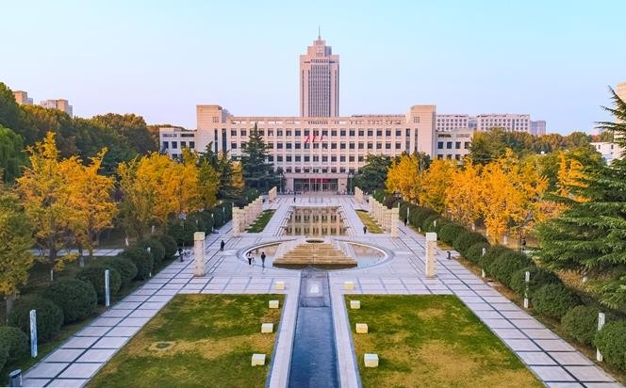
Figure 5: Shandong University (Jinan)
Educational reforms since the early 2000s have focused on promoting STEM disciplines, vocational education, and internationalization. Programs emphasizing bilingual education and global exchange reflect the province’s growing integration into international academic networks.

This impacted to have the study visit of young sinologists from different countries to visit China under the program of Young Sinologists which hosted of Shandong University in the department of international students.
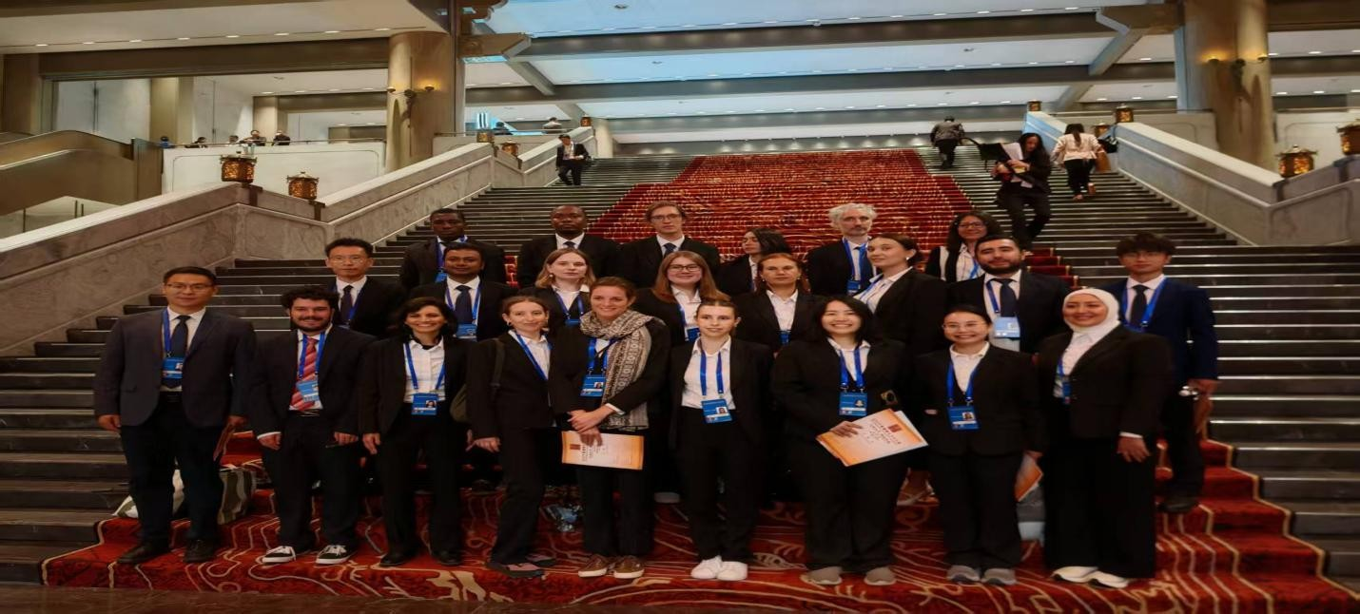
Figure 6: Young Sinologists team

7. Conclusion

Shandong Province exemplifies both historical continuity and cultural transformation. From Neolithic settlements to Confucian intellectualism, imperial rituals, and modern cultural revival, the region has consistently contributed to Chinese civilization. Its contemporary role as a center of heritage preservation and cultural innovation demonstrates the enduring significance of Shandong’s historical and cultural development. Its trajectory reveals a profound adaptability: Neolithic innovation gave rise to early states; the moral ideals of Qi and Lu shaped imperial orthodoxy; industrialization and reform transformed its economy; and cultural revival renewed its spirit. Shandong’s experience illustrates how local identity and global engagement can coexist, offering a model for sustainable modernization rooted in heritage. As China advances into the twenty-first century, Shandong continues to symbolize the moral heart of the nation a province where history, culture, and innovation converge. The study of Shandong thus not only illuminates the past but also provides insights into the ongoing redefinition of Chinese civilization in an interconnected world. Shandong stands as a remarkable testament to the enduring interplay between history, culture, and socio-economic development. Its rich archaeological sites, philosophical heritage, and evolving economic landscape reflect a province that has continuously shaped and been shaped by China’s broader historical trajectory. To fully honor and leverage this legacy, future efforts must balance preservation with innovation: protecting historical and cultural treasures, integrating them into modern development, and fostering interdisciplinary and global research collaborations. By embracing both its past and potential, Shandong can continue to serve as a vital center of cultural insight, educational advancement, and sustainable growth, offering lessons not only for China but for the world.

REFERENCES
Chen, L. (2020). Philosophical Thought and the Jixia Academy in the State of Qi. Journal of Chinese Philosophy, 47(2), 145–162.
Guo, Y. (2019). Bronze Age Civilization in Eastern China: Archaeological Discoveries from Shandong. Beijing University Press.
He, J. (2021). Mount Tai and the Imperial Ritual Tradition. Asian Cultural Studies, 29(3), 57– 74.
Li, X. (2021).Neolithic Cultures in Shandong: From Houli to Longshan. East Asian Archaeology, 12(1), 1–25.
Liu, H. (2019). Folk Culture and Confucian Legacy in Modern Shandong Villages. Journal of Chinese Cultural Heritage, 8(4), 89–103.
Peng, Z. (2017). Colonial Qingdao: German Influence and Modern Urbanism. Modern China Studies, 23(2), 101–120.
Shandong Provincial Government. (2024). Action Plan for Creative Transformation of Excellent Traditional Culture (2022–2025).Retrieved from https://subsites.chinadaily.com.cn/shandong/ Sun, Q. (2018).Ritual and Orthodoxy in Ming–Qing Shandong. History and Culture Quarterly, 19(1), 77–98.
Wang, R. (2019). Confucianism and Modernity in Republican Shandong. Journal of Chinese Modern History, 15(3), 221–238.
Zhang, W., & Liu, J. (2020).Burial Practices and Social Hierarchies in Dawenkou Culture.
Chinese Archaeological Review, 11(2), 55–70.
Zhao, M. (2022).Longshan Civilization and the Roots of Early China. Chinese Historical Studies, 31(2), 44–61
Chen, Shengqian, & Fang, Hui. (2018). Shandong’s Maritime Trade and Coastal Development in the Ming and Qing Dynasties.Journal of Chinese Economic History, 36(2), 45–60.
Shandong Provincial Department of Ecology and Environment.(2023). Annual Environmental Report of Shandong Province 2023. Jinan: Shandong People’s Publishing

Pomeranz, K. (2000). The great divergence: China, Europe, and the making of the modern world economy. Princeton University Press.

So, F. W. L. (2019).Germany’s colony in China: Colonialism, protection and economic development in Qingdao and Shandong, 1898–1914. Routledge.
Li, D., & Xu, R. (2024). The era value and path selection of capitalizing on traditional cultural resources in Shandong Province. Academic Journal of Management and Social Sciences, 4(1).https://doi.org/10.54097/ajmss.v4i2.12225
Rong, W., &Bahauddin, A. (2023). The heritage and narrative of Confucian courtyard and architecture in sustainable development in Shandong, China.Planning Malaysia, 21(26). https://doi.org/10.21837/pm.v21i26.1273
Elman, B. A. (2000). A cultural history of civil examinations in late imperial China. University of California Press

