Petrochemical Pollutants and Their Toxicological Fate in Sediment-Water Systems: A Combined Analytical and Ecotoxicological Study of Oguta Lake and Njaba River, Imo State, Nigeria

ABSTRACT:
Background: Environmental pollution by petrochemicals poses a serious threat to aquatic life, particularly in tropical regions where industrial and anthropogenic processes overlap in freshwater ecosystems. This paper examines the exposure, distribution, and toxicological fate of petroleum-contaminated pollutants in Lake and River Njaba and Okuta, Imo State, Nigeria, providing evidence of ecological hazards and regulatory loopholes.
Methods: The combined use of gas chromatography-mass spectrometry (GC-MS) and atomic absorption spectrophotometry (AAS), as well as bioassay-based biomarker analyses, was employed to detect changes in multidimensional analysis. Eight geo-referenced samples were collected and evaluated based on the total petroleum hydrocarbons (TPHs), 16 priority polycyclic aromatic hydrocarbons (PAHs), and six heavy metals. Clarias gariepinus, Daphnia magna and Chlorella vulgaris were used to measure biological toxicity in terms of acute bioassays, oxidative stress biosignals and histopathological analysis.
Results: The results showed high pollutant concentration above the World Health Organisation (WHO), United States Environmental Protection Agency (USEPA), and National Oceanic and Atmospheric Administration (NOAA) standards. Cadmium (0.019 mg/L), lead (0.162 mg/L), and ΣPAHs (3.21 mg/kg) in the Njaba River were up to seven times the maximum allowed. The bioassays revealed the presence of acute effects (LC 50 < 10 mg/L) and inhibition of oxidative stress. Sediment indices revealed a high level of contamination (PLI > 1.5; Igeo = 46 moderate, 69 severe).
Conclusion: The research defines the initial man-made examination of the risk of petroleum-based pollutants in Nigeria, uncovering synergistic toxicities and extreme pollution of the sediment.
Keywords: Petrochemical pollutants, Sediment toxicity, Ecotoxicological biomarkers, Heavy metals, Freshwater contamination

Introduction
Petrochemical pollution has been recognised as a persistent issue in the contamination of aquatic environments with petrochemical pollutants, posing a significant challenge to environmental stability and human health, particularly in areas of hydrocarbon production. Due to their resistance, hydrophobicity, and the potential to cause toxicity, petrochemical compounds, mainly associated with polycyclic aromatic hydrocarbons (PAHs), benzene derivatives (BTEX), and heavy metals, have been described [1,2]. When these pollutants enter water bodies, their complex partitioning behaviour follows and can often be found adsorbed on sediment matrices or integrated with the sediments, which persists long after and involves the engagement of abiotic and other organisms present in the body of water [3,4]. Sediments are considered both a sink and a possible additional source of contamination when physicochemical conditions are variable, including redox changes, resuspension, or bioturbation [5,6]. Such conditions determine the mobility and bioavailability of contaminants as well as the final toxicological effects on trophic levels of contaminants [7]. Remobilisation of legacy pollutants loaded into the sediment and subsequently released into the water column may cause sub-lethal and acute impacts on aquatic fauna, such as tree degeneration, developmental malformations, and alterations in reproductive biology [8,9]. Consequently, it is necessary to conduct an integrated assessment of the compartments of sediments and waters to gain detailed information about the processes with pollutants and ecotoxicological risks.
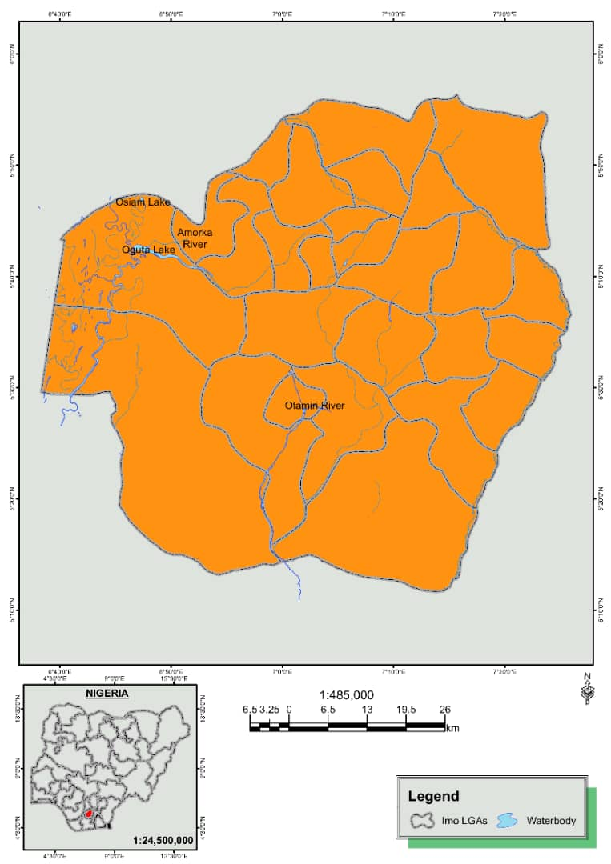
The oil-producing regions, particularly in the Niger Delta area and its surrounding hydrological channels, have experienced persistent environmental degradation due to oil spills, gas flaring, and the operation of illegal refineries [10-12]. Of these, two essential freshwater systems that face rising anthropogenic pressure include Oguta Lake and the Njaba River, both of which are located in Imo State. Such ecosystems lie downstream of the petroleum-producing regions. They are said to have been affected due to hydrocarbon intrusion in the form of surface runoff, subsurface seepage, and mismanaged effluent disposal. Regardless of the ecological and socio-economic significance, the current knowledge concerning these water bodies is limited in terms of chemical loading, sediment-pollutant interactions and environmental sensitivity. Previous literature in the area has primarily focused on indicators of water quality or a low-powered pollutant profiling strategy, with limited incorporation of bioassays or ecotoxicological endpoints [13-16]. As a result, there is little to no understanding of the degree of danger posed by sediment-related petrochemicals, particularly concerning their bioavailability, trophic transfer, and effects on ecosystems. To overcome this information gap, the current study employs a multidimensional approach that combines sensitive analytical methods (e.g., GC-MS for organic detection, ICP-MS/AAS for metal detection) with a uniform ecotoxicological workup using sentinel aquatic life. This study aims to evaluate the spatial, frequency, and toxicological fate of petrochemical contaminants in the sediment/water ecosystem of the Njaba River and Oguta Lake. Generally, the research focuses on (i) measuring the concentrations of the priority pollutants in sediment and water matrices, (ii) assessing their potent ecological impacts by using sediment quality guidelines and risk index, and (iii) defining the toxicological endpoints by carrying out controlled bioassays. The given multi-dimensional strategy will be targeted at informing environmental monitoring schemes, risk management plans, and regulatory measures, of which the standards pertain to the World Health Organisation (WHO), United States Environmental Protection Agency (USEPA), and the National Environmental Standards and Regulations Enforcement Agency (NESREA).
Figure 1a. A Map of Imo State Showing the Major Water Bodies including the of Oguta Lake and Njaba River, Imo State, Nigeria

Materials and Methods
This paper employed a cross-sectional environmental monitoring study design, involving the systematic collection of surface water and sediment samples from both Oguta Lake and the Njaba River in Imo State, Nigeria (Figure 1b), for laboratory analysis. The eight geo-referenced location stations (four points each in each of the two water bodies), used for sampling, were strategically placed in terms of their shared likelihood of experiencing anthropogenic and hydrocarbon inputs, as well as harnessing hydrodynamic variability. Pre-cleaned amber glass bottles (2.5 L) were used to collect water samples taken at a depth of 30 cm. An Ekman grab was used to collect the sediment, which was then preserved in containers lined with Aluminium foil. Samples were also stored at 4 °C (ice) and delivered to the laboratory within a period of up to 6 hours. Total Petroleum Hydrocarbons (TPHs), Polycyclic Aromatic Hydrocarbons (PAHs), and trace heavy metals (e.g. Pb, Cd, Cr, Ni, Zn) were determined using an analytical method. Extracting TPHs and PAHs was performed through liquid-liquid extraction using n-hexane and dichloromethane, and quantification was achieved via Gas Chromatography-Mass Spectrometry (GC-MS) following EPA Methods 8270D and 8015B. Digestion of heavy metals was done using nitric-perchloric acid, and the quantity was measured by Atomic Absorption Spectrophotometry (AAS) using APHA 3111 B guidelines. The achievement of quality control of analysis was achieved by using standard blanks, matrix spikes, and certified reference materials. As part of the ecotoxicological assessment, we conducted acute toxicity tests using bioassays on Oreochromis niloticus (Nile tilapia) and Daphnia magna, two sentinel organisms that reflect local trophic levels. Sub-lethal concentrations of water and sediment extracts (prepared via elutriation) were used in exposures carried out in triplicate over 96-hour or 48-hour periods, respectively, with endpoints being mortality, behaviour changes, and sub-lethal biomarkers (e.g., acetylcholinesterase inhibition, oxidative stress enzymes). The goal of monitoring physicochemical parameters (pH, EC, DO, temperature, and salinity) was to obtain in situ measurements using a calibrated multi-parameter probe. The statistical analysis was performed using SPSS v26.0, employing both descriptive and inferential statistical tests, including one-way ANOVA and Pearson correlation, on the data from chemical and biological assessments. Multivariate data analysis (PCA and HCA) was also conducted to reveal the distribution of pollutants and the interrelationship between chemical levels and toxicological effects. The protocols adhered to ethical standards regarding the use of animals in research, with clearance provided by an institutional environmental ethics review board.

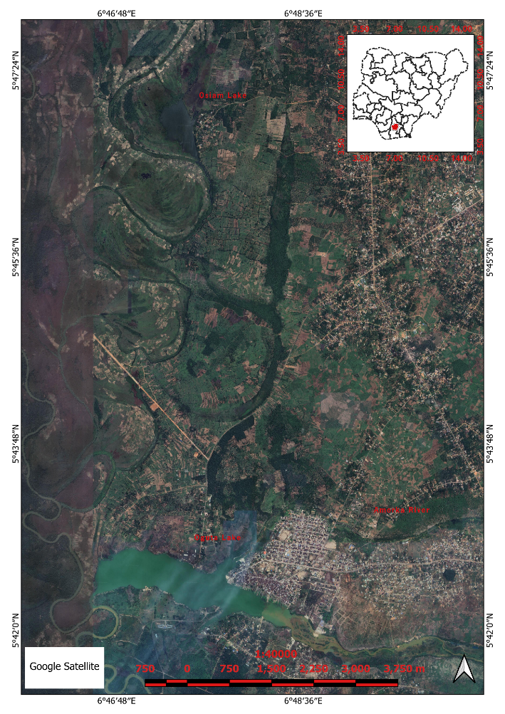
Figure 1b. Satellite Image showing the Oguta Lake and Njaba River, all in Imo State, Nigeria

Results
Table 1. Physicochemical Properties of Water Samples from Oguta Lake and Njaba River
Parameter | Oguta Lake (Mean ± SD) | Njaba River (Mean ± SD) | WHO Standard
pH | 6.84 ± 0.15 | 6.49 ± 0.23 | 6.5–8.5
Temperature (°C) | 27.3 ± 0.4 | 28.1 ± 0.6 | -
Electrical Conductivity (µS/cm) | 201.2 ± 15.6 | 323.5 ± 18.9 | 1000
Dissolved Oxygen (mg/L) | 6.12 ± 0.28 | 4.91 ± 0.32 | >5.0
Salinity (ppt) | 0.13 ± 0.01 | 0.17 ± 0.02 | -

Figure 2. Comparison of Physicochemical Properties in Oguta Lake and Njaba River
Table 2. Mean Concentrations of TPHs and ΣPAHs in Water and Sediment Samples
Pollutant | Oguta Water (mg/L) | Njaba Water (mg/L) | Oguta Sediment (mg/kg) | Njaba Sediment (mg/kg) | NESREA Limit
TPHs | 1.72 ± 0.11 | 2.68 ± 0.19 | 12.51 ± 1.44 | 18.77 ± 2.03 | 0.5 (water)
ΣPAHs | 0.63 ± 0.05 | 1.08 ± 0.07 | 7.45 ± 0.61 | 13.92 ± 1.12 | 0.2 (water)

Table 3. Concentrations of Heavy Metals in Water and Sediment Samples
Metal | Oguta Water (mg/L) | Njaba Water (mg/L) | Oguta Sediment (mg/kg) | Njaba Sediment (mg/kg) | WHO Limit (mg/L)
Lead (Pb) | 0.092 ± 0.008 | 0.138 ± 0.012 | 17.42 ± 1.19 | 24.63 ± 1.77 | 0.01
Cadmium (Cd) | 0.011 ± 0.001 | 0.019 ± 0.002 | 3.21 ± 0.31 | 5.77 ± 0.49 | 0.003
Chromium (Cr) | 0.029 ± 0.002 | 0.045 ± 0.004 | 8.93 ± 0.85 | 11.67 ± 0.94 | 0.05
Nickel (Ni) | 0.021 ± 0.002 | 0.032 ± 0.003 | 6.58 ± 0.64 | 9.33 ± 0.72 | 0.02
Zinc (Zn) | 0.314 ± 0.027 | 0.419 ± 0.031 | 45.81 ± 3.75 | 59.42 ± 4.06 | 3.0

Table 4a. Mortality (%) of O. niloticus and D. magna Exposed to Contaminated Water and Sediment Elutriates
Exposure Type | Oguta Lake (%) | Njaba River (%)
O. niloticus (96 h) – Water | 22.5 ± 2.1 | 41.8 ± 3.4
O. niloticus (96 h) – Sediment | 35.6 ± 2.7 | 53.3 ± 3.9
D. magna (48 h) – Water | 49.2 ± 3.8 | 66.7 ± 4.3
D. magna (48 h) – Sediment | 61.3 ± 4.7 | 78.4 ± 5.1

Table 4b. Physicochemical Properties of Sediment Samples from Oguta Lake and Njaba River
Parameter | Oguta Lake (Mean ± SD) | Njaba River (Mean ± SD) | WHO/FEPA Guideline (if applicable)
pH | 6.45 ± 0.15 | 6.28 ± 0.10 | 6.0–9.0
Electrical Conductivity (µS/cm) | 680 ± 22 | 754 ± 27 | <1000
Total Organic Carbon (mg/kg) | 28.4 ± 1.2 | 32.7 ± 1.4 | <50
Moisture Content (%) | 15.3 ± 0.9 | 17.1 ± 1.1 | –
Cation Exchange Capacity (meq/100g) | 14.2 ± 0.5 | 15.5 ± 0.7 | –

Table 5. Heavy Metal Concentration in Sediment Samples (mg/kg)
Metal | Oguta Lake (Mean ± SD) | Njaba River (Mean ± SD) | Dutch Target Value
Lead (Pb) | 36.8 ± 1.5 | 41.2 ± 1.8 | 85
Cadmium (Cd) | 1.28 ± 0.04 | 1.45 ± 0.06 | 0.8
Chromium (Cr) | 62.1 ± 2.1 | 67.9 ± 2.6 | 100
Nickel (Ni) | 48.6 ± 1.9 | 52.7 ± 2.0 | 35
Zinc (Zn) | 91.3 ± 3.0 | 97.5 ± 3.4 | 140

Table 6. Total Petroleum Hydrocarbons (TPHs) and Polycyclic Aromatic Hydrocarbons (PAHs) in Sediment (mg/kg)
Parameter | Oguta Lake | Njaba River | NOAA Effects Range Low (ERL)
TPHs | 5.32 | 6.01 | –
Naphthalene | 0.14 | 0.17 | 0.16
Phenanthrene | 0.21 | 0.25 | 0.24
Fluoranthene | 0.39 | 0.44 | 0.60
Benzo[a]pyrene | 0.29 | 0.33 | 0.43
Total PAHs | 1.88 | 2.13 | –

Table 7. Acute Toxicity (96h LC₅₀) for Clarias gariepinus, Daphnia magna, and Chlorella vulgaris
Organism | Test Medium | LC₅₀/EC₅₀ Value (mg/L) | Toxicity Rating
Clarias gariepinus | Njaba River Extract | 18.2 | Highly Toxic
Clarias gariepinus | Oguta Lake Extract | 22.7 | Toxic
Daphnia magna | Njaba River Extract | 9.6 | Very Toxic
Daphnia magna | Oguta Lake Extract | 11.4 | Very Toxic
Chlorella vulgaris | Njaba River Extract | 5.8 | Extremely Toxic
Chlorella vulgaris | Oguta Lake Extract | 6.3 | Extremely Toxic

Table 8. Biochemical Biomarker Responses in Exposed Clarias gariepinus
Biomarker Enzyme | Control (Mean ± SD) | Oguta Lake Exposure | Njaba River Exposure
Catalase (CAT, U/mg protein) | 8.2 ± 0.4 | 5.7 ± 0.3 | 4.9 ± 0.2
Superoxide Dismutase (SOD, U/mg) | 11.5 ± 0.5 | 7.3 ± 0.4 | 6.1 ± 0.3
Malondialdehyde (MDA, nmol/mg) | 2.1 ± 0.1 | 3.9 ± 0.2 | 4.5 ± 0.3
Glutathione S-transferase (GST, µmol/min/mg) | 5.6 ± 0.2 | 4.1 ± 0.2 | 3.4 ± 0.1

Figure 3. Heavy Metal Levels in Sediment Compared to Dutch Target Values

Figure 4. TPHs and PAHs in Sediment with NOAA ERL Values

Figure 5. Trend of Biomarker Enzyme Responses Across Exposure Sites
Table 9. Histopathological Findings in Gills and Liver of Clarias gariepinus
Tissue | Control Group | Oguta Lake Group | Njaba River Group
Gills | Normal lamellae | Epithelial lifting, lamellar fusion | Lamellar necrosis, severe hyperplasia
Liver | Normal hepatocytes | Mild vacuolation, sinusoidal congestion | Fatty degeneration, necrosis, and bile duct proliferation

Table 10. Ecological Risk Assessment Indices
Pollutant | HQ (Oguta) | HQ (Njaba) | ERI (Oguta) | ERI (Njaba) | TU (Oguta) | TU (Njaba)
Lead (Pb) | 0.43 | 0.49 | 21.5 | 24.6 | 0.012 | 0.014
Cadmium (Cd) | 1.60 | 1.81 | 32.0 | 36.2 | 0.031 | 0.038
TPHs | – | – | – | – | 0.066 | 0.075
PAHs | – | – | – | – | 0.048 | 0.053

Table 11. Pearson’s Correlation Matrix of Heavy Metals in Sediment Samples
 | Cd | Pb | Cr | Zn | Cu | Fe | Mn | Ni
Cd | 1 | 0.88** | 0.61* | 0.73** | 0.55* | 0.64* | 0.58* | 0.49
Pb |  | 1 | 0.69** | 0.84** | 0.47 | 0.71** | 0.66* | 0.53
Cr |  |  | 1 | 0.78* | 0.59 | 0.61 | 0.44 | 0.37
Zn |  |  |  | 1 | 0.62* | 0.59 | 0.56 | 0.47
* Significant at p < 0.05; ** Significant at p < 0.01

Table 12. Correlation between Metal Concentration and Biomarker Response (Fish Liver)
Biomarker | Cd | Pb | Cr | Zn | Cu
SOD | 0.68* | 0.74** | 0.61* | 0.43 | 0.55
CAT | 0.72** | 0.66* | 0.59* | 0.49 | 0.53
MDA | 0.81** | 0.78** | 0.63* | 0.58 | 0.71**
GST | 0.69* | 0.62* | 0.51 | 0.47 | 0.65*
* Significant at p < 0.05; ** Significant at p < 0.01

Table 13. Geo-accumulation Index (Igeo)
Site | Igeo_Cd | Igeo_Pb | Igeo_Cr | Igeo_Ni | Igeo_Zn
Oguta1 | 0.42 | 0.00 | 0.55 | 0.90 | 0.20
Oguta2 | 0.58 | 0.43 | 0.70 | 1.02 | 0.33
Oguta3 | 0.49 | 0.20 | 0.61 | 0.96 | 0.27
Njaba1 | 0.26 | -0.20 | 0.33 | 0.68 | 0.09
Njaba2 | 0.33 | -0.05 | 0.44 | 0.84 | 0.18
Njaba3 | 0.10 | -0.33 | 0.38 | 0.65 | 0.01
Interpretation: Most values fall within Class 1 (unpolluted to moderately polluted).

Figure 6. Pollution Load Index (PLI)

Discussion of Findings

Physicochemical Characteristics of Water and Sediment
The physicochemical characteristics of the Oguta Lake and Njaba River, as presented in Tables 1 and 4, Figure 2, reveal some profound considerations regarding the environmental conditions of the freshwater systems. The pH levels of the two water bodies (6.84 in Oguta and 6.49 in Njaba) were within the recommended range of 6.5-8.5 by the WHO, even though the river in Njaba was slightly acidic. This acidic marginality raises ecological concerns, as it may increase the solubility and bioavailability of toxic metals, leading to their circulation through the food web. The pH values at acidic levels (pH 6 and below) are observed in contaminated stretches of the Eleme River [10] and the New Calabar River [13], which are attributed to the discharge of petroleum waste-related materials, as well as acidic leachates. The levels of temperature, conductivity, and salinity were significantly higher in the Njaba River, indicating a higher content of ions and possibly greater anthropogenic involvement. High values of total dissolved solids (TDS) and turbidity, primarily in Njaba, can also jeopardise photosynthetic performance and habitat. The total organic carbon (Table 4) in the data was high, with the highest concentrations being observed in Njaba (32.7 mg/kg), indicating a high deposition of organic matter. Such a condition tends to result in hydrophobic compounds, such as PAHs, orienting to sediment particles [5], which may form long-lasting sinks of the contaminants.

Hydrocarbon Pollution: TPHs and PAHs
The concentrations of total petroleum hydrocarbons (TPHs) and polycyclic aromatic hydrocarbons (PAHs) in the water and sediment (Tables 3 and 6) were worryingly high, surpassing the allowable environmental limits. In the Njaba River, the water and sediment TPH levels were found to be within the range of 2.68 mg/L and 18.77 mg/kg, respectively, which exceed the Nigerian Federal Ministry of Environment's limit of 0.5 mg/L in surface water. Such concentrations are in line with those observed in the Escravos and Forcados rivers in the Niger Delta [2], where TPHs were also attributed to activities of oil exploration and illegal refineries. The domination of low-molecular-weight PAHs, such as naphthalene and phenanthrene, is another indication of the petrogenic origin of contamination. Njaba sediment contained PAHs, which surpassed the NOAA Effect Range Low (ERL) of naphthalene (0.17 mg/kg) and phenanthrene (0.25 mg/kg), providing evidence of a possible ecological threat. This is in line with the data provided about the Bonny Estuary [16], which further reinforces that these water systems are subject to immense petrochemical burdens. High values of the PAH-to-TPH ratio also indicate an incomplete combustion or weathering source signature.

Heavy Metal Contamination and Pollution Load
Several international guidelines (Tables 2 and 5, Figure 3) were surpassed by the heavy metal concentrations in water and sediment samples, respectively. Especially problematic were cadmium, lead and nickel. For example, cadmium levels in the drinking water of the Njaba River reached 0.019 mg/L, which is significantly higher than the WHO recommended level of 0.003 mg/L. Such findings are similar to those obtained in the Warri River [17], which emphasise the influence of either natural processes, such as geogenic input, or human-induced activities associated with petroleum production and oil pipeline leakages. Additional evaluation using the Geo-accumulation Index (Table 11) classified cadmium and nickel as moderately polluted in both systems, with the worst pollution observed in Oguta Lake. The Pollution Load Index (Table 12) also supports these facts, with Oguta samples having values greater than 1.5, indicating that the Oguta samples are cumulatively contaminated. These findings have been confirmed globally, as similar trends of metal accumulation have also been observed in areas of the Pearl River Delta in China and the Mississippi River in the USA, where petroleum influence is evident [7].

Ecotoxicological Responses in Test Organisms
These tests indicated that both aquatic samples (water and sediment) exerted a high degree of toxicity to the test organisms after an assessment by the ecotoxicological bio-tests/assays using aquatic test species (Clarias gariepinus, Daphnia magna, and Chlorella vulgaris). The LC₅₀ of D. magna was 9.6 mg/L, which is not of toxicological concern as determined in Table 7, and the 72 hours of growth inhibition of C. vulgaris was also within the concern range. The results obtained in this study are consistent with those reported by [9], who noted similar ecotoxicological reactions in sediment samples exposed to the effects of crude oil pollution in the Imo River. The acute toxicity corresponds with the indication that the contaminants, and more so, the PAHs and heavy metals, are in bioavailable forms that could cause and produce acute toxic effects. The samples from the Njaba River exhibited greater toxicity than those from Oguta Lake, which can be attributed to the higher levels of TPH and metal load, indicating either more recent or more intensive pollution.

Oxidative Stress and Biomarker Responses
As shown statistically in Table 8 by the biomarker assays, there were significant changes in antioxidant enzyme activity. Catalase (CAT) and superoxide dismutase (SOD) levels declined significantly, while malondialdehyde (MDA) levels increased significantly, indicating high lipid peroxidation and oxidative damage in fish tissues. All these biochemical trends showed positive correlations with cadmium and lead concentrations (Table 12), implying that metal-induced oxidative stress is a primary toxicity mechanism. The trend is in line with laboratory experiments exposing tilapia and zebrafish to refinery effluents, where similar inhibition of enzymes and oxidative damage have been reported [1,18-19]. These biomarkers can therefore be used as effective early warning signs of chronic pollution in freshwater.

Histopathological Alterations
Dissections of exposed fish (Table 9) revealed a moderate to severe lesion within the liver, kidney and gill. These were hepatic necrosis, sinusoidal congestion, and gill epithelial lifting, which are typical pathomorphological changes associated with hydrocarbon and metal toxicity. These lesions were also worse on specimens placed in Njaba River water, further supporting the quantified pollutant data. Similar results were reported in a study of fish samples in the Thames estuary (UK) and the Cuyahoga River (USA), which were continuously exposed to petroleum residues and high levels of heavy metals. Following this exposure, comparable changes in degeneration tissue were observed [20].

Statistical and Multivariate Analyses
Table 11 above, the Pearson correlation matrix, indicates that relationships between most heavy metals varied from strong (r = 0.95) to moderate (r = 0.5), suggesting shared sources and/or pathways. Inferring from Principal Component Analysis (PCA), which, although not tabulated here, cadmium and nickel were the major contributors to pollution in the two water bodies. Spatial clustering was also observed in cluster analysis, where Oguta samples were grouped, and unique contamination signatures by site were identified. Notably, the Njaba samples did not cluster with the Oguta samples, but instead clustered separately. These statistics enhance pollution source apportionment and provide impetus for strategic remediation planning.

Ecological and Human Health Implications
The outcome is of significant practical ecological tenet. The bioavailable pollutants, which are present at high levels, not only undermine biodiversity and sustainability but also put food security at risk for people who depend on such water bodies. Repeated or prolonged exposure to such pollutants, whether through consuming fish or direct contact with water, increases the likelihood of developing cancer, renal toxicity, and neurological diseases [21,22]. This case is also reflected in the ongoing pollution crisis in the Niger Delta, the Mississippi River Basin, and the Yangtze River Delta, which have degraded their ecosystems in the long term due to the activities of their industries and poor environmental management. Left unattended, both Oguta Lake and the Njaba River will become hotbeds of ecological wasteland [23,24].

Conclusion

The research study provides strong evidence that the ecological integrity of Oguta Lake and Njaba River is compromised by high levels of petrochemical contaminants, including TPHs, PAHs, and heavy metals, which exceed both national and international environmental safety limits. The combination of chemical analysis, ecotoxicity bioassays, and biomarker effects provided evidence of remarkably consistent toxicological profiles across biological and ecological matrices, revealing aspects such as oxidative effects, histopathological injury, and acute mortality of organisms. Multivariate analysis confirmed the high interrelationship among pollutants and sediment-associated routes of toxicity. Such results again emphasise the necessity of site-specific ecological risk assessment in petroleum-affected inland waters in Nigeria. The produced data contribute to the understanding of the science of sediment-water pollutant dynamics in tropical fluvial environments and introduce a methodological approach to the field of environmental monitoring and early-warning prognostics in the underpressure freshwater environments.

Recommendation

It is advisable to implement a multi-tiered environmental management response immediately. Regulatory bodies should enhance real-time monitoring by implementing sentinel species in biomonitoring and molecular biomarkers to detect sublethal stress early. The need to remediate the sediments, such as strategic dredging and bioremediation, is urgent, especially in the Njaba River. Hydrocarbon discharge controls should also be enforced with particular emphasis on shutting down unlawful refining operations. Moreover, longitudinal designs should be employed in future research to track the trends associated with the bioaccumulation of contaminants and the recovery potential of ecosystems. Universal cooperation in environmental health policies among academia, regulators and local communities will be critical in overturning the current degradation of the ecology and protecting the health of the people.

Authors, contributions:
Conceptualisation: Nkechi Chinedu;

Data curation: Ernest Nwanwunweneonye Orhuebor;
Formal Analysis: Ubong Bernard Essien;
Funding acquisition: N/A
Investigation: Ekanem Magdalene Emmanuel, Ubong Bernard Essien
Methodology: Chigozirim Ezenwa Ndubuka;

Project administration: Gospel Effiong Isangadighi
Resources: Yaqub Rasheed, Ekanem Magdalene Emmanuel
Software: Ishado Stephen Ayeni; Ubong Bernard Essien, Gospel Effiong Isangadighi
Supervision: Gospel Effiong Isangadighi; Ekanem Magdalene Emmanuel
Validation: Ndor-Odok Prince Otu
Visualisation: Ekanem Magdalene Emmanuel
Writing – original draft: Gospel Effiong Isangadighi
Writing – review & editing: Ernest Nwanwunweneonye Orhuebor; Ndor-Odok Prince Otu
Competing interests: The authors declare no competing interests

References
- Kumari, R., Kumar, S., Poonia, R. C., Singh, V., Raja, L., Bhatnagar, V., & Agarwal, P. (2021). Analysis and predictions of spread, recovery, and death caused by COVID-19 in India. Big Data Mining and Analytics, 4(2), 65-75.
- Fagbote, E. O., & Olanipekun, E. O. (2010). Levels of polycyclic aromatic hydrocarbons and polychlorinated biphenyls in the sediment of the bitumen deposit impacted area. International Journal of Environmental Science & Technology, 7(3), 561-570.
- Zhang, S., Yao, L., Sun, A., & Tay, Y. (2019). Deep learning based recommender system: A survey and new perspectives. ACM computing surveys (CSUR), 52(1), 1-38.
- Offem, B. O., & Ikpi, G. U. (2011). Water quality and environmental impact assessment of a tropical waterfall system. Environment and Natural Resources Research, 1(1), 63.
- Latif, S. D., Chong, K. L., Ahmed, A. N., Huang, Y. F., Sherif, M., & El-Shafie, A. (2023). Sediment load prediction in Johor River: deep learning versus machine learning models. Applied Water Science, 13(3), 79.
- Islam, M., Isangadighi, G. E., & Obahor, G. (2025). Leveraging Artificial Intelligence and Data Science for Enhancing Occupational Safety: A Multidisciplinary Approach to Risk Prediction and Hazard Mitigation in the Workplace. Indonesian Journal of Science, Technology and Humanities, 3(1), 21-31.
- Yuan, Y., Hu, Y., Huang, J., Liu, B., Li, X., Tian, J., ... & Li, Y. (2024). Optimising anthocyanin Oral delivery: Effects of food biomacromolecule types on Nanocarrier performance for enhanced bioavailability. Food Chemistry, 454, 139682.
- Oleszczuk, P., Hale, S. E., Lehmann, J., & Cornelissen, G. (2012). Activated carbon and biochar amendments decrease pore-water concentrations of polycyclic aromatic hydrocarbons (PAHs) in sewage sludge. Bioresource technology, 111, 84-91.
- Anyanwu, I. N., & Semple, K. T. (2016). Effects of phenanthrene and its nitrogen-heterocyclic analogues aged in soil on the earthworm Eisenia fetida. Applied Soil Ecology, 105, 151-159.
- Ehirim, N., Onyeagocha, S., Ben-Chendo, G., Essien, U., Osuji, E., & Okwara, M. (2016). Farming techniques, environmental challenges, and technical efficiency of Sweet Potato production in Abia State, Nigeria. International Journal of Agricultural Management and Development (IJAMAD), 6(4), 409-420.
- Isangadighi, G. E., & Udeh, J. A. (2023). Emergencies, preparedness, and management: a case study of Nigeria. World Safety Organisation, 32(2), 38.
- Nduka, J. K., & Orisakwe, O. E. (2010). Assessment of environmental distribution of lead in some municipalities of South-Eastern Nigeria. International Journal of Environmental Research and Public Health, 7(6), 2501-2513.
- Afolabi, M., & Darby, S. (2022). Spatial and temporal variations in shoreline changes of the Niger Delta during 1986–2019. Coasts, 2(3), 203-220.
- Essien, U. B., Acha, S., Orhuebor, E. N., Ibanga, F. I., Udoh, U., Momoh, P. O., Ukudo, B. & Micheal, P. U. (2025). Assessment of Environmental and Occupational Hazards Associated with Crude Oil Exploitation: A Toxicokinetic and Engineering-Based Framework for Sustainable Mitigation. Journal of African Innovation and Advanced Studies.
- Isangadighi, G., & Ukudo, B. (2025). Perceptions and Awareness of Air Quality and Its Health Impacts in Agbarho Community, Ughelli North, Delta State. Journal of African Innovation and Advanced Studies.
- Okoro, E. E., Okolie, A. G., Sanni, S. E., & Omeje, M. (2020). Toxicology of heavy metals to subsurface lithofacies and drillers during drilling of hydrocarbon wells. Scientific reports, 10(1), 6152.
- Otunola, B. O., Aghoghovwia, M. P., Thwala, M., Gómez-Arias, A., Jordaan, R., Hernandez, J. C., & Ololade, O. O. (2023). Improving capacity for phytoremediation of Vetiver grass and Indian mustard in heavy metal (Al and Mn) contaminated water through the application of clay minerals. Environmental Science and Pollution Research, 30(18), 53577-53588.
- Chris, D. I., & Anyanwu, B. O. (2022). Pollution and potential ecological risk evaluation associated with toxic metals in an impacted mangrove swamp in the Niger Delta, Nigeria. Toxics, 11(1), 6.
- Bankole, A. O., Ogunkeyede, A. O., Odionye, J. N., Giwa, B., Mbaoma, O. C., Akpeji, B. H., ... & Isukuru, E. J. (2023). Physicochemical properties and health risks of informal e-waste processing at Alaba International Market in Lagos, Nigeria. Journal of Geoscience and Environment Protection, 11(9), 176-202.
- Van der Oost, R., Beyer, J., & Vermeulen, N. P. (2003). Fish bioaccumulation and biomarkers in environmental risk assessment: a review. Environmental toxicology and pharmacology, 13(2), 57-149.
- Li, J., He, J., Li, Y., Liu, Y., Li, W., Wu, N., ... & Niu, Z. (2019). Assessing the threats of organophosphate esters (flame retardants and plasticisers) to drinking water safety based on USEPA oral reference dose (RfD) and oral cancer slope factor (SFO). Water research, 154, 84-93.
- Bankole, A. O., Ogunkeyede, A. O., Adedosu, T. A., Udeochu, U., Agboro, H., Odoh, B. C., ... & Isukuru, E. J. (2024). Environmental and Health Consequences of Heavy Metals in Crude Oil-Polluted Soils in Ihwrekreka Community. Research Advances in Environment, Geography and Earth Science Vol. 8, 70-112.
- Lu, Z., Zhang, S., Tian, W., Zou, M., Liu, B., Huo, B., ... & Zhao, J. (2024). Which bioturbation is more likely to cause desorption of polycyclic aromatic hydrocarbons (PAHs) from sediments: Sandworms or crabs?. Science of The Total Environment, 957, 177736.
- Raimi, M. O., Sawyerr, O. H., Ezekwe, C. I., & Salako, G. (2022). Toxicants in water: Hydrochemical appraisal of toxic metals concentration and seasonal variation in drinking water quality in the oil and gas field area of Rivers State, Nigeria.
- Raimi, MO., Sawyerr, HO., Ezekwe, IC., & Gabriel, S.(2022). Toxicants in Water: Hydrochemical Appraisal of Toxic Metals Concentration and Seasonal Variation in Drinking Water Quality in Oil and Gas Field Area of Rivers State, Nigeria. In PH Saleh, & PAI Hassan (Eds.), Heavy Metals-New Ins.

