Key Factors Shaping Digital Marketing Strategies for MSMEs: A Study
Abstract:
MSMEs have played a significant role in India’s economic growth, but there are many factors, both internal and external, which impact their ability to effectively utilize digital marketing. This study aims to explore the main factors affecting MSMEs, especially in Mysore district’s digital marketing strategy, taking into account the updated MSME classification framework of 2025, etc. Quantitative study methodology is used, where structured questionnaires were employed to collect primary data, while techniques such as Principal Component Analysis (PCA) and ANOVA were employed.
The results indicate that marketing resources and support, consumer-centric innovation, digital vs. traditional orientation, and post-pandemic effects are the four major factors that influence digital marketing tactics. These variables, when combined, explain a substantial amount of variance in the strategic behavior of MSMEs. The findings of the study also indicate that, unlike digital adoption, consumer behavior is of extremely low influence, but financial resources, government regulations, and post-pandemic effects are of great importance. No statistically significant differences in the characteristics of MSMEs across manufacturing, service, and trading sectors exist, as confirmed by the results of the ANOVA test.
The study concludes that the improvement of digital awareness, the expansion of the reach of government support programs, and the strengthening of organizational capacities are vital for the enhancement of the competitiveness of MSMEs. It highlights the importance of the development of inclusive digital policies and capacity-building programs for the effective and sustainable development of MSMEs.

Introduction
Micro, Small, and Medium Enterprises (MSMEs) play a vital role in India’s economic development by contributing significantly to GDP, employment generation, and exports. As of 2025, India hosts over 63 million MSMEs, covering sectors such as manufacturing, services, and trade. With rapid technological evolution and digital transformation, digital marketing has emerged as a crucial tool for MSMEs to remain competitive, reach wider markets, and improve customer engagement. However, the adoption of digital marketing strategies among these enterprises is influenced by various factors including financial resources, digital infrastructure, government support, and organizational capabilities.
To better support their growth and competitiveness, the Government of India revised the definition of MSMEs in April 2025. Under the new classification, Micro Enterprises are those with investment up to ₹2.5 crore and turnover up to ₹10 crore; Small Enterprises have investment up to ₹25 crore and turnover up to ₹100 crore; and Medium Enterprises include those with investment up to ₹125 crore and turnover up to ₹500 crore. This change reflects inflationary adjustments and expands eligibility for MSME benefits, encouraging more enterprises to scale up without losing support.
Understanding the revised MSME framework is essential, as it influences eligibility for digital initiatives and government schemes. This research aims to identify and analyze the key factors affecting the adoption and effectiveness of digital marketing strategies among MSMEs, particularly in light of their reclassification and evolving business environment.

literature review:
Setiawan et al. (2024) conducted a systematic literature review of 2020–2024 studies on MSME digital marketing They identified themes like the role of social media and digital advertising in boosting MSMEs’ competitive performance. The review highlights persistent adoption challenges and calls for policy support, financial aid, and training to facilitate MSMEs’ digital marketing transformation
Bermeo-Giraldo et al. (2022) studied 120 SMEs in Medellín, Colombia, to uncover factors influencing digital marketing usage during the COVID-19 pandemic Using exploratory and confirmatory factor analyses, they identified five key factors (spanning technological and organizational domains) that drove SMEs’ adoption of digital tools. The findings show that social media and online channels helped SMEs sustain customer engagement during lockdowns, highlighting digital marketing’s value in crisis conditions
Sharabati et al. (2024) surveyed 190 SMEs to examine how digital marketing strategies (e.g. social media, SEO, online ads) affect firm performance Using the Technology Acceptance Model as a framework, they found that adopting digital marketing significantly enhances SMEs’ performance and accelerates digital transformation Engaging customers via digital channels was shown to expand market reach and strengthen competitiveness, underscoring digital marketing as critical for SME growth
Gutiérrez Navas et al. (2025) analysed a large-scale sample of nearly 15,000 MSMEs across Ibero-America Through a PLS-SEM approach, they determined that extensive digital skills training and strong digital leadership are vital drivers of higher-level digital marketing adoption and overall digitization in MSMEs. Notably, they found that technology, financial, human resource, and cultural barriers impede basic digital adoption, but these barriers diminish as firms achieve more advanced digital maturity

Meaning and Classification of MSMEs in India
MSMEs in India are classified based on their investment in plant and machinery/equipment and annual turnover. The definition was revised in June 2020 under the Aatmanirbhar Bharat Abhiyan to expand coverage and promote growth.

Table: Comparison of Old and New Definitions of MSMEs in India
Category | Old Definition (Before June 2020) | New Definition (After June 2020)
 | Manufacturing Sector | All Sectors (Manufacturing + Services)
Micro | Investment ≤ ₹25 lakh | Investment ≤ ₹1 crore and Turnover ≤ ₹5 crore
Small | Investment > ₹25 lakh and ≤ ₹5 crore | Investment ≤ ₹10 crore and Turnover ≤ ₹50 crore
Medium | Investment > ₹5 crore and ≤ ₹10 crore | Investment ≤ ₹50 crore and Turnover ≤ ₹250 crore

As of April 1, 2025, the Government of India has implemented a revised definition for Micro, Small, and Medium Enterprises (MSMEs) to better reflect current economic conditions and support business growth. This update increases the investment and turnover thresholds, allowing more enterprises to qualify for MSME benefits.
Revised MSME Classification (Effective April 1, 2025)
Category | Investment Limit | Turnover Limit
Micro Enterprise | Up to ₹2.5 crore | Up to ₹10 crore
Small Enterprise | Up to ₹25 crore | Up to ₹100 crore
Medium Enterprise | Up to ₹125 crore | Up to ₹500 crore
Source: India Filings

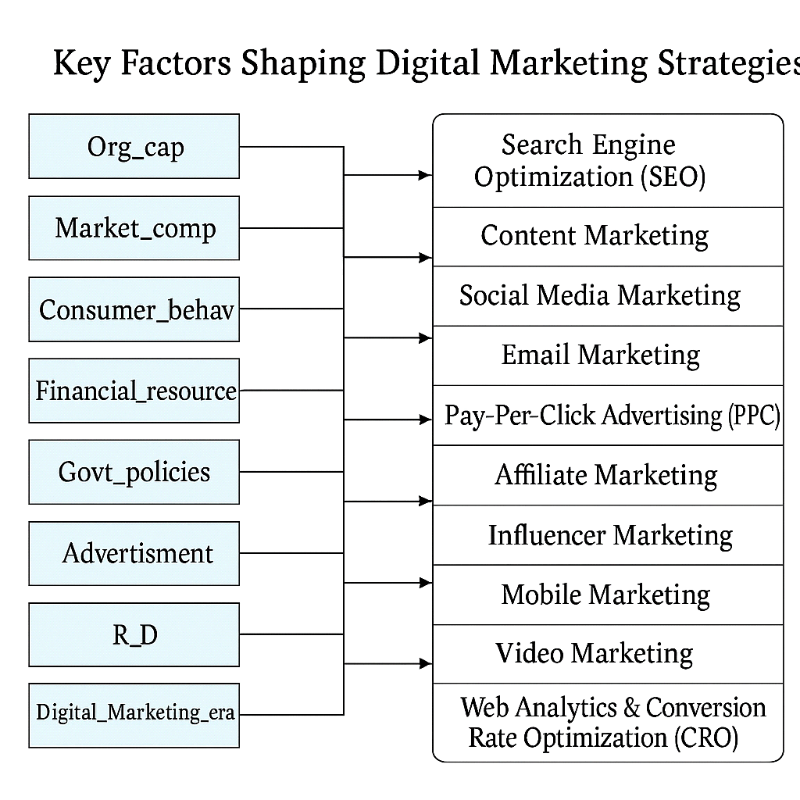

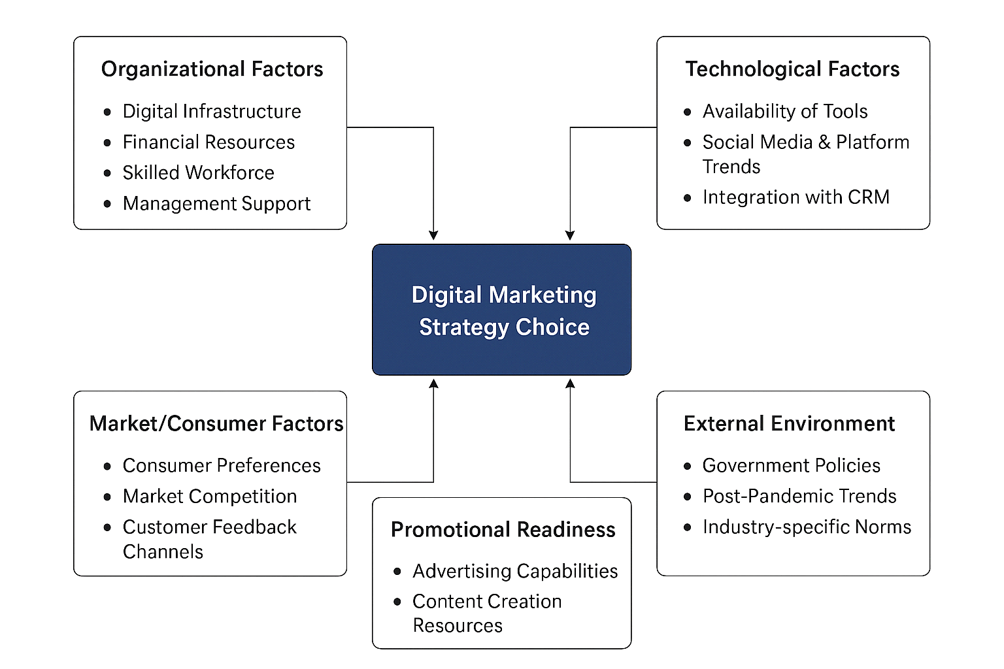
Conceptual framework:

Theoretical Background
The evolving digital landscape compels Micro, Small, and Medium Enterprises (MSMEs) to adopt dynamic marketing approaches tailored to their internal capabilities and external environment. The theoretical framework for this study integrates two comprehensive conceptual models, which collectively explain the multifactorial influences on digital marketing strategy choices among MSMEs.
The first model identifies nine core determinants influencing digital marketing strategies:
- Organizational Capability (Org_cap) – encompassing digital infrastructure and skilled human resources.
- Market Competition (Market_comp) – intensity of competitors pushing MSMEs to innovate.
- Consumer Behavior (Consumer_behav) – changing preferences and online engagement patterns.
- Financial Resources – access to capital for marketing investments.
- Government Policies (Govt_policies) – regulatory support, incentives, or compliance needs.
- Advertisement Capabilities – readiness to engage audiences via promotional content.
- Research and Development (R_D) – innovation and data-driven experimentation.
- Digital Marketing Era Awareness (Digital_Marketing_era) – adaptability to new tools, platforms, and trends.
These factors directly shape strategic decisions involving Search Engine Optimization (SEO), Content Marketing, Social Media Marketing, Email Campaigns, Pay-Per-Click Advertising (PPC), Affiliate and Influencer Marketing, Mobile and Video Marketing, and Web Analytics & Conversion Rate Optimization (CRO).
The second model clusters these variables into five broader domains that underpin strategic decision-making:
- Organizational Factors: These include internal elements like financial stability, skilled workforce, and digital readiness, which influence MSMEs' capacity to plan and implement digital initiatives.
- Technological Factors: Availability and integration of tools, platform compatibility, and CRM systems that affect the feasibility and scalability of digital strategies.
- Market/Consumer Factors: Insights into consumer needs, competition, and feedback mechanisms guide targeted content and channel selection.
- External Environmental Factors: Government regulations, policy frameworks, and industry norms significantly influence digital marketing viability.
- Promotional Readiness: The ability to create and manage compelling advertising content, supported by R&D and innovation, enhances strategic impact.
This integrated theoretical lens reveals that the success of digital marketing in MSMEs is not merely tool-driven but context-dependent, shaped by a dynamic interplay of internal resources, market demands, technological capacity, and regulatory frameworks. It sets a foundation for empirically analysing how these multidimensional factors collectively influence the strategic marketing direction of MSMEs in the digital era.

Objectives:
- To identify and extract the underlying factors that influence the digital marketing strategies of MSMEs in Mysore District using factor analysis
- To examine the factor scores, differ significantly among different types of MSMEs (manufacturing, services, trading), indicating industry-specific influences on digital marketing.
Hypothesis
- H₀: There is no significant difference in the mean factor scores of digital marketing strategies among manufacturing, services, and trading MSMEs.
- H₁: There is a significant difference in the mean factor scores of digital marketing strategies among manufacturing, services, and trading MSMEs.

Research Methodology
This study adopts a quantitative approach using both primary and secondary data. Primary data were collected through structured questionnaires from MSMEs in Mysore District, while secondary data were sourced from government reports and academic literature. Factor analysis (via Principal Component Analysis) was employed to identify latent variables influencing digital marketing strategies. ANOVA and post-hoc tests assessed differences across MSME types.

Table:1

KMO and Bartlett's Test
Kaiser-Meyer-Olkin Measure of Sampling Adequacy. |  | 0.733
Bartlett's Test of Sphericity | Approx. Chi-Square | 340.217
Bartlett's Test of Sphericity | df | 45
Bartlett's Test of Sphericity | Sig. | .000
Table 1 presents the Kaiser-Meyer-Olkin (KMO) and Bartlett’s Test of Sphericity results, which assess the suitability of the data for factor analysis. The KMO Measure of Sampling Adequacy is 0.733 which exceeds the commonly recommended minimum (e.g. >0.6–0.7) for acceptable factor analysis This suggests that the patterns of correlations are relatively compact and the sample is adequate for extracting factors. Bartlett’s test is highly significant (approx. χ² = 340.217, df = 45, p rejecting the null hypothesis that the correlation matrix is an identity matrix. In practical terms, this means there are sufficient inter-correlations between the 10 variables, justifying the use of factor analysis. Together, the KMO and Bartlett’s results indicate that the data is suitable for identifying underlying factors influencing digital marketing strategies of MSMEs.

Total Variance Explained
Component | Initial Eigenvalues |  |  | Extraction Sums of Squared Loadings |  |  | Rotation Sums of Squared Loadings
Component | Total | % of Variance | Cumulative % | Total | % of Variance | Cumulative % | Total | % of Variance | Cumulative %
1 | 2.978 | 29.776 | 29.776 | 2.978 | 29.776 | 29.776 | 2.965 | 29.65 | 29.65
2 | 1.489 | 14.891 | 44.667 | 1.489 | 14.891 | 44.667 | 1.334 | 13.342 | 42.992
3 | 1.274 | 12.739 | 57.406 | 1.274 | 12.739 | 57.406 | 1.28 | 12.798 | 55.79
4 | 1.029 | 10.286 | 67.692 | 1.029 | 10.286 | 67.692 | 1.19 | 11.902 | 67.692
5 | 0.907 | 9.071 | 76.763
6 | 0.732 | 7.317 | 84.08
7 | 0.632 | 6.323 | 90.402
8 | 0.48 | 4.805 | 95.207
9 | 0.278 | 2.783 | 97.991
10 | 0.201 | 2.009 | 100
Extraction Method: Principal Component Analysis.
Table:2

Table 2 summarizes the Total Variance Explained by the extracted factors. Using Principal Component Analysis (PCA) as the extraction methodfile-qrztqwnr1rfory7am55136, four components had eigenvalues greater than and were retained for rotation. The initial eigenvalue for Component 1 is 2.978, indicating it alone accounts for about 29.8% of the variance in the datafile-qrztqwnr1rfory7am55136. Components 2, 3, and 4 have eigenvalues of approximately 1.489 (~14.9%), 1.274 (~12.7%), and 1.029 (~10.3%) respectively, before dropping below 1 for the fifth Cumulatively, the first four factors explain roughly 67.7% of the total variancefile This level of explained variance is reasonable for social science research, as factors often capture ~60–70% of variance in complex phenomena In other words, these four underlying factors represent the majority of information contained in the ten original variables, effectively summarizing the key influences on MSMEs’ digital marketing strategies in the Mysore District

Fig:
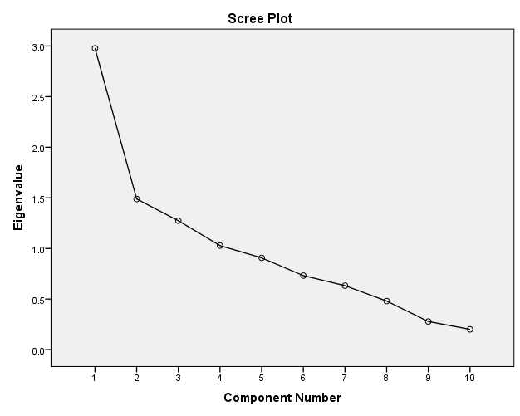
Figure 1: Scree plot of eigenvalues for the ten principal components. The plot shows a clear “elbow” at the 4th component, after which eigenvalues drop below 1 (red dashed line), indicating that four factors should be retained.
Figure 1 is the Scree Plot corresponding to the eigenvalues in Table 2. The scree plot displays each component’s eigenvalue on a downward-curving line. We can observe a noticeable “elbow” at the 4th component, where the slope of the curve levels off. According to the scree test, the point at which the eigenvalues begin to plateau (the elbow) suggests the optimal number of factors to retain In this case, components 1 through 4 form the steep part of the curve (all with eigenvalues > 1), while components beyond 4 have much smaller eigenvalues that lie on the flatter tail of the plot (all < 1.0). This visual evidence reinforces the decision to retain four factors – components to the left of the elbow – as the meaningful underlying factors shaping digital marketing strategies of MSMEs, whereas additional components would contribute only minimal incremental explanatory power.

Table:3
Rotated Component Matrixª
 | Component
 | 1 | 2 | 3 | 4
Org_cap | 0.775 | -0.021 | 0.132 | 0.161
Market_comp | 0.06 | 0.359 | 0.503 | -0.439
Consumer_behav | -0.006 | -0.768 | -0.064 | 0.068
Financial_resource | 0.865 | -0.006 | -0.034 | -0.142
Govt_policies | 0.908 | -0.076 | -0.001 | -0.068
Advertisment | 0.883 | 0.047 | -0.004 | 0.08
R_D | -0.051 | 0.769 | -0.189 | 0.025
Digital_Marketing_era | 0.023 | 0.024 | -0.726 | -0.358
MarketintProscheme | 0.044 | -0.127 | 0.655 | -0.058
Post_pandemic_effect | 0.044 | -0.004 | 0.107 | 0.896
Extraction Method: Principal Component Analysis.
Rotation Method: Varimax with Kaiser Normalization.
a. Rotation converged in 5 iterations.

The rotated component matrix identified four key factors that influence the digital marketing strategies of MSMEs in Mysore District. Factor 1, labeled Marketing Resources & Support, showed high loadings for Organizational Capability, Financial Resources, Government Policies, and Advertisement Capabilities, indicating that internal strengths and external facilitation play a vital role in enhancing MSMEs’ marketing competitiveness.
Factor 2, termed Consumer-Centric Innovation, had a strong positive loading for Research and Development and a strong negative loading for Consumer Behavior, suggesting that MSMEs focusing on innovation and market research may perceive less direct reliance on observable consumer trends, and vice versa.
Factor 3, identified as Traditional vs. Digital Orientation, included significant loadings from Marketing Promotion Schemes and Market Competition, but a negative loading for Digital Marketing Era Awareness. This reflects a strategic tension where MSMEs may still rely on traditional marketing methods while gradually adapting to digital trends.
Factor 4, named Post-Pandemic Effects, was dominated solely by the Post-Pandemic Effects variable. This indicates that the impact of the COVID-19 pandemic represents a distinct and significant influence on how MSMEs approach digital marketing, highlighting the importance of adaptation in the post-pandemic context.
In summary, the four extracted components represent distinct dimensions—organizational support, innovation and market orientation, digital transition, and pandemic-driven change—thereby addressing the first research objective of identifying and extracting underlying factors using factor analysis.

Table:4
ANOVA
 |  | Sum of Squares | df | Mean Square | F | Sig.
Marketing Compitation | Between Groups | 3.6 | 2 | 1.8 | 1.823 | 0.166
Marketing Compitation | Within Groups | 125.4 | 127 | 0.987
Marketing Compitation | Total | 129 | 129
Consumer behaviour | Between Groups | 0.015 | 2 | 0.008 | 0.008 | 0.993
Consumer behaviour | Within Groups | 128.985 | 127 | 1.016
Consumer behaviour | Total | 129 | 129
Post Pandemic effects | Between Groups | 5.013 | 2 | 2.507 | 2.568 | 0.081
Post Pandemic effects | Within Groups | 123.987 | 127 | 0.976
Post Pandemic effects | Total | 129 | 129
Digital Marketing Practices | Between Groups | 0.398 | 2 | 0.199 | 0.193 | 0.825
Digital Marketing Practices | Within Groups | 130.911 | 127 | 1.031
Digital Marketing Practices | Total | 131.308 | 129

Table 4 shows that the ANOVA results revealed no statistically significant differences in the mean factor scores across different types of MSMEs (Manufacturing, Services, and Trading) at the 5% significance level. For the “Marketing Competition” factor, the result was F(2,127) = 1.823 with a p-value of 0.166, indicating no significant variation among the groups. Similarly, the “Consumer Behavior” factor showed F(2,127) = 0.008, p = 0.993, suggesting nearly identical means across industries. The “Post-Pandemic Effects” factor recorded F(2,127) = 2.568 with a p-value of 0.081, which, although higher than the 0.05 threshold, suggests only a marginal and statistically non-significant difference. Lastly, for “Digital Marketing Practices”, the result was F(2,127) = 0.193 with a p-value of 0.825, again indicating no meaningful difference across industry types. Overall, these results imply that the underlying factors influencing digital marketing strategies are consistent across all MSME sectors in Mysore, confirming that the impact of these factors is not industry-specific.

Table:5
Table: Post-Hoc Comparisons (Tukey HSD & Duncan) Across Industries

Factor | Type of Industry | N | Subset Means (α = 0.05) | Sig.
Marketing Competition | Manufacturing | 38 | -0.257 | 0.174 (Tukey)
 | Services | 45 | 0.083 | 0.091 (Duncan)
 | Trading | 47 | 0.129
Consumer Behaviour | Services | 45 | -0.012 | 0.991 (Tukey)
 | Trading | 47 | -0.001 | 0.907 (Duncan)
 | Manufacturing | 38 | 0.015
Post-Pandemic Effects | Manufacturing | 38 | -0.188 (Subset 1) | 0.088 (Tukey)
 | Trading | 47 | -0.103 (Subset 1/2) | 0.690/0.086 (Duncan)
 | Services | 45 | 0.266 (Subset 2)
Digital Marketing Practices | Trading | 47 | -0.012 | 0.831 (Tukey)
 | Services | 45 | 0.001 | 0.588 (Duncan)
 | Manufacturing | 38 | 0.116

Table 5 presents the post-hoc comparisons using Tukey’s HSD and Duncan’s tests to examine mean factor score differences among MSME types, despite ANOVA not indicating significant differences. These results help validate the overall consistency in factor scores across industries.
For the Marketing Competition factor, the mean scores were -0.257 (Manufacturing), 0.083 (Services), and 0.129 (Trading). Although Services and Trading scored slightly above average, and Manufacturing below, all values were close to zero. Tukey’s test showed p = 0.174, and Duncan’s test grouped all three industries into the same subset, confirming no significant pairwise differences.
The Consumer Behavior factor showed nearly identical mean scores across groups: 0.015 (Manufacturing), -0.012 (Services), and -0.001 (Trading). The corresponding Tukey’s test yielded p ≈ 0.991, and all industries fell into the same subset, indicating complete overlap and no meaningful variation.
For the Post-Pandemic Effects factor, mean scores were more spread out: -0.188 (Manufacturing), -0.103 (Trading), and 0.266 (Services). Tukey’s p = 0.088 suggests a marginal difference, with Duncan’s test showing Services in a distinct subset, possibly reflecting a greater post-pandemic digital shift. However, the result is not statistically significant at the 5% level and should be interpreted with caution.
The Digital Marketing Practices factor showed minimal differences: 0.116 (Manufacturing), 0.001 (Services), and -0.012 (Trading), with Tukey’s p = 0.831. All groups were classified into a single subset, reinforcing the uniformity in digital practices adoption.
In summary, post-hoc tests reinforce the ANOVA results, indicating no statistically significant differences in factor scores across MSME types. This supports the view that key digital marketing influences are broadly applicable across manufacturing, service, and trading MSMEs in Mysore.

Findings:
- Factor analysis extracted four major influences—Marketing Resources, Innovation Focus, Digital vs. Traditional Orientation, and Post-Pandemic Effects.
- ANOVA showed no significant variation in factor scores across manufacturing, services, and trading MSMEs.
- Post pandemic effect, financial resources, and government policies were strong drivers of digital marketing adoption.
- Differences in consumer preferences had minimal influence on MSME digital strategies.
Suggestions
- Improve MSME access to digital schemes and government support.
- Provide digital marketing training applicable to all MSME sectors.
- Encourage development of affordable, MSME-friendly marketing platforms.
- Integrate post-pandemic learnings into long-term digital strategies.

Conclusion:
The study concludes that digital marketing strategies of MSMEs are shaped by four core factors, uniformly influencing all sectors. Organizational support and government policies play a vital role, while consumer behavior has limited impact. Strengthening digital capacity and policy awareness is essential for inclusive and sustainable MSME growth.

.

References:
- Setiawan, R., Prasetyo, P. T., & Yuniawan, A. (2024). Digital Marketing Strategy for Sustainable Performance of MSMEs: Literature Review. Research Horizon, 5(1), 33–46.
- Sharabati, A.-A. A., Ali, A. A. A., Allahham, M. I., Hussein, A. A., Alheet, A. F., & Mohammad, A. S. (2024). The Impact of Digital Marketing on the Performance of SMEs: An Analytical Study in Light of Modern Digital Transformations. Sustainability, 16(19), 8667. https://doi.org/10.3390/su16198667
- Gutiérrez Navas, E. B., Sarmiento Suárez, J. E., Ramírez Montañez, J. C., & Rincón Quintero, Y. A. (2025). Determining factors for the digitization of micro, small, and medium-sized enterprises (MSMEs) in Ibero-America. Journal of Innovation & Knowledge, 10(1), 100631. https://doi.org/10.1016/j.jik.2024.100631
- Bermeo-Giraldo, M. C., Valencia-Arias, A., Ramos de Rosas, J. D., Benjumea-Arias, M., & Villanueva Calderón, J. A. (2022). Factors influencing the use of digital marketing by small and medium-sized enterprises during COVID-19. Informatics, 9(4), 86. https://doi.org/10.3390/informatics9040086
- Eze, S. C., Chinedu-Eze, V. C., Awa, H. O., & Diarah, I. S. (2023). Critical issues facing SMEs’ actors in the adoption of emerging digital marketing technology (EDMT). SAGE Open, 13(4), 1–18. https://doi.org/10.1177/21582440231214847

