ErgoGlide: Intelligent Gesture-Based Cursor and Wellness Companion

Abstract—The increased usage of computers has led to various ergonomic disorders like physical discomfort, poor posture, eye strain, and repetition strain injury. The usage of normal interaction devices like keyboards and mice involves increased utilization of hands that often promotes improper posture during long working periods. The current paper describes an intelligent cursor control and wellness assistant tool like ”ErgoGlide” for hands-free computer interaction while continuously evaluating ergonomics through only a normal webcam. The tool uses computer vision approaches for cursor movement through head or nose tracking and click functionalities through accurate detection of eye blinks. For accurate cursor movement, dead zone, smoothing, and step limit functionalities have been employed. Similarly, click functionalities have been implemented through EAR-based calibration, frame validation, and cooldown. The tool also allows for evaluating ergonomics like shoulder, neck, and torso positions for proper posture and gives feedback for improved posture. The tool also checks for abnormal eye blinking that indicates eye dryness. Similarly, abnormal eye blinking that includes long blinks may indicate drowsiness. The tool also allows for micro-break reminders through warnings and maintains a wellness score. The tool also aids in export analysis.
Index Terms—Ergonomics, Gesture-Based Cursor Control, Head/Nose Tracking, Eye Blink Detection (EAR), Posture Mon- itoring, Wellness Score, Micro-break Reminders
- Introduction
In recent years, especially at educational institutions, in workplaces, and among people working remotely, it has be- come impossible to think about everyday life without comput- ers. While extended computer use has increased productivity and access, several ergonomic concerns have arisen. Extended use of a computer with conventional input devices such as a keyboard and mouse frequently leads to physical discomfort, poor sitting posture, eye strain, and repetitive-strain injuries, particularly among users who spend long hours at the screen
without ergonomic guidance [10], [11], [13], [14]. Studies focusing on posture-related workload and biomechanical ef- fects highlight how improper posture contributes to health risks during continuous interaction with digital systems [5], [6], [9]. These concerns emphasize the need for practical systems that assist users in maintaining healthy posture habits during long working sessions [7], [4].
Traditional human-computer interaction techniques require continuous hand movements and constrained body postures, which may lead to harmful postural behavior over time. Moreover, physically disabled users and users with tempo- rary mobility impairments face limitations imposed by such interaction techniques, increasing the demand for hands-free alternatives [16], [17]. Research on assistive and gaze-based interfaces has demonstrated that head motion, eye tracking, and blink-based actions can effectively replace traditional mouse interactions, especially in accessibility-focused designs [18], [19], [20]. Earlier approaches also established that blink and wink detection can provide reliable mouse-event triggering without depending on intrusive hardware, which improves usability for different user groups [16], [18], [20].
Recent advances in computer vision and machine learning allow real-time analysis of face landmarks and human body posture using standard webcams, enabling the next generation of gesture-based systems that do not require specialized hard- ware [15]. MediaPipe-based frameworks have shown strong performance for real-time landmark detection and pose in- ference, supporting efficient ergonomics monitoring pipelines [3], [15]. Temporal approaches such as LSTM-based posture recognition further improve interpretation of movement pat- terns in posture-related tasks and help distinguish safe versus unsafe postures across short action windows [1], [12]. Moti-

vated by these developments, this paper introduces ErgoGlide, an intelligent gesture-based cursor control and wellness com- panion that supports head-based cursor movement and deliber- ate blink-based clicking while continuously monitoring upper- body posture and eye wellness [2], [3]. The design aims to reduce physical strain, improve accessibility, and encourage healthier computing habits during prolonged screen use [8], [10], [11], [13] , [14].
- Literature Survey
Recent advancements in camera-based posture analysis have received considerable interest because they offer non-invasive and economical posture analysis techniques through simple web cameras. [3], [6], [15] MediaPipe has emerged as the principal component in many applications because it can estimate 33 landmark points for real-time pose estimation and ergonomic/health-related analysis through continuous mea- surement of posture and joint parameters [15]. Chaithra et al. used OpenCV for real-time video recording and MediaPipe Pose to identify landmarks in the image, where posture quality was determined by estimating the angle formed by the nose and shoulders and comparing it with predefined thresholds to classify posture automatically [3].
To overcome limitations from analyzing individual frames in posture assessment, temporal modeling approaches have been integrated into motion-related posture tasks. [1], [12] Bagga and Yang employed MediaPipe keypoint extraction along with an LSTM classifier to identify both risk-free and risk-conveying lifting postures from short motion sequences in their work [1]. Their dataset involved video clips captured from multiple angles and distances, and the temporal learning model demonstrated accurate identification of lifting posture patterns. Similarly, posture and action recognition for medical monitoring has used MobileNetV2 and LSTM models to learn human motion dynamics in a more accurate way [12].
Recent works also highlight posture monitoring systems that focus on full-stack deployment and real-time feedback to users. [2] PoseTrack, proposed by Hsieh and Sun, integrates a Raspberry Pi camera for capturing frames, MediaPipe Pose for posture landmark estimation, Flask server-based posture data processing, and a Flutter mobile application for output display and user feedback [2]. The system also employs Firebase authentication and storage, enabling monitoring of posture trends, and experimental results validated the impact of camera placement and lighting on posture recognition performance. [2], [15]
In occupational ergonomics, posture recognition has been widely explored for ergonomic risk evaluation and workload analysis in manual material handling tasks. [4], [5], [6] Zhao and Obonyo investigated deep neural network–based posture recognition for improving ergonomics risk assessment in con- struction environments [4]. Wang et al. proposed a computer- vision-based posture risk evaluation system for workload esti- mation in material handling, proving the possibility of posture risk assessment without wearable sensor data [5]. Addition- ally, Wang et al. developed a computer vision method to
estimate joint angles and L5/S1 spinal moments during lifting using a single-camera setup, supporting ergonomic assessment through vision systems [6]. Deep learning applications have also expanded posture recognition into industrial settings, where Ciccarelli et al. proposed SPECTRE for classification of manufacturing posture types [7], and Hussain et al. presented a digital human modeling approach using RULA for workplace ergonomic analysis [9].
Machine learning integration in ergonomics has been strongly supported for the prevention of musculoskeletal dis- orders. [10], [11] Chan et al. reviewed the role of machine learning in the primary prevention of work-related muscu- loskeletal disorders, highlighting the movement toward auto- mated posture classification systems [10], while Oakman et al. reinforced preventive workplace monitoring needs [11]. Health concerns related to prolonged screen use were also highlighted, where Kahal et al. reviewed computer vision syndrome and its effects on eye/body health [13], and Singh et al. emphasized management strategies and the importance of ergonomic posture [14]. Besides posture analysis, assistive human–computer interaction technologies using eye-tracking and head movements have also been researched. [16], [17], [18], [19], [20] This includes eye-controlled and speech- enabled cursor systems [16], head-controlled mouse systems [17], blink and wink detection for pointer control [18], and cursor systems designed for paralysis support via blink de- tection [19], as well as head and blink controlled mouse systems for hands-free computing [20]. Overall, the literature reflects a strong preference for AI-driven posture tracking and assistive interaction design [1], [4], [7], [8], [10], [12], where integrating MediaPipe with deep learning and real-time platforms strengthens affordable health technology systems. [2], [3], [15]
- Existing Work
Nowadays, state-of-the-art systems for monitoring human posture and ergonomic risks can be broadly categorized into three types: vision-based pose estimation, sensor/wearable solutions for monitoring, or hybrid/deployment-oriented solu- tions that emphasize real-time feedback and simplicity. [2], [4], [6], [8], [15] Vision-based solutions have proliferated rapidly due to efficient human pose estimation algorithms and the accessibility of cameras. [15] MediaPipe Pose, for instance, is capable of detecting body landmarks at real-time resolutions with a single input RGB image, which can then be used to infer human posture parameters such as angles of joints or alignments of various body landmarks. [3], [6], [15] On this approach, Chaithra et al. designed an end-to-end real-time human posture analysis tool with Python’s OpenCV library for real-time video capture and MediaPipe for landmark tracking. [3], [15] The authors evaluated posture quality by analyzing angles around sensitive body regions such as the neck and shoulders. [3] While such solutions are easy to implement with minimal invasiveness, accuracy can be diminished by occlusions, cluttered backgrounds, or high movement speed. [2], [15]

For capturing the dynamics of motion and improved identifi- cation of action and/or pose patterns, deep sequential models have also been adopted. [1], [12] Bagga et al. designed an RTS system for supervision of lifting posture in real time using MediaPipe keypoints as input for an LSTM classifier to distinguish safe and unsafe lifts. [1], [15] This research establishes the benefit of temporal models for repetitive action problems, since information from a single frame can be limited or inconclusive. [1], [12]
In addition to classification, ergonomics research explores estimating biomechanical variables and the relationship of posture to workload or risk scores. [4], [5], [6], [9] Webcam- based solutions examined the possibility of estimating joint angles and surrogate low-back load measures through a sin- gle camera, enabling ergonomic analysis without wearables.
- Posture-based ergonomics risk assessment and workload estimation for material handling was studied to deliver useful safety information directly from video analysis by connect- ing posture detection to ergonomic scoring models. [5], [9] Deep learning was also used for ergonomic risk assessment in construction to identify improper postures and improve model generalization across workers and view angles. [4],
- Another trend is sensor-enabled posture monitoring using wearables, where inertial and magnetic sensors track slouching and leaning and issue warnings when limits exceed thresh- olds. [8] Although accurate in controlled settings, reliance on wearables limits adoption due to comfort and compliance challenges. [8], [10] Review works also mention the growing interest in merging sensing and machine learning for posture monitoring. [10], [11]
- Proposed Work
ErgoGlide is an application for desktop-based assistants utilizing webcam-based computing, including hands-free cur- sor management, click-based management, real-time posture analysis, and eye wellness analysis. The application analyzes information obtained from an webcam video stream using media pipe-based computer vision libraries for facial and upper body landmark analysis, followed by GUI display using PySide6.
For the movement of the cursor, the nose landmark is used for control. A short calibration follows, and the movement of the nose from the neutral point maps to the movement of the cursor across the full virtual desktop. There is a dead zone for unwanted movement and a smooth movement for stability.
Clicking mechanism: Instead of the threshold, the EAR (Eye Aspect Ratio) method has been used for the implementation of the clicking mechanism. For this, the system makes use of specific user-calibration to compute the open EAR baseline and provide the estimated threshold for the specific user, com- pared to which the EAR values are checked for consecutive frames for the completion of the click mechanism, without any false clicks and freeze time.
In addition, ErgoGlide monitors posturing and well-being using pose information such as the alignment of the shoulders and the depth cue positioning of the head, the way the torso
leans, etc. These posturing elements are assessed against their baseline value using hold-time validations. Blink trends are also utilized for predicting dryness or drowsiness risks using a sliding window. In addition, micro-break reminders can be presented. The control parameters that can be adjusted using the GUI include pause/resume, calibration, gain, smoothing, and dead zones.
- Objectives
- Head-based Cursor Movement (Nose Tracking): Move the cursor across the full virtual desktop (including multi- monitor) using nose landmark tracking with dead-zone, smoothing, and step-limits for stability.
- Blink-to-Click (Intentional Click Only): Detect delib- erate blinks using EAR with calibration, frame confirma- tion, and cooldown to avoid accidental clicks.
- Live Posture Checking (Shoulders + Head + Torso): Monitor shoulders, head-forward shift, and torso lean, and mark posture as bad only if it persists for about 2 seconds.
- Blink Pattern Tracking (Eye Comfort + Drowsiness Clues): Track blink rate in a 60-second window, flag low blink risk if it continues 2 minutes, and detect long blinks (≈ 0.6 s+) for drowsiness cues.
- Micro-break Reminders (20-20 style): Trigger a re- minder every 20 minutes for a 20-second break during active use to support healthy screen habits.
- Single Wellness Score (Quick Read): Combine posture, blink behavior, and break compliance into a continuously updated 0–100 wellness score.
- Session Analytics (Useful Logs): Log blink totals/rate, posture states, breaks, and warnings, and export session data in JSON for analysis and reporting.
- System Architecture
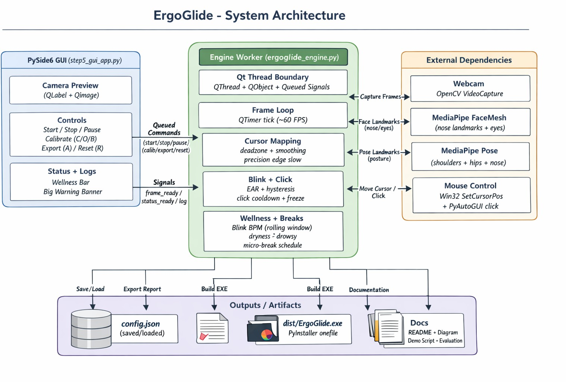
Fig. 1. System Architecture
ErgoGlide is a real-time desktop assistant enabling hands- free cursor interaction and health monitoring using a com- modity webcam, built upon a modular pipeline architecture for smooth and fast performance as is shown in Fig. 1.

- Architectural Overview (Fig. 1)
Overall, as presented in Figure 1, the general architecture has three very important components:
  - PySide6 GUI Layer: The PySide6 layer facilitates user interactions, previews, and parameters of the controls.
  - Engine Worker Layer: It handles real-time vision processing, decision-making, and state generation.
  - External Dependencies Layer: This layer consists of roles related to the operation of the webcam, media pipe landmarks, and mouse operations.
This enables layering, which results in operations on the user interface being separated from those on real-time inference operations, thereby eliminating the possibility of lag between GUI execution as the system processes video frames continu- ously.
- PySide6 GUI Layer (User Interaction Module)
The module for GUI, i.e., ”step5guiapp.py,” is responsible for creating a front end for this application, in which three capabilities are available, which are:
  - Camera Preview: It provides video feedback using a rendering pipeline that contains a QImage.
  - User Controls: Provides functionality to execute com- mands such as Start/Stop, Pause, Calibration, Export, Reset, etc.
  - Status and Logs: It constantly updates the status bar with information on the changes in the “wellness in- dicators” such as the “posture warnings,” “blink state,” “wellness score,” etc.
The GUI interacts with the Engine using queued commands. This guarantees thread-safe message passing.
- Engine Worker Layer (Real-Time Processing Core)
The engine worker (ergoglideengine.py) is the module of decision making and operates inside a Qt-thread boundary. It utilizes the event-driven strategy of Qt for timing and smoother updating. This is depicted in Fig. 1.

Frame Loop Scheduler
A QTimer triggers the processing tick at approximately 60 FPS, where each cycle performs:
    - Frame capture from webcam
    - Landmark inference
    - Cursor control computations
    - Blink/posture/wellness evaluation
    - Feedback state generation

Cursor Mapping Unit
he cursor mapping module converts nose displacement into cursor movement using:
    - deadzone filtering (removes micro jitter)
    - smoothing (stabilizes motion)
    - precision edge slow-down (improves edge accuracy) This ensures stable control even on large or multi- monitor virtual desktops.

Blink + Click Unit
Blink-to-click functionality is implemented through:
    - EAR (Eye Aspect Ratio) computation
    - hysteresis thresholds to prevent flickering detection
    - click cooldown and motion freeze to avoid acciden- tal clicks
This module ensures only deliberate blinks trigger click- ing actions.

Wellness + Breaks Unit
The wellness module continuously evaluates:
    - blink BPM over rolling time windows
    - dryness risk detection using low blink rate trends
    - drowsiness indicators using long blink repetitions
    - scheduled micro-break reminders
It also combines these signals into a single wellness indicator for easier interpretation.
- External Dependencies Layer
The architecture depends on multiple libraries and OS-level APIs, as indicated in Fig. 1:

Webcam Input (OpenCV VideoCapture)
Captures real-time frames which are passed to inference pipelines.

MediaPipe FaceMesh
Extracts facial landmarks, primarily used for:
    - nose landmark tracking (cursor movement)
    - eye landmark tracking (EAR calculation)

MediaPipe Pose
Extracts upper body posture landmarks such as:
    - shoulders, hips, and nose
    - posture tilt, forward head drift, torso lean

Mouse Control Interface
Cursor movement and clicking are executed using:
    - Win32 SetCursorPos (precise screen mapping)
    - PyAutoGUI click (mouse event triggering)
- Outputs and System Artifacts
As shown at the bottom of Fig. 1, ErgoGlide produces usable outputs for both execution and reporting:
- config.json: Stores calibration values and user-specific tuning parameters (gain, smoothing, thresholds).
- Export Report: Session results are exported for evalua- tion and analytics.
- Executable Build: Packaged desktop release as dist/ErgoGlide.exe using PyInstaller in onefile mode.
- Documentation: Includes README, diagrams, demo scripts, and evaluation notes to support reproducibility. These outputs make the system suitable for practical usage and report-based evaluation.
- Methodology
ErgoGlide offers hands-free control of the cursor pointer and clicking ability, postural assessment, and wellness analysis. This can be done using the webcam. The process functions on a real-time pipeline. After calculating the results, they are converted into a human-understood form with the help of the

GUI. The state or functions with their respective meanings and elaboration are presented in Table I. Moreover, the functions performed by the respective modules are listed in Table II.
A. Pipeline Description (Fig. 2)
The processing flow follows these steps:
- Capture a frame from the webcam.
- Convert the frame to RGB and infer (i) face landmarks and (ii) pose landmarks.
- Track nose movement relative to a calibrated neutral point for cursor navigation.
- Compute eye behavior to identify deliberate blinks and trigger mouse clicks.
- Evaluate posture using shoulder/hip alignment and head-
forward drift from a baseline.
TABLE I
System Output States Displayed in the GUI

State Label Meaning
Paused Interaction disabled (safety/user control)
CursorCalibrated Neutral baseline recorded for cursor control
Posture: OK Posture within threshold limits
Posture: BAD HOLDING Poor posture detected but not sustained Posture: BAD Poor posture sustained beyond T_{hold} Dryness: LOW BLINK RISK Blink rate low beyond T_{dry}
Drowsy: LONG BLINK S Frequent long blinks in window W_{d}
Break: BREAK NOW Micro-break currently active

- Blink-Based Clicking Using EAR
Blink detection is based on the eye aspect ratio (EAR), computed from six landmarks around each eye:
p₂ − p₆ + p₃ − p₅
2 p₁ − p₄

- Update blink-rate metrics, micro-break timer, and a
EAR =
. (5)

unified wellness score.
- Render landmarks and status text in the GUI in real time.
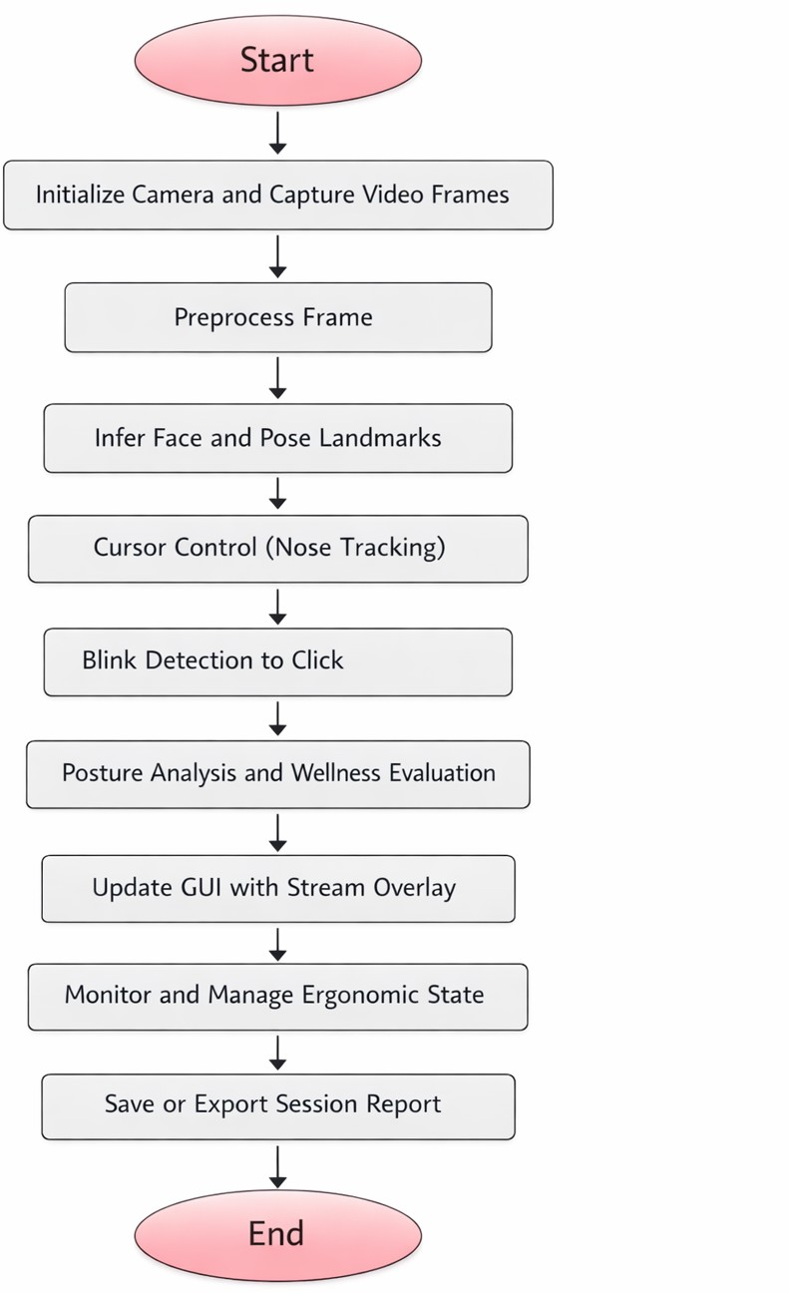

Fig. 2. Pipeline diagram of ErgoGlide
B. Cursor Control via Nose Displacement
A neutral nose coordinate is stored during calibration as
(n⁰ , n⁰). For each frame, the displacement is:
x y
d_{x} = n_{x} − n⁰ , d_{y} = n_{y} − n⁰. (1)
A short calibration step measures open-eye EAR values and sets a personalized threshold:

T = k · EAR_{open}, (6)

where k is a scaling factor and EAR_{open} is the mean EAR during the calibration interval. A blink is confirmed using consecutive-frame logic and hysteresis to reduce false triggers. A click is issued only after confirmation and only if the cool down time has elapsed since the previous click.
D. Posture Monitoring Using Upper-Body Geometry
Upper body pose is monitored by tracking key pose points—left shoulder, right shoulder, left hip, right hip, and nose as a reference point. The baseline is taken by completing a posture calibration routine. The system real-time monitors the pose points, triggering an alert only if the improper pose has been maintained for a certain period of time, thus avoiding false positives due to transient movements. The analysis of pose is performed by monitoring shoulder tilt, forward head position drift, and torso lean positions with reference to the baseline.
E. Wellness Metrics and Micro-Break Scheduling
Blink behavior is summarized using blink rate in blinks per minute (BPM), computed on a rolling window:

x y

The cursor target is derived by mapping displacement to the full virtual desktop (including multi-monitor setups). Let (V_{x}, V_{y}) be the virtual origin and (V_{w}, V_{h}) be its dimensions. The virtual center is:
BPM = Nblinks · 60. (7)
In the set hold period, the lower blink rate acts as an indicator for the risk of dryness, and prolonged blink duration within
W

c_{x} = V_{x}
+ Vw , c
2 y
= V_{y}
+ Vh . (2)
2
the allotted time acts as an indicator of drowsiness. Micro- breaks are scheduled for regular work periods, and during the

With gain parameters (g_{x}, g_{y}), the target position becomes:
x∗ = c_{x} + d_{x} · V_{w} · g_{x}, y∗ = c_{y} + d_{y} · V_{h} · g_{y}. (3)
course of a break, the GUI prompts the user to look away for a short interval. The corresponding GUI output states for these wellness conditions are listed in Table I.

To reduce jitter, exponential smoothing is applied:
x_{s} ← x_{s} + α(x∗ − x_{s}), y_{s} ← y_{s} + α(y∗ − y_{s}), (4)
where α controls responsiveness versus stability. In addition, per-frame cursor movement is capped to avoid sudden jumps.

TABLE II
Main Software Components
C. Multi-Monitor Cursor Mapping and Movement Control
To support extended desktops, the virtual screen rectan-

Component Responsibility gle is obtained from the OS (virtual origin and full virtual

Camera Module Capture and preprocess frames (flip, RGB conversion) Face Module Nose tracking, EAR computation, blink logic
Cursor Module Virtual desktop mapping, smoothing, step limiting Pose Module Landmark extraction, posture features, posture state
Wellness Module Blink BPM, dryness/drowsiness, micro-break timer, score
width/height). This ensures cursor positioning works even when a monitor is placed left of the primary display (negative coordinates). Cursor control uses:

GUI Module Live preview, text overlays, status indicators • Deadzone filtering: small nose movements near the
neutral point are ignored to prevent drift.

F. Unified Wellness Score
The combined index integrates the state of the posture, the state of the blink rate, the risk of dryness, the risk of drowsiness, and the level of micro-break compliance all within a single index that ranges from 0 to 100. The penalties are based on fixed rules and are processed in real-time, so the index represents the actual level of ergonomics with every update. The system output states and indicators presented in the GUI for this process are summarized in Table I, and the main functional module responsibilities contributing to these outputs are described in Table II.
- Implementation
In this section, we clarify that ErgoGlide is presented as a real-time desktop application system with a standard webcam feed that provides (i) hand-free control functionality, (ii) blink- to-click functionality, (iii) posture tracking functionality, and
(iv) wellness functions all under one GUI.
- Development Setup and Libraries
The implementation is developed in Python and integrates the following libraries:
  - OpenCV: webcam capture, frame flip, color conversion, and on-frame overlays.
  - MediaPipe: Face Mesh for facial landmarks and Pose for upper-body landmarks.
  - NumPy: numerical smoothing and statistics for calibra- tion.
  - PySide6: event-driven GUI, signals/slots, and image ren- dering via QImage.
  - PyAutoGUI + Win32 Cursor API: click events and cur- sor positioning; Win32 calls support negative coordinates in multi-monitor setups.
- Event-Driven Real-Time Loop
The application runs in an event-driven manner. A high- frequency GUI timer triggers the processing function (_tick) approximately every 15 ms. Each tick:
- Reads a webcam frame and flips it horizontally.
- Runs Face Mesh and Pose inference on the RGB frame.
- Updates cursor, blink, posture, and wellness states.
- Draws overlays and emits the frame to the GUI as a
QImage.
- Emits a compact status dictionary for updating UI la- bels/progress indicators.
  - Gain scaling: head movement is amplified to cover the full screen comfortably.
  - Exponential smoothing: reduces jitter from landmark noise.
  - Step limiting: caps maximum cursor delta per frame to avoid sudden jumps.
  - Edge precision scaling: movement sensitivity is reduced near screen edges to improve pointing accuracy.
- Blink Detection and Click Triggering
Clicking is implemented using a personalized EAR thresh- old derived from a short open-eye calibration window:
  - Calibration: EAR samples are collected for a fixed duration; the mean is multiplied by an open-eye factor to obtain the user-specific threshold.
  - Hysteresis: separate close/open thresholds avoid rapid toggling due to noise.
  - Consecutive-frame confirmation: the eye must remain below threshold for a small number of frames before a blink is accepted.
  - Cooldown: enforces a minimum time between click actions.
  - Freeze window: briefly freezes cursor motion after blink onset to stabilize clicking.
This design keeps natural blinks from producing frequent accidental clicks and makes the interaction consistent under typical lighting changes.
- Posture Monitoring Using Pose Landmarks
Upper-body posture is evaluated from pose landmarks (left/right shoulders, left/right hips, and nose). The implemen- tation computes:
  - Shoulder slope: absolute vertical difference between shoulders.
  - Head-forward drift: relative forward displacement (depth) of the nose with respect to the shoulder midpoint, compared to baseline.
  - Torso lean: torso angle from vertical using shoulder and hip midpoints.
A baseline posture is recorded through a user action. Poor posture is flagged only when thresholds are exceeded contin- uously for a hold duration, producing stable feedback states such as OK, BAD_HOLDING, and BAD.
- Wellness Analytics and Micro-break Enforcement
A wellness layer runs alongside interaction control:

  - Blink BPM: blink timestamps are stored and maintained in a rolling window to compute blinks per minute.
  - Dryness risk: sustained low blink BPM over a hold period changes the state to low-blink risk.
  - Drowsiness indicator: long blink durations are tracked and counted within a time window; repeated long blinks raise a drowsiness warning state.
  - Micro-break scheduling: a timer triggers periodic breaks (e.g., 20 seconds after each 20 minutes of work time). During an active break, the interface forces a visible reminder.
- Unified Wellness Score Computation
A single score in the range [0, 100] is updated every frame using rule-based penalties. The score aggregates:
  - posture state (normal vs. sustained bad posture),
  - blink quality (very low vs. low vs. normal),
  - dryness and drowsiness warning states,
  - micro-break active state.
This produces an easy-to-read indicator that changes immedi- ately as posture or eye behavior improves.
- GUI Integration and Data Emission
The engine emits two outputs to the GUI:
  - Live frame: the processed frame is converted to QImage and displayed in the GUI.
  - Status packet: a dictionary containing FPS, pause/calibration flags, posture state, blink BPM, dryness/drowsiness states, break state, and wellness score.
Signals/slots are used to keep UI updates responsive and thread-safe. All calibration commands (cursor baseline, open- eye threshold, posture baseline) are queued safely into the engine loop so they do not interrupt ongoing frame processing.
- Safety and Robustness Features
Several safeguards are implemented:
  - Fail-safe pause on face loss: prolonged face loss auto- matically pauses interaction to prevent unintended cursor motion.
  - Click cooldown and blink confirmation: reduces acci- dental clicks.
  - Bounded cursor movement: limits per-frame displace- ment and clamps movement to the virtual screen.
  - Graceful shutdown: releases camera and MediaPipe resources cleanly when stopping.
These measures improve stability in real-world use, especially under partial occlusion or temporary tracking drops.
- RESULT
The developed and validated ErgoGlide application on the live webcam feed within the typical indoor setting; uninter- ruptedly running a GUI that can track face landmarks (cursor
+ blink response), pose recognition (posture), and wellness logic, all within an average per frame processing cycle. Real- time display of GUI overlays and status indicators ascertains
correctness for the main functionalities. Fig. 3 shows the output of the ErgoGlide project during real-time execution.
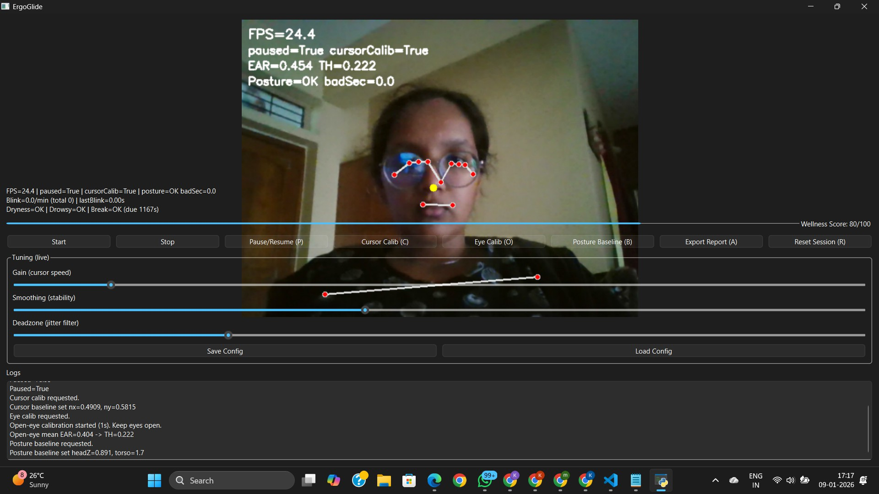

Fig. 3. Output

- Real-time execution output
  - The GUI was showing live frames with an FPS display all through the runtime process.
  - The overlays were Always showing the runtime status information like paused, cursorCalib, EAR/threshold, Posture state (NOPOSE, NOBASELINE, OK, BADHOLDING, BAD)
  - The system went on functioning without any manually initiated restarts because of stable user posture and facial visibility conditions.
- Cursor control (head-nose tracking) output
  - When the engine is not paused and after nose neutral stor- age in cursor calibration, the cursor became responsive to head movements.
  - Movement was limited (step-limited) and smoothed (did not show any sudden jumps in practical use).
  - Multi-monitor capability was made possible by virtual screen rectangle functionality, which enabled mouse op- eration within the entire virtual area.
- Blink detection and click output
  - The values for EARs and the calibrated threshold were shown as they happened.
  - If blinking intentionally satisfied the criteria for the consecutive frame rate and hysteresis settings, then clicks were triggered and validated via console outputs, such as CLICK! in JavaScript.
  - During the time of blinks, the motion of the cursor momentarily halted due to the blink freeze function, which prevented drifting when clicking.
- Posture monitoring output
  - Once the baseline for posture is established, the classifica- tion of posture is conducted in real time through shoulder slope, head forward drift, and torso lean features.
  - This posture logic utilized the hold time functionality correctly before progressing to the ‘BAD’ posture stage

and reverted back to ‘OK’ as soon as the posture went back to normal.
  - It showed the posture status and the accumulated ”bad posture seconds” counter on the GUI.
- Wellness outputs (blink rate, dryness, drowsiness, micro- break)
  - The blink rate was computed on a rolling time window and updated continuously (BPM).
  - State of dryness risk changed when the blink BPM remained low for the configured duration.
  - Drowsiness indication updated when long blinks accumu- lated inside the time window.
  - A micro-break reminder was automatically triggered pe- riodically and confirmed by a console log message.
- Discussions
ErgoGlide is a single-loop process that makes use of the webcam to perform different tasks such as cursor control, blink clicking, posture analysis, and general wellness analysis without making use of sensors or wearables. In the cursor control functionality, the nose landmark is initialized while the cursor is approaching the target based on the limit of the number of pixels that can be moved within a frame, and then by reducing the cursor speed towards the edges of the screens for better pointing precision. In the blink clicking functionality, the open eye threshold for users is personalized, alongside increased hysteresis, frame requirement, and timer.
Posture detection is most effective when a positive sitting baseline is established and when the upper body is in view; using a “hold time” before indicating “bad” posture prevents noise related to natural movement. The “wellness layer” offers many functionalities, including “patterns of blink rates” (which is helpful for extended fixed gaze on screens), “repeated long blinks to indicate fatigue,” and “micro breaks in deep work” despite extended blinks, even when related to relaxed blinking. The largest drawbacks come from visibility and surroundings, including “partial occlusion of face/upper body, poor lighting, and harsh backlighting”—so camera positioning is necessary for optimal functioning.
- Conclusion
This paper introduced ErgoGlide, a real-time web camera- based system for hands-free interaction with the computer and for wellness analysis. This approach combined nose pointing for cursor movement, mouse clicking from blinking, and analysis of upper body positioning of the user for desktop interaction without the aid of sensors or wearable tech. This is made complete with real-world safety features for calibration, smoothing for stability, hold time checking of positioning for validation, pause on loss of face detection, and exposure to a combined wellness analysis index.
This is because the pipeline is able to show live feedback while being able to respond quickly to user inputs, which is made possible by using MediaPipe, OpenCV, as well as a GUI implemented using PySide6. It is also evident that for the
process to work successfully, the user should be in plain sight of the camera, as well as have all the calibrations conducted in actual working conditions. The system has huge potential as a low-cost assisting device for ergonomics support.
References
- E. Bagga and A. Yang, “Real-Time Posture Monitoring and Risk Assessment for Manual Lifting Tasks Using MediaPipe and LSTM,” 2024.
- Y.-C. (H.) Hsieh and Y. Sun, “An Intelligent Mobile Application to Monitor and Correct Sitting Posture Using Raspberry Pi and MediaPipe Pose Detection,” arXiv:2508.11683v1, Aug. 2025.
- C. V. S. Chaithra, M. S. Vikas, B. Pankaja, and N. S. Sowmya, “Posture Assessment Using Pose Detection in Python: A Real-time Approach with MediaPipe and OpenCV,” International Journal for Multidisci- plinary Research (IJFMR), vol. 6, no. 6, Nov.–Dec. 2024.
- J. Zhao and E. Obonyo, “Applying incremental Deep Neural Networks- based posture recognition model for ergonomics risk assessment in construction,” Advanced Engineering Informatics, vol. 50, 2021, doi: 10.1016/j.aei.2021.101374.
- Z. Wang et al., “Posture Risk Assessment and Workload Estimation for Material Handling by Computer Vision,” International Journal of Intelligent Systems, 2023.
- H. Wang et al., “A computer-vision method to estimate joint angles and L5/S1 moments during lifting tasks through a single camera,” Journal of Biomechanics, vol. 129, 2021, doi: 10.1016/j.jbiomech.2021.110860.
- M. Ciccarelli et al., “SPECTRE: a deep learning network for posture recognition in manufacturing,” Journal of Intelligent Manufacturing, vol. 34, no. 8, pp. 3469–3481, 2023, doi: 10.1007/s10845-022-02014-y.
- M. F. Antwi-Afari et al., “Deep learning-based networks for automated recognition and classification of awkward working postures in construc- tion using wearable insole sensor data,” Automation in Construction, vol. 136, 2022, doi: 10.1016/j.autcon.2022.104181.
- M. M. Hussain et al., “Digital Human Modeling in Ergonomic Risk Assessment of Working Postures using RULA,” in Proc. Int. Conf. In- dustrial Engineering and Operations Management, 2019, pp. 2714–2725.
- V. C. H. Chan et al., “The role of machine learning in the primary pre- vention of work-related musculoskeletal disorders: A scoping review,” Applied Ergonomics, vol. 98, 2022, doi: 10.1016/j.apergo.2021.103574.
- J. Oakman, S. Clune, and R. Stuckey, Work-related musculoskeletal disorders in Australia. Safe Work Australia, 2019.
- P. N. Huu and T. P. Ngoc, “Proposing Posture Recognition Sys- tem Combining MobileNetV2 and LSTM for Medical Surveillance,” IEEE Access, vol. 10, pp. 1839–1849, 2022, doi: 10.1109/AC- CESS.2021.3138778.
- F. Kahal, A. Al Darra, and A. Torbey, “Computer vision syndrome: a comprehensive literature review,” PMCID: PMC11901492, PMID: 40055942.
- S. Singh et al., “Interventions for the management of computer vision syndrome,” Ophthalmology, vol. 129, no. 10, pp. 1192–1215, 2022, doi: 10.1016/j.ophtha.2022.05.009.
- C. Lugaresi et al., “MediaPipe: A framework for building perception pipelines,” arXiv:1906.08172, 2019.
- A. Kumar Patel, A. Pandey, and M. Sharma, “Eye Controlled Mouse Cursor and Speech Recognition,” International Journal of Engineering Research and Development (IJERD), vol. 21, no. 5, pp. 01–07, May 2025.
- V. Veeresh and R. S. Patil, “Human Computer Interaction based Head Controlled Mouse,” Mangalore University Journal of Humanities, Social Sciences and Law, vol. 10, no. 1, 2024.
- S. Missimer and M. Betke, “Blink and Wink Detection for Mouse Pointer Control,” in Proc. 3rd International Conference on Pervasive Technologies Related to Assistive Environments (PETRA), 2010.
- S. Geetharani and K. S., “Eyeball-Based Cursor Control for Paralyzed Individuals Using Eye Blink Detection,” International Journal of Engi- neering Research Technology (IJERT), vol. 14, no. 3, March 2025.
- S. Gantyala, W. Godad, and N. Phadnis, “Controlling Mouse Events Using Eye Blink,” International Journal of Advanced Research in Computer and Communication Engineering (IJARCCE), vol. 5, no. 3,
pp. 754–756, March 2016, doi: 10.17148/IJARCCE.2016.53182.

