A Multi-Signal Hybrid NLP Framework for Fake
News Detection Using Content Analysis and Semantic Conflict Verification

Abstract—False news has become a burning issue due to the blistering spread of misleading and false news on the internetbased platforms. Most of the current strategies are primarily based on superficial text attributes or a simplified machine learning detector, which severely constrains their capability to detect more semantic inconsistencies or assess the credibility of news sources. Consequently, these techniques tend to be unable to render correct and reliable predictions.
In order to manage such weaknesses, the present study introduces a Multi-Signal Hybrid NLP Framework of Fake News Detection according to which several complementary signals are incorporated to enhance the accuracy and interpretability. The framework is divided into three major parts: (1) a hybrid content analysis system that employs both TFIDF features and DistilBERT embeddings to obtain both lexical and contextual information, (2) a source credibility verification system that involves testing domain reputation and metadata properties, and (3) a semantic conflict system that verifies all the facts against a knowledge base.

INTRODUCTION
The blistering development of digital communication technologies has changed the nature of information creation, sharing and consumption. Social media, online news websites, and online communities are currently the major providers of real-time information to millions of users the world over. Although there are numerous positive things connected with such a convenient access, the possibility of the spread of false, misleading, and manipulated information has also become as easy as the spread of the real news. Making an opinion misconstrued, altering political results, and leaving people confused in uncomplicated scenarios like elections, a pandemic, or emergencies is the potential of this phenomenon, also known as fake news.
With the amount of online content growing bigger and bigger than ever before, it is no longer feasible to manually check the validity of each and every bit of information. This problem emphasizes the necessity to urgently search for automated systems that will identify misinformation with high precision and effectiveness.
The classical methods of detection of fake news largely rely on superficial textual characteristics, naive statistical measurements, or the standard machine learning classifiers. Despite the fact that these methods offer certain degree of efficacy, they lack the ability to replicate more in-depth semantic content, contextual shades, or the veritable validity of news content. Moreover, a lot of the available methods do not concern the credibility of the source of information, even though the credibility of the source is a key aspect in the formation of the credibility of a news article. Such weaknesses are major constraints to the effectiveness of traditional models in detecting complex or misleading content in a subtle way.
In order to address those difficulties, this paper suggests a Multi-Signal Hybrid NLP model analyzing the fake news through several complementary viewpoints. The proposed framework includes three key parts: (1) a content analysis module which uses the TF-IDF properties with DistilBertbased contextual embeddings to learn both the surface-level and deeper language patterns; (2) a source credibility evaluation module which uses metadata, domain features, and authorrelated information to assess the credibility of news publishers; and (3) a semantic inconsistency detector which compares statements of fact in news material with an accessibly managed and carefully maintained knowledge repository to determine any contradictions or inconsistencies.
These modules are compiled, through a decision-fusion mechanism, into a final Real/Fake classification, and the score of confidence.
Combining these various indicators into one framework, the suggested solution enhances the validity and explicability of fake news detection. Instead of basing on a single perspective, Multi-Signal Hybrid NLP architecture takes numerous factors into consideration, and it aids in minimizing errors that are created by biased words, smartly invented misinformation or
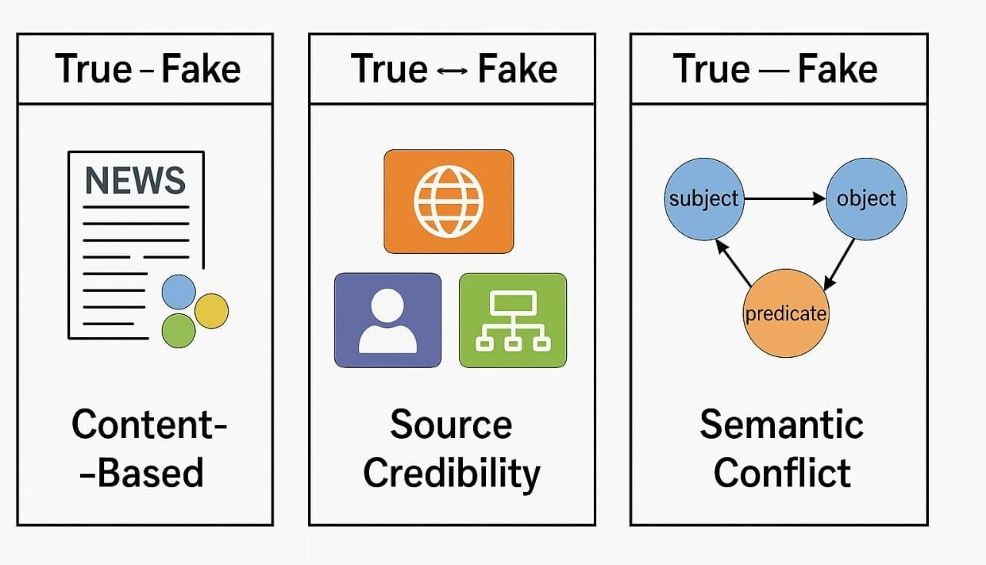
Fig. 1. Sample image for 3 categories for fake news detection
lack of context. Moreover, the assessment of source credibility and semantic consistency testing enables the system to provide more comprehensible and explainable predictions, which is a significant step toward establishing user credibility and helping to make informed decisions. Consequently, the framework is highly applicable to the real-life implementation in the digital information environments of large scale, where precision, expandability, and responsibility are a necessary condition.

LITERATURE SURVEY
The issue of fake news detection has become a hot topic within the last several years because of the rapid distribution of fake information on the Internet. Most of the existing studies tend to classify detection methodologies into three broad categories: content-based analysis, usage of source credibility, and verification approaches based on knowledge.
The initial research was mainly on the content-based classification with the application of the conventional machine learning algorithms like Naive Bayes, Support Vector Machines, and Logistic Regression. These models were based on textual characteristics such as bag-of-words, n-grams and TF-IDF that are hand crafted. Although their results were good but they predominantly obtained superficial patterns and were unable to perceive deeper semantic meaning in news articles.
The initial research was mainly on the content-based classification with the application of the conventional machine learning algorithms like Naive Bayes, Support Vector Machines, and Logistic Regression. These models were based on textual characteristics such as bag-of-words, n-grams and TF-IDF that are hand crafted. Although their results were good but they predominantly obtained superficial patterns and were unable to perceive deeper semantic meaning in news articles. Other work explores early detection using the credibility of publishers and social media users to identify fake news shortly after it begins spreading. In parallel, graphbased and propagation-based methods represent users, posts, and interactions as networks, using graph neural networks to model how misinformation diffuses across social platforms, often achieving strong performance when rich social context is available.
Another research area is on fact-checking and knowledgeenhanced techniques. Knowledge-graph systems Knowledgegraph based systems match claims in news content with external structured knowledge bases which are represented by entity-relation triplets as the interface between the text and the knowledge, and the model learns to reveal differences between them.Recent systems propose both knowledge-guided semantic analysis and dual-branch models, where a branch of the model encodes the news text (usually with BERT), and the other branch encodes structured external knowledge.
Other works combine named entity recognition, language models that are specialized and knowledge graphs to augment semantic interpretation and enhance fake news identification, especially in area-specific.

METHODOLOGY
The suggested fake news detection system is based on a multi-signal analytical framework, meaning that three autonomous models analyze various aspects of a news story: (1) Hybrid Content Analysis, ( 2) Source Credibility Evaluation, and (3) Semantic Conflict Verification. The evidence that each of the framework components captures is of a different kind regarding the credibility of a news article. Such individual outputs are then combined in a decision-level fusion module which enables the system to generate a more robust, interpretable and fact-conscious classification result. It started by gathering news articles out of the dataset, as well as other useful metadata, including headlines, article text, source domains, URLs, and author information. After a process of data acquisition, a process of preprocessing is used to prepare the text to be subjected to analysis. This step entails elimination of irrelevant characters, stopwords, punctuations and other noises. The cleaned up text is subsequently lemmatized to standardize the appearance of words and grouped into one unitary representation which is what will be used as the input of the later analysis modules.
A.Hybrid Content Analysis Model:
Once the preprocessing has been completed, three independent models are adopted to analyze each news article and every model assumes a different aspect of the information. The initial one is called the Hybrid Content Analysis Model and it deals with the analysis of the linguistic structure and semantic meaning of the text..
This model is based on statistical features obtained with the help of TF-IDF method and also forming the contextual representation with the help of the DistilBERT embeddings. The combination of these two sets of features creates a content-based score that implies the degree of the article correspondence to textual and semantic patterns that tend to be typical of fake news.
By emphasizing the actual content of the article, this module is able to capture both surface-level language characteristics and deeper contextual relationships, enabling a more comprehensive understanding of the information being analyzed. This model is concerned with the content of the article, which takes into consideration, both the surface-level linguistic patterns and the context meaning.
1) The use of TF-IDF statistical representation.
The TF-IDF module identifies the importance of specific terms within the document relative to the entire corpus. For a term t in document d, TF-IDF is computed as:
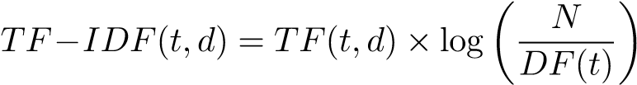
- TF(t,d): frequency of term t in document d
- DF(t): number of documents including t
- N: total number of documents
- DistilBERT Contextual Embedding:
Whereas TF-IDF works well in modelling local and frequencybased textual features, DistilBERT is modeled to extract more contextual-rich semantics of the text. Given an input sequence of n tokens, DistilBERT actually produces a hidden representation h i of each token, the contextual meaning of it in the sentence.
The model uses mean pooling on all token embeddings in order to get a single representation of the sentence in fixed length. The sentence embedding that has resulted. E is computed as:
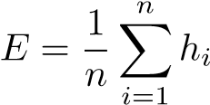
- Output score: The TF-IDF and DistilBert features are concatenated to form a single representation of the news content. This combined feature is then fed to the layer of classification that gives a content-based score of how probable the article is to be fake. The score is obtained based on statistical text patterns and contextual semantic information taken by the combined embeddings. B. Source Credibility Model:
The Source Credibility Model is aimed at evaluating the credibility of the publisher of the news, and not the news content. It looks at a number of source-level features, such as reputation of the domain, author transparency, URL structure, and the features of headlines, to compute a total credibility score. This score is an indicator of whether a news item is a product of a high quality, reliable source, or a potentially low-quality and unreliable publisher. This module builds upon content-based analysis, and, in special, concentrating on the publishing company allows determining the sources that create misleading information or focus on generating clicks all the time.
The model relies on a set of handcrafted credibility indicators, including:
- Domain reputation
- Author presence
- URL structure quality
- Text length and clickbait patterns
A simplified credibility function is expressed as:
CR_{s} = w₁D + w₂A + w₃S
where:
- D = domain trust value
- A = author reliability
- S = structural score
- w₁ + w₂ + w₃ = 1
C.Semantic Conflict Verification Model: The third model of checking the factual correctness of the article is the Semantic Conflict Verification Model. It derives subject-predicate-object triples of the news material and matches them against the proven facts stored in an edited knowledge base. With embedding-based similarity, the model finds out whether the statements provided in the article match known information or go against it, creating a score on semantic conflict. 1) Triple Extraction:
The system produces subject–predicate–object (S–P–O) triples:
T = (s,p,o)
- Knowledge Base Comparison:
Every triple is added and checked with proven facts with the help of cosine similarity:
Sim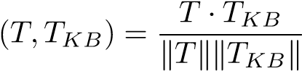
- Conflict Score:
Semantic conflict score is high which implies higher disagreement with known truth:
S_{s} = 1 − max(Sim)
The result is the score of semantic consistency that indicates the agreement of the article with factual knowledge.
TABLE I
FAKE NEWS DETECTION PERFORMANCE
Model Name | Description | Accuracy | F1-Score
Hybrid Content Analysis | TF-IDF | 93.4 | 93.2
Source credibility | trust,author info | 79.6 | 77.5
Semantic conflict | Fact comparision | 85.1 | 83.4
This is a multi-signal system that assists the system to overcome the shortcomings of single-model approaches. The proposed framework provides a more reliable and complete way of detecting fake news by combining the three elements, content, source credibility, and factual consistency to come up with a more valid solution.
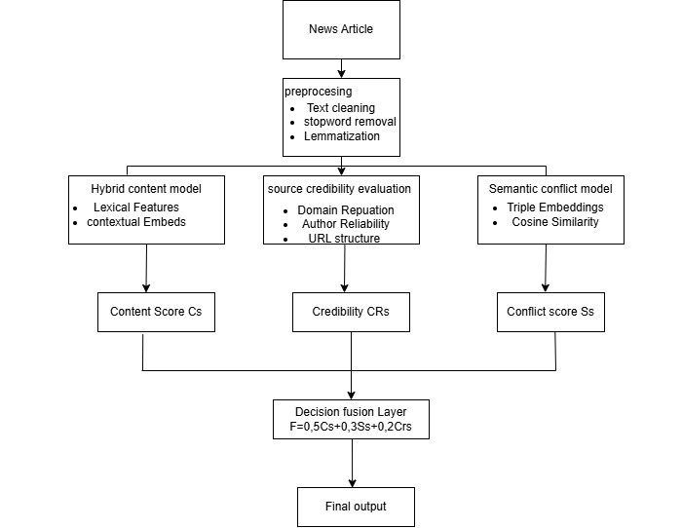
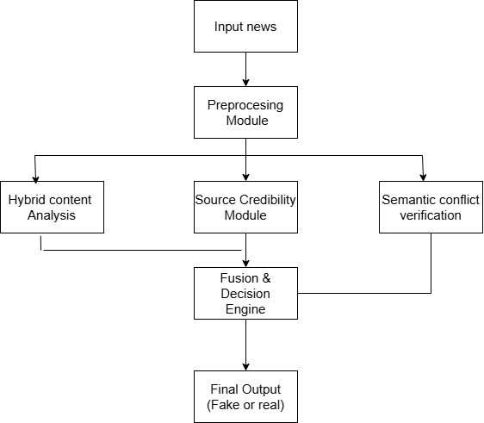
The third division of the framework is referred to as the Semantic Conflict Model that ensures that fact-level verification of the news material takes place. This module is
facts in its analysis.
Each of the models results in its score, content quality,
source credibility, and semantic consistency. These points are
represented by these scores: the language of the article, the
credibility of the source, and the accuracy of the facts of the
article. At the last step, all three signals are synthesized to
arrive at the final decision. This method will so that the system
will not rely on a single factor, but rather it will make use of
several sources of evidence to provide a more balanced and
reliable prediction. The ultimate output categorizes the article
into Fake and Real, and a small description of each module.
Fig. 3. Block diagram of the Fake News detection System
based embeddings. Judging by these representations, the
model identifies writing styles and contextual cues that are
traditionally linked to fake news and generates a (Cs) that
reflects the risk of misinformation.
The
second
component
of
the
framework
includes
the Source Credibility Evaluation Model, which aims at
evaluating the credibility of the news publisher. This module
uses the source level attributes (domain reputation, author
transparency, structural quality of the URL) to calculate a
total Credibility Score (CRs) which is a measure of the
reliability of the source of the article.
This is a multi-signal approach, which is structured to help the system to eliminate the issues of previous singlesystem checkers. The proposed framework is a more powerful, more precise and more comprehensive approach to fake news detection by combining content, source and consistency of Fig. 2. Architecture diagram for fake news detection
The architecture diagram shows the entire process of the proposed multi-signal fake news detection framework. Raw Input News is the first component of the system whereby the title and full article text are extracted out of the dataset and then by the Preprocessing Layer where text normalization is done to prepare the input to proceed with analysis. The step involves text cleaning through the deletion of irrelevant characters, elimination of stopwords, and lemmatization to standardize words. Simultaneously, appropriate metadata characteristics are retrieved. The result of the layer is a neat, organized, and uniform display of the information, which is appropriate in other downstream analytical models.
After the preprocessing, the refined news article is processed by three independent modules that are reviewing a different aspect of the information. The Hybrid Content Model aims to extract the linguistic patterns and semantic context of the text with the help of the TF-IDF features and DistilBERTused to extract subject-predicate-object triples of the article and match them with a verified facts knowledge base through semantic similarity measures. Depending on the degree of agreement or disagreement identified, the model produces a Conflict Score providing the extent of factual discrepancy evident in the article. The Final Output Label is obtained in the last stage by using the results of all the analytical branches to determine the news article to be a Fake or a Real news article.
The architecture diagram is used to show the workflow of the proposed fake news detection system step by step. A news article is used as the input which is initially processed by means of preprocessing operations like eliminating irrelevant or undesired words and breaking the text into the relevant parts that can be further analyzed. The cleaned text is then submitted to three distinct modules, the Hybrid Content Analysis module which removes linguistic and semantic features; the Source Credibility module which verifies the trustworthiness of the source,link style and writer information and the Semantic Conflict Verification module which attempts to find the match of facts by seeking real world names and comparing them with known information; These values are then combined in a fusion and result block to produce the final Fake/Real classification and confidence.

RESULT ANALYSIS
The Kaggle Fake News Dataset was used to test the proposed multi-signal fake news detection framework and includes fake and real news articles. Each of the three models such as the Hybrid Content Analysis, the Source Credibility Evaluation and Semantic Conflict Verification was tested individually and then merged together. The findings also demonstrated that the combined model performs considerably better than the each parts demonstrating the efficiency of different clues use as opposed to the use of an individual thing.

Fig. 4. Resulting Image
As the more precise check reveals, the content checker is effective in identifying stylistically manipulative writing, whereas the semantic model identifies the false statements even though the writing appears to be a normal writing. Credibility model is useful in the detection of suspicious publishing patterns. The complementary strengths are brought together, however, in the joining method and the fake news detection system becomes stronger and easier to comprehend.
The proposed system may be enhanced with the multimodal analysis to verify images, video, and audio related to news pieces. Semantic verification module can be enhanced by connecting to larger constantly updated knowledge graphs as well as real-time fact-checkers. Graph neural networks have the potential to model the user behavior and pattern of propagation to gain more insights about
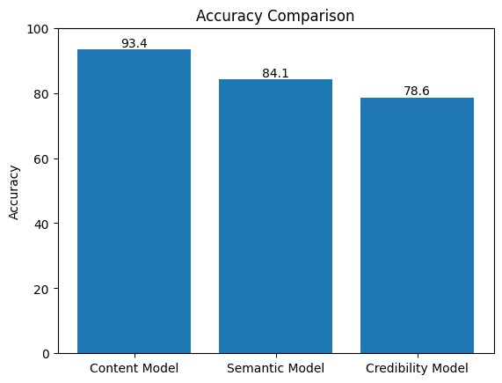
Fig. 5. Accuracy comparision of 3 models
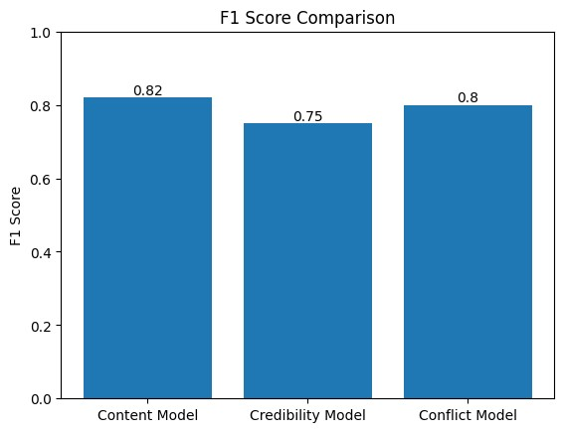
Fig. 6. F1 score comparision for 3 models
how misinformation is propagated. The source credibility module can be configured to adhere to the trust of the websites and realness of writers over a period of time. Further developed models of this may also be incorporated with the help of transformers in order to enhance contextual insight.
REFERENCES
- Barua R, Maity R, Minj D, Barua T, Layek AK. F-NAD: An application for fake news article detection using machine learning techniques. In: 2019 IEEE Bombay section signature conference. 2019. p. 1–6.
- Bedi A, Pandey N, Khatri SK. A framework to identify and secure the issues of fake news and rumours in social networking. In: 2019 2nd international conference on power energy, environment and intelligent control. 2019. p. 70–3.
- Bonato A, Nazareth A. Facts or fake news: Revealing patterns in the COVID-19 tweets of Trudeau and Trump. 2020,
URL https://theconversation.com/factsor-fake-news-revealing-patterns-
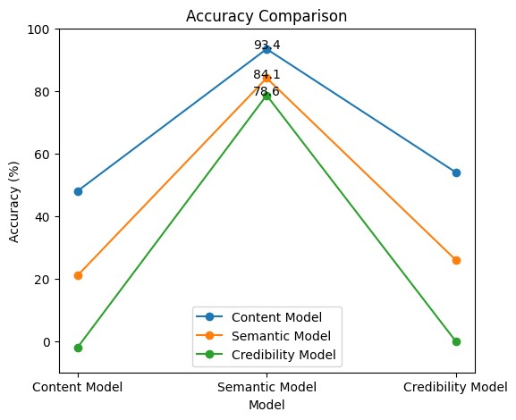
Fig. 7. Model Accuracy Comparison
in-the-covid-19-tweets-of-trudeau-andtrump-142139. [Accessed 10 July 2020].
- Ding Jin, Sun Hailong, Wang Xu, Liu Xudong. Entity-level sentiment analysis of issue comments. In: 2018 IEEE/ACM 3rd international workshop on emotion awareness in software engineering. 2018. p. 7–13.
- Das D, Clark AJ. Satire vs fake news: You can tell by the way they say it. In: 2019 first international conference on ?transdisciplinary AI. 2019. p. 22–6.
- Kang S, Hwang J, Yu H. Multi-modal component embedding for fake news detection. In: 2020 14th international conference on ubiquitous information management and communication. 2020. p. 1–6.
- Manzoor SI, Singla J, Nikita. Fake news detection using machine learning approaches: A systematic review. In: 2019 3rd international conference on trends in electronics and informatics. 2019. p. 230–4.
- Petchot Kamonwan. ‘Fake news’ in the time of COVID-19. 2020, UNESCO Bangkok. URL https://bangkok.unesco.org/index.php/content/press-provides antidote -fake-news-time-covid-19. [Accessed 10 July 2020].
- Qi P, Cao J, Yang T, Guo J, Li J. Exploiting multi-domain visual information for fake news detection. In: 2019 IEEE international conference on data mining. 2019. p. 518–27. [4] Bonato A, Nazareth A. Facts or fake news: Revealing patterns in the COVID-19 tweets of Trudeau and Trump. 2020,
URL https://theconversation.com/factsor-fake-news-revealing-patternsin-the-covid-19-tweets-of-trudeau-andtrump-142139. [Accessed 10 July 2020].
- Ramezani M, Rafiei M, Omranpour S, Rabiee HR. News labeling as early as possible: Real or fake? In: 2019 IEEE/ACM international conference on advances in social networks analysis and mining. 2019. p. 536–7.
- Sa-nga-ngam P, Mayakul T, Srisawat W, Kiattisin S. Fake news and online disinformation. A perspectives of Thai government officials. In: 2019 4th technology innovation management and engineering science international conference, TIMES-ICON. 2019. p. 1–4.
- Snell N, Fleck W, Traylor T, Straub J. Manually classified real and fake news articles. In: 2019 international conference on computational science and computational intelligence. 2019. p. 1405–7.
- Uppal A, Sachdeva V, Sharma S. Fake news detection using discourse segment structure analysis. In: 2020 10th international conference on cloud computing, data science engineering. 2020. p. 751–6.
- Vinit Bhoir S. An efficient fake news detector. In: 2020 international conference on computer communication and informatics. 2020. p. 1–9.

