MICROWAVE-ASSISTED OXIDATION OF CYCLOHEXANECARBOXAMIDE BY DI-TERTIARY-BUTYL CHROMATE IN ORGANIC MEDIA: SYNTHESIS AND CHARACTERIZATION OF PRODUCTS
_______________________________________________________________________________________________
Abstract: Microwave irradiation has profoundly influenced the field of organic synthesis, and has emerged as a valuable technique for enabling rapid and efficient chemical transformations. In this study, we explored the oxidation of cyclohexanecarboxamide using di-tertiary-butyl chromate (TBC) under microwave irradiation in various organic solvents, such as tetrahydrofuran (THF), 1,4-dioxane, and dichloromethane (DCM). The reaction mixtures were prepared by combining the substrate solution with TBC in appropriate ratios, followed by stirring and microwave irradiation for specific durations. The resulting products were characterized using a combination of chemical and instrumental techniques, including elemental analysis, Fourier transform infrared (FTIR) spectroscopy, differential thermal analysis (DTA), thermogravimetric analysis (TGA), and mass loss patterns. Our findings demonstrate that this microwave-assisted approach aligns with the principles of green chemistry and offers a sustainable and efficient route for the oxidation of cyclohexanecarboxamide.
Keywords: Di-tertiary-butyl chromate (TBC), Cyclohexanecarboxamide, Tetrahydrofuran (THF), Dichloro-methane (DCM), and Microwave heating.
- INTRODUCTION
Microwave-assisted organic synthesis (MAOS)^{1_2} and microwave-induced organic reactions (MIOR)³ have revolutionized organic chemistry by offering sustainable and efficient synthetic approaches. These techniques align with green chemistry⁴⁻⁵ principles, reduce reaction times, improve yields, and minimize waste generation. The concept of microwave dielectric heating, introduced by Spencer⁶ in 1947, was applied to organic synthesis in the pioneering work of Gedye et.al.⁷⁻⁹ in 1986. Since then, the field has flourished, with over 2000 research articles demonstrating the versatility of microwave-assisted techniques. A comprehensive review by P. Lindstrom et al ¹⁰. highlighted the advantages of MAOS and MIOR, including significantly reduced reaction times, improved product yields, and minimal waste generation. These techniques are attractive alternatives¹¹ to the conventional heating methods.
In this study, we explored the oxidation of cyclohexanecarboxamide ¹² using di-tertiary-butyl chromate¹³ (TBC) under microwave irradiation. TBC, a robust and versatile oxidant, has been extensively studied since its introduction by Oppenaur and H. Oberrauch¹⁴ in 1949. The products of cyclohexanecarboxamide have the potential to serve as ligands for the formation of Cr complexes in various oxidation states.
Cyclohexanecarboxamide, an alicyclic amide, is a white to light yellow coloured odourless solid. It can act as a precursor for both specialised polymers^{15_17} and bioactive molecules^{18_20} in agricultural and pharmaceutical chemistry. It is also used for the production of alicyclic amines²¹ for further chemical derivatisation it also finds its use in the synthesis of high valent Chromium complexes and mixed ligand²² co-ordination compounds. By oxidizing cyclohexanecarboxamide with TBC under microwave irradiation, we synthesized and characterized chromium complexes^{23_24} in lower oxidation states. This approach expands the scope of ethyl cyclohexanecarboxamide chemistry and demonstrates the versatility of TBC as an oxidizing agent^{25_26}.
- MATERIALS AND METHODS
All chemicals used in this study were of analytical reagent (A.R.) grade procured from commercial sources and used as received. Cyclohexanecarboxamide, chromium (VI) oxide, tertiary butyl alcohol, tetrahydrofuran (THF), 1,4-dioxane, dichloromethane (DCM), acetone, silver nitrate, potassium persulfate, ammonium iron (II) sulfate (Mohr's salt), potassium dichromate, and barium diphenylamine-1-sulfonate has also used.
The oxidant di-tertiary-butyl chromate (TBC) was synthesised in situ through the dissolution of a precisely weighted quantity of chromium (VI) oxide in 10 ml of tertiary butyl alcohol. Cyclohexanecarboxamide (2 g) was dissolved in 10 ml of tetrahydrofuran (THF), 1,4-dioxanloromethane (DCM) in a rigorously cleaned and desiccated beaker under continuous magnetic stirring at room temperature. The substrate-to-oxidant molar ratios were 1:1, 2:1, and 3:1, respectively. The reaction mixture was irradiated in a Samsung household microwave oven G-273V (20 L, 2450 MHz, and 150 W) for various oxidation times. Thermometric measurements were conducted to assess the exothermic and endothermic natures of the reaction by recording the initial and final temperatures of the reaction mixture. The isolated products were subsequently washed with acetone, meticulously dried, labelled A11CHAMIDE, A21CHAMIDE, A31CHAMIDE, B11CHAMIDE, B21CHAMIDE, B31ECHC, C11CHAMIDE, C21 CHAMIDE, C31CHAMIDE, and stored for further analytical and spectroscopic characterization. The percentage compositions of carbon, hydrogen, and nitrogen were determined using a EUROVECTOR E-3000 elemental analyser. The chromium content was subsequently quantified by volumetric titration using potassium persulfate, potassium dichromate, and Mohr's salt solutions. The oxygen content was calculated by subtracting the percentages of carbon, hydrogen, nitrogen, and chromium from 100. The empirical formulae for the complexes were deduced from the elemental analysis data. Fourier transform infrared (FTIR) spectra of the products were recorded on a PerkinElmer Fourier transform infrared spectrometer (FTIR4000-450 cm⁻¹). Thermogravimetric and differential thermal analyses (TG-DTA) of the compounds were performed using a Perkin Elmer Diamond TG-DTA system. The samples underwent a controlled heating process at a constant heating rate of 10°C /min, progressing from ambient temperature to a final temperature of 700°C. The characterization data for all synthesized products, including FTIR spectra, TG-DTA thermographs and corresponding analytical data in Tables 1-3 are summarised.
- ETHICAL COMPLIANCE
This research project involved human participants and was conducted in accordance with the approval granted by the Ethics Committee of the University Department of Chemistry, Ranchi University.
- RESULTS AND DISCUSSION
The exhaustive analytical data presented in Tables 1, 2, and 3, and the FTIR, and TG-DTA graphs encompassing the physical parameters, elemental analysis, and proposed chemical formulations, respectively, coupled with the FTIR, TGA-DTA graphical representations, facilitate the derivation of several pertinent technical conclusions pertaining to the synthesis of chromium-cyclohexanecarboxamide (CHAMIDE) complexes. A meticulous examination of these datasets enables a comprehensive understanding of the complexation process, thereby permitting inferences to be drawn regarding the structural and compositional attributes of the resultant chromium-CHAMIDE complexes.
Table 1: Preliminary product characterisation (Cyclohexanecarboxamide -TBC)
Serial no. | Sample label | Solvent | Subs./ Oxd. Ratio | Microwave Irad. Time (in sec.) | Yield (in gm.) | Colour | Solubility  (in water)
 | A11 CHAMIDE | THF | (1:1)  2g/2g | 44 | 3.12 | Dark Brown | Sparingly Soluble
 | A21 CHAMIDE | THF | (2:1)  2g/1g | 60 | 2.40 | Greyish Green | Sparingly Soluble
 | A31 CHAMIDE | THF | (3:1) 2g/0.67g | 72 | 2.13 | Dak Green | Insoluble
 | B11 CHAMIDE | 1,4- Dioxane | (1:1)  2g/2g | 75 | 2.10 | Brownish Green | Insoluble
 | B21 CHAMIDE | 1,4- Dioxane | (2:1)  2g/1g | 100 | 1.84 | Brownish Green | Insoluble
 | B31 CHAMIDE | 1,4- Dioxane | (3:1) 2g/0.67g | 110 | 1.05 | Brownish Green | Insoluble
 | C11 CHAMIDE | DCM | (1:1)  2g/2g | 64 | 2.55 | Greenish Blue | Sparingly Soluble
 | C21 CHAMIDE | DCM | (2:1)  2g/1g | 82 | 1.86 | Greenish Blue | Sparingly Soluble
 | C31 CHAMIDE | DCM | (3:1) 2g/0.67g | 90 | 1.20 | Brownish Green | Insoluble

Table 2: Product formulation– I
Serial No. | Sample No. | Cr% | C% | H% | N% | O% | Empirical Formula
 | A11  CHAMIDE | 17.87 | 14.43 | 2.06 | 2.40 | 63.24 | Cr₂C₇H₁₂NO₂₃
 | A21  CHAMIDE | 19.92 | 16.09 | 3.06 | 2.68 | 58.25 | Cr₂C₇H₁₆NO₁₉
 | A31  CHAMIDE | 21.94 | 17.72 | 3.37 | 2.95 | 54.02 | Cr₂C₇H₁₆NO₁₆
 | B11  CHAMIDE | 21.94 | 17.72 | 3.37 | 2.95 | 54.02 | Cr₂C₇H₁₆NO₁₆
 | B21  CHAMIDE | 23.42 | 18.92 | 4.05 | 3.15 | 50.46 | Cr₂C₇H₁₈NO₁₄
 | B31  CHAMIDE | 25.49 | 20.58 | 3.43 | 3.43 | 47.07 | Cr₂C₇H₁₄NO₁₂
 | C11  CHAMIDE | 19.84 | 16.03 | 3.43 | 2.67 | 58.03 | Cr₂C₇H₁₈NO₁₉
 | C21  CHAMIDE | 20.47 | 16.53 | 3.54 | 2.75 | 56.71 | Cr₂C₇H₁₈NO₁₈
 | C31  CHAMIDE | 24.29 | 19.63 | 4.20 | 3.27 | 48.61 | Cr₂C₇H₁₈NO₁₃

Table 3: Product formulation– II
Sl. No. | Sample No. | Empirical Formula | Formulation
1. | A11 CHAMIDE | Cr₂C₇H₁₂NO₂₃ | Cr₂O₃ (COOH COOH)₂ 3CO₂ (H₂O)₄ NO₂
2. | A21 CHAMIDE | Cr₂C₇H₁₆NO₁₉ | Cr₂O₃ (HOOCCH₂COOH) (CH₃COOH) (CO₂)₂ (H₂O)₄ NO₂
3. | A31 CHAMIDE | Cr₂C₇H₁₆NO₁₆ | Cr₂O₃ (HOOC(CH₂)₂COOH) (CH₃COOH) (CO₂) (H₂O)₃ NO₂
4. | B11 CHAMIDE | Cr₂C₇H₁₆NO₁₆ | Cr₂O₃ (HOOC(CH₂)₂COOH) (CH₃COOH) (CO₂) (H₂O)₃ NO₂
5. | B21 CHAMIDE | Cr₂C₇H₁₈NO₁₄ | Cr₂O₃ (HOOC(CH₂)₃COOH) (CH₃COOH) (H₂O)₃ NO₂
6. | B31 CHAMIDE | Cr₂C₇H₁₄NO₁₂ | Cr₂O₃ (HOOC(CH₂)₄COOH) CO (H₂O)₂ NO₂
7. | C11 CHAMIDE | Cr₂C₇H₁₈NO₁₉ | Cr₂O₃ (HOOCCH₂COOH) (HOOCCOOH) (CH₃COOH) (H₂O)₄ NO₂
8. | C21 CHAMIDE | Cr₂C₇H₁₈NO₁₈ | Cr₂O₃ (HOOC (CH₂) COOH) (HOOCCOOH) (CH₃COOH) (H₂O)₄ NO
9. | C31 CHAMIDE | Cr₂C₇H₁₈NO₁₃ | Cr₂O₃ (HOOC (CH₂)₃ COOH) (CH₃COOH) (H₂O)₃ NO

FTIR, & TG-DTA Thermographs:

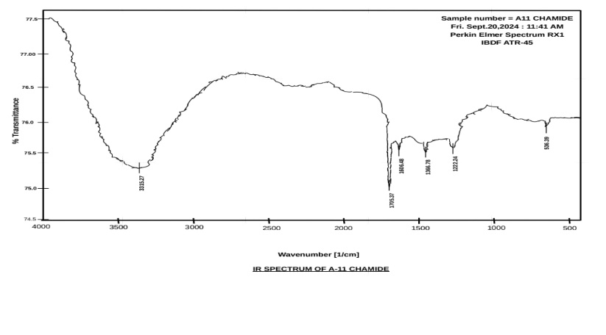Fig. (i) FTIR Spectrum of A-11 CHAMIDE

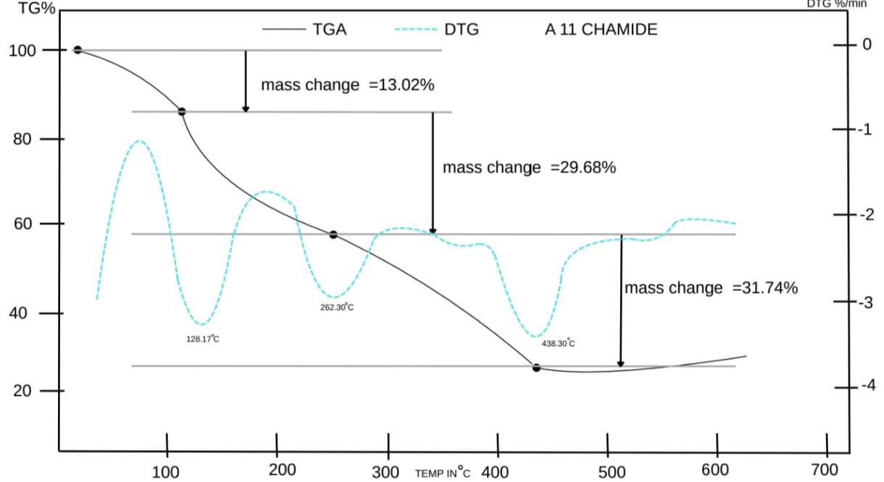Fig. (ii) TG-DTA of A-11 CHAMIDE

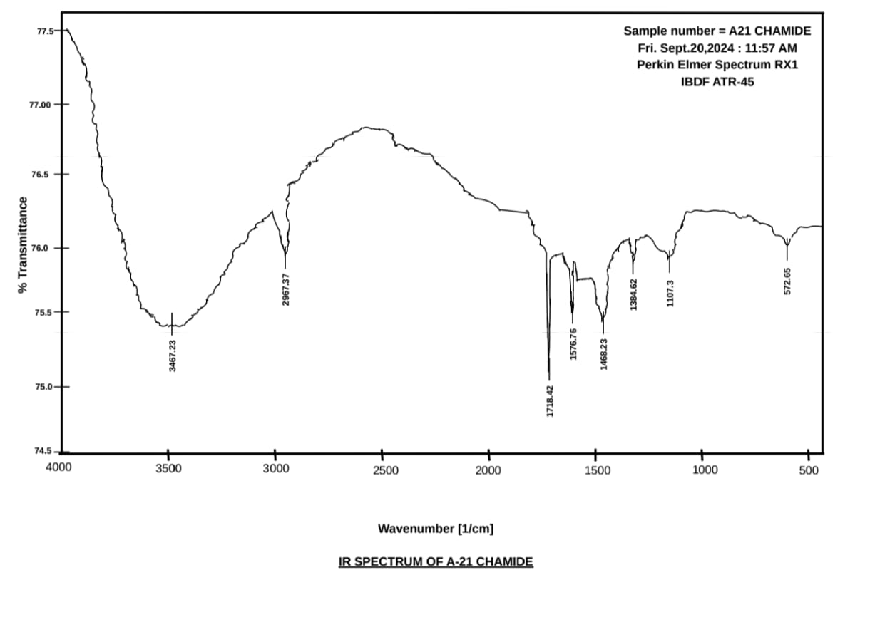Fig. (iii) FTIR Spectrum of A-21 CHAMIDE
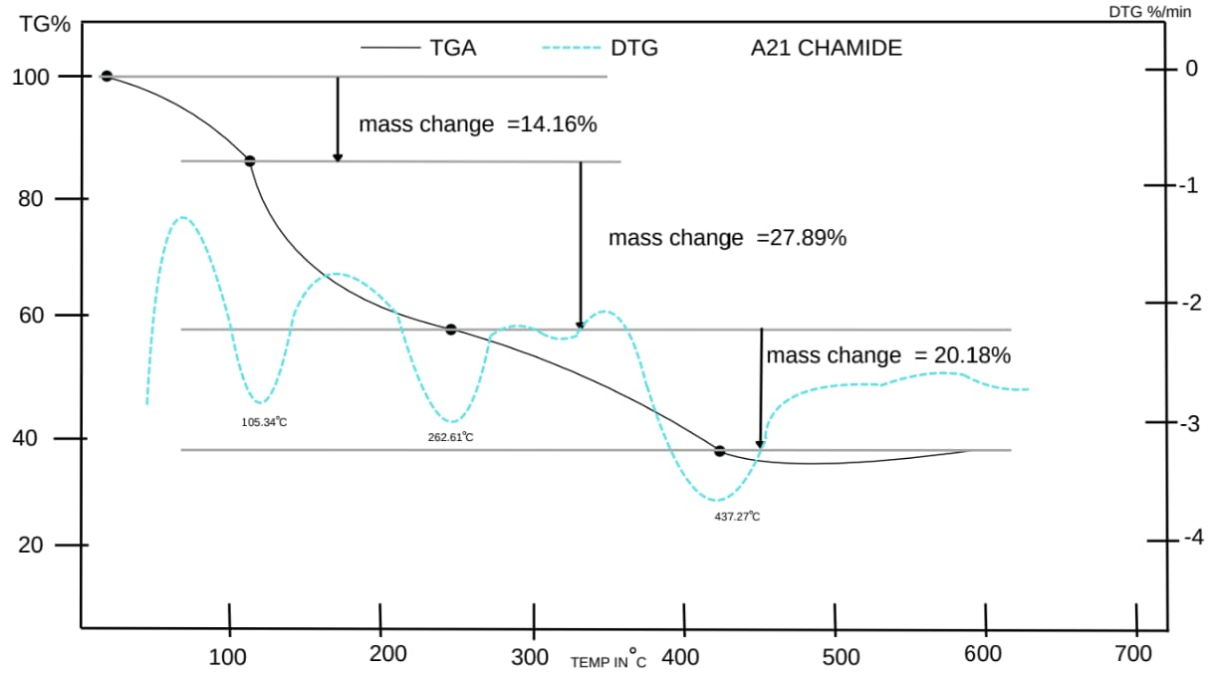Fig. (iv) TG-DTA of A-21 CHAMIDE

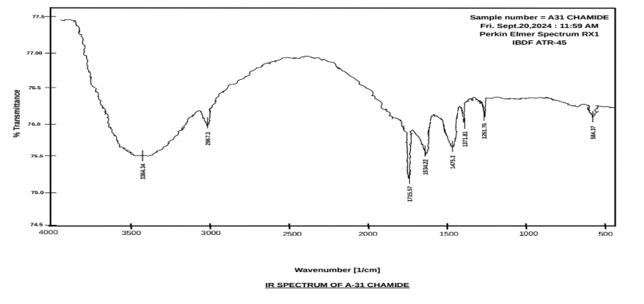Fig. (v) FTIR Spectrum of A-31 CHAMIDE

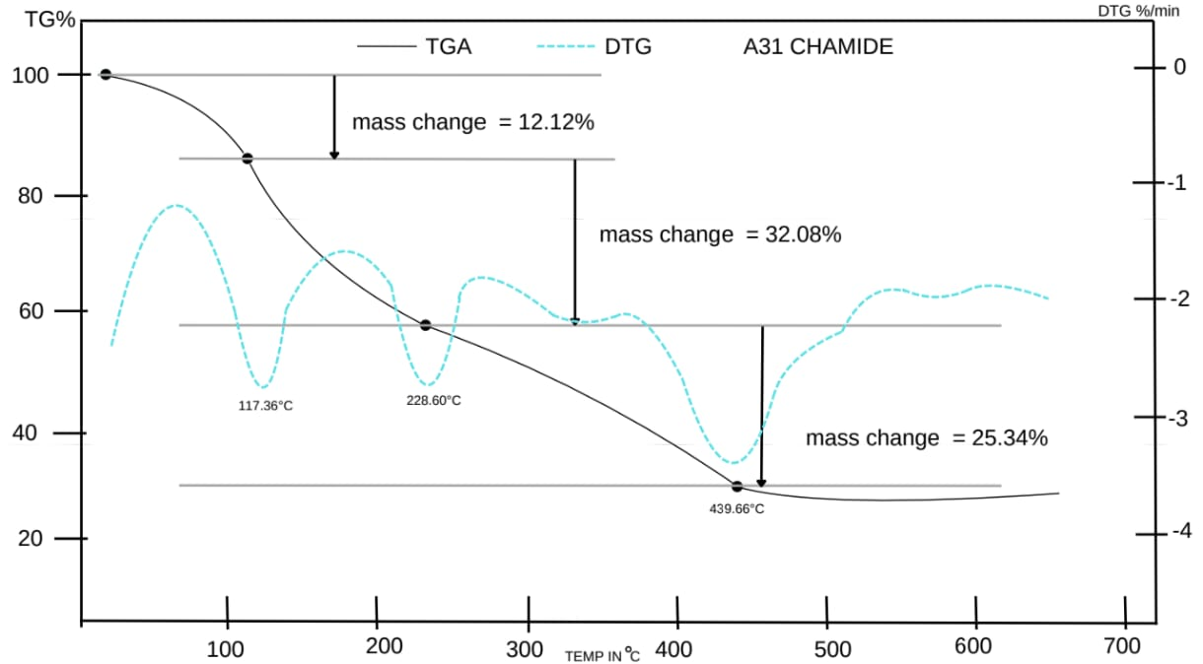Fig. (vi) TG-DTA of A-31 CHAMIDE

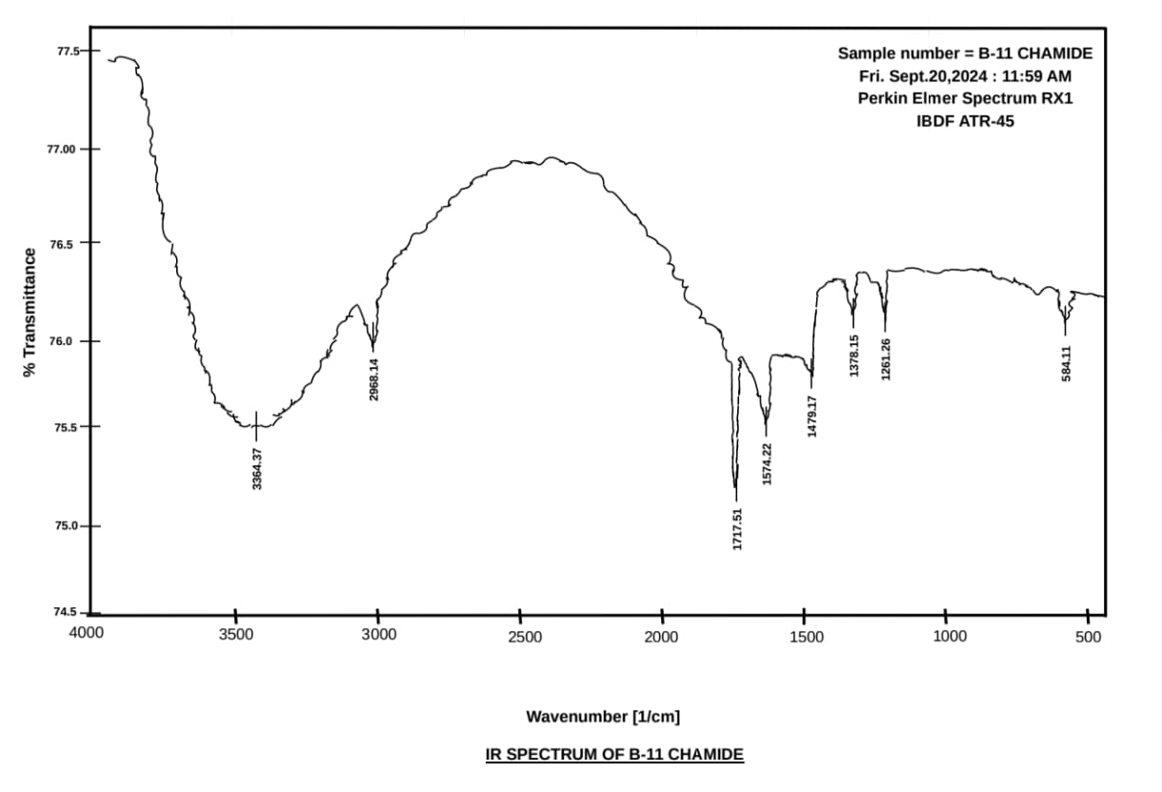Fig. (vii) FTIR Spectrum of B-11 CHAMIDE
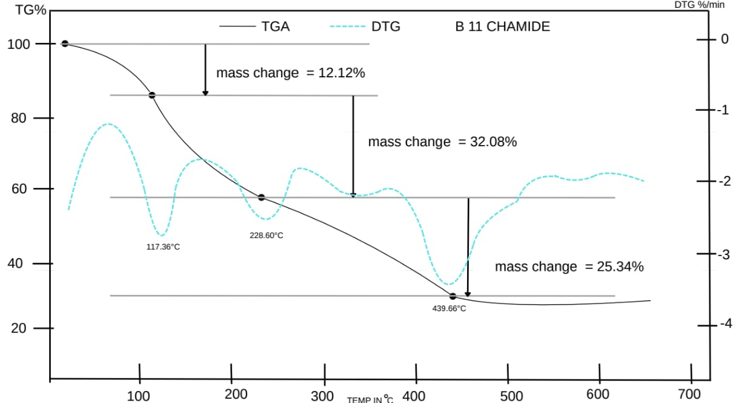Fig. (viii) TG-DTA of B-11 CHAMIDE
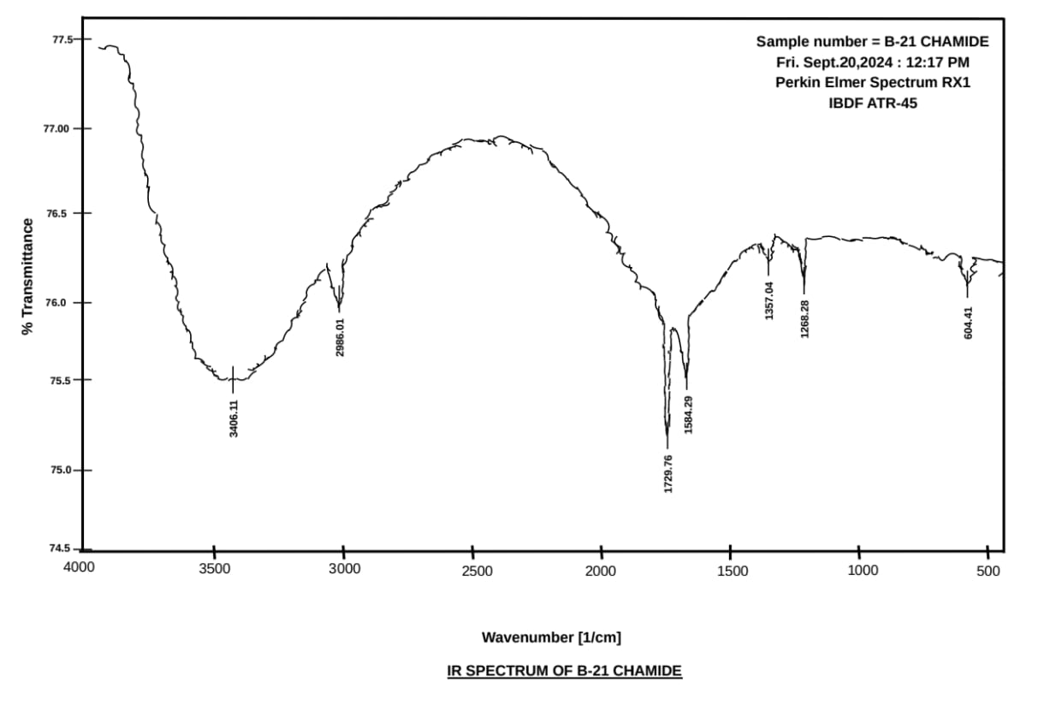Fig. (ix) FTIR Spectrum of B-21 CHAMIDE
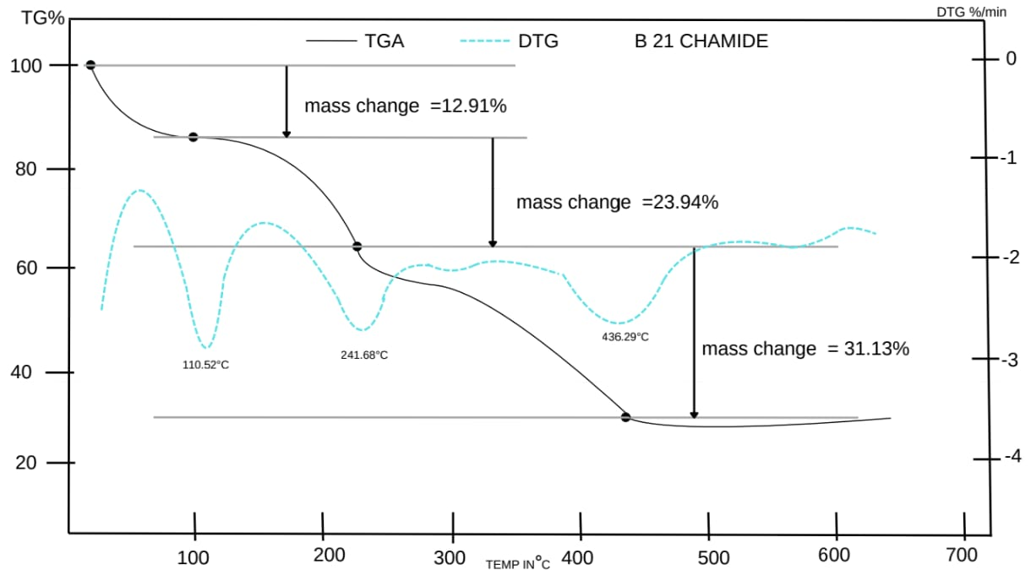
Fig. (X) TG-DTA of B-21 CHAMIDE
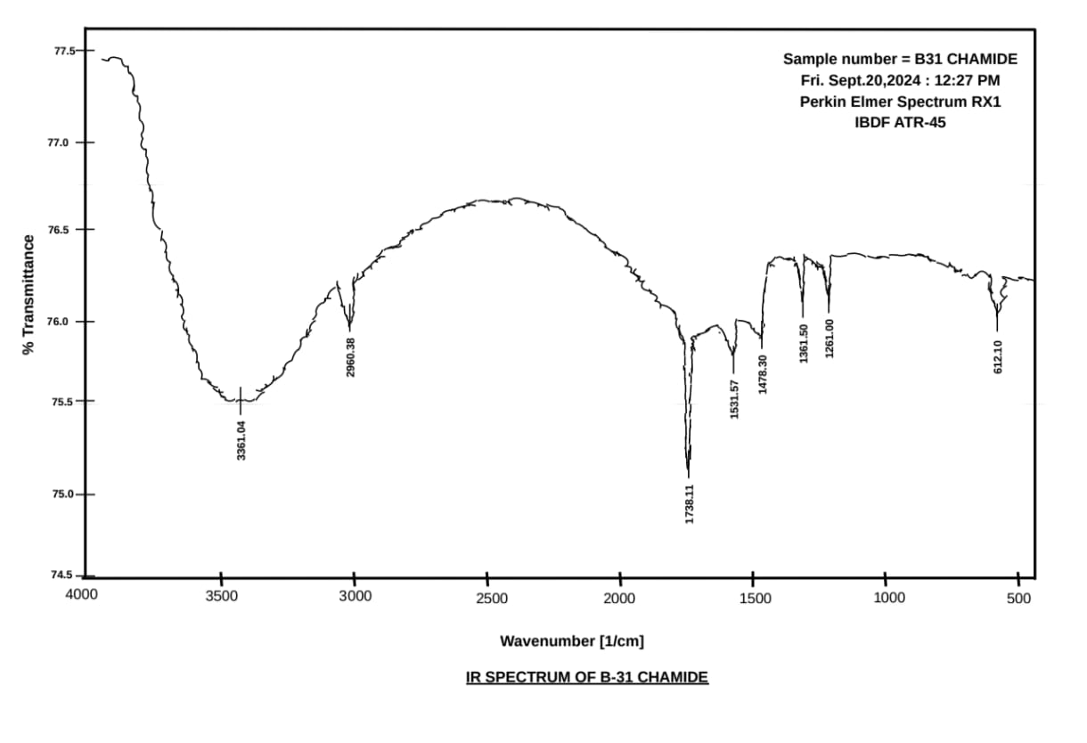Fig. (xi) FTIR Spectrum of B-31 CHAMIDE
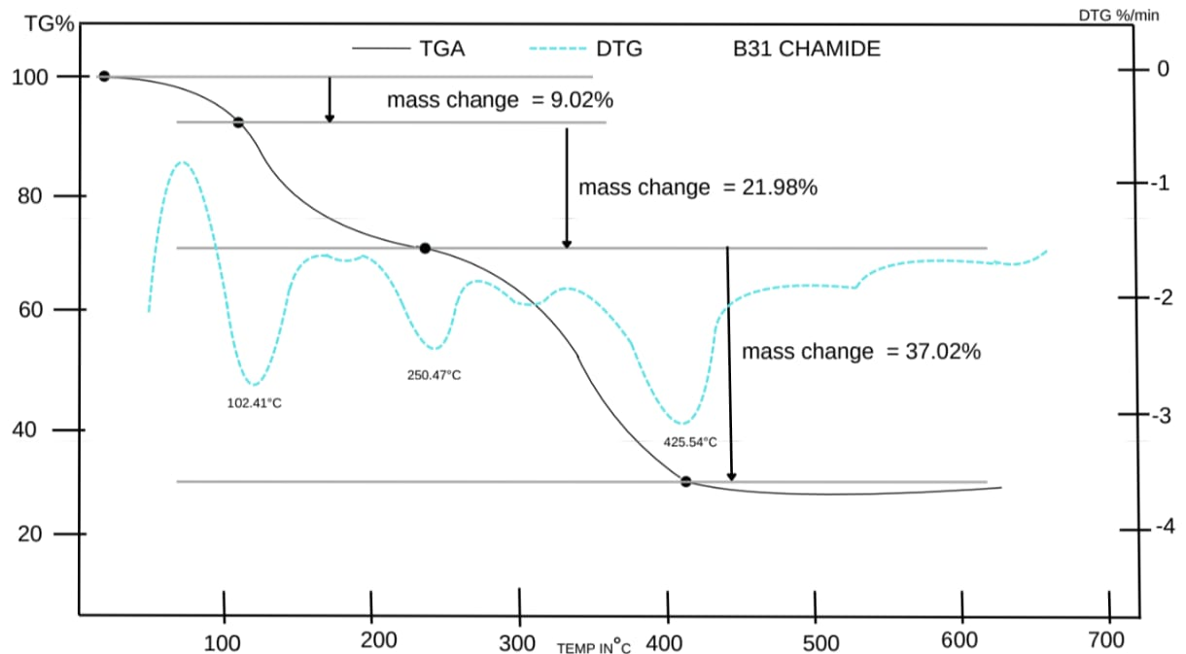Fig. (xii) TG-DTA of B-31 CHAMIDE
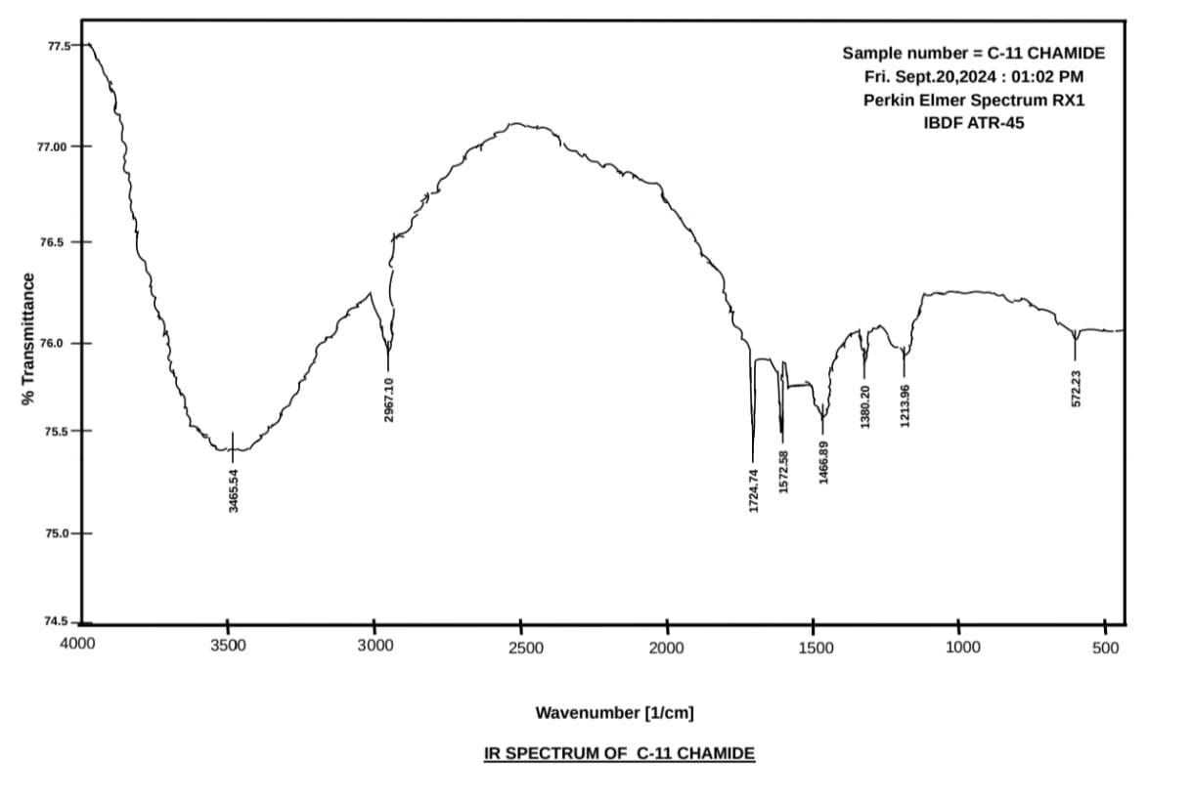Fig. (xiii) FTIR Spectrum of C-11 CHAMIDE
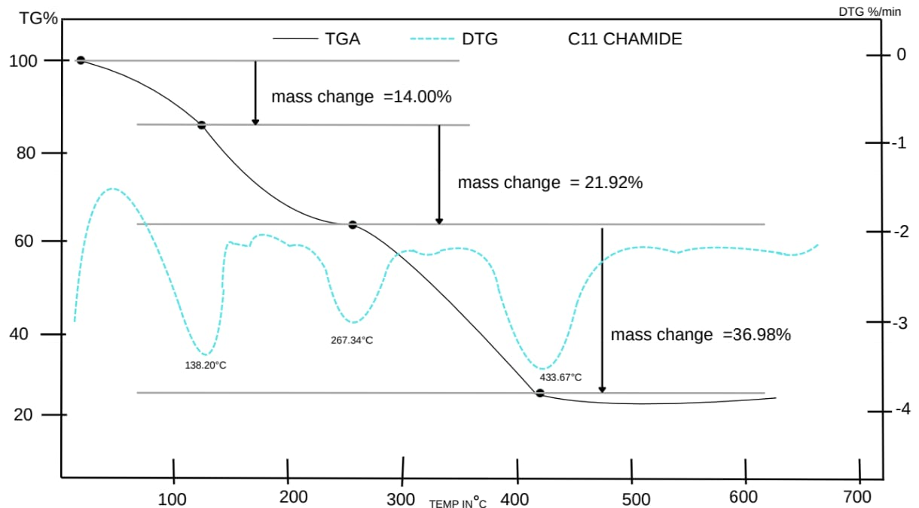Fig. (xiv) TG-DTA of C-11 CHAMIDE
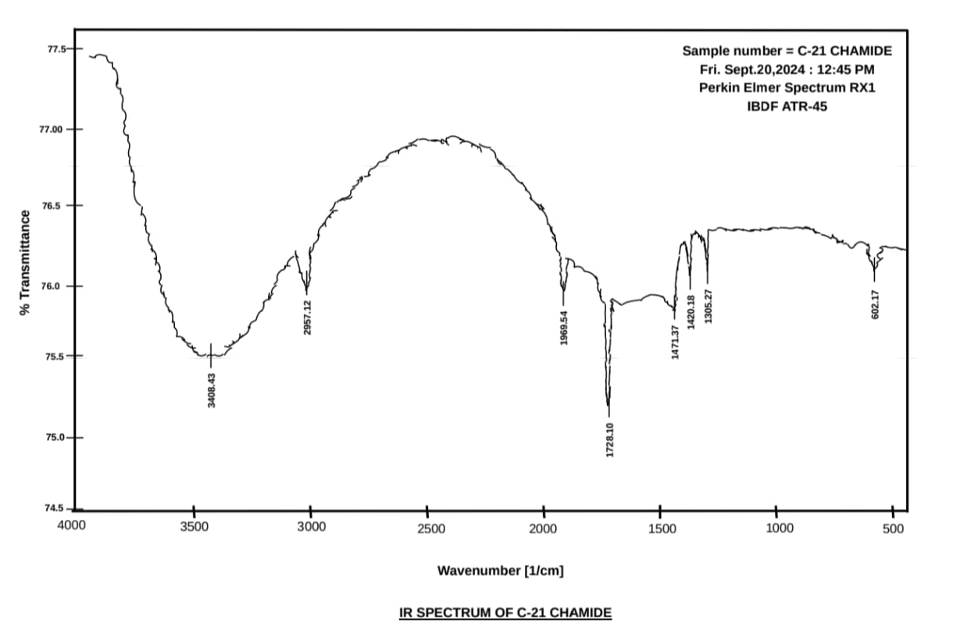Fig. (xv) FTIR Spectrum of C-21 CHAMIDE
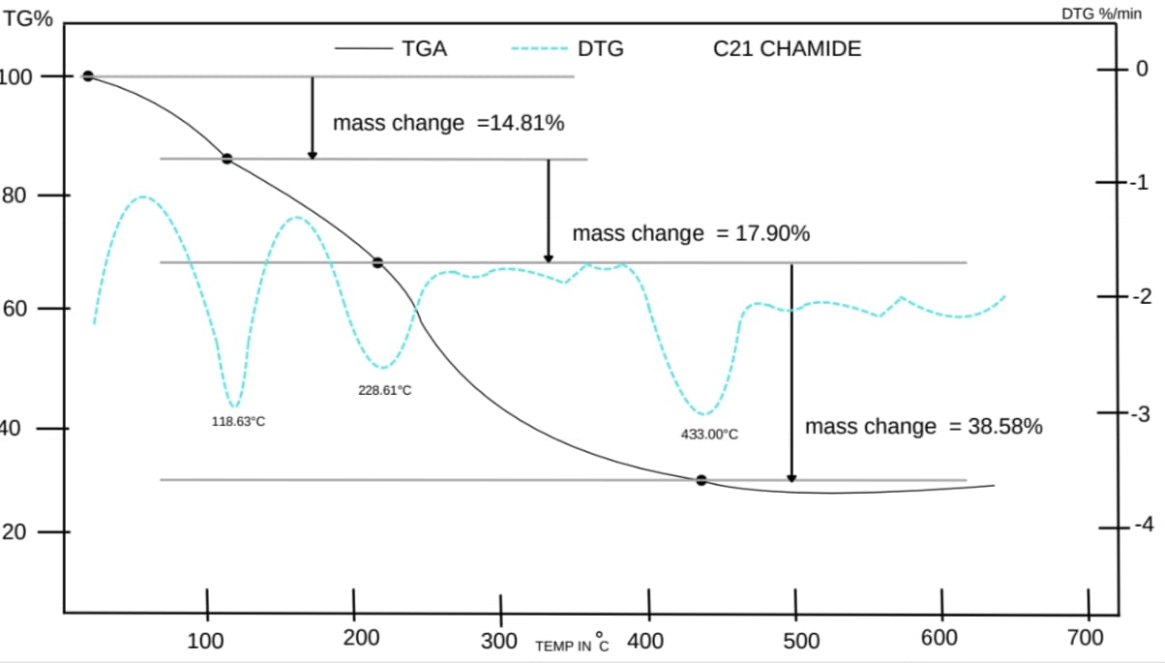Fig. (xvi) FTIR Spectrum of C-21 CHAMIDE
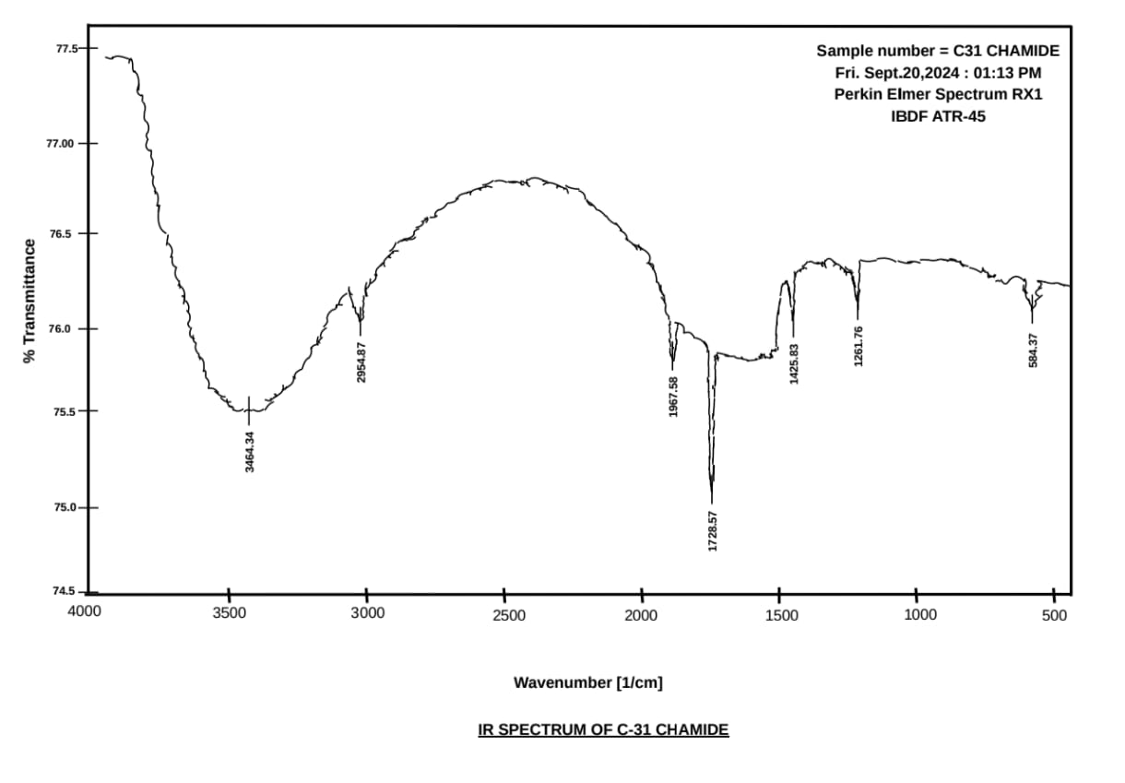Fig. (xvii) FTIR Spectrum of C-31 CHAMIDE
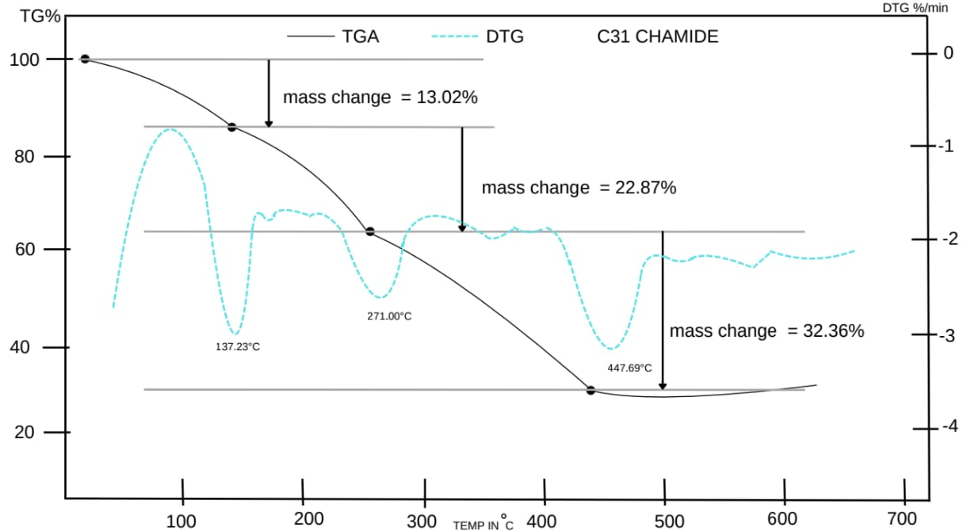Fig. (xviii) TG-DTA of C-31 CHAMIDE

4.1. Synthesis and Preliminary Characterization
​The interactions between cyclohexanecarboxamide and di-tert-butyl chromate (TBC) were investigated under microwave-assisted conditions.
- As summarized in Table 1, the microwave methodology facilitated rapid complexation, with reaction times ranging from 44 to 110 s. This represents a significant kinetic enhancement over classical thermal methods, which traditionally require several hours of reflux.
- Solvent Influence: The dielectric properties of the solvent significantly modulated the reaction rate and yield. Tetrahydrofuran (THF) proved to be the most efficient medium, yielding up to 3.12 g (Sample A11) within the shortest irradiation time (44 s). This efficiency is attributed to the optimal dipole moment of THF, which ensures rapid energy transfer during microwave exposure. In contrast, 1,4-Dioxane and Dichloromethane (DCM) required longer irradiation periods and generally resulted in lower mass recovery.
- Stoichiometric Effects: A clear dependency on the substrate-to-oxidant ratio was observed. The 1:1 ratio consistently provided the highest yields across all solvent systems. As the substrate concentration increased (3:1), a decrease in yield and a transition to complete water insolubility were noted, suggesting the formation of more hydrophobic or potentially higher-order coordination species.

​4.2. Elemental Analysis and Empirical Formulation
​The elemental compositions (C, H, N, O, and Cr) presented in Table 2 were used to derive the empirical formulas for the synthesized complexes.
- ​Chromium content: The chromium content consistently ranged between 17.87% and 25.49%, increasing as the substrate-to-oxidant ratio shifted from 1:1 toward 3:1. This trend indicates that higher substrate concentrations may promote the formation of complexes with a higher relative metal density or a more compact coordination sphere.
- ​Core Structure: The data consistently indicate a binuclear chromium (III) oxide core (Cr₂O₃). This suggests that during the microwave-assisted process, the hexavalent chromium in TBC undergoes a partial reduction and subsequent condensation to form a stable oxo-bridged binuclear framework.

​4.3. Proposed Structural Formulation and Ligand Fragmentation
​The structural formulations detailed in Table 3 provide deep insights into the oxidative role of TBC. The cyclohexanecarboxamide moiety appears to undergo systematic oxidative ring-opening and fragmentation.
- ​Oxidative Cleavage: The identification of various dicarboxylate ligands—including Oxalic acid, Malonic acid, Succinic acid, Glutaric acid, and Adipic acid—within the coordination sphere suggests that the TBC facilitates the cleavage of the cyclohexane ring at different positions depending on the reaction conditions.
- ​Coordination Environment: The Cr₂O₃ core is further stabilized by auxiliary ligands including acetate groups (likely derived from TBC degradation or oxidative byproducts), nitro groups (NO₂), and neutral molecules such as CO₂ and H₂O.
- ​Solvent-Dependent Coordination: Notably the choice of solvent influenced the specific dicarboxylate formed. For instance, THF systems (A-series) yielded oxalate, malonate, and succinate fragments, whereas 1,4-Dioxane (B-series) favoured longer-chain fragments like glutarate and adipate. This indicates that the solvent medium plays a role in stabilizing specific transition states during the oxidative degradation of carbamide.

​4.4. Physical Properties and Stability
​The transition in product colour from Dark Brown to Greenish Blue and Dark Green is indicative of d-d transitions within the chromium centres, consistent with the coordination of different carboxylate ligands. The shift in solubility from sparingly soluble to insoluble as the organic fraction increases suggests that the complexes become more polymeric or less polar as the chain length of the coordinated dicarboxylates increases.
- ​CONCLUSION
The microwave-assisted synthesis of chromium-cyclohexanecarboxamide complexes is a highly efficient, solvent-dependent process. The dual role of TBC as both an oxidant and a complexing agent leads to the formation of a series of binuclear Cr (III) complexes featuring fragmented dicarboxylate ligands. This study underscores the potential of microwave energy to drive complex oxidative coordination pathways in a matter of seconds which would otherwise be unattainable via conventional heating.
- DATA AVAILABILITY STATEMENT
The data presented herein were generated using experimental procedures only.
- ACKNOWLEDGMENTS
The authors acknowledge the cooperation and assistance provided by BIT Mesra, and SAIF Lucknow, which facilitated the testing and analysis of the samples.
Authors Contributions:
[Author 1]: Conceptualization, methodology, software, validation, formal analysis, investigation, resources, data curation, writing (original draft presentation), and funding acquisition.
[Author 2]: Conceptualization, methodology, visualization, supervision, validation, formal analysis, investigation, resources, data curation, writing (review and editing), and project administration.
Funding:
The researchers did not receive any external funding for this study.
Conflict of interest:
The authors declare that they have no conflicts of interest.

- REFERENCES:

- Kappe, C. O. "Microwave-Assisted Chemistry." In "Microwave-Assisted Organic Synthesis," pp. 1-19. Springer, 2013.
- De la Hoz, A., et al. (2011). Microwave-Assisted Organic Synthesis: A Critical Review. Tetrahedron, 67(2), 283-303.
- Singh, M. S., & Singh, A. K. (2019). Microwave-Induced Organic Reactions: A Review. Journal of Chemical Research, 43(10), 557-562.
- The twelve principles of Green Chemistry’ United States Environmental Protection Agency. 2006 Retrieved.
- Lahoz, Antonio De, Diaz-Ortiz, Angel and Prieto, Pilar, Microwave assisted green organic synthesis in alternative energy sources for green chemistry, 2016 pp. 1-33.
- Spencer, P., "Method of Treating Foodstuffs," US Patent 2,495,429, 1950.
- Gedye, R., Smith, F., Westaway, K., Ali, H., Baldisera, L., Laberge, L., & Rousell, J. (1986). The use of microwave ovens for rapid organic synthesis. Tetrahedron Letters, 27(3), 279-282.
- Gedye, R. N., & Wei, J. B. (1998). Microwave-assisted organic synthesis: A review. Canadian Journal of Chemistry, 76(5), 525-532.
- Gedye, R. N., & Rank, W. (1999). Microwave-assisted organic synthesis in solvent-free conditions. Journal of Chemical Research, Synopses, (10), 542-543.
- Lindstrom, P., Tierney, J., Wathey, B. and Westman, J. "Microwave Assisted Organic Synthesis-a Review," Tetrahedron, vol. 57, no. 45, pp. 9225-9283, 2001.
- Katre, Sangita; Study of oxidation of chromic acid with chromium complexes by classical and green approach; Der Chemica Sinicia,2014, 5 (6) Pelagia Research Library, pp 48-50.
- Cyclohexanecarboxamide – Wikidata https://share.google/ACf6pecKFWFbiA2Qg.
- Wheeler, J.M., "Ditertiary Butyl Chromate: A Versatile Oxidant," Journal of Chemical Research, vol. 2001, no. 10, pp. 432-433, 2001.
- Oppenaur, R.V. and Oberrauch, H. "Oxidation of Amines with Di-tert-butyl Chromate," Journal of the American Chemical Society, vol. 71, no. 10, pp. 3421-3424, 1949.
- Blomenhofer, M.; Ganzleben, S.; Hanft, D.; Schmidt, H. W. "Cyclohexanecarboxamides as Highly Efficient Nucleating Agents for Polypropylene." Macromolecules, 2005, 38(9), 3688–3695.
- Kristiansen, M.; Tervoort, T.; Smith, P. "Synergistic Nucleation of Poly(propylene) by Cyclohexanecarboxamide Derivatives." Polymer, 2003, 44(19), 5885–5891.
- Mohammadi, A. Z.; Garmabi, H. "Effect of Cyclohexanecarboxamide Derivatives on the Crystallization Kinetics and Morphology of Polypropylene." Journal of Applied Polymer Science, 2011, 121(4), 2322–2330.
- Scherer, O.; Knauf, W. “N-Cyclohexylcarboxamides: A New Class of Systemic Fungicides.” Pesticide Science, 1974, 5(2), 155–160.
- Smith, P. J.; Taylor, R. J.; Jones, A. M. "Cyclohexyl-substituted Amides as Hydrophobic Mimics in Protease Inhibition." Bioorganic & Medicinal Chemistry Letters, 1996, 6(12), 1483–1488.
- Canceill, J.; Gabard, J.; Schierer, O. "Synthesis and Anticonvulsant Activity of Some Cyclohexanecarboxamide Derivatives." European Journal of Medicinal Chemistry, 1980, 15(3), 221–225.
- Wallis, E. S.; Lane, J. F. "The Hofmann Rearrangement." Organic Reactions, 1946, 3, 267–306.
- Sigel, H.; Martin, R. B. "Coordinating Properties of the Amide Group." Chemical Reviews, 1982, 82(4), 385–426.
- Steiman, T. J., & Uyeda, C. (2015). "Reagents for Reductive Transition Metal Catalysis." Chemical Science, 6, 2327–2337.
- Zeng, X. (2013). "Recent Advances in Chromium-Catalyzed Carbon–Carbon Bond-Forming Reactions." Chemical Society Reviews, 42(13), 5658–5671.
- Katre, Sangita and Pandey, H.O. A Green approach to oxidation of succinic acid by chromium (VI) based complexes functioning as oxidant in International Journal of green chemistry and Bioprocess 2013 3(3) pp.3032.
- Katre, Sangita D. Recent Advances in the Oxidation Reactions of Organic Compounds using Chromium (VI) Reagents in Res.J.Chem.Environ. Vol. 24 (1) January (2020).

