Soil Moisture Mapping of Solano Nueva Vizcaya: A Comparison and Review

ABSTRACT
Soil moisture, defined as the presence or amount of water in the soil, is a critical element in hydrology, agriculture, and climate science, vital for understanding soil health, water cycle, and plant growth. Remote sensing, particularly using satellites like Sentinel-2 which is equipped with Multispectral instruments, offers a powerful tool for monitoring soil moisture across large areas. Therefore, this study was conducted to generate soil moisture maps of Solano Nueva Vizcaya through Geographic Information System by using Sentinel-2 Near InfraRed and Short Wavelength InfraRed bands for the years 2020 and 2025. It further aimed to determine the soil moisture level of the study area and compare soil moisture level differences between the years 2020 and 2025, and at the same time identify the minimum, maximum, and the mean soil moisture per barangay. The results revealed that the municipality of Solano has a minimum soil moisture level increased by 0.304678159, while the maximum decreased by 0.062563121. It was also revealed that most of the dry soil are located within the lowland areas and generally the results indicate a general increasing trend in soil moisture in Solano for the years 2020 and 2025.

Keywords. Near InfraRed, Sentinel-2, Short Wavelength InfraRed, Soil Moisture,

INTRODUCTION
One important element in the scientific and engineering field including hydrology, agriculture, and climate science, is soil moisture. It is referred as the presence or amount of water in the soil, which is very important for understanding soil health, water cycle, and plant growth (Jackson & Hsu, 2004). The great needs for measuring soil moisture content also extends for the purpose of water management, prediction of crop yield, and climate modelling. Traditionally, ground-based methods are mainly used to measure soil moisture, but because of the use of modern technology such as remote sensing instruments, the ability to monitor soil moisture in larger scales have improved (Entekhabi et al., 2010).
Evidences of the importance of soil moisture can be seen across different fields. In agriculture, influencing crop growth and yield, hence considered important for the optimization of irrigation practices and ensuring food security (Jackson & Hsu, 2004). In hydrology, soil moisture is also important as it affects water infiltration, recharge of groundwater, and runoff. Also, soil moisture is a very important element in energy fluxes and rate of evaporation, which justifies its benefit in the field of climate science (Entekhabi et al., 2010).
Remote sensing provides a powerful tool for measuring soil moisture content across extensive geographic regions, overcoming the limitations of ground-based observations (Rizzi, 2022). Satellites equipped with specialized instruments use electromagnetic waves to infer soil moisture levels from space. Active microwave sensing, passive microwave sensing, and optical and infrared sensing are the main remote sensing techniques which are used for soil moisture measurement (NASA MODIS, 2023).
Sentinel-2 satellites can be used for estimating soil moisture given its optical and multispectral sensors. Sentinel-2 satellites are part of the Copernicus program launched by the European Space Agency. Multispectral Instruments (MSI) are installed within these satellites enabling them to capture data across 13 spectral bands which ranges from the visible to the shortwave infrared. The resolution for visible and near-infrared bands is 10 meters while the shortwave infrared band has a resolution of 20 meters. One spatial index that can be used in estimating the soil moisture which can be derived from Sentinel- 2 data is the Normalized Difference Moisture Index (NDMI). For this index, the NIR and SWIR specifically the bands 8a and 11 are used to calculate the soil moisture level. If the calculated value is high, it generally indicates higher soil moisture levels, on the other hand, drier conditions can be associated with lower values (ESA, 2022).
By integrating NDMI data derived from the Sentinel-2 satellite and processing it through GIS software, a relatively accurate soil moisture estimate can be achieved, and the results can be projected through a soil moisture map. Moreover, the researcher can identify which part of the land cover of Solano has dry to wet soil, which can be used for various purposes such as flood and drought monitoring with the following objectives: to generate a comprehensive GIS-based soil moisture map using Sentinel-2 Multispectral Index showing the soil moisture levels of Solano, Nueva Vizcaya for the years 2020 and 2025; to compare the differences in terms of soil moisture level between the year 2020 and 2025 for the whole municipality of Solano; and to identify the minimum, maximum, and mean values of the soil moisture per barangay for the years 2020 and 2025.

METHODOLOGY
Research Design
This study utilized a qualitative research design to generate a soil moisture index map of the study area. Geospatial data, such as the Near Infrared band and Shortwave Infrared band, was collected as a secondary data through the Sentinel’s opensource website. Moreover, the detailed explanation of the soil moisture index map is descriptive and illustrative in nature.
Conceptual Framework

The conceptual framework illustrates the input, process, and output of the study. The figure shows that the inputs are Sentinel-2 data from Copernicus website specifically the band 8A or the Near Infrared band, and the band 11 or the Shortwave Infrared band. These bands are crucial for calculating the Normalized Difference Moisture Index (NDMI) which is indicative of soil moisture content. The first process is the data preprocessing which was executed using the Sentinel- 2 Copernicus Website, where accessing of the Sentinel Level 2A data, clipping of the imagery to the study area, and cloud masking to enhance the accuracy of the satellite data by removing cloud interferences was performed. The next process is the creation of thematic map which was conducted in ArcGIS 10.8 to visualize the spatial distribution of soil moisture across the study area. This step involves creating detailed maps that depict varying levels of soil moisture, thus providing valuable insights into the spatial variability within Solano, Nueva Vizcaya.
Figure 1. Conceptual Framework of the study

INPUT PROCESS OUTPUT
- Sentinel-2 Level 2A spectral band for year 2020 and 2025
  - Band 8A (Near Infrared)
  - Band 11 (Short-wave Infrared)
- Shapefile of the boundary of Solano, Nueva Vizcaya

- Soil Moisture Map for the year 2020 and 2025

- Data Preprocessing using Sentinel-2 Copernicus Website
- Crating of thematic map using ArcGIS 10.8

Research Locale
Solano is a 1st-class municipality in the province of Nueva Vizcaya, situated in the Cagayan Valley region of Luzon, Philippines, located approximately at coordinates 16°31'N latitude and 121°11'E longitude. The municipality has an elevation ranging from approximately 240 meters to 573 meters above sea level. Solano encompasses a total land area of 139.80 square kilometers divided into 22 barangays. The landscape of Solano is characterized by a mix of rolling hills and agricultural plains, with the Magat River and its tributaries playing a significant role in the local ecosystem and agricultural practices. Similar to the broader region, Solano experiences a tropical monsoon climate with pronounced wet and dry seasons. The wet season typically occurs from June to October, while the dry season runs from November to May. Temperatures generally range from the low 20s to low 30s degrees Celsius throughout the year, with the warmest months typically being April and May and the coolest months being December and January.

Figure 2. Location Map of Solano, Nueva Vizcaya
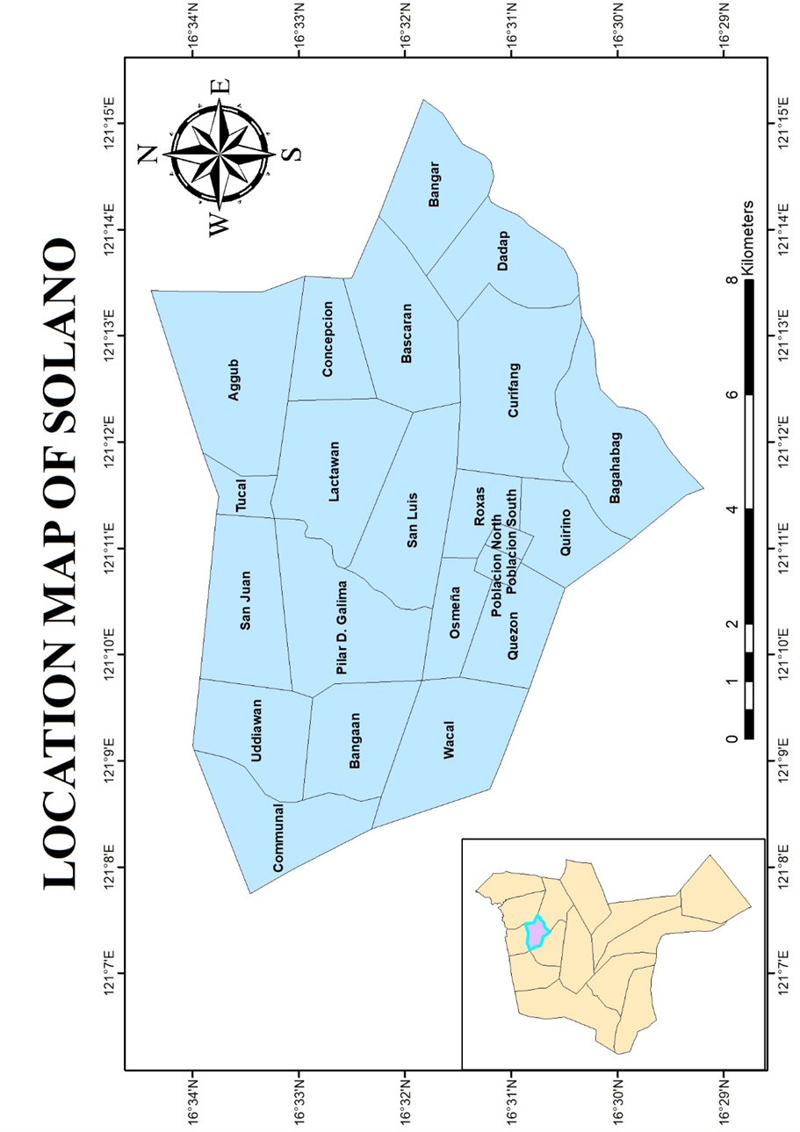

Research Instrument
In this study, the researcher utilized the Sentinel- 2 Copernicus for the preprocessing of data. This involves cloud masking to identify and exclude cloud-covered areas in the satellite images, as clouds can interfere with the accuracy of the soil moisture index to detect and mask clouds, ensuring only clear-sky pixels are used in the analysis. Moreover, the software ArcGIS 10.8 was used as the primary tool for data processing, mapping, and analysis, which will include the importing of the TIFF file exported from Sentinel- 2 Copernicus, and creation of the thematic map.

Data Gathering Procedure
The data gathering procedure involved acquiring geospatial data for spatial analysis. The first step in the data gathering procedure involved acquiring satellite imagery from the Copernicus Open Access Hub, which provides free access to Sentinel-2 imagery. The researcher then specified Solano, Nueva Vizcaya, as the Area of Interest (AOI) by uploading a shapefile of the study area. The temporal filters were then set to select imagery from the specific time period. Next, the data filters were applied to select Sentinel-2 imagery, focusing on Level-2A (Bottom-Of-Atmosphere or BOA reflectance) products, which are reflectance values corrected for atmospheric effects, providing surface reflectance values at the bottom of the atmosphere. Once suitable images were identified, the data was then gathered by downloading the file. Since this study is delimited only to using Sentinel-2 satellite data, without incorporating ground-based measurements for validation or comparison, ground-based measurements are not used.
Statistical Tool
In this study, the researcher used zonal statistics as a suitable statistical tool to facilitate the analysis of the soil moisture data. Zonal statistics involves dividing the study area into smaller, more homogeneous zones and then calculating the average soil moisture content within each of these zones. This method was used for the whole municipality of Solano dividing the zones per barangay. Using zonal statistics, the researcher was able to present the mean data per barangay level to facilitate a descriptive analysis where the characterization and comparison of the NDMI values will be done in order to identify the soil moisture conditions across the study area.
For Problem 1, the researcher utilized ArcGIS 10.8 to generate a comprehensive GIS-based soil moisture index map of Solano using Sentinel-2 spectral bands 8A and 11, and analyze variations in soil moisture across the study area for the years 2020 and 2025.
For Problem 2, the researcher compared the mean, minimum, and maximum soil moisture levels of the whole municipality for the years 2020 and 2025, and descriptively drew conclusion based on the compared values.
For Problem 3, the researcher used the in-system tool in Sentinel-2 Copernicus to compute for the mean, minimum, and maximum soil moisture values per barangay for the years 2020 and 2025.

Statistical Analysis and Procedures
The creation of soil moisture index map involved the application of spatial analysis tools in ArcGIS 10.8. The following provides a concise description of the procedural steps that will be followed to generate the soil moisture index map.
After importing the TIFF data from the Sentinel-2 Copernicus consisting of the necessary Sentinel-2 spectral bands, the Clip tool from the Geoprocessing toolbox was used to focus on the study area. The Project Raster tool was then utilized to ensure that the data is in the correct coordinate system. Next, the composite band tool was used to merge the spectral bands and make one layer of data. Since ground-based measurement will not be used, regression analysis is not required.
The Sentinel-2 Copernicus was again used to calculate for the mean, minimum, and maximum values both for the whole municipality and barangay level for the years 2020 and 2025. The downloaded data was then imported in ArcGIS to complete the needed data for the thematic map.
The researcher then applied appropriate symbology and choose a color ramp that effectively represents soil moisture levels. After all these steps, supplementary steps was done to design the final map layout
For this thematic map, the Kriging Interpolation was applied with a spatial resolution of 10 meters by 10 meters.

RESULTS
Soil moisture variation across Solano as observed from the Sentinel-2 imagery in the years 2020 and 2025
Table 1. Classification of Soil Moisture Levels
Soil Moisture Value | Soil Moisture Classification
-1 to -0.2 | DRY SOIL
-0.2 to 0.4 | OPTIMUM MOISTURE
0.4 to 1 | WET SOIL

Table 2. Soil Moisture Values and Classification of Solano for the years 2020 and 2025
YEAR | Minimum | Maximum | Mean | Classification
2020 | -1 | 0.702479362 | -0.119330379 | OPTIMUM MOISTURE
2025 | -0.695321841 | 0.639916241 | 0.193653007 | OPTIMUM MOISTURE

The minimum, maximum, mean values, and classification of the soil moisture per barangay for the years 2020 and 2025
Table 3. Soil moisture values, rank, and classification of each barangay of the municipality of Solano for
the year 2020
Barangay | Minimum | Maximum | Mean | Rank | Soil Moisture Classification
Aggub | -0.192015454 | 0.362722337 | 0.110687895 | 19th Lowest | Optimum Moisture
Bagahabag | -1 | 0.328968912 | -0.267025207 | 5th Lowest | Dry Soil
Bangaan | -0.144397259 | 0.3933945 | 0.10977656 | 18th Lowest | Optimum Moisture
Bangar | -0.681604651 | 0.702479362 | -0.415830947 | 3rd Lowest | Dry Soil
Bascaran | -0.174167067 | 0.578467131 | 0.040938806 | 9th Lowest | Optimum Moisture
Communal | -0.166549042 | 0.370708376 | 0.136868489 | 21st Lowest | Optimum Moisture
Concepcion | -0.195654988 | 0.375106424 | 0.116039713 | 20th Lowest | Optimum Moisture
Curifang | -0.213046491 | 0.452033758 | 0.035785189 | 8th Lowest | Optimum Moisture
Dadap | -0.776470637 | 0.319413924 | -0.652269548 | 1st Lowest | Dry Soil
Lactawan | -0.116688304 | 0.414840996 | 0.092438991 | 16th Lowest | Optimum Moisture
Osmeña | -0.190005809 | 0.429522157 | 0.047305679 | 10th Lowest | Optimum Moisture
Pilar D. Galima | -0.171787098 | 0.314400256 | 0.073905186 | 14th Lowest | Optimum Moisture
Poblacion North | -0.340126693 | 0.282259881 | -0.298433425 | 4th Lowest | Dry Soil
Poblacion South | -0.744469845 | 0.334218293 | -0.620635318 | 2nd Lowest | Dry Soil
Quezon | -0.218476355 | 0.371428579 | 0.029448271 | 7th Lowest | Optimum Moisture
Quirino | -0.241473928 | 0.357828647 | -0.18106429 | 6th Lowest | Optimum Moisture
Roxas | -0.222969472 | 0.438370019 | 0.047443677 | 11th Lowest | Optimum Moisture
San Juan | -0.152612522 | 0.411024153 | 0.091206992 | 15th Lowest | Optimum Moisture
San Luis | -0.152640551 | 0.355165333 | 0.055470048 | 12th Lowest | Optimum Moisture
Tucal | -0.171593085 | 0.430990428 | 0.103613814 | 17th Lowest | Optimum Moisture
Uddiawan | -0.147683561 | 0.39565137 | 0.143109305 | 22nd Lowest | Optimum Moisture
Wacal | -0.184858501 | 0.304535627 | 0.068659498 | 13th Lowest | Optimum Moisture

Generated Soil Moisture Map for year 2020 and 2025
Figure 3. Soil Moisture Map of Solano, Nueva Vizcaya for the year 2020
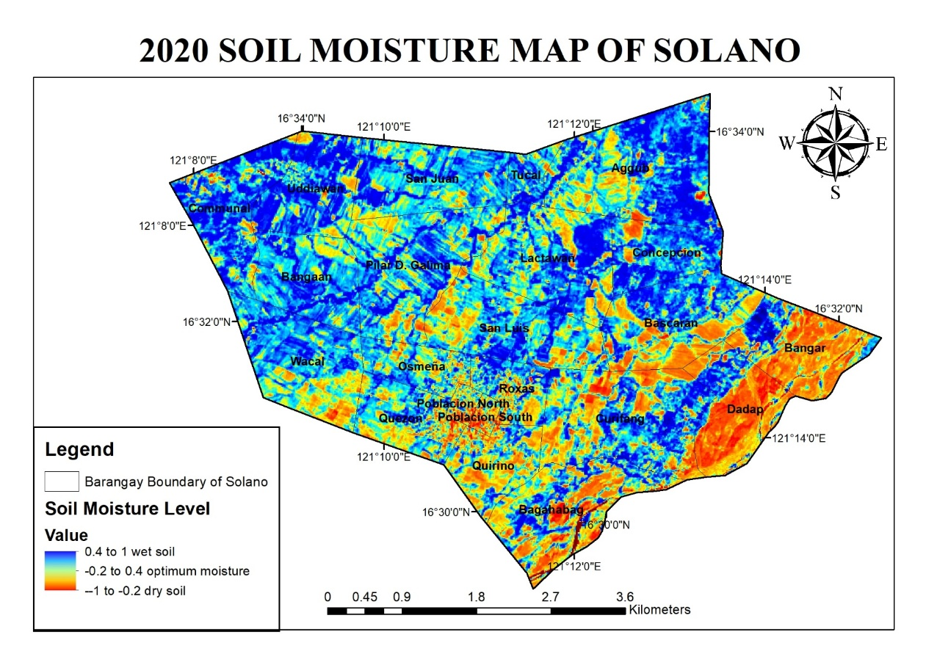

Figure 4. Soil Moisture Map of Solano, Nueva Vizcaya for the year 2025
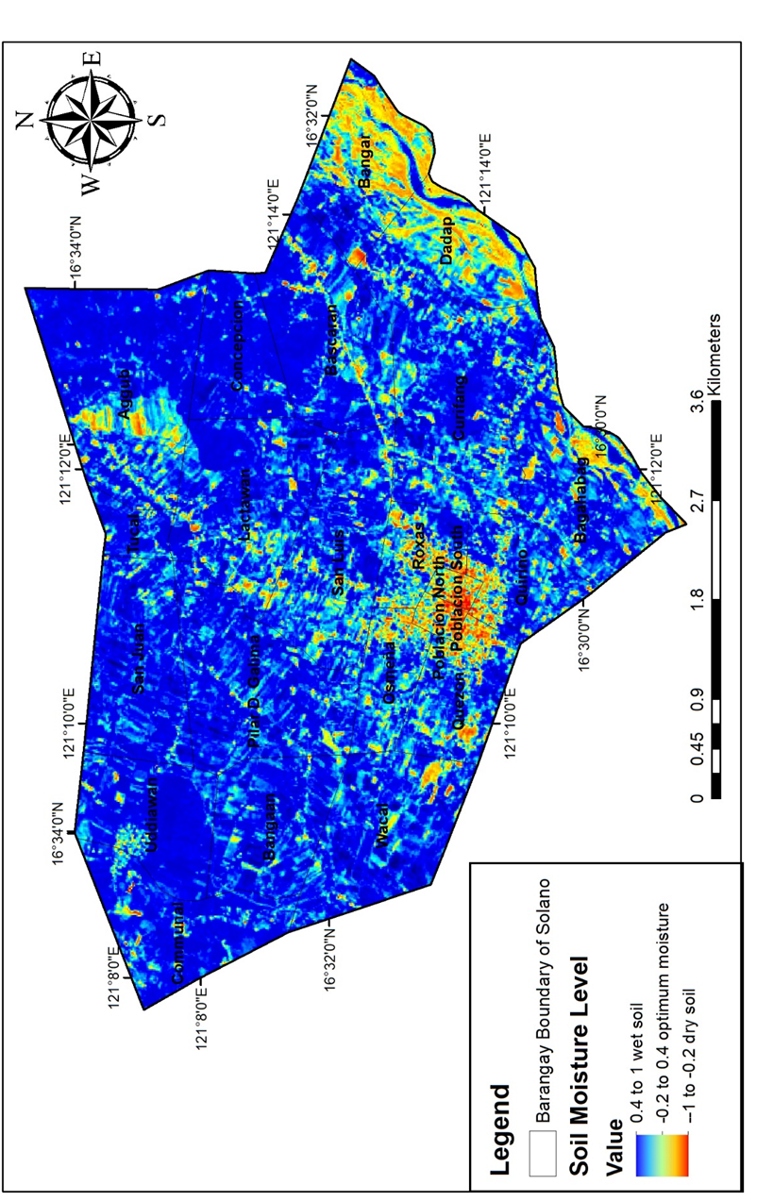

DISCUSSION
Table 1 is the soil moisture classification table which defines the ranges for categorizing soil moisture levels. Dry soil is classified as having soil moisture values from -1 up to -0.2. Optimum moisture is defined by soil moisture values ranging from -0.2 to 0.4. Wet soil is characterized by soil moisture values spanning from 0.4 to
Table 2 shows the soil moisture values and classification of Solano for the years 2020 and 2025. In 2020, the minimum soil moisture value for the whole municipality of Solano is -1, while the maximum reaches 0.702479362. The mean soil moisture value for this year is -0.119330379. Considering the soil moisture classification table, this mean value falls within the Optimum Moisture range.
For 2025, the minimum soil moisture value for the whole municipality of Solano is -0.695321841, and the maximum is 0.639916241. The mean soil moisture value for 2025 is 0.193653007. Referencing from the soil moisture classification table, this mean value falls within the Optimum Moisture range.
Table 2 shows the variations of soil moisture levels in Solano, Nueva Vizcaya from 2020 to 2025 which reveals notable changes in minimum and mean values, although the overall classification remains within the "Optimum Moisture" category for both years.
By 2025, the minimum soil moisture level increased by 0.304678159, the maximum decreased by 0.062563121, and the mean soil moisture significantly rose by 0.312983386.
The shift in mean soil moisture from -0.119330379 in 2020 to 0.193653007 in 2025 indicates a general increase in soil moisture levels across the municipality. Despite these changes, both years fall under the "Optimum Moisture" classification, which is defined by soil moisture values ranging from -0.2 to 0.4
Table 3 shows the soil moisture data for the year 2020, categorized by barangays within the whole municipality of Solano. The data includes minimum, maximum, and mean soil moisture values, along with a soil moisture classification and rank for each barangay.
Figure 3 and Figure 4 represent the soil moisture map for the years 2020 and 2025. The analysis of soil moisture levels in the municipality of Solano, Nueva Vizcaya, reveals a dynamic shift in moisture conditions across its barangays and at the municipal level between 2020 and 2025. In 2020, the distribution of soil moisture among barangays exhibited considerable diversity. Some barangays, such as Dadap, Poblacion South, Bangar, and Poblacion North, were classified as dry soil, indicating relatively low moisture content, with Dadap recording the lowest mean soil moisture of -0.652269548 and minimum values reaching -0.776470637. The majority of barangays, however, fell into the optimum moisture category, suggesting generally favorable conditions for plant growth, although mean soil moisture levels within this category varied from 0.029448271 in Quezon to 0.143109305 in Uddiawan, reflecting a spectrum of water availability. The wide ranges in minimum and maximum soil moisture values within individual barangays also point to potential temporal or spatial variability. By 2025, the soil moisture profile in Solano demonstrated a general trend towards increased moisture retention in many areas. The dry soil classification was confined to only Poblacion North and Poblacion South, with Poblacion South having the lowest mean soil moisture at -0.621713551 and a minimum of -0.695321841. Most barangays continued to be classified as optimum moisture, but the mean soil moisture values within this category generally increased, with Concepcion recording the highest mean soil moisture at 0.281513396.

CONCLUSION
This study aimed to map and compare soil moisture levels in Solano, Nueva Vizcaya, for 2020 and 2025 using Sentinel-2 spectral bands and GIS techniques. Soil moisture, a critical parameter in various scientific and engineering disciplines, including agriculture, hydrology, and climate science, was assessed using the Normalized Difference Moisture Index (NDMI), calculated from Sentinel-2's Band 8A (Near Infrared) and Band 11 (Shortwave Infrared). The methodology involved data preprocessing using the Sentinel-2 Copernicus website and thematic map creation in ArcGIS 10.8, following the conceptual framework of Input-Process-Output.
The findings revealed variations in soil moisture across Solano between 2020 and 2025. In 2020, the municipality's mean soil moisture was -0.119330379, ranging from -1 to 0.702479362, classified as optimum moisture. By 2025, the mean soil moisture increased to 0.193653007 having a minimum of -0.695321841 and a maximum of 0.639916241, still within the optimum moisture range. Barangay-level analysis showed variations, in 2020, barangays like Dadap had dry soil with a mean of -0.652269548, while in 2025, the dry soil classification was less prevalent.
These results indicate a general increasing trend in soil moisture in Solano from 2020 to 2025, highlighting the effectiveness of Sentinel-2 and GIS in monitoring soil moisture dynamics. These align with the broader understanding of soil moisture dynamics and the capabilities of remote sensing. Soil moisture is recognized as a key factor influencing agricultural productivity, hydrological processes, and climate patterns (Jackson & Hsu, 2004). Remote sensing techniques, particularly those employing Sentinel-2 data, have been demonstrated to be effective in monitoring soil moisture over large areas, providing valuable data for environmental monitoring and resource management (Rizzi, 2022). GIS tools play a crucial role in processing and analyzing remote sensing data to generate spatial representations of soil moisture, enabling informed decision-making.
The findings of this study are valuable for stakeholders like the DENR and LGUs for informed decision-making in agriculture, water management, and land use planning in the Solano municipality.

ACKNOWLEDGEMENT
The researchers extend their sincere gratitude to Copernicus Open Access Hub for the free access of Sentinel-2 imagery.

REFERENCES
- Abdulraheem, M.I,. Zhang, W., Li, S., Moshayedi, A.J., Farooque, A., & Hu, J. (2023). Advancement of Remote Sensing for Soil Measurements and Applications: A Comprehensive Review. Sustainability, 15(21), 15444. https://doi.or/10.3390/su152115444
- Allen, R. G., Pereira, L.S., Raes, D., & Smith, M. (1998). Crop Evapotranspiration: Guidelines for Computing Crop Water Requirements. FAO Irrigation and Drainage Paper. 56, 1-300. https//www.fao.org/3/X0490E/x0490e00.htm.Open access
- Angelopoulou, T., Chabrillat, S., Pignatti, S., Milewski, R., Karyotis, K., Brell, M., Ruhtz, T., Bochtis D., & Zalidis, G. (2023). Evaluation of Airborne HySpex and Spaceborne PRISMA Hyperspectral Remote Sensing Data for Soil Organic Matter and Carbonates Estimation. Remote Sens. 2023, 15(4),1106. https://doi.org/10.3390/rs15041106
- Babaeian, E., Homaee, M., Montzka, C., Vereecken, H., Norouzi, A. A., & Van Genuchten, M. T. (2016). Soil Moisture Prediction of Bare Soil Profiles Using Diffuse Spectral Reflectance Information and vadose Zone Flow Modeling. Remote Sens. Environ. 187, 218-229. https://doi.org/10.1016/j.rse.2016.10.029
- Bindlish, N., & Cosh, M. H. (2013). Remote Sensing of Soil Moisture: Recent Advances and Challenges. Hydrology and Earth System Sciences. 17(6), 2217-2230. Open Access.
- Burrough, P. A., & McDonnell, R. A. (1998). Principles of Geographical Information Systems. Oxford University Press. https://global.oup.com/academic/product/principles-of-information-systems-9780198742845. Open Access
- Dorigo, W., Wagner, W., Albergel, C., Albrecht, F., Balsamo, G., Brocca, L., Chung, D., Ertl, M., Forkel M., & Gruber, A. (2017). ESCA CCI Soil Moisture for Improved Earth System Understanding: State-of-the-art and future directions. https://doi.org/10.1016/j.rse.2017.07.01
- Drusch, M., Del Bello, U., Carlier, S., Colin O., Fernandez, V., Gascon, F., & Plummer, S. (2012). Sentinel-2: ESA’s Optical High-Resolution Mission for GMES Operational Services. Proccedings of the Snetinel-2 Symposium, 1-12. Remote Sensing of Environment. https://ui.adsabs.harvard.edu/link_gateway/2012RSEnv.120...25D/doi:10.1016/j.rse.2011.11.026 Open Access
- El Hajj, M., Baghdadi, N., Zribi, M., & Bazzi, H. (2017). Synergic Use of Sentinel-1 and Sentinel-2 Images for Operational Soil Moisture Mapping at High Spatial Resolution over Agricultural Areas. Remote Sensing, 9(12), 1292. https://doi.org/10.3390/rs9121292
- Entekhabi et.al. (2010). The Soil Moisture Active Passive (SMAP) Mission, Proceedings of the IEEE. https://www.researchgate.net/publication/224136559. Open Access
- Esmaeili Sarteshnizi, R., Sahebi Vayghan, S., & Jazirian, I. (2023). Estimation of Soil Moisture Using Sentinel-1 and Sentinel-2 Images. ISPRS Annals of the Photogrammetry, Remote Sensing and Spatial Information Sciences, X-4/W, 137144. https://doi.org/10.5194/isprs-annals-X-4WI-2022-137-2023
- European Space Agency (ESA). (2022). Sentinel-2: Multispectral Instrument, ESA. https://www.esa.int/Applications/Observing_the_Earth/Copernicus/Sentinel-2. Open Access
- Gholizadeh, A., & Kopackova, V. (2019). Detecting Vegetation Stress as a Soil Contamination Proxy: A Review of Optical Proximal and Remote Sensing Techniques. Int. J. Environ. Sci. Technol. 2019, 16, 2511-2524. https:/link.springer.com/article/10.1007/s13762-019-02310-w. Open Access
- Jackson, T. J., & Hsu, A. Y. (2024). Soil Moisture Retrieval from Space: A Review. IEEE. Transaction on Geoscience and Remote Sensing, 42(8), 1740-1753. Open Access
- Jafarbiglu, H., & Pourreza, A. A. (2022). A Comprehensive Review of Remote Sensing Platforms, Sensors, and Applications in Nut Crops. Comput.Election.Agric.2022. https://doi.org/10.1016/j.compag.2022.106844
- Jones, H.G., & Vaughan, R.A. (2011). Remote Sensing of Vegetation: Principles, Techniques, and Applications. Oxford University Press. https://doi.org/10.1111/j.1654-1103.2011.01319.x
- Khanal, S., Fulton, J, & Shearer, S. (2017). An Overview of Current and Potential Applications of Thermal Remote Sensing in Precision Agriculture. Comput. Electron. Agric. 2017, 139, 22-32. https://doi.org/10.1016/j.compag.2017.05.001
- Manfreda, S., McCabe, M. F., Miller, P. E., Lucas, R., Pajuelo Madrigal, V., Mallinis, G., Ben Dor, E., Helman, D., Estes, L., & Ciraolo, G. (2018). On the Use of Unmanned Aerial Systems for Environmental Monitoring. Remote Sens. 2018, 10, 641. https://doi.org/10.3390/rs10040641
- Metcalfe, M., Cracknell, A. P., & Vaughan R. A. (1994). Remote Sensing of Soil Moisture Content: A Methodology for Estimating the Spatial Average in Large Areas. International Journal of Remote Sensing, 15(8), 1707-1717. https://www.mdpi.com/2072-4292/10/4/641
- NASA MODIS. (2023). MODIS Overview and Capabilities. “NASA Goddard Space Flight Center. https://modis.gsfc.nasa.gov/about/. Open Access
- Rizzi, R. (2022). Active and Passive Microwave Remote Sensing for Soil Moisture Monitoring. Remote Sensing, 14(3), 578. Open Access
- Sahbeni, G., Ngabire, M., Musyimi, P. K., & Szekely, B. (2023). Challenges and opportunities in Remote Sensing for Soil Salinization Mapping and Monitoring: A Review. https://doi.org/10.3390/rs15102540
- Schmugge, T. J. (1980). Remote Sensing of Soil Moisture: An Overview. Hydrological Sciences Journal, 25, 1-16. Open Access
- Settu, P., & Ramaiah, M. (2024). Estimation of Sentinel-1 Derived Soil Moisture Using Modified Dubois Model. Environ Dev Sustain 26, 29677-29693. https://doi.org/10.1007/s10668-024-05460-1
- Veronese, F. et al. (2019). Estimating Soil Moisture from Sentinel-2 MSI Data Using Machine Learning Algorithms. Remote Sensing of Environment, 231, 111218. https://doi.org/10.1007/j.rse.2019.111218
- Yahia, O Guida, R., & Iervolino, P. (2021). Novel Weight-Based Approach for Soil Moisture Content Estimation Via Synthetic Aperture Radar, Multispectral and Thermal Infrared Data Fusion. https://doi.org/10.3390/s21103457
- Yao, H., Qin, R., & Chen, X. (2019). Unmanned Aerial Vehicle for Remote Sensing Applications: A Review. Remote Sens, 2019, 11, 1443. https://doi.org/10.3390/rs11121443
- Zhang, S., Roussel, N., Boniface, K., Ha, M. C., Frappart, F., Darrozes, J., Baup, F., & Calvet, J. C. (2017). Use of Reflected GNSS SNR Data to Retrieve Either Soil Moisture or Vegentation Height from a Wheat Crop. https://doi.org/10.5194/hess21-4767-2017
- Zribi, M., Kotti, F., Amri, R., Wagner, W., Shabou, M., Lili-Chabaane, Z, & Baghdadi, N, (2014). Soil Moisture Mapping in a Semiarid Region based on ASAR/Wide Swath Satellite Data. Water Resource Res. 2014, 50, 823-835. https://doi.org/10.1002/2012WR013405

