Study the incorporation of time-dependent holding costs into the model, reflecting how costs increase as the product ages, impacting overall profitability
ABSTRACT:
In this study, we developed an inventory model for Indian perishable products by the incorporation of time-dependent holding costs into the model. Demand is influenced by pricing and advertising decisions for Indian perishable products. We take a linear time-dependent holding cost, which shows the insurance and storage cost of perishable products increases over time. Many traditional studies take holding cost as a constant, which cannot match the real scenario. The optimal replenishment cycle is obtained in this inventory model. Numerical and sensitive analysis is done to validate the inventory model for Indian perishable products.
KEYWORDS: Replenishment cycle, perishable inventory, linear time-dependent holding cost, advertising
INTRODUCTION:
Effective inventory management of perishable products is crucial due to their limited shelf life, susceptibility to spoilage, and potential for deterioration. These factors significantly impact profitability in a unique context like India, where a substantial amount of agricultural produce and food is wasted because of inadequate inventory practices and improper storage methods for perishable goods. In an earlier inventory, it is assumed that holding costs and demand are constant. However, in reality, holding costs tend to increase over time, and demand is influenced by various factors, including selling price, timing, inventory levels, advertising, and the freshness of the product.[1] an inventory model with constant demand and linear holding cost.[2] an inventory model with price- and advertising-dependent demand and show how market decisions affect the demand of the product.[3] an inventory model where demand depends on freshness, stock, and quadratic holding cost; this optimizes the replacement time and maximizes the profit.[4] inventory model for non-instantaneous deterioration and practical payment method and take linear time-dependent holding cost [5] This optimizes the total inventory cost with time-varying holding costs and partial backlogging [6] time-dependent holding costs and a three-stage production inventory model with trapezoidal demand, which minimizes the total cost and constant cost, demonstrating manufacturing cost in the model [7] production inventory with a linear time-dependent production rate but take holding cost as a constant to obtain optimal cycle length and ordering quantity. [8] EOQ model with constant holding cost and linear demand: check how items can be affected by inventory decisions and optimal ordering of products.[9] deteriorating products EOQ model under constant holding cost and obtain optimal solution by numerical analysis. Early studies indicate that both linear and nonlinear holding costs accurately represent the realities of perishable products; however, there remains a gap in applying these models to the conditions of the Indian market. This includes combining the effects of advertising with pricing strategies and conducting sensitivity analysis. The aim of this research incorporates linear time-dependent holding cost, which shows the insurance and storage cost of perishable products increases over time. The optimal replenishment cycle is obtained in this inventory model.
ASSUMPTIONS:
This inventory model focuses on one perishable item from India.
The holding cost is linear and increases with time.
Zero lead time is taken and the replenishment rate is infinite.
It assumed that horizon planning is infinite. The lead time is still of concern, and it is assumed to be insignificant; therefore, replenishment is set to occur at the very beginning of every cycle.
In this inventory a shortage is not allowed.
Order size remains constant.
Advertising frequency and selling price-dependent demand are taken and represented by
$$D(A,p)=A^{γ}(x-yp) x,y>0 and γ>0$$
Where A is advertising frequency and (x-yp) price dependent demand.
NOTATION:
Symbol | Description
p | Selling price in INR
A | Advertising frequency
T | Replenishment cycle length
θ | Rate at which inventory deteriorates
Ca | Expenditure per Advertising in INR
x, y | Price-demand parameters
c | Purchase cost in INR
Cd | Deterioration cost in INR
γ | Advertising Elasticity
Q | Size of order
O | Ordering cost per order in INR
I(t) | At time t quantity of inventory available
H(t) | Holding cost depend on time
D (A, p) | Demand depends on advertising frequency and price of item

MATHEMATICAL MODEL FORMULATION:
In this mathematical inventory model, demand is considered a function of advertising and selling price for perishable products.
Demand rate is defined as
$$D(A,p)=A^{γ}(x-yp) x,y>0 and γ>0$$

By considering assumptions, differential equations are:
$$\frac{dI(t)}{dt}=-D (A,p)-θI(t), T≥t≥0$$
$$\frac{dI(t)}{dt}=-A^{γ}(x-yp)-θI(t), T≥t≥0 (1)$$

By solving differential equation (1), I(t) expressed as
$$I(t)=\frac{A^{γ}(x-yp)}{θ}(e^{θ(-t+T)}-1) (2)$$
With boundary condition $I(t)=Q, I(T)=0 (3)$
$$Q=\frac{A^{γ}(x-yp)}{θ}(e^{(θT)}-1) (4)$$
Ordering cost generated per cycle
$$OC=O (5)$$
Production cost generated per cycle
$$Pr C=Cp\int_{0}^{T}{D(A,p)dt}$$
$Pr C =Cp{ A}^{γ}(x-yp)T$ (6)

Deteriorated items per cycle
$$DC=Cd(Q-\int_{0}^{T}{D(A,p)dt})$$
$$DC=Cd(\frac{A^{γ}(x-yp)}{θ}(e^{(θT)}-1) -{ A}^{γ}(x-yp)T) (7)$$
The Advertising cost per cycle
$$A C=CaA (8)$$
The Holding cost generated per cycle
$$HC=\int_{0}^{T}{I(t)(h+ρt)dt}$$
$$HC=\int_{0}^{T}{\frac{A^{γ}(x-yp)}{θ}(e^{θ(-t+T)}-1) (h+ρt)dt}$$
$$HC=\frac{A^{γ}(x-yp)}{θ}[\frac{h(e^{θT}-1)}{θ}+\frac{ρ(e^{θT}-1)}{θ^{2}}-\frac{ρT}{θ}-hT- \frac{ρT^{2}}{2} ] (9)$$

$$Total Cost=OC+Pr C+DC+A C+HC (10)$$
$$Total Cost=O+Cp{ A}^{γ}(x-yp)T+Cd(\frac{A^{γ}(x-yp)}{θ}(e^{(θT)}-1) -{ A}^{γ}(x-yp)T)+CaA+\frac{A^{γ}(x-yp)}{θ}[\frac{h(e^{θT}-1)}{θ}+\frac{ρ(e^{θT}-1)}{θ^{2}}-\frac{ρT}{θ}-hT- \frac{ρT^{2}}{2} ] (11)$$
The Total cost generated per cycle
$$Tc =\frac{1}{T}[ O+Cp{ A}^{γ}(x-yp)T+Cd(\frac{A^{γ}(x-yp)}{θ}(e^{(θT)}-1) -{ A}^{γ}(x-yp)T)+CaA+\frac{A^{γ}(x-yp)}{θ}[\frac{h(e^{θT}-1)}{θ}+\frac{ρ(e^{θT}-1)}{θ^{2}}-\frac{ρT}{θ}-hT- \frac{ρT^{2}}{2} ]] (12)$$
For optimizing total cost per unit time, the necessary and sufficient conditions are
$$\frac{∂Tc}{∂T}=0 and$$
(13)
$$\frac{∂^{2}Tc}{∂T^{2}}>0 for all 0<T$$
(14)
It satisfies all necessary conditions and gives an optimal solution.
Numerical Applications:
We use numerical values based on realistic assumptions regarding Indian perishable items, such as tomatoes. The selected parameter values meet all the requirements of the inventory model and yield optimal solutions. The parameter values are taken from the secondary sources like government retail price report, earlier Indian perishable product studies.
The parameter values are taken O=220, Cp=15, Cd=5, Ca=18, $θ$=0.07, A=14, x=85, y=28
, γ=28, h=1.3 and $ρ$=0.35 from solving equation (13) we obtain optimal solution T’=1.472.
By putting T’ in equation (12) we obtain Tc’=2434.18.
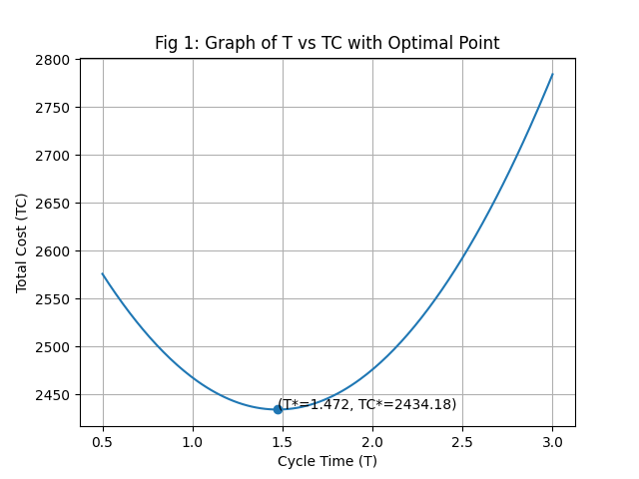
The graphical representation shows that total cost function is convex in nature and gives optimal replenishment cycle solution.
SENSITIVITY ANALYSIS:
We perform sensitive analyses by changing parameters. O, Cp, Cd, h, Ca, A, p, and keeping other parameters original. The optimal values are found when we change one parameter at a time and the other remains the same as the original values, which are taken from the above numerical example.
Sensitivity analysis Table
Parameter | Value | % Change of parameter | T’ | Tc’
O | 176 | -20% | 1.34 | 2398
 | 198 | -10% | 1.41 | 2416
 | 220 | 0% | 1.472 | 2434
 | 242 | +10% | 1.53 | 2452
 | 264 | +20% | 1.58 | 2471
h | 1.04 | -20% | 1.60 | 2395
 | 1.17 | -10% | 1.53 | 2415
 | 1.30 | 0% | 1.47 | 2434
 | 1.43 | +10% | 1.42 | 2453
 | 1.56 | +20% | 1.37 | 2472
$$ρ$$ | 0.28 | -20% | 1.50 | 2428
 | 0.31 | -10% | 1.48 | 2431
 | 0.35 | 0% | 1.47 | 2434
 | 0.38 | +10% | 1.45 | 2438
 | 0.42 | +20% | 1.43 | 2442
A | 10 | -20% | 1.53 | 2430
 | 12 | -10% | 1.51 | 2437
 | 14 | 0% | 1.47 | 2434
 | 16 | +10% | 1.46 | 2436
 | 18 | +20% | 1.49 | 2467
p | 22 | -20% | 1.45 | 2520
 | 25 | -10% | 1.46 | 2477
 | 28 | 0% | 1.47 | 2434
 | 30 | +10% | 1.48 | 2392
 | 33 | +20% | 1.49 | 2350

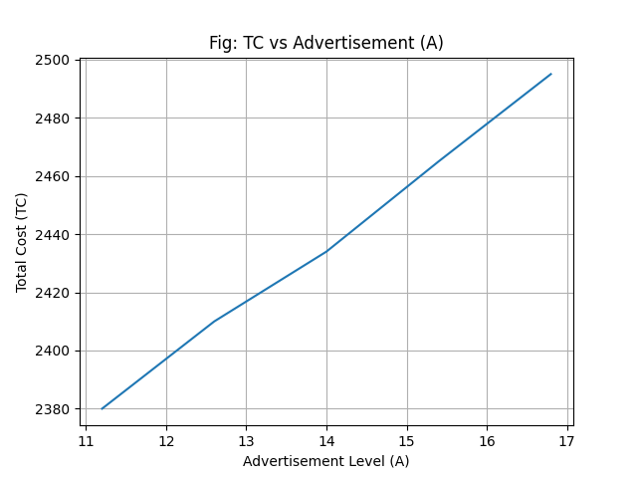
We observe from the graph of total cost and advertising that it represents an increasing trend, which means when we increase advertising, then total cost also increases.
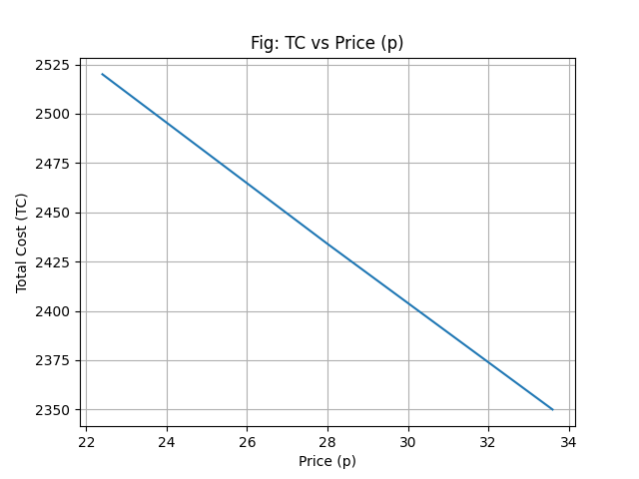
We observe from the graph of total cost and price that it represents a decreasing trend, which means when increase selling price, then total cost decreases.
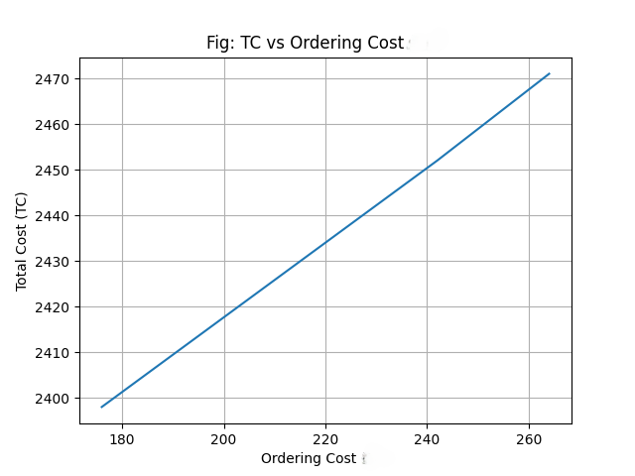
We observe from the graph of total cost and ordering cost that it represents a higher ordering cost than a higher total cost.
CONCLUSION:
In this study, we developed an inventory model for Indian perishable products by the incorporation of time-dependent holding costs into the model. The model considers demand as a function of selling price and advertising frequency. The numerical and sensitive analyses represent validation of the inventory model for Indian perishable products. This study determines the optimal replenishment cycle, which optimizes the total inventory cost for the Indian perishable products.
REFERENCES:
- Singh, S. (2016). An inventory model for perishable items having constant demand with time dependent holding cost. Mathematics and Statistics, 4(2), 58-61.
- Hasan, M. R., & Mashud, A. H. M. (2019). An economic order quantity model for decaying products with the frequency of advertisement, selling price and continuous time dependent demand under partially backlogged shortage. International Journal of Supply and Operations Management, 6(4), 296-314.
- Macías-López, A., Cárdenas-Barrón, L., Peimbert-García, R. E., & Mandal, B. (2021). An Inventory Model for Perishable Items with Price-, Stock-, and Time-Dependent Demand Rate considering Shelf-Life and Nonlinear Holding Costs. Mathematical Problems in Engineering.
- Khan, M. A., Halim, M. A., Alarjani, A., Shaikh, A. A., & Uddin, M. S. (2022). Inventory management with hybrid cash-advance payment for time-dependent demand, time-varying holding cost and non-instantaneous deterioration under backordering and non-terminating situations. Alexandria Engineering Journal, 61(2), 1234-1245.
- Mishra, V., Singh, L., & Kumar, R. (2013). An inventory model for deteriorating items with time-dependent demand and time-varying holding cost under partial backlogging. Journal of Industrial Engineering International, 9(1), 15-25.
- Suvetha, R., Rangarajan, K., & P., R. (2024). A sustainable three-stage production inventory model with trapezoidal demand and time-dependent holding cost. Results in Control and Optimization, 8(1), 101-115.
- Atama, A. M., & Sani, B. (2024). A Production Inventory Model with Linear Time Dependent Production Rate, Linear Level Dependent Demand and Demand and Constant Holding Cost. African Journal of Mathematics and Statistics Studies.
- Adamu, H., & Yakubu, M. I. (2025). A discrete time economic order quantity model for ameliorating items with constant holding cost and linear demand. Journal of Basics and Applied Sciences Research.
- Muniappan, P., Kirubhashankar, C. K., & Mohamed Ismail, A. (2021). An Optimum EOQ model for buyer-vendor with price breaks and fixed holding cost. Journal of Physics: Conference Series.
- Wenji, W. (2021). RETRACTED ARTICLE: Study on inventions of fresh food in commercial aspects using e-commerce over internet. Acta Agriculturae Scandinavica, Section B—Soil & Plant Science, 71(4), 303-310.
- Bhunia, A. K., & Maiti, M. (1998). Deterministic inventory model for deteriorating items with finite rate of replenishment dependent on inventory level. Computers & operations research, 25(11), 997-1006.
- Shah, N. H., & Pandey, P. (2009). Deteriorating inventory model when demand depends on advertisement and stock display. International Journal of Operations Research, 6(2), 33-44.
- Teng, J. T., & Chang, C. T. (2005). Economic production quantity models for deteriorating items with price-and stock-dependent demand. Computers & operations research, 32(2), 297-308.
- Soni, N., Duraphe, S., & Modi, G. (2025). Inventory D2C model where demand depends on price and social media advertisement. Journal of Mathematical Problems, Equations and Statistics, 6(1), 142–147.
- Chand, K., Suresh, A., Dastagiri, M. B., Kumar, S., & Mandal, S. (2021). Fruit marketing, its efficiency and supply chain constraints in India: A case study. Indian Journal of Agricultural Sciences (TSI), 91(8), 1146-1150.

