Integration of Real-time Occupancy Detection Module and Security Encryption Standards for an IoT-based Smart Distribution Metered System

ABSTRACT
Most people contemplate how energy is maintained in houses and offices. Yet, the problems persist and are difficult to disregard. Increasing electricity costs, safety concerns, weaknesses in linked devices, and the financial losses associated with powering vacant quarters are issues that require urgent attention. This study offers an IoT-based smart supply model that collectively tackles efficiency, computerization, and security, rather than treating them as separate problems. The proposed system runs on an ESP32 microcontroller. It is a commonly used option for work that involves IoT, as it does not fail, it is inexpensive, and well-supported. The PIR motion sensors are responsible for occupancy detection by checking whether a room is in use before any devices are switched on. Current sensors display actual power draw. The different parts are not very useful on their own, but working together creates wonders and solves human challenges. Security handling is achieved via AES encryption, which protects metering and control data as it moves through the system. AES is not a new skill. However, applying it consistently to the residential system is still not as common as it perhaps should be, considering how much can be exposed through home energy data. The results showed occupant detection to be 95% accuracy, and energy consumption fell to about 35% compared to a system running without automation. In summary, the study integrated a real-time occupancy detection module and security encryption standards for an IoT-based Metered System.
Keywords— Smart Distribution System, IoT Integration, AES Encryption, Energy Efficiency, Occupancy Detection

INTRODUCTION
The Internet of Things is useful in speed detection ([1] [2]), alcohol detection [3], fire detection [4], irrigation management [5] [6] [7]), and Rest Room Faucet ([8] [9]). The rapid advancement of technologies has significantly impacted different areas of human life ([10] [11] [12] [13] ]14] [15]). Technology has impacted energy conservation efforts, making them essential tools in the management and optimization of modern health systems and power distribution systems ([16] [17] [18] [19] [20] [21]).

LITERATURE REVIEW
Energy consumption is rising, and the environmental pressure that comes with it is real. Managing power more efficiently is no longer something engineers hope to achieve; it has become something very important ([22] [23] [24]). The old energy consumption models were rigid with slow response, and limited processing power as they were not built for the dynamic demands that result from new home electronic devices and what modern energy management requires ([25] [26]). The need for smart distribution metered modules became a necessity to close that gap by offering a smart system that handles the push and pull between energy supply and demand ([27] [28] [29]).

The development of smart grids did not occur instantly. By the 2000s, numerous issues were mounting at the same time, specifically old design structures that had been used for a long time, an increasing number of power generation sources like solar, and a quick technological revolution that made new techniques more viable ([30] [31] [32] [33] [34]). Modern approaches now incorporate advanced automation and metering infrastructure with better supported control schemes ([35] [36] [36] [37]). Collectively, these technologies allow smart grids to monitor, process information, and adapt to modifying settings without the intervention of human beings [38]. Such a quick comeback is essentially important for efficient occupancy detection.

In this study, a real-time occupancy detection module and security encryption standards controlled where energy is actually being used, which makes the management of resources and load adjustment more practical. Such proximity mitigates waste and makes the energy distribution process more economical and environmentally useful [39]. The main techniques applied include integrated volt/VAR control, fault uncovering and repair, enhanced metering infrastructure, and load balancing ([40] [41]). These techniques support each component of a system that responds to real conditions.

Governments' policy support and public funding for smart home deployment have tremendously increased, and the global smart grid market is projected to surpass $125 billion by 2027 [42], [43]. Against that backdrop, this study develops an energy distribution system that draws on current IoT techniques to advance energy conservation, efficiency, and maintainability. The aim is to contribute, even in a modest way, to the ongoing effort of making energy distribution genuinely smarter.
METHODOLOGY
The proposed real-time occupancy detection module and security encryption standards system was designed to address incompetence, high power usage, and security shortcomings associated with old-style power distribution systems. The Internet of Things-based architecture integrated real-time sensors, an automatic control mechanism, and tools to secure transmitted data, into the developed system. The architecture is centered on the ESP32 DevKit microcontroller, Wi-Fi and Bluetooth. The system further integrates PIR motion sensors, ACS712 current sensors, relay modules to control load, and a camera module for occupant’s detection and ,monitoring of power usage. Software development was carried out using the Arduino IDE and ESP-IDF SDK, with C/C++ as programming language for firmware implementation.

The materials and method were chosen to address the inefficiencies and security concerns of traditional power distribution systems. The IoT-based plug energy monitoring system developed by Abraham et al. (2022) provides valuable capabilities for analyzing home appliance energy usage through real-time sensing and data visualization. The system comprises a NodeMCU WiFi module connected to a shunt resistance current sensor, with data transmitted to cloud servers for dashboard access (Albraheem et al., 2022). By obtaining 1Hz power readings that are graphed over time, the system enables tracking standby losses and usage patterns to reduce waste. It also stores all data in a structured MySQL database for conducting customized queries to compare daily or monthly energy consumption by appliance. While the implemented smart plug demonstrates an effective approach to non-intrusive appliance load monitoring, limitations exist in terms of flexibility for electrical grid integration. As the focus is mainly on visualization rather than control functions or data exchanges with distribution infrastructure, expansions would be required to unlock smarter two-way capabilities, as seen in Figure 1.
The proposed system employs a variety of sensors, including HC-SR501 PIR motion sensors for occupancy detection and ACS712 current sensing devices for measuring power usage. The software development was conducted using the Arduino IDE and the ESP-IDF SDK. The Arduino IDE provided a user-friendly environment for programming the ESP32, while the ESP-IDF SDK enabled more advanced control over the hardware capabilities of the ESP32, such as WiFi and Bluetooth management. The Blynk platform created the IoT dashboard and mobile app interface, facilitating remote monitoring and control. The Scrum framework was employed as the research methodology to ensure iterative progress and adaptation to changing requirements.

The individual software modules are tested as subsystems, using simulated occupancy patterns, and performance testing to measure sensor data execution times and network latency. This was carried out to validate the performance of the developed real-time occupancy detection module and security encryption standards for IoT Smart home and office systems.

The modular design gave room for additional development and subsystem testing. This approach guarantees the system's adaptation to real-world applications.
How the Control Algorithm Works

The automated control algorithm runs in a nonstop loop, continuously checking the occupants’ status at each location in the office or home. That status information is obtained from the occupant’s tracking algorithm, which collects data from both PIR motion sensors and camera vision to decide whether a given area is occupied or empty. Therefore, if the room is occupied, the algorithm switches on whatever devices are linked to it, whether that is the lights, the air conditioning, or both. At the same time, a countdown timer is started, set to five minutes. That timer becomes relevant later.
When there is no occupant in the room or office, the algorithm will not instantly cut power. But examines if the stipulated timer had run down. When this occurs, the device goes off. Otherwise, the timer stays a little longer in the loop interval. That delay is intentional to prevent triggering an immediate shutdown when occupants briefly leave a room.
The outcome is a developed system that responds to the real-time presence of occupants without being overly reactive. It means that the devices are powered down automatically after a home or office has been declared empty.
RESULTS
The system showed a clear improvement in occupants' presence detection, managing the energy usage, and someone's ability to interact with it. In Figure 1, the microcontroller is seated at the center with connected sensors, control devices, and cloud support. It handles information processing, radio communication, and the GPIO interface straightforwardly.
Designing the model into modules or components has made the development process to be less stressful. It enables the testing of each part before testing the full system. That bit-by-bit approach helps to solve small issues earlier before they cause bigger problems. The use of the Arduino IDE cannot be overemphasized as it connects all sensors to its board. Figure 2 gives a distinct picture of how the system architecture was assembled and how the whole process was simply put together.
For occupant detection, the system uses an algorithm in computer vision to get about 95% accuracy in recognizing and classifying motion. That figure shows that the developed system is perfect and it is efficient. There are instances when someone will stand very still, thus making the detection not instantaneous. Despite this, compared to the simpler motion sensors show a noticeable improvement. The validation and evaluation process involved in comparing the results obtained with existing findings across different scenarios is seen in Figures 3 and 4.
Automating device control is one of the more practical aspects of IoT applications. Based on the occupants’ data, the system has automatically adjusted device usage that leads to an average energy saving of 35% when compared to manual control. That reduction is very useful and significant in a real household, as it will lower electricity bills through energy usage management.

The user interface is designed for ease of use and to allow people to monitor and adjust settings without much confusion. Figure 5 displays how the interface will look like in practice. The overall testing was carried out for both occupants’ detection accuracy and energy savings, with the main results listed in Table 1. Put together, the system did meet its goals.
It shows clear potential for improving how smart homes can manage energy and respond to real-life conditions, even if there is still room to refine certain aspects.
Tables and figures
The tables (Table 1 and 2) and the figures (Figures 1 to 5) explain the activities and interactions that goes on within the system components.

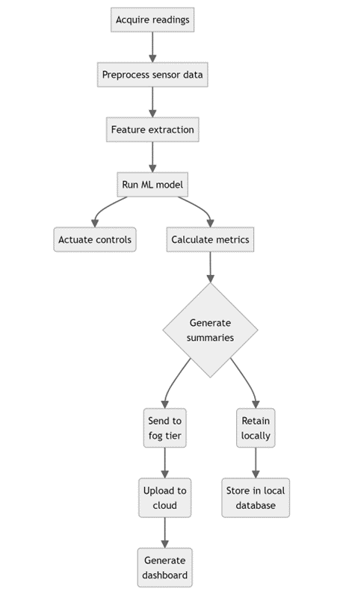
Figure 1. Activity Flow Diagram

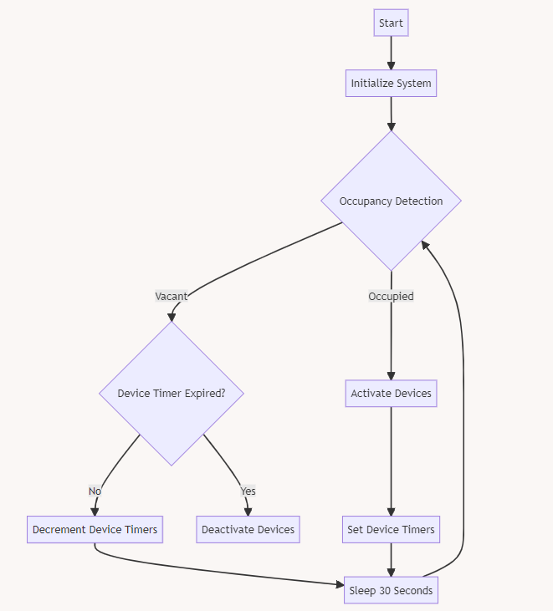

Figure 2. Flowchart of the system.

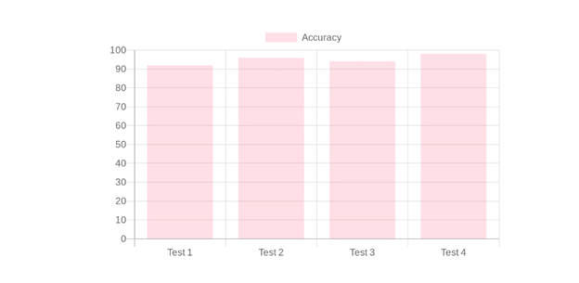
Figure 3. Accuracy Test of the System

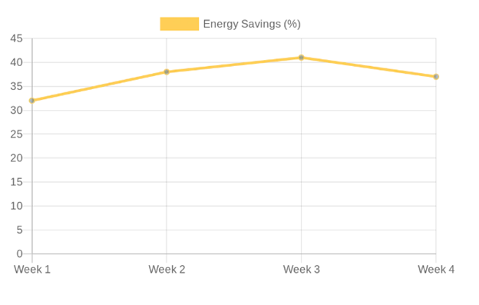
Figure 4. Energy Saving Test of the System

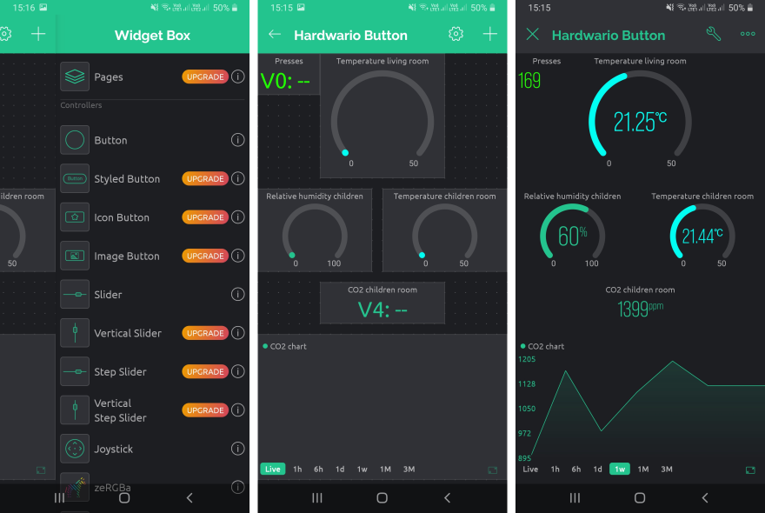

Figure 5. Blynk mobile application dashboard for the smart distribution system

Table 1. Test Cases and Expected Results
Test Case | Description | Expected Results | Actual Results | Pass/Fail | Test Case
Sensor connectivity | Read PIR and current sensor values | Non-zero digital and analog readings | As expected | Pass | Sensor connectivity
Occupancy detection accuracy | Simulate motion and track detection rate | >90% of motion events detected | 95%detected | Pass | Occupancy detection accuracy
Device activation | Trigger occupancy: validate devices activate | All devices turn on when the zone occupied | Working as expected | Pass | Device activation

Table 2. Test model specifications and test conditions
Metric | Result
Occupancy Detection Accuracy | 95%
Energy Savings from Automation | 35% average reduction
User Interface Usability Rating | 4.2 out of 5

DISCUSSION
Testing of the different components gave a clearer view of what the system can do. Applying scenarios showrd how the system can behave and perform under changing conditions. This integrating of a real-time occupancy detection module and security encryption standards gives the system the capability to detect whether a space was occupied, automate responses reliably, and deliver meaningful reductions in energy use, while remaining straightforward enough for a regular user to interact with.
The standout result was the computer vision component. It correctly identified occupancy events in ninety-five out of a hundred cases, which is a reasonable margin for a system operating in real-world conditions. Not perfect, but strong enough to take it seriously.
Beyond the numbers, the testing process itself revealed something useful about how the system behaves in practice. The automation responded consistently, which matters more than it might sound. A system that works well in controlled conditions but falters under irregular use is not genuinely reliable.
The modular design also proved its worth during development. Breaking the system into distinct, manageable components made it easier to test each part independently and refine it before integration. That approach tends to reduce the risk of compounding errors, and here it helped produce a final system that improved both energy management and the overall user experience in ways that felt practical rather than theoretical.

CONCLUSION
The core aim of this research is to build a smarter home automation system that reduces power consumption by tracking whether spaces are actually occupied. That sounds simple, but existing systems have real gaps, and bridging them required more than just adding a sensor.

To improve accuracy, two sensing approaches were combined. Computer vision and passive infrared detection work together to complement each other, so that what one can miss, the other can provide. A stand-alone PIR sensor fails to identify when people are sitting still, but the addition of a camera-based system provides a result that shows a more reliable photo of occupancy in real time.
The designed system can be reused as the interface has the capabilities to set schedules, modify rules, and tune behavior. The developed system picks up usage patterns over time and then adjusts its control logic to provide long-term efficiency gains.

REFERENCES
- Akazue M. I., Ajenaghughrure I. B. (2016). Internet of Vehicle Speed Detection and Reporting System Based on RFID, Journal of the Nigerian Association of Mathematical Physics, Vol 34, pp219-226.
- Ajenaghughrure I. B., Akazue M.I., Ekurume E. O.. (2015). Application of Fuzzy Logic in a Hybrid Intelligent Zero Tolerance Alcohol Influenced Vehicle Driving System, Science Focus, Vol. 20 No.2, pp. 35 – 45
- Akazue M. I. (2016a) An Automated Fuzzy Logic Based Temperature Control Model for Sustaining Server Room Temperature Stability. Journal of the Nigerian Association of Mathematical Physics, Vol 34, pp233-240
- Akazue, M. I. (2017) Users’ Perception in an Intelligent Automatic Fire Detection System for Developing Countries. Journal of Computer Science and its Applications Vol 24, No.2, pp 111 -119
- Akazue, M., Pirah, L. O., Ogeh, C., & Otegbalor, S. A. (2024a). DEVELOPMENT OF ENHANCED AGRICULTURAL GREENHOUSE SYSTEMS FOR DEVELOPING COUNTRIES. Nigerian Journal of Science and Environment, 22(1), Vol 22 (1) 68 –77. https://doi.org/10.61448/njse221246.
- Akazue M. I. (2016b). A fuzzy based intelligent irrigation system. Science-Tech Journal, Vol1, No1, pp12-22.
- Ukadike, I. D., Akazue, M., Omede, E., Akpoyibo, T. P (2023). Development of an IoT-based Air Quality Monitoring System, FUPRE Journal of Scientific and Industrial Research (FJSIR) Vol. 7 Number 4, pp 53-62
- Akazue Maureen I., and Ajenaghughrure Ighoyota Ben (2017)..Fuzzy Based Enhanced Smart Rest Room Automated Faucet System. Intl Journal of Engineering and Manufacturing, Vol. 7, No. 3 , pp 20-30.
- Akazue, M., Esiri, K. H., & Clive, A. (2024b). Application of RFM model on Customer Segmentation in Digital Marketing. Nigerian Journal of Science and Environment, 22 (1) 57 –67. https://doi.org/10.61448/njse221245
- Ako, R. E., Aghware, F. O., Okpor, M. D., Akazue, M. I., Yoro, R. E., Ojugo, A. A., Setiadi, D. R. I. M., Odiakaose, C. C., Abere, R. A., Emordi, F. U., Geteloma, V. O., & Ejeh, P. O. (2024). Effects of Data Resampling on Predicting Customer Churn via a Comparative Tree-based Random Forest and XGBoost. Journal of Computing Theories and Applications, 2(1), 86–101. https://doi.org/10.62411/jcta.10562
- Ojie D., Akazue M., Imianvan A. (2023a). A Framework for Feature Selection using Data Value Metric and Genetic Algorithm, International Journal of Computer Applications, Volume 184, Issue 43, p14-21, doi:10.5120/ijca2023922533
- A. A. Ojugo, M. I. Akazue, P. O. Ejeh, N. C. Ashioba, C. C. Odiakaose, R. E. Ako, and F. U. Emordi (2023) Forging a User-Trust Hybrid Memetic Modular Neural Network Card Fraud Detection Ensemble: A Pilot Study, Journal of Computing Theories and Applications, vol. 1, no. 2, page 1-11.
- M. D. Okpor, F. O. Aghware, M. I. Akazue, A. A. Ojugo, F. U. Emordi, C. C. Odiakaose, R. E. Ako, V. O. Geteloma, A. P. Binitie, P. O. Ejeh (2024). Comparative Data Resample to Predict Subscription Services Attrition Using Tree-based Ensembles, Journal of Fuzzy Systems and Control, Vol. 2, No 2, 117-124, DOI: 10.59247/jfsc.v2i2.213.
- Akazue, M., Esiri, K. H., & Clive, A. (2024b). Application of RFM model on Customer Segmentation in Digital Marketing. Nigerian Journal of Science and Environment, 22 (1) 57 –67. https://doi.org/10.61448/njse221245
- Ajenaghughrure, I., Sujatha, P., Maureen, A. (2017). Fuzzy based multi-fever symptom classifier diagnosis model. International Journal of Information Technology and Computer Science, Vol. 9, No. 10, pp. 13–28. DOI: 10.5815/ijitcs.2017.10.02.
- Akazue, M.I and Onyekweli C.O, (2015) Survey of Automated Electricity Billing and Metering Systems: Acceptability and Implementability factors. Science Focus, Vol. 20 No.2, pp. 20 – 28.
- Ali, I., Patterson, M., Rahman, S., Yao, L., & Wu, L. (2021). Australia’s transition towards smart metering: Issues, statuses, policies, and impacts on future grid. Renewable and Sustainable Energy Reviews, 135, 110105
- Ojie D.V, Akazue M, Omede E.U, Oboh E.O, Imianvan A. (May 2023b) Survival Prediction of Cervical Cancer Patients using Genetic Algorithm-Based Data Value Metric and Recurrent Neural Network, International Journal of Soft Computing and Engineering (IJSCE) ISSN: 2231-2307 (Online), Volume-13 Issue-2, May 2023
- Chen, Q., Zhang, X., & Sun, H. (2021). Application of Multi-source Heterogeneous Data Fusion for Power Equipment State Visualized Management. IOP Conference Series: Earth and Environmental Science, 787(2), 022032.
- Dio T., M. I. Akazue, S. N. Okofu (November 2023). Development of an Online Examination Monitoring System using Zoom, International Journal of Computer Applications (0975 – 8887) Volume 185 – No. 40, pp 1 -10.
- Chou, P. C., Guttromson, R. T., Bhatnagar, D., Lysiak, M. S., & Wang, J. (2020). Simulation-assisted distributed energy resource interconnection analysis. IEEE Transactions on Smart Grid, 12(1), 79-88
- Cardenas, J. A., Gemoets, L., Ablanedo Rosas, J. H., &Sarfi, R. (2014). A literature survey on Smart Grid distribution: An analytical approach. Journal of Cleaner Production, 65, 202--216. https://doi.org/10.1016/j.jclepro.2013.09.019
- Albraheem, L., Alajlan, H., Aljenedal, N., Alkhair, L. A., &Gwead, S. B. (2022). An IoT-based smart plug energy monitoring system. Computers & Electrical Engineering, 102, 108253. https://doi.org/10.1016/j.compeleceng.2022.108253.
- Asamoah, A., Zhang, J., Ramos, C., Neto, J. P., Kyriakides, E., Granados, J. A. T., ... & Shahidehpour, M. (2022). Machine learning in smart-grid operations: A comprehensive overview. Transactions of the Institute of Measurement and Control, 01423312221109579.
- Andren, F., Vukovic, O., Karedal, J., & Jonsson, F. (2022). Performance Analysis of Wireless Technologies for Smart Metering Communications in a Digital Twin Testbed. Technologies, 10(1), 2.
- Arias, M. V., Rey, J. M., & Vizcaino, I. (2022). Smart grid development: A worldwide policy analysis. Electric Power Systems Research, 208, 107703.
- Wan, C., Li, D., Liu, X., & Qiu, J. (2018). A general test platform for smart grid applications. Energies, 11(1), 230.
- Ihama E.I., Akazue M.I. , Omede E., Ojie D. (2023). A Framework for Smart City Model Enabled by Internet of Things (IoT). International Journal of Computer Applications (0975 – 8887) Volume 185 – No. 6, May 2023, pp 6-11
- M.I. Akazue and B. O. Ojeme (2016). An RFID Based Driver’s License Authentication Model for Enhancing City Transport. The Journal of the Nigerian Institution of Production engineers, Vol 20, pp 282-294.
- IHAMA, E. I., AKAZUE, M.I., & AMENAGHAWON, V. A. (2025a). Vehicular Movement Prediction Via Supervised Vector Machine, FUPRE Journal of Scientific and Industrial Research, 9(1):206-215
- S. N. Okofu, T. Anning-Dorson, & H. I. Duh (2025). Consumer Adoption and Continual Use of E-Vouchers: A Study of the Nigeria Telecommunication, International Research Journal of Multidisciplinary Scope, 06(02):330-342, DOI:10.47857/irjms.2025.v06i02.03788
- Okofu, S. N., Akazue, M. I., Ajenaghughrure B. I., Efozia F. N. (2018). An Enhanced Speech Based Airline Ticket Reservation Data Confirmation Module, Journal of Social and Management Sciences 13 (1), 11-21
- IHAMA E. I., AKAZUE M.I. , OBAHIAGBON K.O., (2025b). A Survey of Smart City Development and the Role of Internet of Things, FUPRE Journal of Scientific and Industrial Research, 9(1):28-37(2025)
- Akpoyibo, T. P., Akazue, M. I., & Ukadike, I. D. (2023). Development of a Floating Surface Water Robotic Oil Spillage Surveillance (Swross) System. Global Scientific Journal, 10(11), 2214 – 2230
- Asmus, P., Forsten, K., & Daniels, A. (2022). Next Wave of Grid Intelligence: Advanced Distribution Management Systems. Guidehouse Insights.
- Giraldez, J., Diaz-Gonzalez, F., Gotseva, M., Gomis-Bellmunt, O., &Sumper, A. (2021). Testing Smart Distribution Grid Functionalities in a Hardware-in-the-Loop Environment. Applied Sciences, 11(3), 1280.
- Jia, L., Yuchi, M., Yu, X., Gu, C., Li, R., & Dong, Z. Y. (2022). Detecting Cyber Intrusions in Distribution SCADA Systems Using Machine Learning Techniques. IEEE Transactions on Smart Grid, 13(3), 2326-2335.
- Whaley, R. (2022). Progress in Smart Grid and Renewable Energy Integration Demonstrations. IEEE Power and Energy Magazine, 20(5), 19-28.
- Erol-Kantarci, M., Mouftah, H. T., & Oktug, S. (2011). A survey of architectures and localization techniques for underwater acoustic sensor networks. IEEE Communications Surveys & Tutorials, 13(3), 487-502
- Mahmud, K., Hossain, M. J., & Ravishankar, J. (2019). Internet-of-things-enabled smart grid infrastructure supporting industry 4.0. IET Cyber-Physical Systems: Theory & Applications, 4(3), 260-268.
- Yoro RE, Okpor MD, Akazue MI, Okpako EA, Eboka AO, Ejeh PO, et al. (2025) Adaptive DDoS detection mode in software defined SIP-VoIP using transfer learning with boosted meta-learner. PLoS One 20(6): e0326571. https://doi.org/10.1371/journal. pone.0326571
- Fortune Business Insights. (2022). Smart grid market size, share and industry analysis, By Software (Advanced Metering Infrastructure, Smart Grid Distribution Management, Smart Grid Network Management, Grid Asset Management), By Hardware (Smart Meters), By Service (Consulting, Deployment and Integration, Support and Maintenance), By End-User (Public Utility, Private Utility) and Regional Forecast, 2019 - 2026. Fortune Business Insights
- Kezunovic, M., Ren, B., Hansen, M. R., Jacobson, D. A., Ehsani, M., Korunović, L. M., & Ghavami, M. (2022). Building blocks for smart and resilient distribution grid of the future: Texas A&M smart distribution grid testbed. Electric Power Systems Research, 207, 107743

