Lunch Plate Survey in a Pediatric Ward at a Tertiary Care Center in a Developing South Asian Country

RESEARCH TITLE
Lunch Plate Survey in a Paediatric Ward at a Tertiary Care Center in a Developing South Asian Country
Keywords: Children, Hospital lunch plate, Quality, Quantity

ABSTRACT
Background
The hospital food service given free of charge in public sector is a frequently overlooked component of holistic healthcare. Food of unsatisfactory quantity and quality leads to reduced intake, infection and even prolongation of hospital stay as well as unnecessary wastage of finances and resources. Proper nutrition in children during sickness is vital for recovery as well as for growth and development in long run.

Objectives
To determine the nutritional quality and quantity of a lunch plate of food served at a selected paediatric ward in a tertiary care center in a developing South Asian country.

Design
Descriptive cross sectional study was carried out to analyze the quality and quantity of nutrients of a lunch plate served at a paediatric ward at a tertiary care center in a developing South Asian country over the consecutive seven days of a week during late August and early September 2024. Three randomly selected lunch plates served daily to inward patients were weighed and data entered to NutriSurvey- 2007 for analysis and the nutrient average of the three plates was taken for each day. The Recommended Dietary Allowance (RDA) reference for 4 – 6 year age group was taken for the calculation of %RDA supplied by the lunch plate as the majority of the inward patients belonged to this age group.

Results
During all seven days, main carbohydrate was rice and the protein source was eggs and sprats prepared in same way. It was observed that the composition of nutrients were not uniform during the week. More than one third of the daily calorie and more than 100% of RDA for proteins were offered in the lunch plates. Percentage of RDA for the analyzed micronutrients (except vitamin D) were satisfactory throughout the week.

Conclusion
Our main observation was the lack of food diversity and lack of variability in cooking method of food items during the course of the week. Adequacy of energy and analyzed micronutrients (except vitamin D) were satisfactory with an excess in proteins in a single lunch plate.
INTRODUCTION
The hospital food service is a frequently overlooked component of holistic healthcare, despite being a fundamental requirement in the management of an inward patient. Majority of people who are admitted to government hospitals in Sri Lanka rely on the food supplied by the hospital due to financial as well as social reasons.
The quality of the food served is a crucial factor. Reduced food intake amongst hospitalized patients is a serious problem, which results in poor recovery and malnutrition. Food of unsatisfactory quality can lead to reduced intake, infection and even prolongation of hospital stay as well as unnecessary wastage of finances and resources ⁽¹⁾. With regards to children, it is usually understood that the younger age groups are generally more difficult to feed which worsens further during illness. Having a visually appealing plate of food would encourage adequate consumption as well as positive behaviour during hospital stay and compliance to medical treatment.
It should also be noted that the quality of food does not only infer the quality of the nutrients, but also the freshness and hygiene of food. The latter is carried out by Public Health Inspectors in Sri Lanka and the food sample should be checked daily by the administration before being served to the patients on a routine basis.
Food and dietary guidelines are diverse, and there is a hospital diet circular (General Circular No:01-21/2015)⁽²⁾ issued by the Ministry of Health indicating on the required nutrient content of a meal. Yet, the quality and quantity of nutrient composition of the diet received by a patient is not compared with the RDA of a child.
The general recommendation of nutrient composition of a meal has been looked into deeply by the global research community, yet there are very few publications regarding the quality of food served in an institution which bears the task of maintaining and promoting health.
Quality of food served in a hospital will have a significant impact on health outcomes of the inward patients. Many publications have looked into the issue of malnutrition during the hospital stay, and also patient satisfaction with the food services received.
As important as these are, the quality assessment of the average meal in hospitals has been overlooked, and where it has been studied, the results show much room for improvement. Provision of good quality consumable meal from the hospital will be very useful especially when it comes to the paediatrics when the mother has to stay in the hospital with the child and the availability of home cooked food become questionable.
Our research aims to fill the knowledge gap, with a view of developing an appropriate menu plan for the paediatric patients warded at the Colombo South Teaching Hospital.
We conducted our search using online research databases, namely PubMed, BioMed Central, National Library of Medicine, Google Scholar, and many journals such as the British Medical Journal, Sri Lankan Journal of Hospital Administration, The Journal of Nutrition and Food Sciences, Sri Lanka using the keywords as NUTRITION, HOSPITAL DIET, HOSPITAL FOOD, QUALITY, PAEDIATRIC, HOSPITAL FOOD SERVICE, SRI LANKA.
Wijesinghe and Fernando et al⁽¹⁾ critiqued the quality and standards of the hospital food services in a brief review. They described the hospital food chain (of custody), patient satisfaction with meals, and food wastage. Notably however, they discovered that most hospital food was described unappetizing, and quality of the food item, portion size, temperature, presentation, and lack of variety contributed to the situation. They also drew attention to a previously conducted study by the same team, which was an assessment of the quality of food at Teaching Hospital Karapitiya, Sri Lanka, in which they stated as “The meal quality and food safety aspects of the food service in Sri Lankan health care settings can be far from optimal”. The full article was not available for public access and could not be reviewed.
The remainder of studies available focused on qualitative diet assessment as opposed to quantitative ⁽³⁾ , and on a critique of hospital food systems as a whole as opposed to selected case-by-case review⁽⁴⁾, and on patient satisfaction with the food services.
We understood by our review of literature that internal audits similar to ours seldom make it into publication. Currently there are no firmly stipulated guidelines in conducting a review such as ours to assess hospital food, which indicates that this area of research is lacking. Hence, our research would be one of the first studies of its kind, and would aim to guide future studies of similar nature.

AIMS
General Objective
To determine the nutritional quality and quantity of a lunch plate of food served at a selected paediatric ward in a tertiary care center in a developing South Asian country
Specific Objectives
1. To describe the existing food service system at the Paediatric Ward in the Colombo South Teaching Hospital
2. To determine the macro-nutrient (carbohydrate, protein and fat) composition of a plate of food served at a selected paediatric ward in a tertiary care center in Colombo, Sri Lanka
3. To determine the selected micronutrient composition in a plate of food served at a selected paediatric ward in a tertiary care center in Colombo, Sri Lanka
4. To determine the nutritional adequacy of a plate of food served at a selected paediatric ward in a tertiary care center in Colombo, Sri Lanka
RESEARCH METHODOLOGY
STUDY DESIGN
This study was carried out as a descriptive cross sectional study
STUDY SETTING
The study was conducted in Professorial Paediatric Unit of the Colombo South Teaching Hospital, Kalubowila which is a tertiary care center.
SAMPLING METHOD
We obtained a sample of three plates of food per meal, for a total of seven days, Monday to Sunday on a week. The meals offered at lunch time were considered for the purpose of our research due to availability of the investigators during working hours. Total of 21 plates of food were assessed.
DATA COLLECTION METHOD/STUDY INSTRUMENT
Routine practice of food distribution was to bring preordered food from the kitchen in large containers and to be served by a member of minor staff on duty to personal plates without any standard measuring spoons. It was also noticed that the age of the patient was not taken into consideration during the serving of food. We opted to collect samples following our observation.
Lunch plates were obtained anonymously by three designated nursing staff members from the meals served to patients, using the simple random sampling method without the knowledge of the minor staff member who was serving the food. The nursing officers were not involved in the study. Each staff member collected one meal plate from the minor staff member serving lunch and handed over to the investigators. During the week of data collection, the diet clerk was informed to order three extra lunch meals each day.
Each food item in the lunch plate was separated using a spoon and weighed. The full amount of coconut and oil used for the preparation of each curry item was obtained directly from the kitchen in charge and the amount per food item was calculated accordingly considering the number of inward patients.
The following circulars and standards were used in data analysis.
- Dietary Guidelines in Sri Lanka ⁽²⁾
For the assessment of quantity of food portions in a plate, it is imperative that current available standards are compared. The Ministry of Health in Sri Lanka has published a circular (Diet Circular SL) regarding diets to be served in hospitals for patients and employees. Within this circular, the section on paediatric diet is described in detail below:
The paediatric population has been divided into four groups –
- Scale 1: 6 -12 years
- Scale 2: 2 -6 years
- Scale 3: 1 -2 years
- Scale 4: 6 months to 1 year
Based on this, the required proportions of nutrients have been calculated and given as below in table 1.

Table 1: Calculated proportions of nutrients among paediatric population
Description of diet | Scale 1  (6-12 years)  Grams | Scale 2  (2-6 years)  Grams | Scale 3  (1-2 years)  Grams | Scale 4  (6 months -1 year)  Grams | Scale 5  No diet  Grams
Rice | 180 | 180 | 120 | 30
Bread rusks | 120 | 120 | 60 | 120
Milk (formula 1 or 2) | 336 ml | 336ml | 560ml | 600ml
Eggs (should be 45 grams) | 01 | 01 | ½ | *
Beef/fresh fish | 45 | 30 | 30 | 15
Dry fish | 30 | 15 | 15 | 7.5
Limes | 1/8 | 1/8 | 1/8 | 1/16
Pulses | 30 | 30 | 15 | 7.5
Vegetable leaves | 45 | 30 | 30 | 15
Vegetables Starch | 45 | 30 | 30 | 15
Vegetables fruit | 45 | 30 | 30 | 15
Tea | 2 ½ | 2 ½ | 2 ½ | 1 ¼
Sugar | 30 | 30 | 30 | -
Ripe bananas or fruits | 02 | 02 | 02 | 01
Salt | 05 | 03 | 03 | -
Coconut (should be 850 grams) | 1/6 | 1/6 | 1/6 | 1/12
Coconut oil | 07 | 07 | 3.5 | 1.75
Margarine | 15 | 07 | 07 | 3.5
Green chillies | 01 | 01 | 01 | ½
Curry stuff portions (according to schedule no. 3) | ¼ | ¼ | ¼ | 1/8

2. Dietary Reference Intakes for Sri Lankans, 2022⁽⁵⁾
Similarly, a handbook published by the Department of Nutrition of the Medical Research Institute, Sri Lanka, has provided the recommended dietary allowance (RDA-Table 2) and /or adequate intake (AI-Table 3) for the Sri Lankan population across all age groups for most of the nutrients.

Table 2: Daily Recommended Dietary Allowance (RDA) for energy, protein, vitamins and minerals
from Dietary Reference Intakes for Sri Lankans, 2022
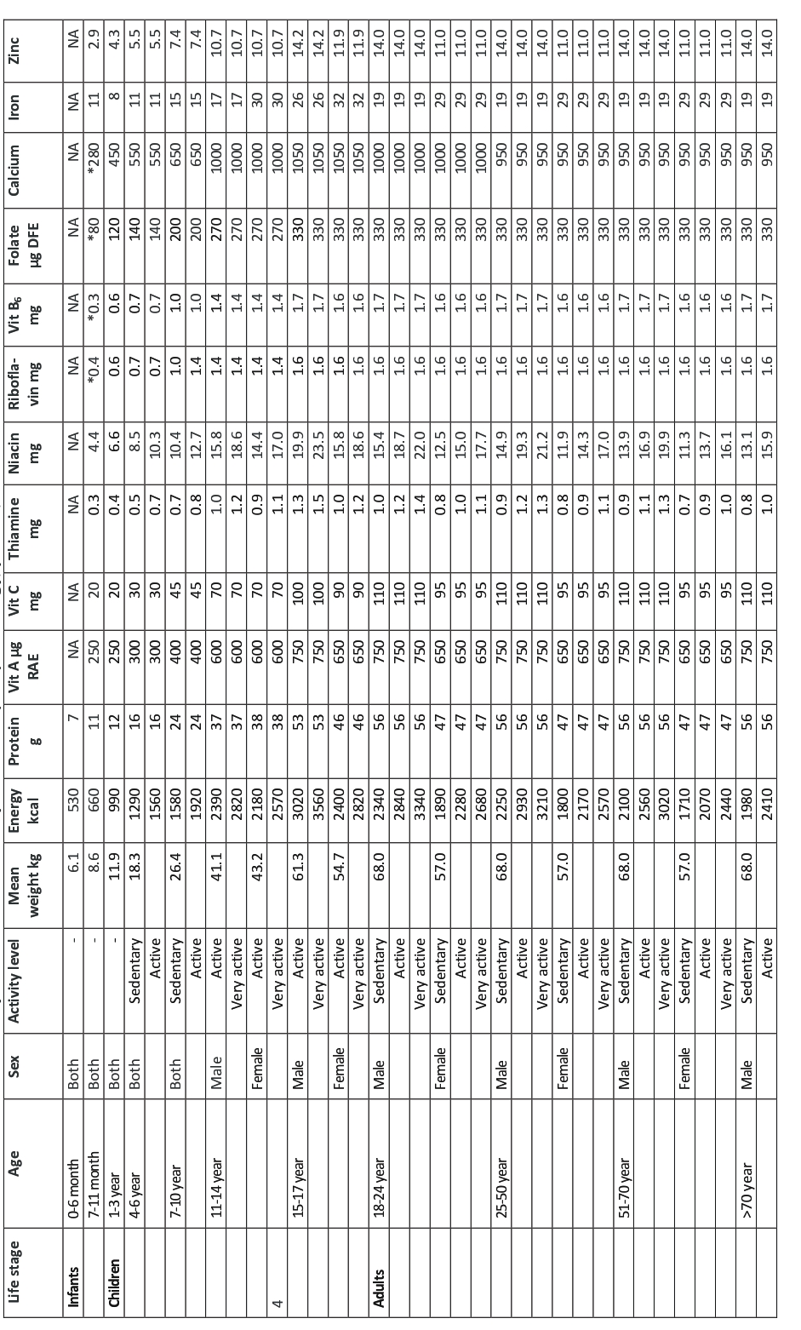
Table 3: Adequate Intake (AI) for minerals from Dietary Reference Intakes for Sri Lankans, 2022
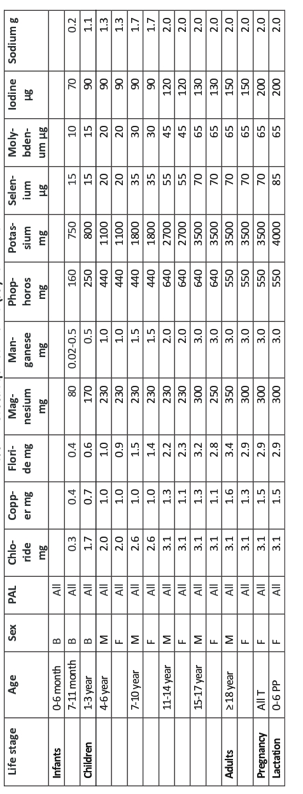
From the above tables, the required nutrient composition of the meal was calculated. These reference values were compared with our findings to ascertain if the meals served in the paediatric ward were adequate for the patients.

Food weighing scale
A digital kitchen scale (Salter) was calibrated according to standard weights used in the hospital pharmacy. All the weights from 2g upwards were accurately measured, with the exception of the 1g weight, occasionally producing an error. The smallest readable value was 1g and therefore the standard error was +/- 1g. Each item on the plate was weighed using this scale.
DATA ANALYSIS
Each food item’s weight was entered into Nutrisurvey 2007⁽⁶⁾. Standard tables from the USDA, Thailand and India food composition tables in Nutrisurvey were used to evaluate the food items which were not readily available.
As per normal national guidelines, three different types of food plates should be issued to the patients in a paediatric ward according to the age groups. However, it was observed that all the plates were served in a similar manner in the study setting. During the time of the study, majority of the patients were in 4-6 year age category. Therefore we selected the reference range for 4-6 year age group for the purpose of comparison of the RDA.
The energy, protein and micronutrients (vitamins A, B1, B2, B6, folic acid, C, D, E and minerals iron, sodium, potassium, calcium, zinc, phosphorus and magnesium) composition were analyzed in each plate. The average nutrient composition of the three plates were taken for each day for the comparison with respective values of RDA table.

RESULTS
The following table demonstrate the distribution of demographic details of paediatric patients in-ward.
Table 4: Demographic data of patients during the week of analysis
Date | Total | Sex | Age  (< 6 months) | Age  (6 months to 1 year) | Age  (1 – 2 years) | Age  ( 2 - 6 years) | Age  (6–12 years)
26/08 | 4 | M - 3  F - 1 | 1 | 0 | 0 | 2 | 1
27/08 | 11 | M - 2  F - 9 | 1 | 1 | 0 | 5 | 4
28/08 | 9 | M - 3  F - 6 | 3 | 1 | 0 | 3 | 2
29/08 | 7 | M - 3  F - 4 | 2 | 1 | 0 | 2 | 2
30/08 | 10 | M - 4  F - 6 | 4 | 1 | 0 | 3 | 2
31/08 | 11 | M - 5  F - 6 | 1 | 2 | 0 | 6 | 2
01/09 | 12 | M - 6  F - 6 | 1 | 0 | 2 | 5 | 4

The following table demonstrates the composition of the food plate during the study week.
Table 5: Meal Composition (Lunch)
Day | Monday | Tuesday | Wednesday | Thursday | Friday | Saturday | Sunday
Item 1 | Rice, red | Rice, red | Rice, red | Rice, white | Rice, red | Rice, red | Rice, white
Item 2 | Egg, boiled | Egg, boiled | Egg, boiled | Egg, boiled | Egg, boiled | Egg, boiled | Egg, boiled
Item 3 | Sprats curry | Sprats curry | Sprats curry | Sprats curry | Sprats curry | Sprats curry | Sprats curry
Item 4 | Potato curry | Pumpkin curry | Dhal curry | Dhal curry | Pumpkin curry | Pumpkin curry | Dhal curry
Item 5 | Cucumber, salad | Mukunuwenna  tempered | Capsicum, Tempered | Carrot sambol | Cabbage, Tempered | Long beans, tempered | Soya meat, devilled
Item 6 | - | - | Cabbage mallum | - | - | - | Beetroot curry
 | 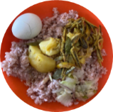 | 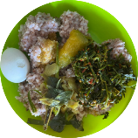 | 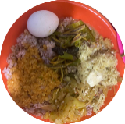 | 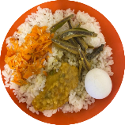 | 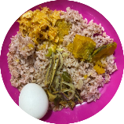 | 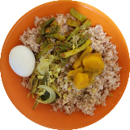 | 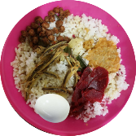

As shown above, the carbohydrate source on all seven days was rice, which is the staple carbohydrate of the Sri Lankan diet. With regard to the protein source, all seven days had similar forms of eggs and sprats served, the eggs being boiled and the sprats being served as a curry. There was a variation of vegetables served across the week, as well the method in which they were cooked.
Macroscopic composition of the breakfast and dinner plates are displayed in Table 3 for the holistic appreciation.
Table 6 in this study indicates other meals offered including breakfast and dinner.
Table 6: Daily Meal Distribution
Day | Breakfast | Lunch | Dinner
Monday | Tea, rice, dhal, Coconut sambol | Rice red, egg boiled, sprats curry, potato curry, cucumber salad | Tea, banana, rice, long beans, cucumber, dhal, fish
Tuesday | Tea, black eyed pea (cowpea), coconut, chili sambol | Rice red, egg boiled, sprats curry, pumpkin curry, mukunuwenna tempered | Tea, banana, rice, fish, dhal, snake gourd
Wednesday | Tea, rice, potato, coconut sambol | Rice red, egg boiled, sprats curry, dhal curry, capsicum, tempered, cabbage mallum | Tea, banana, rice, fish, dhal, mukunuwenna, cooked mango
Thursday | Tea, milk rice, chili sambol | Rice white, egg boiled, sprats curry, dhal curry, carrot sambol | Tea, banana, rice, fish, dhal, coconut sambol
Friday | Tea, chickpea (kadala), coconut | Rice red, egg boiled, sprats curry, pumpkin curry, cabbage tempered | Tea, banana, rice, fish, dhal, soyameat, coconut sambol
Saturday | Tea, milk rice, chili sambol | Rice red, egg boiled, sprats curry, pumpkin curry, long beans tempered | Tea, banana, rice, fish, cabbage, dhal,
Sunday | Tea, rice, dhal, coconut sambol | Rice white, egg boiled, sprats curry, dhal curry, soya meat devilled, beetroot curry | Tea, banana, rice, fish, dhal, coconut sambol, soyameat

It was observed that quality protein source was not available in the breakfast plates and fish was offered in dinner plates throughout the week.
Table 7: Average nutrient composition per plate day
Date | Monday | Tuesday | Wednesday | Thursday | Friday | Saturday | Sunday
Energy  kCal | 478.86 | 435 | 502.1 | 480.27 | 367.8 | 516.13 | 625.87
Carbohydrate g | 82.06 | 74.4 | 86.573 | 80.73 | 61.43 | 89.57 | 94.9
Protein g | 16.46 | 15.13 | 18.46 | 17.7 | 12.9 | 17.56 | 32.7
Fat g | 9.27 | 8.17 | 9.06 | 9.5 | 7.67 | 9.57 | 12.5

It was observed that composition of nutrients were not uniform during the week.

Figure 1: Average nutrient composition per plate on a day

Table 8: Nutrient comparison with % RDA (4-6 years) obtained from the meal assessed
Day / RDA* | Monday |  | Tuesday |  | Wednesday |  | Thursday |  | Friday |  | Saturday |  | Sunday
 | Qty | %  RDA | Qty | %  RDA | Qty | %  RDA | Qty | %  RDA | Qty | %  RDA | Qty | %  RDA | Qty | %  RDA
Energy / 1290 kcal | 478.86 | 37.12% | 435 | 33.72% | 502.1 | 38.92 % | 480.27 | 37.23% | 367.8 | 28.51% | 516.13 | 40.01% | 625.87 | 48.51%
Protein / 15.55 g | 16.46 | 105.85 % | 15.13 | 97.30 % | 18.46 | 118.71 % | 17.70 | 113.83 % | 12.90 | 82.96% | 17.56 | 112.93% | 32.70 | 210.29%
Vit. A/300µg | 138.3 | 46.1% | 194.83 | 64.94% | 197.33 | 65.78% | 509.17 | 169.72% | 210.2 | 70.07% | 296.03 | 98.68% | 150.47 | 50.15%
Vit. B1/ 0.5mg | 0.4 | 80 % | 0.37 | 73.3% | 0.43 | 86.67% | 0.4 | 80% | 0.3 | 60% | 0.47 | 93.33% | 0.57 | 113.33%
Vit. B2/ 0.7mg | 0.13 | 19.05% | 0.2 | 28.57% | 0.2 | 28.57% | 0.2 | 28.57% | 0.2 | 28.57% | 0.2 | 28.57% | 0.27 | 38.09%
Vit. B6/ 0.7mg | 0.6 | 85.71% | 0.57 | 80.95% | 0.7 | 100% | 0.57 | 80.95% | 0.47 | 66.67% | 0.57 | 80.95% | 0.7 | 100%
tot. fol.acid/ 140 µg | 44.13 | 31.52% | 38.93 | 27.81% | 96.07 | 68.62% | 91.67 | 65.48% | 44.3 | 31.64% | 60.03 | 42.88% | 171.87 | 122.76%
Vit. C/ 30mg | 5.8 | 19.33% | 28.83 | 96.11% | 66.5 | 221.67% | 4.03 | 13.44% | 6.03 | 20.11% | 9.03 | 30.11% | 5.13 | 17.11%
Vit D/  15 mcg | 1.4 | 9.3% | 1.6 | 10.6% | 1.5 | 10.0% | 1.4 | 9.3% | 1.4 | 9.3% | 1.6 | 10.6% | 1.6 | 10.6%
sodium | 132.33 | 10.18% | 100.73 | 7.75% | 93.23 | 7.17% | 123.67 | 9.51% | 104.13 | 8.01% | 237.13 | 18.24% | 367.07 | 28.23%
potassium | 550.07 | 50.01% | 488.23 | 44.38% | 586.27 | 53.30% | 555.73 | 50.52% | 367.37 | 33.40% | 614.63 | 55.88% | 916 | 83.27%
Calcium/ 550mg | 120.63 | 21.93% | 177.57 | 32.28% | 129 | 23.45% | 116.53 | 21.19% | 84.03 | 15.28% | 125.23 | 22.77% | 175.23 | 31.86%
magnesium | 160.37 | 69.72r% | 164.37 | 71.46% | 173.33 | 75.36% | 163.4 | 71.04% | 123.83 | 53.84% | 185.73 | 80.75% | 222.93 | 96.93%
phosphorus | 383.8 | 87.23% | 360.77 | 81.99% | 434.23 | 98.69% | 414.07 | 94.11% | 311.63 | 70.82% | 431.73 | 98.12% | 584.6 | 132.86%
Iron/ 11mg | 2.93 | 26.67% | 3.6 | 32.72% | 3.87 | 35.18% | 4.13 | 37.54% | 2.43 | 22.09% | 3.57 | 32.45% | 6.13 | 55.73%
Zn/ 5.5 mg | 2.77 | 50.30% | 2.6 | 47.27% | 3.13 | 56.91% | 3.1 | 56.36% | 2.3 | 41.82% | 3.17 | 57.63% | 3.93 | 71.45%
*Average daily amount of nutrients that a healthy population consumes, which is assumed to be enough to meet their needs is defined as Adequate intake (AI) ⁽⁵⁾. As the RDA values were not available for sodium, potassium, phosphorous and magnesium, AI is taken as the denominate for calculation.

According to the above table, it is observed that more than one third of the daily calorie requirement is covered by the lunch, which is satisfactory. However, almost all the days during the week of the study period, more than 100% of RDA for proteins is achieved with this single meal. Since the same rotation of foods is served every week, the patient will receive this throughout their hospital stay. Although the protein requirement would be slightly increased during illness according to the underlying disease, giving excess proteins at one time will not give the maximum benefit to the patient.
In general, lunch plates of all seven days provided a considerable proportion of all the vitamins which were analyzed. High percentage of Vitamin A on Thursday diet and the high percentage of vitamin C on Wednesday diet probably due to raw carrot and capsicum curry respectively. The vitamin D level of a single meal was 1.5 micrograms on average, which is equivalent to 10.0% of the RDI value for the respective age, which is markedly insufficient. Much of the vitamin D was sourced from the eggs (1.2 mcg ~ 8%).
Sodium level of our plates show low values as the added salt was not analyzed during the assay.
Daily inclusion of sprats and full egg in the lunch attributed to the high phosphate level in the meal. Iron and zinc are provided adequately from the meals.

DISCUSSION
According to our observations, paediatric patients were served boiled plain rice for lunch throughout the week. Including an egg on a daily basis for lunch provides high quality protein and the source of vitamin D to children, but preparation in the same manner (boiled) can lead to a higher chance of food rejection by them. Cooked sprats curry was served on a daily basis, which serves as a main source of calcium to the lunch plate yet lacking in variety. From Monday to Saturday, lunch plate provided around one third of the daily calorie target of the 4-6 year age group. However, almost 50% of the energy target of the same age group was provided by the Sunday lunch plate. The daily lunch plate consisted at least two varieties of vegetables on Tuesday, Wednesday, Friday and Saturday, yet the variability over the week was not satisfactory. It was observed that potato and dhal replaced vegetables on Monday, Thursday and Sunday which will lead to reduction in insoluble fibre content in the meal. Selected micronutrient analysis revealed the adequacy of vitamins A, B1, B2, B6, folic acid, C, E and minerals iron, sodium, potassium, calcium, zinc, phosphorus and magnesium. However it was concerning to observe the lack of Vitamin D content in the meal throughout the week which is an important contributor for illness recovery. Our study observation on lack of diversity and variety of food items were similar to the study done by Fernando and Wijesinghe et al at Karapitiya Hospital ⁽¹⁾. As we have not been able to find any study with quantitative food plate analysis with regard to micronutrients, a comparison was not performed.
In a normal paediatric ward setting, children aged 0-14 years are admitted and the diet circular is designed to order and serve food as per different age categories. But according to our observation, ordering of food was done as per the circular, yet similar quantities of food was served on to all plates without considering the age of the child. This will lead to energy and protein gaps with deficits or excesses as well as wastage.
Recommendations
- To modify the menu of the hospital diet for the paediatric wards with more diversity and variety in food items and cooking methods.
- Provision of standard partitioned food serving trays.
- Further studies including food wastage and direct nutrient analysis of the consumed food.
- Children prefer variability in appearance, taste and texture in food and same types of food are likely to cause rejection of food, especially during illness which can have adverse effects on recovery as well. Although boiled rice is the staple carbohydrate for most Sri Lankans, there are many alternative methods in which it could be prepared (eg: fried, tempered, yellow rice etc).

Table 9: Recommended meal plan for paediatric wards
Meal | Monday | Tuesday | Wednesday | Thursday | Friday | Saturday | Sunday
Breakfast | Parboiled rice , egg boiled,  dhal curry, coconut sambol, | Egg omlet, chickpeas boiled | Parboiled rice, egg boiled, potato curry, coconut sambol | Milk rice, chili sambol | Chickpea boiled, fresh coconut grated | Parboiled rice, egg boiled, dhal curry, coconut sambol | Milk rice, chili sambol
Lunch
Week 1 | Vegetable fried rice, chicken curry, potato curry, cucumber salad | Parboiled rice, fish curry, pumpkin black curry, mukunuwenna malum | Red rice, soya meat curry, beans curry, cabbage malum, | Vegetable fried rice, chicken curry, dhal curry, cucumber salad | Parboiled rice, egg boiled, pumpkin curry/ sweet potato curry, cabbage malum | Red rice, sprats curry, potato curry, ladies finger curry | Yellow rice, egg boiled, dhal curry, beetroot/beans curry
Week 2 | Vegetable fried rice, chicken curry, potato curry, cucumber salad | Parboiled rice, fish curry, dhal curry, kankun devilled | Parboiled rice, dhal curry, pumpkin curry, long beans devilled | Vegetable fried rice, chicken curry, dhal curry, cucumber salad | Parboiled rice, egg boiled, potato curry, banana blossom deviled | Red rice, sprat curry, sweet potato curry, long beans curry | Yellow rice, egg boiled, dhal curry, beetroot/beans curry
Week 3 | Vegetable fried rice, chicken curry, potato curry, cucumber salad | Parboiled rice, fish curry, pumpkin black curry, mukunuwenna malum | Red rice, soya meat curry, beans curry, cabbage malum | Vegetable fried rice, chicken curry, dhal curry, cucumber salad | Parboiled rice, egg boiled, pumpkin curry, cabbage malum | Parboiled rice, sprats curry, potato curry, lady fingers curry | Yellow rice, boiled egg, dhal curry, beetroot/beans curry
Week 4 | Vegetable fried rice, chicken curry, potato curry, cucumber salad | Parboiled rice, fish curry, dhal curry, kankun devilled | Parboiled rice, dhal curry, pumpkin curry, beans curry | Vegetable fried rice, chicken curry, dhal curry, cucumber salad | Parboiled rice, manioc/ridged gourd bitter curry, banana blossom curry devilled | Red rice, sprats curry, sweet potato curry, long beans curry, | Yellow rice, egg boiled, dhal curry, beetroot/beans curry
Dinner | Parboiled rice, fish white curry, dhal curry, cooking melon black curry/long beans devilled | Red rice, dhal curry, snake gourd white curry, dry fish devilled | Parboiled rice, fish curry, dhal curry, mango curry, mukunuwenna malum | Red rice, fish curry, dhal & spinach curry, coconut sambol | Red rice, chicken curry, dhal curry, coconut sambol, | Parboiled rice, fish curry dhal curry, coconut sambol | Red rice, fish curry, dhal curry, cabbage curry

CONCLUSION
As per our lunch plate survey at a paediatric ward, we have observed that quantity of macronutrients as well as micronutrients (except vitamin D) were adequate with regards to energy and analyzed micronutrients, yet excess of proteins. As a developing nation with limited resources, the fact of providing a free meal to all in patients should be appreciated. However as stakeholders of children’s health in our nation we wish to highlight the main observation of lacking of food diversity and variability in cooking method of food items during the course of the week. These drawbacks will lead to food aversions by children who are anyway picky eaters which will get worse when they are sick, resulting in food wastage and nutritional deprivation. This paves pathway for our next audit on food wastage from food plates.
Limitations
- We have only compared the nutrient requirements for 4-6 year age group, as the majority of the sample were in that group.
- As our study was carried out only during a one week period, seasonal availability of the vegetables not accounted.
- We have only analyzed the lunch plate and the nutrient requirement contribution was taken as at least one third of the daily requirement.
- The proportion of the food shared from the food plate by the guardians was not taken into the consideration. Separate food plates were not issued to the by standers in routine paediatric setting and we have assumed that the whole food plate was consumed by the child and the wastage was not taken into consideration.
- Micronutrient contribution from the spices and condiments were not taken into consideration for the analysis.
Funding Statement
This is a self-funded research study within the cost of LKR 5000.00
Acknowledgments
The Director, Colombo South Teaching Hospital, Kalubowila, Sri Lanka
The Sister in charge – Professorial Pediatric Unit, Colombo South Teaching Hospital, Kalubowila, Sri Lanka
In ward Patients and parents of Professorial Pediatric Unit, Colombo South Teaching Hospital, Kalubowila, Sri Lanka
Kitchen staff of Colombo South Teaching Hospital, Kalubowila, Sri Lanka
Conflict of Interest
The authors declare that they have no known competing financial interests or personal relationships that could have appeared to influence the work reported in this paper.
Author Contribution
Conceptualization, Funding acquisition, Methodology and Supervision - Ruwanthi Perera, Jayani Tennakoon Jayaweera
Data curation, Formal analysis, Resources and Software - Gihan Gunasekara, Jainie Ratnaweera, Baarckavy Nanthakumar
Project Administration, Validation, Visualization - Dasanya Kaluarachchi
Writing – original draft and Writing – review & editing - Ruwanthi Perera, Jayani Tennakoon Jayaweera, Gihan Gunasekara, Jainie Ratnaweera, Baarckavy Nanthakumar, Dasanya Kaluarachchi

ETHICAL CONSIDERATIONS
The ethical clearance was obtained from the ERC committee of the Colombo South Teaching Hospital. Written informed consent was granted by the Hospital Director.

REFERENCES
- Fernando, G. H. S., & Wijesinghe, C. J. (2017). Quality and standards of hospital food service; a critical analysis and suggestions for improvements. Galle Medical Journal, 22(2), 17. https://doi.org/10.4038/gmj.v22i2.7970
- Ministry of Health, Sri Lanka. Diet circular SL. General Circular No:01-21/2015. http://www.previousmoh.health.gov.lk/CMS/cmsmoh1/viewcircular.php?cno=01-21/2015&med=english
- Williams, J., Townsend, N., Rayner, M., Jayawardena, R., Katulanda, P., Manoharan, S., & Wickramasinghe, K. (2019). Diet quality of adolescents in rural Sri Lanka based on the Diet Quality Index-International: findings from the “Integrating Nutrition Promotion and Rural Development” project. Public Health Nutrition, 22(10), 1735–1744. https://doi.org/10.1017/S1368980019000430
- Ahmed, M., Jones, E., Refdmond, E., Hewedi, M., Wingert, A. El, & Rab, M. G. (2015). Food production and service in UK hospitals. In International Journal of Health Care Quality Assurance (Vol. 28, Issue 1).
- Medical Research Institute, Sri Lanka. Dietary Reference Intakes for Sri Lankans. (2022). https://www.mri.gov.lk/units/nutrition/survey-reports/
- Nutrition surveys and assessment. https://www.nutrisurvey.de/
- Osman, N. S., Nor, N. M., Sharif, M. S. M., Hamid, S. B. A., & Rahamat, S. (2021). Hospital food service strategies to improve food intakes among inpatients: A systematic review. In Nutrients (Vol. 13, Issue 10). MDPI. https://doi.org/10.3390/nu13103649

