CLIMATE CHANGE MITIGATION AND ADAPTATION FOR NATURAL RESOURCE MANAGEMENT
ABSTRACT
This paper highlights the crucial implications of change in climate as a global concern, emphasizing its serious repercussions for biodiversity, natural resource management and ecosystems. The primary factors for the change in climate are thought to be human-induced activities, specifically the emission of greenhouse gases, which leads to temperature change, different patterns of precipitation, and a raise in extreme weather. The way to address Climate change is by adaptation and mitigation. One aspect of mitigation is lowering release of greenhouse gases, whereas focusing on raising resilience to cope with inevitable impacts. The natural resource management, including fisheries, forestry, agriculture, water and biodiversity conservation is important to address the issue of climate change. covered in the following discussion. Aim: the aim of this paper is to examine the role of mitigation and adaptation in minimizing climate change impacts on natural resources. Methodology: This study adopted qualitative literature review with two illustrative case studies to understand and analyses the Natural resource management. Results: This study summarizes the best practices for mitigation (e.g. carbon sequestration through reforestation, energy efficiency in construction) and adaptation (e.g. salt-tolerant crops, rainwater harvesting, resilient infrastructure). The case studies demonstrate practical applications: in the Sundarbans, community initiatives (salt-resistant rice varieties, water storage, mangrove planting, solar lighting) have improved agricultural resilience; in India’s cement industry, energy-saving innovations and alternative fuels have significantly reduced CO₂ emissions. These examples illustrate how integrating local knowledge and sustainable technology can reduce vulnerability and emissions simultaneously. Importance of the study: The findings underscore the importance of integrated strategies which can combine ecosystem restoration, resource-efficient practices, and stakeholder collaboration to enhance long-term resource sustainability under climate change.
Keywords: Climate-change, Ecosystems, Adaptation, Mitigation, Resource Management

- Introduction
Climate change is one of the most significant worldwide issues of our day, with extensive ramifications for ecosystems, biodiversity, and natural resource management (United Nations, n.d.). Greenhouse gas emissions into the atmosphere caused by human activities are the primary cause of major changes in Earth’s climate (Intergovernmental Panel on Climate Change, 2021; European Commission, n.d.). These changes, including increases in temperature, shifting patterns of precipitation, and increases in the frequency and intensity of extreme weather events, have immense effects on the quality and availability of natural resources, posing unprecedented challenges to ecosystems and human societies (United Nations, n.d.; Jeff Turrentine, n.d.).bAs a crucial response to this emerging issue, mitigation and adaptation are two strategies that can be explored. Mitigation involves reducing or preventing greenhouse gas emissions to curb the extent of climate change, while adaptation concentrates on fostering resilience and putting plans in place to deal with the inevitable effects (Intergovernmental Panel on Climate Change, 2021; United Nations, n.d.). The management of natural resources includes an extensive spectrum of activities such as agriculture, biodiversity preservation, forestry, water management, and fisheries. The implications of climate change for these sectors are profound, as shifts in temperature and precipitation patterns, sea-level rise, and ecosystem changes challenge traditional approaches to resource utilization (Youmatter, n.d.). Thus, for long-term sustainable development, it is important to understand and implement efficient adaptation and mitigation strategies in the framework of natural resource management (European Commission, n.d.). Mitigation strategies involve promoting sustainable practices that reduce carbon emissions and enhance carbon sequestration. For example, reforestation contributes to biodiversity conservation and helps absorb atmospheric carbon dioxide (United Nations, n.d.). Adaptation strategies focus on improving the resilience of ecosystems and communities to changing climate conditions. Sustainable practices such as improved water management and sustainable urban infrastructure aim to minimize vulnerability and ensure the continued availability of vital resources (Ayfer Baykal, 2012; United Nations Convention to Combat Desertification, n.d.). Integrating these two strategies and understanding the interconnections between ecosystems, climate, and human activities are essential for combating the effects of climate change on natural resources (Intergovernmental Panel on Climate Change, 2021).

1. Materials and Methods
This study adopts a qualitative research approach to explore mitigation and adaptation strategies implemented across the country for climate change. The study draws data from a diverse range of sources such as peer-reviewed journal articles, books, and online datasets and reports related to climate change and environmental management. A systematic review of available literature was conducted based on relevant keywords and thematic categorization of data. In-depth analysis of two case studies was carried out to provide concrete examples of adaptation and mitigation strategies in practice.

2. Literature Review

2.1 Climate Change
Changes in the planet's average temperature that are mostly brought about by human activities define climate change, a global phenomenon of climatic transformation (United Nations, n.d.; Intergovernmental Panel on Climate Change, 2021). Due to the imbalance in Earth’s climate system, the survival of civilizations, the stability of the global economy, and the resilience of ecosystems are increasingly under threat (Youmatter, n.d.). Human economic activities and industrial development, particularly the burning of fossil fuels and land-use changes, are recognized as the primary causes of global warming (Jeff Turrentine, n.d.; European Commission, n.d.).

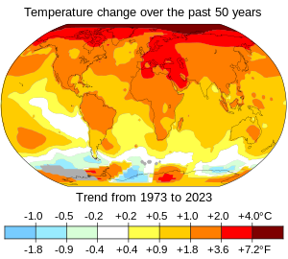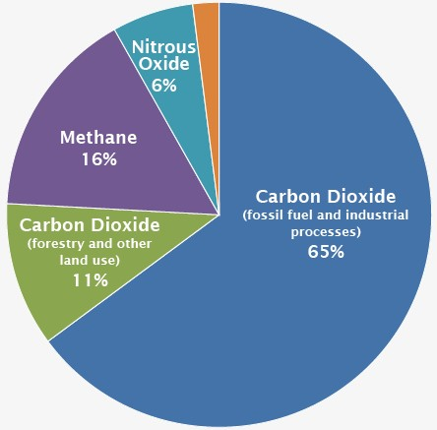
Figure 1: Temperature change over the past 50 years. Figure 2: Global GHG emissions.
Source:https://en.wikipedia.org/wiki/Climate_change Source: https://www.epa.gov/globalgreenhouse-gas-emissions-data

2.2 Reasons of climate change
Below are the major reasons for climate change. Fossil fuels such as coal, oil, and natural gas are the dominant sources of greenhouse gas emissions worldwide, contributing to a large share of global carbon dioxide emissions (Intergovernmental Panel on Climate Change, 2021; European Commission, n.d.). These fuels are responsible for nearly 90% of carbon dioxide emissions and about 75% of total global greenhouse gas emissions (United Nations, n.d.). Greenhouse gases trap the sun’s heat in the atmosphere, leading to global warming, which in turn alters weather patterns and disturbs the natural balance of ecosystems (Intergovernmental Panel on Climate Change, 2021). Deforestation is another significant contributor to climate change. When forests are cleared, the carbon stored in trees is released into the atmosphere, increasing carbon emissions. Additionally, the capacity of forests to absorb carbon dioxide decreases when trees are replaced by urban infrastructure and buildings that generate emissions during construction and operation (United Nations, n.d.; Jeff Turrentine, n.d.). Transportation also contributes significantly to greenhouse gas emissions. The increasing number of vehicles worldwide results in higher levels of carbon dioxide emissions, with the transport sector accounting for approximately one-quarter of global energy-related CO₂ emissions (European Commission, n.d.). Rapid urban development and population migration have further accelerated deforestation, destruction of wetlands, and degradation of natural carbon sinks. These ecosystems previously acted as reservoirs that stored large amounts of carbon and helped regulate atmospheric carbon dioxide levels (United Nations, n.d.). Agriculture also plays a critical role in greenhouse gas emissions. Modern agricultural practices, including the excessive use of chemical fertilizers to increase crop productivity, release methane and nitrous oxide into the atmosphere. These gases have a much higher heat-trapping potential than carbon dioxide and contribute significantly to global warming while also affecting soil fertility and ecosystem balance (Intergovernmental Panel on Climate Change, 2021; Jeff Turrentine, n.d.).
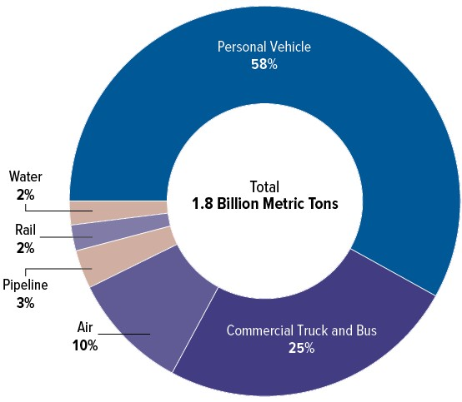
Figure 3: Emissions of Carbon Dioxide in the Transportation Sector.
Source: https://www.cbo.gov/publication/58861
The amount of time people spend indoors is directly connected to energy consumption and associated carbon emissions. Many daily activities rely heavily on electrical equipment and appliances, including cooking, working on laptops, cooling, heating, and other household operations, all of which require significant amounts of energy and contribute to greenhouse gas emissions (European Commission, n.d.; Jeff Turrentine, n.d.). The increasing demand for electricity, particularly when generated from fossil fuels, contributes significantly to the emission of carbon dioxide and other greenhouse gases into the atmosphere (Intergovernmental Panel on Climate Change, 2021). The concentration of greenhouse gases such as carbon dioxide, methane, and nitrous oxide in the atmosphere has reached levels unprecedented in the past 800,000 years (Intergovernmental Panel on Climate Change, 2021). Certain greenhouse gases, such as hydrofluorocarbons (HFCs), are largely synthetic and do not naturally occur in the atmosphere but are produced by human industrial activities (United Nations, n.d.). Continuous emissions of these gases have increased the Earth’s average temperature and intensified the occurrence of hazardous and more frequent weather extremes (Intergovernmental Panel on Climate Change, 2021). Although climate change affects the entire global population, its impacts are not distributed equally. Economically and politically marginalized communities often experience a disproportionate burden of climate impacts despite contributing relatively little to global greenhouse gas emissions (United Nations, n.d.).

2.3 Impact of Climate Change on Natural Resources and Ecosystems
One of the most evident consequences of climate change across regions is the increasing instability of weather patterns. Extreme weather events such as floods, wildfires, cyclones, and droughts are becoming more frequent and intense due to rising global temperatures (Intergovernmental Panel on Climate Change, 2021). Rising sea levels, degradation of forest areas, and the loss of fragile ecosystems and biodiversity are additional consequences of climate change that threaten environmental sustainability (United Nations, n.d.). Water availability is becoming a major challenge in many regions around the world. Global warming exacerbates water shortages, particularly in areas already experiencing water stress (European Commission, n.d.). Climate change also increases the likelihood of ecological and agricultural droughts, which can damage crops and weaken ecosystem resilience (United Nations Convention to Combat Desertification, n.d.). Drought conditions can trigger destructive sand and dust storms that transport billions of tons of sand across continents, further degrading land and reducing agricultural productivity (United Nations Convention to Combat Desertification, n.d.). In addition, the expansion of desert areas reduces the amount of land available for food production, increasing the risk of water scarcity and food insecurity for many populations around the world (United Nations, n.d.).
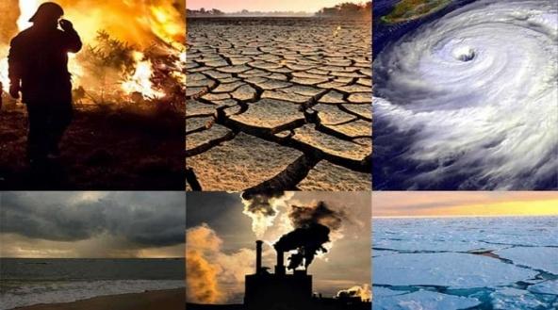
Figure 4: Consequences of Climate change.
Source: https://www.tajmedun.tj/en/news/university/rapid-climate-change-and-its-impact-on-people-s-lives/
The majority of heat generated by global warming is absorbed by the oceans, which has resulted in a dramatic increase in ocean warming at various depths over the past two decades (Intergovernmental Panel on Climate Change, 2021). As ocean temperatures rise, seawater expands, causing an increase in ocean volume and contributing to rising sea levels (United Nations, n.d.). Additionally, the melting of glaciers and polar ice sheets further accelerates sea-level rise, placing coastal and island communities at significant risk (Intergovernmental Panel on Climate Change, 2021). Oceans also absorb a substantial portion of atmospheric carbon dioxide, which helps reduce the amount entering the atmosphere. However, this process leads to ocean acidification, which threatens coral reefs and marine ecosystems (European Commission, n.d.). Changes in climate and increasing extreme weather events are contributing to the growing prevalence of global hunger and malnutrition, as agricultural production, fisheries, and livestock systems become increasingly vulnerable (United Nations, n.d.). Marine resources are also under threat due to ocean acidification, which affects the ecosystems that sustain billions of people worldwide (Intergovernmental Panel on Climate Change, 2021). In Arctic regions, traditional food supplies derived from fishing, hunting, and herding have been disrupted due to changes in snow and ice cover (United Nations, n.d.). Similarly, water scarcity and heat-stressed grasslands can negatively affect crop productivity and livestock populations (European Commission, n.d.). Climate change significantly impacts India’s natural resources, affecting sectors such as forestry, agriculture, biodiversity, and water resources.

2.4 Agriculture
Climate change can alter temperature and precipitation patterns, which directly affect crop production by shifting growing seasons and modifying agricultural conditions (Intergovernmental Panel on Climate Change, 2021). Increased temperatures can cause heat stress in crops, thereby reducing agricultural productivity (United Nations, n.d.). Changes in rainfall patterns and higher evaporation rates due to rising temperatures can also lead to water scarcity, affecting irrigation systems and overall agricultural output (European Commission, n.d.). Furthermore, the increasing frequency and intensity of extreme weather events such as cyclones, floods, and droughts can damage crops, disrupt agricultural operations, and threaten food security (Intergovernmental Panel on Climate Change, 2021).

2.5 Water Resources
The Himalayan glaciers, which are an essential source of freshwater for major rivers such as the Ganges and Brahmaputra, are rapidly melting due to rising global temperatures, thereby affecting downstream water availability (Intergovernmental Panel on Climate Change, 2021). Climate change can also disrupt traditional monsoon patterns, altering the timing and distribution of rainfall across regions (United Nations, n.d.). Such changes can lead to water shortages in some regions while increasing the risk of flooding in others. In addition, rising sea levels can cause saltwater intrusion into coastal aquifers, compromising the quality of freshwater resources and posing challenges for drinking water supply and agriculture (European Commission, n.d.).

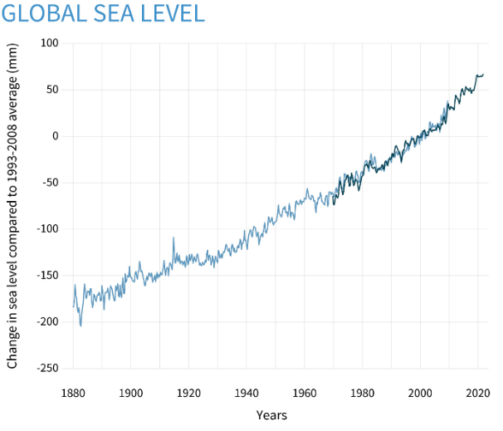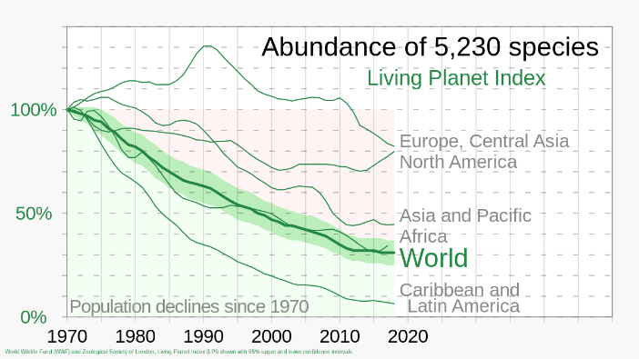
Figure 5: Global Sea Level till 2020. Figure 6: Living Plant Index declining over the years.
Source: Fig.5: https://www.climate.gov/understanding-climate/climate-change-global-sea-level
Fig.6: https://en.wikipedia.org/wiki/Living_Planet_Index

2.6 Biodiversity
Changes in temperature and precipitation patterns can alter ecosystems and lead to habitat loss for various plant and animal species, posing significant threats to biodiversity and ecological stability (Intergovernmental Panel on Climate Change, 2021). Such climatic variations can disrupt ecological balance by affecting species interactions, food chains, and ecosystem functions (United Nations, n.d.). Some species may migrate to different regions in response to changing climate conditions, resulting in shifts in the geographical distribution of flora and fauna as they attempt to adapt to new environmental conditions (European Commission, n.d.; Intergovernmental Panel on Climate Change, 2021).

2.7 Forestry
Increased temperatures and changes in precipitation patterns can contribute to more frequent and intense forest fires, significantly affecting forest ecosystems and biodiversity (Intergovernmental Panel on Climate Change, 2021). Climate change can also influence the prevalence and distribution of pests and diseases, thereby affecting the health and productivity of forest ecosystems (United Nations, n.d.). The livelihoods of communities that depend on forests for income and survival are also affected due to disruptions in forest resources and ecosystem services (European Commission, n.d.). In addition, climate change may increase the risk of the spread of vector-borne diseases, which can negatively impact the health of communities living near forested regions (United Nations, n.d.). The following sections highlight the effects of climate change on natural resources commonly used in the construction sector. Climate change can influence the availability, quality, and cost of construction materials.

2.8 Timber and Wood Products
Changes in precipitation patterns, rising temperatures, and the increasing frequency of forest fires can affect the growth and availability of timber resources (Intergovernmental Panel on Climate Change, 2021). Climate-induced droughts, pests, and diseases can further weaken forest health and reduce the availability of timber and other forest-based construction materials (United Nations, n.d.).

2.9 Aggregate and Sand
Extreme weather events such as droughts and floods can affect the extraction and availability of aggregates and sand used in construction (European Commission, n.d.). Changes in river courses and increased sedimentation caused by heavy rainfall may also influence the quality and quantity of these resources. Additionally, the reconstruction of infrastructure after climate-related disasters often increases the demand for construction materials, which may lead to over-extraction and depletion of natural resources (Intergovernmental Panel on Climate Change, 2021).

2.10 Energy Resources
Climate change can affect the availability and reliability of energy resources used in construction. For instance, hydropower generation can be impacted by changes in river flow patterns and extreme weather conditions (European Commission, n.d.). Furthermore, global climate mitigation efforts are accelerating the transition toward renewable energy sources, which may influence the availability and cost of traditional energy resources used in construction activities (Intergovernmental Panel on Climate Change, 2021).

2.11 Minerals and Metals
Climate-related events such as floods, storms, and wildfires can disrupt mining operations and affect the availability of minerals and metals required for construction (Intergovernmental Panel on Climate Change, 2021). Changes in temperature and precipitation patterns may also influence ore quality and mining productivity. Additionally, the increasing demand for materials used in renewable energy technologies and infrastructure development may raise the prices and affect the availability of certain minerals and metals (European Commission, n.d.).

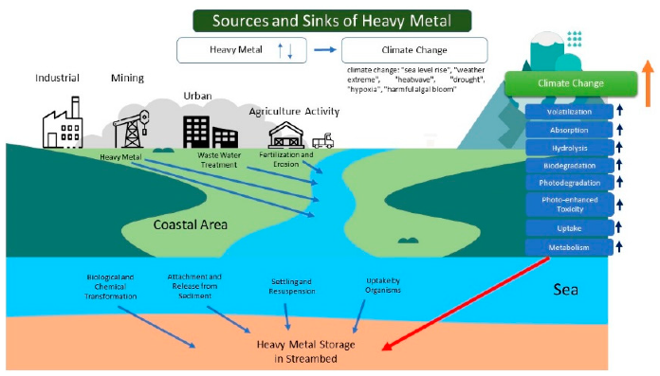
Figure 7: Effects of climate change on metals.
Source: (Understanding Climate Change and Heavy Metals in Coastal Areas: A Macroanalysis Assessment, Mok, Ghaffar, Noor, Lanana and Azra)

2.12 Land Resources
Changes in land use patterns due to climate change, such as shifts in vegetation cover, can impact the availability of land for construction projects. Changes in land values and increased vulnerability to climate-related risks can influence decisions regarding where and how construction projects are developed.

- Adaptation and Mitigation
The effects of climate change, such as rising sea levels and increasingly powerful storms, are already being experienced in many regions of the world and are projected to intensify in the future (Intergovernmental Panel on Climate Change, 2021; United Nations, n.d.). Adaptation measures are developed in response to these impacts in order to reduce vulnerability and enhance resilience to climate-related risks (Intergovernmental Panel on Climate Change, 2021). Mitigation measures aim to reduce the concentration of greenhouse gases in the atmosphere by addressing the sources of emissions caused by human activities or through nature-based solutions that enhance carbon storage (European Commission, n.d.). Intact ecosystems play a crucial role in carbon sequestration, which makes many ecosystem-based adaptation actions beneficial for climate change mitigation as well (United Nations, n.d.). When carbon sequestration is considered as a goal during the early stages of adaptation planning, adaptation projects can be designed in ways that also deliver mitigation benefits, thereby addressing climate change more effectively through integrated strategies (Intergovernmental Panel on Climate Change, 2021).

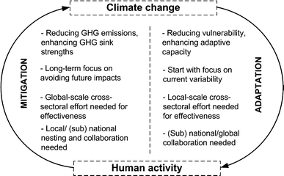
Figure 8: The two main interventions in the two-way link between human activity and
global climate change: mitigation and adaptation.
Source: https://link.springer.com/article/10.1007/s00267-014-0331-x

3.1 Mitigation Strategies
One example of mitigation strategies is the practice adopted by indigenous farmers who manage land according to sustainable principles. Through the adoption of regenerative agriculture practices, emissions from the agricultural sector can be reduced while enhancing the soil’s capacity to capture and store carbon from the atmosphere, which also contributes to healthier food production systems (Intergovernmental Panel on Climate Change, 2021; United Nations, n.d.). Buildings can also be designed to be highly energy efficient, thereby reducing greenhouse gas emissions while lowering operational costs for users (European Commission, n.d.). Standards for sustainable sourcing of materials can be promoted through certification systems that ensure responsible extraction and harvesting practices. Recycling and reusing construction materials can significantly reduce the demand for new raw resources and minimize environmental impacts associated with material extraction (Intergovernmental Panel on Climate Change, 2021). Materials with lower environmental impacts, such as bamboo and bioplastics, can also serve as alternatives to conventional materials that contribute significantly to greenhouse gas emissions (United Nations, n.d.). Transportation and logistics systems can also be optimized to reduce the carbon footprint associated with the delivery of construction materials and the operational use of buildings (European Commission, n.d.). Sustainable forest management practices that balance timber harvesting with conservation goals should be implemented to ensure the long-term health and productivity of forest ecosystems (United Nations, n.d.). Fire management strategies are also important to prevent and control forest fires, which release large amounts of carbon into the atmosphere (Intergovernmental Panel on Climate Change, 2021).
Land-use planning practices that prioritize biodiversity conservation and natural habitat protection can further support climate mitigation efforts. Rainwater harvesting can be implemented as an effective method for storing rainwater and reducing dependence on groundwater resources (European Commission, n.d.). Industrial wastewater and toxins should be treated before discharge into water bodies to prevent contamination of freshwater resources, and treated water can be reused for non-potable purposes (United Nations, n.d.).
Declining groundwater recharge and improper drainage systems can increase flood risks. These issues can be addressed through the use of permeable pavements, urban green spaces, and green roofs that improve water infiltration and manage stormwater runoff (European Commission, n.d.). Integrating indigenous shrubs and trees into landscapes can also enhance carbon sequestration, increase biodiversity, and provide economic benefits through timber and non-timber forest products (United Nations Convention to Combat Desertification, n.d.).

3.2 Adaptation Strategies
Climate-resilient materials that can withstand extreme weather conditions should be selected for construction projects (Intergovernmental Panel on Climate Change, 2021). Water-efficient construction practices should also be adopted to ensure sustainable water use during building operations (European Commission, n.d.). During the design and construction of infrastructure, climate-related natural disasters such as floods, storms, and cyclones should be considered so that structures remain functional and can serve as emergency shelters if required (United Nations, n.d.). Encouraging the use of locally available construction materials can reduce transportation-related emissions and minimize supply chain disruptions caused by extreme weather events (Intergovernmental Panel on Climate Change, 2021). Risk assessment planning is another crucial step, enabling stakeholders to identify potential climate-related impacts on natural resources and infrastructure and develop appropriate management strategies.
Historically, construction practices were deeply connected with local communities, whose traditional knowledge of climate patterns and locally available materials helped meet environmental challenges. Integrating local community participation in planning and construction processes can improve climate resilience and sustainability (United Nations, n.d.). Continuous monitoring and assessment of climate impacts on construction projects can support adaptive management strategies and enable timely adjustments to development plans (European Commission, n.d.). Ecosystem restoration can play an important role in rehabilitating degraded forests and protecting biodiversity. Establishing wildlife corridors can connect fragmented habitats, enabling species to migrate and adapt to changing climate conditions while maintaining genetic diversity (Intergovernmental Panel on Climate Change, 2021). Increasing awareness among stakeholders, policymakers, local communities, and the public about climate adaptation is also essential for effective climate action (United Nations, n.d.). The development of alternative materials, resource-efficient technologies, and sustainable construction techniques is becoming increasingly important in addressing climate challenges. Reducing the impacts of climate change on natural resources used in the construction sector requires climate-resilient planning and sustainable infrastructure development (Intergovernmental Panel on Climate Change, 2021). Incorporating climate change considerations into the management of natural resources used in construction is essential for developing sustainable, resilient, and environmentally responsible built environments (European Commission, n.d.). Achieving this goal requires collaboration among governments, the construction industry, academic institutions, and local communities (United Nations, n.d.).

- Case Studies
  - Case Study 1
    - Climate Adaptation
(Dave, Parikh, Pillai, Coping with Climate Change, Case Studies and Experiences)
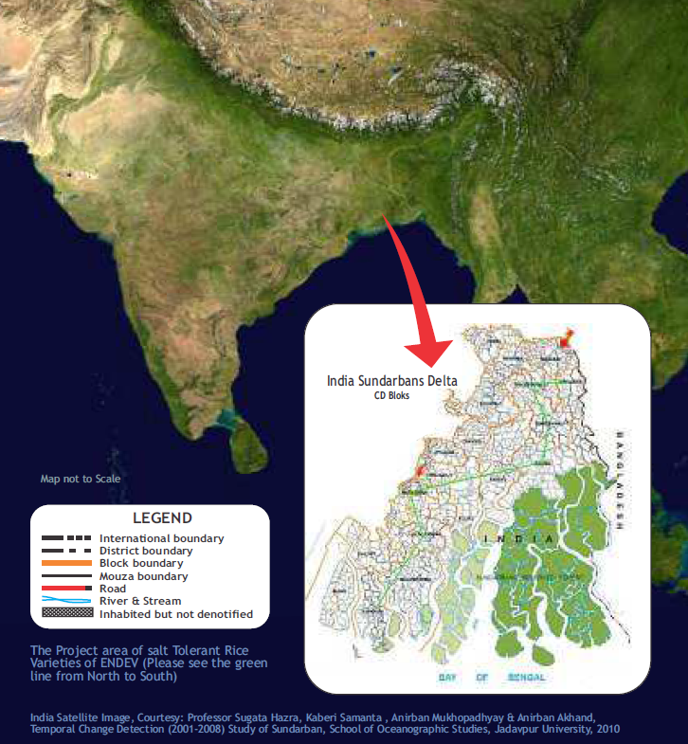

Figure 9: Climate Adaptation: Partnership to evolve synergy and action at local level
Lutheran World Service India Trust and ENDEV- Society for Environment and Development.
Location: 24, south Parganas, Sundarbans, West Bengal

A delicate ecology, the Sundarbans are located in Bangladesh and India. It is highly susceptible to change in climate, and because of its lower human development index, the effects are amplified. Many people depend on agriculture in Sundarbans. It is also susceptible to severe storms, which are common during the pre-monsoon season. In this location, agriculture is primarily limited to paddy farming because freshwater resources are few. Even after two years the paddy fields are affected by the saline conditions of the soil. In 2009, due to the cyclone Aila, the salinity levels in soil increased which affected the crop, potable water and entire flora and fauna.
ENDEV: helps the farmers by making the salt tolerant rice varieties in salinized soil available in the Sundarbans.
LWSI: Along with ENDEV, helps underprivileged rural and urban communities.

4.1.2 Project Interventions:
- They promoted and preserved salt-tolerant rice varieties like as Matla and Talmugur, resulting in higher rice yield in these locations.
- This helped the community to build resilience to such conditions and also adapt to the post storm stresses.
- It additionally helped them in establishing community grain banks to assure access to food grains, as well as 54 seed banks to preserve traditional seed varieties.
- In an area of 0.33 acre of land, a pond of 50’x40’x5.5’ was created which ensured water availability for irrigating and reducing saline content of the soil.
- These ponds have also become a source for fishing. They call this intervention as “Bhumi Samskar”.

Figure 10: The artificial pond created.
Source: (Coping with Climate Change, Case Studies and Experiences, Pooja Dave, Reema Parikh, Kinjal Pillai)

- In 87 hectares of land, 2,15,000 mangrove plantations have been facilitated with survival rate of 70 to 80%. These mangroves help in sequestering around 990.93 tonnes of carbon dioxide per year.
Figure 11: Mangrove Plantation
Source: (Dave, Parikh, Pillai, Coping with Climate Change, Case Studies and Experiences)

- 185 solar lanterns and solar home lights were provided in addition to these and training was provided for the maintenance of solar systems.
- The cropping increased from 14% to 51%, migration reduced, hygienic conditions increased and safe water sources were made accessible with these interventions.

4.1.3 Inferences:
Organizations in the rural development sector like LWSIT and action-based research institutions like ENDEV are assisting communities in overcoming the obstacles presented by climate change. A strategic approach to climate change is seen in the collaborative efforts of ENDEV—the Society for Environment & Development—and Lutheran World Service India Trust, which work together to find solutions and mainstream traditional knowledge through community involvement.

  - Case Study 2:
    - Climate Mitigation
(Dave, Parikh, Pillai, Coping with Climate Change, Case Studies and Experiences)
Meeting Benchmark and Promoting Excellence: Kymore Cement Works, ACC Limited.
Location: Kymore, Madhya Pradesh

Figure 12: Kymore Cement Works, Kymore, Madhya Pradesh.
Source: (Dave, Parikh, Pillai, Coping with Climate Change, Case Studies and Experiences)

One of the most energy intensive industry in India is the cement industry. The cement sector's intrinsic process and energy requirements account for 137 million tonnes of CO2, or approximately 7% of India's total man-made CO2 emissions. ACC Cement has sixteen cement plants of capacity 27 million tonnes/annum and produces PPC and OPC. It established the factory in 1923, and used wet process technology for cement production. In 1996, it adopted the dry process technology. With Limestone as the primary raw material and coal as primary source of energy, it has two kilns, one with capacity of 4590TPDand one with 4626 TPD clinker. The average energy consumption is about 79.41 kWh/Ton of cement.

    - Innovations to save Energy:
- Dream runs: a performance target is set by the unit itself for production and energy consumption by operating dream runs, which undertakes measures to achieve those and provides for best figures.
- Clinker factor is reduced and the clinker strength is increased.
- An average of 34.5% fly ash absorption in PPC is achieved.
- Alternative fuel resources like Biomass have been used which helps in mitigating carbon dioxide by saving 1.34T of carbon dioxide per ton of biomass and aids in reduction of coal usage.
- They gradually raised the thermal substitution rate (TSR) by using biomass, which led to a 25.5 crore rupee yearly cost savings.
- They have an AFR policy which acts as a management commitment tool for utilization of biomass.

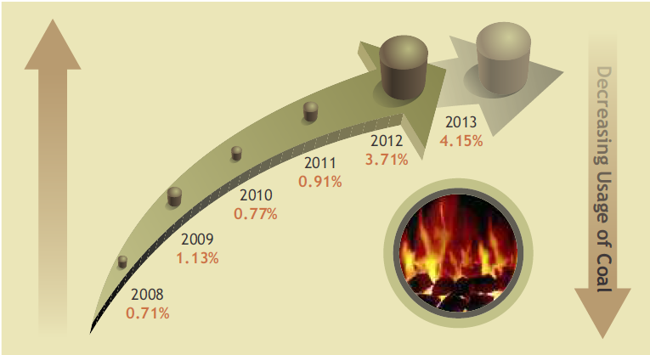
Figure 13: AFR use at 4.15 against BAT of 5.0.
Source: (Dave, Parikh, Pillai, Coping with Climate Change, Case Studies and Experiences)

The energy-intensive industries were given a set of goals to meet in accordance with the national aim to improve energy efficiency. Since the cement business is covered by the PAT plan, KCW has a goal as well. The 2014–15 PAT target of 810 GtG kCal/Eq has been met to date (749 GtG kCal/Eq).

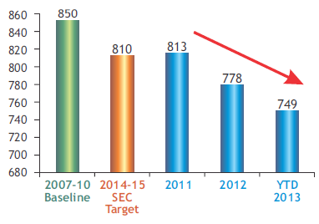
Figure 14: GtG kcal/kg Eq major product (PPC)
Source: (Dave, Parikh, Pillai, Coping with Climate Change, Case Studies and Experiences)

- With the help of co-processing at cement kilns, release of ozone depleting substances can be prevented.
- This was the first initiative in India to use Holcim's technological expertise to establish a framework for a permission system that uses Ozone cells and MoEF-ODS as "hazardous substances."
- 131.342 tons of carbon dioxide emissions in the atmosphere are equal to 16.325 tons of ODS avoided.
- Water Conservation was also taken care of in this project. The dependence on Mahanadi River for water availability was eliminated and water source was water harvested in used mine pits.
- For cement plant, power plant and colony, treated rain water was used.
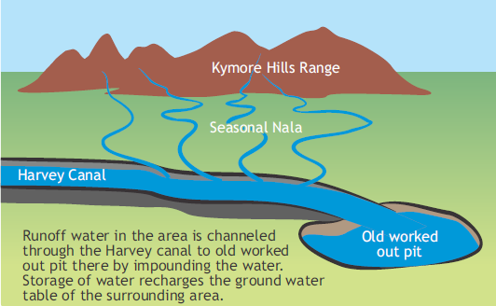
Figure 15: Water source for cement plant.
Source: (Dave, Parikh, Pillai, Coping with Climate Change, Case Studies and Experiences)

4.2.3 Inferences:
ACC concentrated on achieving managerial excellence and the potential of various technical developments. It has proven to be effective in preventing the emission of substances that deplete the ozone layer and carbon dioxide from the environment, as well as in conserving energy and water. The responses that show managerial commitment and consistent efforts to mitigate climate change were revealed by this example.

- Discussion and Conclusions:
This study highlights that effective climate action in the natural resource sector requires both mitigation and adaptation. Our review confirms that human activities (fossil fuel burning, land-use change) continue to drive greenhouse gas emissions and environmental degradation, threatening water, food, energy, and construction resources. At the same time, we show that targeted adaptation measures – such as developing saline-resistant crops and local water storage systems – can markedly improve community resilience in vulnerable regions (e.g. the Sundarbans case study). Similarly, industry-focused mitigation (as at the Kymore cement plant) demonstrates how technology and process changes can lower emissions while sustaining production. Key contribution of this work includes a synthesis of cross-sector strategies and clear examples of implementation: it bridges high-level concepts (IPCC recommendations, UN guidelines) with grassroots and industrial practices in the Indian context. Limitations of this research stem from its qualitative, literature-based approach: it does not include quantitative impact assessments or broader geographic sampling. The case studies are context-specific and outcomes may vary in different settings. Future work should evaluate the measurable impacts of these strategies (e.g. carbon reduction, yield improvements) and explore policy mechanisms to scale successful practices. Further research could also examine adaptation–mitigation trade-offs (for example, whether certain adaptation actions inadvertently increase emissions. In conclusion, our findings emphasize that climate-resilient management of resources is achieved through integrated solutions. Stakeholder collaboration – involving governments, communities, and industry – is essential to mainstream sustainable practices. By aligning ecosystem-based adaptation with low-carbon development (for instance, promoting forestry projects that both support livelihoods and sequester CO₂), long-term sustainability goals become attainable. Addressing climate change impacts in natural resource sectors will require continual innovation, supportive policies, and learning from community-driven interventions to safeguard the environment and human well-being.

- References:
- Baykal, A. (2012). Climate change adaptation and mitigation strategies. Environmental Policy Journal.
- Dave, P., Parikh, R., & Pillai, K. (n.d.). Coping with climate change: Case studies and experiences. (Publication details not specified).
- European Commission. (n.d.). Causes of climate change. Retrieved from https://climate.ec.europa.eu/climate-change/causes-climate-change_en
- European Commission. (n.d.). Climate change causes and greenhouse gas emissions. Retrieved from https://climate.ec.europa.eu/climate-change/causes-climate-change_en
- European Commission. (n.d.). Climate change mitigation and adaptation strategies. Retrieved from https://climate.ec.europa.eu/
- European Commission. (n.d.). Climate change impacts, adaptation and mitigation. Retrieved from https://climate.ec.europa.eu/
- European Commission. (n.d.). Climate change causes and impacts. Retrieved from https://climate.ec.europa.eu/
- Intergovernmental Panel on Climate Change. (2021). Climate change 2021: The physical science basis. Cambridge University Press.
- Mok, G., Ghaffar, S., Noor, A., Lanana, M., & Azra, N. (n.d.). Understanding climate change and heavy metals in coastal areas: A macroanalysis assessment.
- Turrentine, J. (n.d.). Global warming 101. Natural Resources Defense Council. Retrieved from https://www.nrdc.org/stories/global-warming-101
- United Nations. (n.d.). Causes and effects of climate change. Retrieved from https://www.un.org/en/climatechange/science/causes-effects-climate-change
- United Nations. (n.d.). Climate change impacts and environmental sustainability. Retrieved from https://www.un.org/en/climatechange
- United Nations Convention to Combat Desertification. (n.d.). Desertification, land degradation and drought. Retrieved from https://www.unccd.int/
- United Nations. (n.d.). Climate change and its impacts. Retrieved from https://www.un.org/en/climatechange
- United Nations. (n.d.). What is climate change? Retrieved from https://www.un.org/en/climatechange
- Youmatter. (n.d.). Climate change and natural resource management. Retrieved from https://youmatter.world/
- Youmatter. (n.d.). Climate change: Causes, effects and solutions. Retrieved from https://youmatter.world/en/definition/climate-change-definition-causes-and-effects/

Conclusions
).

