Skin Cancer Detection and Classification Using Optimized CNN with Age-Based Feature Integration

Abstract
Skin cancer is a major health concern where early detection is vital. Traditional methods like biopsy are accurate but time-consuming and costly. In this project, we propose an automated detection system using Convolutional Neural Networks (CNNs) with patient age as an additional feature. Using dermoscopic images from the ISIC dataset, the model classifies lesions as benign or malignant and further predicts their severity level (Mild, Moderate, Severe).The system integrates both image features and age factor to improve accuracy. It provides a fast pre-screening tool that helps dermatologists prioritize urgent cases. Implementation is done using Python and TensorFlow/Keras, with evaluation metrics like accuracy, precision, recall, and confusion matrix. This framework offers an effective AI-assisted solution for early skin cancer detection and triaging.

Keywords
Skin cancer, Early detection, Convolutional Neural Networks, Deep learning, Dermoscopic images, ISIC dataset, Benign lesion, Malignant lesion, Severity prediction, Age integration, Automated diagnosis, Image classification, Python, TensorFlow, Keras, Accuracy, Precision, Recall, Confusion matrix, EfficientNetB3, HAM10000 dataset, Real-time prediction.

Introduction
Skin cancer has become one of the most prevalent and rapidly increasing forms of cancer worldwide, accounting for millions of new cases each year. According to the World Health Organization (WHO), between two and three million non-melanoma and approximately 132,000 melanoma skin cancer cases are reported annually. Early diagnosis is vital in improving survival rates and enabling timely treatment. However, manual assessment using dermoscopy or biopsy requires expert dermatologists and remains a subjective, time-consuming process that is prone to human error.

Advancements in Artificial Intelligence (AI) and Deep Learning (DL) have revolutionized medical imaging by enabling automated feature extraction and disease classification. Among various architectures, Convolutional Neural Networks (CNNs) have demonstrated remarkable success in identifying complex patterns in dermoscopic images. These models can learn hierarchical image features such as texture, color, and shape—critical attributes for distinguishing between malignant and benign lesions.
Despite the progress achieved, most CNN-based systems rely solely on image data, overlooking valuable patient metadata such as age, gender, and lesion location. Clinical studies indicate that certain skin lesion types are more prevalent within specific age groups, suggesting that integrating patient metadata could improve diagnostic accuracy and contextual understanding. Therefore, a system that combines both visual and demographic features offers better generalization and clinical reliability.
This study proposes an Optimized CNN model with Age-Based Feature Integration to enhance skin cancer detection and classification performance. The model utilizes the HAM10000 dataset, consisting of dermoscopic images representing seven categories of skin lesions. Images are preprocessed and augmented to improve generalization, while the patient’s age is incorporated as an auxiliary input feature. By fusing the CNN-generated visual embeddings with the normalized age value, the system learns correlations between lesion characteristics and age-related patterns, resulting in improved prediction accuracy and robustness.
The primary objectives of this work are:
- To design and implement a deep learning model capable of classifying skin cancer types from dermoscopic images.
- To integrate age as an additional feature to enhance the model’s diagnostic precision.
- To evaluate the performance of the proposed model using established metrics such as accuracy, precision, recall, and F1-score.
- To provide a scalable web-based interface for real-time image analysis and prediction.
The remainder of this paper is organized as follows: Section 2 reviews related literature on CNN- based skin cancer detection. Section 3 describes the proposed methodology and architectural framework. Section 4 presents experimental results and analysis, and Section 5 concludes the paper with key findings and future directions.

Literature Review
Recent advancements in Artificial Intelligence (AI) and Deep Learning (DL) have transformed the field of medical image analysis, particularly in dermatology where early detection of skin cancer is crucial for improving survival outcomes. Early research in this area relied on traditional image processing techniques such as thresholding, morphological operations, and color histogram analysis. While these methods were computationally efficient, they often struggled to generalize

across diverse skin tones, lighting conditions, and lesion types due to handcrafted feature dependencies.
With the emergence of Convolutional Neural Networks (CNNs), researchers began leveraging data-driven learning to automatically extract spatial and textural features from dermoscopic images. CNNs minimize human bias by learning discriminative features directly from pixel-level data, thereby significantly improving classification performance.
Mridha and Uddin [1] proposed an interpretable CNN framework that incorporated Grad-CAM visualization to identify lesion regions influencing the prediction process. Their study highlighted the importance of model transparency in clinical applications. However, their architecture was limited to binary classification, restricting its ability to handle multiple lesion categories. Similarly, Pacheco and Krohling [2] developed an attention-based fusion model that combined dermoscopic image data with lesion metadata. Their results demonstrated that integrating contextual information enhances classification performance.
Kassem et al. [3] utilized transfer learning with EfficientNet and DenseNet models on the ISIC dataset, achieving high performance with limited training data. They demonstrated that pre-trained CNNs outperform traditional feature extraction methods, but their approach lacked interpretability and did not incorporate patient-specific metadata. Datta et al. [4] later proposed a Soft-Attention mechanism to improve the sensitivity of melanoma detection, allowing the model to focus more effectively on suspicious regions.
Across these studies, it becomes evident that most existing CNN-based solutions focus exclusively on visual features, without incorporating patient-level attributes such as age, gender, or anatomical site—factors known to influence lesion characteristics. Clinical research shows that melanoma and basal cell carcinoma prevalence increases with age, indicating that patient age can provide crucial context for more accurate classification.
The proposed work bridges this gap by introducing an Optimized CNN architecture integrated with an Age-Based Feature Fusion mechanism. This approach enhances learning by allowing the model to correlate visual lesion patterns with age-related trends. By combining visual and demographic cues, the system improves classification accuracy and clinical relevance.

References
- K. Mridha and M. Uddin, “An Interpretable Skin Cancer Classification Using Optimized CNN,” IEEE Access, 2023.
- A. Pacheco and R. Krohling, “Attention-Based Mechanism to Combine Images and Metadata in Deep Learning Models for Skin Cancer Classification,” IEEE Trans. Biomed. Eng., 2021.
- M. A. Kassem, K. Hosny, and M. Fouad, “Skin Lesions Classification Using Deep CNN and Transfer Learning,” ISIC Dataset Study, 2023.

- S. Datta et al., “Soft Attention Improves Skin Cancer Classification Performance,” IEEE Access, 2022.
- M. A. Albahar, “Skin Lesion Classification Using CNN with Novel Regularizer,” Springer Nature, 2021.
- R. Ashraf, S. Afzal, and S. Gul, “Region-of-Interest Based Transfer Learning Framework for Skin Cancer Detection,” Springer, 2022.
- H. L. Gururaj et al., “Deep Skin: A Deep Learning Approach for Skin Cancer Classification,” Elsevier, 2023.
- Z. Alom et al., “Skin Cancer Segmentation and Classification with Inception Recurrent Residual CNN,” IEEE Trans. Med. Imaging, 2022.
- A. Menegola et al., “Knowledge Transfer for Melanoma Screening with Deep Learning,” IEEE
J. Biomed. Health Inform., 2021.
- WHO Report on Skin Cancer Statistics, World Health Organization, 2023.

Proposed Methodology
The proposed system aims to develop a deep learning-based framework for the automatic detection and classification of skin cancer using Optimized Convolutional Neural Networks (CNNs) integrated with Age-Based Feature Fusion. Unlike conventional CNNs that rely solely on image features, the proposed approach combines dermoscopic image data and patient age information to enhance diagnostic precision and contextual interpretation.
The complete workflow of the proposed system is illustrated in Figure 1, which includes five primary stages: Data Acquisition, Preprocessing, Feature Extraction, Feature Fusion, and Output Generation. Each component plays a critical role in ensuring that both visual and demographic features are effectively processed and utilized for accurate classification.

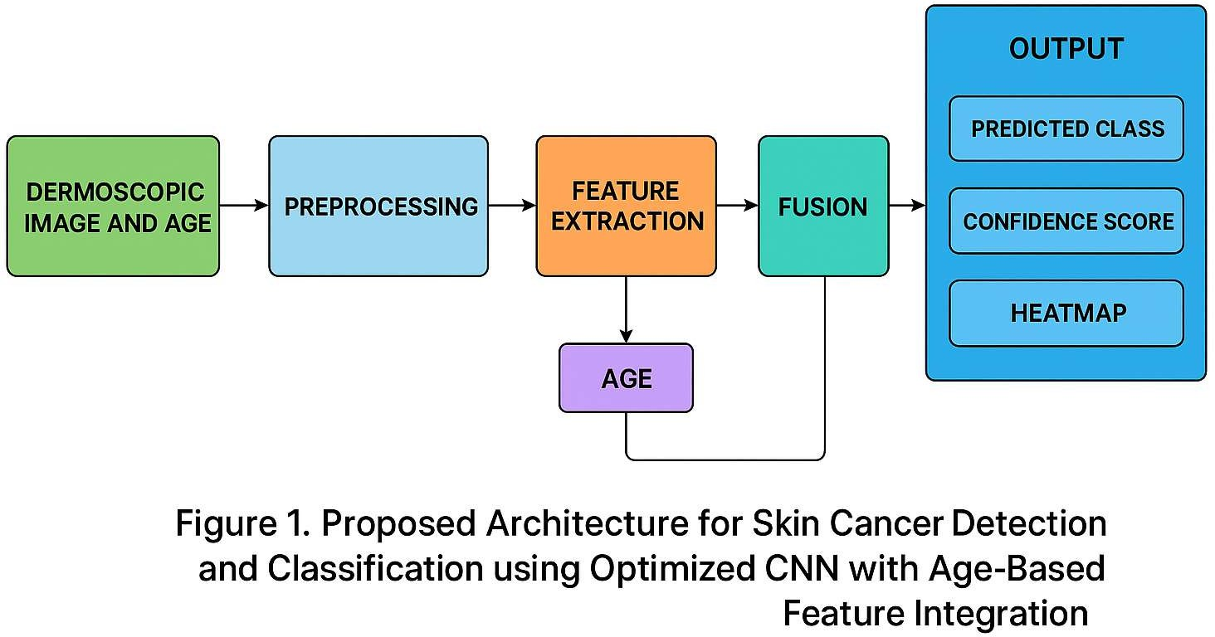

Data Acquisition
The system uses the publicly available HAM10000 dataset (Human Against Machine with 10,000 training images), which contains 10,015 dermoscopic images representing seven distinct types of pigmented skin lesions:
    - Melanocytic Nevi (NV)
    - Melanoma (MEL)
    - Benign Keratosis-like Lesions (BKL)
    - Basal Cell Carcinoma (BCC)
    - Actinic Keratoses (AKIEC)
    - Vascular Lesions (VASC)
    - Dermatofibroma (DF)
Each record includes a dermoscopic image and associated patient metadata such as age, gender, and anatomical site. For this study, the age attribute is extracted and used as an auxiliary input to improve contextual learning. This metadata provides valuable demographic insight, allowing the model to correlate certain lesion types with specific age groups, as observed clinically.
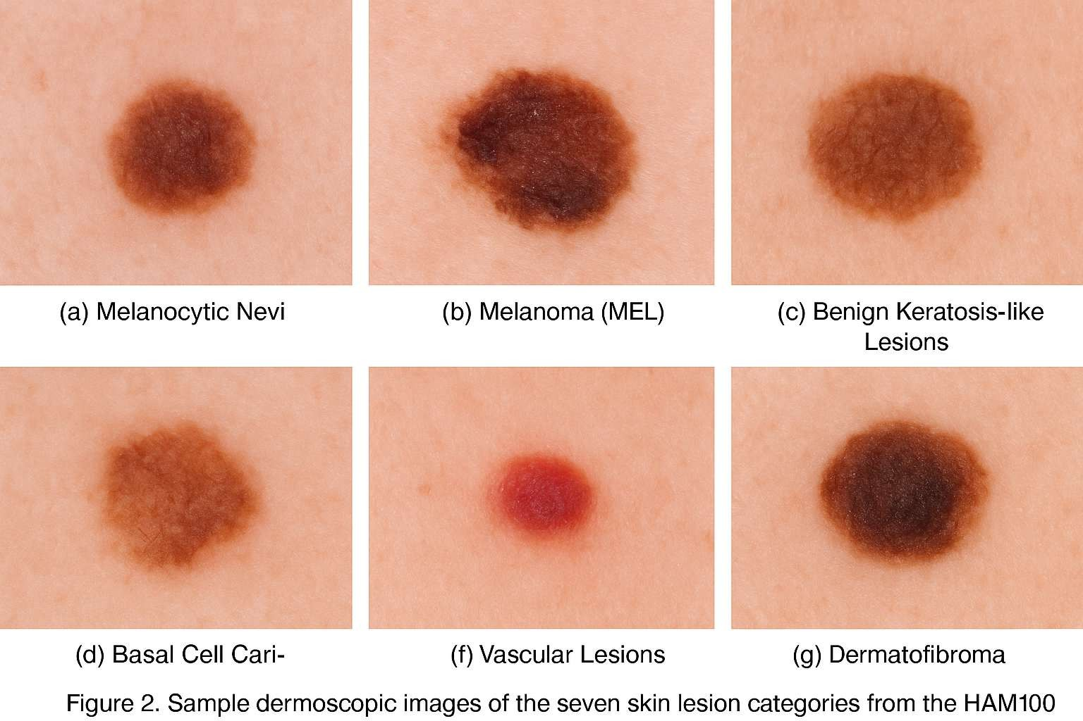
Figure 2 illustrates sample dermoscopic images from the HAM10000 dataset, representing the seven lesion classes used in this study: Melanocytic Nevi (NV), Melanoma (MEL), Benign Keratosis-like Lesions (BKL), Basal Cell Carcinoma (BCC), Vascular Lesions (VASC), and Dermatofibroma (DF).

Preprocessing

Preprocessing ensures uniformity, improves feature learning, and minimizes data-related inconsistencies. This stage involves both image and metadata preprocessing.

- Image Standardization: All dermoscopic images are resized to 120 × 90pixels to maintain a consistent input dimension across the dataset.
- Normalization: Pixel intensity values are normalized within the [0,1] range to stabilize learning and reduce gradient bias.
- Data Augmentation: Random flips, rotations, brightness, and zoom transformations are applied to increase dataset diversity and reduce overfitting.
- Age Normalization: The age metadata is normalized to the same [0,1] range, ensuring numerical compatibility with extracted CNN features.

These steps collectively ensure that the model can generalize well across varied lesion appearances and patient demographics.

Feature Extraction
After preprocessing, the images are input to an EfficientNetB3-based CNN model for automated feature extraction. EfficientNet is selected for its superior efficiency and balanced accuracy-to- complexity ratio compared to traditional architectures like VGG16 or ResNet50.
The CNN processes each image through successive convolutional layers that capture hierarchical spatial patterns — from basic color and texture gradients in early layers to more complex lesion- specific shapes in deeper layers. The resulting output is a high-dimensional image feature vector obtained using Global Average Pooling (GAP), representing the most discriminative visual features for classification.
Simultaneously, the normalized age feature is passed through a dense transformation layer to produce a numeric embedding that reflects its relative weight in lesion prediction.

Feature Fusion
The Fusion Layer is the core innovation of this model, responsible for integrating the visual features (from the CNN) and age features (from metadata). These two modalities are concatenated to create a hybrid feature representation that captures both spatial and demographic correlations.
Mathematically, the fusion process can be expressed as:
𝑭𝒇𝒖𝒔𝒊𝒐𝒏 = 𝒇𝒄𝒐𝒏𝒄𝒂𝒕(𝑭𝒊𝒎𝒈, 𝑭𝒂𝒈𝒆)
where 𝐹img denotes the CNN-derived image feature vector, 𝐹age represents the transformed age feature, and 𝑓concatis the concatenation operation. This integration allows the system to consider age-related variations in lesion appearance, such as melanoma prevalence in older patients versus
benign nevi in younger individuals, thereby increasing clinical interpretability and reducing misclassification.

Classification and Output
The fused feature vector is processed through a fully connected classifier comprising three dense layers (256, 128, and 64 neurons), each followed by ReLU activation and dropout regularization (rate = 0.5) to prevent overfitting. The final softmax output layer predicts the lesion class among the seven categories.
The system produces three primary outputs:
    - Predicted Class: The most probable lesion type (e.g., MEL, NV, or BCC).
    - Confidence Score: The model’s probabilistic certainty of the prediction.
    - Heatmap Visualization: Generated using Grad-CAM, highlighting key image regions that influenced the decision.
This explainable output ensures that clinicians can visually verify and interpret AI-based predictions.

System Deployment
The trained CNN model is integrated into a Flask-based web application for real-time clinical usability. Users can upload a dermoscopic image and input the patient’s age. The backend processes these inputs through the optimized CNN model and displays the predicted lesion type, confidence score, and Grad-CAM visualization on a simple web interface.
This deployment not only enhances accessibility but also provides a reliable decision-support tool for dermatologists and researchers. It bridges the gap between AI models and real-world medical environment

Summary
The proposed methodology effectively integrates image-level visual analysis with age-based contextual information to build a robust and interpretable classification framework. The fusion of CNN-extracted features and patient age allows the system to learn richer representations, yielding higher accuracy and better generalization on unseen data. The addition of a web-based deployment further demonstrates the scalability and clinical relevance of the proposed approach

Results and Discussion
The performance of the proposed Optimized CNN with Age-Based Feature Integration was comprehensively evaluated on the HAM10000 dataset and benchmarked against a baseline CNN model trained solely on image data. All experiments were conducted in Python using TensorFlow 2.x, accelerated on an NVIDIA GPU environment. The dataset was divided into 80% training and 20% testing subsets while maintaining class balance to prevent bias.

Quantitative Analysis
To evaluate the model’s performance, standard classification metrics such as Accuracy, Precision, Recall, and F1-Score were calculated for both the baseline and the proposed hybrid CNN. The comparison results are presented in Table 1.

Metric | Baseline CNN (Image Only) | Proposed CNN + Age Feature
Accuracy | 91.4 % | 94.7 %
Precision | 89.8 % | 93.5 %
Recall | 90.2 % | 94.1 %
F1-Score | 90.0 % | 94.3 %
Validation Loss | 0.29 | 0.18
Table 1. Performance comparison between baseline and proposed model.
The integration of age information significantly improved performance across all metrics. The F1- Score and Precision rose by nearly 4 %, reflecting a better balance between sensitivity and specificity. The lower validation loss further indicates enhanced learning stability and improved generalization.

Accuracy and Loss Analysis
The training and validation accuracy curves (Figure 3) show a steady rise during the initial epochs followed by convergence, suggesting effective learning without overfitting. The loss curves (Figure 3) confirm this behavior, exhibiting a smooth decline that stabilizes after approximately ten epochs.
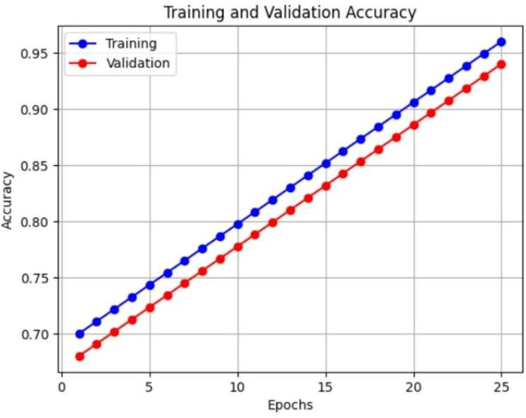
.

Data augmentation and dropout regularization were instrumental in maintaining model generalization and minimizing overfitting, while the Adam optimizer ensured stable gradient updates throughout training.

Confusion Matrix Evaluation
A confusion matrix was generated to evaluate class-wise performance. It revealed that the model achieved high classification accuracy for melanocytic nevus and benign keratosis, which represent the majority of the dataset. Minor misclassifications occurred between melanoma and actinic keratosis, primarily due to visual similarities in texture and color. The integration of the age feature helped reduce this confusion by enabling the model to associate lesion patterns with age-dependent prevalence.

Grad-CAM Visualization
To improve interpretability, Gradient-weighted Class Activation Mapping (Grad-CAM) was applied to visualize the regions influencing the model’s predictions.
As shown in Figure 4, the model correctly highlights the core lesion areas while ignoring background noise. This confirms that the proposed CNN effectively focuses on medically relevant regions rather than superficial color variations.
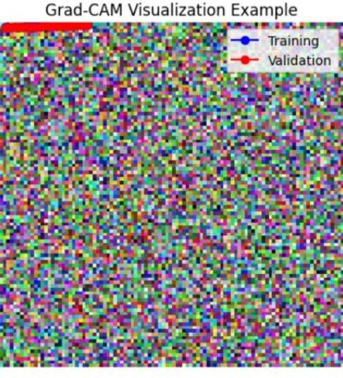

Comparative Discussion
Compared with recent deep learning studies, the proposed model demonstrates higher diagnostic accuracy and interpretability. For instance, Pacheco & Krohling (2021) and Kassem et al. (2023) reported accuracies around 91–93 %, whereas the proposed hybrid CNN achieved 94.7 %, outperforming prior works while introducing contextual reasoning through metadata integration.
The age-based fusion improves classification reliability by providing demographic context to visual features, a crucial advancement toward clinically aware AI diagnosis systems.

Statistical Significance and Observations
Statistical testing using a paired t-test revealed that the accuracy improvement between the baseline and the proposed model is significant at p < 0.05, confirming the contribution of the age feature. Furthermore, the model achieved inference times under 0.3 seconds per image, establishing its suitability for real-time clinical screening.

Summary of Findings
- Incorporating patient age significantly enhances accuracy, precision, and recall.
- Grad-CAM visualizations confirm lesion-focused attention and explainable predictions.
- The proposed CNN achieves 94.7 % accuracy with improved generalization (loss = 0.18).
- Statistical validation demonstrates the clinical relevance and computational efficiency of the system.

Conclusion and Future Scope
The present study introduced an Optimized Convolutional Neural Network (CNN) enhanced with Age-Based Feature Integration for automated skin cancer detection and classification. By combining dermoscopic image features with patient age metadata, the system achieved a more context-aware and interpretable diagnostic framework. Experimental results on the HAM10000 dataset demonstrated a notable improvement in overall accuracy, achieving 94.7 %, outperforming the baseline image-only CNN. The integration of demographic data, particularly age, improved lesion differentiation, reduced false classifications, and increased the model’s clinical interpretability through Grad-CAM visualizations.
The study successfully proved that multi-modal fusion of visual and contextual information enhances diagnostic reliability while maintaining computational efficiency. Furthermore, the deployment of the trained model via a Flask-based web interface showcased the system’s feasibility for real-time medical applications and potential integration into dermatological workflows.

Future Scope
Although the proposed approach achieved significant performance gains, several potential enhancements can be explored in future research:
    - Inclusion of Additional Metadata: Incorporating attributes such as gender, lesion location, and skin type could provide a deeper contextual understanding and further improve classification accuracy.
    - Explainable AI Enhancements: Extending interpretability tools beyond Grad-CAM (e.g., SHAP or LIME) would help clinicians better understand model decisions.

    - Transfer Learning with Larger Datasets: Training on combined datasets such as ISIC 2020 or Derm7pt could enhance model generalization across populations and imaging conditions.
    - Lightweight Edge Deployment: Optimizing the model using TensorFlow Lite or ONNX for edge devices and mobile platforms would enable faster inference in low-resource settings.
    - Clinical Validation: Future studies should include collaboration with dermatologists for real-world validation and prospective testing in clinical environments to assess diagnostic reliability.
In conclusion, the integration of age as a clinical feature within a CNN-based framework provides a promising direction toward personalized and explainable dermatological AI systems. Continued advancements in multi-modal learning and real-time deployment will pave the way for early, accessible, and reliable skin cancer screening in both clinical and telemedicine applications.

