INTERNET OF THINGS (IoT) BASED REAL-TIME KITCHEN MONITORING SYSTEM

Abstract
The emergence of Internet of Things (IoT) has undoubtedly transformed safety, automation, and monitoring systems across various sectors, particularly in smart home environments. This study presents the design and implementation of an Internet of Things (IoT)-based real-time kitchen monitoring and automation system aimed at enhancing safety, efficiency, and intelligent control within kitchen environments. The system was developed to address the limitations of manual monitoring processes, which are often labor-intensive, error-prone, and unreliable in emergency situations. The system integrates multiple sensors to enable real-time alerts and automated responses. Wireless communication is achieved through a Wi-Fi network connected to the Blynk IoT platform, allowing remote monitoring via smartphones and laptops. Upon detection of hazardous conditions such as gas leakage, fire outbreak, abnormal temperature levels, motion intrusion, or low water levels, the system triggers local alarms and transmits notifications to users through the IoT dashboard. Sensor fusion techniques were applied to enhance data accuracy and reduce false alarms. Experimental evaluation was conducted under simulated real-world kitchen scenarios to assess responsiveness, accuracy, and reliability. The results demonstrated an overall system accuracy of 91.8%, with high detection reliability across all integrated sensors and minimal false positives.
Keywords: Internet of Things (IoT), Real-Time Monitoring, Kitchen Automation, Smart Kitchen.

- Introduction
The use of information and communication technologies has had a significant influence on human life. The digital world of today is getting easier and easier to reach. These days, social media and the internet are indispensable to everyone. Various internet connection types have enabled people to access the internet more quickly and with greater quality. An extension of this technology is the "Internet of Things," which enables intelligence and connectivity. Smartphone communication, wireless sensor networks, and internet-connected devices work together to achieve this. These system components help deliver the product according to its plan. The Internet of Things helps process automation in the electronics industry and improves current safety regulations.
In a while, the traditional kitchen has undergone transformation, and now it is poised for yet another dramatic shift. We are living in a time where our kitchens are getting smarter, more automated, and more efficient thanks to the Internet of Things (IoT). IoT-based kitchen monitoring systems, with an emphasis on appliance automation, are at the vanguard of this revolution.
Imagine a kitchen where your phone can monitor the amount of humidity, receive updates when there is a flame in the kitchen, detect when someone enters the kitchen, also receive notifications when there is a gas leak from the burner, horse pipe, or gas cylinder. This is a real-life scenario that is quickly materializing in homes all across the world, not a scene from a futuristic film ^{3.} The way we use our kitchens is changing as a result of the Internet of Things (IoT) being incorporated into equipment and systems. This indicates that cooking will become more accurate, energy use will be more economical, and we will enjoy our time in the kitchen more.
One cannot stress the significance of this technical revolution. The demand for effective and clever kitchen solutions rises as urbanization and smaller living areas both rise. Moreover, IoT-based kitchen systems provide a route to more ecologically friendly household management in light of the growing global movement towards sustainability and the growing awareness of energy saving.
Automation technology is advancing to make human life easier, more comfortable, and less demanding across the board. With a real-time kitchen monitoring system, you can watch and operate your home's kitchen equipment from anywhere in the globe using a laptop or smart mobile device. These days, automated systems are favored over manual ones ⁶. The Internet of Things, or IoT, is a promising technology that allows you to connect, control, and monitor your kitchen equipment remotely. Real-time kitchen monitoring systems have gained a lot of attention due to the advancements in communications technology. A real-time kitchen monitoring system, or Internet of Things (IoT), connects, monitors, and controls kitchen appliances and behavior (condition) through the use of Internet technology. With little to no human contact, a system made of Internet of Things technology (IoT) connected sensors and kitchen appliances may be watched over and communicated on their own. With a real-time kitchen monitoring system, we may simplify activities in and around our living units, such as gas leak detection, flame detection, motion detection, humidity detection, fan control, and so on. A list of ideal conditions is also added, including comfort, convenience, economy, safety, security, and dependability. The Internet of Things is a concept for a network of intelligent, communicative items, such as wearable technology, automobiles, manufacturing equipment, and many types of sensors. These gadgets can be configured to carry out duties and respond either automatically or in response to user input to the demands of the inhabitants ⁸. The core of real-time kitchen monitoring and automation technology is the Internet of Things (IoT), a system that connects actual items and the sensors that are linked to them to the global computer and associated networks. Irrespective of the mode of communication, the objects may comprise non-electronic things such as food and clothes and have the ability to interact, read, recognize, locate, and/or control themselves over the Internet. A real-time kitchen monitoring and automation system is a network of interconnected appliances and equipment in a house that can be controlled remotely and interact with one another. Because of its improved convenience, energy efficiency, and security, this technology has had a significant impact on how people interact with their homes.
Automation of various functions such as entertainment, HVAC (heating, ventilation, and air conditioning), lighting, and security may be achieved through the integration of various IoT (Internet of Things) devices, sensors, and actuators in real-time kitchen monitoring systems ¹³. Homeowners may remotely monitor and change the settings of these systems from anywhere in the house using tablets, and smartphones. Modern technology has been incorporated into real-time kitchen monitoring systems, which improve convenience, effectiveness, and security in houses, revolutionizing residential life in recent years. These systems build a network where different appliances and systems may interact, coordinate tasks, and be managed remotely using Internet of Things (IoT) devices, sensors, and communication protocols.
- Material and Methods
Sensor fusion is a technique used to combine data from multiple sensors to create a more accurate, reliable, and comprehensive understanding of the environment or system being monitored ¹.
Sensor fusion techniques play a critical role in enhancing data accuracy within embedded systems, particularly in applications that require precise environmental monitoring and real-time decision-making. As the demand for more advanced and reliable embedded systems grows driven by advancements in fields such as robotics, automotive systems and the Internet of Things (IoT) the integration of multiple sensors has become essential for achieving accurate and robust data interpretation. By combining data from various sources, sensor fusion enables systems to mitigate uncertainties, reduce noise and improve overall performance.
Components used are:
- Sensors (Inputs):
- DHT11 sensor (temperature & humidity)
- MQ-2 gas sensor
- PIR sensor (motion detection)
- Flame sensor
- Ultrasonic sensor
- Controller & Communication:
- NodeMCU (ESP8266)
- Mobile hotspot / Router (Wi-Fi)
- IoT server (Blynk server)
- Display & User Interfaces:
- I2C module
- LCD display
- User smartphone
- User laptop device

- Actuators & Outputs:
- Buzzer
- DC motor fan (exhaust fan)
- 4-channel relay module
- Controlled Loads:
- Socket outlet
- 5V bulb
- DC water pump
- Fan
- Power Supply:
- 9V DC supply
- Block Diagram and Materials
Fig 1 shows the block diagram of the system, which combines several components for intelligent control and monitoring. It uses a NodeMCU microcontroller to collect data from several sensors, including motion, temperature, gas, flame, and ultrasonic sensors.
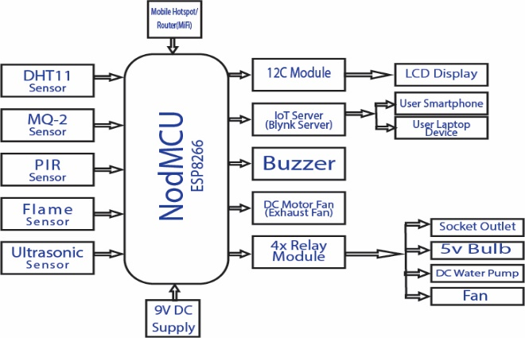
Fig 1. Block diagram of IOT-Based Kitchen Monitoring System.
- Block Diagram and Materials
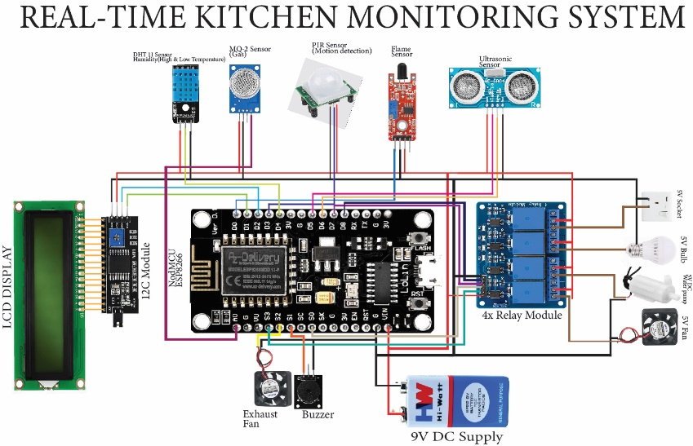
The hardware connection shown in Fig 2 depicts the architectural design of the block diagram in Fig 1.
Fig 2. Hardware component connection.

- Result
The results from the various sensor tests were analyzed to assess the system's overall performance and reliability. Whereby, each sensor’s output was compared with expected values or reference measurements, and the accuracy was calculated to evaluate whether the system met the required operational standards. The results are summarized as follows:
Table 1, shows the confusion matrix results of the test conducted on the system.
Sensor/Test case | True Positive | True Negative | False Positive | False Negative
MQ-2 (Gas Detection) | 12 | 1 | 0 | 1
PIR (Motion Detection | 9 | 0 | 0 | 1
DHT11 (Temp/Humidity) | 10 | 1 | 0 | 1
Flame Sensor (Fire Outbreak) | 12 | 0 | 0 | 1
Ultrasonic Sensor (Water Level Test) | 10 | 1 | 0 | 1

- Discussion
The sensor testing phase was a crucial step in authenticating the system’s capability for real-time monitoring. Each sensor was examined under various conditions to simulate the types of circumstances or scenarios it might encounter in an operational kitchen environment. The aim was not just to see whether the sensors could “work,” but to determine whether they could work continuously, quickly, and precisely when an emergency needed attention. The MQ-2 gas sensor demonstrated high sensitivity, accurately detecting hazardous gas levels and triggering alarms, notifications, and automated exhaust fan responses, with an overall accuracy of 92.9% despite a single false negative attributed to environmental or network factors. This test as shown in the above table, out of 13 trail that was carried out, there was 10 True Positive, 1 True Negative, 0 False Positive, and 1 False Negative. This shows that the system detected 10 trail correctly while in a another case in detected but didn’t raise an alarm because it detected a gas but not combustible gas while in the last there was a leakage it didn’t detect because of network failure. The PIR motion sensor performed reliably across short to medium distances, achieving 90% accuracy, though its performance degraded under strong daytime ambient light, causing one false negative at long range. In this phase out of the 13 trails carried out 9 where correctly detected and 1 case wasn’t detected because of the interference of high ambient light that interfered the Infrared Rays. The DHT11 temperature and humidity sensor effectively distinguished between safe and unsafe thermal conditions, minimizing false alarms and achieving an accuracy of 91.7%. 12 trails were carried out 10 (TP) where correct and alarm received while in a 1 (TN) it detected but didn’t raise an alarm because it senses that the humidity is high which shows that the heat was artificially introduced since the humidity is still high. The flame sensor showed strong fire detection capability, particularly in low-light conditions, with 92.3% accuracy, while occasional daytime false negatives were linked to ambient infrared interference. 13 trails carried out, 12 fire outbreak was detected except for 1 that wasn’t detected due to high interference of light between the sensor and the fire outbreak. The ultrasonic water level sensor reliably classified low, normal, and full tank conditions, issuing appropriate alerts and achieving 91.7% accuracy. In this phase, 12 trails were carried out, 10 of it where correct, in 1 case the system detected low water level and didn’t raised an alarm due to low network coverage, and 1 case didn’t detect nor send an alarm which is due to no network coverage. This shows that the water level monitor can’t efficiently work without strong network connection.

- Comparative Analysis
Table 2 and Fig 3 present a comparative analysis of the accuracy performance of two IoT-based real-time kitchen monitoring systems, showing that both studies achieved closely related and high accuracy levels (91.8% and 91%), thereby indicating the reliability and effectiveness of IoT technologies for real-time kitchen monitoring and automation applications.

Table 2 Comparison results
Title of the research | Accuracy
Internet of Things (IoT) based real-time kitchen monitoring  System | Achieved 91.8%
Design and Implementation of Real-Time Kitchen Monitoring and Automation System Based on Internet of Things Hassan et al., (2022) | Achieved 91%
Fig 3 Comparison results.

- Conclusion
This system focused on the design, development, and implementation of an IoT-based real-time kitchen monitoring system. The system integrates multiple sensors such as MQ-2 gas sensor, PIR motion sensor, DHT11 temperature and humidity sensor, flame sensor, and ultrasonic sensor for water level detection to be controlled by a NodeMCU ESP8266 microcontroller. The objective was to enhance kitchen safety, improve monitoring, and provide timely alerts to prevent accidents or potential threats within the system.
- Reference
- Ann, C., & Student, L. (2024). Bluetooth-Based Home Automation System Using Android Phone Bluetooth Based Home Automation System Using Android Phone ( ACM : IA-I-RRL-PM-R-A ). June.
- Alex Thompson (2024). Sensor Fusion Techniques in Embedded Systems for Enhanced Data Accuracy. Department of Computer Engineering, Innovation University, Boston, USA
- Baballe, M. A., & Bello, M. I. (2022). Gas Leakage Detection System With Alarming System. Review of Computer Engineering Research, 9(1), 30–43. https://doi.org/10.18488/76.v9i1.2984
- Bhawana Bharti, Indu Bharadwaj, & Ajay Bhardwaj, A. B. (2023). Smart Kitchen Using Iot. Global Journal of Innovation and Emerging Technology, 1(2), 27–31. https://doi.org/10.58260/j.iet.2202.0110
- Bharthi, R., & Poongothai, M. (2022). Gas sensor-based detection system. International Journal of Engineering Trends and Technology, 70(2), 22–27.
- Favelli, S., Xie, M., & Tonoli, A. (2024). Sensor Fusion Method for Object Detection and Distance Estimation in Assisted Driving Applications. Sensors, 24(24), 1–21. https://doi.org/10.3390/s24247895
- Gayaki, P., Kamat, T., Bangari, K., & Jarande, Y. (2023). Fully Automated Smart kitchen. 22(03), 925–931. http://ymerdigital.com
- Hassan, C. A. U., Iqbal, J., Khan, M. S., Hussain, S., Akhunzada, A., Ali, M., Gani, A., Uddin, M., & Ullah, S. S. (2022). Design and Implementation of Real-Time Kitchen Monitoring and Automation System Based on Internet of Things. Energies, 15(18). https://doi.org/10.3390/en15186778
- Karakaya, A. (2023). Motion Sensors: Enhancing Security and Automation. International Journal of Sensor Networks and Data Communications, 12(3), 1–2. https://doi.org/10.37421/2090-4886.2023.12.213
- Kimutai, M. S., Kelvin, O. K., & Jasper, O. M. (2022). Challenges and Opportunities for Smart Homes Deployment in Developing Countries: A Case Study of the User Perspective in Kenya. OALib, 09(07), 1–8. https://doi.org/10.4236/oalib.1107679
- Lalaoui, K. (2022). 1st International Conference on Innovative Academic Studies on 10-13 September in 2022 at Konya/Turkey. September.
- Lety Istikhomah Puspita Sari, E., & Ketut Agung Enriko, I. (2023). Design Gas LPG Leak Detection System Based on Internet of Things. JIM: Jurnal Ilmiah Mahasiswa Pendidikan Sejarah, 8(3), 1053–1060. http://jim.unsyiah.ac.id/sejarah/mm
- S., B., & M., P. (2022). IoT based Kitchen Monitoring and Control System. International Journal of Computer Applications, 184(7), 30–34. https://doi.org/10.5120/ijca2022922034
- Sari, D., & Enriko, F. (2023). IoT-based smart home gas leakage detection and prevention system. Journal of Emerging Trends in Engineering and Applied Sciences, 14(2), 101–109.
- Saunders, M. N. (2023). Research methods for business students (Issue August).
- Singh, S., Anand, S., & Satyarthi, M. K. (2023). A Comprehensive Review of Smart Home Automation Systems. Advances in Computer Science and Information Technology (ACSIT), 10(2), 61–66. http://www.krishisanskriti.org/Publication.html
- Sodiq, S. (2024). DESIGN AND CONSTRUCTION OF GAS LEAKAGE DETECTION AND ALERTING. October. https://doi.org/10.13140/RG.2.2.23406.01604
- State, G., Performance, A., & Report, E. (2021). Federal university of kashere. 2021.
- Zabi, M. A. (2023). Gas leakage detection and alarm system using Arduino microcontroller, GPS module and exhaust fan [Unpublished master’s thesis]. Federal University of Kashere.

