Title: “Removal of Heavy Metals from Drinking Water Using Low-Cost Adsorbents and Chemical Methods: A Comparative Environmental Chemistry Study”

Title: “Removal of Heavy Metals from Drinking Water Using Low-Cost Adsorbents and Chemical Methods: A Comparative Environmental Chemistry Study”

ACKNOWLEDGEMENT

We would like to express our sincere gratitude to Professor Rajkumar, Head of the Department, for his valuable guidance, encouragement, and constant
support throughout the course of this project. His academic insight,motivation, and leadership played a significant role in shaping our understanding and maintaining the quality of this work.

We are deeply thankful to Dr. Krishna Anand, our co-supervisor, for his continuous assistance, constructive suggestions, and patient guidance at every
stage of the project. His expertise, clarity of concepts, and willingness to help whenever required greatly contributed to the successful completion of this study.

We also extend our heartfelt appreciation to the faculty members and staff
of Maa Shakumbhari University, whose teaching, support, and academic environment provided us with the necessary foundation and resources to carry out this work effectively.

We would like to thank our friends and classmates for their encouragement, cooperation, and moral support, which made this academic journey both productive and mamorable.

ABSTRACT
Heavy metal contamination in drinking water has become a major environmental and public health concern due to the toxic, persistent, and non-biodegradable nature of metals such as lead (Pb), cadmium (Cd), arsenic (As), and mercury (Hg). Lead is known for its neurotoxic effects, particularly impairing cognitive development in children, while cadmium primarily affects renal function and causes bone demineralization. Arsenic, commonly found in groundwater, is a well-established carcinogen associated with skin, lung, and bladder cancers, whereas mercury, especially in its organic forms, severely damages the central nervous system and leads to neurological disorders. The increasing presence of these metals in water resources is mainly attributed to industrial discharge, mining operations, agricultural activities, and improper waste disposal.
The present study focuses on the removal of these hazardous metals from drinking water through a comparative evaluation of low-cost adsorption techniques and conventional chemical treatment methods. Low-cost adsorbents such as biochar, rice husk, activated carbon, and clay minerals have gained considerable attention due to their high surface area, porous structure, and the presence of functional groups capable of binding metal ions through mechanisms such as ion exchange and surface complexation. On the other hand, chemical methods including precipitation, coagulation–flocculation, ion exchange, and redox processes offer rapid and effective removal, particularly in large-scale water treatment systems, although they are often associated with higher costs and secondary sludge generation.
Comparative analysis indicates that while chemical methods ensure faster removal efficiency, adsorption-based approaches provide a more sustainable, cost-effective, and environmentally friendly solution, especially for rural and resource-limited areas. Furthermore, the integration of both approaches offers a promising strategy for improving overall treatment performance.
This study highlights the need for developing efficient, affordable, and scalable technologies to ensure safe drinking water and reduce the adverse impacts of heavy metal contamination.

KEYWORDS

Heavy Metals; Drinking Water; Adsorption; Chemical Treatment; Low-Cost Adsorbents; Water Purification; Sustainability

INTRODUCTION
🔷 1.1 Background and Significance
Water is an essential natural resource required for the survival of all living organisms; however, its quality has been significantly deteriorating due to rapid industrialization, urbanization, and various anthropogenic activities. Among different classes of pollutants, heavy metals have emerged as one of the most critical contaminants due to their high toxicity, persistence, non-biodegradable nature, and bioaccumulative behavior. Unlike organic pollutants, heavy metals cannot be degraded into harmless substances and tend to accumulate in living organisms, causing long-term environmental and health hazards.

🔷 1.2 Sources and Occurrence of Heavy Metals
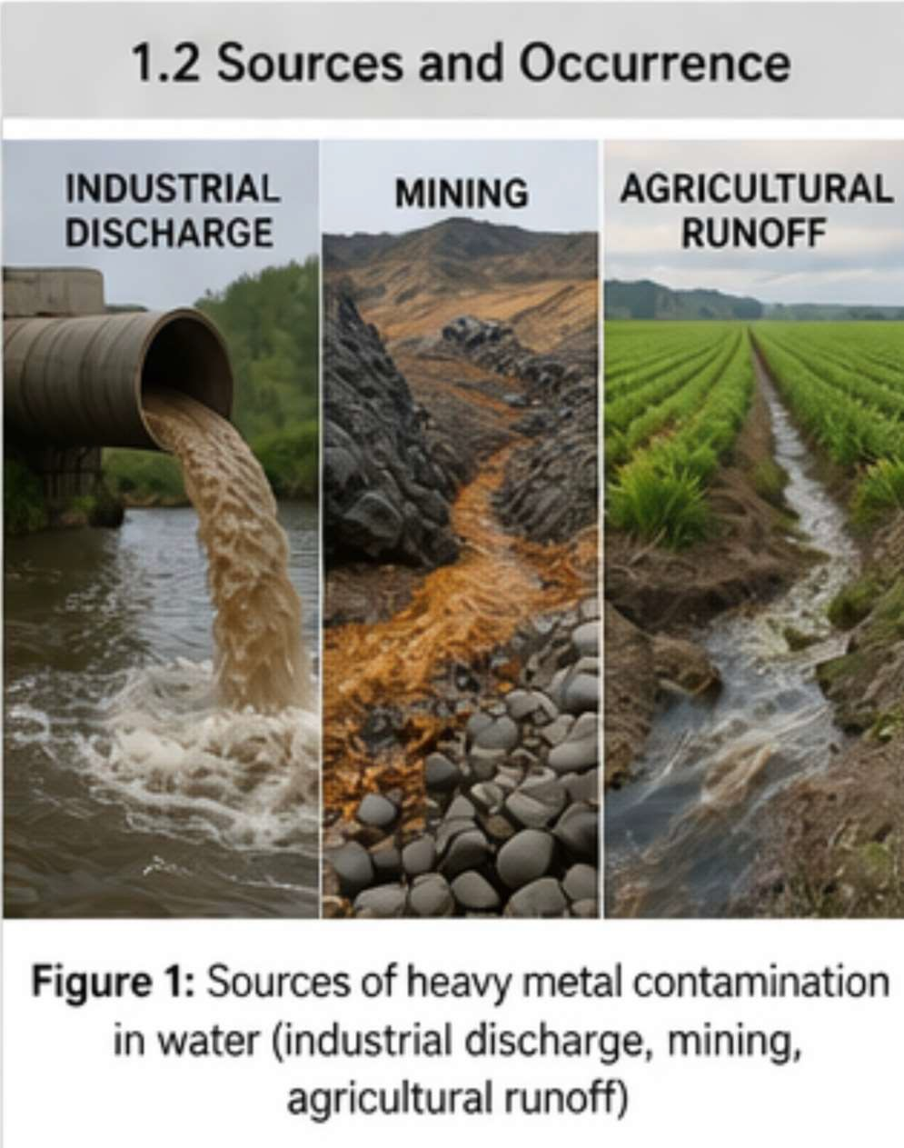
Heavy metals are generally defined as elements with relatively high atomic weight and density that exhibit toxic effects even at trace concentrations. The most commonly encountered toxic heavy metals in drinking water include lead (Pb), cadmium (Cd), arsenic (As), and mercury (Hg), which are widely recognized as priority pollutants.
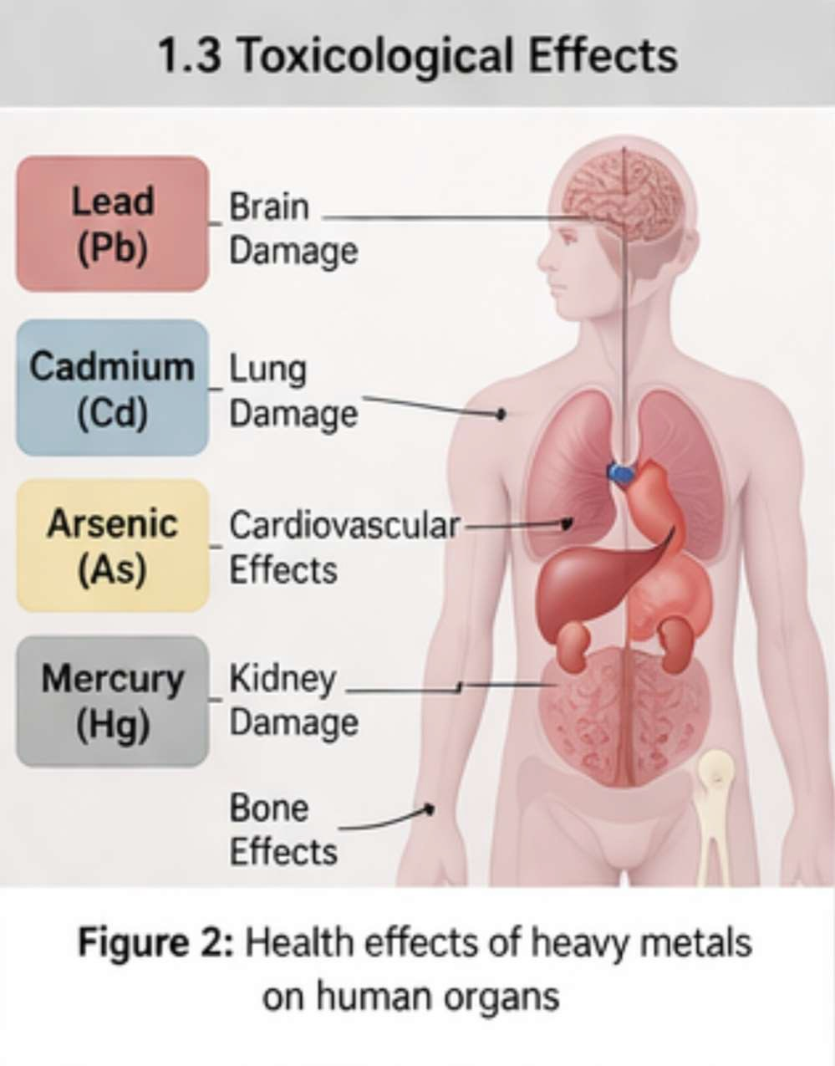
These metals enter water bodies through both natural and anthropogenic sources. Natural sources include weathering of rocks and geological formations, whereas anthropogenic sources include industrial effluents, mining and smelting operations, agricultural runoff containing fertilizers and pesticides, corrosion of plumbing systems, and improper disposal of hazardous wastes.

🔷 1.3 Toxicological Effects of Major Heavy Metals
Each heavy metal exhibits distinct toxicological effects depending on its chemical nature and interaction with biological systems.
- Lead (Pb): Lead is a potent neurotoxin that primarily affects the central nervous system. It is especially harmful to children, causing reduced cognitive ability, behavioral disorders, anemia, and kidney damage.

- Cadmium (Cd): Cadmium accumulates in the kidneys and causes renal dysfunction. It also leads to bone demineralization and skeletal damage, and prolonged exposure results in severe metabolic disorders.
- Arsenic (As): Arsenic is a well-known carcinogen commonly found in groundwater. It causes skin lesions, pigmentation changes, cardiovascular diseases, and cancers of the skin, lungs, and bladder.
- Mercury (Hg): Mercury, particularly in its organic form (methyl mercury), affects the central nervous system, leading to neurological disorders, memory loss, and sensory impairment.

Table 1: Major Heavy Metals, Sources and Health Effects

Heavy Metal Major Sources Toxic Effects
Lead (Pb) Pipes, paints, batteries, industrial effluents Neurotoxicity, anemia, kidney damage Cadmium (Cd) Fertilizers, industrial waste, batteries Kidney damage, bone disorders Arsenic (As) Groundwater, pesticides, mining Carcinogenic, skin lesions
Mercury (Hg) Industrial discharge, chemical waste Neurological disorders

🔷 1.4 Conventional Chemical Methods for Heavy Metal Removal
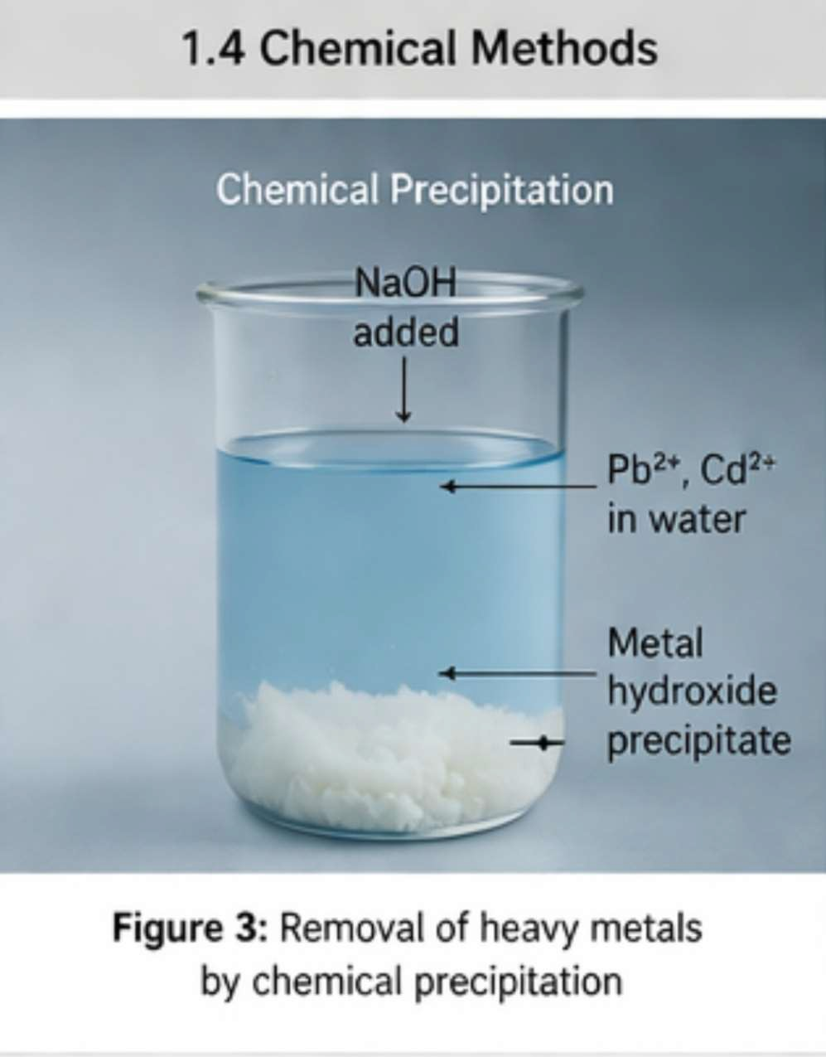
The increasing concentration of heavy metals in drinking water has necessitated the development of effective chemical treatment methods. These methods are widely used due to their high efficiency and rapid action, particularly in large-scale water treatment systems. They generally involve chemical reactions that convert soluble metal ions into insoluble or less toxic forms, which can be removed by sedimentation or filtration.

Chemical Precipitation
In this method, metal ions are converted into insoluble hydroxides or sulfides.
Hydroxide precipitation: Pb²⁺ + 2OH⁻ → Pb(OH)₂ ↓ Cd²⁺ + 2OH⁻ → Cd(OH)₂ ↓ Fe³⁺ + 3OH⁻ → Fe(OH)₃ ↓
Sulfide precipitation: Cd²⁺ + S²⁻ → CdS ↓ Hg²⁺ + S²⁻ → HgS ↓

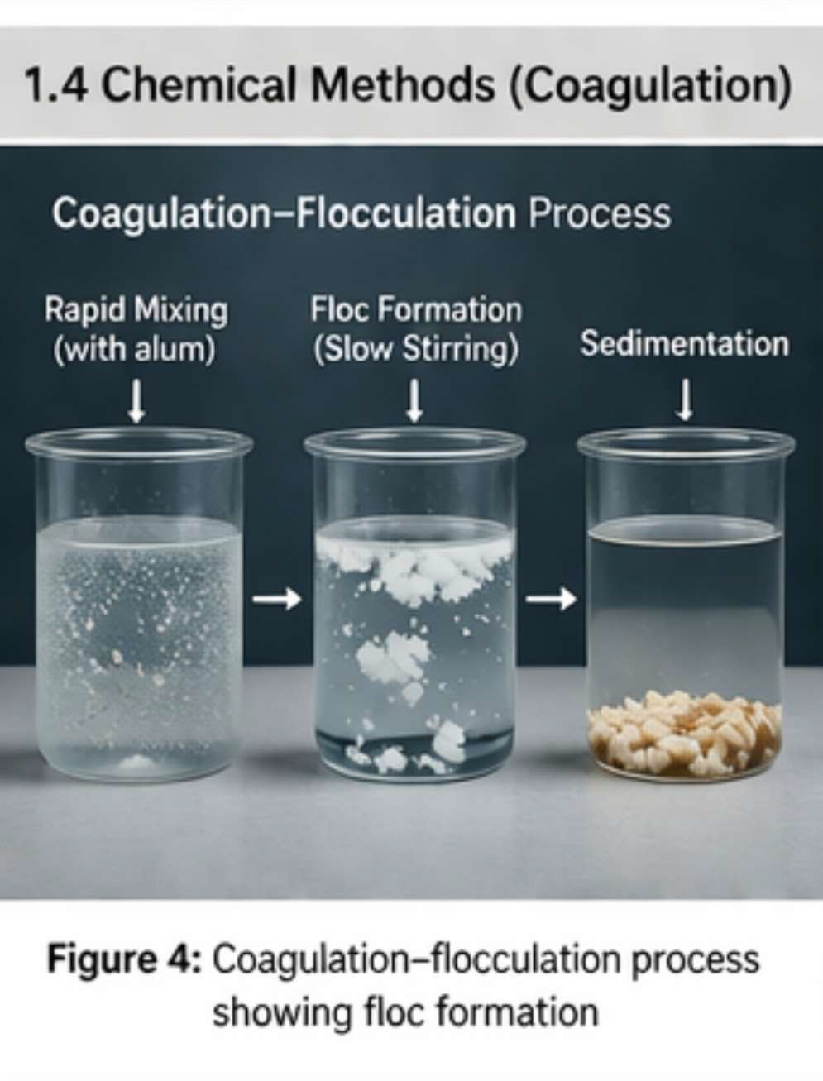
Coagulation–Flocculation
Coagulants such as alum and ferric salts are added to water, which form hydroxide flocs that trap heavy metals.

Reactions:
Al³⁺ + 3H₂O → Al(OH)₃ ↓ + 3H⁺ Fe³⁺ + 3H₂O → Fe(OH)₃ ↓ + 3H⁺

Ion Exchange
In this process, toxic metal ions are replaced by non-toxic ions using ion-exchange resins.

Reaction:
2R–Na + Pb²⁺ → R₂–Pb + 2Na⁺

Oxidation–Reduction
This method involves conversion of toxic metal ions into less toxic forms.

Example:
Cr₂O₇²⁻ + 6Fe²⁺ + 14H⁺ → 2Cr³⁺ + 6Fe³⁺ + 7H₂O Cr³⁺ + 3OH⁻ → Cr(OH)₃ ↓

Carbonate Precipitation
Metal ions can also be removed as insoluble carbonates.

Reaction:
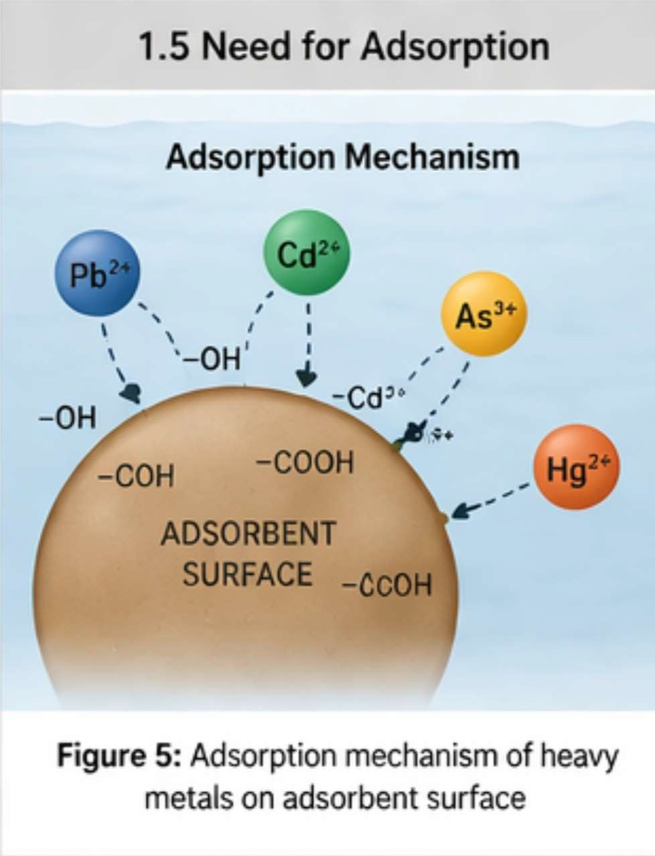
Pb²⁺ + CO₃²⁻ → PbCO₃ ↓

Despite their effectiveness, these chemical methods have limitations such as high operational cost, sludge generation, and the need for skilled handling.

🔷 1.5 Need for Low-Cost Adsorption Techniques
In recent years, adsorption has gained significant attention as an alternative method for heavy metal removal due to its simplicity, cost-effectiveness, and environmental friendliness.

Low-cost adsorbents such as biochar, rice husk, sawdust, activated carbon, and clay minerals are widely used due to their availability and high adsorption capacity.
These materials possess large surface area and functional groups that facilitate the binding of metal ions through mechanisms such as ion exchange, surface complexation, and electrostatic interactions. Moreover, their low cost and ease of application make them particularly suitable for rural and resource-limited areas.

🔷 1.6 Objective of the Study
The main objective of the present study is to provide a comprehensive and comparative evaluation of the removal of heavy metals from drinking water using low-cost adsorption techniques and conventional chemical methods. The study aims to analyze their efficiency, cost-effectiveness, and practical applicability in rural regions.

METHODOLOGY
🔷 2.1 Materials
For the present study, commonly available chemicals and low-cost natural adsorbents were used for the removal of heavy metals from contaminated water. Analytical grade chemicals such as lead nitrate [Pb(NO₃)₂], cadmium chloride (CdCl₂), and sodium hydroxide (NaOH) were used for preparing synthetic contaminated water samples.
Low-cost adsorbents including rice husk, biochar, sawdust, activated carbon, and natural clay were selected due to their easy availability, low cost, and high adsorption potential.
Distilled water was used throughout the experimental work to avoid any external contamination.

🔷 2.2 Preparation of Contaminated Water Sample
Synthetic contaminated water was prepared by dissolving known amounts of heavy metal salts such as lead nitrate and cadmium chloride in distilled water to obtain desired concentrations (e.g., 10–50 mg/L). The solution was stirred properly using a magnetic stirrer to ensure uniform distribution of metal ions.
The pH of the solution was adjusted using dilute hydrochloric acid (HCl) or sodium hydroxide (NaOH), depending on the requirement of the experiment.

🔷 2.3 Preparation of Adsorbents
The selected adsorbents were prepared before use to enhance their adsorption efficiency.
- Rice husk and sawdust were washed thoroughly with distilled water to remove dust and impurities, followed by drying in an oven at 80–100°C.
- Biochar was prepared by controlled burning of agricultural waste in limited oxygen conditions.
- Activated carbon and clay were sieved to obtain uniform particle size.

🔷 2.4 Adsorption Experiment

A fixed volume of contaminated water (e.g., 100 mL) was taken in a conical flask, and a known amount of adsorbent (e.g., 1–2 g) was added. The mixture was stirred continuously using a mechanical shaker for a specific contact time (30–120 minutes) to allow maximum interaction between the adsorbent surface and metal ions.
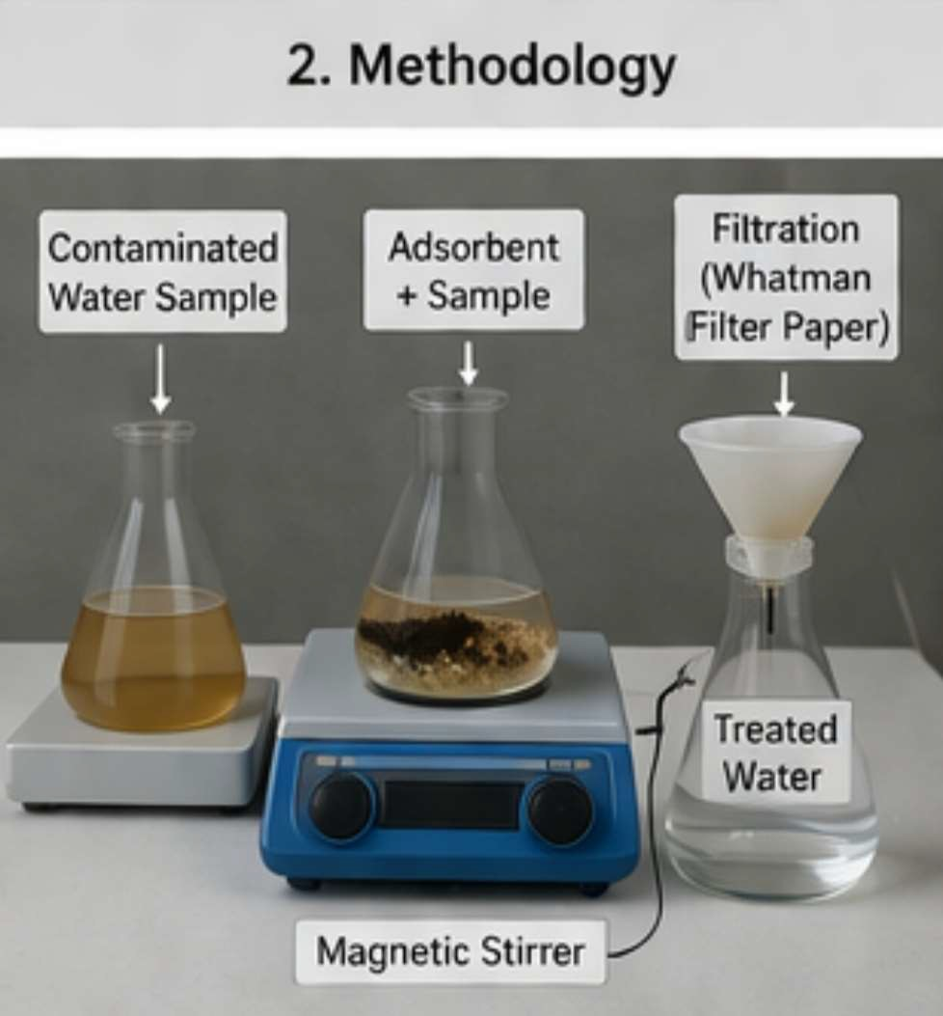
After completion of the adsorption process, the solution was filtered using filter paper to separate the adsorbent. The filtrate was then analyzed to determine the remaining concentration of heavy metals.

🔷 2.5 Chemical Treatment Methods
For comparison, conventional chemical methods were also applied to the contaminated water samples.

Chemical Precipitation
Sodium hydroxide (NaOH) solution was added to the contaminated water to increase the pH and precipitate metal ions as hydroxides.

Reaction:
Pb²⁺ + 2OH⁻ → Pb(OH)₂ ↓
The precipitate formed was allowed to settle and then removed by filtration.

Coagulation–Flocculation
Alum (Al₂(SO₄)₃) was added to the water sample and stirred rapidly, followed by slow mixing to allow floc formation.

Reaction:
Al³⁺ + 3H₂O → Al(OH)₃ ↓ + 3H⁺
The formed flocs trapped metal ions and settled down, which were then removed.

Ion Exchange
Ion exchange resin was added to the contaminated water, allowing exchange of heavy metal ions with harmless ions.

Reaction:
2R–Na + Pb²⁺ → R₂–Pb + 2Na⁺

🔷 2.6 Parameters Studied
The efficiency of heavy metal removal was evaluated by studying different parameters:
  - Effect of pH: pH was varied to determine optimum removal conditions
  - Contact Time: Time required for maximum adsorption
  - Adsorbent Dose: Amount of adsorbent used
  - Initial Metal Concentration: Different concentrations of heavy metals

🔷 2.7 Determination of Removal Efficiency
The removal efficiency of heavy metals was calculated using the following formula: Removal Efficiency (%)= C₀ – C_{e} /C₀ x100
Where:
  - C₀= Initial concentration of metal ions
  - C_{e} = Final concentration after treatment

🔷 2.8 Comparative Analysis
The performance of low-cost adsorption techniques and chemical methods was compared based on removal efficiency, cost, ease of operation, and environmental impact. The results obtained were analyzed to identify the most effective and sustainable method for heavy metal removal from drinking water.

RESULTS AND DISCUSSION
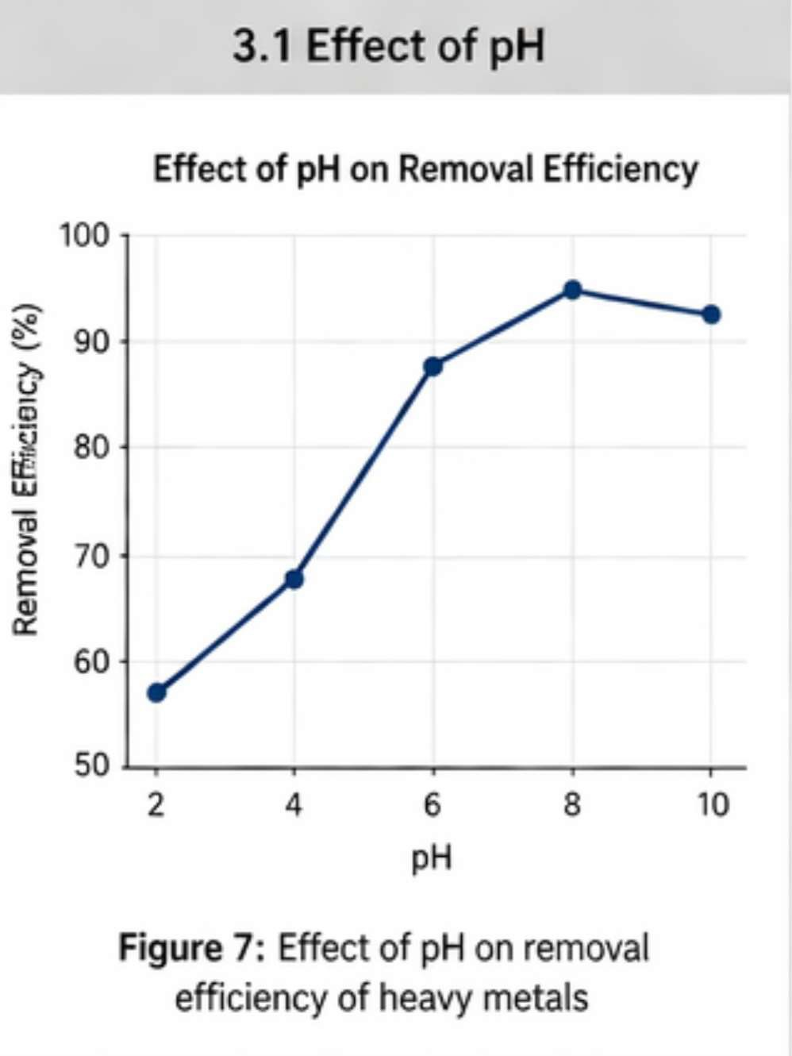
🔷 3.1 Effect of pH on Heavy Metal Removal
The pH of the solution was found to play a crucial role in the removal of heavy metals by both adsorption and chemical methods. Experimental observations indicates that at low pH (acidic conditions), the removal efficiency was relatively low due to the competition between hydrogen ions (H⁺) and metal ions for active adsorption sites.
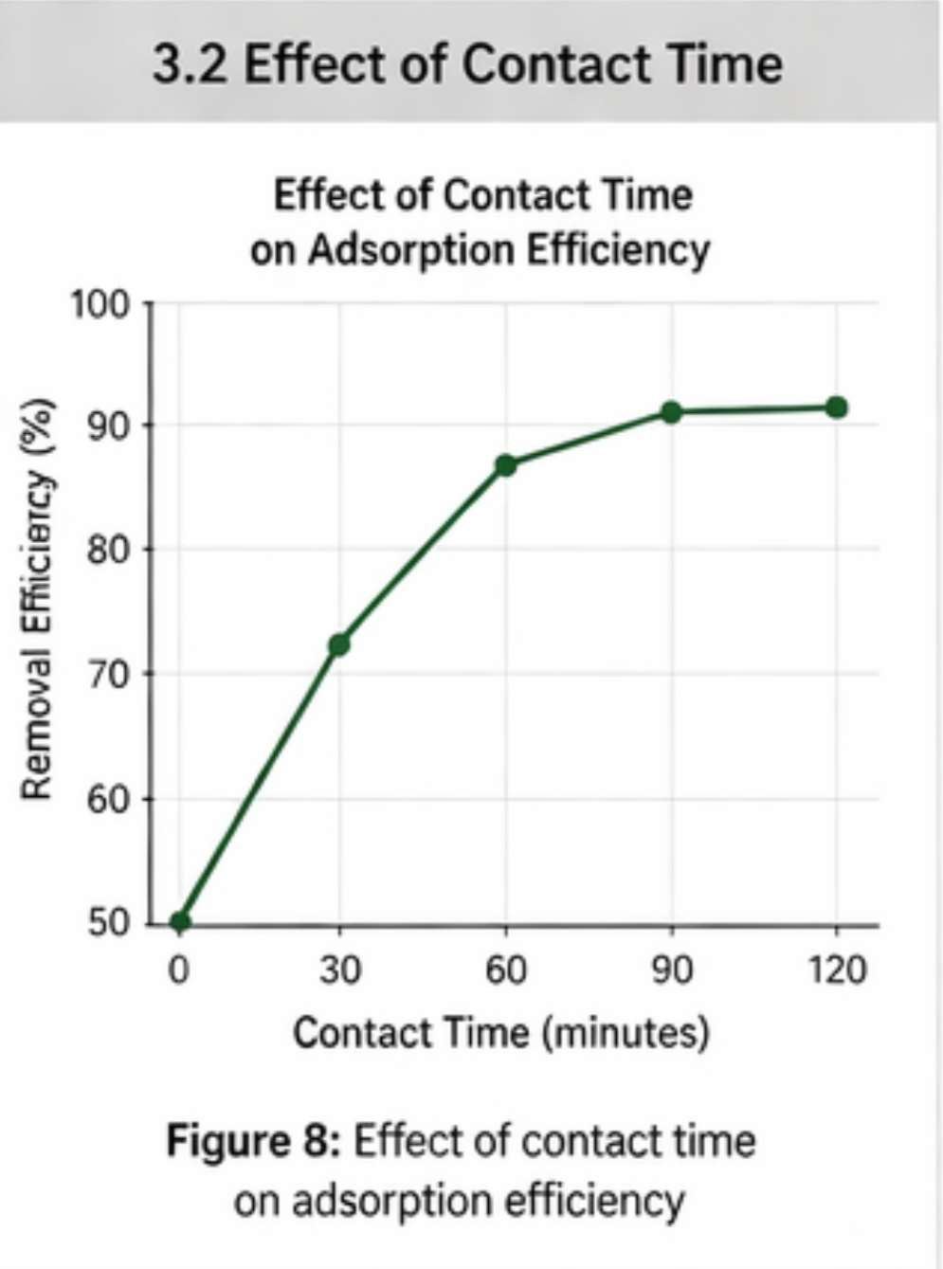
As the pH increased, the removal efficiency improved significantly, reaching an optimum range between pH 6 and 8. At higher pH values, the formation of metal hydroxide precipitates further enhanced removal efficiency in chemical methods.

🔷 3.2 Effect of Contact Time
The removal efficiency of heavy metals increased with an increase in contact time. Initially, rapid adsorption was observed due to the availability of a large number of active sites on the adsorbent surface.
Equilibrium was generally achieved within 60–90 minutes, after which no significant increase in removal efficiency was observed. This indicates saturation of adsorption sites.

🔷 3.3 Effect of Adsorbent Dose
An increase in adsorbent dose resulted in higher removal efficiency due to the increase in available surface area and active binding sites.
However, beyond an optimum dose (around 1.5–2 g per 100 mL), the increase in efficiency was marginal, indicating that most of the metal ions had already been removed.

🔷 3.4 Removal Efficiency of Different Heavy Metals
The removal efficiency of selected heavy metals using low-cost adsorbents and chemical methods is presented in Table 2.

📊 Table 2: Removal Efficiency (%) of Heavy Metals

Heavy Metal | Adsorption (%) | Chemical Methods (%)
Lead (Pb) | 85–92% | 95–98%
Cadmium (Cd) | 80–88% | 92–96%
Arsenic (As) | 75–85% | 90–95%
Mercury (Hg) | 82–90% | 94–97%
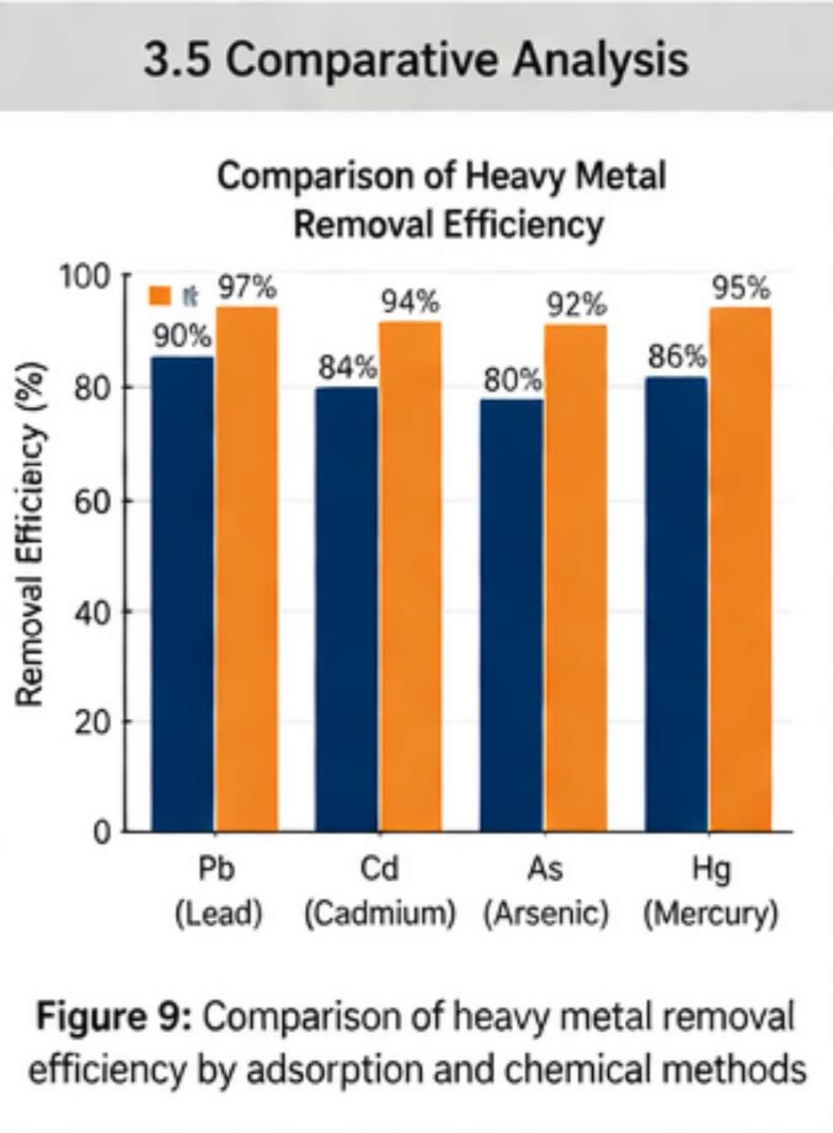
🔷 3.5 Comparative Analysis of Methods
The results clearly indicate that both adsorption and chemical methods are effective in removing heavy metals from drinking water. However, chemical methods showed slightly higher removal efficiency due to rapid precipitation and coagulation mechanisms.
On the other hand, adsorption using low-cost materials demonstrated satisfactory removal efficiency along with advantages such as low cost, simplicity, and environmental friendliness. These materials proved particularly effective in removing lead and mercury ions due to strong surface interactions.

🔷 3.6 Mechanism of Removal
The removal of heavy metals by adsorption involves several mechanisms, including ion exchange, surface complexation, and electrostatic attraction. Functional groups present on the surface of adsorbents (such as –OH, –COOH) play a significant role in binding metal ions.
In chemical methods, removal occurs mainly through precipitation reactions, where metal ions are converted into insoluble hydroxides or sulfides, which are then removed by filtration.

🔷 3.7 Practical Implications
The study demonstrates that while chemical methods provide higher removal efficiency, they involve higher costs and generate sludge, which may require further treatment.
In contrast, low-cost adsorption techniques offer a sustainable and economical alternative, especially for rural and resource-limited areas where advanced water treatment facilities are not available.

“The results suggest that an integrated approach combining adsorption and chemical methods can significantly enhance the overall efficiency of heavy metal removal from drinking water.”

CONCLUSION

The present study demonstrates that heavy metal contamination in drinking water, particularly due to lead (Pb), cadmium (Cd), arsenic (As), and mercury (Hg), poses significant risks to human health and the environment due to their toxic and bioaccumulative nature. Effective removal of these metals is therefore essential to ensure safe and sustainable water quality.
A comparative evaluation of low-cost adsorption techniques and conventional chemical methods revealed that both approaches are capable of achieving substantial removal of heavy metals. Chemical methods such as precipitation and coagulation–flocculation exhibited higher removal efficiencies and faster treatment; however, they are associated with higher operational costs, sludge generation, and handling complexities. In contrast, low-cost adsorbents such as biochar, rice husk, sawdust, and clay materials demonstrated considerable removal efficiency along with advantages of cost-effectiveness, simplicity, and environmental sustainability.
The findings indicate that adsorption techniques are particularly suitable for rural and resource-limited regions, where affordable and easy-to-operate water treatment methods are required. Furthermore, the integration of adsorption and chemical methods offers a promising approach to enhance overall treatment efficiency while minimizing individual limitations.
In conclusion, the study highlights that the development and implementation of cost-effective, efficient, and environmentally sustainable water treatment technologies are essential for addressing the growing problem of heavy metal contamination and ensuring access to safe drinking water for all.

REFERENCES

- Sharma, Y. C., Srivastava, V., Singh, V. K., Kaul, S. N., & Weng, C. H. (2009). Nano-adsorbents for the removal of metallic pollutants from water. Environmental Technology, 30(6), 583–609.
- Babel, S., & Kurniawan, T. A. (2003). Low-cost adsorbents for heavy metals uptake from contaminated water: A review. Journal of Hazardous Materials, 97(1–3), 219–243.
- Fu, F., & Wang, Q. (2011). Removal of heavy metal ions from wastewaters: A review. Journal of Environmental Management, 92(3), 407–418.
- Gupta, V. K., & Ali, I. (2013). Environmental Water: Advances in Treatment, Remediation and Recycling. Elsevier.
- Rao, M. M., Ramesh, A., Rao, G. P. C., & Seshaiah, K. (2006). Removal of copper and cadmium from wastewater using activated carbon. Journal of Hazardous Materials, 129(1–3), 123–129.
- Tchounwou, P. B., et al. (2012). Heavy metal toxicity and the environment.
Molecular, Clinical and Environmental Toxicology, 101, 133–164.
- World Health Organization (WHO). (2017). Guidelines for Drinking-water Quality (4th Edition).
- Central Pollution Control Board (CPCB), India. (2020). Status of Water Quality in India.
- APHA (American Public Health Association). (2017). Standard Methods for the Examination of Water and Wastewater.
- United States Environmental Protection Agency (EPA). (n.d.). Heavy Metals in Drinking Water.

