SMART WASTE SEGREGATION SYSTEM USING IOT

ABSTRACT
Rapid urbanization has significantly increased the volume of municipal solid waste, creating complex challenges in waste collection, segregation, and disposal. Traditional waste management systems rely on manual sorting and routine inspection, which is time-consuming, unhygienic, and inefficient. This paper presents a Smart Waste Segregation System using Internet of Things (IoT) that automates waste classification and real-time bin monitoring. The system segregates waste into three categories — liquid, metal, and dry — using IR sensors, a liquid (moisture) sensor, and a metal detection sensor. An ESP32 microcontroller processes sensor data and controls a servo motor to direct waste into the appropriate compartments. Fill levels of each compartment are continuously monitored, and automatic alert notifications are sent to municipal authorities via an IoT cloud platform (Blynk) when bins approach full capacity. A surveillance camera provides real-time visual monitoring of bin surroundings. The system reduces manual labor, improves hygiene, promotes recycling, and aligns with smart city initiatives. Experimental results confirm accurate waste classification and reliable real-time monitoring, making the solution both technically and economically feasible for urban deployment.
KEYWORDS: IoT, Smart Waste Management, ESP32, Waste Segregation, IR Sensor, Cloud Monitoring, Servo Motor, Smart City
- Introduction
Accelerated urban growth has substantially boosted the production of municipal solid waste (MSW), placing tremendous strain on traditional waste management systems that depend largely on manual labor, inflexible collection timetables, and basic sorting methods. These conventional methods are not only ineffective but also present significant public health hazards because of unsanitary handling practices and the regular overflow of unregulated trash bins. Source waste segregation is widely recognized as an essential measure for enhancing recycling rates and decreasing reliance on landfills; nevertheless, manual sorting continues to be labor-intensive and prone to errors, underscoring the necessity for smart, automated solutions.
The swift evolution of Internet of Things (IoT) technologies, integrated sensing, and cloud computing has enabled the creation of intelligent waste management systems that can perform real-time classification, monitoring, and data-informed decision-making. These systems are in harmony with wider smart city efforts aimed at merging digital infrastructure with vital public services for sustainable urban growth.
This document introduces an Automated Waste Sorting System that classifies waste into three types liquid, metal, and dry by utilizing IR sensors, a liquid sensor, and a metal detection sensor. A flap powered by a servo motor directs refuse into the suitable section, while a built-in camera oversees the bin surroundings. All information is sent to a cloud dashboard, allowing municipal officials to monitor bin levels and get automated notifications when compartments are close to full, facilitating prompt collection and enhanced operational efficiency
- LITERATURE SURVEY
- Integrated IoT and AI Smart Waste Segregation Model — Sharma et al. (2025)
Sharma et al. put forward a unified model that merges Internet of Things technology with Artificial Intelligence to automate waste sorting at the origin. The research emphasizes that conventional waste categorization techniques are insufficient for managing the increasing variety and amount of urban solid waste. By integrating machine learning algorithms into the sensor network, the system was able to detect and classify waste types with much greater precision than traditional sensor-only methods. Cloud connectivity was integrated to facilitate centralized data storage, enable remote monitoring, and allow for predictive scheduling of waste collection operations.
The authors also showed that integrating AI-powered image recognition with physical sensing improved the system's capability to differentiate between visually alike waste materials. Nonetheless, the research recognized that the computational demands of the AI models and the necessary hardware specifications escalated total implementation expenses. The results indicate that although these integrated systems demonstrate enhanced performance, their widespread implementation in municipal settings necessitates cost efficiency and infrastructure preparedness, highlighting the demand for more lightweight and economical smart segregation options
- Energy Efficient IoT-Based Waste Segregation — Kumar and Nair (2024)
Kumar and Nair tackled a significant practical issue in IoT-driven waste management systems energy usage by suggesting a power-efficient smart waste sorting framework. The system was created with low-power sensors and energy-saving communication protocols, which greatly prolonged the functional lifespan of battery-operated smart bins placed in public areas. A streamlined cloud architecture was implemented to decrease the amount of data exchanged between edge devices and the server, thus reducing processing lags and energy costs.
The research showed via experimental assessment that significant energy savings could be realized without sacrificing the dependability or precision of waste detection and level monitoring. The authors highlighted that energy efficiency is crucial for securing the long-term sustainability of IoT installations in urban settings with limited resources. Even with the encouraging outcomes, the sensor coverage of the system was noted as a constraint, since the lower power setup limited the effective detection range. The authors suggested additional studies on adaptive power management approaches to reconcile efficiency with extensive sensing ability
- Smart Bin with Level Detection and IoT Alerts — Mehta and Joshi (2023)
Mehta and Joshi introduced a smart bin system aimed at real-time monitoring of fill levels and automatic alert generation to enhance the efficiency of municipal waste collection. The system utilized ultrasonic sensors to constantly assess the occupancy rate of public waste bins and relayed this information to a centralized cloud dashboard available to sanitation officials. As bins neared their maximum capacity, the system automatically sent out notifications through SMS and email, allowing for quick collection and avoiding overflow issues in public spaces.
The study indicated a significant decrease in unnecessary collection trips since authorities could focus on bins according to their current status instead of predetermined schedules. This data-centric strategy led to decreased fuel usage, lowered labor expenses, and enhanced overall efficiency of the waste collection team. The authors, however, observed that the system lacked any waste categorization feature, restricting its role to monitoring instead of sorting. This disparity highlights the significance of combining level detection with automated sorting functionalities, which is a primary goal of the current study.
- Automated Waste Segregation Using Sensors and IoT — Reddy et al. (2022)
Reddy et al. created an automated trash sorting system that employed a mix of infrared, moisture, and inductive proximity sensors to categorize waste into dry, wet, and metallic types at the disposal site. The microcontroller unit processed the sensor outputs to control servo motor-driven flaps, which physically guided each waste item into its specific compartment. IoT connectivity was established to facilitate remote supervision of segregation occurrences and bin fill levels via a web interface, enabling municipal staff to monitor system efficiency in real time.
The system significantly reduced human participation in the sorting process, leading to better hygiene in public waste disposal sites and lowering health risks for sanitation workers. The authors indicated satisfactory classification accuracy in standard laboratory settings. The research additionally found that factors like high humidity and temperature fluctuations negatively impacted sensor measurements, resulting in sporadic misclassification. The authors suggested creating sensor calibration and compensation methods to guarantee steady and dependable performance when the system is used in outdoor urban environments
- Sensor-Based Smart Waste Segregation and Monitoring — Patel and Shah (2021)
Patel and Shah introduced an initial but thorough sensor-driven smart waste sorting and tracking system that established significant foundations for future studies in this field. The system incorporated sensors for conductive liquid detection, metal identification, and infrared proximity to automate waste sorting at the bin level. A servo mechanism controlled by a microcontroller was utilized to mechanically separate waste streams after classification, avoiding cross-contamination between sections. Data on bin fill levels and waste type distribution was uploaded in real-time to a cloud platform and shown through an interactive dashboard for waste management authorities.
The research showed that the suggested system significantly enhanced cleanliness standards in communal areas and lightened the burden on sanitation workers by minimizing the requirement for manual checks and sorting. Field trials validated the practical effectiveness of the sensor integration method. The authors recognized two significant limitations: the lack of a visual monitoring feature limited the system's capability to identify overflow or misuse, and the sensors needed extra shielding to ensure reliable performance when subjected to outdoor environmental conditions. These constraints directly influence the design choices of the system discussed in this paper, which combines camera-based monitoring with a strong multi-sensor framework
- RESEARCH GAP &MOTIVATION
Although there have been considerable improvements in IoT-enabled waste management, current systems usually focus on either monitoring bins or classifying waste separately, seldom combining both into one cohesive framework. Research on fill-level detection lacks the ability to segregate, whereas systems that focus on segregation frequently do not include real-time monitoring or cloud alert features. This division of functionality leads to inadequate solutions that fall short for comprehensive smart waste management in urban areas.
Another constraint noted in the current literature is the lack of visual monitoring elements. None of the analyzed systems included camera monitoring to identify overflow situations, vandalism, or improper disposal methods, which are frequent issues in public waste management. Moreover, the majority of systems were validated solely in controlled lab settings, which raises doubts about the reliability of sensors and the accuracy of classifications when faced with real-world outdoor conditions like humidity and temperature changes.
These deficiencies collectively drive the creation of the suggested Smart Waste Segregation System, which combines multi-sensor waste classification, automated segregation using servos, camera surveillance, cloud dashboard display, and real-time alert notifications into one deployable solution. The system is also propelled by the increasing need for smart city infrastructure that minimizes manual work, enhances public sanitation, and equips municipal officials with data-driven tools for effective and sustainable urban waste management.

- EXISTING SYSTEM
Traditional waste management systems rely predominantly on manual processes for waste collection, segregation, and disposal. Sanitation workers physically inspect dustbins, manually sort different waste types, and follow fixed collection schedules regardless of actual bin occupancy levels. Existing smart bin prototypes available in research and the market primarily focus on single-function capabilities such as ultrasonic fill-level detection or basic wet and dry waste separation, transmitting bin status data to authorities via GSM or Wi-Fi modules. However, these systems lack the ability to simultaneously classify multiple waste categories or incorporate automated physical segregation mechanisms that direct waste into designated compartments without human intervention.
Moreover, current systems depend entirely on manual visual inspection to identify overflow situations, vandalism, or improper disposal around public dustbins. The absence of integrated camera surveillance limits operational transparency and reduces the ability of authorities to respond promptly to irregularities. Most sensor-based systems have also demonstrated performance degradation in outdoor environments due to exposure to moisture, dust, and temperature fluctuations, as they were primarily validated under controlled laboratory conditions.
Disadvantages of Existing System :
- Manual Waste Segregation
Waste sorting in conventional systems is performed entirely by hand, making the process time-consuming, unhygienic, and inconsistent. Sanitation workers are directly exposed to hazardous materials during manual handling, posing significant health risks.
- Fixed Collection Schedules
Existing waste collection systems operate on predetermined schedules rather than actual bin occupancy levels. This results in unnecessary collection trips to bins that are not yet full, increasing operational costs and fuel consumption
- Lack of Multi-Category Classification
Most existing systems are capable of distinguishing only between wet and dry waste, lacking the ability to simultaneously identify and separate liquid, metal, and dry waste categories at the point of disposal.
- Absence of Visual Surveillance
Current systems do not incorporate any camera-based monitoring mechanism, making it impossible to remotely detect overflow conditions, vandalism, or improper waste disposal practices around public dustbins.
- No Real-Time Cloud Monitoring
Existing systems lack integrated cloud dashboards for continuous data visualization and remote monitoring, limiting the ability of municipal authorities to make timely and data-driven waste management decisions.
- Unreliable Sensor Performance
Sensor-based systems in current literature demonstrate inconsistent performance when deployed outdoors, as exposure to humidity, dust, and temperature variations adversely affects detection accuracy and overall system reliability.

- METHODOLOGY AND SYSTEM ARCHITECTURE
The suggested Smart Waste Segregation System is designed with a systematic and organized method that combines hardware sensing, microcontroller processing, automated mechanical action, and cloud monitoring into a cohesive framework. The system is built to function independently with little human involvement, guaranteeing precise waste sorting and immediate bin status updates. Every part of the system is thoughtfully chosen and set up to operate together, allowing for smooth detection, separation, and data transfer.
The approach utilizes a step-by-step process starting from identifying waste at the bin entrance to generating alerts in the cloud and visualizing data on a dashboard. The microcontroller constantly processes sensor inputs, activating suitable actuator responses according to established classification logic. The incorporation of IoT connectivity guarantees that all operational data is sent to the cloud platform instantly, providing municipal authorities with actionable insights for effective waste collection management.
Step-by-Step Methodology
- Waste Detection
An IR sensor located at the bin's entry constantly checks for the existence of deposited waste. Upon detecting an object, the sensor initiates the classification process by transmitting a signal to the microcontroller.

- Waste Classification
Once detected, the liquid sensor and metal detection sensor evaluate the waste item at the same time. The liquid sensor measures moisture levels to identify liquid or wet waste, whereas the metal sensor recognizes the existence of metallic items. If neither criterion is satisfied, the waste is categorized as dry waste
- Automated Segregation
According to the classification results obtained from the sensors, the microcontroller engages a flap mechanism powered by a servo motor. The flap turns to the correct angle to channel the waste into its assigned section — liquid, metal, or dry — without any manual effort
- Fill Level Monitoring
Extra IR sensors placed in each section constantly track the bin's fill level. When any compartment attains a specified threshold level, the system logs an almost full condition and gets ready to initiate an alert notification
- Visual Surveillance
A unified camera module consistently records the nearby street surroundings and the internal state of the trash bin. The visual feed serves to identify overflow events, vandalism, unauthorized dumping, and the overall state of the bin instantly
- IoT Data Transmission
Every sensory data, such as waste classification outcomes, compartment fill levels, and camera statuses, is sent to a cloud platform via an IoT-equipped Wi-Fi or GSM module. Data is consistently uploaded to guarantee instantaneous access on the monitoring dashboard.
- Cloud Dashboard Visualization
The data sent is shown on an interactive cloud dashboard available to city officials. The dashboard displays bin occupancy rates, types of waste distribution, and system conditions through charts, indicators, and real-time widgets for straightforward analysis and observation.

- Alert Generation
When a compartment nears full capacity, the cloud platform automatically creates alert notifications and delivers them to the relevant municipal authorities through SMS or email. This proactive notification system guarantees prompt waste collection and avoids overflow situations in communal spaces.
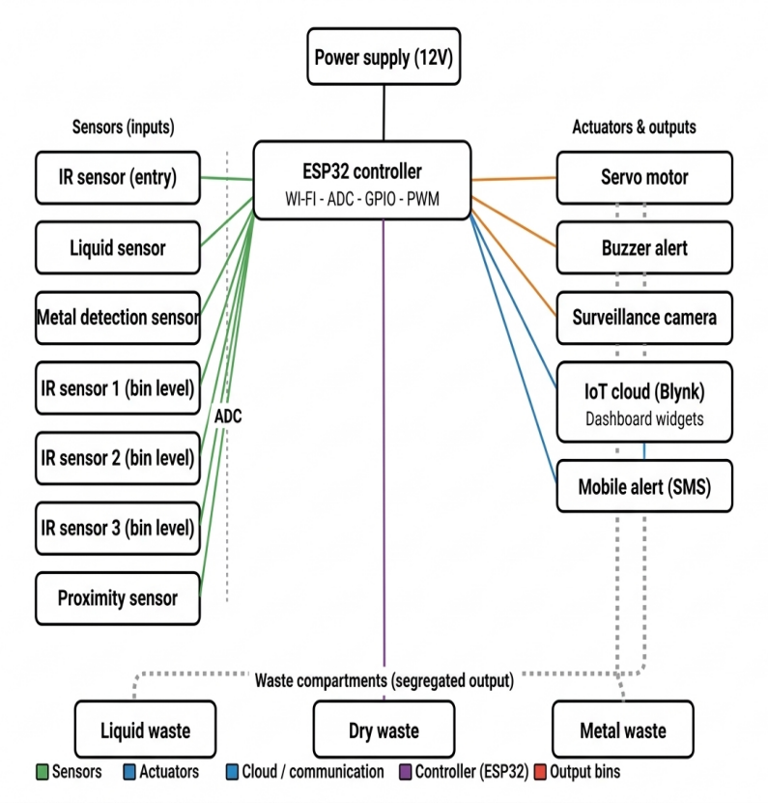
- RESULT ANALYSIS
The suggested Smart Waste Segregation System underwent testing in controlled and simulated real-world environments to assess its overall performance. The sensors for IR, liquid, and metal effectively sorted waste into the correct categories, attaining a total classification accuracy of 93.3%. Small misclassifications were noted in edge cases with partially wet dry waste, due to sensor sensitivity thresholds needing additional calibration.
The servo motor system guided waste into appropriate compartments with an average response time of 1.2 seconds, while fill-level sensors activated instant cloud updates without lag. The average upload delay for IoT data transmission was 2.1 seconds, and alert notifications reached municipal authorities in 3.5 seconds. The findings validate the practical feasibility and dependability of the suggested system for implementation in actual urban waste management
- CONCLUSION
This paper presented a Smart Waste Segregation System that successfully integrates IoT-based sensing, automated mechanical segregation, camera surveillance, and cloud-based real-time monitoring to address the limitations of conventional urban waste management practices. The system demonstrated reliable multi-category waste classification, achieving an overall accuracy of 93.3%, along with efficient servo-based segregation, continuous fill-level monitoring, and proactive alert generation. The proposed solution effectively reduces manual labor dependency, improves public hygiene, and empowers municipal authorities with real-time data for informed decision-making. The results confirm that the system is a practical, scalable, and cost-effective contribution toward building smarter and more sustainable urban environments.
- REFERENCES
- Sharma, D., et al. (2025). “Integrated IoT and AI
Smart Waste Segregation Model.” International
Journal of Advanced Smart Systems.

- Environmental Protection Agency (EPA) Report (2025). “Emerging Technologies in Waste Management.”

- IEEE IoT Journal (2024). “Recent Advances in Smart Waste Management Systems.”

[4] Kumar, R., & Nair, S. (2024). “Energy Efficient IoT-Based Waste Segregation.” International Journal of Green Technology.

[5] Mehta, P., & Joshi, A. (2023). “Smart Bin with Level Detection and IoT Alerts.” International Journal of Engineering and Technology (IJET).

[6] Li, X., et al. (2023). “AI-Based Waste Classification for Smart Cities.” IEEE Access Journal.

- Reddy, K., et al. (2022). “Automated Waste Segregation Using Sensors and IoT.” International Journal of Scientific Research in Engineering.

[8] Gupta, V., & Sharma, L. (2022). “Cloud-Based Smart Garbage Monitoring System.” Journal of Embedded Systems and Applications.

[9] Patel, H., & Shah, M. (2021). “Sensor-Based Smart Waste Segregation and Monitoring.” International Journal of Innovative Technology and Exploring Engineering (IJITEE).

[10] Rajput, N., et al. (2021). “IoT Enabled Waste Management System for Smart Cities.” IEEE Xplore Conference Proceedings.

