Effect of Quarry Dust-Plantain Leaf Ash Filler on Asphalt Concrete Strength Performance

ABSTRACT
The escalating demand for sustainable construction materials has driven the exploration of agricultural and industrial wastes as alternative fillers in asphalt concrete. This study investigates the synergistic effect of Plantain Leaf Ash (PLA), an agricultural waste, and Quarry Dust (QD), an industrial by-product, as composite fillers on the mechanical properties of asphalt concrete. The research aimed to determine the optimal blend that balances sustainability with structural performance. Initially, the physical properties of the base materials—including the specific gravity of aggregates, the grading of the bitumen (60/70 penetration grade), and the particle size distribution of the aggregates—were characterized. The control aggregate (gravel) was found to be gap-graded, deficient in intermediate particles. Asphalt concrete specimens were prepared with varying proportions of PLA (0%, 2%, 4%, 6%, 8%, and 10% by weight of filler) and QD (0%, 2%,4%, 6%, 8%, and 10%) in a full factorial design. The specimens were evaluated for Marshall Stability, This study investigates the effects of Plantain Leaf Ash (PLA) and Quarry Dust (QD) on the compressive strength and compressive elastic modulus of asphalt concrete. Experimental analyses were conducted using varying percentages of PLA (0% to 10%) and QD (0% to 10%) to assess their impact on the mechanical properties of the asphalt mixture. The results revealed that the incorporation of Quarry Dust significantly enhanced both the compressive strength and the elastic modulus, indicating its effectiveness as a mineral filler. Conversely, increasing PLA content consistently led to reductions in both compressive strength and elastic modulus, suggesting limited benefits in its role as a partial replacement. The optimal mix identified for superior mechanical performance was 10% QD with 0% PLA, achieving the highest strength and stiffness measures. These findings underscore the potential of Quarry Dust in asphalt concrete applications, while highlighting the need for further investigation into the long-term performance implications of using Plantain Leaf Ash in construction materials. The insights gained contribute to advancements in sustainable construction practices by optimizing material use in asphalt pavements.

Keywords: Plantain Leaf Ash; Quarry Dust; Asphalt Concrete; Marshall Stability; Compressive strength; Sustainable Pavement; Filler Modification

1. INTRODUCTION
As the demand for sustainable construction materials grows, researchers have increasingly focused on the use of waste materials to enhance the properties of traditional construction materials like asphalt concrete. The integration of alternative fillers, particularly industrial by-products and natural materials, has been the subject of various studies aimed at improving both strength and durability while reducing environmental impact.
Recent literature highlights the potential of using agricultural waste as a partial replacement for conventional fillers. Plantain leaf ash (PLA), a by-product of plantain processing, has garnered attention for its pozzolanic properties, which can improve the mechanical performance of asphalt concrete. [1] investigated the impact of plantain ash on the soil geotechnical properties, and reported that the ash initiated more than 100% increment in the soil CBR. CBR is one of the parameters used to assess soil samples load-bearing capacity and strength characteristics. Also studies indicate that incorporating PLA can enhance the compressive strength, tensile strength, and overall durability of asphalt mixtures. However, the optimal percentage of PLA for maximizing these properties remains inadequately addressed, representing a research gap.
In addition to PLA, quarry dust (QD) has also been explored as a filler material in asphalt concrete. It was initially considered as waste, QD is now utilized in road construction as filler in the bituminous concrete blend and as a surface finishing material, reducing waste and environmental impact while enhancing pavement durability and performance significantly [2]. The properties of QD, such as its high strength, angularity, and gradation, can improve the stability and workability of asphalt mixes. Previous research suggests that QD can effectively replace traditional fillers, but its combination with PLA has not been thoroughly investigated. This dual approach of using both PLA and QD in asphalt concrete offers an innovative avenue for improving environmental sustainability while enhancing material performance.
Despite the encouraging findings regarding each material separately, there is limited research on the combined effects of using plantain leaf ash and quarry dust as filler materials in asphalt concrete. The existing studies often lack comprehensive evaluations of their synergistic effects on strength and durability. Therefore, this research aims to bridge the gap by examining how varying proportions of PLA and QD can influence the mechanical properties of asphalt concrete, providing valuable insights into sustainable construction practices.
This study will contribute to the existing body of knowledge by exploring the optimal compositions of PLA and QD that yield the best performance in asphalt concrete applications. By addressing this gap, we hope to pave the way for the adoption of more sustainable materials in road construction, ultimately leading to improved environmental benefits and resource efficiency in the construction industry.

2. Materials and Methods
2.1 Materials
The bitumen used in this study was obtained from Reynold Construction Company (RCC)
Asphalt plant in Rivers State, Nigeria. Coarse Aggregates used was gravel obtained from dealers at Mile 3 Market in Port Harcourt City of Rivers State. The coarse (gravel and fine (sand) aggregates were obtained from the dealers Mile III building materials in Port Harcourt, Rivers State. The Quarry dust used was gotten from a chipping dump at Eleme Junction in Port Harcourt. While Plantain leaves were gotten from various plantain plantation farms scattered all over Rivers State, Nigeria. The plantain leaves were dried and burnt to ashes and the ashes sieved using 200 microns which then used in the investigation
2.2 Methods
2.2.1 Classification and Characterization of Materials
Sieve analysis provides the particle size distribution, it is required in classifying the aggregates and also used in the blending of aggregates. Sieve analysis was carried out on the coarse and fine aggregates in accordance with ASTM C136 (2001) see Table 1 for the sieve analysis result of the aggregates. The specific gravity test was conducted in line with ASTM C128 (2001) for gravel, sand, bitumen and plantain leaf ash (PLA). Table 2 shows the specific gravity of materials used. The penetration test involve the depth in tenth of mm of a bitumen sample at 25ºC temperature with a standard needle under a load of 100g for 5 seconds. The test procedure was in accordance with ASTM D1586 (2011). The viscosity test involved the measurement of time it will take fluid (bitumen) flowing through an orifice at a given temperature to fill a 50ml receiver. The Standard tar viscometer was used as specified by ASTM D4402 (2006). The softening point of the specimen was measured using the ring and ball softening point test as specified by ASTM D3461 (2014).The result of physical property tests of bitumen used is shown in Table 3.

2.3 Blending of Aggregates/ Mix Proportions
For specification and classification requirements of aggregate gradation to be met, the particle size distribution of each aggregate was obtained and recorded. The Excel Solver method of aggregate combination was adopted to get the blending proportion for the aggregates. The specification limits are provided in accordance with ASTM C136 (2001).Table 4 gives the particle size distribution of the gravel and sand with their mix proportion to meet the specification used. While Figure 1 shows the specification envelope and the mixed material particle size distribution.
2.4 Sample Preparations
The method used in preparing the test specimen was in accordance with AASHTO T245The total weight of one specimen is 1200g. The sample was prepared by heating the aggregates and bitumen before mixing them. The specimen was compacted by subjecting it to 75 blows on both top and bottom (corresponding to heavy volume traffic category on wearing course) by a hammer 6.5 kg rammer in weight, dropped from a height of 450 mm manually. The specimen was extruded from the mould and allowed to cool overnight before testing. The testing method used involved the application of load to the specimen in compression, to failure in the Marshall Stability testing machine. The Marshall Stability test was carried out on varying amount of bitumen (between 4 – 6%) and optimum asphalt cement was obtained which was then used in the specimen preparation
Similar procedure was carried out, for the preparation of modified asphalt concrete mixes with varying percent (2%, 4%, 6%, 8% and 10%) granite dust and plantain leave ash (PLA) blend content at optimum binder content (O.B.C) in accordance to the matrix combination shown in Table 1. Compressive Strength of the specimen according to (ASTM D6931) were then determined and the results shown in Table 6
Table 1: Blending Schedule for Quarry Dust (QD) and Plantain leave Ash (PLA)
PLA (%) | Quarry Dust (QD) %
PLA (%) | Blend A | Blend B | Blend C | Blend D | Blend E
PLA (%) | 2 | 4 | 6 | 8 | 10
0 | 0 : 0 | 0 : 0 | 0 : 0 | 0 : 0 | 0 : 0
2 | 2 : 2 | 4 : 2 | 6 : 2 | 8 : 2 | 10 : 2
4 | 2 : 4 | 4 : 4 | 6 : 4 | 8 : 4 | 10 : 4
6 | 2 : 6 | 4 : 6 | 6 : 6 | 8 : 6 | 10 : 6
8 | 2 : 8 | 4 : 8 | 6 : 8 | 8 : 8 | 10 : 8
10 | 2 :10 | 4 : 10 | 6 : 10 | 8 : 10 | 10 : 10

2.5 Determination of Compressive Strength of Asphalt Concrete Mixes
Compressive strength is a fundamental measure of a material's load-bearing capacity.
It is actually the strength of the material in compression. The compressive strength of the asphalt concrete samples was determined using equation 1.

${ σ}_{c}=\frac{6P}{πdt}$ 1
Where;
σ_{c} = Tensile strength (MPa)
P = failure load during indirect tensile test (N)
d = diameter of asphalt concrete sample at failure (mm)
t = thickness of asphalt concrete sample (mm)

3. RESULTS AND DISCUSSION
3.1 Preliminary Tests
The result of laboratory tests to determine the gradation of gravel, sand and combined aggregate; specific gravity of gravel, sand and plantain leave ash (PLA) used are presented in Table 2 and 3 respectively. While Table 4 contains the physical properties of the Bitumen.
The mix proportion of 60% of gravel and 40% of sand meet the specification requirement for particle size distribution see Table 4
Table 2. Combination of Aggregates
Sieve Size (mm) | Specification  limit | % Passing Aggregate A (Gravel) | % Passing Aggregate B (Sand) | The Blend A=.60%  B = 40%
19 | 100 - 100 | 100 | 100 | 100.0
12.5 | 86 - 100 | 95.7 | 100 | 97.4
9.5 | 70 - 90 | 62.5 | 100 | 77.5
6.3 | 45 - 70 | 15 | 100 | 49.0
4.75 | 40 - 60 | 1.5 | 99 | 40.5
2.36 | 30 - 52 | 0.5 | 95.8 | 38.6
1.18 | 22 - 40 | 0.5 | 88.1 | 35.5
0.6 | 16 - 30 | 0.5 | 77.5 | 31.3
0.3 | 9 - 19 | 0.5 | 25.4 | 10.5
0.15 | 3 - 7 | 0.5 | 3.4 | 1.7
0.075 | 0 - 0 | 0.5 | 0.3 | 0.4

Table 3. Specific Gravity of Materials
Material | Specific Gravity
Gravels (Coarse aggregate) | 2.60
Sand (fine aggregate) | 2.78
Quarry Dust (filler) | 2.62
Plantain Leaf Ash (PLA) | 1.80

Gravel Sand, Gravel and Quarry Dust) with high specific gravities (2.60–2.78) are suitable for conventional asphalt concrete, and PLA (Biomass material) with a low specific gravity (1.80), can be used as a lightweight filler or pozzolanic material, see Table 2.
Table 4. Physical Properties of Bitumen
Physical properties | Value
Specific Gravity | 1.01
Penetration | 63.3
Viscosity 100 (sec) | 65
Softening Point (ºC) | 51.1

The results in Table 4 indicate a standard 60/70 penetration grade bitumen. It possesses a balanced set of properties: it is hard enough to resist deformation (Penetration), has a good temperature susceptibility (Softening Point), and is workable (Viscosity). This specific combination makes it suitable for paving applications in regions with average temperature variations.
3.2 Marshall Stability of QD – PLA mix Modified Asphalt Concrete
Table 5. Marshall Stability Result of QD –PLA Modified Asphalt Concrete
% of PLA | Stability (KN)
% of PLA | % of QD
% of PLA | 0 | 2 | 4 | 6 | 8 | 10
0 | 35.6 | 36.2 | 37.5 | 38.9 | 39.2 | 42.2
2 | 33.1 | 33.5 | 35.0 | 36.6 | 36.8 | 37.1
4 | 32.2 | 31.9 | 33.5 | 34.0 | 35.8 | 39.0
6 | 29.0 | 30.3 | 32.8 | 32.5 | 33.8 | 36.6
8 | 27.7 | 29.4 | 29.2 | 30.4 | 30.9 | 32.4
10 | 25.8 | 26.7 | 26.8 | 27.8 | 30.8 | 32.0

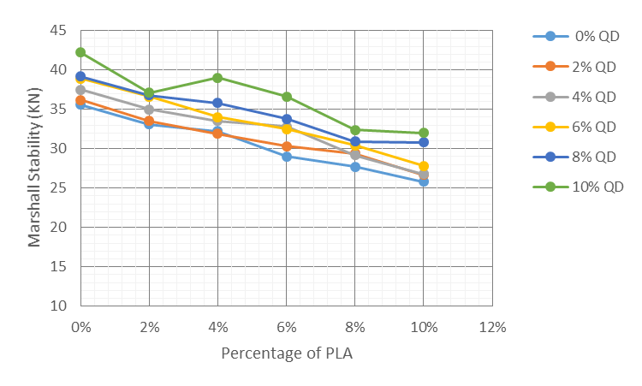
Figure 1: Graph of Marshall Stability against Percentage of PLA
Table 5 shows the Marshall Stability values (in kN) for asphalt concrete mixes with varying percentages of PLA (0% to 10%) and QD (0% to 10%). For a fixed percentage of Quarry Dust (QD), the Marshall Stability generally decreases as the percentage of Plantain Leaf Ash (PLA) increases. At 0% QD, Stability decreases from 35.6 kN at 0% PLA to 25.8 kN at 10% PLA.
Also at 10% QD, Stability decreases from 42.2 kN at 0% PLA to 32.0 kN at 10% PLA. This trend suggests that increasing the PLA content, which is an agricultural waste ash, will lead to a less stiff or weaker matrix, possibly due to the chemical composition or particle characteristics of the PLA. Some studies on agricultural ashes (like Plantain Peel Ash) in cementitious materials show pozzolanic properties, but when used as a filler in asphalt, if the ash has a high calcium oxide content and lower silica and alumina content, it might not interact as effectively with the bitumen as conventional fillers, or it might absorb more bitumen, leading to a less coated aggregate structure and reduced stability [3]. Research on other waste ashes used as fillers in asphalt concrete indicates that stability often increases up to an optimum filler content, after which it may decrease [10;11]. The consistent decrease here suggests that the PLA in this study is acting as a less effective filler than the control (0% PLA) or the QD.
For a fixed percentage of Plantain Leaf Ash (PLA), the Marshall Stability generally increases as the percentage of Quarry Dust (QD) increases. At 0% PLA, Stability increases from 35.6 kN at 0% \QD to 42.2 kN at 10% QD. Also at 10% PLA, Stability increases from 25.8 kN at 0% QD to 32.0 kN at 10% QD. Quarry dust is a conventional mineral filler, and its addition is expected to improve the mechanical properties of the mix by filling the voids between the aggregates, thereby increasing the internal friction and stiffness, which translates to higher Marshall stability [12]. The data strongly supports this, as the highest stability value 42.2 kN is recorded at 0% PLA and 10% QD.
The maximum stability achieved in the tested range is 42.2 kN at 0% PLA and 10% QD. This suggests that at the tested bitumen content, the mix benefits most from the inclusion of the maximum tested QD and no PLA. The minimum stability recorded is 25.8 kN at 10% PLA and 0% QD.
The results indicate that the incorporation of Quarry Dust (QD) as a mineral filler generally enhances the Marshall stability of the asphalt concrete mix, which is consistent with its role in providing particle gradation and increasing the stiffness of the mastic phase [12]. Conversely, the addition of Plantain Leaf Ash (PLA) appears to decrease the Marshall stability across the tested range.
3.3 Compressive Strength of QD-PLA mix Modified Asphalt Concrete
Table 5. Compressive Strength Result of QD –PLA Modified Asphalt Concrete
% of PLA | Compressive Strength (N/mm²)
% of PLA | % of QD
% of PLA | 0 | 2 | 4 | 6 | 8 | 10
0 | 10.54 | 10.70 | 11.09 | 11.50 | 11.59 | 12.48
2 | 9.80 | 9.92 | 10.36 | 10.82 | 10.88 | 10.97
4 | 9.52 | 9.45 | 9.92 | 10.07 | 10.59 | 11.55
6 | 8.59 | 8.96 | 9.71 | 9.61 | 9.99 | 10.84
8 | 8.19 | 8.71 | 8.65 | 9.00 | 9.15 | 9.59
10 | 7.62 | 7.91 | 7.94 | 8.23 | 9.11 | 9.48

Table 5 shows the compressive strength values for mixes with varying percentages of Plantain Leaf Ash (PLA) and Quarry Dust (QD). For a constant percentage of Quarry Dust (QD), the compressive strength generally decreases as the percentage of Plantain Leaf Ash (PLA) increases. At 0% QD, the strength drops from 10.54 N/mm² at 0% PLA to 7.62 N/mm² at 10% PLA. At 10% QD, the strength drops from 12.48 N/mm² at 0% PLA to 9.48 N/mm² at 10% PLA. This consistent decrease suggests that PLA, when used as a partial replacement as a filler, is less effective at contributing to early-age strength development compared to the control or the QD. PLA exhibits pozzolanic activity, which can improve later-age strength by reacting with calcium hydroxide Ca(OH)₂ [13], the data here shows a clear strength reduction across the board, indicating a negative impact on the overall strength development within the tested curing period. Studies on PLA in concrete sometimes show an initial strength drop before late-age strength gains [13]. The high calcium oxide CaO content sometimes found in PLA might lead to poor pozzolanic performance or affect the microstructure negatively compared to the control mix [13].

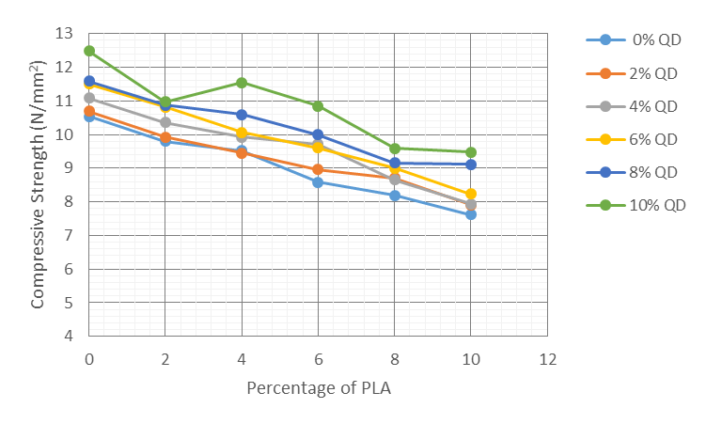
Figure 2: Graph of Compressive Strength against Percentage of PLA
For a constant percentage of Plantain Leaf Ash (PLA), the compressive strength generally increases as the percentage of Quarry Dust (QD) increases. At 0% PLA, Strength increases from 10.54 N/mm² at 0% QD to 12.48 N/mm² at 10% QD. Also at 10% PLA, Strength increases from 7.62 N/mm² at 0% QD to 9.48 N/mm² at 10% QD. This positive trend is typical when Quarry Dust (QD) is used as a partial replacement for sand (fine aggregate) in concrete [14]. QD, being a byproduct of crushing, has a finer particle size and a rougher texture than natural sand, which can lead to a better interlocking of particles and a denser matrix when mixed with cement paste [14]. This improved packing and increased surface area for bonding generally results in enhanced compressive strength up to an optimal replacement level [14]. Research indicates that QD replacement of sand can increase compressive strength [14;15].
The maximum compressive strength observed in the tested range is 12.48 N/mm² at 0% PLAand 10% QD. This mix benefits from the full inclusion of the conventional filler/fine aggregate replacement (QD) while avoiding the inclusion of PLA. The minimum strength recorded is 7.62 N/mm² at 10% PLA and 0% QD. The beneficial effect of adding QD is evident, as the strength consistently improves with increasing QD. The negative effect of PLA appears to dominate, as the strength is lowest in the 10% PLA row. In studies involving QD and other supplementary cementitious materials for example fly ash, the combination often yields the best results, suggesting that QD alone is beneficial, but the PLA component in this study is detrimental to the strength development observed [15].
The results suggest that the incorporation of Quarry Dust (QD) as a partial replacement for filler has a positive influence on the compressive strength of the material, consistent with its role in creating a denser microstructure [14]. Conversely, the addition of Plantain Leaf Ash (PLA) appears to have a detrimental effect on the strength within the tested parameters. The best performance, 12.48 N/mm², was achieved with the highest tested level of 10% QD and 0% PLA. For the material to be considered structurally sound, these strength values would need to be compared against the specified design strength for the intended application.
3.4 Compressive Elastic Modulus of QD-PLA mix Modified Asphalt Concrete
Table 6. Compressive Elastic Modulus Result of QD –PLA Modified Asphalt Concrete
% of PLA | Compressive Elastic Modulus (N/mm²)
% of PLA | % of QD
% of PLA | 0 | 2 | 4 | 6 | 8 | 10
0 | 0.566 | 0.590 | 0.622 | 0.644 | 0.652 | 0.702
2 | 0.507 | 0.517 | 0.549 | 0.572 | 0.577 | 0.582
4 | 0.473 | 0.473 | 0.504 | 0.511 | 0.540 | 0.589
6 | 0.450 | 0.482 | 0.531 | 0.525 | 0.548 | 0.594
8 | 0.414 | 0.443 | 0.447 | 0.466 | 0.475 | 0.496
10 | 0.371 | 0.387 | 0.394 | 0.411 | 0.455 | 0.470

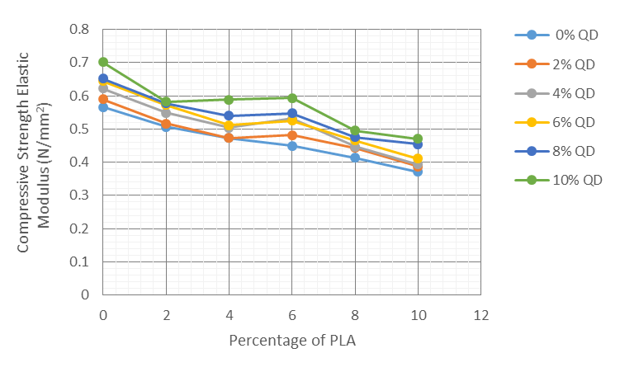
Figure 3 Graph of Compressive Elastic Modulus against Percentage of PLA
The Compressive Elastic Modulus (often related to the stiffness or resilient modulus in asphalt engineering) measures the material's stiffness or resistance to elastic deformation under load. Table shows values for mixes with varying percentages of Plantain Leaf Ash (PLA) and Quarry Dust (QD).
For a fixed percentage of Quarry Dust (QD), the Elastic Modulus generally decreases as the percentage of Plantain Leaf Ash (PLA) increases. At 0% QD, The modulus drops from 0.566 N/mm² at 0% PLA to 0.371 N/mm² at 10% PLA. Also at 10% QD, The modulus drops from 0.702 N/mm² at 0% PLA to 0.470 N/mm² at 10% PLA. This consistent decline indicates that increasing the PLA content reduces the overall stiffness of the mix. In asphalt concrete, mineral fillers are known to stiffen the bitumen (asphalt binder), leading to a higher complex modulus or elastic modulus, which is generally desirable for load-bearing capacity and resistance to rutting [16]. The decrease observed with PLA suggests that it is either less effective at stiffening the asphalt mastic or that its inclusion negatively impacts the overall aggregate structure, leading to a less stiff material compared to the control or QD-dominant mixes. This aligns with the previous observation that PLA may be detrimental to mechanical properties in this context [17].
For a fixed percentage of Plantain Leaf Ash (PLA), the Elastic Modulus generally increases as the percentage of Quarry Dust (QD) increases. At 0% PLA, the modulus increases from 0.566 N/mm² at 0% QD to 0.702 N/mm² at 10% QD. Also at 10% PLA, the modulus increases from 0.371 N/mm² at 0% QD to 0.470 N/mm² at 10% QD. This positive trend is expected, as Quarry Dust (QD) functions as a conventional mineral filler. Mineral fillers are known to increase the resilient modulus of asphalt mixtures by improving asphalt cohesivity and providing better particle packing [18]. The data strongly supports that QD contributes positively to the stiffness of the mix across all PLA levels tested.
The maximum Elastic Modulus achieved is 0.702 N/mm² at 0% PLA and 10% QD. This confirms that the mix benefits most from the inclusion of the conventional filler (QD) and the absence of the PLA. The minimum modulus is 0.371 \text N/mm² at 10% PLA and 0% QD. The data clearly indicates that the beneficial stiffening effect of Quarry Dust overrides any potential stiffening or detrimental effects of the Plantain Leaf Ash. The presence of PLA consistently correlates with a lower elastic modulus, suggesting a less stiff pavement layer, which could be more susceptible to permanent deformation (rutting) at high temperatures, although a very high modulus can also lead to brittleness and cracking at low temperatures [16].
The results demonstrate that the Elastic Modulus, a key indicator of pavement stiffness, is significantly influenced by the composition of the filler system. The use of Quarry Dust (QD) enhances the stiffness, which is generally favorable for load-bearing capacity [18]. Conversely, the incorporation of Plantain Leaf Ash (PLA) appears to reduce the stiffness of the asphalt concrete. For engineering design, the mix with 0% PLA and 10% QD provides the stiffest material within the tested matrix. Further investigation would be required to determine if the highest modulus mix is optimal for the intended service conditions (e.g., balancing high-temperature rutting resistance with low-temperature cracking resistance) [19].

4. CONCLUSION
This study investigated the effects of Plantain Leaf Ash (PLA) and Quarry Dust (QD) on the compressive strength and compressive elastic modulus of asphalt concrete. The findings revealed the following:
The introduction of Quarry Dust significantly enhanced the compressive strength across all tested levels, indicating its beneficial role as a mineral filler in asphalt mixtures. Conversely, increasing the percentage of Plantain Leaf Ash consistently reduced the compressive strength, suggesting its limited effectiveness as a partial replacement for traditional materials.
A similar trend was observed in the compressive elastic modulus, where higher QD content improved stiffness, while higher PLA concentrations diminished it. The presence of QD provided a more cohesive and robust mix, optimizing load-bearing capabilities, whereas PLA appeared to weaken the overall elasticity of the material.
The study identified that 10% QD with no PLA combination yielded the highest compressive strength and elastic modulus, establishing a strong foundation for performance under structural loads.

REFERENCES
1. Alshawmar,E., (2024). Utilization of Nano Silica and Plantain Leaf Ash for Improving Strength Properties of Expansive Soil. Sustainability 2024, 16, 2157. Retrieved from https://doi.org/10.3390/ su16052157

2. Oba, K. M. and Tigbara, E. L., (2021). Characterisation of Saw Dust Ash – Quarry Dust Bituminous Concrete.. International Journal of Engineering and Management Research e-ISSN: 2250-0758 | p-ISSN: 2394-6962 Volume-11, Issue-1 (February 2021) www.ijemr.net https://doi.org/10.31033/ijemr.11.1.17 123

3. American Society for Testing and Materials. (2001). ASTM C136: Standard test method for
gradation of aggregates. ASTM International, USA

4. American Society for Testing and Materials. (2001). ASTM C128: Standard test method
for specific gravity and absorption of fine aggregate. ASTM International, USA

5. American Society for Testing and Materials. (2011) ASTM D1586: Standard test method
for penetration of bituminous material. ASTM International, USA

6. American Society for Testing and Materials. (2006) ASTM D4402: Standard test method for
viscosity of bituminous material. ASTM International, USA

7. American Society for Testing and Materials. (2014) ASTM D3461: Standard test method for
softening point of bituminous material. ASTM International, USA

8. American Association of State Highway and Transportation Officials (2017). AASHTO
T245: Procedure for hot mix asphalt using Bruce Marshall Mix Design. Washington DC

9. Ezema N., Adinna B., Anayo C., (2022). Effect Sugarcane Bagasse Ash and Plantain Leaf
Ash on Geotechnical properties of Clay soil from Efab Estate, Awka, Anambra Stat. Nigerian
Journal of Technology (NIJOTECH), 41(6), 949–954.
.
10. Niraj Bohara (2018). Study of the Influence of Fly Ash and Its Content in Marshall
Properties of Asphalt Concrete. Journal of Sustainable Construction Maetrials and
Technologies. Vol.3, issue 3 Pp 262 - 270

11. Wan Noor Hin Mior Sani. (2025). Volumetric Properties of Waste-Modified Asphalt
Mixtures through Marshall Stability. Current Problems in Research. Vol. 1, Issue 1. Pp 37 -
51

12. Oba, K. M., LongJohn, T. A., & Ijeje, K. A. (2022). Suitability of Saw Dust Ash and
Quarry Dust as Mineral fillers in Asphalt Concrete. International Journal of Engineering
and Management Research, 12(2), 24–29.

13. Sharma, P., & Sharma, S. (2016). Influence of Quarry Dust on Compressive Strength of
Concrete. SciRes Journal of Technology, 2016, Article 47

14. Oba, K. M., LongJohn, T. A., & Ijeje, K. A. (2022). Suitability of Saw Dust Ash and Quarry
Dust as Mineral fillers in Asphalt Concrete. International Journal of Engineering and
Management Research, 12(2), 24–29.

15. S. N. Ramana, M. F. M. Zainb, H. B. Mahmuda & K. S. Tanb (2005). Influence of Quarry
Dust and Fly Ash on the ConcreteCompressive Strength Development. ResearchGate.

16. Anggraini Z., Yick D. W. and Darren D. S. (2012). Effects of Fillers on Properties of
Asphalt-Concrete Mixture. Journal of Transportaion Engineering. Vol 138, issue 7. Pp 902
907

17. Lesueur, D., Blázquez, M. L, Garcia D. A. and Rubio A. R. (2017). On the impact of the
filler on the complex modulus of asphalt mixtures. Road material and Pavement Design

18. Zhenyang F., Xuancang W., Zhuo Z., and Yi Z. (2019). Effects of Cement–Mineral Filler on
Asphalt Mixture Performance under Different Aging Procedures. MDPI. Vol. 9, Issue 18. Pp
1 -15

19. Setiawan A. Latif B., and Agus t. M. (2017). Developing the Elastic Modulus Measurement
of Asphalt Concrete using the Compressive Strength Test. Proceedings of the 3rd
ICONBUILD 2017. DOI: 10.1063/1.5011541

