NeoD-A No-Code Visual Neural Network Designer.

Abstract— It is challenging to design expert neural net architectures from scratch, and it also requires a good domain knowledge of programming (and its implementation of machine learning), acting as a major entry barrier for students, researchers in other fields, and aspiring practitioners in general. In the proposed work, we present our experience designing and evaluating this web application-based no-code visual neural net designer. Using a graphical UI drag-and-drop interface and property pages, the application allows for the design and configuration of complex neural net architectures in a codeless or no-code fashion, with actual code implementation of the design left to work its magic behind the scenes on some underlying framework code (PyTorch / TensorFlow, etc.). A user study of general developers and computer science students on prototyping a neural net architecture design model was used to test the suggested method in comparison to source code programming.
Keywords—No-code neural network design, Visual model builder, Drop and drag interface, low barrier AI tools, Pytroch/TensorFlow Export, Web-based Application and user friendly.
- INTRODUCTION
Neural networks have recently become a crucial component of contemporary artificial intelligence, enabling significant advances in robotics, computer vision, natural language processing, and other scientific domains. Neural network designers and optimizers are in greater demand because of their expanding influence. However, creating neural network models is an extremely difficult and complicated process. This necessitates both a thorough understanding of machine learning concepts and the ability to write complex code using TensorFlow or PyTorch.

To address these problems, we present "NeoD – A No-Code Visual Neural Network Designer," a tool that makes building and analyzing neural network models easier. This tool was created with novices, students, and recently emerging professionals, giving them a welcoming environment in which they can graphically design neural network architectures without any prior experience with machine learning or programming.
- LITERATURE REVIEW
In 2017, Google introduced Teachable Machine, an innovative technological solution that makes machine learning simple to use even for non-

programmers. This feature is consistently highlighted as one of its most influential elements in nearly every study. For example, both Weng (2018) and Miller et al. (2020) believe that offering an intuitive and user- friendly interface that enables users to work with image, sound, and pose recognition, lessens the difficulty associated with AI adoption. Because it is close to the gap related to machine learning, it is simple to use. Teachable Machine is widely used as a pedagogical tool in educational settings. According to researchers, it improves experiential learning by enabling users to collect their own datasets, instantly train models, This feature is consistently highlighted as one of its most influential elements in nearly every study. For example, both Weng (2018) and Miller et al. (2020) believe that offering an intuitive and user-friendly interface that enables users to work with image, sound, and pose recognition, lessens the difficulty associated with AI adoption. Because it is close to the gap related to machine learning, it is simple to use. Teachable Machine is widely used as a pedagogical tool in educational settings.

But there are some drawbacks to this simplicity as well. Although Teachable Machine effectively collects user-generated data and
trains models in an easy-to-use way, it frequently conceals the underlying mechanics from the learner. Most of the time, users don't know what goes on behind the scenes, like how data is organized, how convolutional neural networks work, or which optimization procedures power training. The platform mainly focuses on pose, image, and audio classification; it offers fast results but little information about computational reasoning or model architecture.
By exposing the background processes that Teachable Machine abstracts away, NeoD fills this gap. It demonstrates how CNN layers, data configurations, optimizers, and performance graphs connect as nodes to create a functional architecture. Instead of depending on a simplified black-box system, this transparency gives users more control and comprehension, enabling them to investigate, alter, and run models in accordance with their own needs.
- METHODOLOGY

NeoD is developed using a multi-layered approach that combines neural network training pipelines, frontend interaction, backend processing, and visualization systems into a unified low-code platform. The following elements make up the methodology's structure.
  - System architecture Overview
NeoD is a web-based framework that lets users build, train, and assess neural networks visually. To guarantee smooth real-time experiences, the system architecture blends potent deep learning runtimes with contemporary UI technologies.

  - Frontend Methodology
    - User Interface Framework (React.js)
React.js is utilized as the core library for the user interface due to its component-based architecture and scalability. It allows for the smooth rendering of complex interactions needed for the development of a neural network.
    - Visual Workflow Builder (React Flow)
For easier neural network development, React Flow offers a node and edge interface where the different layers, such as the convolution layer, pooling layer, and dense layer, can be easily dragged and dropped.
Its functionalities:
      - Drag-and-drop layer creation
      - Editable node properties (filters, kernel size, activation)
      - Auto-generated computational graphs Dynamic validation of connections

    - Interface Components (Hero UI)
Hero UI offers pre-designed interface components such as modals, sliders, buttons, cards, and input fields. These help improve usability, look, and accessibility.

- Backend Methodology
  - In Browser Deep Learning (TensorFlow.js) In Browser Deep Learning (TensorFlow.js) TensorFlow.js allows for the training and inference of models to happen inside the browser.
The Advantages:

    - No installation is required.
    - Privacy-preserving (data never leaves the client).
    - GPU acceleration through WebGL
TensorFlow.js converts the React Flow graph into a computational model and runs it as a CNN.
Optional Server-Side Extension (PyTorch) For more complex or large-scale experiments:

- PyTorch library is being used for backend.
- This backend is invoked through Node.js endpoints.
- The backend allows for custom layers, data sets, and large CNN architectures. The above approch allows for flexibility, both for beginners and experts.
  - Backend Communication Layer(Nodej.s) Node.js orchestrates:
- API routing Dataset uploads.
- Model export/import.
- Handling training requests (when using PyTorch)
- Managing user configurations

The event-driven architecture facilitates smooth interaction between the front-end tools and the runtimes.

  - Neural Network Processing
- Model Graph Constructor
The drag-and-drop interface creates a JSON graph that describes:

- Layer type
- Hyperparameters
- Connections
The model graph is used to create a CNN using TensorFlow.js or PyTorch.
- Training Pipeline
The training loop consists of the following steps:
- Loading the dataset (the images or user- uploaded content)
- Preprocessing the data (resizing, normalizating)
- Forward pass
- Backpropagation
- Calculating the Metric (accuracy, loss)

Real-time graphs are also included to facilitate the understanding of the learners.
- Model Evalution NeoD includes the following:
  - Confusion matrix.
  - Predicted labels.
  - Error analysis.
  - Intermediatefeature visualizations
(activation maps).
These elements provide a better understanding of the working of CNNs.
  - Integration Workflow
    - Frontend Backend Synchronization
User interactions such as adding a layer, adjusting the parameters, and starting the training process are all synced through the following:
  - React State.
  - REST APIs from Node.js
  - TF.js Execution calls
This ensures immediate visual and computational updates.
    - Real-time Feedback Loop
As models train, the backend sends:
  - Real time accuracy updates
  - Instant loss updates.
  - Visual layer activations

These updates are rendered byHero UI + graph libraries in the frontend.

- SIMULATION
For testing NeoD, various CNN models have been created using TensorFlow.js directly in the browser. The performance of the system was also tested by using the drag-and-drop feature for designing the models. The performance of the system was visualized using accuracy and loss graphs. Various combinations of layers have been

used to test the system's ability to convert the visual design into a model. Usability of the system has also been tested to evaluate the user experience. The tests have confirmed the capability of NeoD for visual model building.

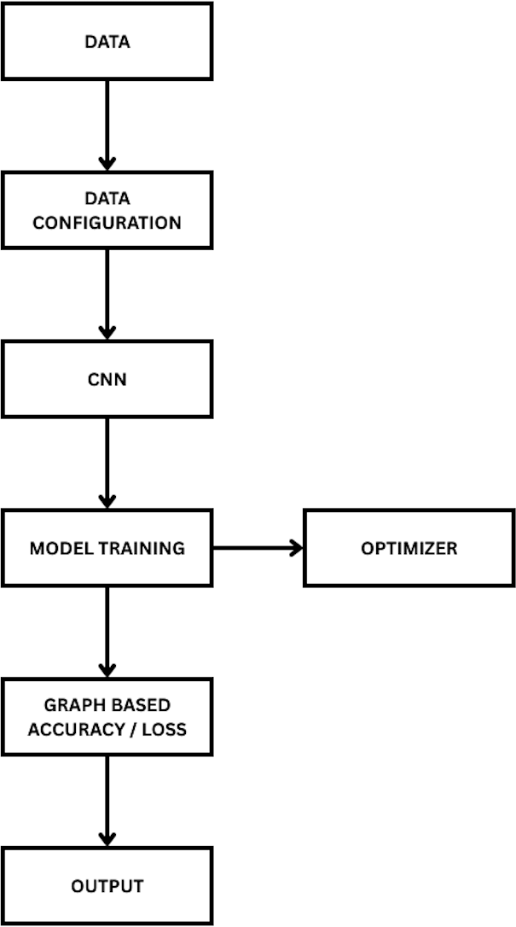

Diagram 4.1: System Workflow

- RESULTS & DISCUSSION
The findings from using NeoD indicate that visually created CNN models can be trained within the browser, providing smooth and instant feedback. The accuracy and loss charts were continuously updated during the training process, confirming that TensorFlow.js was functioning correctly for the generated models. Users found it easier to comprehend the network architecture using the drag-and-drop feature. Even simple models were found to converge, and more complex models showed consistent performance when resources are not an issue for the browser. The findings suggest that NeoD not only works well as a low-code deep learning tool but also helps users comprehend the models
better by making the models more transparent.

- CONCLUSION

NeoD demonstrates the potential for advanced artificial intelligence techniques to be presented in such a manner that it becomes easily digestible and visually intuitive, making it easier for new learners to overcome the hurdles that prevent them from learning and working with deep learning techniques. By removing the need for human coding and providing a visual workflow, NeoD allows learners, educators, and new developers to easily understand, create, and work with neural networks.

This is achieved through the platform’s drag-and-drop interface, training feedback, and browser-based execution. This bridges the gap between theoretical knowledge and actual hands-on creation of AI. This is important because it does not only help in the learning process but also provides a platform for creativity. This is because, by providing a platform for the creation of AI, it encourages the user to be creative without the fear of making mistakes.

As both an education tool and a rapid prototyping tool, NeoD represents the promise of low-code and no-code solutions in defining the future of AI literacy. As accessibility becomes a key concern in the progression of AI, tools like NeoD demonstrate how proper visualization, interaction, and web deployment can bring a broader, more varied crowd into the realm of machine learning.

- REFERENCES
[1] Sharma, A., et al. (2024). "Democratizing Artificial Intelligence through No-Code and Low- Code Platforms." IEEE Access.
[2] Chen, X., & Li, Y. (2023). "Visual Programming for Deep Learning: An Overview and Challenges." Journal of Visual Languages and Computing.
[3] Gupta, R., et al. (2022). "AI for All: Lowering Barriers through Visual Model Design." ACM Transactions on Computing Education.
[4] Smilkov, D., et al. (2019). "TensorFlow.js: Machine Learning in the Browser." Proceedings of the Web Conference (WWW).
[5] Wadhwani, P., et al. (2021). "Google Teachable Machine: Exploring No-Code AI Education Tools." Computers & Education:

Artificial Intelligence.
[6] Liu, Z., et al. (2022). "Visual Analytics for Deep Neural Networks: A Comprehensive Survey." IEEE Transactions on Visualization and Computer Graphics.
[7] Ramaswamy, K., et al. (2023). "No-Code AI: Bridging the Gap Between Non-Programmers and Artificial Intelligence." Springer AI Review.
[8] Kahng, M., et al. (2020). "Interactive Visualization of Neural Network Training." IEEE InfoVis Conference.
[9] Kim, R., et al. (2023). "A Framework for AI Education Using No-Code Platforms." Springer.
[10] Liu, Y., et al. (2022). "Web-Based Deep Learning Frameworks: Trends and Opportunities." IEEE Internet Computing.
- Sculley, D., et al. (2015). “Hidden Technical Debt in Machine Learning Systems.” Advances in Neural Information Processing Systems (NeurIPS).
- Amershi, S., et al. (2019). “Software Engineering for Machine Learning: A Case Study.” IEEE/ACM International Conference on Software Engineering (ICSE).
- Buitinck, L., et al. (2013). “API Design for
Machine Learning Software: Experiences from the Scikit-Learn Project.” European Conference on Machine Learning and Principles and Practice of Knowledge Discovery in Databases.
- Zaharia, M., et al. (2018). “Accelerating the Machine Learning Lifecycle with MLflow.” IEEE Data Engineering Bulletin.
- Abadi, M., et al. (2016). “TensorFlow: A System for Large-Scale Machine Learning.” USENIX Symposium on Operating Systems Design and Implementation.
- Paszke, A., et al. (2019). “PyTorch: An Imperative Style, High-Performance Deep Learning Library.” Advances in Neural Information Processing Systems (NeurIPS).
- François, C. (2015). “Keras: The Python Deep Learning Library.” GitHub Documentation and Technical Reports.
- Howard, J., & Gugger, S. (2020). “Fastai: A Layered API for Deep Learning.” Information Journal.
- Alammar, J. (2021). “Visualizing Machine Learning Models and Neural Networks.” O’Reilly Media Technical Series.
- Holzinger, A., et al. (2018). “What Do We Need to Build Explainable AI Systems for the Medical Domain?” arXiv / Springer Lecture Notes in Computer Science

