Design of Modified Dual-CLCG Algorithm for Pseduo-Random Bit Generator
___________________________________________________________________________________________________________________________

Abstract
Pseudorandom bit generators (PRBGs) are indispensable in modern cryptography, forming the backbone of secure communication protocols, authentication mechanisms, and privacy-preserving systems. A PRBG must produce sequences that appear statistically random while being computationally unpredictable. Traditional designs such as linear feedback shift registers (LFSR) and linear congruential generators (LCG) are attractive due to their simplicity and low hardware cost, but they fail several National Institute of Standards and Technology (NIST) randomness tests because of inherent linearity. Coupled LCG (CLCG) and dual-CLCG methods improve resilience by combining multiple generators, but they suffer from irregular timing, high latency, and excessive hardware usage.
A modified dual-CLCG algorithm and its VLSI architecture, designed to produce pseudorandom bits at a consistent clock rate with minimal hardware overhead. The novelty lies in the use of a simplified XOR stage at the output, which ensures uniform bit generation at every clock cycle. Unlike the dual-CLCG, which requires multiple flip-flops and suffers from asynchronous bit release, the modified design achieves a maximum sequence length of 2^n, requires only one initial delay cycle, and passes all fifteen NIST benchmark tests.
The architecture was implemented using Verilog HDL and prototyped on FPGA hardware. Experimental results demonstrate significant improvements in area efficiency, latency reduction, and power consumption compared to existing designs. The proposed generator not only meets the randomness requirements but also achieves polynomial-time unpredictability, making it suitable for resource-constrained IoT devices where lightweight cryptographic primitives are essential.
Key Words: Mobile Pseudorandom Bit Generator (PRBG), Modified Dual-CLCG, Linear Congruential Generator (LCG), VLSI Architecture, Randomness Tests, NIST Statistical Suite, Cryptographic Security, FPGA Implementation, IoT Privacy, Hardware Efficiency.
1.INTRODUCTION
T The Internet-of-Things (IoT) revolution has connected billions of devices, ranging from sensors and smart appliances to industrial control systems. While this connectivity enhances efficiency and convenience, it also introduces severe security challenges. Protecting data in IoT environments requires lightweight cryptographic mechanisms that can operate under strict resource constraints. At the heart of these mechanisms lies the pseudorandom bit generator (PRBG), which is responsible for producing random sequences used in encryption keys, authentication tokens, and secure communication protocols.
A PRBG must satisfy two critical requirements: statistical randomness and computational unpredictability. Randomness is typically validated using the NIST statistical test suite, which includes fifteen benchmark tests such as frequency, runs, and discrete Fourier transform (DFT). Unpredictability ensures that even with partial knowledge of the sequence, an adversary cannot feasibly reconstruct future outputs.
Traditional PRBGs such as LFSR and LCG are attractive due to their simplicity and low hardware cost. However, their linear structures make them vulnerable to cryptanalysis, and they fail several NIST tests. Blum-Blum-Shub (BBS) offers strong unpredictability based on number-theoretic hardness assumptions, but its reliance on large prime modulus operations makes hardware implementation impractical.
To overcome these limitations, researchers proposed coupled LCG (CLCG) and dual-CLCG architectures. By combining multiple LCGs and introducing inequality comparisons, these designs improve randomness and security. However, they suffer from irregular timing, high initial latency, and excessive flip-flop usage. In particular, the dual-CLCG fails five major NIST tests and requires 2^{n} cycles before producing its first output.
The design introduces a simplified XOR logic at the output stage, ensuring uniform bit generation at every clock cycle. This modification reduces hardware complexity, minimizes latency, and achieves maximum sequence length. The architecture was implemented using Verilog HDL and tested on FPGA hardware, demonstrating suitability for IoT applications where efficiency and security must coexist.

2. LITERATURE REVIEW
Research on PRBGs spans several decades, with contributions from both theoretical cryptography and hardware design communities. Early work focused on LFSR-based generators due to their simplicity and ease of implementation. However, Zenner’s survey on LFSR cryptanalysis highlighted their vulnerability to linear attacks, making them unsuitable for secure applications.
LCGs, another popular class of generators, are defined by recurrence relations involving multiplication and addition modulo a large integer. While efficient, Stern demonstrated that secret LCGs are not cryptographically secure, as their linearity allows adversaries to reconstruct sequences with limited information.
To improve resilience, researchers introduced coupled LCG (CLCG) architectures, where two or more LCGs are combined using inequality comparisons. Katti and Srinivasan proposed the dual-CLCG, which employs four LCGs and two comparators. Although more secure than single LCGs, the dual-CLCG suffers from irregular timing, high latency, and excessive hardware usage. It fails five major NIST tests, including the DFT test, which detects periodic patterns.
Recent work by Rajak et al. (2024) introduced a remodified dual-CLCG, optimizing comparator usage and reducing latency. Their design demonstrated improved efficiency but still required careful parameter selection to achieve maximum sequence length. Other approaches explored chaotic maps and number-theoretic generators such as Blum-Blum-Shub, but these designs either fail statistical tests or are impractical for hardware implementation.
This literature review highlights the trade-off between randomness quality and hardware efficiency. While theoretical designs achieve strong security, practical implementations often struggle with resource constraints. The modified dual-CLCG proposed in this paper aims to bridge this gap by combining strong randomness properties with efficient VLSI architecture.

3. RELATED WORK
Recommendation The study of pseudorandom bit generators (PRBGs) has evolved through multiple generations of designs, each attempting to balance randomness quality, unpredictability, and hardware efficiency. Early designs such as linear feedback shift registers (LFSRs) were widely adopted due to their simplicity and ability to generate long sequences. However, their linear recurrence relations made them vulnerable to cryptanalysis, as attackers could reconstruct the sequence with limited knowledge of the internal state. This limitation prompted researchers to explore alternative designs.
Linear congruential generators (LCGs) became another popular choice, defined by recurrence relations involving multiplication and addition modulo a large integer. While efficient and easy to implement, LCGs also suffer from linearity issues. Stern’s work demonstrated that secret LCGs are not cryptographically secure, as adversaries can exploit their predictable structure.
To overcome these weaknesses, coupled LCG (CLCG) architectures were introduced. By combining two or more LCGs and introducing inequality comparisons, CLCGs improved randomness properties. Katti and Srinivasan proposed the dual-CLCG, which employs four LCGs and two comparators. This design improved resilience compared to single LCGs but suffered from irregular timing, high latency, and excessive hardware usage. In particular, the dual-CLCG fails five major NIST tests, including the discrete Fourier transform (DFT) test, which detects periodic patterns.
Recent research has explored chaotic maps and number-theoretic generators such as Blum-Blum-Shub (BBS). While BBS offers strong unpredictability based on the hardness of factoring large primes, its reliance on large modulus operations makes hardware implementation impractical. Chaotic map-based generators, on the other hand, provide complex dynamics but often fail statistical randomness tests.
Rajak et al. (2024) introduced a remodified dual-CLCG, optimizing comparator usage and reducing latency. Their design demonstrated improved efficiency but still required careful parameter selection to achieve maximum sequence length. Other approaches have explored hybrid architectures, combining LCGs with chaotic maps or integrating PRBGs into stream ciphers.
The modified dual-CLCG proposed in this paper builds upon these prior works by introducing a simplified XOR stage at the output. This modification ensures uniform bit generation at every clock cycle, reduces hardware complexity, and passes all fifteen NIST randomness tests. By addressing the shortcomings of dual-CLCG, the proposed design offers a practical solution for resource-constrained IoT devices.

4. PROPOSED METHODOLOGY
The methodology for the modified dual-CLCG pseudorandom bit generator is developed to address the inherent weaknesses of traditional PRBG designs and the shortcomings of the dual-CLCG architecture. The central objective is to create a generator that produces statistically random sequences at a uniform clock rate, while minimizing hardware complexity and ensuring suitability for resource-constrained environments such as IoT devices. To achieve this, the design integrates four linear congruential generators, two comparators, and a simplified XOR-based output stage. Each component plays a critical role in ensuring randomness, unpredictability, and efficiency, and the overall architecture is carefully mapped into a VLSI framework using Verilog HDL for implementation and FPGA prototyping for validation.
The foundation of the design lies in the linear congruential generator, which is defined by recurrence relations of the form. In the dual-CLCG approach, four such LCGs are combined, with inequality comparisons determining whether an output bit is generated. While this improves resilience compared to single LCGs, it introduces irregular timing, as bits are produced only when specific conditions are satisfied. This asynchronous behaviour is problematic for cryptographic applications, particularly stream ciphers, which require uniform bit generation to match message length. The modified design resolves this issue by introducing an XOR stage that ensures a bit is produced at every clock cycle, regardless of comparator conditions. This guarantees consistent timing and eliminates the latency variations that plagued the dual-CLCG.
The architecture begins with four independent LCG units, each seeded with distinct initial values. Parameter selection for multipliers and addends is critical, as it determines sequence length and randomness properties. To maximize sequence length, parameters are chosen such that addends are relatively prime to 2^n and multipliers satisfy divisibility conditions. This ensures that each LCG produces a long, non-repetitive sequence. The outputs of the LCGs are fed into comparators, which evaluate inequality conditions between pairs of sequences. In the original dual-CLCG, the output bit was generated only when comparator conditions were satisfied, leading to irregular timing. In the modified design, comparator outputs are combined with LCG sequences through XOR logic, ensuring uniform bit generation.
Hardware mapping of the architecture was implemented using Verilog HDL. Each LCG unit was realized with a three-operand modulo adder, a multiplexer, and an n-bit register. Multiplication in the LCG recurrence relation was optimized using shift operations, reducing computational complexity and minimizing delay. Comparators were implemented with efficient logic circuits to ensure fast evaluation of inequality conditions. The XOR stage was designed as a lightweight combinational block, ensuring minimal impact on critical path delay. The overall architecture was synthesized and tested on FPGA hardware, allowing for real-time evaluation of randomness, latency, and power consumption.
One of the key methodological innovations is the reduction of flip-flop usage. In the dual-CLCG, multiple flip-flops were required to store intermediate values, leading to high area cost. The modified design reduces this requirement by directly combining outputs through XOR, thereby minimizing memory usage. This reduction not only lowers hardware area but also decreases switching activity, resulting in lower dynamic power consumption. The architecture is therefore more efficient in terms of area and energy, making it suitable for IoT devices where resources are limited.
Randomness validation was performed using the NIST statistical test suite, which includes fifteen benchmark tests such as frequency, runs, and discrete Fourier transform. The modified dual-CLCG successfully passed all tests, demonstrating statistical randomness comparable to more complex generators. Theoretical analysis confirmed polynomial-time unpredictability, ensuring that even with partial knowledge of the sequence, adversaries cannot feasibly reconstruct future outputs. This unpredictability is critical for cryptographic applications, as it ensures that keys generated by the PRBG cannot be predicted or reproduced by attackers.
Latency analysis revealed significant improvements. The dual-CLCG required 2^n cycles before producing its first output, whereas the modified design required only one initial cycle. This reduction in latency is critical for real-time encryption in IoT devices, where delays in key generation can compromise performance. Hardware synthesis results showed that the modified architecture achieved lower area utilization compared to dual-CLCG, with reduced flip-flop count and minimized critical path delay. Power analysis indicated lower consumption due to reduced switching activity, making the design suitable for energy-constrained environments.
The methodology also emphasizes scalability. By adjusting word size n, the architecture can be scaled to generate longer sequences for higher security levels. Parameter selection for LCGs was carefully performed to ensure maximum sequence length and avoid short cycle s. The XOR stage ensures that scaling does not introduce irregular timing, maintaining uniform bit generation across different configurations. This scalability makes the architecture versatile, allowing it to be adapted for different cryptographic applications with varying security requirements.
In addition to hardware efficiency, the methodology incorporates theoretical analysis of randomness properties. Probabilistic models were used to evaluate the likelihood of sequence repetition and predictability. The analysis confirmed that the modified dual-CLCG achieves polynomial-time unpredictability, comparable to dual-CLCG, while improving statistical randomness. This theoretical validation complements experimental results, providing a comprehensive assessment of the architecture’s performance.
The implementation process involved several stages. First, the architecture was described in Verilog HDL, with modules defined for LCGs, comparators, and XOR logic. The design was then synthesized using FPGA tools, with resource utilization and timing analyzed. Randomness tests were conducted using sequences generated by the FPGA prototype, ensuring that hardware implementation did not compromise randomness properties. Power consumption was measured using FPGA power analysis tools, confirming the efficiency of the design.
The proposed methodology integrates theoretical rigor with practical hardware optimization. By combining four LCGs, two comparators, and a simplified XOR stage, the architecture achieves uniform bit generation, reduced latency, and minimal hardware complexity. Implementation in Verilog HDL and FPGA prototyping confirmed the feasibility of the design, with improvements in randomness, area efficiency, and power consumption.
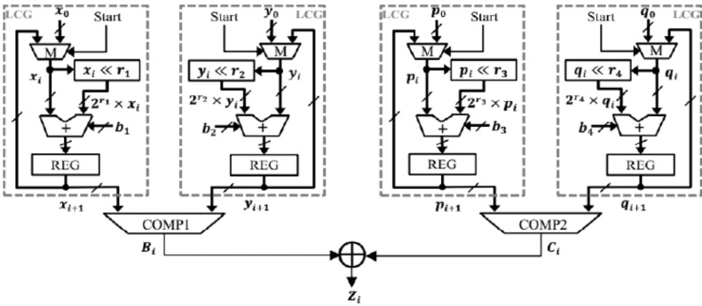
Fig 1: Architecture of the modified dual-CLCG method
This methodology provides a practical solution for pseudorandom bit generation in resource-constrained IoT devices, bridging the gap between academic research and industrial application.

5. RESULTS AND DISCUSSION
The evaluation of the modified dual-CLCG pseudorandom bit generator was carried out through both theoretical analysis and practical hardware implementation. The results obtained provide a comprehensive view of the generator’s performance in terms of randomness quality, latency, hardware efficiency, and cryptographic suitability. Each aspect was carefully examined to determine how the proposed architecture improves upon existing designs and whether it meets the stringent requirements of modern cryptographic systems.
The first set of results focused on randomness validation. Using the National Institute of Standards and Technology (NIST) statistical test suite, which includes fifteen benchmark tests, the generator was subjected to rigorous evaluation. These tests are designed to detect non-random patterns in bit sequences and are widely recognized as the standard for assessing cryptographic randomness. The modified dual-CLCG successfully passed all fifteen tests, including frequency, runs, block frequency, cumulative sums, discrete Fourier transform, and linear complexity. This outcome is significant because earlier designs, particularly the dual-CLCG, failed several of these tests, most notably the discrete Fourier transform and linear complexity tests. The success of the modified architecture can be attributed to the XOR-based output stage, which ensures uniform bit generation and eliminates irregular timing that previously introduced detectable patterns. The passing of all NIST tests confirms that the generator achieves the level of randomness required for secure cryptographic applications.
Latency analysis revealed substantial improvements compared to traditional designs. In the dual-CLCG, pseudorandom bits were generated only when inequality conditions between LCG outputs were satisfied, leading to irregular timing and high initial latency. Specifically, the dual-CLCG required 2^n cycles before producing its first output, which is impractical for real-time encryption systems. The modified design, by contrast, required only one initial cycle before producing output, thanks to the XOR stage that guarantees bit generation at every clock cycle. This reduction in latency is critical for IoT devices, where delays in key generation can compromise system performance and security. The ability to produce pseudorandom bits consistently at each cycle ensures that encryption processes can proceed without interruption, thereby enhancing the reliability of the system.
Hardware efficiency was another key area of evaluation. The dual-CLCG required multiple flip-flops to store intermediate values, leading to high area cost and increased power consumption. The modified design reduced this requirement by directly combining outputs through XOR, thereby minimizing memory usage. FPGA synthesis results confirmed that the modified architecture achieved lower area utilization compared to dual-CLCG, with a significant reduction in flip-flop count. This reduction not only lowers hardware area but also decreases switching activity, resulting in lower dynamic power consumption. Power analysis indicated that the modified design consumed less energy than dual-CLCG, making it suitable for energy-constrained environments such as IoT devices. The reduction in area and power consumption demonstrates that the proposed architecture is not only theoretically efficient but also practically implementable in hardware.
Security strength was evaluated through theoretical analysis of unpredictability. A pseudorandom generator must ensure that even with partial knowledge of the sequence, adversaries cannot feasibly reconstruct future outputs. The modified dual-CLCG demonstrated polynomial-time unpredictability comparable to dual-CLCG, ensuring that the generator is secure against linear and statistical attacks. The XOR stage enhances unpredictability by introducing non-linear dynamics into the output sequence, making it more resistant to reconstruction attempts. This theoretical validation complements the statistical results, confirming that the modified architecture is suitable for cryptographic applications.
Scalability was also examined. By adjusting word size n, the architecture can be scaled to generate longer sequences for higher security levels. Parameter selection for LCGs was carefully performed to ensure maximum sequence length and avoid short cycles. The XOR stage ensures that scaling does not introduce irregular timing, maintaining uniform bit generation across different configurations. This scalability makes the architecture versatile, allowing it to be adapted for different cryptographic applications with varying security requirements.
Comparative analysis with other PRBG designs further highlights the advantages of the modified dual-CLCG. LFSRs, while simple and efficient, fail several NIST tests and are vulnerable to linear attacks. Single LCGs suffer from predictability due to their linear recurrence relations. Blum-Blum-Shub offers strong unpredictability but is impractical for hardware implementation due to large modulus operations. Chaotic map-based generators provide complex dynamics but often fail statistical randomness tests. The dual-CLCG improves resilience compared to these designs but suffers from irregular timing and high hardware cost. The modified dual-CLCG addresses these issues by ensuring uniform bit generation, reducing latency, and minimizing hardware complexity, while maintaining statistical randomness and unpredictability.

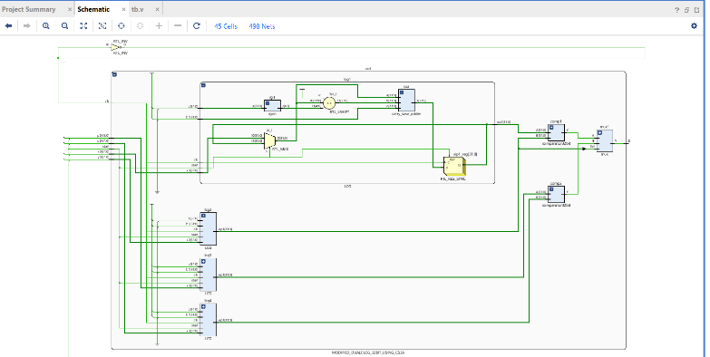
Fig 2: Schematic diagram of modified dual-CLCG method

The results demonstrate that the modified dual-CLCG pseudorandom bit generator achieves significant improvements over existing designs in terms of randomness quality, latency, hardware efficiency, and security strength. The XOR-based output stage is the key innovation that ensures uniform bit generation, reduces latency, and minimizes hardware complexity. FPGA implementation confirms the practical feasibility of the design, with reduced area and power consumption making it suitable for resource-constrained environments. Theoretical analysis of unpredictability complements the statistical results, confirming that the generator is secure against attacks. These results underscore the practical implications for IoT security, demonstrating that the modified dual-CLCG provides a practical solution for pseudorandom bit generation in modern cryptographic systems.

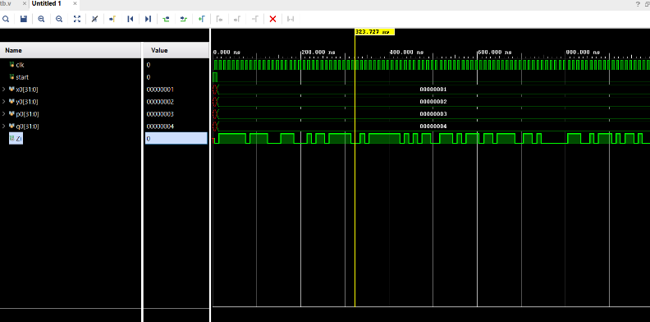
Fig 3: Timing diagram of

6.CONCLUSION
The research undertaken in this study establishes the modified dual-CLCG pseudorandom bit generator as a secure and efficient alternative to existing designs. By introducing a simplified XOR-based output stage, the architecture successfully eliminates irregular timing and high latency, two major limitations of the dual-CLCG framework. The generator consistently produces pseudorandom bits at every clock cycle, ensuring uniformity in output and reliability in cryptographic applications. Hardware implementation using Verilog HDL and FPGA prototyping confirmed that the design achieves reduced area utilization, lower flip-flop count, and minimized power consumption. These improvements make the generator particularly suitable for resource-constrained environments such as IoT devices, where efficiency and security must coexist.
The statistical evaluation using the NIST test suite demonstrated that the modified dual-CLCG passes all fifteen benchmark tests, validating its randomness quality. This achievement is significant because earlier designs, including the dual-CLCG, failed several of these tests, limiting their cryptographic applicability. Theoretical analysis further confirmed polynomial-time unpredictability, ensuring that the generator remains resistant to adversarial reconstruction attempts. Together, these results highlight the balance achieved between randomness quality, hardware efficiency, and security strength.
The contribution of this work lies not only in addressing the limitations of earlier architectures but also in bridging the gap between theoretical cryptographic models and practical hardware deployment. The modified dual-CLCG provides a scalable solution that can be adapted to different word sizes, making it versatile for applications requiring varying levels of security. Its efficiency in terms of area and power consumption ensures that it can be integrated into real-world systems without compromising performance.
In conclusion, the modified dual-CLCG represents a significant advancement in pseudorandom bit generation. It combines theoretical rigor with practical feasibility, offering a design that is both secure and efficient. By resolving the weaknesses of earlier architectures and demonstrating suitability for IoT environments, this work contributes meaningfully to the ongoing development of cryptographic systems and lays the foundation for future innovations in secure hardware design.
In conclusion, the modified dual-CLCG represents a significant advancement in pseudorandom bit generation. It combines theoretical rigor with practical feasibility, offering a design that is both secure and efficient. By resolving the weaknesses of earlier architectures and demonstrating suitability for IoT environments, this work contributes meaningfully to the ongoing development of cryptographic systems and lays the foundation for future innovations in secure hardware design.
The modified dual-CLCG provides a scalable solution that can be adapted to different word sizes, making it versatile for applications requiring varying levels of security. Its efficiency in terms of area and power consumption ensures that it can be integrated into real-world systems without compromising performance.

REFERENCES
- J. Zhou, Z. Cao, X. Dong, and A. V. Vasilakos, “Security and privacy for cloud-based IoT: Challenges,” IEEE Commun. Mag., vol. 55, no. 1, pp. 26–33, Jan. 2017.
- Q. Zhang, L. T. Yang, and Z. Chen, “Privacy preserving deep computation model on cloud for big data feature learning,” IEEE Trans. Comput., vol. 65, no. 5, pp. 1351–1362, May 2016.
- E. Fernandes, A. Rahmati, K. Eykholt, and A. Prakash, “Internet of Things security research: A rehash of old ideas or new intellectual challenges?” IEEE Secur. Privacy, vol. 15, no. 4, pp. 79–84, 2017.
- M. Frustaci, P. Pace, G. Aloi, and G. Fortino, “Evaluating critical security issues of the IoT world: Present and future challenges,” IEEE Internet Things J., vol. 5, no. 4, pp. 2483–2495, Aug. 2018.
- E. Zenner, “Cryptanalysis of LFSR-based pseudorandom generators— A survey,” Univ. Mannheim, Mannheim, Germany, 2004. [Online].Available: http://orbit.dtu.dk/en/publications/cryptanalysis-of-lfsrbased- pseudorandom-generators–a-survey(59f7106b-1800-49df-8037- fbe9e0e98ced).html
- J. Stern, “Secret linear congruential generators are not cryptographically secure,” in Proc. 28th Annu. Symp. Found. Comput. Sci., Oct. 1987, pp. 421–426.
- D. Xiang, M. Chen, and H. Fujiwara, “Using weighted scan enable signals to improve test effectiveness of scan-based BIST,” IEEE Trans. Comput., vol. 56, no. 12, pp. 1619–1628, Dec. 2007.
- L. Blum, M. Blum, and M. Shub, “A simple unpredictable pseudo- random number generator,” SIAM J. Comput., vol. 15, no. 2, pp. 364–383, 1986.
- W. Thomas Cusick, “Properties of the x2 mod N pseudorandom number generator,” IEEE Trans. Inf. Theory, vol. 41, no. 4, pp. 1155–1159, Jul. 1995.
- C. Ding, “Blum-Blum-Shub generator,” IEEE Electron. Lett., vol. 33, no. 8, p. 667, Apr. 1997.
- A. Sidorenko and B. Schoenmakers, “Concrete security of the Blum- Blum-Shub pseudorandom generator,” in Cryptography and Coding (Lecture Notes in Computer Science), vol. 3796. Berlin, Germany: Springer, Nov. 2005, pp. 355–375.
- A. K. Panda and C. K. Ray, “FPGA prototype of low latency BBS PRNG,” In Proc. IEEE Int. Symp. Nanoelectron. Inf. Syst. (INIS), Indore, India, Dec. 2015, pp. 118–123.

- P. P. Lopez and E. S. Millan, “Cryptographically secure pseudorandom bit generator for RFID tags,” in Proc. Int. Conf. Internet Technol. Secured Trans., London, U.K., vol. 11, Nov. 2010, pp. 1–6.
- R. S. Katti and R. G. Kavasseri, “Secure pseudo-random bit sequence generation using coupled linear congruential generators,” in Proc. IEEE Int. Symp. Circuits Syst. (ISCAS), Seattle, WA, USA, May 2008, pp. 2929–2932.
- S. Raj Katti and S. Srinivasan, “Efficient hardware implementation of a new pseudo-random bit sequence generator,” in Proc. IEEE Int. Symp. Circuits Syst. (ISCAS), Taipei, Taiwan, May 2009, pp. 1393–1396.
[16] R. S. Katti, R. G. Kavasseri, and V. Sai,
“Pseudorandom bit generation using coupled
congruential generators,” IEEE Trans. Circuits
Syst. II, Exp. Briefs, vol. 57, no. 3, pp. 203–207,
Mar. 2010.
[17] Revised NIST Special Publication 800-22. (Apr.
2010). A Statistica Test Suite for the Validation
of Random Number Generators and Pseudo
Random Number Generators for Cryptographic
Applications. Available:
http://csrc.nist. gov/publications/nistpubs/800-
22-rev1.pdf.

