Dynamic Analysis of a Motor–Generator Feedback System with Voltage Amplification: A Detailed Analysis
Abstract
A self-coupled motor–generator feedback system is sometimes proposed as a method to sustain continuous power generation by feeding the electrical output of a generator back into the motor that drives it. In theory, if the output power equals or exceeds the input power, the system could operate continuously without external energy input. However, due to inefficiencies inherent in electrical machines and transformers, the total efficiency of such a system is always less than unity. This paper presents a detailed theoretical analysis of a motor–generator feedback loop and investigates whether the introduction of a step-up transformer can increase the feedback power sufficiently to sustain operation. Using energy conservation principles and efficiency models of the motor, generator, and transformer, it is demonstrated that the system cannot achieve self-sustained operation because total system losses always exceed any apparent voltage gain provided by a transformer.
Keywords—Motor–Generator Set, Energy Conservation, Thermodynamics, Efficiency, Perpetual Motion, Electromechanical Energy Conversion.
Introduction
Electric generators and electric motors are fundamental electromechanical devices. A generator converts mechanical energy into electrical energy, whereas a motor converts electrical energy into mechanical energy. When electrically and mechanically coupled, they form a closed energy conversion system commonly used in laboratories for performance testing, in industry for voltage/frequency conversion, and in renewable systems for energy transfer studies.
The coupling between these two machines can be:
1. Mechanical Coupling – via shaft connection
2. Electrical Coupling – via direct electrical connection
3. Electromechanical Coupling – combination of both
Motor–generator (MG) sets are widely used in electrical engineering applications such as frequency conversion, voltage stabilization, and electrical isolation. However, proposals occasionally emerge suggesting that a motor mechanically coupled to a generator could sustain itself by feeding back generated electrical power to the motor. The concept of a self-sustaining motor–generator system has been proposed in various engineering discussions as a means of generating continuous electrical power without external energy input. In such a system, an electric motor drives a generator, and the electrical output of the generator is fed back to the motor to maintain rotation.
At first glance, it may appear that by manipulating electrical parameters—such as using a step-up transformer to increase voltage in the feedback path—the system could provide sufficient power to sustain itself. However, such systems are constrained by thermodynamic laws, particularly the First Law of Thermodynamics (energy conservation) and the Second Law of Thermodynamics (entropy increase).
The purpose of this paper is to analyze the power balance in a self-coupled motor–generator feedback system and to determine whether a step-up transformer can compensate for system losses and evaluates the feasibility of such a system using rigorous physical principles.
Discussion
Basic Principles of Operation
Electric Generator
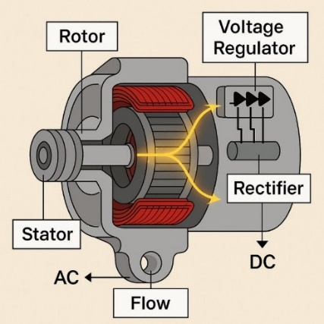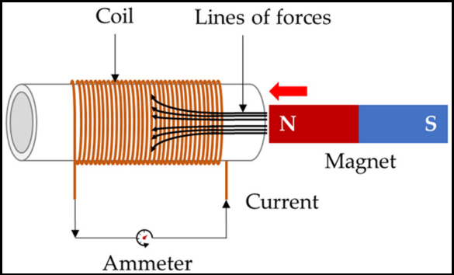
A generator operates on Faraday’s Law of Electromagnetic Induction, which states:
e = -N (dф/dt)
where:
e = induced emf
N = number of turns
ф = magnetic flux
Mechanical rotation of the rotor in a magnetic field induces an electromotive force (EMF) in the stator windings.

Electric Motor
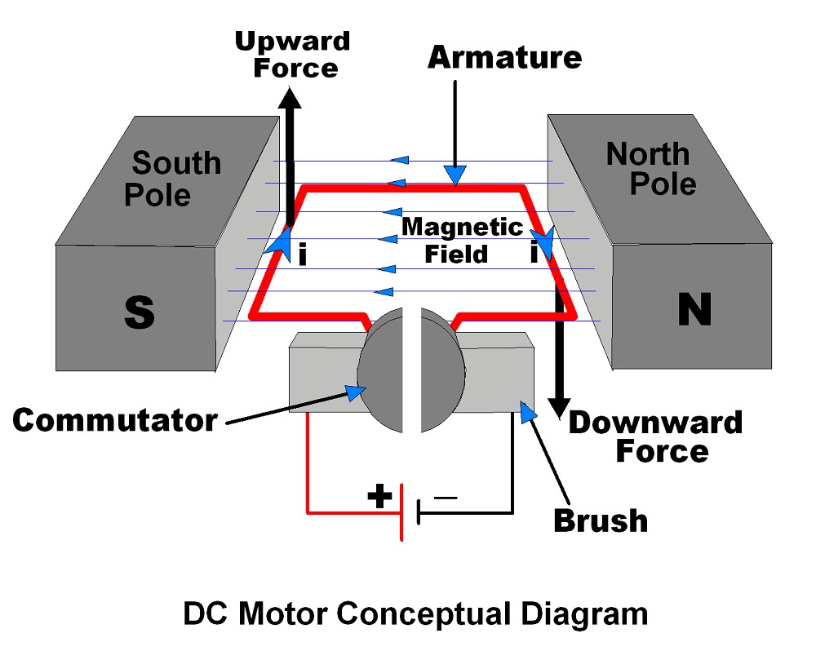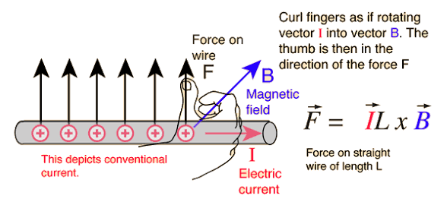

A motor works on the Lorentz Force Principle, where a current-carrying conductor placed in a magnetic field experiences a force:
F = B I L
This force produces torque:
T = k ф I_{a}
where:
T = torque
ф = flux
I_{a} = armature current
Types of Generator–Motor Coupling
Mechanical Shaft Coupling
In this method, the motor drives the generator through a rigid or flexible shaft coupling.
Applications: Motor–Generator (MG) sets, Laboratory testing benches, Frequency conversion systems
Advantages: Simple construction, Easy measurement of torque and speed
Electrical Coupling
The generator output feeds directly into the motor input.
Example: DC generator supplying DC motor, Alternator supplying induction motor
Here, power balance equation applies:
P _{mechanical} = P _{electrical} + Losses
Combined Electromechanical Coupling
Used in closed-loop systems where the motor drives the generator, and generator output feeds back to the motor through control circuitry.
Used in: Regenerative braking systems, Renewable energy conversion
Power Transfer Analysis
For steady-state condition:
P_{motor input} = V I cos ф
P_{generator output} = V I
Total system efficiency:
η_{total​} = η_{motor} ​× η _{generator}
Losses include:
Copper losses ( I²R ), Iron losses (hysteresis + eddy currents), Mechanical losses (friction and windage)
Dynamic Characteristics
Torque–Speed Matching
Proper coupling requires matching torque-speed characteristics: DC motor: Linear torque-speed curve, Induction motor: Non-linear curve, Mismatch may cause: Instability, Overheating, Mechanical stress
Synchronization
In AC systems: Frequency of generator must match motor requirement, Phase sequence must be correct, Voltage regulation must be controlled
Control Strategies
1. Voltage Control – regulates motor speed
2. Field Control – adjusts generator output
3. Power Electronic Converters – improves efficiency and stability
4. Feedback Control Systems – PID-based regulation
Modern systems use:
PWM drives, Variable Frequency Drives (VFDs), Smart controllers
Applications
Motor–Generator (MG) Sets
Used for: Voltage stabilization, Frequency conversion, Electrical isolation
Renewable Energy Systems: Wind turbine (generator) feeding motor-driven loads, Solar power systems
Electric Vehicles : Regenerative braking involves motor operating as generator.
Laboratory Testing; Used to determine: Efficiency, Load characteristics, Performance curves
Experimental Setup (Typical Laboratory Arrangement)
Components: DC/AC Motor, Generator, Coupling shaft, Tachometer, Voltmeter & Ammeter, Load bank
Procedure:
1. Start motor
2. Gradually apply mechanical load
3. Measure voltage, current, speed
4. Calculate efficiency
9. Advantages and Limitations
Advantages: Energy conversion flexibility,Voltage/frequency control, Educational importance
Limitations: Combined efficiency less than 100%, Mechanical wear, Alignment issues
System Description
The proposed system consists of: (i) an electric motor, (ii) a mechanical shaft coupling, (iii) an electric generator, and (iv) a feedback control circuit. Initial electrical power is supplied to start the motor. The generator output is then partially fed back to the motor while the remainder is intended for external load usage.
Energy Conversion Chain:
Electrical Energy → Mechanical Energy → Electrical Energy
Electromechanical Energy Conversion Theory
For a motor, electrical input power is given by:
P_{in} = V I
Mechanical output power of the motor:
P_{mech} = T ω
Motor efficiency is defined as:
η_{m} = P_{mech} / P_{in}
For the generator, electrical output power is:
P_{out} = V_{g} I_{g}
Generator efficiency is:
η_{g} = P_{out} / P_{mech}
Combined System Efficiency
The total system efficiency is the product of motor and generator efficiencies:
η_{total} = η_{m} × η_{g}
Since both η_{m} < 1 and η_{g} < 1, their product must satisfy:
η_{total} < 1
For self-sustained operation, P_{out} ≥ P_{in} is required. However:
P_{out} = η_{total} × P_{in}
Thus, because η_{total} < 1, it follows that P_{out} < P_{in}. Therefore, the system cannot sustain continuous operation.

Rigorous Thermodynamic Analysis
According to the First Law of Thermodynamics (Energy Conservation):
ΔU = Q − W
For steady-state operation in a cyclic system, ΔU = 0. Therefore:
Q = W
In real electromechanical systems, irreversible losses convert useful work into heat (Q_loss). Hence:
W_{output} = W_{input} − Q_{loss}
Since Q_loss > 0 due to entropy production, it follows that:
W_{output} < W_{input}
From the Second Law of Thermodynamics, entropy generation (S_gen) must satisfy:
S_{gen} ≥ 0
This guarantees that no real cyclic energy conversion system can achieve 100% efficiency.
Numerical Example
Assume η_{m} = 0.92 and η_{g} = 0.91.
η_{total} = 0.92 × 0.91 = 0.8372
If Pin = 1000 W, then Pout = 837.2 W. A deficit of 162.8 W prevents self-sustained operation.
Discussion
The analysis confirms that the proposed feedback system falls under the category of a Perpetual Motion Machine of the First Kind. Such systems violate fundamental energy conservation laws. Practical motor–generator sets require continuous external energy input.
Basic Configuration of the Motor–Generator Feedback System
System Components: The system consists of:
- Electric Motor
- Mechanical Shaft Coupling
- Electric Generator
- Step-Up Transformer
- Feedback Circuit
Conceptual Operation
- External power initially starts the motor.
- The motor converts electrical power into mechanical power.
- The generator converts mechanical power into electrical power.
- Part of the generator output is fed back to the motor.
- The transformer increases voltage in the feedback loop.
Block Diagram of the System

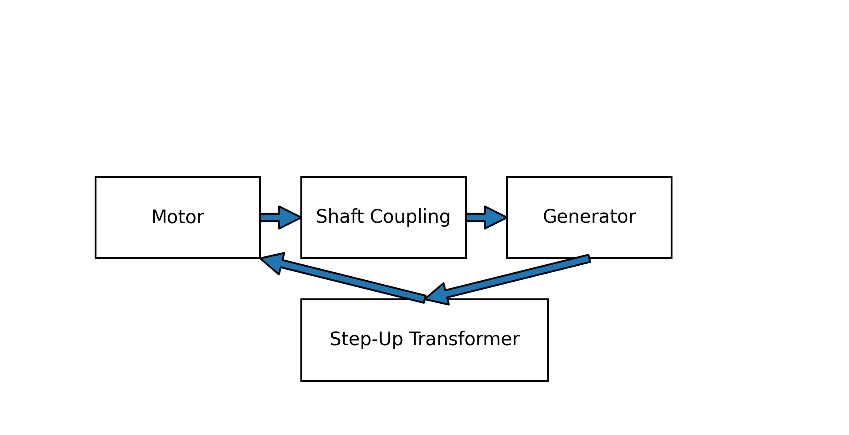

Mathematical Model of the System
Let
Pin = Electrical input power to motor
Pm = Mechanical power output of motor
Pg = Electrical power output of generator
Motor efficiency:
ηₘ = Pm / Pin
Generator efficiency:
η_{g} = Pg / Pm
Therefore
Pg = Pin × ηₘ × η_{g}
Total system efficiency:
ηtotal = ηₘ × η_{g}
Power Balance in the Feedback Loop
For continuous operation:
Pg ≥ Pin
Substituting:
Pin × ηₘ × η_{g} ≥ Pin
Dividing by Pin:
ηₘ × η_{g} ≥ 1
However, since:
ηₘ < 1
η_{g} < 1
Therefore
ηₘ × ηg < 1
Hence
Pg < Pin
Thus the system cannot sustain continuous operation.
Effect of Introducing a Step-Up Transformer
A transformer changes voltage and current, but not power (ignoring small losses).
For an ideal transformer: P_{primary} = P_{secondary}
If voltage increases by factor k: V₂ = kV₁
Current decreases: I₂ = I₁ / k
Thus
P₂ = V₂ × I₂
P₂ = (kV₁)(I₁/k)
P₂ = V₁I₁ = P₁
Therefore a transformer cannot increase power.
Transformer Efficiency
Real transformers also have losses: ηt ≈ 0.95 – 0.98. Thus P_{feedback} = P_{g} × η_{t}
Total efficiency becomes: η_{total} = ηₘ × η_{g} × η_{t}
Example:
Motor efficiency = 0.9
Generator efficiency = 0.9
Transformer efficiency = 0.97
η_{total} = 0.9 × 0.9 × 0.97
η_{total} = 0.7857
Thus only 78.6% of input power returns to the motor.
Therefore: P_{feedback} < Pin
External power is always required.
Thermodynamic Considerations
Energy First Law of Thermodynamics
cannot be created or destroyed.
Pin = Pout + Losses
Losses include:
- Copper losses
- Iron losses
- Mechanical friction
- Windage losses
- Transformer losses
Second Law of Thermodynamics
Every real process increases entropy.
Energy degradation occurs through:
- Heat generation
- Electrical resistance
- Magnetic hysteresis
Therefore 100% efficiency is impossible.
Entropy Generation Analysis
Entropy generation due to losses:
Ṡ_{gen} = Q_{loss} / T
Where
Q_{loss} = Pin − P_{feedback}
Since losses > 0
Ṡ_{gen} > 0
Thus the system moves toward thermodynamic equilibrium and cannot sustain itself.
Practical Engineering Example
Assume
Motor input power = 1000 W
Motor efficiency = 90%
Mechanical power
Pm = 1000 × 0.9
Pm = 900 W
Generator efficiency = 90%
Electrical output
Pg = 900 × 0.9
Pg = 810 W
Transformer efficiency = 97%
Feedback power
P_{feedback} = 810 × 0.97
P_{feedback} = 785.7 W
Thus Loss = 1000 − 785.7 = 214.3 W
External power of 214 W must continuously be supplied.
Although a step-up transformer increases voltage, it does not increase energy. Because the product of voltage and current determines power, any increase in voltage corresponds to a proportional decrease in current.
Consequently: Voltage gain ≠ Power gain.
The motor-generator feedback loop always suffers cumulative losses from:
- electromagnetic conversion
- mechanical friction
- resistive heating
- magnetic hysteresis
- transformer losses
These losses guarantee that the total efficiency remains below unity.

Conclusion
The coupling between electric generator and electric motor represents a fundamental electromechanical energy conversion system. Proper mechanical alignment, electrical matching, and control strategies are essential to ensure efficient and stable operation. Advances in power electronics and smart control techniques have significantly improved performance, making generator–motor coupling systems highly relevant in renewable energy, electric vehicles, and industrial applications.
A rigorous electromechanical and thermodynamic analysis demonstrates that a self-coupled motor–generator feedback system cannot operate autonomously. The total system efficiency is inherently less than unity due to unavoidable loss mechanisms. Continuous energy generation without external input is therefore physically impossible.
This study analyzed a self-coupled motor–generator feedback system with a step-up transformer. Mathematical modeling and thermodynamic principles demonstrate that:
- The total system efficiency is the product of individual efficiencies.
- Since each efficiency is less than unity, the overall efficiency is also less than unity.
- A transformer cannot increase power, only voltage.
- Energy losses in the motor, generator, and transformer prevent continuous self-operation.
Therefore, a self-sustaining motor–generator system is physically impossible, even with the inclusion of a step-up transformer.
Scope for Future Research
Future research may focus on:
- High-efficiency motor–generator sets
- Energy storage assisted feedback systems
- Smart power management using power electronics
- Hybrid renewable-energy coupled generator systems
Such systems cannot create energy but may improve overall system efficiency.
References
- Fitzgerald, A. E., Kingsley, C., & Umans, S. D. Electric Machinery. McGraw-Hill.
- Chapman, S. J. Electric Machinery Fundamentals. McGraw-Hill.
- Callen, H. B. Thermodynamics and an Introduction to Thermostatistics. Wiley.
- Van Valkenburg, M. E. Network Analysis. Prentice Hall.
- IEEE Power Engineering Society, Energy Conversion Systems.
- H. Goldstein, C. Poole, and J. Safko, Classical Mechanics, 3rd ed. Pearson, 2002
- Y. A. Çengel and M. A. Boles, Thermodynamics: An Engineering Approach, 8th ed. McGraw-Hill, 2015
- S. J. Chapman, Electric Machinery Fundamentals, 5th ed. McGraw-Hill, 2011
- D. P. Kothari and I. J. Nagrath, Electric Machines, 4th ed. McGraw-Hill, 2010
- R. C. Dorf and J. A. Svoboda, Introduction to Electric Circuits, 9th ed. Wiley, 2014.

