Diabot:A Chatbot for Diabetic Patient Care and Management

Abstract—While digital healthcare tools have improved access to diabetic monitoring, most current diabetes management systems still cannot offer continuous personalized guidance, interpret patient health patterns in real time, or support interactive communication for lifestyle improvement. To address these gaps, this research introduces Diabot, a smart and user-friendly chatbot platform designed for diabetic patient care. The system combines natural language interaction, meal tracking, personalized diet planning, anomaly detection, and report generation in one integrated environment. Diabot uses Natural Language Processing (NLP) to understand user queries and employs machine learning-based analytics to spot unusual glucose trends and provide practical recommendations, without needing medical expertise or manual interpretation. It also includes a reporting module that focuses on visualization to improve transparency and patient awareness. Supported by modern healthcare conversational systems and data-driven monitoring methods, the proposed framework integrates a Python-based backend using Flask, secure health data storage, and real-time analytics dashboards to ensure scalable and reliable performance. The designed system aims to improve patient engagement, reduce glucose fluctuations, enhance self-management, and encourage proactive diabetic care through intelligent digital assistance.
Index Terms—Diabetes management, healthcare chatbot, Natural Language Processing (NLP), machine learning, anomaly detection, meal tracking, diet planning, recommendation system, report generation, Flask framework, health analytics, patient monitoring.
The majority of the existing systems used in the administration of diabetes care services do not connect in a comprehensive manner, where the patient will not be able to maintain one application for glucose monitors, one application for diet, one application for consulting a doctor, among others, considering that the majority of the patients will not be consistent in the administration of the application, considering that the majority of the existing systems are not connected in a comprehensive manner. Other existing systems are not dynamic, according to research, in that they are not responsive to the changing health behavior, which would otherwise enable the patient to know abnormalities relating to glucose monitors in a specific circumstance.

LITERATURE REVIEW
A system to help people with diseases was talked about in [1] to support them through normal conversations and automatic health advice. This study showed that patients were more involved. The chatbot used a lot of fixed answers and did not really understand the patient. The conversational healthcare support system did not have the ability to adjust to the patient in time. The system for healthcare support relied on the healthcare support system to work.

  - Introduction
The digitization process in healthcare has, in most ways, affected the administration of chronic disease care services, with most hospitals, organizations, and even individuals using digital platforms such as mobile applications, glucose monitors, and consultation platforms in managing diabetes care services. The majority of the existing platforms used in the administration of diabetic care services are not connected in a comprehensive manner, where not only are glucose monitors disconnected from diet monitoring, but the monitoring, recommendation, and reporting are also disconnected as well.
The authors created a healthcare monitoring platform in [2] that uses Flask and small databases so that it can be set up quickly and record information. This system works well for a number of people but it has some problems when it comes to handling a lot of people and doing analytics all the time. The healthcare monitoring platform they designed is good for scale use but the healthcare monitoring platform is not good, for large scale use.
The work in [3] looked at how virtual assistants that use Natural Language Processing can be used in healthcare to generate responses in time. This way of doing things made healthcare more accessible to people. It only worked well if the virtual assistants were good at figuring out what people meant and recognizing medical terms.

The virtual assistants that use Natural Language Processing were really helpful..They needed to be able to detect the intent of the people using them and recognize the medical entities correctly which is a key part of how Natural Language Processing virtual assistants work in healthcare.
A health analytics dashboard was introduced to help people see how their glucose levels are doing over time for people with diabetes. This dashboard is really good for people with diabetes because it helps them see what is going on with their glucose levels. The study that looked at this dashboard found out that when people can see what is going on with their glucose levels they make choices to take care of themselves.. Sometimes people do not write down their glucose levels all the time, which makes it hard to get a clear picture of what is going on with their glucose levels and that affects how accurate the information is. The health analytics dashboard is a tool for diabetic patients to see their glucose trends.
The people who made this system used some methods to find out when glucose levels were not normal. They used numbers and statistics to do this. The system was able to find the readings but the people had to be very careful when they set it up or it would say there was a problem when there was not. They used this to detect glucose fluctuations. The system was good at finding anomalies in glucose fluctuations. It needed to be adjusted just right or it would give wrong answers, about glucose fluctuations.
The people who wrote the paper in [6] looked at patient support models that use computers to give advice and also let patients keep track of their health. They found out that these models actually helped patients do what they were supposed to do.. The fact that patients could not have a conversation with the computer made it harder for them to use the models. The patient support models in [6] are still an idea because they help patients but they need to be improved so that patients can talk to the computer and get help that way. The patient support models need to have interfaces so that patients can use them more easily.
Reference [7] talked about ways to make healthcare applications more secure so patient records are safe. They came up with some ideas to protect these records.. Even with these new security measures it was still hard to manage who could see what. For example the system had to control what patients could do and what caregivers could do. What clinicians could do. This was a challenge because patient records, caregiver access and clinician access all had to be managed properly.
A simple system to manage data was made using SQLite. This system was good at storing records in a neat and organized way.. When the amount of data got really big the system started to work more slowly. The diabetic data management system had trouble handling amounts of information.
The paper in [9] talked about how important it's to keep track of glucose levels all the time and understand patient behavior when giving them care. This made it easier to keep an eye on health. It did not have any suggestions from artificial intelligence that were part of the system. The idea of glucose monitoring is really key here and the paper in [9] showed that continuous glucose
monitoring can make a big difference in patient care.
The people who did the research in [10] found out that looking at glucose levels over time can help us see problems before they happen even before we notice them ourselves.. To make sure the results are really accurate we need to keep track of glucose levels all the time for a long time. This way glucose time-series analysis can be really helpful. Glucose time-series analysis is good for finding high-risk patterns on.
The people who wrote [11] used modeling to try and figure out who might get diabetes and what their glucose levels might do. They were really good at making predictions but it took a lot of computer power to do it which made it hard to use in real time for the predictive modeling. The predictive modeling was very helpful. It was slow, for real time use.
The people who made a system to help patients take care of themselves wrote about it in [12]. This system sends reminders and health tips to users automatically. It was good for helping people remember to take their medicine. The system did not really know who the patients were or what they needed. The system was not good at giving patients the information at the right time because it did not understand the patient. The patient engagement mechanism was not very good at personalizing interactions, for the patients.
The people who made recommendation systems did something in [13]. They created systems to help people with diabetes have a diet plan. This plan was based on what they eat. The system made things better. It needed a lot of information from the users. It had to be consistent so the system could work properly with the diabetic diet planning. The recommendation systems were good for diet planning because they used the historical meal patterns of the users.
The diabetic care system that was talked about in [14] does things like monitoring keeping track of what you eat and giving advice on how to live a healthier lifestyle, which is pretty similar to what Diabot does.. When a lot of people use it at the same time the diabetic care system has some problems with handling all of those users, which is a big concern for diabetic care systems, like this one.
The people in charge made a try to put Progressive Web Application technology into use in something they did in [15]. This was done to let people get to healthcare resources even when they are not online. It became easier for people to get these resources. To get the latest information and to get suggestions they still needed to be connected to the internet. The Progressive Web Application technology they used was supposed to help with this. It did not work out that way for the live analytics and recommendations part of the Progressive Web Application.
The people who made this health monitoring dashboard that you can use to track your glucose levels and how your lifestyle affects them did a job. This dashboard was made to show you what is going on with your body in time. But it had a problem. When a lot of people used it and asked for information it took a time to get an answer back. The health monitoring dashboard was supposed to help people see how their glucose levels changed and how their lifestyle affected these changes.

A website for taking care of people with diabetes was made. This website lets doctors change the care plans for their patients at any time. The system worked well. It was really slow if the database was not set up correctly. The database needs to be organized in a way so the website can work fast. A diabetic care portal like this one is very useful, for doctors and patients. The diabetic care portal is a tool.
The people who made the system looked at how to use automated feedback mechanisms to give advice from patient logs in [18]. They were able to provide help but medical situations that were complicated needed more thought and consideration, about the medical advice.
The system they talked about in [19] put together chat-based helpers for healthcare, with boards that show important numbers but it had a lot of trouble working fast when it had to do things in real time with the chat-based healthcare assistants.
The things talked about in [20] were about keeping track of our health over a time. This was the starting point for finding out about health problems early on which is discussed in [21]. In
[21] they used tools that monitored our health in time which made a big difference in taking care of ourselves before problems got serious.
The people who made health recommendation engines did something in [22]. They created these engines using maps of guidelines. These systems were correct, from a point of view. However they needed a lot of work to get the decision rules ready. The health recommendation engines required people to prepare these rules, which took a lot of time.
A study was done to compare backend frameworks for healthcare chatbot systems. This study found that Flask is a choice for small and medium sized patient support applications. This is why Flask was chosen for Diabot. The study, in [23] showed that Flask works well for these kinds of applications.
The research in [24] applied behavioral analytics to detect early signs of poor diabetic adherence, enabling timely interventions, though prediction accuracy varied based on user consistency.
Finally, a comprehensive survey in [25] emphasized the increasing need for intelligent, adaptive, and conversational healthcare systems for chronic disease support—features strongly aligned with the objectives of the Diabot system.
- Methodology
The goal of the proposed Diabot system is to integrate intelligent recommendations, meal tracking, personalized diet planning, conversational diabetic assistance, and health report generation into a single healthcare support environment. It is a modular and service-oriented architecture. Figure 3.1 shows the entire system workflow. To guarantee secure patient data handling, real-time response generation, and a seamless user experience, each component communicates via controlled API-based interactions. The strategy is as follows.

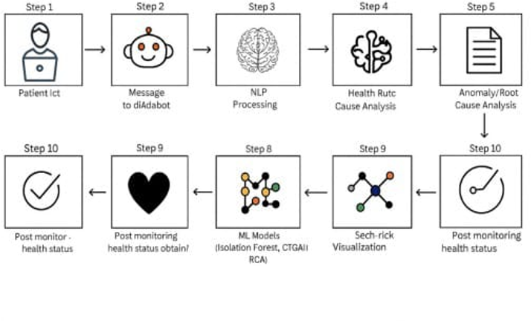
Fig 3.1.Architecture Diagram of our Project

- User Interaction Layer
Patients access Diabot via a standard web/mobile interface in the User module, which initiates system interaction. Logging in, entering glucose readings, tracking meals, requesting diet plans, posing health-related queries, and downloading health reports are just a few of the actions that users take. HTTP-based requests are used to send user actions to the system. The frontend processes these requests before sending them to the backend for additional analysis.
- Frontend Interface (HTML/CSS/JavaScript)
HTML, CSS, and JavaScript are used in the Diabot platform's frontend implementation to create a user-friendly and responsive healthcare interface. It is the main way that patients interact with the system. Modules like the chatbot window, glucose tracking form, meal tracking page, diet plan view, and report dashboard are all part of the interface. Additionally, it controls how user requests are routed to the backend via organized API calls. Chatbot responses, suggestions, anomaly alerts, and visualization outputs are sent from the backend to the frontend, which then presents them in an understandable manner. For users of all ages, this architecture guarantees easy navigation, real-time updates, and accessibility.
- Backend Processing Module (Python Flask)
Flask is used in the development of Diabot's backend, which serves as the system's central processing unit. It manages CRUD operations for patient profiles, meal logs, glucose records, and feedback in addition to user authentication and role-based access control. Additionally, the backend works with machine learning modules to generate personalized recommendations, detect anomalies, and preprocess data. It gets structured data ready for reporting and visualization. The backend makes sure patient interactions are handled safely, effectively, and dependably by acting as the main coordinator between the frontend, database, and AI modules.
- Chatbot Processing Engine (NLP + Conversational AI)
One of Diabot's main features is its NLP-based chatbot engine. "Why is my sugar high after lunch?" or "Suggest a diet plan for today" are examples of natural language health questions that patients can ask. NLP techniques like tokenization, intent

detection, and entity extraction are used by the system to process the message. In order to produce appropriate responses, it recognizes health parameters such as glucose level, meal type, insulin dosage, or symptoms and transmits them to the analysis module. This improves patient engagement and allows for real-time conversational support.
- Health Data Analytics Module (ML Models – Isolation Forest & Trend Analysis)
This module uses machine learning techniques to analyze patient data intelligently. To identify anomalous trends, the system examines medication patterns, activity logs, meal habits, and glucose history. Anomalies like unusual glucose spikes or drops are detected using models like Isolation Forest. Additionally, trend prediction is used to offer proactive recommendations and early warnings. This module is essential for preventive care and real-time diabetes monitoring.
- Database Layer (SQLite / Firebase Storage)
Diabot uses a database layer like SQLite or Firebase to store patient information securely. The database contains user profiles, login details, glucose logs, meal tracking records, diet plans, recommendation history, and generated reports. The backend carries out controlled read and write operations to maintain data integrity and privacy. Well-organized storage helps the system monitor long-term health progress and assist with future recommendations.
- Analytics and Visualization Layer (Graphs and Reports)
Diabot includes a dashboard for visualization and reporting to help with the easy interpretation of health data. The backend creates datasets like glucose trends, meal impact analysis, weekly summaries, anomaly alerts, and adherence patterns. These results are shown through interactive charts and graphs using visualization tools like Matplotlib, Plotly, and Chart.js. The visualization layer allows patients to understand their progress clearly, spot risky behavior, and improve the consistency of self-management.
- Integrated Workflow
All user interactions from the frontend are sent to the backend as structured requests for the next steps. The backend retrieves necessary health records from the database, processes chatbot queries using NLP, and triggers health analytics with ML models. Once the analysis is complete, results such as recommendations, anomaly alerts, diet plans, and visual reports are sent back to the frontend for display. The entire system works through a synchronized workflow that ensures smooth and secure data exchange between all modules. This workflow forms the basis of Diabot, allowing a continuous cycle of monitoring, analyzing, recommending, and improving diabetic patient care.

RESULT AND ANALYSIS
The Diabot system went through a simulated rollout and several tests. During these tests, we recorded different metrics like usability, system responsiveness, and the performance of the integrated healthcare modules.
This separation by role ensures access control and user-specific functions are maintained, which keeps the system secure and private. The interface was designed with a simple and modern layout to lessen user cognitive load, improve accessibility, and make it more user-friendly, especially for those with limited technical or medical knowledge.

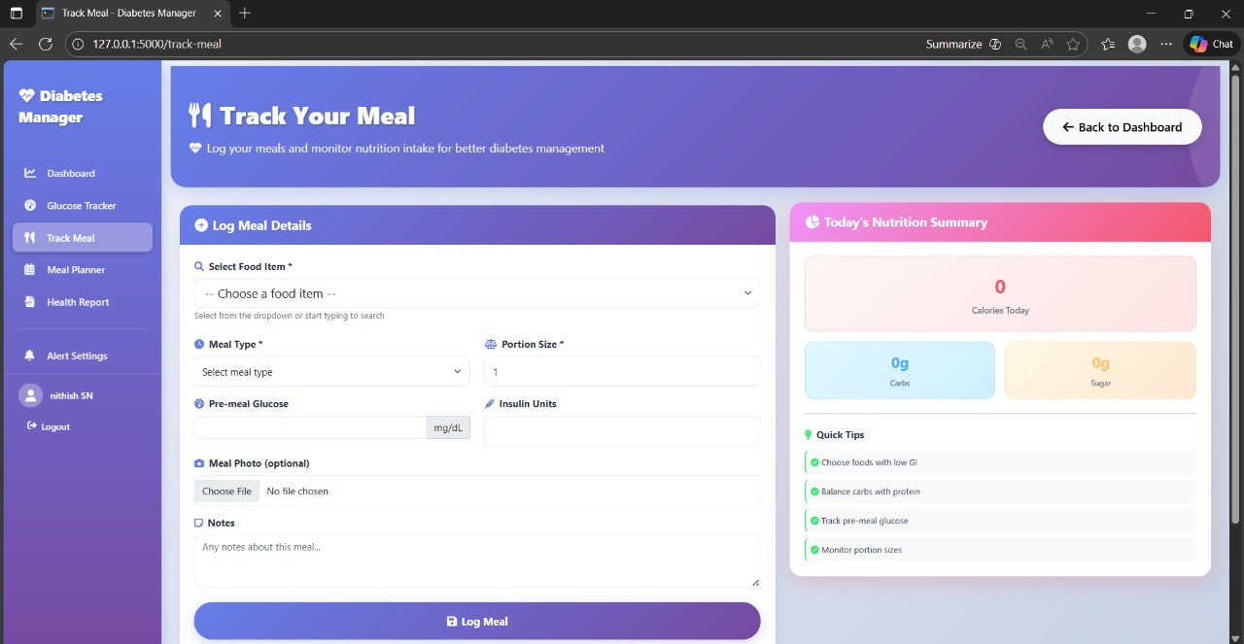
Fig. 4.1. User Input Page
After confirming the user’s credentials, the system redirects the patient to the dashboard (Fig. 4.1). This dashboard shows a personalized welcome message and acts as a central hub for navigating the key features of the Diabot platform. The dashboard makes it easy to access modules like chatbot assistance, glucose tracking, meal tracking, diet plan creation, recommendation system, and report generation. It is designed to help users smoothly enter a continuous cycle of monitoring, analysis, recommendation, and improvement. This promotes user engagement and supports consistent diabetes self-management.
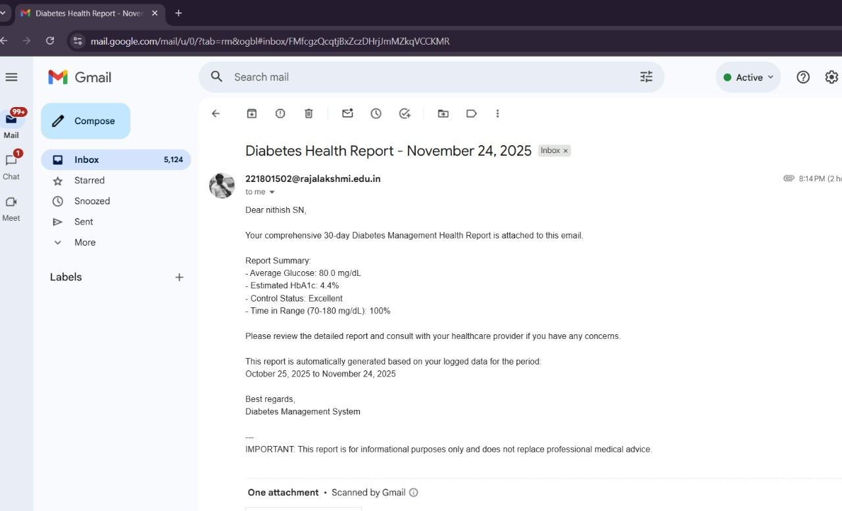

Fig 4.2.Mail to user

The system worked efficiently and reliably in all modules without significant functional problems. The chatbot interface allowed for smooth, real-time interaction. Users could quickly ask questions, log glucose readings, and get personalized responses. The Flask and SQLite backend pipeline enabled fast execution of key tasks like user login, meal entry, diet plan creation, and report storage. The health analytics and visualization module produced interactive charts based on real-time or recorded data. This helped users clearly understand glucose changes, meal effects, and weekly health trends.

These visual outputs motivated users by clearly showing their progress. They also guided them by highlighting unusual patterns, such as sudden glucose spikes or frequent fluctuations that needed attention. The system testing phase focused mainly on confirming the smooth operation of the entire workflow, which included user interaction, backend processing, anomaly detection, recommendation generation, and visualization outputs. Overall, the results show that Diabot effectively supports diabetic patients by integrating conversational help, health monitoring, personalized recommendations, and progress tracking in a user-friendly digital healthcare setting.

CONCLUSION
The project has significantly improved the diabetic healthcare support environment with the development of Diabot. This is an intelligent and interactive chatbot-based system that addresses the shortcomings of current diabetes management tools. By incorporating Natural Language Processing (NLP), meal tracking, personalized diet planning, anomaly detection, real-time recommendations, and a modular Flask backend, the system serves as a complete digital healthcare assistant. It supports continuous monitoring and data-driven diabetic care.
The system's design allows users to easily log glucose readings and meals, receive recommendations, and view health reports. This increases patient engagement and reduces the fragmentation often seen in traditional diabetic self-management practices.Testing and evaluation have shown that Diabot handles user interactions effectively. It processes real-time health data, generates personalized recommendations, and clearly visualizes glucose trends through easy-to-understand analytics. Thus, the system marks a significant step toward digital healthcare solutions that can be expanded for real-world clinical support and personalized chronic disease management.

FUTURE WORK
Upcoming improvements to the Diabot system will focus on expanding the range of diabetic care scenarios the platform can manage effectively. Future versions will include a machine learning-powered recommendation engine that learns from individual patient history and lifestyle patterns. This engine will automatically detect high-risk habits, predict glucose fluctuations, and suggest suitable preventive actions. To make the system more useful in clinical settings, it will also support additional health conditions commonly linked to diabetes, such as hypertension, obesity, and cardiovascular risks. This change will enable monitoring of multiple diseases within the same platform.
Furthermore, Diabot can connect with wearable and IoT health devices, like Continuous Glucose Monitors (CGMs) and fitness trackers. This feature will provide real-time glucose updates and automatic health logging. The platform will also have engagement features, including daily reminders, streak tracking, goal completion badges, and motivational notifications. These elements will encourage users to stick with their plans and improve their lifestyles. Additionally, a mobile-friendly or app-based version will be created to increase accessibility for users who rely on smartphones for daily healthcare.

REFERENCES

- D. Palanivel and R. Kumar, “Conversational AI Systems for Chronic Disease Management,” IEEE Access, 2023.

- S. Raj and P. Rathi, “Lightweight Web Frameworks for Healthcare Applications,” International Journal of Advanced Computing, 2022.

- P. Orits and L. Chen, “Privacy-Preserving Synthetic Medical Data Generation using GAN Models,” IEEE Access, 2023.

- Y. Kim and T. Abbas, “Visualization-Driven Health Monitoring Dashboards for Patient Analytics,” IEEE Transactions on Biomedical Engineering, 2021.

- R. Kumari and J. Patel, “Machine Learning Models for Glucose Trend Prediction in Diabetes,” Education and Information Technologies, 2022.

- F. Lopez et al., “Hybrid AI Feedback Models for Personalized Healthcare Assistance,” Computers in Biology and Medicine, 2022.

- H. Tan and S. Wong, “Secure Authentication Models for Healthcare Chatbots,” IEEE Access, 2021.

- J. Patel and A. Singh, “SQLite-Based Patient Health Record Tracking Systems,” Journal of Web Technologies, 2022.

- K. Devi and P. Rao, “Health Analytics and Anomaly Detection for Diabetes Self-Monitoring,” IEEE Biomedical Analytics Review, 2021.

[10] N. Das and Y. Cho, “Predictive Models for Monitoring Patient Health Patterns using Time-Series Data,” IEEE Access, 2023.

[11] L. Samson, “Progress-Based Digital Health Support Models for Chronic Disease Care,” International Journal of Smart Healthcare Systems, 2021.

[12] A. Kumar et al., “Personalized Healthcare Recommendation Systems using Patient Behavior Patterns,” Springer AI in Healthcare, 2023.

[13] S. Rameez and K. Bose, “Hybrid Medical Analytics Frameworks for Remote Patient Monitoring,” IEEE Journal of Biomedical and Health Informatics, 2022.

[14] G. Lin and H. Zhao, “PWA-Based Digital Health Platforms for Remote Monitoring,” Mobile Computing Journal, 2021.

[15] F. Ahmed, “Interactive Dashboards for Chronic Disease Management and Patient Engagement,” IEEE EDUNET, 2023.

[16] P. Senthil and R. Joseph, “Role-Based Healthcare Platform Architectures for Patient and Clinician Access,” International Journal of Healthcare Management Systems, 2022.

[17] T. Myers, “Automated Medical Response Engines for Conversational Healthcare Support,” ACM HealthTech, 2023.

[18] R. Sheth et al., “Virtual Healthcare Assistants with Wearable Device Integration,” IEEE Access, 2022.

[19] S. Ramesh, “Long-Term Patient Health Tracking and Diabetes Monitoring Systems,” Healthcare Analytics Review, 2020.

[20] A. Gupta and D. Paul, “Real-Time Monitoring Systems for Digital Healthcare Applications,” IEEE Learning Technologies, 2021.

