BIAS AND FAIRNESS IN AI-POWERED MEDICAL DIAGNOSTIC TOOLS: EVALUATING ETHICAL AND PROFESSIONAL CHALLENGES IN HEALTH ANALYTICS

ABSTRACT
The use of Artificial Intelligence (AI) in the field of healthcare diagnostics has grown to such an extent that it applies to the practices of radiology, pathology, dermatology, and triage systems. It is not uncommon to herald AI as diagnostic tools, claiming that the tools will likely increase the effectiveness, precision, and affordability of the tools. However, there are severe ethical and professional concerns regarding their use, particularly issues relating to biases, transparency, equality and sustainability. The systems are usually trained with the large dataset which is heavily influenced by the past and social inequalities, which can be a problem for the systems developing further biases, especially on marginalized groups. This report is a critical look into the ethical, social, regulatory, and professional issues attributed to the bias, and fairness in AI diagnostic systems. Based on actual case studies and empirical literature, it examines current frameworks, like the EU AI Act and the National Health Service (NHS) AI Code of Conduct, and proposes innovative ways of solving the problem, like the creation of inclusive datasets, explainable AI and transparency in algorithms. The outcomes also highlight that the elements of justice, transparency, and moral honesty need to become integrated at all stages of artificial intelligence design and implementation in healthcare. The report will end with effective policy recommendations which will make sure that medical AI diagnostic tools are effective and equitable in their use.

INTRODUCTION
The adoption of AI in healthcare has become so common and have taking deep root in medical diagnostics, enabling systems to interpret medical images, laboratory data, and patient histories with increasing precision. Several tools such as Google DeepMind, IBM Watson for Oncology, and Aidoc have been deployed in fields like oncology and radiology due to their diagnostic accuracy and precisions. (Wiens et al., 2019).
Regardless of the technological progress, there are still doubts concerning fairness. Most AI mediated medical diagnostic mechanisms are trained using data that is not representative of different classes of people. As an example of many other, (Obermeyer et al., 2019) revealed that a medical diagnostic tool, used in about 80 percent of U.S. hospitals, underestimated healthcare needs of the Black patients further contributing to systemic inequalities. The costs of discriminatory algorithms in clinical diagnostics are deep, as it may result in the incorrect diagnosis, delayed medications, the loss of patient confidence and much more. What is more, the so-called black box characteristic of numerous AI medical diagnostic models, being a situation in which the mechanism of decision-making is obscure, impedes transparency and clinician control (Rajkomar et al., 2018). Despite the existence of regulatory programs, like the EU Artificial Intelligence Act, The European Commission (Bürgin, 2021); the U.S. Food and Drug Administration (FDA), Software as a Medical Device (SaMD) strategy (Whitfield and Hamblin, 2022) and National Health Service (NHS) Code of Conduct (Malaysian Educational Research and Development Institute (MERDI), 2021), they leave much to be desired in terms of coherency and enforceability, which facilitated the emergence of accountability gaps Accordingly, resolving the issue of bias and fairness in medical AI diagnostics is not only a technological but also a moral, social, and professional concern.
REVIEW OF RELATED LITERATURE
Critical Analysis of Ethical, Social, Sustainability, and Regulatory Issues
One of the most urgent challenges that can be raised is bias in AI-driven medical diagnostics since it threatens to increase health disparities instead of reducing them. As noted by Obermeyer et al as cited above, one of the well documented cases showed that an algorithm deployed in U.S. hospitals to systematically under-estimated the healthcare needs of black patients by taking into consideration healthcare cost as a proxy to need. This went against such ethics as non-maleficence and justice.
Additionally, facial ID systems employed in the medical professionals present critical error percentages in darker-skinned people as shown in figure i below. The moral irresponsibility of poor generalized AI use in clinical practice is proven by a study conducted at MIT that revealed the error rate of up to 34% in darker-skinned women (Wu, D. et al., 2021).
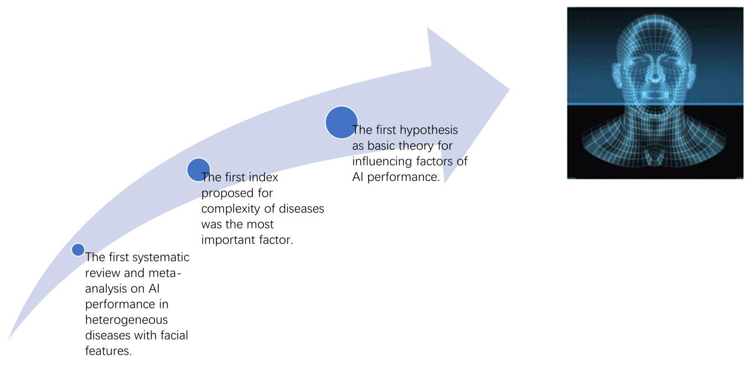
Figure i: Facial recognition intensity
The other ethical issue is non-transparency of black-box algorithms. An example of this kind of threat is cardiology tools that use opaque AI models and thus tend to issue diagnostic results without acceptable reasons. This has negative effects on informed consent, reduces clinician and patient autonomy, and trust to medical technologies (Ribeiro, Singh and Guestrin, 2018).

Social Issues
As it is, discrimination in medical AI systems propagates existing social inequalities, especially in cases where there might be a dissimilarity in the medical results arrived at by the AI system depending on their race, gender, or economic status of the individual. Notably, the medical AI-powered triage chatbot deployed at the NHS in the UK by Babylon health was shown to respond differently to the same symptoms in males and females; in the former it would indicate chest pain suggesting a heart attack, yet in the case of female patients, less serious evaluations were suggested according to reports.
Moreover, remote medical diagnostics that are based on the use of AI are over representative of older adults, low-income earners, and people living in rural areas as they are often dependent on technology that requires wearable or a reliable internet connection. Such inequalities came to the forefront particularly during the COVID-19 pandemic as AI-based remote monitoring systems were not readily available to lower-income areas, creating a serious issue about social fairness (Thompson and Bennett, 2025).
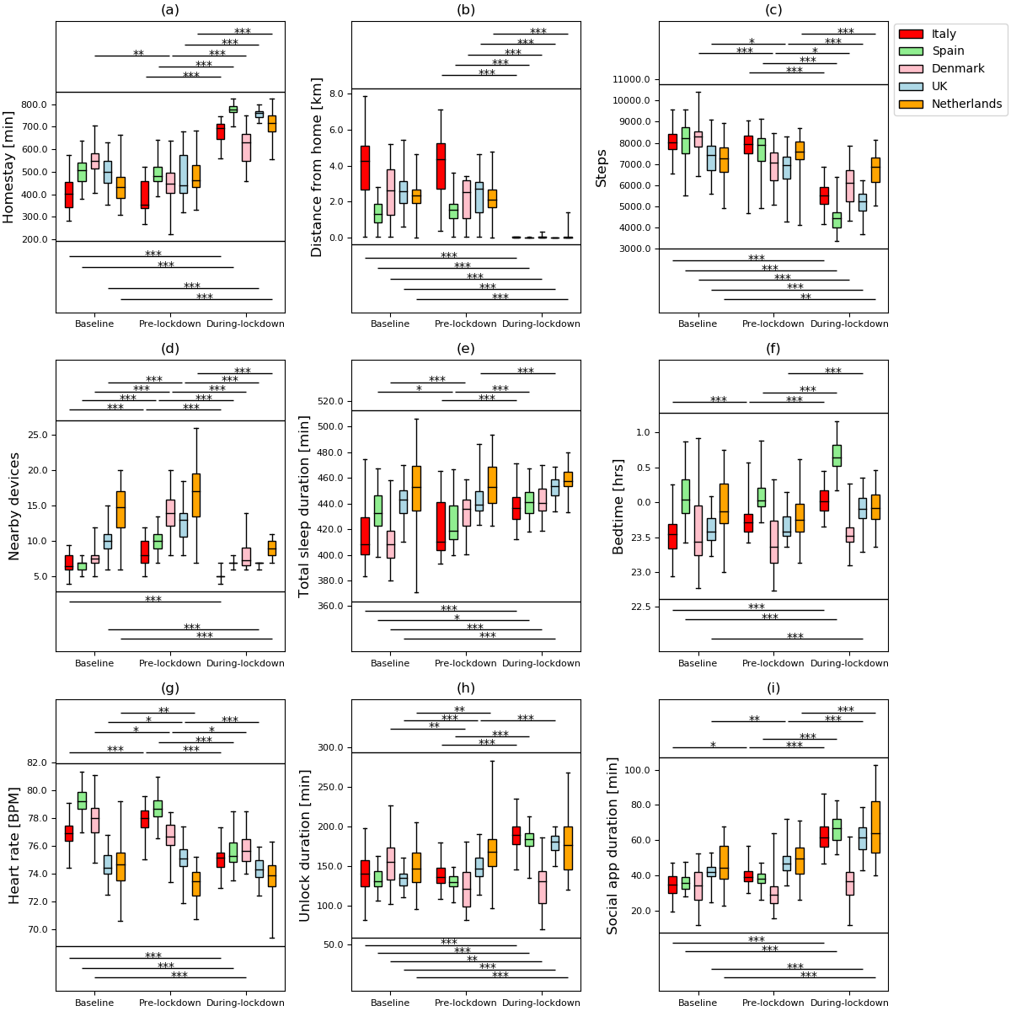
Figure ii: Box plots for comparisons among baseline, pre-lockdown, and during lockdown phases for different features. (a) homestay duration, (b) maximum distance from home, (c) Fitbit step count, (d) maximum number of nearby devices, (e) total sleep duration
According to (Sun et al., 2020), the above image depicts the outcome of the quantitative study on COVID-19 and its respective lockdown-related mobility, physiological measurements, and phone use characteristics based on passive data retrieved via mobile gadgets (smartphones and wearable devices of the type Fitbit) of participants who joined 5 European nations in the Remote Assessment of Disease and Relapse (RADAR) program. They could determine substantial differences in behavioral characteristics at baseline, pre-lockdown, and the lockdown itself. However, they were conducted in the European states and the other developing nations were not taken in this initiative which points to social injustice.

Sustainability Issues
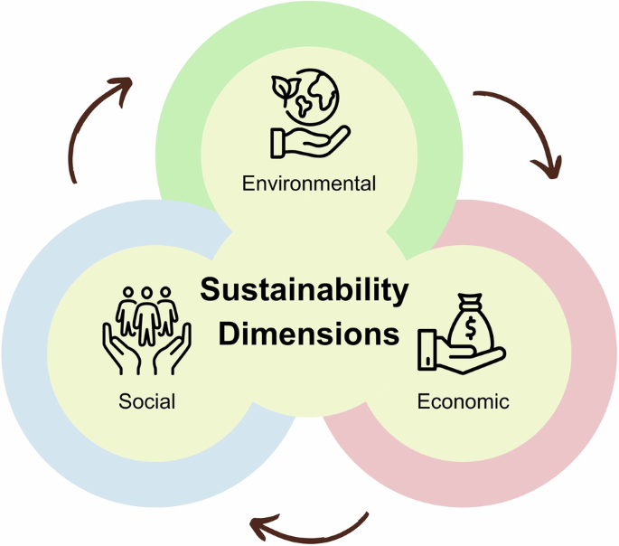
Figure iii: Sustainability dimensions
Sustainability in AI healthcare, as demonstrated in the diagram above, is not limited to environmental sustainability but it has to do with the economic value, social pertinence, fairness and time relevance as well. As an example, the efficacy of COVID-19 diagnostic algorithms, which had been trained on the data on the early stages of the outbreak, diminished rapidly because of the viral mutations that occurred in various locations around the world, which confirmed the model drift and obsolescence (Wu, X. et al., 2021).
On the environment front, the AI systems occupy very high computation requirements. According to a research by the University of Massachusetts Amherst, training a single large medical diagnostic AI model like the Fuzzy Logic, Machine Learning, and Deep Learning requires very much power and can emit some harmful elements to the environments. In radiology e.g., that would mean real-time image processing of an imaging study, say a CT scan, MRI or X-ray, which might need constant operation of a server.
According to (Kocak et al., 2025), taking the energy required for a single training run as an example, researchers analyzed the cumulative energy consumption of the top 20 AI systems in terms of carbon emissions published between 2021 and 2024 . Total energy consumption per training run stands at 108 million kilowatt hours, indicating a carbon emission of 103 thousand metric tons of CO₂-eq (carbon dioxide equivalent). To put this into perspective, the total CO₂ (carbon dioxide) emissions from a single AI training run are equivalent to the daily carbon footprint of 7.5 to 8 million people worldwide (excluding aviation). Further explanations are shown in the diagram below.
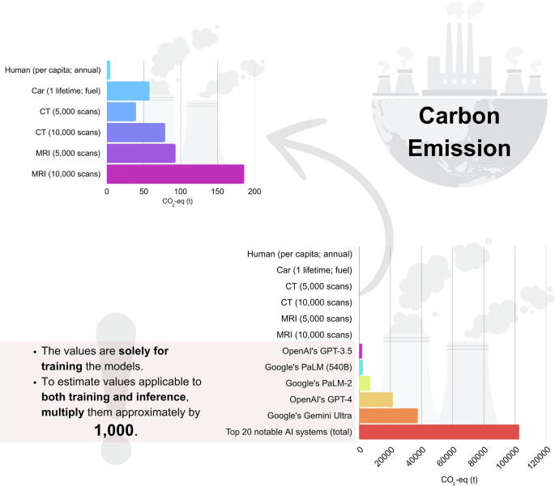
Figure iv: Carbon emissions of AI Medical Diagnostic systems and relevant comparisons
Moreso, another issue that has grown without many people paying much attention to it is the energy that is being used to cool such high-performance computing systems by using water. It has been projected that global AI demand can reach a total of 4.2 to 6.6 billion cubic meters of water withdrawal by 2027 which is 4 to 6 times more than the yearly consumption of Denmark or half of that of the United Kingdoms.

Regulatory Issues
Although the spread of AI in medicine is growing at a high rate, the corresponding regulatory system is incoherent. The U.S. Federal Drug Administration (FDA) approved in 2018 Diabetic Retinopathy (IDx-DR), an artificial intelligence (AI) based medical assistant diagnostic technology in diabetic retinopathy. Nevertheless, the approval was based on internal operation reports and not a result of peer-reviewed clinical trials casting a shadow on governance and transparency (Shah et al., 2021).
In addition, the NHS AI Code of Conduct in the UK provides the ethical guidance without providing the mechanisms for enforcing it. The case of the Royal Free Hospital and Google DeepMind was a graphic demonstration of more than 1.6 million records of patients being shared without due consent and with an abuse of the UK data protection law (Powles and Hodson, 2017).
The cases highlight that we must take every possible step to ensure comprehensive and enforceable rules limiting the need to use ethical and fair AI in clinical environments (European Commission, 2021; NHSX, 2021).

Creative Problem-Solving Solutions

Rationale for Proposed Solutions
The bias and fairness issues in the AI-powered medical diagnostics demands a holistic and ethically driven solution. Those challenges are not only technical ones but require moral responsibility and professional decision-making as well as structural transformation. That is why the mitigation measures need to embrace the AI lifecycle: data collection and model design through deployment and post-market review (Shahriar et al., 2023).
More importantly, the above solutions must be based on the premises of inclusivity, transparency, and accountability informed by ethical approaches to computing (Hosseini Tabaghdehi and Ayaz, 2025). The enhancement of fairness is more than code alteration; it has been a prolonged plan of a reliable innovation by all the parties.

Professional and Ethical Frameworks to Guide Solutions
a) Inclusive and Representative Data Collection
An initial remedy to reduce bias is to ensure that training data are demographically broad and representative of the facts in the real world. To give an idea of the possible range, the study by All of Us Research Program based in the U.S. collects health data on more than one million participants with diverse racial, gender, and economic backgrounds to improve AI equity (Mapes et al., 2020). The demographic imbalances should be identified and dealt with at the earliest stage of development by using data audits, as well as regular bias testing at the pipeline stage.
b) Fairness-Aware Machine Learning
Fairness metrics that developers can use to determine the differences in performance between the subgroups include demographic parity and equalized odds or one that measures predictive parity. The tools, such as the AI Fairness 360 developed by IBM or Fairlearn toolkit by Microsoft can be used to aid this process, providing open-source solutions to the issue of algorithmic discrimination and helping eliminate it (IBM, 2022; Microsoft, 2022).
c) Explainable AI (XAI) and Model Transparency
The use of transparent AI models particularly in the medical diagnostic tools enables the stakeholders to interpret the reasoning of the prediction. Such approaches as Local Interpretable Model-Agnostic Explanations (LIME) are aimed at interpreting the black-box models, thereby improving clinical accountability (Zafar and Khan, 2021).
Moreover, so-called model cards created by Google include uniform documentation on how a model would perform medical diagnosis across groups, its intended application, and restrictions, which is of utmost importance in the responsible use of a model (Mitchell et al., 2019).
d) Human-in-the-Loop Systems
AI is supposed to complement human knowledge not to substitute it. There should be a management system in clinical processes with a validation process by medical professionals of AI suggestions. Even such FDA-approved autonomous tools as IDx-DR mentioned in the report earlier may have human review steps in practice to increase safety and confidence.
e) Compliance with Ethical and Legal Standards
The AI systems should be aligned to the best ethical standards including and not limited to the following laws and codes of conduct: the General Data Protection Regulation (GDPR), the NHS AI Code of Conduct, the EU AI Act, and the Ethically Aligned Design by IEEE; NHSX, European Commission. The systems of consent should be re-engineered, so that the patients have an idea on how their data is going to be used, and whether AI will be involved in their diagnosis or treatment.

Unsuitable Paradigms to Be Avoided
Several prevalent practices undermine fairness and ethical integrity in AI development:
Some of the most common practices ruin fairness and ethical integrity in the creation of AI models especially as it concerns healthcare are explained below:
- Historical data that has not been adjusted to structural bias entrenches unfairness in healthcare provision.
- Black-box models are proprietary, making it difficult to have accountability and provide external checks (Mapes et al., 2020).
- Hastily deployed products that have no clinical-backed grounding, like in the chatbot by Babylon Health, may present safety risks and compromise the trust of people. Babylon Health chatbot.
These raise issues of unethical professional behavior to avoid doing harm, to facilitate openness and to place the welfare of people above business interests.

CONCLUSION
This report has brought out the information that bias and fairness of AI power in medical diagnostic tool is not just a technical matter entangled in ethical, social and professional work only. The issues require a system and a reflective thought process that touches on all stakeholders, including developers, clinicians and policymakers (Grace and Uveges, 2022).
Inclusive data practices and fairness-aware machine learning can be extremely effective solutions to better nullify issues of AI medical diagnostic outcomes. Nevertheless, methods can consume ongoing investment, stringent testing regimes, and transdisciplinary cooperation.
Additionally, although explainable AI can promote faith and responsibility, it can erode performance unless carefully done. Such solutions as fairness-aware machine learning and inclusive data practices can help to address the inequality of the outcomes of medical diagnostics to a significant extent. However, adequate investment into this methodology, strict testing conditions, and cooperation with other disciplines are needed (Mousa Alqarny et al., 2024).
On the same note, explainable AI is a more form of trust and accountability, although it may disrupt performance using it improperly.
Regulatory systems, such as the EU AI Act and the NHS AI Code of Conduct, have useful ethical premises, but they have not had as much effect due to variations in enforcement and the lack of obligatory auditing processes (European Commission, 2021; NHSX, 2021). Therefore, the success of these frameworks lies in the fact that they should be combined with organizational ethics, legal responsibility and professional supervision.
Overall, medical AI diagnostic tools should be designed, implemented, and controlled with ethical awareness that guarantees the safety of patients, equity, and social confidence.

Practical Recommendations for Future Practice
To operationalize ethical and fair AI in healthcare diagnostics, the following actionable recommendations are proposed:
- Mandatory Bias Audits
The regulatory agencies must mandate healthcare services providers and vendors to release third party audit records that append to measure the AI medical diagnostic devices per demographic bias prior to use.
- Formation of AI Oversight Committees
Research institutions and hospitals ought to create cross-functional regulatory committees that consist of ethicists, clinicians, data scientists, and even patient advocates and assess AI medical diagnostic tools in terms of safety, fairness, and clinical benefit (Mousa Alqarny et al., 2024).
- Transparent AI Documentation
Promote the development of openly sourced models whose documentation (including model cards and datasheets) is publicly available to help promote reproducibility and openness as it was stated by Mitchell in the extensive quote above.
- Professional Ethics Training
Incorporate ethical AI training into the education and Continuing Professional Development (CPD) of those working in technology and in healthcare, to focus on equity, accountability of algorithms and the effects upon society (Bergenhenegouwen, 1996).
- Post-Market Surveillance and Continuous Monitoring
Set up mechanisms of real time monitoring of deployed medical AI diagnostic tools to identify model drift, emergent bias, or performance decline so that remediation can be implemented promptly (Khinvasara, Tzenios and Shankar, 2024).
- Enhanced Patient Consent Protocols
Disclose the use of AI in the diagnosis of their conditions and give them an option of human review, thus complying with the requirements of autonomy and transparency.
These steps would contribute to the establishment of a sustainable and fair environment of AI-medical based diagnostics, which finalizes the targeted population and constitutes professional responsibility.

REFERENCES

- Bergenhenegouwen, G.J. (1996) Professional code and ethics for training professionals. Journal of European Industrial Training, [Online] 20 (4), pp. 23–29 Available from: https:// . [13 June, 2025].
- Bürgin, A. The european commission. (2021) Environmental Policy in the EU. ed. [Online] : Routledge, pp. 93–109. Available from: https:// . [13 June 2025].
- Grace, P.J. and Uveges, M.K. (2022) Nursing ethics and professional responsibility in advanced practice. ed. [Online] : Jones & Bartlett Learning. Available from: https:// . [03 July, 2025].
- High, R. (2012) The era of cognitive systems: An inside look at IBM Watson and how it works. IBM Corporation, Redbooks, [Online] 1 , pp. 16 Available from: https:// . [Accessed].
- Hosseini Tabaghdehi, S.A. and Ayaz, Ö (2025) AI ethics in action: a circular model for transparency, accountability and inclusivity. Journal of Managerial Psychology, [Online] , pp. Available from: https:// . [12 June, 2025].
- Khinvasara, T., Tzenios, N. and Shankar, A. (2024) Post-market surveillance of medical devices using AI. Journal of Complementary and Alternative Medical Research, [Online] 25 (7), pp. 108–122 Available from: https:// . [24 June 2025].
- Kocak, B., Ponsiglione, A., Romeo, V., Ugga, L., Huisman, M. and Cuocolo, R. (2025) Radiology AI and sustainability paradox: environmental, economic, and social dimensions. Insights into Imaging, [Online] 16 (1), pp. 88 Available from: https:// . [27 June, 2025].
- Mapes, B.M., Foster, C.S., Kusnoor, S.V., Epelbaum, M.I., AuYoung, M., Jenkins, G., Lopez-Class, M., Richardson-Heron, D., Elmi, A. and Surkan, K. (2020) Diversity and inclusion for the All of Us research program: A scoping review. PloS one, [Online] 15 (7), pp. e0234962 Available from: https:// . [29 June, 2025].
- Mitchell, M., Wu, S., Zaldivar, A., Barnes, P., Vasserman, L., Hutchinson, B., Spitzer, E., Raji, I.D. and Gebru, T. (2019) Model cards for model reporting. In: . , [Online] Available from: https:// . [31 May, 2025].
- Mousa Alqarny, H.A., Maed Algarni, A.N., Mohammed Alshehri, A.S., Yahia Alshehri, M.A., Mohammed Alshehri, M.M., Alshehri, A.A., Ahmed Albariqi, F.A., Ayed Al-Ammari, A.A. and Dahman Al-Shahri, D.S. (2024) Interdisciplinary Collaboration in Healthcare: The Synergy of Nurses, Laboratory Services, Anesthesiologists, Emergency, and Operative Teams. Journal of International Crisis & Risk Communication Research (JICRCR), [Online] 7 , pp. Available from: https:// . [24 June, 2025].
- Obermeyer, Z., Powers, B., Vogeli, C. and Mullainathan, S. (2019) Dissecting racial bias in an algorithm used to manage the health of populations. Science, [Online] 366 (6464), pp. 447–453 Available from: https:// . [23 June 2025].
- Powles, J. and Hodson, H. (2017) Google DeepMind and healthcare in an age of algorithms. Health and technology, [Online] 7 (4), pp. 351–367 Available from: https:// . [23 June, 2025].
- Rajkomar, A., Oren, E., Chen, K., Dai, A.M., Hajaj, N., Hardt, M., Liu, P.J., Liu, X., Marcus, J. and Sun, M. (2018) Scalable and accurate deep learning with electronic health records. NPJ digital medicine, [Online] 1 (1), pp. 18 Available from: https:// . [23 June, 2025].
- Ribeiro, M.T., Singh, S. and Guestrin, C. (2018) Anchors: High-precision model-agnostic explanations. In: . , [Online] Available from: https:// . [23 June, 2025].
- Shah, A., Clarida, W., Amelon, R., Hernaez-Ortega, M.C., Navea, A., Morales-Olivas, J., Dolz-Marco, R., Verbraak, F., Jorda, P.P. and Van der Heijden, A.A. (2021) Validation of automated screening for referable diabetic retinopathy with an autonomous diagnostic artificial intelligence system in a Spanish population. Journal of diabetes science and technology, [Online] 15 (3), pp. 655–663 Available from: https:// . [8 June, 2025].
- Shahriar, S., Allana, S., Hazratifard, S.M. and Dara, R. (2023) A survey of privacy risks and mitigation strategies in the artificial intelligence life cycle. IEEE Access, [Online] 11 , pp. 61829–61854 Available from: https:// . [10 June, 2025].
- Strickland, E. (2019) IBM Watson, heal thyself: How IBM overpromised and underdelivered on AI health care. IEEE Spectrum, [Online] 56 (4), pp. 24–31 Available from: https:// . [19 June, 2025].
- Sun, S., Folarin, A.A., Ranjan, Y., Rashid, Z., Conde, P., Stewart, C., Cummins, N., Matcham, F., Dalla Costa, G. and Simblett, S. (2020) Using smartphones and wearable devices to monitor behavioral changes during COVID-19. Journal of medical Internet research, [Online] 22 (9), pp. e19992 Available from: https:// . [13 June, 2025].
- Thompson, M. and Bennett, J. (2025) The Impact of AI-Powered Diagnostics on Early Detection of Diseases: Lessons Learned from the COVID-19 Pandemic. , [Online] , pp. Available from: https:// . [9 June, 2025].
- Whitfield, G. and Hamblin, K. (2022) Technology in social care: spotlight on the English policy landscape, 2019-2022. Centre for Care.URL: https://centreforcare.ac.uk/wp-content/uploads/2022/12/Technology-in-social-care-report-Dec-2022_FINAL.pdf [accessed 2024-04-29], [Online] , pp. Available from: https:// . [17 June, 2025].
- Wiens, J., Saria, S., Sendak, M., Ghassemi, M., Liu, V.X., Doshi-Velez, F., Jung, K., Heller, K., Kale, D. and Saeed, M. (2019) Do no harm: a roadmap for responsible machine learning for health care. Nature medicine, [Online] 25 (9), pp. 1337–1340 Available from: https:// . [12 June 2025].
- Wu, D., Chen, S., Zhang, Y., Zhang, H., Wang, Q., Li, J., Fu, Y., Wang, S., Yang, H. and Du, H. (2021) Facial recognition intensity in disease diagnosis using automatic facial recognition. Journal of Personalized Medicine, [Online] 11 (11), pp. 1172 Available from: https:// . [10 June, 2025].
- Wu, X., Chen, C., Zhong, M., Wang, J. and Shi, J. (2021) COVID-AL: The diagnosis of COVID-19 with deep active learning. Medical image analysis, [Online] 68 , pp. 101913 Available from: https:// . [27 June, 2025].
- Zafar, M.R. and Khan, N. (2021) Deterministic local interpretable model-agnostic explanations for stable explainability. Machine Learning and Knowledge Extraction, [Online] 3 (3), pp. 525–541 Available from: https:// . [11 June, 2025].

