’EFFECT OF HEAT TREATMENT VARIABLES ON MICROSTRUCTURE AND MECHANICAL PROPERTIES OF AISI 4130 LOW ALLOY STEEL’’
Abstract:-
AISI 4130 grade is a versatile alloy with main elements are Cr,Mo. It’s offered different strength levels, toughness and fatigue strength due to change in the different heat treatment cycles basically heat treatment cycle differs by change in different tempering temperature followed by hardening at 860 ⁰ C and soaking for 8 hr followed by water quenching, basically this heat treatment is for quit huge Cross section area say (Ø 390 mm x 265 L mm) different tempering temperatures are (1) 472 ⁰ C (2) 518⁰ C at this tempering temperature very good combination of mechanical properties are obtained like tensile strength, hardness & toughness.
Introduction:-
1 INTRODUCTION

In this modern world we come across various engineering materials, but when these materials are scrutinized we find that steel remains predominant. Steel has provided modern engineer the leverage to tailor engineering components ranging from a small nut to huge skyscrapers.

Amongst various classes of steel, Medium carbon steels stands apart and are considered to be the backbone of modern industry. Steel can briefly be divided into three types; one of them is medium carbon steel. A medium carbon steel having 0.80-1.10% Cr, 1% Ni and 0.28-0.33 C with Tempered Martensite structure can be considered as a medium carbon steel. Medium carbon steels occupy a unique status as engineering materials by virtue of their excellent combination of properties such as high strength, adequate ductility, toughness and good corrosion resistance. These steels find extensive application in chemical plants, power generation equipment’s, in gas turbines as turbine and compressor blades and discs, aircraft engine components and fittings and in marine components.

These steels can be heat treated to obtain a wide range of mechanical properties to meet the requirements of specific application AISI 4130 is one of the most potentially attractive steels in this medium carbon steel class used extensively for parts requiring a combination of high tensile strength, good toughness and corrosion resistance. 4130 is a high chromium-low nickel low hardenability Medium carbon steel and generally used as hardened and tempered in the tensile range 655 min MPa, Brinell range 204-244 BHN. Characterised by very good corrosion resistance in general atmospheric corrosive environments, good resistance to mild marine and industrial atmospheres, resistant to many organic materials, nitric acid and petroleum products coupled with high tensile and high yield strength plus excellent toughness in the hardened and tempered condition. So AISI 4130 is used in highly-stressed aircraft components, pump shafts and valve stems etc.

Generally heavy components of AISI 4130 steel like shaft, axle etc can be manufactured
by open die hot forging (heavy forging). The forging of type AISI 4130 steel is carried out between the ranges of 900 to 1200 °C followed by slow cooling up to room temperature. The slow cooling of materials shall be done by either furnace or insulating materials. Normalizing process (after cooling of heavy forged part) immediately required for forged products to make them machinable after normalizing followed hardening and tempering.

Experimental work:-

- Normalizing has been done at 890°C (Ø390 X 1140 mm Lg ), Soaking for 10 hr, cooling in furnace.
- After normalizing, hardness is 184-191 BHN,

- Microstructure Observation of normalized condition :- (Ferrite + pearlite phase observed)

- 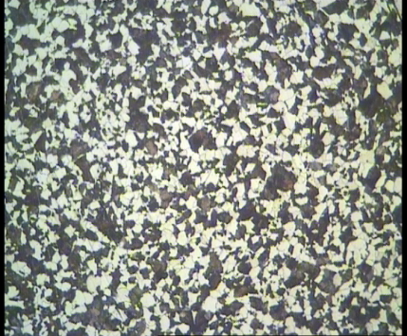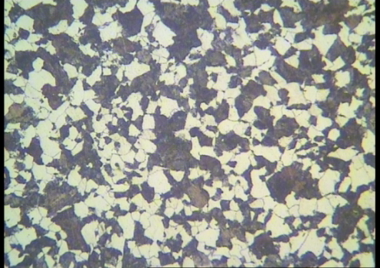

- 100 X 200 X
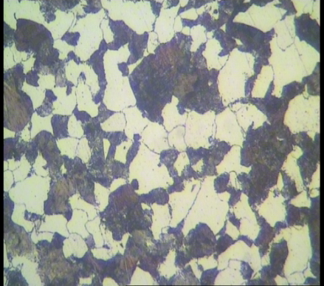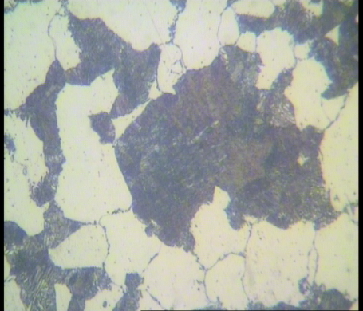

400 X 1000X
- ^{Parametric- variables:-}
^{Object dimension (mm)} | ^{Normalizing Temp} | ^{Tempering Temp (0 C)}
^{Sample A 390 Ø x 265 L} | 860º C | ⁴⁵⁰ ⁺ ²² ⁼ ⁴⁷²
^{Sample B 390 Ø x 265 L} | 860º C ‘’ | ⁴⁷² ⁺ ⁴⁶ ⁼⁵¹⁸
- ^{Experiment 1:-}
- ^{Hardening}
- Hardening of Sample A (Ø390 X 265 mm Lg) is done at 860 ֯ C, Soaking for 8 hr and Water quenching.
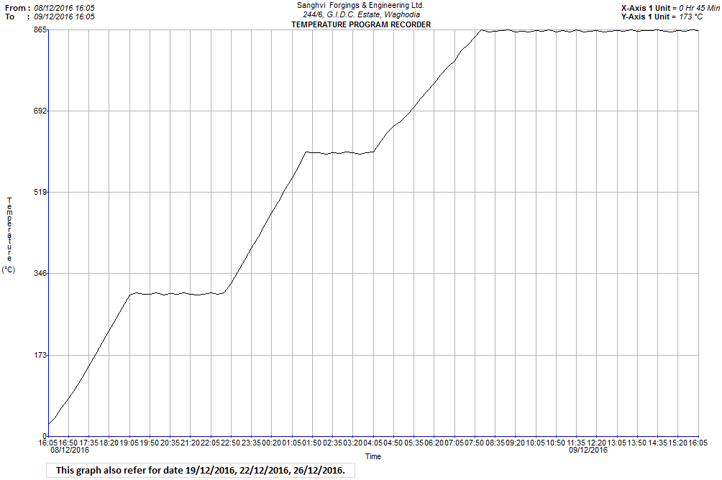
Fig: Heat treatment cycle for hardening
- ^{TEMPERING}
After Hardening, tempering is done at 472 ֯ C, soaking for 13 hr, air cooling.

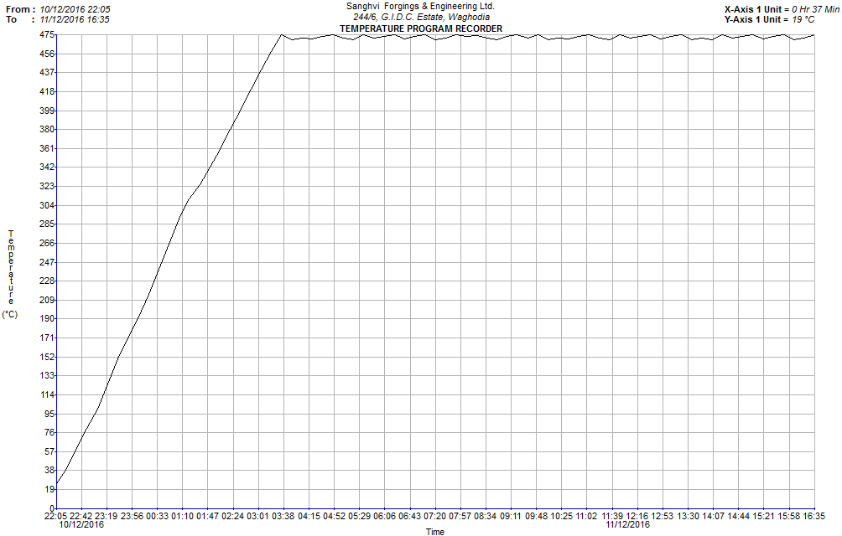

Fig:- Heat treatment cycle for tempering
- ^{Experiment 2:-}
Hardening:- Hardening of Sample B (Ø390 X 265 mm Lg) is done at 860 ֯ C,
- Heat treatment cycle is same as per experiment 1.
- ^{Tempering:-}
Tempering of Sample B is done at 518 ֯ C, Soaking for 13 hr and air cooling.
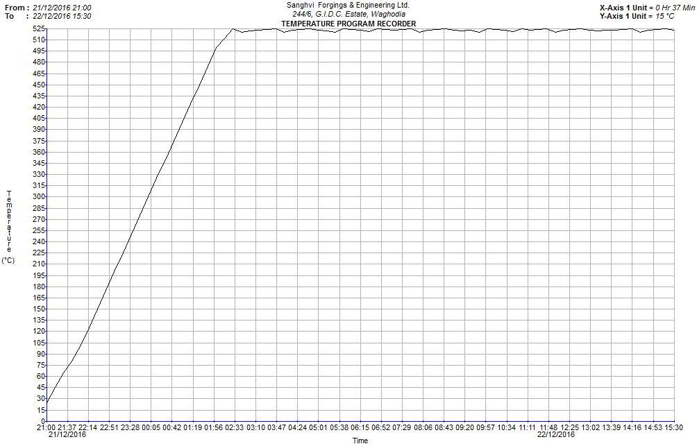
Fig:- Heat treatment cycle of Tempering

^{Result of Experiment 1 & 2}
- Result of Tensile , Micro and Impact Testing:-
^{Sample (Ø390 X 265 mm Lg)} | Hardness after hardening at 860 ֯ C (BHN) | Hardness after tempering at 472 ֯ C  ^{(BHN)} | Hardness after tempering inside 30 mm on slide | ^{Yield strength}  ^{(MPa)} | ^{Tensile Strength}  ^{(MPa)} | ^{Elongation}  ^{(%)} | ^{Reduction}  ^{Area (%)} | ^{Impact (Charpy V notch) Temp}  ^{– 45 ֯c (J)} | ^{Avg}
^{A} | ^{382,382,364} | ^{312,297,312} | ^{262,252,262} | ⁶⁸⁷ | ⁹⁰³ | ²⁵ | ^{58.946} | ^{26,23,7} | ^{18.66}

Table:- Result of Tensile Testing, Impact & Hardness to Experiment
- Microstructure Analysis after tempering as below:-

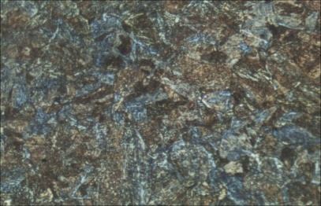
at 100X at 400X

Fig: Microstructure observed tempered martensite & upper bainite , blue colour show tempered martensite,Etchant Berasas.

^{Sample}  ^{(Ø390 X 265 mm Lg)} | Hardness after hardening at 860 ֯ C (BHN) | Hardness after tempering at 518 ֯ C  ^{(BHN)} | Hardness after tempering inside 30 mm on slide | ^{Yield strength}  ^{(MPa)} | ^{Tensile Strength}  ^{(MPa)} | ^{Elongation}  ^{(%)} | ^{Reduction}  ^{Area (%)} | ^{Impact (Charpy V notch) Temp}  ^{– 45 ֯c (J)} | ^{Avg}
^{B} | ^{382,400,419} | ^{382,364,400} | ^{242,232,242} | ⁷³¹ | ⁸⁷⁹ | ^{24.16} | ^{58.593} | ^{28,12,32} | ²⁴
Table: Result of Tensile,Impact & Hardness of Experiment 2.
^{Sample}  ^{(Ø390 X 265 mm Lg)} | Hardness after hardening at 860 ֯ C (BHN) | Hardness after tempering at 518 ֯ C  ^{(BHN)} | Hardness after tempering inside 30 mm on slide | ^{Yield strength}  ^{(MPa)} | ^{Tensile Strength}  ^{(MPa)} | ^{Elongation}  ^{(%)} | ^{Reduction}  ^{Area (%)} | ^{Impact (Charpy V notch) Temp}  ^{– 45 ֯c (J)} | ^{Avg}
^{B} | ^{382,400,419} | ^{382,364,400} | ^{242,232,242} | ⁷³¹ | ⁸⁷⁹ | ^{24.16} | ^{58.593} | ^{28,12,32} | ²⁴


100 X 400X
Fig: Microstructure observed tempered martensite, Etchant 2% Nital
^{Conclusion:-}
- The present study investigated the effect of different tempering temperatures on the mechanical properties and microstructure of hardened steel samples. Based on the experimental results and analysis, the following conclusions are drawn:
- Hardening at 860°C followed by tempering significantly influences the balance between strength and toughness of the material.
Tempering at 472°C (Experiment 1) resulted in higher ultimate tensile strength but comparatively lower impact toughness due to the presence of tempered martensite along with upper bainite.
Tempering at 518°C (Experiment 2) led to improved impact energy and better toughness, attributed to the formation of a more uniform tempered martensitic structure.
^{Refrences:-}
1). http://nptel.ac.in/courses/112107144/Metal%20Forming%20&%20Powder%20
metallurgy/lecture5/lecture5.htm
2). http://www.scotforge.com/Why-Forging/Metallurgical-FAQs
3). http://www.nptel.ac.in/courses/112101005/downloads/Module_4_Lecture_7_fi
nal.pdf
4)http://www.substech.com/dokuwiki/doku.php?id=iron-carbon_phase_diagram
5). http://www.efunda.com/materials/alloys/alloy_home/steels_properties.cfm
6). http://metals.about.com/od/properties/a/Steel-Applications.htm
7) http://www.azom.com/article.aspx?ArticleID=470
8)ASM Handbook volume 1 Properties & selection Irons steels & High performance alloys
9) ASM Handbook Volume 14 – Forming & Forging.

I

