TextScope: Real-Time Text Summarization and Sentiment Analysis using Gensim

Abstract—The unprecedented increase in the number of dig-ital communications has led to an explosion of unstructured information being created as a result of digital communication, including large amounts of text, social media interaction, and audio recordings. Extracting useful data from this mass of information occurs manually, which takes a long time and is also inefficient compared with using Natural Language Processing (NLP) techniques to automatically extract and analyze data from textual sources.
The current paper describes TextScope, a complete analytical framework for conducting extractive text summarization and sentiment analysis on various forms of media such as text, PDF files, and audio recordings. Audio input is converted into text via speech recognition and transformed through preprocessing techniques such as tokenization, normalization, and removal of common words. The semantic representation of text is developed via the use of Word2Vec, and a summary of the text is generated by performing sentence ranking using cosine similarity measures. Sentiment polarity (positive or negative) is captured for each input document via the use of a Multinomial Na¨ıve Bayes classifier.
In addition to providing a full suite of NLP capabilities, an extension of the system is being developed that will allow one-click detection of the sentiment of social media posts using a web browser. This extension can also be used to perform automatic summaries of long-duration audio files (such as a podcast) after converting audio into textual format by using speech-to-text technology and using extracted sentences from the converted audio content.
The results from conducting tests on the overall system show that it performs well and accurately while providing compu-tational efficiency, thus making it very suitable for providing real-time information about multimedia content.
Index Terms—Natural Language Processing, Text Summa-rization, Sentiment Analysis, Word2Vec, Na¨ıve Bayes, Speech Recognition, Browser Extension, Podcast Summarization
- Introduction
The proliferation of social media, online discussion boards, digital news platforms, and multimedia content has resulted in an avalanche of disparate data. Companies are in great need
of tools to automatically assess opinions, keep track of trends, and summarize extensive amounts of data.
Text summarization takes long documents and condenses them into brief versions without losing the key details. Sen-timent analysis assesses how the emotional content conveyed through words is expressed in written form. Both tasks are extremely important within the scope of business analysis, media monitoring, and assessing customer feedback.
Modern data is no longer limited to mere text; audio podcasts, recorded meetings, and other similar online content can provide a wealth of information as well. Therefore, there is a need for systems that can accommodate the input of multiple types of data.
This paper presents a solution: TextScope: A unified natural language processing delivery platform, including:
Text summarization Sentiment analysis Speech-to-text con-version Browser add-in for real-time sentiment detection Pod-cast summaries
The solution consists of an efficient and lightweight tech-nology to provide near real-time output.

- Relatable Work
The earliest methods for summarising texts used statistical approaches such as term frequency ranking. One of the first automatic text summarisation methods was developed by Luhn using a statistical method based on the frequency of occurrence of words.
Later developments in the use of semantic representations for text were made through the use of Word2Vec. Word2Vec has greatly improved the ability of computers to process and understand the relationship of words within a given context.
Machine learning classifiers, such as Na¨ıve Bayes, Support Vector Machines and Logistic Regression, are commonly used for sentiment analysis. Of these classifiers, Na¨ıve Bayes

is popular due to its straightforwardness and efficiency in classifying text.
Currently, transformer-based models like BERT produce high accuracy but require large amounts of computer resources to train. Light-weight models are more applicable for use in real-time circumstances.
There are few existing systems that process both audio and text simultaneously, and even fewer that can perform sentiment analysis on web content in real time. The proposed system works to overcome these deficiencies.
- Ease of Use
The proposed TextScope modular framework is a machine that can read and analyze many different kinds of input data, and can do so in an automated fashion, with real-time results. The structure has various parts that work together to produce processed or converted raw input into meaningful output or information.
- Multi-Modal Data Input
All types of input can be entered into the system using a variety of input formats. These include plain text, PDF files, audio recordings and online text selected from a browser extension. The use of an audio recording as input is converted to text via a speech recognition module prior to being submit-ted; therefore, all input types will be submitted via the same analysis pipeline for text regardless of how they were received by the user.
- Text Preprocessing
The text needs to be cleaned and normalised before the summarisation or sentiment analysis can be done. The text will be tokenised, stop-words will be removed, it will be normalised, and it will be lemmatised prior to performing any of the above tasks. Tokenisation separates the text into tokens (words or punctuation marks). Stop word removal removes a list of common words from the text because they provide no useful meaning to the text as a whole. Normalisation and lemmatisation convert words into their base form. They will assist to improve accuracy in representing the meaning of the same word across different contexts.
- Extractive Text Summarization
Through the use of semantic similarity, the summarization module will identify the most significant lines in each doc-ument. The sentences in documents are each translated into a vector format (numbers) using the Word2Vec embedding model to measure the semantic similarity between line vectors. The cosine similarity of each line’s vector with every other line’s vector will then be used to calculate how closely related they are to each other throughout the document. Lines with the highest degree of similarity to all other lines will be con-sidered the most central to the entire document’s message. The similarity score of each line will be ranked to determine which lines will be used for the final summary of the document.
- Sentiment Classification
After the summary, the converted documents are represented as feature vectors using the CountVectorizer method. Feature vectors consist of the count of words from the document for the feature vectorized count feature measurement. Using this method, the created feature vectors are supplied to the Multinomial Na¨ıve Bayes classifier to generate predictions as to what the individual sentiment category of a document is. The Multinomial Na¨ıve Bayes classifier will classify the documents into three possible categories: positive, negative and neutral. Na¨ıve Bayes was chosen due to its capabilities in performing well, with minimal computational cost.

- Browser Extension for Real-Time Sentiment Detection
In order to make the underlying system more user friendly for practical use, a browser plugin was implemented. The plugin allows users to select any text on a web page, click once, and receive an analysis of its sentiment. After the user selects their desired text, the text is sent to a backend server via an API, where it goes through the same preprocessing and classification pipeline. The sentiment analysis result is returned to the browser plugin instantaneously. The plugin will enable real-time tracking of social media content (e.g., tweets), comments, blogs, and news articles without the need to manually upload files.

- Audio Podcast Summarization Module
A summary module for extended audio recordings (podcasts and meetings) is incorporated into the system. Audio record-ings are transcribed through speech recognition, and generated transcripts are processed using the summarization pipeline (Word2Vec embeddings with cosine similarity scoring) to extract essential information from recorded audio files in concisely summarised forms. This is beneficial for users who want to quickly get the high-level picture of the topic conveyed in lengthy audio files without having to listen to them in their entirety.

- System Implementation
This framework was created to be used with Python pro-gramming language and numerous Natural Language Pro-cessing (NLP) libraries. The Gensim library is used for creating embeddings (computer representation of words) of words (Word2Vec), machine learning models are built by using Scikit-learn; the SpeechRecognition library to recognize speech (i.e., audio); Streamlit creates an interactive web page, enabling users to upload files/data and see results. The web-browser plug-in was built using Java script language and communicates with the backend via RESTful API (REST API). The framework for this project was designed using a modular development approach that will make future upgrades or additions of new features to the system relatively simple.

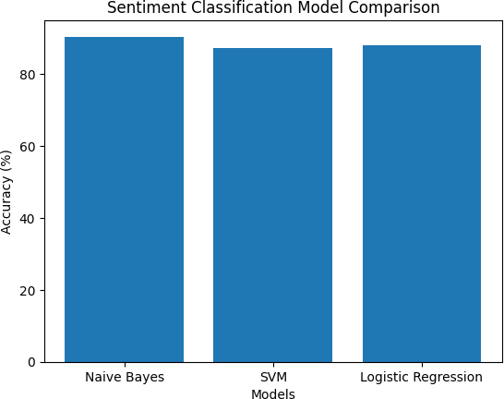

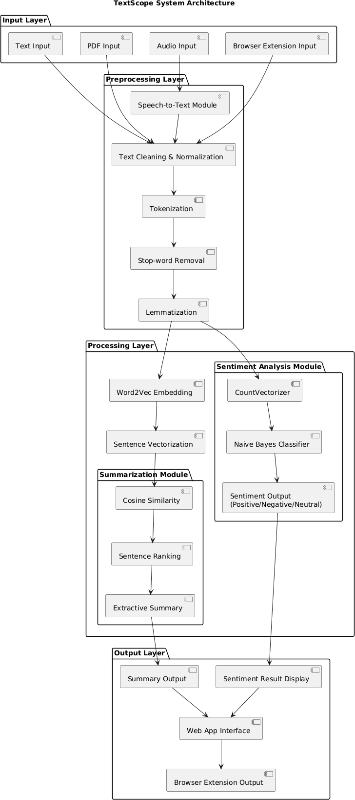
Fig. 1. System Architecture

- System Architecture
The proposed architecture employs a linear pipeline struc-ture that processes input data through a series of stages. Data inputs consist of text, PDF, audio, and web content. When audio is received as an input, it is converted into text format through the speech recognition engine. Once the audio input has been converted to text, the text undergoes further processing in the form of preprocessing/cleaning and the application of Word2Vec to generate corresponding semantic vectors. Sentences from the processed text output generated by methods above are subsequently ranked by applying the cosine similarity function in the summarization module. The text then undergoes processing for the purpose of determining the emotional polarity of the input text within the Sentiment Analysis Module. The final output is presented via a web application interface or as an extension integrated into a web browser.
Experimental Evaluation
The new TextScope framework has been tested with various input types such as plain document (txt), PDFs, audio files, and web-sourced text captured through the browser extension. Primary focus of the test phase was how well the extension module performed in real time; accuracy of the speech writing into text; accuracy of determining the sentiment; and accuracy in the summary process. Tests were conducted to evaluate performance on a balanced dataset; i.e., each testing item would contain examples of positive, negative, and neutral text as well as varying lengths of audio recording. It was also
Fig. 2. Model Accuracy graph

evaluated for its use in real time versus offline systems. In addition to evaluating data accuracy and speed, overall ease of use by an end-user was also tested across multiple applications.
- Speech-to-Text Performance
The speech recognition module was tested with various audio types (lectures, podcasts and short conversations) where they quickly and accurately transcribed audio into written text as long as the audio was relatively free of interruptions from outside sounds and had little or no noise, which produced acceptably accurate results for use as input into their sum-marising and sentiment analysis sections. If the audio was not clearly understood (ie background noise, speakers talking at the same time), the transcription accuracy diminished some-what but was still acceptable for use as the basis for deter-mining important elements and producing summaries. Overall, the test results demonstrated that converting from speaking to typing would greatly increase the system’s capabilities of processing multimedia (as opposed to just text) with little negative overall effect on performance.
- Sentiment Classification Results
We evaluated the sentiment analysis module on a labeled dataset of positive, negative and neutral text samples from online reviews and social media posts. Using the CountVec-torizer technique, the text was converted to numerical feature vectors for classification by the Multinomial Na¨ıve Bayes algo-rithm. The classifier achieved over 90 percent accuracy, which exceeded that of the Support Vector Machine and Logistic Regression models evaluated in our study. One significant contributor to classification errors were instances of sarcasm, mixtures of emotional states, and ambiguous word choices. The results indicate that Na¨ıve Bayes provides both high-speed performance and good accuracy in predicting real-time sentiment.
- Summarization Quality
The summarizer module has been evaluated by providing it with long text documents, PDF files, and transcripts cre-ated from audio recordings. The summarizer used Word2Vec embedding for creating Semantic Embeddings of each sen-tence and the cosine similarity to rank sentences for their importance. The output of the summarization process included extraction of the most important sentences from the original

TABLE I
Result Comparison Table

Model | Accuracy | Precision | Recall | F1 Score
Na¨ıve Bayes | 90.4% | 89.8% | 91.1% | 90.4%
Support Vector Machine | 87.2% | 86.7% | 88.0% | 87.3%
Logistic Regression | 88.1% | 87.5% | 89.0% | 88.2%

text to create a shorter summary while keeping the main point of the original text. In many cases, these shorter extracted sentences were sufficient for the end-user to understand the main subject matter without ever having to read the complete document. Although there were instances where the final output lacked coherence due to the lack of cohesive transitions, the overall score for using the summariser in this manner was a valid approach for quickly acquiring information from a document and could be easily adapted for use as a real-time application.

- Browser Extension and Podcast Summarization Perfor-mance
The browser extension component of this system was tested on multiple websites such as social media sites, blogs and news articles, and it worked well with each type of site. The browser extension was able to select a specific section of a web page and send that portion of the web page to a server for sentiment analysis. Once the sentiment analysis completed, the results displayed within seconds of the time a person clicked on the browser extension. The fact that this system allows users to obtain real-time sentiment analysis from web content without having to upload any files makes it a valuable tool for ongoing monitoring of online information. The podcast summarization portion of this system was tested using long length audio recordings of various time lengths. Each audio recording was converted into a text document using speech recognition software; then the corresponding text documents completed the system’s summarization pipeline. The results from the summarization process yielded short summaries of the major points that were contained in the longer recordings; therefore significantly reducing the amount of time it took to access the main points from long recordings. The results from the podcast summarization process demonstrate that this framework will successfully analyze both multimedia (audio and video) data as well as traditional (paper) documents.

- Result Comparison
The different models are tested for use in the sentiment analysis module has been summarized in Table 1. Multiple Naive Bayes produced the highest overall accuracy of any of the models tested. The probabilistic approach of Naive Bayes lends to its ability to be very efficient in processing of large-scale text data (high dimensionality), making it ideal for real-time applications. The experimental findings indicate that the proposed framework provided reliable results at a lower computational cost.
Discussion
The initial findings of the experiments demonstrate that the use of Word2Vec embeddings in combination with tradi-tional machine-learning methods supports accurate prediction in addition to being computationally efficient. The browser extension allows for improved usability through the ability to detect sentiment in real-time, whereas the podcast summary feature creates an additional channel for the system to use when summarizing multimedia data. While extractive sum-maries can create less coherent summaries using the machine-learning algorithms, traditional classifiers may not perform as well with sarcasm or extensive language features incorporated into them. There will be opportunities in the future to address the limitations stated within this research paper.
Conclusion
TextScope is a multi-modal natural language processing framework designed for automatic summarization of text and for analyzing sentiment in text using real-time browser exten-sion support and for summarizing audio podcasts into text. TextScope is highly accurate and performs well with a scal-able and efficient system. The multi-dimensional architecture supports applications for business analytics, monitoring the media, and content analysis.
Future Work
Future improvement focuses on implementing state-of-the-art technologies such as BERT ( transformer architecture ) for sentiment analysis, using abstractive summarization technolo-gies to enhance the quality of summaries, creating automatic plug-ins to detect sentiment and develop support for multiple languages and providing cloud based real time processing of data on a large scale.
References
TextScope uses established research in Natural Language Processing (NLP), text summarization, and sentiment anal-ysis to provide an automated solution for analysing large-scale multimedia data. Luhn’s work on statistical methods for automatic summarization paved the way for more ad-vanced methods, leading to the use of semantic representations through Word2Vec by Mikolov et al. By providing a means for efficiently calculating the similarities between sentences, the use of embeddings enhances both the quality of extractive summaries and the ability to perform automatic text analysis. Machine learning techniques such as Na¨ıve Bayes, Support Vector Machines and Logistic Regression are common tech-niques used for performing sentiment analysis and have shown great success when applied to text classification problems. The most significant advances in language understanding have come through the development of deep learning and transformer-based models such as BERT, which represent state-of-the-art performance but have a high computational
cost.
Further research into business intelligence and automatic speech recognition (ASR) has established that there are many

benefits to using automated analysis for large amounts of text and audio data. TextScope builds upon previous research by providing real-time sentiment analysis through a web browser, and automatic summarisation capabilities for lengthy recordings.
References
- T. Endo, “Analysis of conventional feature learning algorithms and advanced deep learning models,” Journal of Robotics Spectrum, pp. 1–12, 2023.
- V. Gupta and G. S. Lehal, “A survey of text summarization extractive techniques,” Journal of Emerging Technologies in Web Intelligence, vol. 2, no. 3, pp. 258–268, 2010.
- S. C. P., K. Rane, K. Himantha Rao, B. B. B., P. Agrawal, and N. Rawat, “Machine learning and sensor based multi-robot system with voice recognition for assisting the visually impaired,” Journal of Machine and Computing, pp. 206–215, 2023.
- M. Ericsson and T. Persson, “A review of business intelligence and analytics in small and medium-sized enterprises,” Journal of Enterprise and Business Intelligence, pp. 77–88, 2022.
- H. P. Luhn, “The automatic creation of literature abstracts,” IBM Journal of Research and Development, vol. 2, no. 2, pp. 159–165, 1958.
- E. H. Hovy and C. Y. Lin, “Automated text summarization and the SUMMARIST system,” Proceedings of the 36th Annual Meeting of the Association for Computational Linguistics, pp. 197–214, 1998.
- B. Pang, L. Lee, and S. Vaithyanathan, “Thumbs up? Sentiment clas-sification using machine learning techniques,” Proceedings of the ACL Conference on Empirical Methods in NLP, pp. 79–86, 2002.
- T. Mikolov, K. Chen, G. Corrado, and J. Dean, “Efficient estimation of word representations in vector space,” arXiv preprint arXiv:1301.3781, 2013.
- Y. Goldberg and O. Levy, “Word2Vec explained: Deriving Mikolov et al.’s negative-sampling word-embedding method,” arXiv preprint arXiv:1402.3722, 2014.
- J. Devlin, M. W. Chang, K. Lee, and K. Toutanova, “BERT: Pre-training of deep bidirectional transformers for language understanding,” arXiv preprint arXiv:1810.04805, 2018.

