OPTIMIZING BENEFICIATION TECHNIQUES OF MANGANESE ORE FOR ENHANCED ENERGY STORAGE SOLUTIONS IN NIGERIA’S GREEN ECONOMY (MADAKA, RAFI L.G.A, NIGER STATE).

Abstract
This study optimized the beneficiation techniques of Madaka manganese ore, located in the Rafi Local Government Area of Niger State, Nigeria, to enhance its potential as a valuable resource for energy storage solutions in the country’s green economy. The research identified manganese oxide (MnO) as the dominant compound in the ore, comprising 48.44%, which aligns with battery-grade standards. Froth flotation experiments were conducted using varying concentrations of sodium oleate (3 g/kg, 7 g/kg, and 10 g/kg), with the highest manganese grade (65.20%) achieved at 3 g/kg, coupled with a recovery rate of 99.11%. However, higher reagent dosages resulted in decreased manganese grades and recovery, with 10 g/kg achieving the lowest recovery at 90.99%. Metallurgical accounting revealed an inverse relationship between recovery and grade, emphasizing the need for a balance to optimize the beneficiation process. The study concludes that 3 g/kg sodium oleate is optimal as a collector for maximizing manganese recovery and grade, and recommends further optimization of reagent concentrations and the exploration of advanced beneficiation techniques, such as bioleaching or selective flotation, to improve extraction efficiency. It also suggests investigating the integration of processed manganese ore from madaka, Niger state, Nigeria, into renewable energy storage systems like flow batteries and supercapacitors, and stresses the importance of promoting sustainable mining practices in Nigeria’s manganese industry to support local economic growth and contribute to the global transition to green energy.
Keywords: Manganese ore, beneficiation, froth flotation, energy storage, Nigeria’s green economy.

Introduction

Manganese ore plays a crucial role in the production of energy storage materials, with its growing importance in the global transition to renewable energy systems. As demand for sustainable and efficient energy storage solutions intensifies, Nigeria, endowed with abundant mineral resources, stands at a pivotal point. Specifically, the beneficiation of manganese ore sourced from regions such as Madaka, located in the Rafi Local Government Area of Niger State, has become increasingly vital to the country’s green economy aspirations (Bai et al., 2021). The ore’s transformation through beneficiation processes is essential for producing high-quality materials that can be utilized in renewable energy storage systems, such as batteries for solar and wind power (Jones & McWilliams, 2020). The research seeks to explore and optimize these beneficiation techniques to make Nigerian manganese ore a sustainable resource for advanced energy storage, contributing significantly to the nation's renewable energy goals and promoting economic growth through sustainable mining practices (Wambugu et al., 2021).

Figure 1. Location, Accessibility, Drainage and Relief Map of Madaka Area (NGSA, 2020).

Nigeria’s vast mineral wealth presents a remarkable opportunity to harness domestic resources for powering the nation’s green energy revolution. Manganese, an indispensable component in energy storage devices like lithium-ion and sodium-ion batteries, enables efficient storage and utilization of renewable energy (Wang et al., 2019; Leung et al., 2020). Madaka, a region rich in manganese ore deposits, holds great potential to serve as a sustainable source of this crucial material for renewable energy solutions. However, the current beneficiation methods employed to process the ore are insufficient and require optimization to improve both its quality and the efficiency of its conversion into usable energy storage materials (Muriana et al., 2014). Optimizing beneficiation processes will ensure that the manganese ore meets the stringent quality standards needed for high-performance energy applications. Through the implementation of advanced mineral processing methods, this research aims to address these limitations, not only assisting Nigeria in its green energy transition but also contributing to local economic development by promoting sustainable mining practices (Roberts et al., 2021). By enhancing beneficiation techniques, the study will enable Nigeria to produce high-quality manganese ore for use in renewable energy storage systems, thus supporting the country’s transition toward cleaner and more efficient energy solutions.
Nigeria’s manganese ore deposits, particularly in the Madaka region of Niger State, present a significant opportunity to contribute to the country’s green energy goals. However, inefficient beneficiation practices hinder the effective use of these resources in advanced green energy technologies. Manganese is a key element in energy storage devices, such as batteries for solar and wind power systems, where it facilitates the efficient storage and use of renewable energy. The current beneficiation techniques for Madaka manganese ore do not meet the high-quality requirements necessary for energy storage applications, limiting its potential contribution to Nigeria’s green economy.
The primary objective of this study is to optimize the beneficiation techniques of Madaka manganese ore to improve its quality and suitability for use in high-performance energy storage systems, which will contribute to Nigeria’s green economy and renewable energy transition. The specific objectives of the study are as follows: to evaluate the current beneficiation methods used for Madaka manganese ore; to develop and test advanced beneficiation techniques aimed at improving the quality of manganese ore for energy storage applications; and to assess the performance of processed manganese ore in renewable energy storage systems, such as batteries for solar and wind power.
This study is significant for several reasons, all of which align with Nigeria’s energy and economic development goals. First, optimizing the beneficiation of Madaka manganese ore will enhance the quality of locally sourced materials, making them more suitable for use in renewable energy storage systems. This can help reduce Nigeria’s reliance on imported materials, ultimately contributing to national energy security. Second, the successful implementation of advanced beneficiation techniques will support local economic growth by creating value-added industries around manganese ore processing. By improving the ore’s quality, Nigeria can foster a thriving mining industry, which could stimulate job creation, technological innovation, and infrastructure development. Furthermore, this research will contribute to the global drive for sustainable energy solutions. The optimization of manganese ore processing not only supports Nigeria’s green energy goals but also promotes responsible mining practices. In the long term, this study has the potential to position Nigeria as a key player in the global energy storage market, fostering economic resilience while supporting the country’s transition to a low-carbon economy. By advancing the beneficiation of manganese ore, this research will play a critical role in Nigeria's sustainable development, helping to meet the challenges posed by climate change and energy demands.

Research Gap
Despite the significant manganese ore deposits in Madaka, Niger State, Nigeria, the current beneficiation methods for the ore are inefficient and fail to meet the high-quality standards required for energy storage applications. While manganese plays a crucial role in the production of batteries for renewable energy storage, the existing beneficiation techniques have not been optimized for this purpose. Advanced methods to improve the quality and efficiency of the beneficiation process for Madaka manganese ore have not been thoroughly explored. This gap presents an opportunity for further research to optimize beneficiation techniques, ensuring that the ore can meet the stringent quality requirements for high-performance energy storage systems such as batteries for solar and wind power. Addressing this gap could significantly contribute to Nigeria’s green economy and reduce its reliance on imported materials, while promoting sustainable mining practices.

2.0 Methods

The study aimed to optimize the beneficiation techniques of Madaka manganese ore for enhanced energy storage solutions in Nigeria’s green economy. To achieve this, manganese ore samples were collected from various locations within Madaka, Rafi Local Government Area, Niger State, ensuring that the samples were representative of the region’s ore deposits. The ore samples were physically examined to determine its hardness, on the Mohs hardness scale. Following the physical examination, a detailed chemical compositional analysis of the crude ore was carried out using X-ray fluorescence (XRF) spectroscopy, providing essential information for determining the ore’s suitability for beneficiation and energy storage applications.
For the beneficiation process, froth flotation experiments were conducted using sodium oleate as the collector at varying concentrations of 3 g/kg, 7 g/kg, and 10 g/kg. The reagents used in the flotation process included sodium oleate, sodium silicate, and fuel oil, which were mixed with the ore to facilitate the separation of valuable manganese minerals from gangue materials. After the flotation process, the concentrate and tailing fractions were collected and analyzed for their chemical composition, using XRF to determine the grade of manganese and other constituent elements in both fractions. Metallurgical accounting was performed to assess the effectiveness of the flotation process, calculating parameters such as metal recovery, concentration ratio, and enrichment ratio using standard formulas. These metrics allowed for an evaluation of the recovery efficiency at different collector concentrations, providing insights into the relationship between recovery and grade of manganese in the concentrate.

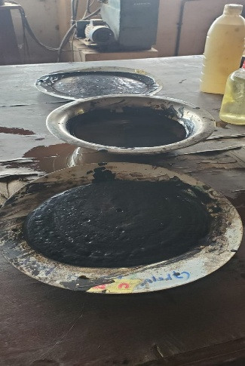
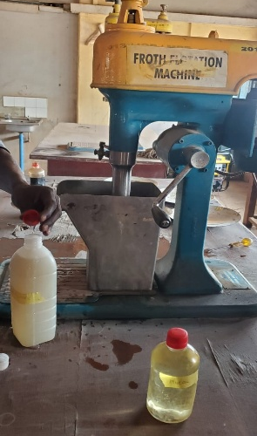
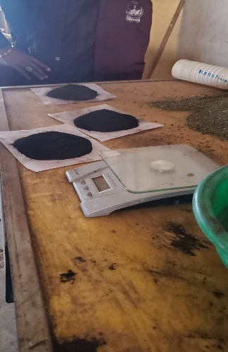
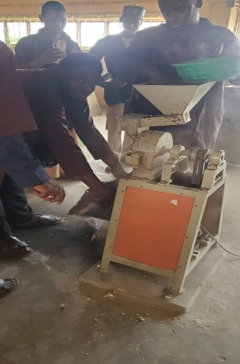

Plate 1. Photos Showing the Floatation Procedure Conducted

at Laboratory of the Department of Mineral & Petroleum Resources Engineering, Kaduna Polytechnic

3. Results and Discussions

3.1. Physical Examination of the Crude Ore Sample
The hand specimen of the crude ore was visually inspected and identified as grayish-black, with occasional white patches and non-magnetic substances. The ore exhibited a hardness greater than 5.5 on the Moh’s scale.

3.2 Characterization of Madaka Manganese Ore

3.2.1 Chemical Compositional Analysis of Crude Madaka Manganese Ore

The chemical composition of the crude Madaka manganese ore sample was carried out to determine the elemental composition and the result in shown in the table below:

Table 1: Chemical Compositional Analysis of Madaka Manganese Ore by XRF

Chemical Formula | SiO₂ | Al₂O₃ | Fe₂O₃ | TiO₂ | CaO | MnO | Cr₂O₃ | Na₂O | K₂O | SO₃
% Present | 3.1 | 2.37 | 12.32 | 0.64 | 0.17 | 48.44 | 0.07 | 0.04 | 1.86 | 0.08

The chemical composition of the crude Madaka manganese ore sample revealed that manganese oxide (MnO) was the most abundant component, making up 48.44% of the ore. This finding is consistent with previous studies, such as Zhou et al. (2014), who reported 49.5% MnO in the raw Madaka manganese ore. Other significant compounds found in the ore included iron oxide (Fe₂O₃) at 12.32%, silicon dioxide (SiO₂) at 3.1%, and aluminum oxide (Al₂O₃) at 2.37%. These values indicate that the ore has a high manganese content, which classifies it as blast furnace grade.The chemical composition of the Madaka manganese ore further informs the selection of beneficiation techniques. The relatively high manganese content indicates the ore’s potential for producing valuable energy storage materials, such as those used in batteries for solar and wind power applications.

3.2.2 Mineralogical Analysis of the Crude Madaka Manganese Ore Sample
X-ray diffraction (XRD) analysis of the crude Madaka manganese ore revealed several key mineral phases, which identifies the mineral phases present within the ore.

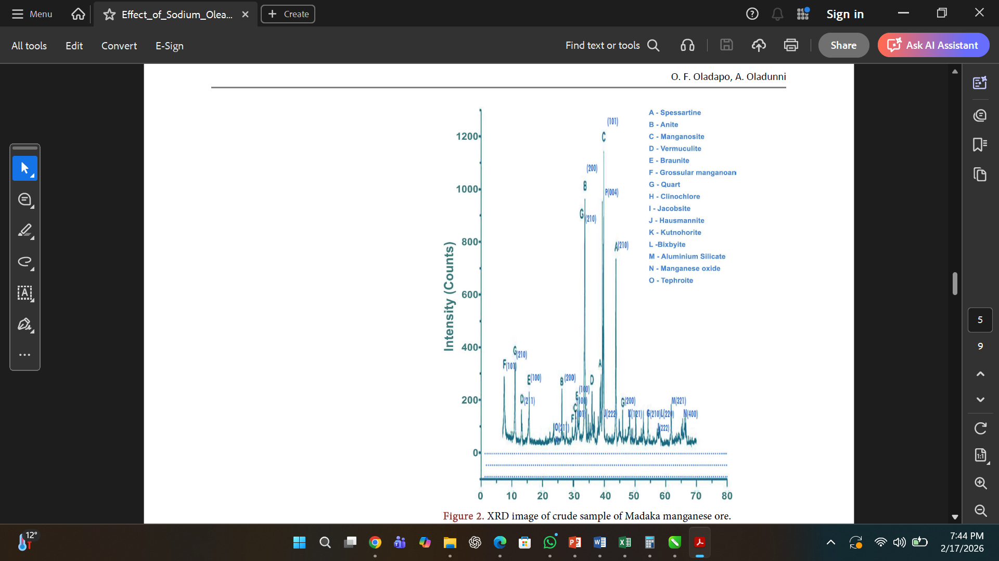

Figure 2: XRD Image of Crude Sample of Madaka Manganese Ore

Figure 2 displays the X-ray diffraction (XRD) image of the crude Madaka manganese ore sample, including magnosite (MnO), spessartine (Mn₃Al₂Si₃O₁₂), Hausmannite (Mn₃O₄), Braunite (Mn₆SiO₁₂), jacobsites (MnFe₂O₄), and Tephroite (Mn₂SiO₄). The gangue minerals identified in the sample included vermiculite, annite, clinochlore, and quartz. These findings highlight the ore’s complex mineralogical composition, which must be considered when selecting appropriate beneficiation methods.

3.3. Beneficiation of Madaka Manganese Ore Using Froth Flotation Process
The froth flotation process effectively separated the concentrate and tailing fractions, using Sodium oleate, sodium silicate and fuel oil in ratio 3,1 and 4 in the first run, 7,1 and 4 in the second run and 10,1 and 4 in the third run as shown in Table 2 below.

Table 2: Reagent Combination for the Flotation Experiment
Reagent | Concentration (g/kg)
Sodium oleate/sodium silicate and fuel oil | 3, 1, and 4 respectively
Sodium oleate/sodium silicate and fuel oil | 7, 1, and 4 respectively
Sodium oleate/sodium silicate and fuel oil | 10, 1, and 4 respectively

The Table 2 above presents the reagent combinations used for the froth flotation process, designed to evaluate the impact of varying sodium oleate concentrations on the separation efficiency of valuable minerals from gangue materials.

3.4 Assay of the Products of Concentration of Madaka Manganese Ore
The concentrates and tailings obtained from the flotation of Madaka Manganese ore were analyzed using X-ray fluorescence (XRF). The result is shown in the Table 3 below:

Table 3: Chemical Analyses of Concentrate and Tailing at Varied Sodium Oleate Concentrations
Composition | 3 g/kg Concentrate | 3 g/kg Tailing | 7 g/kg Concentrate | 7 g/kg Tailing | 10 g/kg Concentrate | 10 g/kg Tailing
Si | 4.58 | 4.05 | 3.76 | 4.35 | 4.99 | 4.10
Al | 4.32 | 4.65 | 3.40 | 4.50 | 4.78 | 4.55
Fe | 9.39 | 7.80 | 9.48 | 7.80 | 9.48 | 7.70
Ti | 0.08 | 0.25 | 0.67 | 0.30 | 0.67 | 0.30
Ca | 0.70 | 0.45 | 0.75 | 0.55 | 0.75 | 0.60
Pb | 0.01 | ND | ND | ND | ND | ND
Mg | 0.13 | 0.85 | 0.18 | 0.90 | 0.18 | 0.85
Mn | 65.2 | 20.0 | 60.03 | 15.0 | 61.3 | 10.5
Cr | ND | 0.05 | 0.02 | 0.05 | 0.02 | 0.05
Na | 0.06 | ND | 0.05 | 0.01 | 0.05 | 0.00
K | 0.32 | 0.02 | 0.30 | 0.25 | 0.30 | 0.15
S | ND | 0.015 | 0.03 | 0.02 | 0.03 | 0.015

The results of the froth flotation process presented in Table 3 shows that manganese ore, as shown in the table, reveal the efficiency of the separation process across varying reagent dosages (3 g/kg, 7 g/kg, and 10 g/kg). In general, the beneficiation process is more effective at lower reagent concentrations (3 g/kg), as it concentrates a higher percentage of manganese (Mn) in the concentrate fraction and reduces impurities in the tailing. Specifically, at 3 g/kg reagent dosage, the concentrate contains 65.2% Mn, with a corresponding tailing of only 20.0% Mn, suggesting efficient separation. Silicon (Si) and aluminum (Al) exhibit trends that support effective separation, with both impurities showing higher concentrations in the tailings compared to the concentrate. At 3 g/kg reagent, Si is more concentrated in the tailing (4.05%) than the concentrate (4.58%), and a similar trend is observed with Al, indicating that the flotation process is capable of removing these impurities. Iron (Fe), calcium (Ca), and titanium (Ti) also follow a similar trend, showing higher concentrations in the tailings across the three reagent dosages, although the differences between concentrate and tailing are relatively small. Magnesium (Mg) is another element that remains more concentrated in the tailings than in the concentrate. This may suggest that magnesium is not as efficiently separated, especially at higher reagent dosages, with values reaching up to 0.90% in the 7 g/kg tailing. The data also shows that lead (Pb) is only detected in the 3 g/kg concentrate, with no trace found in the tailing at higher reagent dosages, indicating that lead is effectively separated during the flotation process.

3.5. Metallurgical Accounting for the Froth Flotation Process

The metallurgical accounting of the beneficiated ore at varying sodium oleate concentrations was carried out where the metal recovery, concentration ratio and enrichment ratio were calculated as shown in the Table 4 below.

Table 4: Metallurgical Accounting of the Beneficiated Ore at Varied Collector Concentrations

Collector Dosage (g/kg) | % of Feed (F) | % Grade of Feed (f) | % Weight of Concentrate (C) | % Grade of Mn (c) | % Grade of Tailing (t) | % Metal Recovery
3 | 100 | 65.20 | 100 | 65.20 | 20.0 | 99.11
7 | 100 | 60.03 | 100 | 60.03 | 15.0 | 98.14
10 | 100 | 61.3 | 100 | 61.3 | 10.5 | 90.99

The metallurgical accounting results in table 4 reveal the efficiency of the froth flotation process for manganese ore at different collector dosages (3 g/kg, 7 g/kg, and 10 g/kg). At a 3 g/kg reagent dosage, the beneficiation process is the most efficient, as it achieves the highest manganese concentration in the concentrate (65.20%) and a recovery rate of 99.11%. This indicates that the flotation process is highly effective in separating manganese from the waste (tailing), with only 20.0% manganese remaining in the tailing. In comparison, at 7 g/kg, the grade of manganese in the concentrate drops slightly to 60.03%, and the recovery decreases to 98.14%. The tailing grade also improves, with only 15.0% manganese remaining, suggesting a more efficient separation but with some loss of manganese compared to the 3 g/kg dosage.

4.0 Conclusion and Recommendations

This study successfully optimized the beneficiation techniques of Madaka manganese ore, illustrating its significant potential as a critical resource for energy storage solutions in Nigeria’s green economy. Through comprehensive physical, chemical, and mineralogical analyses, the research identified manganese oxide (MnO) as the predominant compound in the ore, constituting 48.44%, which meets the battery-grade standard as outlined by the Government of India Ministry of Mines, 2025. The results from the froth flotation experiments showed that varying sodium oleate concentrations as a collector, influenced both the recovery and grade of manganese in the concentrate. The highest manganese grade of 65.20% was achieved at a 3 g/kg concentration, while recovery increased with higher collector concentrations, peaking at 19.61% at 10 g/kg. Metallurgical accounting revealed the trade-off between recovery and grade, emphasizing the inverse relationship between the two. The study highlighted the critical need to balance recovery and grade to optimize beneficiation for energy storage applications.
Based on the findings, it is recommended that further optimization of sodium oleate concentrations and especially other classes of reagents like frothers, be conducted to improve manganese recovery while maintaining an acceptable grade for energy storage purposes. Additionally, exploring advanced beneficiation techniques such as bioleaching or selective flotation could further enhance the efficiency of manganese extraction. The research also suggests the necessity for investigating the integration of processed manganese ore into large-scale renewable energy storage systems, including flow batteries and supercapacitors, to fully harness its potential. Finally, the study underscores the importance of promoting sustainable mining practices in Nigeria’s manganese industry to support local economic growth and contribute to the global transition to green energy, thus optimizing the potential of Madaka manganese ore in Nigeria's green economy.

Reference
Akbar, M. R. and Mohammad, R. H. (2013). Characterization and Beneficiation of Iranian Low-Grade Manganese Ore. Physicochemical Problems of Mineral Processing Journal, 50, 982-993.
Armstrong, F. A. (2008). Why Did Nature Choose Manganese to Make Oxygen? Philosophical Transactions of the Royal Society, London Biological Sciences, 5, 1263-1270.
Basu, D. S., Pal, D., and Ghost, K. P. (2010). Beneficiation of Low-Grade Manganese Ore Fines. Dastur & Co. Pvt. Ltd., Calcutta, 2, 415-420.
Corathers, L. A. (2015). Mineral Commodity Summaries 2015. U.S. Department of Interior, U.S. Geological Survey, 3, 100-101.
Ishaq, A. (2016). Preliminary Investigations for the Upgradation of North Waziristan Manganese Ore. Science, Technology and Development, Pakistan Council for Science and Technology, 35, 22-25.
Khan, A., Shah, M. T., Ali, L., and Mohammad, W. (2004). Beneficiation Study of the Manganese Ore of Saidgi Area, North Waziristan Agency, Pakistan. Geological Bulletin University, Peshawar, 3, 191-197.
Norman, C., Anca, N., Doug, W., Igor, A., and Hoe, T. (2010). The Recovery of Manganese from Low-Grade Resources: Bench Scale Metallurgical Test. American Manganese Inc., IRAP Project, 712681, 1-81.
Lasheen, T. A., El-hazek, M. N., Helal, A. S., and El-Nagar, W. (2009). Recovery of Manganese Using Molasses as Reductant in Nitric Acid Solution. International Journal of Mineral Processing, 5, 109–114.
Muriana, A. A., Muzenda, E., and Abubakre, O. K. (2014). Extraction and Production Kinetics of Industrial-Grade Manganese Sulphate Crystals from Manganese. Journal of Engineering Research, 19, 87-97.
Wills, A. B. and Tim, N. (2016). Mineral Processing Technology: An Introduction to the Practical Aspects of Ore Treatment and Mineral. Elsevier Science & Technology Books, 7, 89-93.

