ORBITS OF OPPORTUNITY: Decoding Ventures, their Vision and its Vigilance in Space

Abstract: Every great leap in human history began with a bold question: What lies beyond? Today, space ventures are how we seek that answer, not just through telescopes but through missions, machines, and minds working
across the global. What once seemed unreachable is now being engineered, launched, and landed. Space ventures have turned distant planets into the next frontier for human progress. They are no longer just about rockets and astronauts but about solving problems, building economies, and rewriting the future. This research paper explores the deeper reasons behind the need for space ventures, not only for survival and knowledge but also for driving innovation and global progress. It highlights the key players in this race: national space agencies like NASA and ISRO, and private companies like SpaceX and Blue Origin, who are reshaping how we think about space. Alongside these exciting developments, the paper also dives into the real challenges of the industry, the risks during investment, and even after missions with examples from the past and present. Space is not easy but it is essential. With each launch and landing, the space industry teaches us to think bigger, fail smarter, and prepare better. This research paper presents a clear picture of where we are in this exciting journey and why the venture into space is one of humanity’s most important missions yet.

Keywords: Space start-ups, Space Industry Veterans, Government Space Directives, Risk Management Mitigation Strategies, Business Opportunities.

Overview
Space Ventures are defined as initiatives that trans-form celestial ambitions into market realities conducted through the efforts of entities like space agencies, public-sector bodies and commercial space enterprises. This pa-per explores both historical as well as emerging economic, technological and governmental dimensions of Space Ven-tures. It elaborates how these ventures have evolved from rocket science to driving innovation that impacts our daily lives.

Introduction
When it comes to what can truly fascinate us, surely space will rank highest. But have you ever scratched your head to think where it all began and what made Humans ex-plore and study cosmos? What convinced them to spend billions on something that was uncertain and did not yield guaranteed results? This established Space era, which we know today began with a very small ball-sized probe, just 58 cm in diameter and weighing 83.6 kg. Back in 1957, on 4th October, Russia launched Sputnik 1 the worlds first artificial satellite to orbit around the Earth. It or-
bited the planet for less than 2 hours (98 minutes to be precise)[1]. But, was enough to create a technological discontinuity which was capable of starting an entirely new industry. Since then, humanity has witnessed a re-markable series of technological breakthroughs that have shaped our understanding of the cosmos and paved the way for future discoveries. It might surprise you that this space era actually began as a fierce competition between the Soviet Union and the United States, ignited in the tense atmosphere of the Cold War after World War II. For both nations, each achievement in space became a powerful symbol of national prestige.
Below is the timeline of key historic firsts from each side that not only showcased technological triumphs but also catalyzed national pride.
- 1957 - first animal in orbit on Sputnik 2 (Laika, So-viet Union)
- 1959 - first artificial object to leave Earths orbit (Luna 1, Soviet Union)
- 1961 - first man in orbit on Vostok 1 (Yuri Gagarin,

Soviet Union)
- 1962 - first commercial satellite (Telstar 1, USA)
- 1966 - first landing on another planet (Venus, Venera 3, Soviet Union)
- 1969 - Neil Armstrong became the first human to walk on the Moon (Apollo 11, USA)
- 1971 - first space station (Salyut 1, Soviet Union), first landing on Mars (Mars 3, Soviet Union)[1]

The 1975 launch of the American Apollo spacecraft and the Soviet Soyuz spacecraft, which docked in orbit during the Apollo-Soyuz Test Project (ASTP), effectively eased Cold War tensions by fostering cooperation in space rather than competition. It set the stage for future international collaborations, such as the Shuttle-MIR program and the International Space Station[2]. Around the 2000s, bold new players entered the space industry not as govern-ment flags, but as private companies driven by vision-ary entrepreneurs. The Spaceship One (SS1), developed by Scaled Composites and Paul Allen (Co-founder of Mi-crosoft), marked the worlds first privately funded human spaceflight program. Soon after, the Big Two Blue Origin (founded by Jeff Bezos in 2000) and SpaceX (founded by Elon Musk in 2002), both started a wave of reusable rock-ets, commercial payloads and suborbital tourism flights. This era also saw the rise of small satellite constellations, led by ventures such as OneWeb and Starlink, aiming to revolutionize global connectivity.[3]
As Space Ventures continue to evolve, it becomes es-sential to understand why they matter, what ventures al-ready exist, how governments are shaping policies, how risks are managed, and what are the forthcoming devel-opments. The following sections discuss these aspects.

Why to have Galactic Ambitions? The Need for Space Ventures
As discussed earlier, mankinds understanding of space and their desire to uncover its mysteries have expanded greatly since the start of the Space Age. But this raises an im-portant question why do we explore something so distant and uncertain when we already live on Earth, the only planet known to support life in the solar system? While many may simply say curiosity, that alone doesnt justify the billions spent on these ventures. So, why is this taken into account by many?
This part of the paper will address these questions with the following subsections: Economic Imperative, Strate-gic and Societal Needs, and Technological Breakthroughs all of which together explain why space ventures are not just a choice, but a necessity for the future.

ECONOMIC IMPERATIVE
Global space activities have exhibited consistent high growth, reflecting its increasing significance in mod-ern society. Today, it stands as a launchpad for the 21st-century economy. Such growth is driven by a broad array of sectors, including satellite manufacturing, launch services, navigation systems, and emerging suborbital applications. As per the, Q1 (Quarter 1) 2025 Space Report by the Space Foundation, Space sector employment growth has surpassed U.S. private sector employment growth. Over the last decade, while overall private sector employment rose by 14.3%, space sector employment increased by 27%. The five-year growth trajectory has been even more significant as space employment increased by 18% from 2019 to 2024[4]. Such expansion underscores that space ventures are not just growing markets they are also creating jobs and strengthening our economy. This upward momentum is not only visible in employment trends but also boldly reflected in the industrys financial trajectory with the estimated global space revenue of $595 billion in 2024 as per the latest industry data[5]. The graph below presents the total annual turnover and year over year (YoY) growth percentages since 2009.

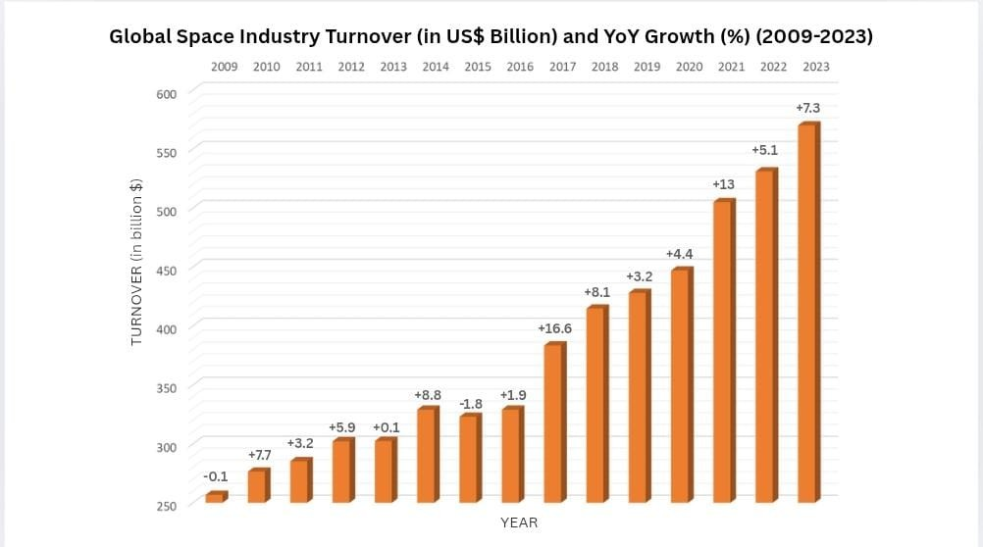
.

.

Fig. 1 SOURCE-https://www.statista.com/statistics/946341/space-economy-global-turnover

Revenue in 2009 declined by 0.1% compared to 2008, as an aftermath of the 2008 financial crisis [6] However, the sector rebounded strongly in 2010. This recovery was largely driven by increased demand for space based ser-vices such as GPS navigation, direct-to-home television, and smartphones using GNSS (Global Navigation Satel-lite System) along with the expansion of international space programs, which played a key role in sustaining growth.[7].The global space economy experienced a slight dip again in 2015, with a minor decline of 1-2% compared to 2014. This unusual drop was primarily due to change in currency. Between 2014 and 2015, the
U.S. dollar became much stronger. As a result, although space companies and budgets in other countries were growing in their own currencies, they appeared smaller when converted to U.S. dollars.[5]
A pronounced spike occurred in 2017, with the global space economy growing by approximately 16-17%. This surge was because of explosive growth in the commercial segment and renewed government investment. Notably, the number of satellites launched and deployed doubled compared to the previous year, largely due to the rise of large constellation and smallsat developments.[8]

According to the Space Foundation, the space sector not only faced the challenges of the Covid-19 pandemic in 2020, but came out even stronger. Despite pandemic, the space economy increased by 4.4%, supported by increase in demand for connectivity and remote sensing services during the pandemic.[9]

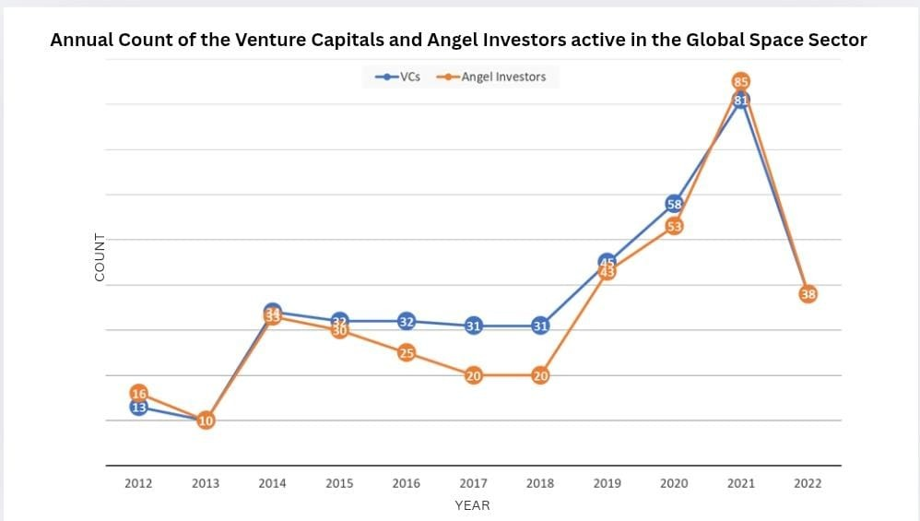
.
Fig. 2 source link

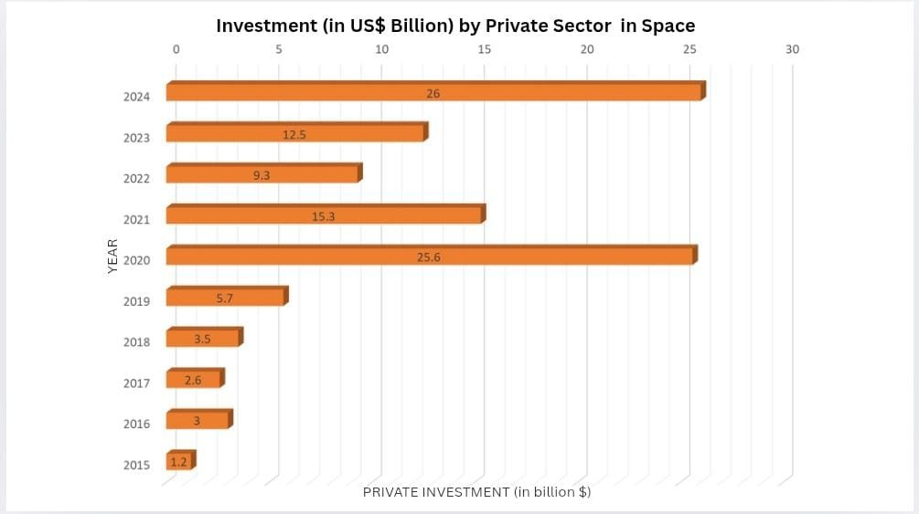
Fig. 3 source link

Another significant jump occurred in 2022, about 8% growth was recorded. Key drivers a steep rise in gov-ernment spending (in reaction to geopolitical tensions, notably the war in Ukraine) and continued expansion of commercial constellations.[10]
While government initiatives and commercial innova-tion have played a central role in driving space sector growth, a key force behind this momentum has been pri-vate investment. Investors from venture capitalists to institutional firms have increasingly recognized the space industrys economic potential. Falling launch and satellite costs are driven by a surge in private investment. This influx of capital has en-abled new space ventures and lower barriers to enter.[11] This growing investor confidence is clearly reflected in the rising number of active investors and the steady expan-sion of private sector funding, as illustrated in the graph below.

TECHNOLOGICAL BREAKTHROUGHS
What once seemed like science fiction is now reality. Once which was slow, costly and exclusive is now fast, efficient and increasingly accessible. The changes below reflect this shift: transformative, precisely engineered, and driven by innovation.

FROM TINY SALYUT CAPSULE TO GI-GANTIC ISS
section The first station, Salyut 1 (launched in 1971), was only 20m long and held a three-man crew for just
24 days. [12] Years later, MIR station was a multi-
module Russian lab that stayed continuously inhabited for 10 years.[13]Today, the ISS is far more advanced: its a one million-pound international lab in space spanning an area comparable to football ground.[14] It has been continuously crewed since November 2000, with up to seven astronauts aboard at a time.[15] On September 23, 2024 Dr. Oleg Kononenko and Nikolai Aleksandrovich Chub of Roscosmos set a record for the longest single stay aboard the ISS, spending 374 consecutive days in orbit. This milestone highlights how the ISS has evolved into a fully functional space habitat, capable of sustaining hu-man life for extended periods without adverse effects. To stay healthy in microgravity, astronauts exercise about 2-3 hours every day using special gear: a resistive weightlift-ing machine, a treadmill and a stationary bike.[16]Its ad-vanced water filtration system recycles up to 93% of on-board water, that also helps to generate oxygen. Every six
weeks, astronauts receive customized food supplies based on their preferences. Interestingly, on August 10, 2015, astronauts sampled their first space-grown salad and to-day they are able to cultivate radishes in space a crucial step toward long term space habitation.

STAT-ION | LAUNCH YEAR | TOTAL VISI-  TORS | COUNT-RIES  IN-VOLVED | CONTI-NUOUS MANNED | CREW CAPAC-ITY
Salyut 1 | 1971 | 3 | 1 (USSR) | No (24-  day mis-sion) | 3
MIR | 1986 | 125 | 12 | Yes (10 years) | 3
ISS | 1998 | 285 | 23 | Yes (24+  year) | 6-7
Table 1 Comparison of space stations

On the ISS, research happens in orbit much like in Earth lab but with weightlessness. Cargo spacecraft ( e.g. SpaceX Dragon) regularly deliver essentials and bring back experimented samples to Earth. It has en-abled thousands of experiments across biology, physics, medicine and Earth science which resulted in the growth of high quality protein crystals for drug development, and operation of Alpha Magnetic Spectrometer has collected data on over 100 billion cosmic particles that is help-ing scientists to study dark matter, fifth state of matter is achieved called as Bose-Einstein condensate (BEC), this may provide a better understanding of fundamental laws of quantum mechanics. Additionally, it has helped to uncover the surprising ways in which the human body changes in microgravity and has contributed to studies on major diseases like Alzheimers, Parkinsons, Cancer, Asthma and cardiovascular conditions. [16]
The journey from Salyut to MIR to the ISS shows how each generation of stations has taught us how to live in space and why exploring is worth the effort .

FROM COLUMBIA TO FALCON: EVOLU-TION OF REUSABILITY
The concept of reusing rockets began with NASAs Space Shuttle program, where Columbia played a key role. While it was a groundbreaking idea at the time, the technology had several limitations and risks. Years later, SpaceX brought a new approach to reusability with its Falcon rockets, making space travel more efficient and

cost efficient. Below is a comparison of how these two systems differ in design purpose, and performance.

ASPECT | COLUMBIA SPACE SHUTTLE | FALCON 9
Propulsion/Tech | Launched by three  reusable RS-25 main engines and two solid boosters. The orbiter carries a robotic arm  for cargo operations and uses thermal tiles for re-entry. | It uses 9 Merlin 1-D  engines (gas generator cycle, RP-1). A single Merlin vacuum engine powers the upper stage. Falcon 9 uses grid fins and legs to control de-scent and emphasizes  rapid boosters reuse.
MATERIAL | The orbiter and tank use aluminium alloys. The orbiters bottom is cov-  ered with silica based  tiles and carbon-carbon panels, Solid Rocket Boosters have steel cas-ing. | Tanks are made up of aluminium-lithium al-loy. The interstage and nose fairing are carbon-fiber composite. Land-  ing legs are carbon-fiber with aluminium honey-comb cores.
OPERATIONAL EF-FICIENCY | Orbiters only flew 25–30 missions each and re-  quired months of main-tenance between flights. The fleet launched only a few times per year on average | Falcon 9 has flown 500+ missions by mid 2025, individual boosters have flown 20–28 times. Rapid booster reuse en-ables many launches per year.
REUSABLE PARTS | Orbiter (the main  winged spacecraft) and 2 Solid Rocket Boosters | First stage booster with 9 engines and landing  legs
NON REUSABLE PARTS | External Fuel Tank (dis-carded after launch) | Second Stage (burns up after delivering payload).
HOW IT IS REUSED | The Orbiter glides back to Earth and lands on a runway. Solid Rocket Boosters fall into the ocean with parachutes and are recovered & re-furbished. | First stage lands verti-cally after mission com-pletion.

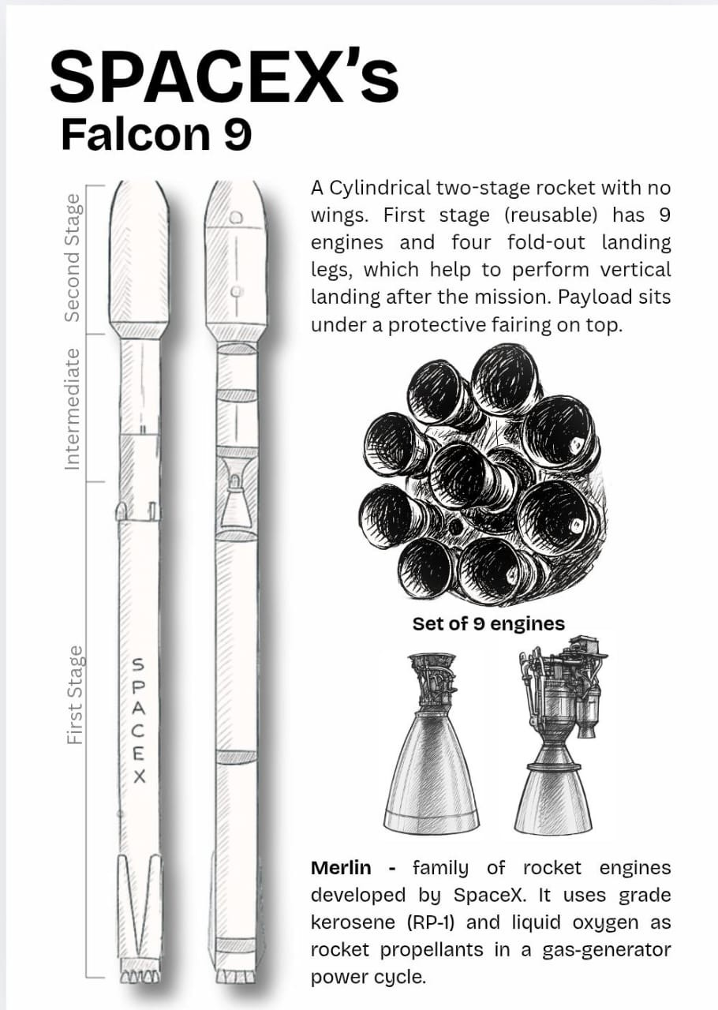
.

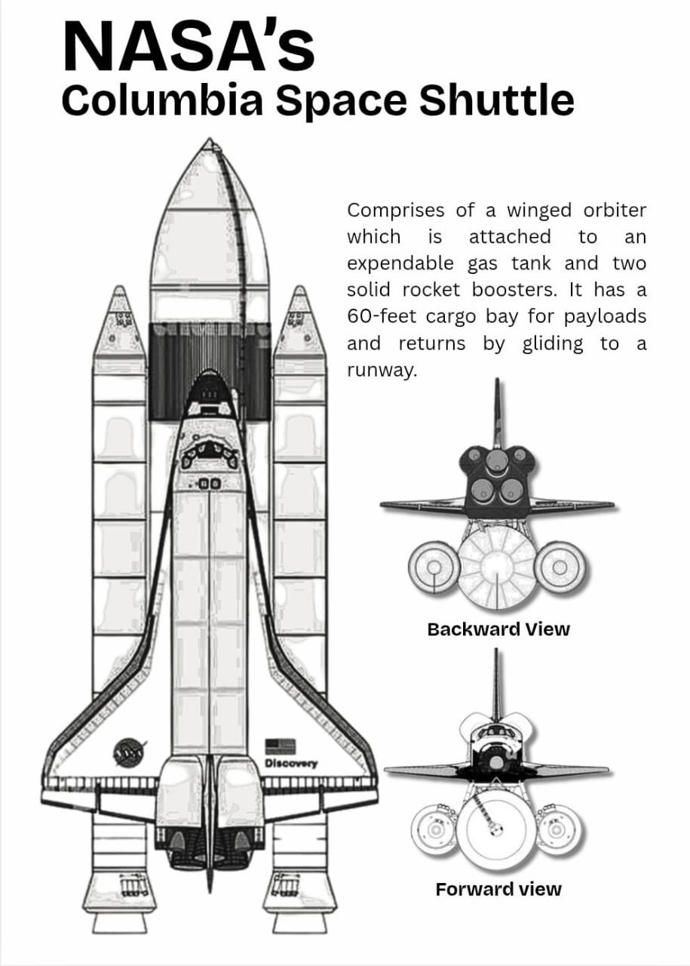
.

ADVANCEMENTS IN SATELLITE MANU-FACTURING METHODS
Satellites used to be very large, custom-built machines made by big space agencies. They were expensive and took many years to build. Today, many satellites are small and built from standard parts. This change has made space more accessible and cheaper. In the following sec-tion, we are going to compare traditional large-scale man-ufacturing with modern small/cubesat methods in terms of cost, size, efficiency, lifespan, and reliability. Manu-facturing Costs from high custom costs to low modular production. [17]
- Large Satellites: Custom design and assembly make them very expensive. A single large satellite (for ex-ample, a GPS satellite) can cost tens of millions of dollars . Conventional satellites often cost $ 110-330 million each. Development is labor-intensive and takes 5-10+ years. Most parts must be designed and tested from scratch, adding to the cost.
- CubeSats and smallsats: Use standardized, off-the-shelf modules. A CubeSat can cost only thou-sands to a few hundred thousand dollars to build. Factory-style production and Commercial-off-the-shelf (COTS) products cut costs. Launch costs are lower too, because CubeSats are light, it costs only
$5,000-10,000 per pound to reach low Earth orbit. Small sats can often ride as secondary payloads or use rideshare.
Size and Mass Heavy satellites vs compact CubeSats and Smallsats
- Large Satellites: Weigh hundreds to thousands of kilograms. For example, a typical large satellite weighs 500 kg, often 1000 kg. They can be sev-eral meters across when solar panels and antennas are extended.
- CubeSats and smallsats: Are much smaller and lighter. A standard CubeSta unit (1U) is just a 10 × 10 × 10 cm cube (1–1.5 kg). Even larger small-sats (microsats) stay below 500 kg.
Efficiency and Use Cases Performance, deployment speed, and accessibility
- Large satellite: Carry powerful instruments (big an-tennas, cameras, telescopes) for tasks like global
communications, high-resolution Earth imaging, or deep-space science. They offer high performance per satellite. However, they take many years to design and build. Launching a large satellite usually requires a dedicated rocket or heavy-lift vehicle, and waits for a launch slot. This makes deployment slow and costly. Only governments or large companies could traditionally afford and use them.
- CubeSats and smallsats: Are deployed much faster and by more users. Small satellites often use the lat-est electronics and can be ready in months instead of years. They can hitch rides on rockets as secondary payloads, so launch schedules are made flexible. Be-cause they are lower-cost, universities, startups, and small countries can build and launch them. CubeSats are often used in constellations dozens or hundreds working together, providing services (like Earth im-agery or IoT communication) that would otherwise need one big satellite. This redundancy also dis-tributes risk (if one CubeSat fails, others can con-tinue).
Lifespan Difference in mission duration
- Large Satellites: Designed for long missions. Most geostationary and major satellites are built with 15 years lifespan. They undergo extensive testing to last a decade or more before retirement. Operators usu-ally plan to decommission or move them to a grave-yard orbit at the end of 15 years.
- CubeSats and Smallsats: Have shorten mission lives. A typical CubeSat is only expected to operate for 1–4 years. They carry smaller batteries and are in low orbits where atmospheric drag can decay them. This short life is by design, constellations regularly replace Cubesats with updated versions. In contrast, large satellites remain on the same mission for many years, even using older technology by the end of their life.
Failure Rate - improved designs lower satellite failure
- Large Satellites: Are built and tested to very high standards. Failures are rare a well planned large satellite has about a 90% success rate. If a large satellite fails (for example during launch or early or-bit), it is a major loss and replacing it can take years. Operators use redundant systems and exhaus-tive testing to avoid failures.

- CubeSats and Smallsats: Early many smallsats failed more often. A NASA study found that from 200–2026 about 41% of small satellites had total or partial mission failures. However, lessons learned and bet-ter designs have greatly improved reliability. Recent CubeSats succeed much more often. NASA reports the smallsats failure rate has roughly halved in the past decade. In practice, CubeSats constellations use backups, so a single failure does not stop the mission (other units take over).

FROM CHEMICAL PROPULSION TO ION AND NUCLEAR PROPULSION CON-CEPTS
Early chemical rockets burn liquid or solid fuels with an oxidizer to create a high-pressure gas that rushes out a nozzle, producing a powerful thrust. Pioneers like Robert
H. Goddard launched the first liquid rocket in 1926 and Hermann Oberth and Wernher von Braun developed ever larger chemical rockets (e.g. the V2 and Saturn V) to reach space and the Moon. Chemically propelled rock-ets require carrying large fuel loads. For example, NASAs documentation shows that the Saturn V first stage test in 1967 fired five F-1 engines at once. These engines produced an enormous bright flame as they burned pro-pellant. Modern rockets use similar combustion, Space Shuttle main engines (RS-25) or future SpaceX raptor engines burn thousands of gallons of propellant for a few minutes to generate lift off. The specific impulse of these engines (hundreds of seconds) limits how far they can go before running out of fuel. Once their tanks are empty,
the rockets have almost no thrust left. [18]
ION AND ELECTRIC PROPULSION: HIGH EFFI-
CIENCY, LOW THRUST In the mid-20th century, sci-entists proposed using electrical energy to accelerate ions or plasma . Herman Ob earth described the idea of an ion engine as early as 1929. Practically, NASA researchers Ernest Stuhlinger and Harold Kaufman built the first ion engines in the 1950s. Ion thrusters (and related Hall-effect thrusters) work by ionizing a noble gas (like xenon) and using electric/magnetic fields to expel the ions at very high speed. This yields a very high effective exhaust velocity and impulse (often thousands of seconds). How-ever, each thrusters produces only a few millinewtons of force (fraction of a newton). For example, Dawns 12.5 kW ion thrusters produced about 91mN each at full power (roughly the force of holding a single sheet of paper). At that gentle push, it would take days just to reach high-
way speeds. Because they can fire for months or years, ion engines can achieve very lare velocity changes with tiny propellant mass. As NASA notes, electric propulsion can cut propellant needs by 90% compared to a chemical mission, saving millions in mass (which is crucial for deep-space probes). In summary, ion/electric systems trade low thrust for extremely high impulse, they can slowly but steadily push a spacecraft for long duration, making mis-sions to distant targets (asteroid, comets, outer planets) feasible without prohibitive fuel. [19]

STRATEGIC AND SOCIETAL NEEDS
Space Ventures are not driven solely by scientific curiosity or technological progress they are deeply rooted in strate-gic priorities and the broader well being of human society. These efforts support national security, enable critical en-vironmental monitoring, aid in disaster management, and contribute to humanity s long-term survival. Moreover, they play a vital role in improving everyday life through advancements in communication, navigation, healthcare, education and bridging the digital inequality, especially in underserved regions.
Imagine waking up and realizing that all satellite sig-nals have suddenly disappeared. A Day where nothing seems to work as usual might look like this: your phone shows no connection, your breakfast order never arrives because the delivery person cant locate your address. Not just a meal your newly ordered shoes and even your last minute booked cab cant reach you, forcing you to get them yourself. You fail to make a video call and send a text message, watching live sports or international news become impossible as streaming services go down. Mean-while, bus schedules are not updated, flight arrivals or delays become uncertain, making travel plans chaotic. In case of an emergency, ambulances and rescue teams are unable to locate people or send timely alerts. Even a sin-gle day like this without satellites would disrupt countless services society often takes for granted. These potential breakdowns underscore how deeply our modern infrastruc-ture depends on space-based systems and highlights why space ventures are not just important they are essential.

HEALTHCARE

USE CASE | SPACE PRO-GRAM/ OR-GANIZA-  TION | HOW SPACE TECH WAS USED | BENEFIT ACHIEVED | QUANTIFIABLE IMPACT
Telemedicine | ISROs  Telemedicine program | Satellite network links remote clin-ics, GEO satellite (INSAT, GSAT) | Facilitated remote spe-cialists consultation, contributing to a decline in mortality rates. | Network consists of 100 hospi-tals 78 rural hospitals/health care centres with 22 super  speciality hospitals in urban cities. In Karnataka, among 1000 rural patients, approxi-  mately 80% of travel related expenses were saved. [20]
Diagnostics | NASAs ADUM  program (Ad-vanced diag-nostic ultra-sound in mi-  crogravity) via ISS. | Uses low-cost portable ultra-sound devices connected via NASAs TRDSS  or commercial  satellites to trans-mit medical data in real time. | Enabled tele-ultrasound in rural clinics, allows non-experts to perform diagnostic scans with  remote expert guidance. | 45,000+ healthcare workers trained across 60+ countries, improved early diagnosis in low-resource settings (e.g.  Lung injury detection) [21]
Contactless Health Monitors | NASA | Uses radar sensing tech to construct “Cardi/o” Moni-tor: tracks heart  rate and breathing from a distance, data sent online to doctors. | Reduces need for fre-quent in-person check-ups, enables remote monitoring of chronic conditions. | Deployed in homes and clinics; effective in monitoring conges-tive heart failure (CHF) and sleep apnea. [22]

EDUCATION

USE CASE | SPACE PRO-GRAM/ OR-GANIZA-  TION | HOW SPACE TECH WAS USED | BENEFIT ACHIEVED | QUANTIFIABLE IMPACT

Satellite distance learning | ISROs  EDUSAT and Tele Education Program | Satellite network helps to connect  remote classrooms with educators | Improved rural and re-mote access to quality education, reduced the urban-rural education gap. | Approximately 15 million  students benefit each year; network spans over 59,700  schools and colleges, includes 4,700 two-way interactive classrooms and 55,000+ one-way terminals. [23]
Space Sta-tion edu-cation out-reach | NASA, ISS, ARISS | ISS used for stu-dent science projects, radio  chats with astro-nauts and educa-tional videos. | Global science engage-ment for youth, exposed millions of students to  real-life space science. | ARISS has reached over 160,000 people worldwide. ’ISS Above’ engages 80,000+ users. Sally Ride EarthKAM reached 100,000+ students.

AGRICULTURE

USE CASE | SPACE PRO-GRAM/ OR-GANIZA-  TION | HOW SPACE TECH WAS USED | BENEFIT ACHIEVED | QUANTIFIABLE IMPACT
Precision Irrigation | NASAs GOES  and Landsat, TULE tech-  nologies (USA) | Satellite imagery and field sensors calculate evapo-transpiration and water use. | Optimised irrigation, conserved water while maintaining yield. | Achieved 50% reduction in irrigation water consumption. [24]
Vertical farming | NASA plant growth R&D, Intravision (Canada) | LED and hydro-ponic systems  from space life support applied in indoor farms. | High yield food with minimal land and water. | Facility grows 300400 tons of lettuce/year using 95% less water. [25]
Space-bred crops | CNSA | Seeds exposed to space for mu-tation, better  yield/stress tol-  erance tested after return. | Boosted food produc-tion and national secu-rity. | Produced 240+ new crop va-rieties, ’Luyuan 502’ wheat grows on 6.7M hectares, boosting grain output by 2B+ kg/year.

TRANSPORTATION

USE CASE | SPACE PRO-GRAM/ OR-GANIZA-  TION | HOW SPACE TECH WAS USED | BENEFIT ACHIEVED | QUANTIFIABLE IMPACT

Global Nav-igation | US GPS,  Galileo (EU) | GNSS satellites provide position-ing, navigation, and timing. | Reduces travel time, fuel use, enables new  services like ride hailing. | Galileo serves nearly 4B de-  vices globally, 4x better accu-racy than GPS.
Automotive materials | Goodyear + NASA | Mars parachute fiber adapted to tires. | Increased tire durabil-ity, safety, and reduced replacements. | Tread life increased by 1,000 miles, reduced customer costs.

SATELLITE AIDED DISASTER RELIEF AND ENVIRONMENTAL MONITORING

USE CASE | SPACE PRO-GRAM/ OR-GANIZA-  TION | HOW SPACE TECH WAS USED | BENEFIT ACHIEVED | QUANTIFIABLE IMPACT
Search and rescue | NASA, NOAA, COSPAS-SARSAT | GPS beacons send emergency signals to satellites for location tracking. | Faster rescue response and saved lives. | 407 lives saved in USA (2024);  50,000+ globally since 1982.  [1.8]
Satellite  Internet in crisis | SpaceX Star-link, Iridium | Satellite inter-net deployed to  restore communi-cation. | Enabled rescue coordi-nation and critical com-munications. | Starlink: 800+ terminals  post Hurricane Ian. Iridium: 5,000+ devices in use. [26]
Tsunami early warn-ings | NASA, NOAA,  Iridium | DART buoys send tsunami data via satellites. | Faster alerts and evacu-ation readiness. | Alerts issued within minutes of offshore quakes. [27]
Wildfire monitoring | NASA, NOAA | Satellites scan forests for ther-mal and smoke signatures. | Real-time alerts enable faster response. | Hourly/daily fire maps track dozens of wildfires.[28]
Flood fore-casting | NOAA, ESA  Copernicus Sentinel-1 | Satellites monitor rainfall, rivers, flood extent. | Improved evacuation and relief planning. | Bangladesh extended flood warning lead time from 3 to 5 days. [29]
Hurricane tracking | NOAA, Japan | Satellites observe storm metrics for better prediction. | More accurate hurricane forecasts. | JPSS data provides 85% of  inputs for storm models. [30]
Volcano monitoring | NOAA, EU-METSAT | Satellites detect thermal hotspots, ash clouds, SO₂. | Timely warnings for air and public safety. | Meteosat-11 tracked  ash/SO₂ over Sicily; flights rerouted.[31]
Deforestation tracking | NASA, ESA,  Brazil INPE DETER | Satellites monitor forest loss, illegal logging. | Targeted conservation and carbon emission reduction. | Preserved 652,000 km2 of Amazon forest (20002015).  [32]

Who is turning Space ambition into reality? The Leaders behind Space Missions
Behind every satellite launch, crewed mission, and deep space probe, there are powerful players working tirelessly From national space agencies with decades of experience to private companies revolutionizing the space economy, and innovative startups disrupting traditional methods each plays a vital role. This section takes a closer look at these key contributors, beginning with government agen-cies, followed by private sector giants, and finally, the rising startups shaping the next era of space ventures.

NATIONAL SPACE AGENCIES
section For decades, national space agencies have been the primary architects of humanitys journey beyond Earth. Backed by government funding, scientific institutions, and international alliances, these agencies have achieved re-markable milestones from the first Moon landing to on-going deep space exploration. Each agency reflects the vision, priorities, and technological strengths of its na-tion, playing a crucial role in shaping the global space agenda.

NASA National Aeronautics and Space Ad-ministration (USA)
It was created in the Cold War era as the United States civilian space agency, in response to the Soviet Sputnik launch, Congress passed the National Aeronautics and Space Act of 1958, and President Eisenhower signed it on July 29, 1958.[33] NASA officially opened for business in 1958, incorporating the National Advisory Committee for Aeronautics (NACA) and several research centres. Its initial purpose was to lead Americas exploration of space and aeronautical research, with goals in science, technology and international cooperation.[34]
1961–1963 | PROJECT MERCURY  The first American human space-flight program proved that humans could launch and re-enter. Techni-cally it developed heat shield reen-try capsules, basic life support, and  guidance for orbital insertion.[37]
1965–1966 | PROJECT GEMINI  Its twelve crewed missions tested critical technologies: two astronaut operations, orbital maneuvering, docking systems, and the first U.S. extra-vehicular activity (Gemini IV saw Ed Whites first U.S. spacewalk). It introduced the Titan II and two-man Gemini capsule. It validated long-duration flight, spacecraft ren-  dezvous and orbital station keeping (using onboard thrusters). [38]

Future Missions:
NASAs upcoming missions reflect a bold new era of exploration, Artemis III set for 2027, aims to return humans to the Moon-landing near the lunar South

Pole with SpaceXs Starship, construction of the Lunar
Gateway, a modular station in cislunar orbit launching by 2028.[35] NASA also plans a crewed Mars mission in the 2030s, building on Artemis experience, Mars Sample Return and technologies like deep-space propulsion.[36] In planetary science, the Europa Clipper (2024-2030) will study Jupiters icy moon for habitability. From 2028 to 2034, Dragonfly will explore Titans surface (moon of Sat-urn) with a nuclear-powered rotorcraft. NASAs Nancy Grace Roman Space Telescope (2027) will investigate dark energy, exoplanets and cosmic structures. Additional missions VERTAS and DAVINCI+ to Venus, SPHEREx for cosmic inflation, and continued solar and interplane-tary studies.

Timeline of Major Achievements

1968–1972 | APOLLO PROGRAM  Its goals were to land Americans on the Moon, establish U.S leadership in space and conduct science on the lunar surface. Milestones include Apollo 8 (first crewed lunar orbit,  Dec 1968), Apollo 11 (first Moon  landing, July 1969). [39]
1973–1974 | SKYLAB SPACE STATION  Three astronaut crews (each 28–56 days) performed 270 experiments in life sciences, Earth observations, solar physics, etc. It demonstrated long-duration human habitation,  multi-module assembly, and in-orbit repair. [40]
1975 | APOLLO-SOYUZ TEST PROJECT  The first U.S.-Soviet joint crewed mission. U.S. astronauts and So-viet cosmonauts conducted joint experiments. This historic docking established international docking  standards and bi-national mission protocols.[41]
1981–2011 | SPACE SHUTTLE PROGRAM  Reusable orbiters (Columbia, Chal-lenger, Discovery, Atlantis, Endeav-our) flew for 135 missions over 30 years. Shuttle missions greatly ex-panded space access: they deployed satellites, interplanetary probes, serviced Hubble, and carried con-struction crews to the ISS. It also launched planetary science mis-  sions and performed microgravity research.[42]
1990–  present | HUBBLE SPACE TELESCOPE  It was placed in low Earth orbit as a space-based observatory which delivered deep and clear images of galaxies, nebulae and exoplanet at-mospheres. It carries a 2.4 m pri-mary mirror and multiple inter-  changeable instruments (cameras, spectrographs).[43]

2004–2017 | CASSINI-HUYGENS MISSION  (Saturn)  It orbited Saturn from 2004 to 2017. It was the first long-term Saturn or-biter, returned with detailed data on Saturns rings, magnetosphere and its  moons. It discovered liquid methane lakes and water-ice plumes.[44]
2004–2018 | MARS ROVERS (Spirit and Op-portunity)  NASA landed twin rovers on Mars in 2004. Both of them outlived their 90-day design lifetimes (Spirit until 2010 and Opportunity until 2018).  They confirmed that Mars once had liquid water, found sedimentary rocks and minerals (e.g. sulphates). Each rover had a suite of cameras, spectrometers and a rock abrasion tool, powered by solar panels and could travel 28 km. They demon-strated successful Mars landing, au-tonomous mobility, and long-term  planetary surface operations.[45]
2012–  present | MARS ROVER CURIOSITY  It was a Mars Science Laboratory mission landed in Gale Crater. At launch it was the largest and most capable Mars rover. Its goal was to assess the past habitability of Mars.  Its discoveries include evidence of ancient streambeds and organics, confirming Mars wet history.[46]
2018–  present | PARKER SOLAR PROBE (Sun)  It has set records for the closest  human-made object to the Sun. It makes repeated close passes of the Sun, studying the solar corona.[47]
2021–  present | JAMES WEBB SPACE TELE-SCOPE  It is an infrared space observatory with 8 m square mirror, jointly with ESA and CSA. Its goal is to study  the early universe, galaxy forma-tion, star formation, and exoplanet atmospheres.[48]

ISRO Indian Space Research Organisation (INDIA)
Year | Details
1975 | ARYABHATA  Indias first satellite launch by USSR. Its main objective was to study  Earths ionosphere and solar X-ray emissions.
1979 | BHASKARA-I  First Indian remote sensing satellite launched by the USSR, carried TV cameras and microwave radiometer to gather environmental data.
1980 | Rohini Satellite RS-1  It was successfully launched by In-  dias rocket (SLV-3). Its purpose was to monitor launch-vehicle perfor-mance.
1981 | ARIANE PASSENGER PAYLOAD EXPERIMENT (APPLE)  First Indian 3-axis stabilized satellite, tested GEO station-keeping (being  in the designated orbit without get-ting drifted by forces present in the space) and advanced communication experiments.
1983 | INSAT-1B  First operational satellite in INSAT series, expanded Indias national com-munication and weather monitoring capabilities.
1988 | INDIAN REMOTE SENSING SATELLITE (IRS-1A)  First indigenously built remote sens-ing satellite, carried cameras that provided high-resolution imagery.
1994 | POLAR SATELLITE LAUNCH VE-HICLE (PSLV)  First successful flight of PSLV, IS-ROs own medium-lift launcher.

Indias space programme was initiated in the early 1960s under Dr. Vikram Sarabhai. In 1962 Sarabhai founded the Indian National Committee for Space Research (IN-COSPAR) under the Department of Atomic Energy. The first activities took place in a converted church in Thumba, Kerala which was used as INCOSPARs first laboratory. On 15 August 1969 the Government of In-dia replaced INCOSPAR with the Indian Space Research Organisation (ISRO). A Space Commission and Depart-ment of Space were established in 1972, making ISRO an autonomous agency under government sponsorship. [51]
Future Missions
ISRO has planned a human spaceflight program Gaganyaan, to send an Indian crew to 400 km orbit. Preparation includes uncrewed test flights and life-support development. According to ISROs plan: an uncrewed Gaganyaan flight is targeted by late 2025 and a crewed flight (three astronauts , called Gagannauts) by 2027. Ul-timately, ISRO intends to build Indias own space station, the Bharatiya Antariksha Station that is going to have 5 modules and is expected to be operational by 2035. ISRO is also preparing for Shukrayaan-1 (a Venus orbiter) for launch around 2028, with instruments (radar, spectrom-eters) to study Venus’s atmosphere and geology. The RLV-TD hypersonic glider (flown in 2016) is also planned
to scale up to a two-stag reusable launcher. [52]

Timeline of major achievements [2]
2021–  present | PERSEVERANCE MARS ROVER  It was landed at Jezero Crater and has similar design to Curiosity rover but with a drill to collect core sam-ples and ground penetrating radar.  Also, has Ingenuity, the first powered Mars helicopter, which achieved the first extraterrestrial powered flight  — beginning Mars Sample Return campaigns. [49]
2022 | ARTEMIS I (Moon)  The first flight of NASAs new deep-space system. It was an uncrewed  test of the Space Launch System (SLS) rocket and Orion spacecraft around the Moon. Its success cleared the way for Artemis II (crewed lunar  orbit) and Artemis III (lunar land-ing). [50]

2008 | CHANDRAYAAN-1  India’s first lunar mission, confirmed the presence of water/hydroxyl on  the Moon. It returned detailed to-pographic and spectral data of the lunar surface.
2013 | INDIAN REGIONAL NAVIGATION SATELLITE SYSTEM-1A  Initiated Indias indigenous naviga-tion constellation (NavIC), provided autonomous positioning and timing services regionally.
2013 | MARS ORBITAL MISSION (MAN-GALYAAN)  Indias first Interplanetary mission to study Martian surface and atmo-sphere. This made India, the first  country to reach Mars orbit on its maiden attempt.
2014 | GEOSYNCHRONOUS SATELLITE LAUNCH VEHICLE  First successful launch using Indias own cryogenic engine, placed GSAT-14 into precise orbit a major step in heavy-lift capability.
2015 | ASTROSAT  Indias first dedicated space tele-scope, enabled simultaneous UV and X-Rays observations of stars, galax-ies and other cosmic sources.
2017 | PSLV-C37 (CARTOSAT-2D and 103 NANOSATS)  Set a world record by launching 104 satellites in one mission.
2023 | SMALL SATELLITE LAUNCH VE-HICLE -D2  First successful flight of SSLV, injected EOS-07, Janus-1 and AzaadiSAT-2 into their intended or-bits, enabling rapid, low cost access for nanosatellites.
2023 | CHANDRAYAAN-3  First India soft landing on the moon.

2023 | ADITYA-L1  Indias first space based solar mission, placed in halo orbit at L1 for unin-terrupted solar corona observation (studying Coronal Mass Ejections (CMEs), flares, etc).

JAXA Japan Aerospace Exploration Agency (JAPAN)

It was officially established in 2003 by merging three earlier organizations: ISAS (Institute of Space and As-tronautical Science), NASDA (National Space Develop-ment Agency), and NAL (National Aerospace Labora-tory). [1] This integration united Japans space and aero-nautics research under one agency, designated as a core national R&D organisation for aerospace. Before this, ISAS (founded in 1964) had launched Japans first satel-lite Ohsumi in 1970, while NASDA (founded in 1969) developed the H-II rocket and even selected Japans first astronauts in 1990. [53] By bringing these capabilities together, JAXA inherited a legacy of satellite launches, rocket development, and astronaut training, enabling it to conduct integrated missions from scientific research to exploration.

Timeline of major achievements [3]

Year | Details
2006 | ALOS  It was the first satellite launched specially for high resolution carto-  graphic mapping and disaster obser-vation.
2007 | SELENE  Japans first large scale lunar mis-sion to study the Moons origin, com-position, and geological evolution.  Used radar sounders, spectrometers, and terrain cameras. Provided the most detailed global lunar topog-  raphy map to date, confirmed the Moons ancient volcanic activity.

2008 | KIBO (ISS JAPANESE EXPERI-MENT MODULE)  Installed with pressurised and un-pressurised sections, enabled long-term materials, biological and fluid dynamics research in microgravity.  Supported global scientific collabora-tion aboard the ISS.
2010 | HAYABUSA & AKATSUKI  Hayabusa became the worlds first mission to return samples from an asteroid (Itokawa), despite major system failures. Akatsuki initially  failed Venus orbit insertion in 2010 but it successfully entered orbit in 2015 and is still returning valuable data on Venusian cloud structures and atmosphere dynamics.
2010 | IKAROS  Worlds first successful solar sail mis-sion. Its purpose was to demonstrate solar sail propulsion a method of  space travel that uses the pressure of sunlight (photons) to move a space-craft. It deployed a 20-meter wide ultra-thin sail made of reflective ma-terial in deep space. It used sunlight alone for propulsion and small LCD panels to control direction via solar  reflectivity. Also, carried instruments for gamma-ray burst detection and  space plasma studies.
2014 | HAYABUSA 2  Its objective was to collect and re-turn samples from asteroid Ryugu to study early solar system materials and organic molecules.
2014 | ALOS-2  The purpose was to monitor disas-ters, forest changes and infrastruc-ture damages with improved resolu-tion (nearly 1m), faster revisit time, nighttime and all-weather imaging.  Focused entirely on L-band Synthetic Aperture Radar (SAR).

2020 | HAYABUSA 2 Sample Return  Sample Capsule was landed safely in Australia, provided pristine carbon-rich asteroid material, including hy-drated minerals and organics key to understanding solar system forma-tion and prebiotic chemistry.
2023 | XRISM  X-Ray Imaging and Spectroscopy Mission to study black holes, galaxy clusters, and supernovae.

Future Missions JAXA is developing several next-generation programs. Its new H3 rocket, designed for higher reliability and lower cost had its first test launch in March 2023 and will become JAXAs primary launcher.
[4] Planned deep space missions include MMX,a Mars-Moon sample-return mission, which is going to launch in 2026. A technology demonstrator mission to fly the as-teroid Phaethon under the program DESTINY+ is also planned.

ROSMOSCOS the State Corporation for Space Activities (RUSSIA)

Rosmoscos is the national space agency of the Russian Federation and the direct institutional successor to the Soviet Union. It was formally established on 25 February 1992, originally under the name Russian Space Agency (RSA) after the dissolution of the Soviet Union. This agency underwent several restructuring becoming the Russian Aviation and Space Agency in 1999, and the Fed-eral Space Agency in 2004 before being reconstituted as a state corporation in 2015, following its merger with the United Rocket and Space Corporation. [54]

Timeline of major achievements
Year | Details
1957 | SPUTNIK 1  Worlds first uncrewed satellite that started the space race. It returned a simple beep signals and atmospheric data.
1961 | VOSTOK 1  First human spaceflight that car-ried cosmonaut Yuri A. Gagarin. He completed one full orbit of Earth.
1963 | VOSTOK 6  It carried Valentina V. Tereshkova into space, making her the first woman to travel beyond Earth. She orbited the Earth for 48 times over a period of 3 days. [55]
1965 | VOSKHOD 2  During this mission Alexei Leonov performed the first ever human ex-travehicular activity (spacewalk). He floated outside the spacecraft for 12 minutes by an umbilical cable. This tested new spacesuit and life-support technologies essential for future lunar and station missions. [56]
1966 | LUNA 9  It became the first spacecraft to  achieve a soft landing on the Moon. It deployed antennas and cameras, transmitted the first panoramic pho-tographic of the lunar surface and soil data. Its success disproved the theory that any lander would sink into dust of the Moons surface. [57]
1970 | LUNOKHOD 1  It was the first remote-controlled rover that was delivered in space. It softly landed on Mare Imbrium (part of the Moon). This eight wheeled rover was operated by controllers on Earth and carried television cameras, spectrometers and soil-test devices. [58]

1970 | LUNA 16  It performed the first automated return of lunar samples to Earth, collected 101g of lunar soil and launched this sample back to Earth. [59]
1971 | SALYUT 1  It was the orbital laboratory, the worlds first space station.
1986 | MIR  It was designed as a modular com-plex with multiple docking ports,  hosted a continuous human presence from 19861999, with 125 astronauts  from 12 countries. [60]
1998 | ZARYA  It was a functional cargo block and the first module of the International Space Station. It provided electric-ity and attitude control until a later module arrived. [61]
2016 | FIRST LAUNCH FROM VOS-TOCHNY  Soyuz-2 rocket lifted off from Rus-sias new Vostochny Cosmodrome. This first launch carried three satel-lites and opened a new Russian spaceport in the Amur Region, re-ducing dependence on Kazakhstans  Baikonur bases.[62]

Future Missions
ROSMOSCOSs long term plan includes completing the Luna series of Moon landers/orbiters, joining China on a permanent lunar base (ILRS) by mid 2030s, building its own space station (ROSS) by 2030, and eventually launching human missions to the Moon and Mars. Along-side these, Russia will continue launching navigation, me-teorology, remote-sensing and communication satellites, as well as science observatories (e.g. Spektr-UV, Spektr-M, Gamma-400). Major development projects include the Angara (modular rocket family to replace older rock-ets), Amur (reusable low cost rocket, powered by liquid methane and oxygen) launcher family and Oryol crew ve-

hicle. [63]
2003 | MARS EXPRESS  ESAs first Mars Mission to study its atmosphere, geology, water inven-tory and potential for life. Results  include detection of small methane plumes in the atmosphere, mapping seasonal CO₂ clouds, auroras and  ancient river valleys.
2004 | ROSETTA  First mission to orbit and land on a comet. It has returned vast data, re-vealing the comets two-lobed shape, abundant complex organics and sil-icates, surface dust processes and even suggestive links between its and Earths atmosphere (e.g. delivery of noble gases).
2005 | VENUS EXPRESS  Delivered the first global infrared map of Venuss surface and atmo-sphere. Key findings included ev-idence that Venus once had plate  tectonics and oceans (based on min-eral variation). Discovered unex-pected atmospheric chemistry (hy-droxyl and nitric oxide nightglow) and monitored volcanism, polar vor-tices and water loss processes.
2009 | HERSCHEL SPACE OBSERVA-TORY  The largest infrared telescope, it made observations of star-forming regions and galaxies, detecting  huge amounts of water and other molecules in planetary birthplaces.  Its results have advanced knowledge of how stars and solar systems form.
2009 | PLANCK  Cosmic Microwave Background (CMB) Mission at L2 (located 1.5 million kilometres directly behind  the Earth as viewed from the Sun). Produced the most precise all-sky temperature and polarization maps of CMB ever made.

ESA European Space Agency
It is a pan-European space organisation established in 1975 by merging the European Launcher Development Organisation (ELDO) and the European Space Research Organisation (ESRO). It now has 23 member states, governance includes a Council of representatives from each member country and a Science Program Commit-tee, with a Director General as chief executive. Major ESA facilities include ESTEC (technical R&D, Nether-lands), ESOC (mission control, Germany), ESRIN (data processing, Italy), EAC (astronaut training, Germany), ESAC (science archives, Spain) and the Guiana Space Centre (launch operations, French Guiana). [64

Timeline of major achievements

Year | Details
1985 | GIOTTO  First ESA deep-space probe to Comet Halley, obtained the first  close-up images of a comet nucleus and first detection of organic com-pounds in Halleys Comet.
1999 | XMM-NEWTON  X-ray multi mirror mission to survey the hot and extreme universe (galaxy cluster, black hole, neutron star) with X-ray telescope.
2002 | INTEGRAL  First space observatory to image in gamma-rays, X-rays, and visible light simultaneously. It has discovered  new gamma-ray sources, imaged gamma-ray bursts and supernovae and probed element formation in dy-ing stars.
2003 | SMART-1  First European spacecraft to orbit  the Moon, conducted the first com-plete elemental mapping of the lunar surface and searched for water ice at the poles.

2.1.6.1 Timeline of key achievements
2013 | GAIA  Over more than ten years, it col-lected trillions of stellar observa-tions, producing the largest and most precise star catalog to date.  Its data has revealed the structure of the Milky Ways spiral arms, warp, galactic bar, streams from ancient mergers; founded thousands of new star clusters and exoplanet hosts; detected hundreds of thousands of  asteroids and even discovered nearby black holes and quasars.

Year | Details
1999 | SHENZHOU-1  First uncrewed test of new crewed spacecraft, verified life support and docking system.
2003 | SHENZHOU-5  First Chinese human spaceflight. Yang Liwei became the first Chinese astronaut, orbited the Earth for ap-proximately 21 hours.
2005 | SHENZHOU-6  Carried two astronauts for nearly 5 days testing life-support and scien-tific experiments.
2007 | ASAT MISSILE TEST  Ground-launched ASAT missile de-stroyed Chinas FY-1C satellite, demonstrated anti-satellite capa-  bility.
2007 | CHANGE 1 - LUNAR ORBITER  First Chinese lunar probe, mapped the Moons surface (3D terrain, ele-ment abundance), aiding later land-ing site selection.
2008 | SHENZHOU-7  Crewed mission that included a spacewalk for the first time, per-formed by a Chinese astronaut.
2010 | CHANGE 2 - LUNAR ORBITER  Improved lunar mapping to prepare for landings. It flew by asteroid Tou-tatisChinas first visit to an asteroid.
2011 | TIANGONG-1 SPACE LAB  Space laboratory prototype, tested  spacecraft docking and crewed visits.
2011 | SHENZHOU-8  Uncrewed docking test. Chinas  first orbital rendezvous and dock-ing. Shenzhou-8 docked twice with Tiangong-1.

Future Missions
The European Space Agency (ESA) has an ambitious roadmap of future missions spanning human exploration, planetary science, astrophysics and Earth observation through 2047. Key projects include continued contribu-tions to NASAs Artemis program with the European Ser-vice Module for lunar missions and the development of Space Rider, a reusable orbital platform. ESA plans to launch the JUICE mission to study Jupiters icy moons, the Rosalind Franklin Mars rover, and EnVision to probe Venus geology and climate. In astronomy, ESA will lead missions like PLATO, Ariel, Athena and LISA to explore exoplanets, black holes, and gravitational waves. Earth-focused initiatives include EarthCARE, Biomass, FLEX, and future Copernicus satellites to monitor climate and ecosystems. ESA is also advancing space safety with mis-sions like Hera (asteroid deflection), ClearSpace-1 (debris removal) and Vigit (solar weather monitoring).

CNSA China National Space Administration (CHINA)
It is Chinas space agency, established in 1993 and operates under the State Administration for Science, Technology and Industry for National Defense (SASTIND). It is responsible for policy planning, international cooperation, mission coordination, and overseeing Chinas national space programs through the actual spacecraft and launch systems developed by major state-owned enterprises like CASC. CNSA manages all major scientific, exploratory and human spaceflight programs, including lunar and planetary missions, Earth observation, and space station operations.

 | 2013 | CHANGE-3 LANDER  Lunar landing mission, softly landed on Mare Imbrium with Chinas first lunar rover Yutu. | Future Missions  Chinas future space roadmap, coordinated by CNSA is extreme and strategically aligned with national goals. By 2047, China plans to maintain a continuous human pres-ence aboard the Tiangong space station, expand it with additional modules, and open it to international partic-ipation, including training and flying foreign astronauts. CNSA is advancing deep-space exploration with Tianwen-2, launched in 2025 to asteroid samples and then explore a main-belt comet. Around 2028, it aims to introduce Tianwen-3 to return Mars samples, and Tianwen-4 in the 2030s will target Jupiter and its moons. China is enter-ing the next phase of lunar exploration with Change-7 (is scheduled to launch in 2026) and Change-8 (is sched-uled to launch in 2028), focusing on the Moons south pole and testing in-situ resource utilization. These will feed into the development of the International Lunar Re-search Station (ILRS), jointly planned with Russia for the 2030s, which will lay the groundwork for a long-term lu-nar base. Technological advances include a new gener-ation crewed spacecraft (Mengzhou) and a super-heavy-lift Long March-9 rocket for deep-space and human lu-nar missions. CNSA also plans dozens of science mis-sions by 2050, including large space telescopes and space weather platforms, International cooperation is a priority, with shared satellite missions, foreign payloads on probes and global data-sharing through the belt and Road Space Information Corridor.  2.2 PRIVATE SECTOR GIANTS  In recent decades, the space industry has witnessed a shift from being dominated by government agencies to an in-creasingly dynamic and competitive landscape driven by private companies. These private sector giants have not only introduced innovative technologies but have also dra-matically reduced launch costs, accelerated timeline and redefined access to space. Their impact extends beyond national borders, contributing to globe connectivity, sci-entific advancements and the growth of a trillion-dollar space economy.  To better understand their scale, strategies, and spe-cialities, the table below presents a comparative overview of the worlds leading private space companies.
 | 2016 | TIANGONG-2 & SHENZHOU-11  Tiangong-2 launched and Shenzhou-11 docked with two astronauts aboard. Conducted 30 days of life-support experiments, material sci-ence, and space environment studies.
 | 2019 | CHANGE-4 LANDER  First ever soft landing on the far side of the Moon. Deployed Yutu-2 rover, which performed low-frequency radio astronomy and the first biological experiment (seed sprouting) on the Moon.
 | 2020 | BEIDOU-3  Launch of Beidou-3 satellite com-pleted Chinas 30-satellite global nav-igation system (like GPS), providing high precision positioning and timing worldwide.
 | 2020 | TIANWEN-1  Chinas first Mars exploration mis-sion. Included lander, orbiter, and rover (Zhurong). China became the second nation to place a rover on Mars. Rover searched for subsur-  face water using ground-penetrating radar.
 | 2020 | CHANGE-5  Lunar sample-return mission. Landed near Oceanus Procellarum and re-turned 1.73 kg of lunar soil to Earth, providing new geological insights.
 | 2021 | SHENZHOU-12  First crewed mission to the Chinese space station. Three astronauts docked successfully and spent 3  months aboard, testing station op-erations.
 | 2025 | TIANWEN-2  First Chinese mission to sample an asteroid and to explore a comet.

Table 7 Comparative Overview of Leading Private Space Companies

 | SPACEX [1] | BLUE ORIGIN [2] | VIRGIN GALAC-TIC [3] | ROCKET LAB [4]
Founded (Year) | 2002 | 2000 | 2004 | 2006
Country of Origin | United States | United States | United Kingdom (operations are pri-marily in the U.S.) | New Zealand (head-quarters in the U.S.)
Founder | Elon Musk | Jeff Bezos | Richard Branson with Burt Rutan | Peter Bbeck
Public/Private | Private (not publicly traded) | Private (100% funded by Bezos) | Public (New York stock exchange (NYSE)) | Public (National As-sociations of Secu-  rities Dealers Auto-mated Quotations)
No. of Launches | 523 | 32 | 32 | 69
Successful Launches and Success rate | 512, as of June 2025 (97.8%) [5] | 31, as of June 2025  (96.8%) [6] | 12 (37.5%) as of  June, 2024 [7] | 65 (94.2%) as of  June, 2025 [8]
Mission types (till date) | reusable rocket/ launch vehicle de-velopment (Star-ship, falcon), satel-lite internet net-work (starlink), ISS cargo/crew transfer launches. | Suborbital flights  (space tourism), de-velopment of orbital launch vehicles (New Shepard). | Commercial Space Tourism and re-search programs, development of spaceship (Virgin Spaceship Unity). | Reusable rocket/ launch vehicle de-velopment (Elec-tron, Photon (ca-pable of in-space operations)), re-search programs.
Vehicles & Tech-nology | Active: Falcon 9  (first stage reusable rocket, partially  reusable rocket capable of Ver-tical takeoff & Vertical landing (VTVL), 423 re-  flights), falcon  heavy (15 flights), Dragon Crew/Cargo (ISS Dockable, 31 flights), Starlink  Sats (V2 mini) | Active: New Shepard (sub-orbital tourism system, fully reusable rocket capable of Vertical takeoff & Vertical landing (VTVL))  In Development:  New Glenn (heavy-lift reusable orbital space vehicle), Blue Moon (lunar landers  (robotic & crewed)), Blue Ring (space platform for in-space logistics), Orbital Reef (commercial  space station). | Active: VSS Unity (suborbital space-plan), VMS Eve (launcher aircraft) In Development: Delta Class (sub-orbital commercial flight), hypersonic jets (future high-speed transport) | Active: Electron  (small-sat launcher) In Development: Neutron (space ve-hicle aims to ad-  dress medium-lift and crewed missions with a reusable de-sign., Photon (ad-vanced spacecraft  bus to support deep space and lunar missions).

Future Missions | In Development: Starship/Super | Interplanetary mis-sions to Moon and | Development of Spaceship III ve- | Development of life-saving pharma-
 | Heavy (capable of | Mars with the | hicle that aims to | ceuticals in space.
 | carrying heavy pay- | development of | explore point to | Planned Mars Mis-
 | loads). Starlink Sat | Blue Moon. Boost | point commercial | sion Escapada, first
 | (V2 Full, V3). | commercial space | orbital tourism. It | private mission to
 | Starship/Super | tourism, ensuring | also aims to expand | Venus, construc-
 | Heavy (rocket un- | low costs and effi- | the spaceport net- | tion of 18 Tranche
 | der development for Mars and Moon | cient methods with the development of | work. | 2 Transport Layer-Beta (T2TL- Beta)
 | missions). Star-ship lunar lander | New Glenn. |  | space vehicles. Victus-Haze, a ren-
 | for NASA Artemis, |  |  | dezvous and prox-
 | DragonXI (Cargo |  |  | imity operations
 | for Moon), next-gen |  |  | mission, designed to
 | Starlink satellite. |  |  | improve tactically responsive space
 |  |  |  | processes.

2.3 NEW-AGE STARTUPs
While private giants have already redefined the commer-cial space landscape, a parallel wave of innovation is be-ing driven by a new generation of startups. Their rapid growth reflects a shift toward democratizing access to space and expanding the ecosystem far beyond traditional players.

Ambitions in Peril? Risk manage-ment in Space Ventures
While space is often viewed as a symbol of innovation and human ambition, it is also a domain marked by significant destruction and risk. From catastrophic satellite collisions and launch vehicle failures to deliberate military actions and technical miscalculations, the history of space explo-ration includes events that have caused major setbacks both operationally and politically. These incidents not only result in the loss of valuable missions and assets but also contribute to a growing cloud of space debris that threatens future ventures. This section highlights some of the most critical destruction events in space, their causes, and their lasting impact on the safety , security , and sus-tainability of outer space activities.

INDUSTRY-LEVEL RISKS
section The Space Industry faces many risks even before a mission begins. Understanding these risks is important,
as they affect how space agencies and private companies plan missions and manage investments

ENVIRONMENTAL UNCERTAINITY
Space missions must operate in extremely harsh and poorly understood environments. Many space conditions
- such as vacuum, microgravity, cosmic radiation, extreme temperature and corrosive atmosphere cannot be fully re-produced on Earth, so engineers often fly blind. Early beliefs can turn out disastrously wrong. For example, be-fore the 1970s Venus was thought to be a warm tropical world but Soviet Venera probes revealed crushing condi-tions instead surface pressure over 90 times that of Earth and temperatures around 480 degree Celsius.
  - Unreplicable conditions
Some hazards like long term exposure to space radia-tion, ultra-high vacuum or meteoroid bombardment are impossible to stimulate perfectly on Earth, so hardware may behave unexpectedly in orbit.

  - Unknown Hazards
Environmental factors (e.g. sulfuric acid clouds on Venus, charging from space weather, micromete-oroids) can destroy components in many ways which cant be determined in tests. Historical missions (Venera, Pioneer) encountered Murphys Law, expe-rienced unmodeled factors.

Table 8 Solutions for Environmental Uncertainty
SOLUTION TYPE | PROVIDERS | WHAT IT DOES
Physical | Dynavac, | Replicate many space
Simulation | Angstrom | conditions (vacuum
Facilities | Sciencetech, NASA test labs | chambers, thermal cycling, radiation sources)
Digital Sim- | Ansys, | Various conditions
ulation | SpaceBEL, | like an in-orbit en-
Software | ESAs SCOS-  2000, Rocket lab | vironment can be achieved.
Hardware- | Benchmark | Integrates real hard-
in-the-loop | Space Sys- | ware (avionics,
(HIL) test- | tems, Aegis | propulsion) with vir-
ing | Aerospace | tual mission stimu-lators to test perfor-
 |  | mance under realistic
 |  | flight scenarios.

HIGH COST FAILURE RISKS
Space missions involve enormous financial investments, and even a single failure can lead to significant losses. Whether its a satellite malfunction, launch failure, or mis-sion delay, the high cost of space hardware and operations means that errors are not just technical setbacks - they can result in multi-million dollar failures. Each new mis-sion can uncover fresh unknowns. Early Venus probes had eight failures before Venera-9 finally returned useful data in 1975. This trial-and-error approach causes huge cost overruns and delays - it took decades to develop probes that could survive even a couple of hours on Venus. This high cost failure may lead to imperfect or not to neces-sary extend tests, engineers can add heavy margins (extra shielding, robust materials), which raises weight and cost.
The most effective solution to this challenge is to un-dertake mutually collaborative space missions. Such part-nerships help distribute both the financial burden and po-tential losses, while also bringing together diverse tech-nologies, expertise, and problem-solving approaches to address challenges that may arise during the mission.

ETHICAL RISKS
In early years of space exploration, both animals and vul-nerable humans used to test how the body reacts to space. One well-known example is Laika, the dog sent by the So-viet Union in 1957 on the Sputnik 2 mission. She died just a few hours after launch due to overheating, with no rescue plan. Similarly, both the USA and the Soviet Union launched many animals, including monkeys and mice to study the effects of zero gravity and spaceflights. In an-other case, 11 deaf men. Known as the Gallaudet Eleven, were chosen by NASAs early research programs because their inner ears made them resistant to motion sickness. They were exposed to extreme conditions in gravity ex-periments. While these missions helped advance science, they raise serious ethical concerns.
- To reduce this, several solutions have been proposed. Robotic systems and high-quality simulations can re-place living test subjects in many cases. For example, advanced humanoid robots can now mimic human responses in microgravity.
- Space Agencies should strictly follow the 3Rs prin-ciple in animal research, REPLACE animals where possible, REDUCE the number used, REFINE the experiments to cause the least harm.
- All human experiments must follow international eth-ical standards, such as informed consent, risk mini-mization, and independent ethical review as outlined in the Helsinki Declaration.

INVESTMENT RISKS
The Space Industry poses a unique risk profile to investors, combining traditional business uncertainties such as exe-cution challenges, technological obstacles, and regulatory hurdles - with operational risks inherent to the hostile space environment. Moreover, the sector suffers from im-mature market dynamics including unclear demand pat-terns, unpredictable pricing models, and extended time-lines for return on investment often extending 10-20 years, particularly for infrastructure projects. These fac-tors collectively repel private equity and venture capital firms, which typically seek returns within 3-7 years. His-torical precedents such as the satellite investment boom of late 1990s that led to a wave of bankruptcies., raises investor concern even further.
Despite these challenges, several practical solutions

have emerged to mitigate investment risk in Space Ven-tures.
- The Rise of small-scale startups leveraging CubeSat technology and offering services like analytics or com-ponent manufacturing has enabled capital efficient entry with funding rounds between 1Mand100M.
- An increasing trend toward mergers and acquisitions (M&A) is helping companies achieve the scale nec-essary to attract larger institutional investors.
- Flexible business models such as data-as-a-service, leasing frameworks, and milestone - based contracts can reduce cash flow volatility and align with invest-ment expectations.
Additionally, public-private partnerships, blended fi-nancing mechanisms and government=backed risk guar-antees can play a critical role in building investor confi-dence. Finally, drawing in long-horizon capital sources-such as sovereign wealth funds, strategic corporate in-vestors - may be essential for sustaining large-scale space infrastructure projects.
One of the less visible but significant investment risks in space ventures is the gap between perceived and actual market opportunity, often explained through the TAM-SAM-SOM model, while reports predict a $1 Trillion TAM for the global space economy by 2040, the portion of this market that a particular company can target (SAM) or realistically capture (SOM) is much smaller. To reduce this risk, both investors and space startups must move be-yond the headline TAM figures and instead ground their decisions in realistic SOM evaluations. Startups should conduct detailed market segmentation, studying not just global demand, but also their own capacity, launch fre-quency, pricing power, and competitive edge.

REGIONALISATION IN SPACE ACTIVI-TIES
Many nations now pursue independent space agencies, leading to a regionalized approach rather than unified global efforts. Space programs defined by national or re-gional priorities often result in duplicate efforts such as similar satellites and launch systems along with bureau-cratic inefficiencies and no common or universal rules for collecting, storing, using data that hinder global coordina-tion. Resolving this regionalization is vital for sustainable space development, UNOOSAs (United States Office for
Outer Space Affairs) space sustainability guidelines em-phasize that broad international cooperation - involving governments and industry - is essential for the long-term sustainability of outer space activities. Only by align-ing national programs and forging global partnerships can build space community, efficient infrastructure, manage the orbital environment safely, and fully leverage the col-lective scientific and economic benefits of space.

GEOPOLITICAL RISKS
Space launch sites are often sited in extreme locations - coasts, deserts or remote areas - and thus face power-ful environmental and political hazards. Harsh weather, tectonic events can suddenly affect a region, delaying or damaging launches. For example, hurricanes and tropical storms threaten Floridas Space Coast and other coastal pads. In 2022 NASA actually delayed its Artemis moon rocket at Cape Canaveral to ride out Hurricane Nicole. Similarly, Japans Tanegashima Space Centre regularly postpones missions during typhoon season. Even high-altitude jet-stream winds over Guiana spaceport have forced delays of a major launch.
Human and political geography matter too. Local un-rest or labor strikes have grounded spacecraft: in 2017 protestors in French Guiana blocked roads into the Kourou spaceport, forcing an indefinite postponement of Ariane and Soyuz launches. More broadly, geopolitical conflicts can cut off entire supply chains. For instance, after Rus-sias 2022 invasion of Ukraine, broken partnerships left many Western agencies without Soyuz rockets or RD-180/181 engines, causing mission cancellations and de-lays. Even routine export controls or diplomatic dis-putes can prevent critical parts from reaching a launch-pad. In sum, the industrys dependence on fixed geography means that location-specific storms, earthquakes or polit-ical shifts can halt space access and damage expensive hardware. To address these geopolitical risks, agencies and companies use a mix of engineering , planning and policy measures
- Resilient infrastructure: Build pads and support fa-cilities to withstand local hazards. This can include hurricane proof hangers, wind and flood resistant towers, hardened electronics, and sea walls or raised foundations at coastal sites. For example, Floridas launch pads are designed for high wind loads and are equipped with movable roofs or drainage systems. Redundant power, communications and water sup-plies help ensure quick recovery after storms.

- Distributed Launch sites: Operators often maintain multiple spaceports in different climates (e.g. US launches from both East and West coasts) so one bad weather region doesn’t halt all flights.
- Flexible operations and Forecasting: Advanced weather monitoring and flexible launch scheduling are crucial. Launch providers maintain proper meteo-rology teams to forecast storms or upper-level winds. They plan backup windows and ride out crews to se-cure vehicles if a storm nears, just as NASA did for the Artemis rocket. In practice, missions often have multiple launch attempts set in far-apart slots to wait out bad weather.
- Climate Adaptation: For long-term changes, space-ports must adapt to evolve. This means updating flood maps and raising or relocating vulnerable facil-ities ahead of sea-level rise. In some cases, entirely new inland sites or launch technologies (like hori-zontal air-launches) are considered to escape coastal risk. Continual site reassessment keeps sites or launch industry aligned with shifting environment threats.

RISKS DURING SPACE MISSIONS
Space missions are full of risks at every stage - before launch, during flight, and while returning to Earth. Even small technical issues can lead to major failures. Careful planning, strong systems, and safety checks are needed to reduce these risks and protect both the mission and the crew.

PRE-LAUNCH RISKS
Technical risks before launch arise from engineering flaws, component failures, or hazardous environments that can cause system malfunctions. For example, a tiny spark or fault can lead to a catastrophic fire or explosion if com-bustible materials and pressurized propellants are present. Mission hardware is therefore subjected to extensive re-view and testing to catch flaws early (e.g. design review, fault-tree analyses and environmental simulations). Typ-ical technical hazards include electrical shorts, structural weakness, leaks in propellant or pressure systems, software bugs, and the use of flammable materials under pressure. The Case of APOLLO 1: During a 1967 ground test of Apollo 1, an electrical spark in a 100% oxygen cabin ig-nited flammable materials (nylon suits, Velcro, wiring), producing fire that consumed the Command Module in
seconds. The pure-oxygen atmosphere (pressurized above 1 atm) made the fire even more vigorous, making it dif-ficult for for crew to open 6 manual bolts in time and even the inward-opening plug hatch could not be opened against the internal pressure, trapping the crew All three astronauts perished from smoke inhalation, and the mis-sion never flew. In response, NASA grounded the pro-gram and launched a thorough spacecraft redesign. The modified Block II Apollo command module features an outward-opening quick-release (just within 7 secs) hatch, strict limits on flammable materials, protected wiring bun-dles, and flame-resistant crew suits. These fixes (applied to both Command and Lunar Modules) eliminated the hazardous conditions. With those engineering changes and better quality control, Apollo missions resumed suc-cessfully (Apollo 7 crewed flight in 1968 ) using the up-graded spacecraft.
In modern launches, teams follow strict procedures. During the Artemis I in 2022, NASA encountered a tech-nical fault when a liquid hydrogen seal began leaking during fueling. Engineers tried a warm and chill tech-nique and alternate pressurization to reseat the quick-disconnect, but the leaking was constant. NASA chose to cancel the launch until the connector was replaced. Common mitigation strategies include:
- Extensive system-level testing and multi-phase re-views help catch design flaws.
- Tests usually use an inert gases mixture instead of pure oxygen, and non flammable materials are used inside spacecraft, as learned from Apollo 1.
- Critical systems (hatches, valves, avionics) are given backup mechanisms or safe fallback modes.
- Real-time instrumentation on the pad (e.g. leak de-tectors, oxygen sensors) provides early warning of anomalies.

AFTER LAUNCH RISKS: IN ORBIT OR IN SPACE
in -orbit technical risks arise when a spacecraft encounters the harsh realities of space or due to hardware/software flaws after launch. Once vehicles operate in vacuum and microgravity, and are exposed to extreme temperature and high-energy radiation. Even tiny micrometeoroids or fragments of debris striking at orbital velocities can punc-ture walls or disable instruments. Cosmic rays and so-lar particles can induce single-event upsets in electronics,

leading to software glitches or computer resets. In sum, unanticipated leaks, electrical shorts, attitude-control fail-ures, or navigation errors can occur in orbit.
The Case of Apollo 13: Apollo 13s Service Module suf-fered a catastrophic oxygen tank rupture about 56 hours into the flight. Failed wire-insulation stirring mechanism ignited insulation inside tank 2, causing it to explode and vent both of the Command and Service Modules oxy-gen tanks. Without an oxygen tank, the fuel cells lost the reactant needed for power, and the spacecraft nearly lost its electricity and life support. The crew and ground controllers immediately shut down the Command Mod-ule and moved into the Lunar Module (LM). In lifeboat mode, the LMs oxygen supply and descent-engine propul-sion kept the crew alive and on a return trajectory even though theLM was only designed for two men on the Moon. Mission Control improvised fixes (such as adapting the square shaped carbon-dioxide scrubber cartridges) to manage power, heat, and CO2 removal. All these efforts paid off as the crew returned to the Earth safely.
Common mitigation strategies include:
- Continuous monitoring from Earth, helps to avoid the problem or resolve problems in the orbit itself. For example, if a close approach is predicted, vehi-cles use on board thrusters or attached tug ships to change orbit.
- Critical Systems (power supplies, avionics, thrusters, life support) are built with backups and fault-tolerant designs. If sensors detect anomalies (e.g. un-usual pressure or voltage), the spacecraft can au-tonomously enter a protective safe mode - shutting down non-essential loads, pointing solar panels sun-ward and maintaining only basic functions. In safe mode the vehicle can ride out transients or await ground commands.
- Electronics and materials are selected or shielded to withstand particle impacts. Space-related chips with error-correcting codes prevent most single-event upsets, and hardware can tolerate many power cy-cles. Spacecraft structures and windows often in-clude Whipple shields or multilayer insulation to blunt micrometeoroid impacts. Thermal coatings and insulation guard against extreme heat/cold.
- Desiccated centres (National Oceanic and At-mospheric Administrations Space Weather Predic-tion Centre and NASAs Community Coordinated
Modeling Centre) monitor the Sun and forecast flares/Coronal Mass Ejections days in advance. When a major storm is predicted, operators can sus-pend sensitive operations, orient the craft safely, or delay maneuvers.
- Crew training is important to perform guided tasks at the time of emergency.On crewed spacecraft like the ISS, astronauts are required to do regular sys-tem checkouts and also check for leaks, fires, and decompression.

POST MISSION RISKS
While much focus is given to launch and in orbit chal-lenges significant risks also exist after space missions are completed . These include dangers faced during re-entry to the Earth, landing, and post-landing recovery.
Human Space missions Human spacecraft face intense stresses during atmosphere return. High re-entry heating and aerodynamic loads can threaten the heat shield and air frame Some common failures:
- Thermal protection failure is a critical hazard; even a small hole in the heat shield can let super-hot plasma into the vehicle.
- A Parachute failure or control error can cause a hard landing.
- High deceleration during re-entry stresses the crew and vehicle.
- Ocean splashdown or remote ground landings pose risks.
The Case of Columbia: In the Columbia disaster (STS-107, 2003), a piece of foam struck Columbias left wing during launch, punching a hole in the thermal tiles. Dur-ing re-entry this hole allowed hot gases to penetrate the wing causing structural breakup and the loss of all seven crew (including Kalpana Chawla). The investiga-tion board criticised NASAs culture of past success substi-tuting for solid engineering and urged rigorous safety fixes. In response, NASA made several technical and procedural improvements. The external tank was re-designed to shed less foam, and new inspection procedures were added. For example, on the first-Columbia flight (STS-114 in 2005), astronauts and on-board cameras and the robotic arm to scan the orbiters belly and wings for damage. Ground con-trollers also added more launch-camera coverage to detect

debris impacts immediately 3.2.3.2 Satellite and Robotic Missions Robotic satellites and rockets also pose risks at the end of mission when they re-enter. Fortunately, the risk to the public is very low, most debris burns up in the atmosphere, and Earth is mostly uninhabited. In fact, to date no known injury has resulted from falling space de-bris. Small to medium satellites usually completely disin-tegrate on re-entry. Historically, heavy stations like Skylab (1979) and Mir (2001) were deorbited, scattering debris in remote areas.
Some common methods to avoid this risk:

- Large spacecraft are usually burned over inhabited regions. For example, Russia performed a controlled re-entry of the Mir Space station over the South Pa-cific in 2001, Similarly, ESAs Automated Transfer Vehicles (uncrewed ISS cargo ships) have all been de-orbited over the Pacific Ocean on purpose. These planned re-entry minimize risk to people.
- Engineers intentionally choose materials and shapes that can be demised during re-entry. ESA and NASA guidelines promote design for demise ensur-ing that remaining fragments burn up. Components which can survive intense conditions are minimized or placed in less critical parts of the spacecraft.
- International standards require low-risk disposal. LEO satellites must either re-enter within 25 years of mission end or move to a graveyard orbit.
- Geosynchronous satellites are usually boosted into high graveyard orbits to avoid later re-entry risk.
- Agencies like ESA tracks large re-entry closely, So-phisticated models predict where debris might fall and estimate casualty probabilities.
- Launch and spacecraft operators run these analyses in advance. IF a mission cannot meet the limit by natural decay, it must perform a controlled de-orbit over a safe area.

MODERN RISKS
As the space industry rapidly expands, so do the types of risks it faces. Traditional concerns like launch failures and mechanical malfunctions are now joined by newer, more complex threats driven by
technology, global connectivity, and orbital crowd-ing. Understanding these risks is critical for design-ing safer missions, protecting assets, and ensuring the long-term sustainability of outer space activities.
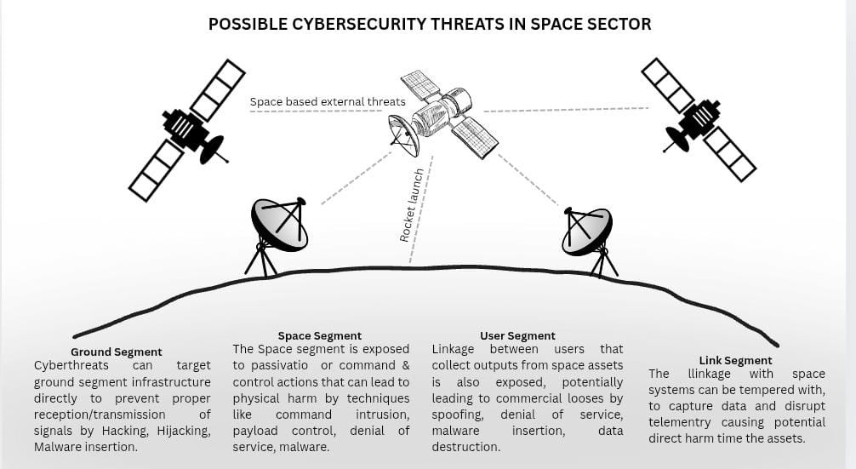

REFERENCES
- I. Paladini et al., The New Frontiers of Space: Eco-nomic Implications, Security Issues and Evolving Scenarios, I. Paladini, Ed. Springer, 2019. doi: 10. 1007/978-3-030-19941-8.
- O. o. T. A. U.S. Congress, “U.s.soviet cooperation in space (partă5 of ota reportă8533),” U.S. Govern-ment Printing Office, Tech. Rep., 1985. [Online]. Available: https://www.princeton.edu/~ota/ disk2/1985/8533/853305.PDF.
- United Nations Office for Outer Space Affairs, Timeline of un outer space activities, 2025. [On-line]. Available: https : / / www . unoosa . org / oosa/en/timeline/index.html.
- Space Foundation, Space foundation, home-page, cited as general organizational source, 2025. [Online]. Available: https : / / www . spacefoundation.org/.
- Voronoi & AlloyInsights, “How big is the space economy? (projection: $8trillion byă2035),” n.d. in-teractive visualization. [Online]. Available: https:
//www.voronoiapp.com/space/How-Big-Is-the-Space-Economy%E2%80%913979%5C#:%5C~: text=,8%20trillion%20by%202035.



- Space Foundation. (2010). The Space Report 2010 Reveals Global Space Economy Grew 40 Percent Over Five Years. Space Report 2010 Press Release. https://www.spacefoundation.org/2010/04/12/t he-space-report-2010-reveals-global-space-
economy-grew-40-percent-over-five-years/
- Space Foundation. (2011). The Space Report 2011 Is Now Available. Space Report 2011 Press Release.
https://www.spacefoundation.org/2011/05/02/t he-space-report-2011-is-now-available/
- Space Foundation. (2016). Five Things to Know About Global Space Activity (2015 figures: $323 billion).
https://www.spacefoundation.org/2016/08/30/fi ve-things-to-know-about-global-space-activity/
- Space Foundation. (2018). Space Foundation Report Reveals Global Space Economy at $383.5 Billion in 2017. Press Release. https://www.spacefoundation.org/2018/07/19/s pace-foundation-report-reveals-global-space-
economy-at-383-5-billion-in-2017/
- Space Foundation. (2021). Global Space Economy Rose to $447 B in 2020, Continuing Five-Year Growth. Press Release. https://www.spacefoundation.org/2021/07/15/gl obal-space-economy-rose-to-447b-in-2020-continuing-five-year-growth/
- Space Foundation. (2023). The Space Report 2023 Q2. Press Release. https://www.spacefoundation.org/2023/07/25/t he-space-report-2023-q2/
- Barghini, T. (2025, April). The Space Boom Is Here. Global Finance Magazine. https://gfmag.com/technology/space-tech-companies-financing-investment/
- BryceTech. (2025). Space Sector Annual & Mid-Year Reports. https://brycetech.com/reports.html
- Petronio, M. S. (2024). Private Sector Investment f[]in the Space Economy: PE, VC, Angel Investors, Corporates. (Master’s thesis, LUISS University). https://tesi.luiss.it/29455/1/225821_PETRONIO_ MARIA%20SOLE.pdf
- Organisation for Economic Co-operation and Development (OECD). (2024). Space Economy Investment Trends Report 2024.
https://www.oecd.org/content/dam/oecd/en/pu blications/reports/2024/04/space-economy-investment-trends_7eafcb97/9ae9a28d-en.pdf
- Space Capital. (2023). Space Investment Quarterly – Q4 2023.
https://www.spacecapital.com/publications/spac e-investment-quarterly-q4-2023
- Statista. (2024). Revenue of Global Space Economy 2009–2023.
https://www.statista.com/statistics/946341/spac e-economy-revenue-worldwide/
- European Space Policy Institute (ESPI). (2024). ESPI Yearbook 2023.
https://espi.or.at/publications/espi-yearbook-2023
- National Aeronautics and Space Administration (NASA). (2025). About NASA: Missions, Programs, and Future Goals. https://www.nasa.gov/about
- Indian Space Research Organisation (ISRO). (2025). ISRO Programmes and Missions. https://www.isro.gov.in
- European Space Agency (ESA). (2025). Exploring Space Together. https://www.esa.int
- Japan Aerospace Exploration Agency (JAXA). (2025). About JAXA. https://global.jaxa.jp
- China National Space Administration (CNSA). (2025). CNSA Missions Overview. http://www.cnsa.gov.cn
- Roscosmos State Corporation for Space Activities. (2025). Roscosmos Official Website. https://www.roscosmos.ru

30

- SpaceX. (2025). SpaceX Official Website – Missions & Starship Updates. https://www.spacex.com
- Blue Origin. (2025). Blue Origin – Gradatim Ferociter. https://www.blueorigin.com
- Rocket Lab. (2025). Electron and Neutron Launch Vehicles. https://www.rocketlabusa.com
- Relativity Space. (2025). Building Rockets with 3D Printing. https://www.relativityspace.com
- Arianespace. (2025). Launch Services and Space Transport. https://www.arianespace.com
- Virgin Galactic. (2025). Commercial Spaceflight and Tourism. https://www.virgingalactic.com

31

