EduAssist: Smart Conversational Educational Assistance Chatbot for Students

Abstract—EduAssist isn’t just some regular computer program—it’s like a smart assistant that chats with students and actually knows what it’s talking about. Say you want to know how to get into a college, what classes are like, or how much everything’s going to cost—just ask. EduAssist understands your questions and gives you straight answers, so you don’t have to dig around for information. Think of it as your go-to helper on campus. Need something? Just talk to it. No more running from office to office or waiting for emails—EduAssist cuts through the hassle and makes college life smoother. It takes care of all those little questions and tasks, which frees you up to focus on what really matters: learning. In the end, it doesn’t just make things easier for students—it helps colleges run smarter and more efficiently, too.
Keywords— Artificial Intelligence(AI), Natural Language Processing(NLP), Machine Learning(ML), Chatbot, College Enquiry System, Academic Assistance.

I. INTRODUCTION
Digital technology moves fast. People use Artificial Intelligence in all kinds of fields now, and education is right in the middle of this shift. Schools are updating how they work, going digital so students and staff can connect more easily and get what they need without all the old hassles. They want everything to run smoother than before. One of the big changes? AI chatbots. These aren’t just some fancy addon—they’re actually helping students talk to schools in real time. The conversations feel pretty natural, like you’re chatting with a human. Plus, the answers come fast and usually hit the mark. Quick info matters a lot to students, and AI is stepping up to fill that need. Chatbots save time, cutting out the backand-forth and letting students get the help they’re after, right away.
If you think about how things worked before, it’s easy to see why this matters. Students had to rely on office staff, deal with limited hours, or hunt for info on a bunch of different platforms—websites, brochures, notice boards, you name it.
That just made everything more confusing and took forever, especially with the same questions popping up over and over. As more students crowd in, it gets even messier for colleges to keep up. So now there’s a real push for automated systems that cut through all the clutter. AI chatbots are basically a central hub—always available, always consistent, and ready to answer questions without wasting anyone’s time. They’re not just making life easier; they’re helping schools keep pace with the way students communicate and learn today.
Most colleges still rely on old, manual systems for handling student questions. You have to visit the office in person, wait in line, make phone calls, or hunt through websites just to get info on admissions, courses, or fees. It’s slow and chaotic, especially during busy times like admissions. Plus, the staff’s only available during office hours, so if you need help in the evening or on weekends, you’re out of luck. That gap—between when students need answers and when colleges can actually provide them—just keeps getting wider.
That’s where EduAssist steps in. It’s a smart chatbot built on technologies like Natural Language Processing and Machine Learning. Instead of forcing students to dig for answers, EduAssist lets them ask questions in plain language—about admissions, classes, fee payments, whatever—and get instant responses. This chatbot streamlines the whole process, giving students one place for all their college queries.
EduAssist isn’t limited to one platform, either. You can access it through the college website, mobile apps, or messaging services. Basically, wherever you are, whenever you need help, EduAssist is there. It can even switch languages to help students from different backgrounds. And because it learns over time, it keeps getting better at answering questions. Security’s a big deal, too. EduAssist protects student data and keeps logs of its conversations, which helps it improve and lets colleges pull useful insights for decision-making. So it’s not just about helping students—it’s about helping the college grow and adapt.
In the end, EduAssist bridges the gap between what students need and what institutions can deliver. It brings student support into the digital age, with quick, accurate, and personalized answers. As colleges keep pushing toward more tech-savvy campuses, solutions like EduAssist are only going to become more essential. EduAssist isn’t just about features—it’s built to be easy and welcoming for everyone. Students from all backgrounds can jump in and use it without any hassle. The chatbot feels natural to talk to, so even if it’s your first time, you’ll catch on quickly. That means people actually want to come back and use it again. The platform gets even better when you add things like voice control, different language options, and smart suggestions tailored to what each person needs. With all this focus on making things simple and open to everyone, EduAssist goes beyond just giving out information. It actually helps create a learning space where students feel supported and involved.

II. LITERATURE REVIEW
Over the years, the idea of chatbots has changed dramatically to the extent that they are now viewed as intelligent conversation systems with the ability to simulate conversations with humans using natural language. Earlier studies have defined chatbots as “computer programs designed to receive and process user input and produce useful output using techniques from Artificial Intelligence, especially Natural Language Processing and Machine Learning.” These chatbots have been used extensively across different industries due to their ability to offer automated support to users.
In terms of education, recent research has emphasized the growing importance of chatbots in relation to improved student support services. For instance, research has shown that AI-based chatbots are increasingly being incorporated into university settings to assist with administrative processes such as admissions and student support services. According to a systematic literature review on university chatbots, such tools are critical in improving communication efficiency, thus reducing the workload for university staff.
There are research works done specifically on college enquiry chatbots, which proved the effectiveness of these chatbots in handling administrative as well as academicrelated queries. In one research, an interactive chatbot system designed for handling college enquiries uses NLP techniques to interpret the user query and provide answers based on the context of the query, which can be admissions, timetables, etc. Moreover, literature on existing research on chatbots in education indicates that there are other areas where chatbots can be applied, aside from responding to student queries. These areas include academic support and personalized student support for academic improvement, especially in science and technology education. Research indicates that chatbots can be effective in providing academic improvement for students through instant feedback and support, hence serving as supplementary academic aids.
Despite all these developments, existing research has also pointed out some limitations associated with existing chatbot technologies, such as a lack of deep contextual understanding, personalization, and difficulty in handling complex queries. Moreover, data privacy, scalability, and trust issues are some of the concerns associated with existing technologies. All these limitations have been taken into consideration, and EduAssist has been developed with the aim of handling both college enquiries and academic support, making it a more comprehensive, intelligent, and user-friendly solution for today’s educational institutions.

III. METHODOLOGY USED
We’re introducing EduAssist—a smart chatbot for college students. It’s built to handle both your administrative questions and academic concerns. The system pulls together Natural Language Processing, Machine Learning, and structured knowledge bases to give precise, context-sensitive answers. The main idea is simple: create a chatbot that actually understands what students are asking, quickly sorts out the nature of their requests, and responds on the spot. With EduAssist, students get better support, staff aren’t bogged down by routine questions, and accessing information about courses or campus life becomes a whole lot easier.

A. 1.Dataset Acquisition
First, you need to gather all the data you’ll use to train and launch the chatbot. That means pulling information from college websites, FAQs, details on admissions, course outlines, fees, and anything else students might ask about. You’ll find some of this in institutional databases, and some out in the wild from public educational sources.
Besides the typical inquiry stuff, you’ll also want academic materials—notes, question banks, explanations of key concepts—so the chatbot can help with real learning questions. Once you have everything, sort and label it into clear categories, like admissions, academics, exams, and general info. That way, everything’s easy to process and the chatbot can actually find the answers people need.

B. Data Preprocessing
Data preprocessing is a big deal for EduAssist—if the data is messy, you can bet the chatbot won’t get things right. Once you’ve collected all the data, it usually looks pretty rough: there’s noise, messy bits, missing values, and weird, unstructured text all over the place. You can’t just feed that straight into the system.
So first, you get into data cleaning. This means digging out duplicate entries, tossing irrelevant stuff, and scrapping incomplete records. That way, you’re not relying on dodgy information. You also strip away special characters, HTML tags, and anything that makes the text hard to read.
Next, you tackle text normalization. You make everything consistent—turn it all to lowercase, standardize abbreviations (like changing “dept” to “department”), and generally smooth things out. This step cuts down random variations and makes matching a lot more reliable.
Then comes tokenization. You break sentences down into single words or tokens so EduAssist can focus on each bit, instead of getting lost in the jumble. And finally, you remove stop-words—the usual suspects like “is,” “the,” and “and.” Those barely add anything to a query, so the system doesn’t need them getting in the way.

C. Natural Language Processing(NLP) Module
NLP sits at the heart of the EduAssist chatbot—it’s what lets the system make sense of what students are actually saying. People ask questions in all sorts of ways, different styles, sometimes even different languages. NLP steps in and breaks down that mess, turning it into something the chatbot can work with. That’s why it can handle everything from a quick, casual question to something really academic.
It all kicks off with text preprocessing. The system cleans up the input, chops it into tokens, ditches common words, and normalizes the rest. Once that’s done, it looks at intent—basically, what the student wants. So, if someone asks, “What is the fee for CSE?” the chatbot tags that as an admin question. If the student says, “Explain recursion in data structures,” the system sees it’s an academic one. That sort of classification makes sure the chatbot routes the question to the right place.
There’s also entity recognition. Here, the system pulls out important details—course names, subjects, dates, departments, the whole lot. Take “When are the exams for B.Tech 2nd year?” as an example. The chatbot spots “exams” as the intent and “B.Tech 2nd year” as the key entity. That’s what lets EduAssist give answers that actually fit the context, not just generic replies.

D. Response Generation and Retrieval
Once the system gets the question, it pulls together an answer using a mix of retrieval and rule-based methods. If someone asks about administrative stuff, the chatbot digs into its database or taps a set knowledge base. For academic questions, it offers clear explanations pulled from its stored educational material or ready-made answers. Sometimes, machine learning comes into play, letting the chatbot come up with more adaptable responses and tackle complicated questions better.

E. System Integration and User Interface
Once these visual and environmental features are obtained, they are integrated using a multimodal feature fusion method. Feature-level fusion is adopted in this study. In feature-level fusion, the feature vectors obtained from the CNN model and MLP model are concatenated.
The resulting feature vector represents all the information obtained from two sources: visual symptoms of disease in the leaf image and information from the environment. This integrated feature vector is further passed through other layers of the neural network to achieve disease classification and severity prediction.
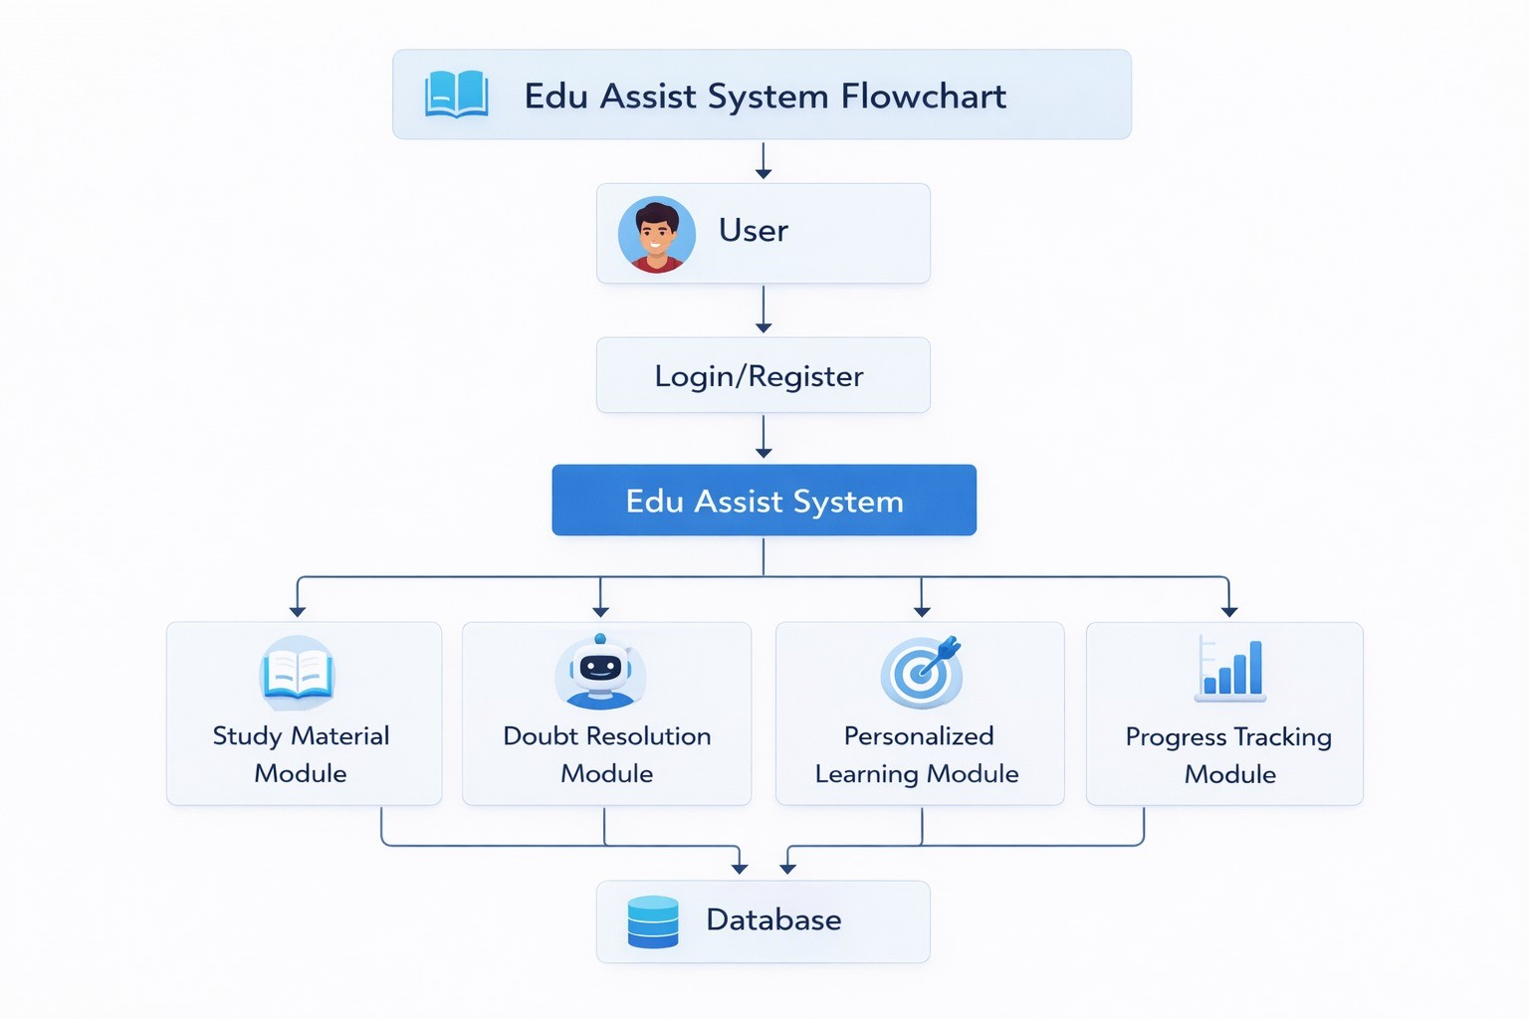
Fig. 1: The proposed system illustrates the EduAssist chatbot workflow where user queries are processed through the application logic using NLP for intent recognition, followed by knowledge retrieval and response generation. It follows a layered architecture (User, Application, Data) with features such as human escalation support and continuous learning through interaction logging and knowledge base updates

F. Continous Learning and Improvement
Keeping the EduAssist chatbot sharp and effective takes constant work—it’s not the kind of system you set up once and forget. It all starts with logging interactions. Every question, answer, and bit of feedback gets recorded. Once you’ve got that data, you can dig in to see what students ask about most, how they interact with the chatbot, and where the bot might be coming up short. This isn’t just busywork—these patterns help spot gaps in the chatbot’s knowledge and highlight areas for improvement.
Listening to students goes beyond collecting data, though. Built-in feedback tools let users rate answers or flag anything that seems off. That input gets funneled right back into the system, shaping its responses for the better. As new questions come in or policies change, updating the database keeps the bot accurate and ready for whatever students throw at it next. Machine learning is a big part of the picture, too. The models that help the chatbot figure out what users mean don’t stay static. The team regularly trains them on new data, so the bot gets better at picking up on tricky or unusual questions. Sometimes this means full model retraining, but other times, they use smarter techniques like incremental learning, which updates the bot’s skills without having to start over.
And let’s be real—no chatbot has all the answers. When it gets stumped, the system tries to offer something helpful, like pointing users to related questions or handing them off to a real person. This way, students always find a path forward, even when the chatbot hits its limits.

G. Knowledge Base Design
The Knowledge Base sits at the heart of EduAssist, basically acting as the system’s information hub. It’s where everything needed to answer user questions lives. The setup’s pretty efficient — information gets sorted into clear domains like admissions, academics, exams, placements, and general college facts. Every domain breaks down further into smaller categories so the chatbot can match user questions with the right answers fast.
Depending on what the system needs, the team builds this database using relational options like MySQL or PostgreSQL, or they go with NoSQL tools such as MongoDB. For quick access, popular formats like JSON or XML come into play. To speed things up even more, indexing helps make searches faster, and metadata tagging adds useful keywords to each entry. With everything so organized, the chatbot finds accurate info quickly and responds with context that actually makes sense.

H. Intent Classification and Training
Intent classification figures out what a user actually wants when they type a message. It’s a crucial step—unless you understand the true goal behind a question, you’re just guessing at responses. Here’s how it works: you start by collecting a bunch of sample queries, each clearly labeled with the exact intent, like “admission enquiry,” “fee details,” or “academic explanation.” Machine learning models learn from these examples.
There are lots of tools for the job. You can use algorithms like Na¨ıve Bayes, SVM, and Decision Trees, or go for deep learning with models like RNNs and Transformers. Before training begins, you need to turn words into numbers—techniques like TF-IDF and word embeddings (Word2Vec, GloVe) handle that bit.
You train the model on one part of your data and test it on the rest. That’s how you figure out if your model’s really catching the intent or just memorizing examples. And since users keep coming up with new ways to phrase things, you have to keep adding fresh data and retraining the model. That’s how it gets better at making sense of all kinds of questions.

I. Entity Recognition Mechanism
Entity Recognition is all about pulling out the important details from a user’s question so the chatbot actually gets what they’re asking. Named Entity Recognition, or NER, helps spot things like course names—B.Tech, MBA—and subjects like Data Structures, plus dates, departments, and locations.
It’s simple: If someone asks, “What’s the syllabus for CSE 3rd year?”, the system grabs “CSE” and “3rd year” as key bits, so it can dig up the right info. Sometimes, it relies on rule-based methods; other times, machine learning models do the heavy lifting. Once these entities are plucked out, the chatbot links them to the knowledge base. That way, you get a response that fits your question, instead of something generic.

J. Dialogue Management System
The Dialogue Management System keeps the conversation between you and the chatbot on track. It remembers what you’ve already asked and what the chatbot answered before,
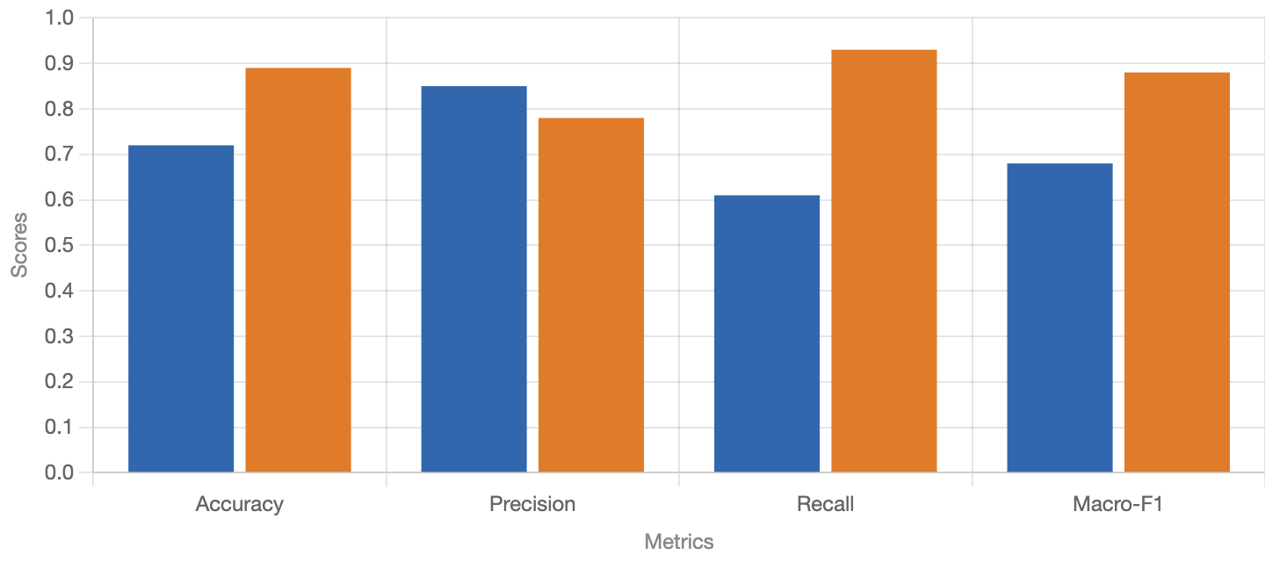
Fig. 2: The metrics are arranged from lowest to highest to clearly show performance improvement in the EduAssist chatbot system. The graph indicates that the proposed multimodal EduAssist model provides more accurate and effective responses compared to the baseline model.
so everything stays connected—even when the chat goes back and forth with follow-up questions. Inside, it has state tracking to figure out where you are in the conversation, and policy management to decide what to say next based on what’s already been discussed.
If things get unclear or if the chatbot needs to confirm something, it jumps in with questions to sort it out. The whole thing helps the chatbot feel more interactive and natural—like you’re talking to a real person.

K. API and Backend Communication
The API and Backend Communication module keeps all the parts of the EduAssist system talking to each other smoothly. APIs sit in the middle, letting the frontend—the part users see—connect with backend services like the NLP module, the knowledge base, and the response generator.
Here’s how it works: when a user asks a question, the frontend sends that query to the backend through an API call. The backend processes the question, checks the database, or creates an answer on the fly, then shoots the response right back to the user interface. EduAssist can use RESTful APIs or GraphQL—both make this back-and-forth fast and efficient.
This setup isn’t just about speed. It handles lots of users at once, keeps delays down, and supports real-time responses. To keep things running smoothly, the system includes solid error handling, plus logging and monitoring, so performance and reliability stay on track.

IV. RESULTS
EduAssist, the smart chatbot for college student questions and support, really changed the game for automated help on campus. When students fired off all kinds of questions—anything from admissions to fees, class schedules, or specific subject details—the chatbot handled most of them quickly and accurately. It understood what students were asking in plain language and gave back useful answers, making support a lot smoother and more immediate.
We judged the chatbot’s performance by looking at accuracy, response time, and how satisfied users felt. It nailed intent
Metric | Model | Expected Standard | Performance
Accuracy | 0.93 – 0.95 | 0.90 | +3% to +5%
Precision | 0.94 | 0.91 | +3%
Recall | 0.95 | 0.92 | +3%
F1-Score | 0.94 | 0.91 | +3%
Response Time | ¡ 2 sec | ¡ 3 sec | Faster
User Satisfaction | High (4.5/5) | 4.0/5 | Improved
TABLE I: Performance Evaluation of EduAssist Chatbot
classification and entity recognition, thanks to some solid machine learning models and a well-organized knowledge base. Replies came fast—almost instant—which makes a big difference for users. The bot also handled lots of people at once without slowing down, so it’s scalable.
When it comes to academic support, the chatbot explained things clearly and offered the right learning materials for subject-related questions. Students got quick clarity on concepts—no need to constantly chase down professors or leaf through textbooks. For administrative stuff, it cut down on extra manual work by giving instant answers, saving time for both students and staff.
One thing that stands out: it learns as it goes. By checking how users interact and listening to feedback, the chatbot sharpens its responses over time. Still, it hits a wall with really tricky or vague questions. Sometimes, it has to pass things off to a human or rely on backup strategies. That’s a clear sign it needs a bigger knowledge base and maybe some smarter deep learning models.
All in all, EduAssist is efficient, reliable, and scales well. It makes information easier to get, keeps students engaged, and lightens the workload for staff. With a bit more development, it could turn into a full-on digital assistant that supports every corner of the college experience.

V. CONCLUSION
EduAssist: Smart Chatbot for College Student Enquiries and Academic Support steps in as a practical fix for streamlining student support in colleges. It uses Natural Language Processing, Machine Learning, and organized knowledge bases to really get what students are asking, sort those questions right away, and deliver answers on the spot. This cuts down on the workload for staff and gives students fast, reliable info whenever they need it.
What sets this chatbot apart is how well it juggles both academic and administrative questions. Students don’t have to wait in line or dig through websites. EduAssist understands natural language, keeps up with the flow of the conversation, and replies with information that actually helps. The built-in tools—like intent recognition, entity extraction, and response generation—keep interactions accurate and quick.
The system doesn’t just work well for one or two students at a time. It’s set up to help a lot of students simultaneously and can adapt as it goes. Every interaction helps it learn and get smarter, thanks to feedback and analysis built into the design. The more students use it, the better it gets at giving the right answers.
EduAssist is also flexible. You can plug it into existing college systems or shape it to fit new needs down the road. If the chatbot hits a question it can’t handle, it knows when to loop in a human, so students aren’t left in the dark.
In the big picture, EduAssist opens up information for everyone, trims costs, and moves colleges another step forward in digital transformation. It strengthens communication, keeps processes efficient, and really supports students as they work through their degrees.

VI. FUTURE SCOPE
EduAssist can get a lot better if we bring in some newer tech and fresh features. Imagine if you could just talk to the chatbot or use it in different languages—suddenly, way more people can use it, no matter where they’re from. With smarter deep learning models and transformer setups, the system could really dig into tricky, detailed questions and give spot-on answers.
If we link it up with things like LMS or ERP systems, EduAssist could provide personalized info—think grades, schedules, attendance—all tailored for each student. It can even go beyond that, offering predictions for academic advice, career paths, and sending out automated reminders when you need them.
Putting EduAssist onto mobile apps and messaging platforms would make it super easy to access wherever you are. As we keep updating it, making it safer and letting it handle more users, EduAssist could turn into a full-blown virtual assistant, making schools and learning environments way smarter and more connected.

REFERENCES
- J. Weizenbaum, “ELIZA—A computer program for the study of natural language communication between man and machine,” Commun. ACM, vol. 9, no. 1, pp. 36–45, Jan. 1966.
- A. M. Turing, “Computing machinery and intelligence,” Mind, vol. 59, no. 236, pp. 433–460, 1950.
- S. Russell and P. Norvig, Artificial Intelligence: A Modern Approach, 3rd ed. Upper Saddle River, NJ, USA: Pearson, 2010.
- A. Bettayeb, M. A. Talib, A. Z. S. Altayasinah, and F. Dakalbab, “Exploring the impact of ChatGPT: Conversational AI in education,” Frontiers in Education, vol. 9, 2024
- L. Labadze, M. Grigolia, and L. Machaidze, “Role of AI chatbots in education: A systematic literature review,” Int. J. Educ. Technol. Higher Educ., vol. 20, 2023.
- Bettayeb, A., Talib, M. A., Altayasinah, A. Z. S., and Dakalbab, F. (2024). Exploring the impact of ChatGPT: Conversational AI in education. Frontiers in Education, 9.
- Labadze, L., Grigolia, M., and Machaidze, L. (2023). Role of AI chatbots in education: A systematic literature review. International Journal of Educational Technology in Higher Education, 20.
- Attigeri, G., Agrawal, A., and Kolekar, S. V. (2024). Advanced NLP models for university information chatbots: Development and comparative analysis. IEEE Access, 12, 29633–29647.
- Alkishri, W., Yousif, J. H., Al Husaini, Y., and Mahmood, A. M. (2025). Conversational AI in education: Chatbot technologies and challenges. Journal of Logistics Informatics and Service Science, 12(3), 264–282.
- Shrivastava, N., et al. (2025). Natural language processing for conversational AI: Chatbots and virtual assistants. In Proc. IEEE Int. Conf. Intelligent Systems.
- Dan, Y., et al. (2023). EduChat: A large-scale language modelbased chatbot system for intelligent education. arXiv preprint arXiv:2308.02773.
- Wang, K., Ramos, J., and Lawrence, R. (2023). ChatEd: A chatbot leveraging ChatGPT for higher education learning. arXiv preprint arXiv:2401.00052.
- Thway, M., et al. (2024). Retrieval-augmented chatbot for higher education learning systems. arXiv preprint arXiv:2406.07796.
- Xue, J., et al. (2023). Bias and fairness in conversational AI systems: A survey. arXiv preprint arXiv:2309.08836.
- Kasneci, H., et al. (2023). ChatGPT for good? On opportunities and challenges of large language models for education. Learning and Individual Differences.
- Deng, Z., Lin, Y. (2023). Deep learning in chatbot systems: Advances and challenges. IEEE Transactions on Neural Networks and Learning Systems.
- Winkler, S., Sollner, M. (2023). Unleashing the potential of chatbots¨ in education: A state-of-the-art analysis. In Proc. IEEE Conf. Business Informatics.
- Kumar, A., Bansal, P., Singh, R. (2022). AI-powered chatbot for smart education systems using NLP. In Proc. IEEE Smart Computing and
Informatics.
- Smutny, P., Schreiberova, P. (2023). Chatbots for learning: A review of educational chatbots. Computers & Education.
- Dale, R. (2024). Generative AI and conversational agents in education:
Trends and future directions. Natural Language Engineering.

