XAI-CropCare:An Explainable Multimodal Deep Learning Framework for Crop Disease Detection,Severity Grading,and Decision Support

Abstract—Crop disease is known to have significant impacts on crop productivity. Therefore, crop disease identification is essential in order for it to be effectively managed. For accurate crop disease identification, this paper proposes an intelligent system known as XAI-CropCare: An Explainable Multi-modal Deep Learning Framework for Crop Disease Detection, Severity Grading, and Decision Support. The system is designed in a way that incorporates crop leaf images with environmental parameters such as temperature, humidity, and rainfall. While environmental parameters utilize a multi-layer perceptron model, crop leaf images utilize a convolutional neural network model. Moreover, crop disease identification is also done using Grad- CAM, which provides visual explanations of crop disease. Crop management is also provided.The suggested framework is ben- eficial for intelligent agricultural applications since it increases prediction accuracy and transparency.
Keywords— Crop disease detection, multimodal deep learning, explainable AI (XAI), severity grading, decision support, Grad-CAM.
- Introduction
Grapevine can be cited as one of the most valuable hor- ticultural crops that significantly contribute to the overall economy of agriculture. Grapevine productivity and quality are highly susceptible to foliar diseases and pest infestations. Therefore, it is important to implement effective strategies for monitoring and managing diseases. The conventional methods used for managing diseases are mainly based on manual inspection and experiential knowledge. These techniques take a lot of time and rely on experiential knowledge, which could be influenced by human judgment. To avoid these limitations, automation-based methods are being explored. The automation-based methods include using expert system tools and machine learning[1].
Today’s agricultural practices are highly influenced by the requirement to increase crop productivity while reducing
resource consumption and labor intensity. Efficient disease monitoring and quality assessment are key factors in increasing crop productivity and yield.The recent developments in image processing, machine learning, and deep learning technolo- gies have paved the way for the development of automated crop monitoring technologies. These techniques help in early disease detection and quality assessment, thus supporting precision agriculture practices[2].The deep learning models are able to learn complex non-linear relationships between various agricultural variables. By using heterogeneous data, such as field data, climatic parameters, and images, deep learning models can make accurate predictions compared to conven- tional statistical models. For instance, the growth of plants can be predicted using climatic and soil data, whereas leaf diseases can be identified using images of leaves. These data- driven models make an important contribution to precision agriculture by optimizing the use of resources and increasing crop production [2].
Despite their excellent performance in pattern classification, these networks are typically considered ”black-box” models due to their lack of interpretability. The internal mechanisms used by these networks are not easily comprehensible. Such limited interpretability makes it difficult for users to trust these networks, especially when they are used for making critical decisions. In agriculture, where making critical decisions can influence crop yields, it is essential that AI networks used for diagnosing diseases are transparent and reliable.Explainable Artificial Intelligence (XAI) has been proposed as a means of enhancing our comprehension of how AI networks make crucial decisions in order to get around these constraints. XAI has introduced various techniques that can help users understand how features used as input influence AI networks. In plant disease diagnosis, using XAI with CNN architectures

has helped users visualize areas that are used as input features when classifying diseases [3].
Although high accuracy has been reported by various methods of image-based plant disease classification, some limitations still exist. Most of the existing literature has been based solely on visual features without considering environ- mental factors like temperature and humidity, which are major contributing factors to diseases. Moreover, most of the existing literature is limited to disease classification without severity grading and decision support. Explainability is still lacking in multimodal approaches.
To tackle these issues, we suggest XAI-CropCare, a mul- timodal deep learning approach with explainability for grape disease detection, severity grading, and decision support. It uses images for feature extraction and environmental data fusion with explainable AI for decision support.
- Literature Review
Recent advancements in deep learning have greatly im- proved systems for detecting and diagnosing plant diseases. A multimodal interpretable framework was proposed in [4] for diagnosing tomato diseases and estimating their severity. This framework predicts severity based on weather conditions by combining recurrent neural networks with EfficientNet- based image classification. The study used LIME and SHAP to improve interpretability and applied a late-fusion strategy to integrate visual and environmental features. The model showed high accuracy in both classification and severity prediction, demonstrating the advantages of multimodal fusion and ex- plainable AI in agriculture.
Explainable deep learning has also been studied for classi- fying mango leaf diseases in [5], where researchers introduced a custom CNN architecture called MangoLeafXNet. This model achieved high accuracy across several datasets and used explainable AI techniques like Grad-CAM, Saliency Maps, and LIME to highlight important areas influencing predictions. The study further improved practical use by creating a real- time user interface, showing how important interpretability is for building user trust and promoting field adoption.
A detailed review in [6] analyzed various deep learning approaches for detecting grape leaf diseases, focusing on archi- tectures like VGG, ResNet, DenseNet, and EfficientNet. The review highlighted the importance of transfer learning, dataset augmentation, and model optimization for enhancing perfor- mance. However, it also pointed out significant limitations in current systems, such as overfitting on small datasets, lack of real-world testing, and a main focus on classification accuracy instead of severity grading or decision support integration.
To boost classification robustness and transparency, an en- semble learning framework combined with explainable AI was suggested in [7]. By merging predictions from multiple CNN architectures, this framework improved generalization performance and lessened model bias. The use of explainable AI techniques made it possible to visualize important image areas related to classification decisions, addressing the issues of black-box models in deep learning. Still, the system was
limited to image-based classification without integrating mul- timodal data.
In a similar study, [11] presented an explainable CNN-based framework for detecting mulberry leaf diseases. This model used Grad-CAM visualization to interpret disease predictions and achieved strong classification results. The authors noted that interpretability helps agronomists validate AI-driven deci- sions and better understand disease symptoms. However, like many earlier studies, this approach relied only on image inputs and did not consider environmental factors or mechanisms for estimating severity.
Overall, while there has been notable progress in CNN- based classification and explainable AI for plant disease detec- tion, most research mainly focuses on single-modality image analysis. Multimodal integration, severity grading, and more complete decision support systems are still not fully explored, highlighting the need for the development of more integrated and interpretable frameworks for precision agriculture.
- Methodology Used
This research proposes a new framework called XAI- CropCare. It is an explainable multimodal deep learning framework for detecting crop diseases, grading their severity, and supporting decision-making. It combines deep learning, multimodal data fusion, and explainable artificial intelligence. The goal is to detect crop diseases, estimate their severity, and provide useful recommendations to farmers. The methodology aims to create a clear and reliable system that merges visual crop symptoms with environmental conditions. This approach seeks to improve prediction accuracy and decision-making.
- 1.Dataset Acquisition
Gathering crop leaf photos and environmental information needed for model training and assessment is the first stage in the suggested framework. Healthy and diseased leaf samples from publicly accessible agricultural datasets like PlantVillage and other field-condition datasets make up the image dataset. High-quality labeled photos of various crop diseases in both controlled and natural settings can be found in these datasets. The model can learn disease-specific visual patterns because each image is associated with a particular disease category. Environmental factors like temperature, humidity, and rainfall are taken into account in addition to image data. These ele- ments play a crucial part in enhancing the prediction system’s dependability since they have a major impact on the emergence
and spread of crop diseases.
Following collection, the dataset is categorized into various disease classes and examined to ensure that no corrupted or poor-quality images remain. To ensure that all classes are well represented in all subsets, the final dataset is then split into training, validation, and testing sets using a stratified splitting techniques for project.
- Data Preprocessing
For the purpose of making the collected data ready for effec- tive training of the deep learning models, data preprocessing

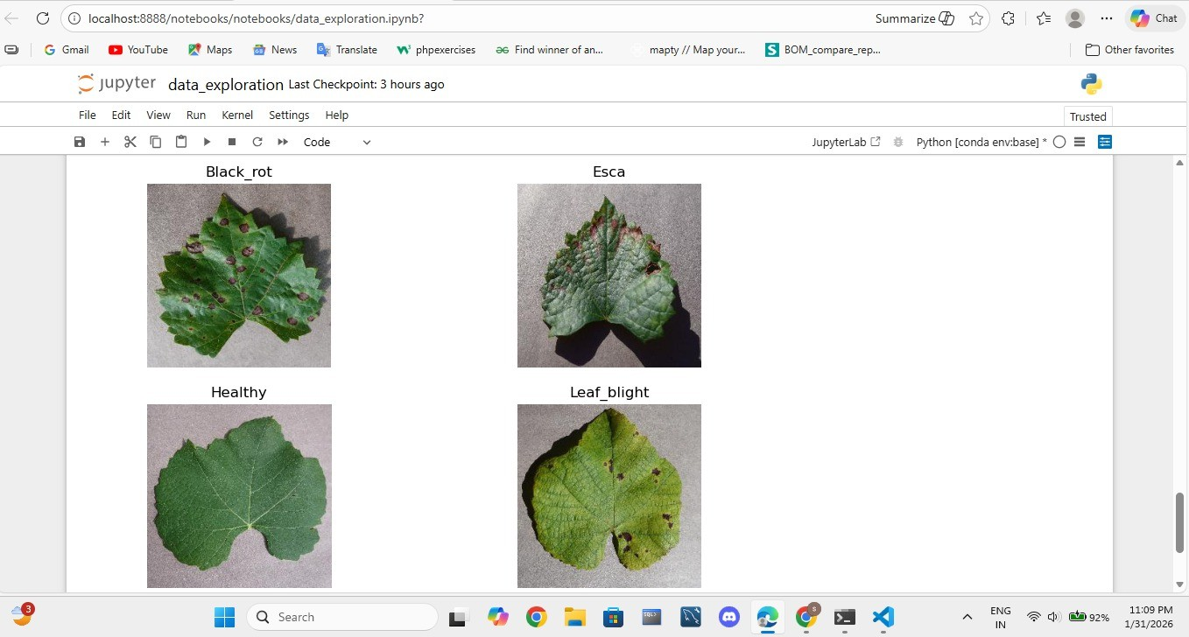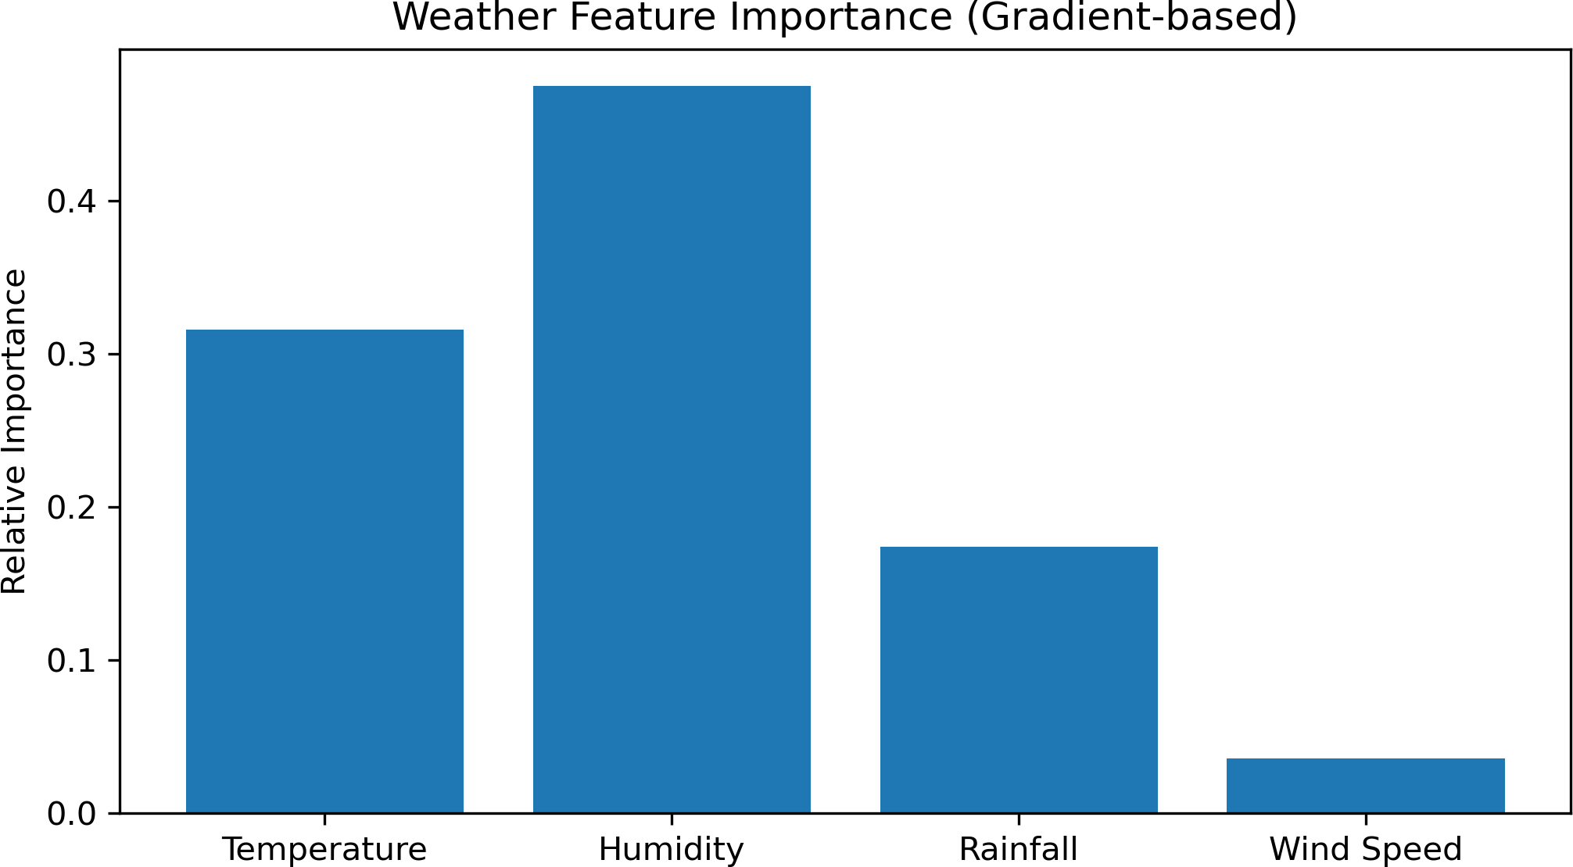

Fig. 1: Leaf Disease Classification

is carried out. For maintaining data consistency in the dataset, all the images are resized to a fixed dimension because the quality and resolution of the images collected from various sources may vary.
In order to stabilize the learning process and speed up model convergence, normalization is used to scale pixel values to a standardized range. Data augmentation techniques are used to increase generalization and lower the risk of overfitting. These methods include zooming, flipping images horizontally and vertically, rotating the image, and making small bright- ness adjustments. By making altered versions of pre-existing images without changing their labels, augmentation broadens the diversity of datasets.
Preprocessing is also applied to environmental data. In order to ensure that each feature contributes equally during model training, numerical values representing temperature, humidity, and rainfall are normalized using feature scaling techniques.
- Image Feature Extraction using CNN
A Convolutional Neural Network (CNN) is used in feature extraction to investigate the visual symptoms present in the leaves of crops. The EfficientNet-B0 is used in the proposed system because of its superior performance in image classifi- cation problems and its efficiency.
From the input images, the CNN automatically picks up hi- erarchical features. While deeper layers pick up more intricate disease-related patterns like lesions, discoloration, and irregu- lar spots on leaves, early layers record low-level characteristics like edges, color variations, and textures. These acquired characteristics create a condensed image representation that can be applied to the classification of diseases.
The transfer learning technique is applied by using the EfficientNet model and loading the model with the pretrained weights of the image dataset. This technique helps the model achieve better performance and train the model faster because the model has prior knowledge of the visual features.
- Environmental Feature Encoding
It is to be noted that crop diseases are generally dependent on environmental factors. For example, some fungal diseases are more likely to occur in high humidity, while others are
Fig. 2: Feature importance analysis of environmental pa- rameters (temperature, humidity, rainfall) demonstrating their influence on crop disease prediction.

more likely to occur in high temperatures. To account for this, environmental factors are included in the proposed system.
A Multilayer Perceptron (MLP) is used to represent the environmental factors like temperature, humidity, and rainfall. The MLP is composed of fully connected layers, which map the environmental inputs to a feature space that is compatible with the image feature space obtained from the CNN.
This step enables the model to discover the relationship between environmental factors and crop diseases, thereby improving the accuracy of the model.
- Multimodal Feature Fusion
Once these visual and environmental features are obtained, they are integrated using a multimodal feature fusion method. Feature-level fusion is adopted in this study. In feature-level fusion, the feature vectors obtained from the CNN model and MLP model are concatenated.
The resulting feature vector represents all the information obtained from two sources: visual symptoms of disease in the leaf image and information from the environment. This integrated feature vector is further passed through other layers of the neural network to achieve disease classification and severity prediction.
Multimodal learning is beneficial in terms of system per- formance because it uses all available information.
- Disease Classification
The fused feature representation is further processed by a classification layer that predicts the type of crop disease that is present in the input image. This is done by using a softmax function that provides probability scores for each disease class. The model will choose the class that has the highest probability as the disease category. This step allows the system to automatically detect different classes of crop diseases based on the patterns that have been learned in the training dataset. To assess how well the classification model performs, we use evaluation metrics like accuracy, precision, recall, and F1-
score.

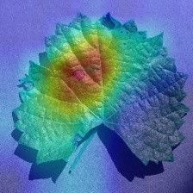
Fig. 3: Black rot disease with highlighted regions of interest from explainable model output.

- Disease Severity Grading
Apart from the identification of the type of disease, the system also estimates the severity of the infection. Severity grading helps in the understanding of the extent of damage caused by the disease.
For this purpose, the infected area of the leaf is analyzed using the visual explanation map provided by the model. The proportion of the infected area relative to the total leaf area is computed and used to classify the severity level.
The severity analysis helps the farmers understand the level of damage caused by the disease and hence decide if any action needs to be taken.
- Explainable AI Integration
For the purpose of increasing the transparency and trust in the system, Explainable Artificial Intelligence (XAI) methods are also incorporated. The Grad-CAM technique is used to generate heatmaps that indicate the areas of the leaf image that the model is considering for prediction.
The heatmaps will visually show the infected areas of the image used for prediction. The heatmap can also be overlaid on the original image, and the areas of the leaf used for the detection of the disease will be visible.
Explainability is also significant in agriculture because it will enable the farmer or agricultural expert to verify the predictions made by the model and ensure that the model is not focusing on irrelevant features.
- Decision Support System
After identifying the nature of the disease and its severity, the system will provide decision support recommendations. This will be done using a rule-based approach that will relate the nature of the disease and its severity to appropriate management strategies for the crop.
For instance, the system will recommend the application of pesticides, irrigation management, and so on based on the nature of the disease and the conditions in the environment.
- System Implementation and Deployment
The entire system is developed using Python and deep learn- ing frameworks such as TensorFlow or PyTorch. Additionally,
image preprocessing and visualization can be achieved by using various libraries such as OpenCV and Matplotlib.
For making the system easily accessible to end-users, a web interface is created using Streamlit. The system interface al- lows users to input crop leaf images along with environmental information and presents the resulting predictions. The system also displays information such as disease type, severity levels, explanation images, and treatment options.
The interface is developed with a focus on accessibility, ensuring usability for end-users such as farmers, agricultural researchers, and field experts.
- Summary
The proposed methodology incorporates image-based dis- ease detection, environmental data analysis, and decision sup- port, as well as explainable artificial intelligence, in a multi- modal framework. The multimodal approach, which takes into consideration the images and the environmental information, provides better accuracy in the predictive results and also helps in making the decision process transparent. This is beneficial in the efficient management of agricultural activities.
- Results
The proposed framework XAI-CropCare: An Explainable Multimodal Deep Learning Framework for Crop Disease Detection, Severity Grading, and Decision Support has been tested and evaluated to assess the effectiveness of the proposed framework in crop disease detection and grading.

Metric | Baseline Model | Multimodal Model | Improvement
Accuracy | 0.9329 | 0.9624 | +2.95%
Precision | 0.9441 | 0.9662 | +2.21%
Recall | 0.9463 | 0.9683 | +2.20%
Macro-F1 | 0.9449 | 0.9669 | +2.20%
TABLE I: Performance Comparison between Baseline and Multimodal Models

The deep learning model has been able to classify the crop leaf diseases with high accuracy using the leaf image. From the experimental results, the proposed CNN-based model has been able to correctly classify the different disease categories with minimal classification errors.
In order to enhance the performance of the predictions, environmental factors like temperature, humidity, and rainfall were incorporated into the image features using a multimodal learning approach. The proposed approach outperformed the baseline image-based model, thereby confirming the signifi- cance of environmental factors.
The system also performed grading of the severity of diseases by analyzing the infected regions on the leaves. The level of infection was classified into mild, moderate, and severe based on the regions of the leaves.
Furthermore, the proposed explainable AI technique, Grad- CAM, generated heatmaps that identified the regions of the leaves that were infected. This ensured that the predictions were based on regions of disease occurrence.

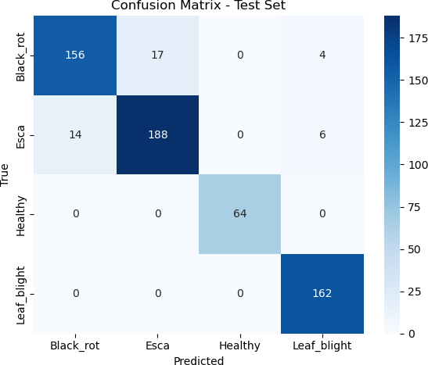
Fig. 4: Confusion matrix for baseline image-based model, used for comparison with the proposed multimodal approach.
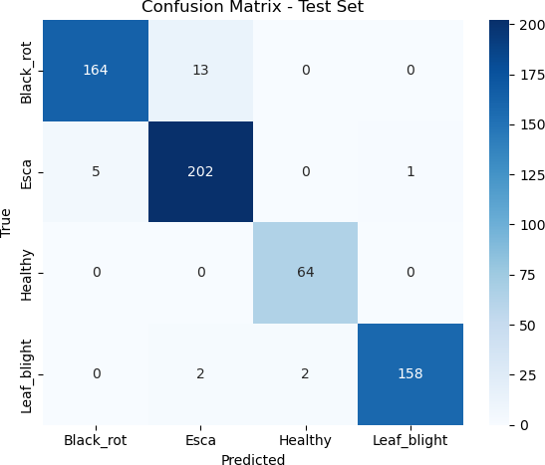
Fig. 5: Confusion matrix for multimodal disease classification model, illustrating prediction accuracy and class-wise perfor- mance.

Overall, the proposed approach has shown that the system can be used for accurate disease detection, severity assessment, and predictions.

- Conclusion

The proposed study outlines an intelligent framework named ”XAI-CropCare: An Explainable Multimodal Deep Learning Framework for Crop Disease Detection, Severity Grading, and Decision Support.” The proposed framework is designed for crop disease detection and decision support for crops using artificial intelligence. The proposed framework combines deep learning methods and environmental information to enhance the reliability and accuracy of crop disease detection. The proposed framework combines image-based crop disease de- tection and environmental information such as temperature, humidity, and rainfall to enhance crop disease detection and decision support for crops.
Moreover, the proposed framework incorporates artificial intelligence techniques to improve the reliability and accuracy of crop disease detection. The proposed framework includes Grad-CAM heatmaps to enable users to visualize infected areas on leaf images. The proposed framework will enable farmers and agricultural experts to better understand crop disease detection results. Moreover, the proposed framework includes decision support to enable farmers to manage crops effectively. The proposed framework will enhance crop man- agement and productivity using artificial intelligence methods.
- Future Scope
Although the proposed system has produced good results, some improvements can be made in the proposed system for better performance in the future.
Extension of the data set with more crops and disease types for better generalization.
Inclusion of real-time environmental sensor data or IoT devices for better accuracy.
The proposed system includes the development of a mobile application that allows farmers to carry out disease detection tasks in practical, real-world environments.
Inclusion of better multimodal models and transformer architectures for better prediction accuracy.
Extension of the proposed system for real-time monitoring and crop health management.
References
- Li, W., Zhou, B., Zhou, Y., Jiang, C., Ruan, M., Ke, T., ... Lv, C.
(2025). Grape disease detection using transformer-based integration of vision and environmental sensing. Agronomy, 15(4), 831.
- Kunduracioglu, I., Pacal, I. (2024). Advancements in deep learning for accurate classification of grape leaves and diagnosis of grape diseases. Journal of Plant Diseases and Protection, 131(3), 1061-1080.
- Nasir, N., Ramzan, S., Ali, B., Jabbar, S., Raza, A., Kim, C., ... Fitriyani, N. L. (2025). Interpretable deep multimodal-based tomato disease diagnosis and severity estimation. Scientific Reports, 15(1), 37919.
- D. P. Hughes and M. Salathe´, “An open access repository of images on plant health to enable the development of mobile disease diagnostics,” arXiv preprint arXiv:1511.08060, 2015.
- Rayed, M. E., Jim, J. R., Islam, M. J., Mridha, M. F., Kabir, M. M., Hossen, M. J. (2025). MangoLeafXNet: An explainable deep learning model for accurate mango leaf disease classification. IEEE Access.
- Aher, P. G., Sabnis, V., Jain, J. K. (2025). Deep learning for grape leaf disease detection: A review. Multidisciplinary Reviews, 8(11), 2025364.
- Rashid, M. R. A., Korim, M. A. E., Hasan, M., Ali, M. S., Islam, M. M., Jabid, T., ... Islam, M. (2025). An Ensemble Learning Framework with Explainable AI for interpretable leaf disease detection. Array, 26, 100386.
- Shafik, W., Tufail, A., De Silva, L. C., Haji Mohd Apong, R. A. A., Kim, K. H. (2025). Deep learning technique for plant disease classification and pest detection and model explainability elevating agricultural sustainability. BMC Plant Biology, 25(1), 1491.
- Herna´ndez, I., Gutie´rrez, S., Barrio, I., ´In˜iguez, R., Tardaguila, J. (2024). In-field disease symptom detection and localisation using explainable deep learning: Use case for downy mildew in grapevine. Computers and Electronics in Agriculture, 226, 109478.
- Devi, K., Benila, S., Lekshmi, K., Omana, J. (2025). HVAF-XAI-Net: A Multimodal Explainable AI Framework for Accurate Mulberry Leaf Disease Detection. Smart Agricultural Technology, 101377.
- Nargotra, D., Sharma, V. (2023). Grape leaf disease detection using deep learning. Journal of Scientific Research and Technology, 128-139.
- A. Fuentes, S. Yoon, S. Kim and D. Park, “A robust deep-learning- based detector for real-time tomato plant diseases and pests recognition,” Sensors, vol. 17, no. 9, p. 2022, 2017.
- M. Brahimi, K. Boukhalfa and A. Moussaoui, “Deep learning for tomato diseases: classification and symptoms visualization,” Applied Artificial Intelligence, 2017.
- S. M. Lundberg and S. I. Lee, “A unified approach to interpreting model predictions,” in Advances in Neural Information Processing Systems, 2017.
- I. Goodfellow, Y. Bengio and A. Courville, Deep Learning. MIT Press, 2016.
- Y. LeCun, Y. Bengio and G. Hinton, “Deep learning,” Nature, vol. 521, no. 7553, pp. 436–444, 2015.
- F. Chollet, “Xception: Deep learning with depthwise separable convolu- tions,” in Proceedings of the IEEE Conference on Computer Vision and Pattern Recognition (CVPR), 2017.

- C. Shorten and T. M. Khoshgoftaar, “A survey on image data augmen- tation for deep learning,” Journal of Big Data, vol. 6, 2019.
- K. Kamble, S. Patil and P. Patil, “Plant disease detection using convo- lutional neural networks: A review,” International Journal of Advanced Computer Science and Applications, 2021.

