ROLE OF SOCIAL MEDIA LITERACY IN IMPROVING THE CYBERSECURITY MEASURES: A CASE STUDY IN INDIA

Abstract
In the modern world social media literacy plays a significant role in enhancing cybersecurity measures specifically in India. Background information regarding the research topic has been discussed effectively along with highlighting the aim, objectives along with research questions that reflect as a foundation of the research. Besides this, lack of digital literacy in rural and urban areas of India has been discussed as an issue. In-depth literature review along with thematic implications such as “Protection Motivation Theory (PMT)” and “Theory of Planned Behaviour (TPB)” has also been illustrated in this research. Furthermore, the selection of “secondary data collection method” along with expected outcome has also been discussed in this report.
Keywords: Social Media, Literacy, Cybersecurity, Phishing, Cyberbullying, India Scams, Privacy, Protection Motivation Theory (PMT), Theory of Planned Behaviour (TPB)

Table of Contents
Chapter 1: Introduction 4
1.1 Background of the Research 4
1.2 Aim and Objectives 4
1.3 Research Questions 4
1.4 Research Rationale and Significance 5
1.5 Dissertation Structure 6
Chapter 2: Literature Review 7
2.1 Importance of social media literacy in India 7
2.2 Advantages of social media literacy in Cyber-crime prevention 7
2.3 Shortcomings in increasing social media literacy in India 7
2.4 Solutions to increase social media literacy in India 8
2.5 Conceptual framework 8
2.6 Theoretical underpinning 9
2.6.1 Protection Motivation Theory (PMT) 9
2.6.2 Theory of Planned Behaviour (TPB) 9
2.7 Literature gap 9
Chapter 3: Methodology 10
3.1 Research Philosophy 10
3.2 Research approach 10
3.3 Research design 10
3.4 Data collection method and data type 10
3.5 Sampling and inclusion criteria 11
3.6 Data analysis 11
3.7 Ethical considerations 11
Chapter 4: Estimated Outcome 13
Reference List 14

Chapter 1: Introduction

1.1 Background of the Research
Social media literacy reflects a crucial role in improving cybersecurity measures with the help of enabling users to recognize threats as well as practice safer online habits. Based on the ideas of Syafitri et al. (2022), social media literacy assists to empower individuals to become the initial stage of defence against social engineering attacks along with other malicious activities that are prevalent on these platforms. Besides this, literate users can effectively distinguish legitimate communications from the phishing scams. In addition to this, phishing scams often use social media in order to trick people into revealing sensitive information and in some cases clicking malicious links. It can be noted that the present generation are trained to scrutinize the URLs, check for grammatical errors as well as verify the sender's identity, which is one of the noteworthy approaches to avoid cyberattacks (Almousa and Anwar, 2023). Apprehending ways regarding information spread along with can be manipulated on social media assists users avoid falling victim in order to targeted disinformation campaigns that might be designed to spread malware or influence opinions.

1.2 Aim and Objectives
Aim
The aim of this research is to analyse the role of social media literacy in improving the cybersecurity measures in India.
Objectives
- To analyse the significance of social media literacy in enhancing cybersecurity measures in India
- To evaluate the role and impact of social media literacy in improving cybersecurity measures in India
- To identify the challenges prevailing in social media literacy and its influence on cybersecurity measures in India
- To access recommendations to combat challenges related to social media literacy and improving cybersecurity measures in India

1.3 Research Questions
Q1: What is the significance of social media literacy in enhancing cybersecurity measures in India?
Q2: What is the role of social media literacy and how does it impact cybersecurity measures in India?
Q3: What are the challenges prevailing in social media literacy and its influence on cybersecurity measures in India?
Q4: What are the recommendations to overcome challenges related to social media literacy and improving cybersecurity measures in India?

1.4 Research Rationale and Significance
Based on the reports India’s digital population has rapidly increased over the past decade, crossing “800 million active internet users in 2025” (statista.com, 2025). This reflects that the internet penetration rate in India is increasing at an extensive rate that reflects issues in the cybersecurity attributes due to lack of social media literacy among the people in India. The other reports have revealed that cybersecurity incidents have increased from “10.29 lakh in 2022 to 22.68 lakh” in India in 2024 (pib.gov.in, 2025). In this regard, increasing cybersecurity incidents in India reflect threats for its effective usage and pose multiple concerns such as spread of misinformation and others.
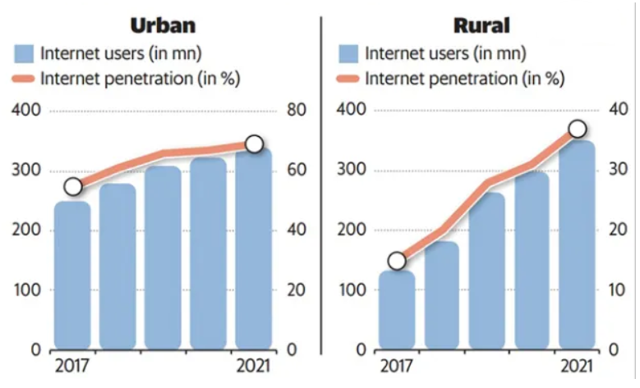
Figure 1: Internet penetration in India in the rural and urban areas
(Source: medium.com, 2025)
Internet penetration rate in the rural areas of India is increasing compared to urban areas (medium.com, 2025). However, only “38% of Indian households” are digitally literate along with this the situation is much worse in the rural areas that can reflect cybersecurity issues (medium.com, 2025). The respective research is significant as it assists to address the increasing gap between the rise of social media, the linked cyber threats as well as the ability of users' to protect themselves. The research can be helpful for developing practical strategies in order to protect individuals as well as organisations, improving public awareness, reducing cybersecurity incidents such as phishing, data theft and malware followed by informing curriculum and policy development.

1.5 Dissertation Structure
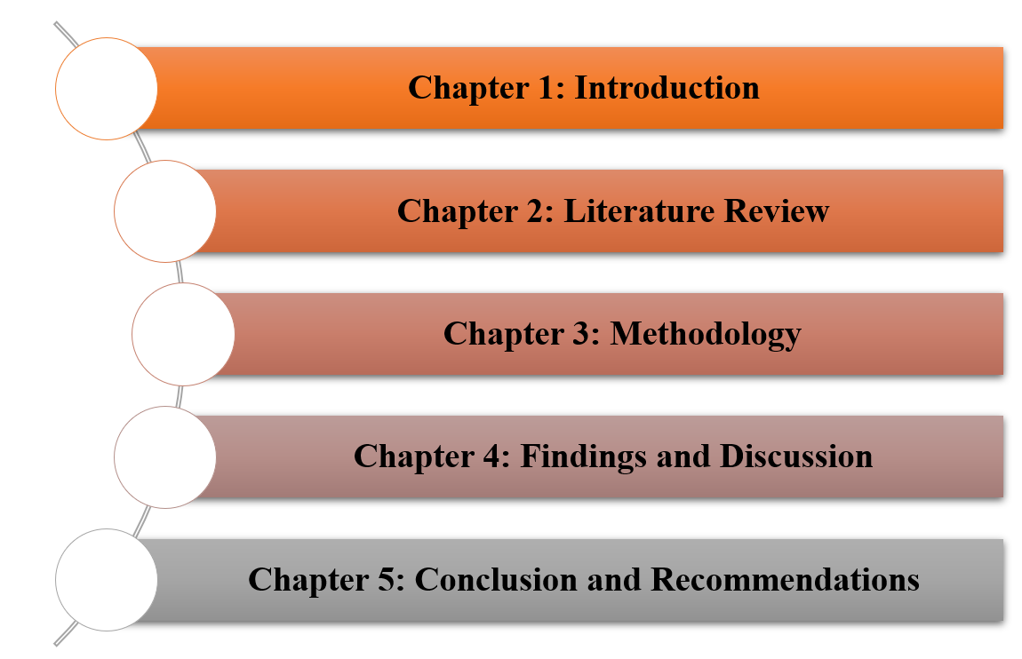
Figure 2: Structure of the dissertation
(Source: Self-Created)

Chapter 2: Literature Review

2.1 Importance of social media literacy in India
Based on the ideas of Salleh et al. (2023), social media literacy is significant in order to combat the spread of misinformation, protect citizens from online risks such as scams and cyberbullying followed by fostering responsible digital citizenship. Improvement in literacy empowers individuals to effectively evaluate online content, verify information, recognize bias and protect privacy in India. On the other hand Sugeng (2022), stated that social media literacy helps to protect users from privacy risks, cyberbullying and scams, specifically young people along with the elderly. Beside this, it fosters critical thinking skills that allows users to identify hidden agendas, question the source of information along with avoiding falling for manipulation tactics. Furthermore, social media literacy assists to encourage users to not only consume media critically yet to create as well as share content in a respectful and ethical manner.

2.2 Advantages of social media literacy in Cyber-crime prevention
According to Agbaka (2024), stated that social media literacy assists to prevent cybercrime with the help of empowering users to identify as well as avoid scams, use privacy settings effectively and protect personal information. The noteworthy advantages include avoiding oversharing, recognizing phishing attempts, comprehending the risks of public Wi-Fi along with grasping knowledge to report cybercrimes along with protecting legal rights online. However, Currie and Kelly (2022), mentioned that literacy can aid users to recognize and reject suspicious friend requests as well as messages on the social media platforms. Additionally, these are common tactics for initiating “social engineering attacks” such as identity and phishing theft. Apart from this, it encourages users to create strong passwords, regularly audit privacy settings in order to control the preview of information and avoid sharing personal details excessively. Collier et al. (2022), revealed that users can learn legal rights online along with ways to report cybercrimes to authorities that can be helpful to avoid future attacks. Furthermore, social media literacy is an effective method to combat cyberbullying by understanding and managing online interactions better.

2.3 Shortcomings in increasing social media literacy in India
Sugeng et al. (2024), revealed that lack of awareness regarding privacy risks as well as the spread of misinformation. Additionally, these are exacerbated by regional disparities along with the rapid, unregulated growth of digital space. In contrast Afzal et al. (2023), the digital divide reflects differences in digital skills across age groups as well as regions along with this limited ability of educators in order to keep pace with technological changes that can further hinder progress. Besides this, some of the users lack the skills in order to critically recognize or evaluate content regarding addictive patterns in platform design that can lead to negative consequences for productivity and mental health.

2.4 Solutions to increase social media literacy in India
Yu et al. (2024), stated that integrating digital literacy into school curricula, creating public-private partnerships for the curriculum development, providing accessible training programs in local languages as well as leveraging technology for education and fact-checking can be helpful. In contrast, Lähdesmäki and Maunula (2023), empowering educators, involving parents and communities along with building a national media literacy mission with the integration of policy support as well as certifications can be helpful. Furthermore, expanding internet connectivity along with establishing digital learning centres, specifically in rural areas in India can be beneficial. Moreover, social media literacy in India with developing different programmes to enhance knowledge of people that can shed a positive impact in improving the cybersecurity.

2.5 Conceptual framework
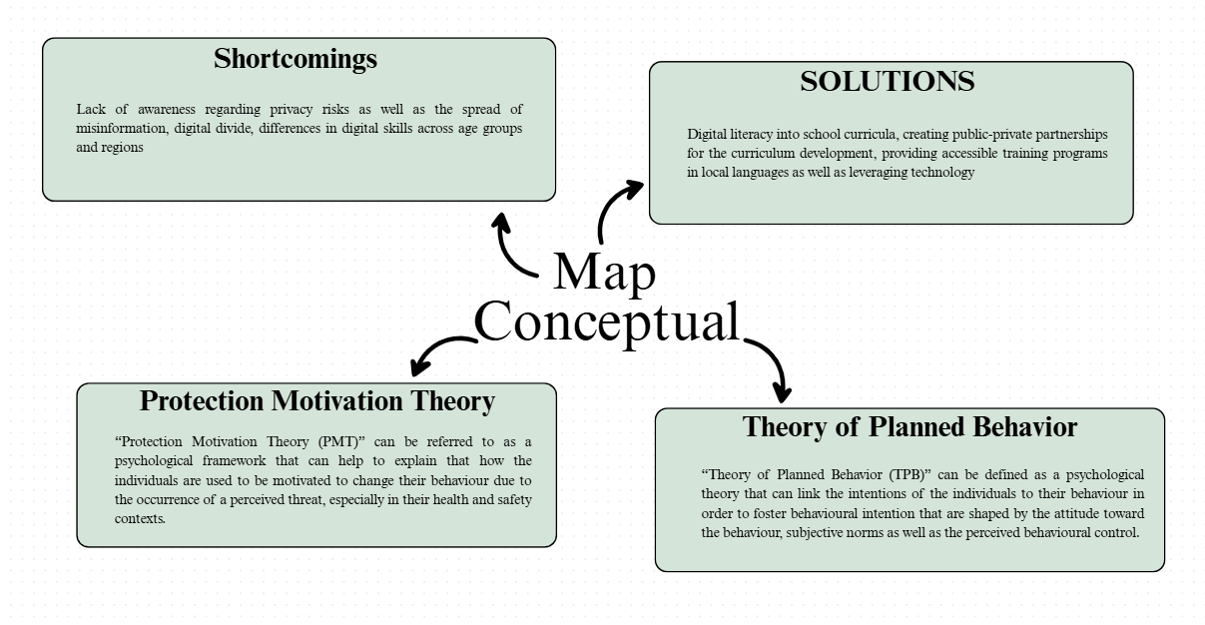
Figure 3: Conceptual framework
(Source: Self-Created)

2.6 Theoretical underpinning

2.6.1 Protection Motivation Theory (PMT)
As per the study of Ezati Rad et al. (2021) it has been highlighted that the “Protection Motivation Theory (PMT)” can be referred to as a psychological framework that can help to explain that how the individuals are used to be motivated to change their behaviour due to the occurrence of a perceived threat, especially in their health and safety contexts. In this context, the appraisals of PMT can ultimately help the individuals to build their motivation as well as to adopt a protective behaviour (Estebsari et al., 2023). Therefore, it can be summarised that the appraisals of PMT can help the residents of India to build social media literacy and to prevent cyber-crime activities.

2.6.2 Theory of Planned Behaviour (TPB)
As per the study of Kachkar and Djafri, (2022) it has been evaluated that the “Theory of Planned Behaviour (TPB)” can be defined as a psychological theory that can link the intentions of the individuals to their behaviour in order to foster behavioural intention that are shaped by the attitude toward the behaviour, subjective norms as well as the perceived behavioural control. In this context, the Theory of Planned Behaviour (TPB) can be significantly applied to the social media literacy contexts along with the utilisation of 3 constructs such as attitude, subjective norms and perceived behavioural control in order to predict the intentions toward the responsible social media use. In addition to these, the positive attitude toward being media literate, immense social support for it from their peers and family along with the belief that the individuals have the capability to use social media responsibly can potentially increase the behavioural intention and subsequent action of them to be literate online (Jiang et al., 2024). Therefore, the TPB framework can also help the individuals to inform the core interventions in order to improve their digital behaviours such as the identification of the risks and promotion of a healthier habit.

2.7 Literature gap
In some of the literature there was lack of information regarding the social media literacy attributes specific to India. Apart from this, there was limited knowledge regarding the different challenges that are prevailing due to lack of social media literacy such as cybersecurity issues. Beside this, lack of theoretical underpinning some of the literatures reflected challenges in understanding the context effectively.

Chapter 3: Methodology

3.1 Research Philosophy
The researcher will conduct the research by following the “interpretivism research philosophy” in order to highlight the effect of social media literacy in India. As per the opinion of Pervin and Mokhtar, (2022) it has been highlighted that “interpretivism researcher philosophy” can be supremely facilitating for the researchers to hypothetically conduct the research based on subjective experiences. In addition to these, the study of Junjie and Yingxin, (2022) has also demonstrated that the “interpretivism research philosophy” can provide sufficient flexibility to the researcher that can be helpful for the researchers to conduct research with their own inputs.

3.2 Research approach
The researcher will surely focus on the implication of “deductive research approach” in this present research. As per the study of Hall et al. (2023) it has been reflected that the consideration of the “deductive research approach” can be strongly facilitating for the researchers to create the initial base of the research with rational planning. Apart from these, the “deductive research approach” can be extremely facilitating secondary research as it can help the researchers to input flexibility in research outcomes (Michelen et al., 2024). In this context, the researcher will ignore the “inductive research approach” and consider the “deductive approach”.

3.3 Research design
The researcher will shed light on the implementation of “descriptive research design” in this present research with the purpose to elaboratively conduct the data collection and analysis processes. On the other hand, as per the study of Van Quaquebeke et al. (2022) it has been determined that the consideration of “descriptive research design” can help the researchers to conduct the study with cost effectiveness and speed that can allow the researchers for quick data collection from large groups. In this context, the researcher will follow the “descriptive research design” due to the purpose of quickly accomplishing the research without investing huge amounts of resources.

3.4 Data collection method and data type
The researcher will follow the “secondary data collection method” in order to collect a sufficient amount of “qualitative data sets”. As per the opinion of Mazhar et al. (2021) it has been highlighted that the consideration of “secondary data collection methods” can be highly beneficial for the researchers to gather an adequate amount of data within lesser time. On the other hand, the researchers are used to focusing on the gathering of “qualitative data sets” to avoid the numerical calculation for data interpretation (Chandrasekar et al., 2024). In this context, the researcher will avoid the “primary data collection” and inherently follow the “secondary qualitative data collection methods”.

3.5 Sampling and inclusion criteria
The researcher will follow the “non-probability convenience sampling method” in this secondary qualitative study with the purpose to collect significant data sets, collected from the authentic database. As per the opinion of Alzghaibi and Hutchings, (2025) it has been reflected that the consideration of the “non-probability convenience sampling method” can be supremely facilitating for the researchers to conduct the research papers with significant secondary sources within less time. However, the researcher will follow some inclusion criteria to select the samples.
- Current sources will be collected (within last 4 years)
- Sources that are available in English language
- Sources that are relevant to the research topics
- Peer reviewed journals and authentic sources only

3.6 Data analysis
The researcher will follow the “thematic analysis method” with the tabular format. As per the renowned study of Braun and Clarke, (2021) it has been stated that the consideration of “thematic analysis” can be extremely beneficial for the researchers to evaluate and criticise the qualitative data sets. In addition to these, the “thematic analysis method” can allow the researchers to interpret the “qualitative data sets” with their own perspectives (Braun and Clarke, 2023). In this context, the researcher will conduct a list of themes in this research that will be based on the research objectives as well as collect secondary sources to support the themes.

3.7 Ethical considerations
The researcher will strictly follow the legal frameworks while accomplishing the research such as the consideration of “General Data Protection Regulation Act 2018 and Copyright Act 1956”. The consideration of the “General Data Protection Regulation Act 2018” can be supreme for further researchers to maintain privacy of the sources (gov.uk, 2025). On the other hand, the “Copyright Act 1956” can help the researchers to increase distinction and uniqueness of the research outcomes from other researches (legislation.gov.uk, 2025). In addition to these, the researcher will surely follow all the inclusion criteria for sampling and data collection processes. Apart from these, the research paper will be submitted with an alphabetical reference list in order to acknowledge the authors of the secondary sources in this research.

Chapter 4: Estimated Outcome
The researcher has conducted the entire study on the purpose of highlighting the effects of social media literacy on the cyber-crime prevention standards of India. In this regard, as per the study of Kumar et al. (2024) it can be stated that social media literacy can significantly foster the cyber-crime prevention standards in India along with empowering the social media users to recognize and avoid the online threats as well as by reducing their vulnerability to multiple crimes such as phishing, identity theft and cyberbullying. However, there are some emerging issues to prevent the cybercrime standards in India such as a significant digital literacy gap to make the citizens vulnerable to social engineering tactics such as phishing and scams.

Reference List
Afzal, A., Khan, S., Daud, S., Ahmad, Z. and Butt, A., 2023. Addressing the digital divide: Access and use of technology in education. Journal of Social Sciences Review, 3(2), pp.883-895.
Agbaka, J., 2024. Integrated approaches to combat cyber-crime on social media: legislative, educational, and technological solutions. PERSPEKTIF, 13(4), pp.1213-1222.
Almousa, M. and Anwar, M., 2023. A URL-based social semantic attacks detection with character-aware language model. IEEE Access, 11, pp.10654-10663.
Alzghaibi, H. and Hutchings, H.A., 2025. Barriers to the implementation of large-scale electronic health record systems in primary healthcare centers: a mixed-methods study in Saudi Arabia. Frontiers in Medicine, 12, p.1516714.
Braun, V. and Clarke, V., 2021. Thematic analysis: A practical guide.
Braun, V. and Clarke, V., 2023. Toward good practice in thematic analysis: Avoiding common problems and be (com) ing a knowing researcher. International journal of transgender health, 24(1), pp.1-6.
Chandrasekar, A., Clark, S.E., Martin, S., Vanderslott, S., Flores, E.C., Aceituno, D., Barnett, P., Vindrola-Padros, C. and Vera San Juan, N., 2024. Making the most of big qualitative datasets: a living systematic review of analysis methods. Frontiers in big Data, 7, p.1455399.
Collier, B., Thomas, D.R., Clayton, R., Hutchings, A. and Chua, Y.T., 2022. Influence, infrastructure, and recentering cybercrime policing: Evaluating emerging approaches to online law enforcement through a market for cybercrime services. Policing and Society, 32(1), pp.103-124.
Currie, D.H. and Kelly, D.M., 2022. Critical Media Literacy for Uncertain Times: Promoting Student Reflexivity. Journal of Media Literacy Education, 14(2), pp.15-26.
Estebsari, F., Khalifehkandi, Z.R., Latifi, M., Farhadinasab, A., Vasli, P. and Mostafaie, D., 2023. Protection motivation theory and prevention of breast cancer: a systematic review. Clinical Breast Cancer, 23(4), pp.e239-e246.
Ezati Rad, R., Mohseni, S., Kamalzadeh Takhti, H., Hassani Azad, M., Shahabi, N., Aghamolaei, T. and Norozian, F., 2021. Application of the protection motivation theory for predicting COVID-19 preventive behaviors in Hormozgan, Iran: a cross-sectional study. BMC Public Health, 21(1), p.466.
gov.uk, (2025). “Data protection”. Available at: https://www.gov.uk/data-protection [Accessed on: 23rd November 2025]
Hall, J.R., Savas-Hall, S. and Shaw, E.H., 2023. A deductive approach to a systematic review of entrepreneurship literature. Management Review Quarterly, 73(3), pp.987-1016.
Jiang, M.M., Xiao, Y.W. and Liao, Z.L., 2024. Pathways of media contact to health literacy in middle-aged and older people: the chain mediation effect of perceived social support and self-efficacy. Journal of Multidisciplinary Healthcare, pp.111-121.
Junjie, M. and Yingxin, M., 2022. The Discussions of Positivism and Interpretivism. Online Submission, 4(1), pp.10-14.
Kachkar, O. and Djafri, F., 2022. Exploring the intentional behaviour of refugees in participating in micro-enterprise support programmes (MESP): is theory of planned behaviour (TPB) still relevant?. Journal of Entrepreneurship in Emerging Economies, 14(4), pp.549-576.
Kumar, A., Joshi, A., Pandey, R.K. and Sharma, A.K., 2024. Navigating the Digital Era: Social Media’s Influence, Issues, and Cybercrime. The Indian Police, p.12.
Lähdesmäki, S. and Maunula, M., 2023. Empowering media literacy skills: enhancing student teachers’ awareness of new literacy competencies in teacher education. International Journal of Technology and Inclusive Education, 12(2), pp.1910-1919.
legislation.gov.uk, (2025). “Copyright Act 1956”. Available at: https://www.legislation.gov.uk/ukpga/Eliz2/4-5/74/enacted [Accessed on: 23rd November 2025]
Mazhar, S.A., Anjum, R., Anwar, A.I. and Khan, A.A., 2021. Methods of data collection: A fundamental tool of research. Journal of Integrated Community Health, 10(1), pp.6-10.
medium.com, (2025). “Where India Stands on Digital Literacy ft. Social Media”. Available at: https://medium.com/@AbdulWahab./where-india-stands-on-digital-literacy-ft-social-media-f64076feed10 [Accessed on: 23rd November 2025]
Michelen, M., Phan, M., Zimmer, A., Coury, N., Morey, B., Montiel Hernandez, G., Cantero, P., Zarate, S., Foo, M.A., Tanjasiri, S. and Billimek, J., 2024. Practical qualitative data analysis for public health research: A guide to a Team-Based approach with flexible coding. International journal of qualitative methods, 23, p.16094069241289279.
Pervin, N. and Mokhtar, M., 2022. The interpretivist research paradigm: A subjective notion of a social context. International Journal of Academic Research in Progressive Education and Development, 11(2), pp.419-428.
pib.gov.in, (2025). “Curbing Cyber Frauds in Digital India”. Available at: https://www.pib.gov.in/PressReleasePage.aspx?PRID=2176146 [Accessed on: 23rd November 2025]
Salleh, A.S.S., Latif, A., Anis, W., Zambri, A.M., Latiff, D.I.A. and Kamal, S., 2023. Media literacy and digital citizenship in the era of social media. International Journal of Academic Research in Business & Social Sciences, 13(11), pp.918-929.
statista.com, (2025). “Social media usage in India - statistics & facts”. Available at: https://www.statista.com/topics/5113/social-media-usage-in-india/?srsltid=AfmBOoqvbAQZieweBhQgEsyK-leVOs37Iyv09TrTcOzRzinni25KSc0A#topicOverview [Accessed on: 23rd November 2025]
Sugeng, S., Fitria, A. and Bastomi, S., 2024. Epistemic Injustice and Digital Disinformation: Addressing Knowledge Inequities in the Digital Age. DISKURSUS-JURNAL FILSAFAT DAN TEOLOGI STF DRIYARKARA, 20(1), pp.135-169.
Sugeng, S., Fitria, A. and Rohman, A.N.R.A.N., 2022. Promoting digital literacy for the prevention of risk behavior in social media for adolescents. JurnalKeamanan Nasional, 8(1).
Syafitri, W., Shukur, Z., Asma’Mokhtar, U., Sulaiman, R. and Ibrahim, M.A., 2022. Social engineering attacks prevention: A systematic literature review. IEEE access, 10, pp.39325-39343.
Van Quaquebeke, N., Salem, M., van Dijke, M. and Wenzel, R., 2022. Conducting organizational survey and experimental research online: From convenient to ambitious in study designs, recruiting, and data quality. Organizational Psychology Review, 12(3), pp.268-305.
Yu, J., Bekerian, D.A. and Osback, C., 2024. Navigating the digital landscape: challenges and barriers to effective information use on the internet. Encyclopedia, 4(4), pp.1665-1680.

