Abstract

The rapid growth of industrialization and increasing global energy demand have intensified the need for efficient energy management strategies in industrial automation systems. In this context, Artificial Intelligence (AI) has emerged as a transformative technology for enhancing energy efficiency and enabling sustainable industrial operations. This paper presents a comprehensive review of AI-based approaches for energy conservation in industrial automation, focusing on techniques such as machine learning (ML), deep learning (DL), reinforcement learning, and hybrid intelligent systems.
AI-driven methods enable real-time monitoring, predictive analytics, and adaptive control of industrial processes by leveraging data collected from sensors, Industrial Internet of Things (IIoT) devices, and cyber-physical systems. These techniques facilitate key applications such as predictive maintenance, process optimization, energy demand forecasting, and intelligent resource allocation, thereby significantly reducing energy consumption and operational costs.
The review also highlights the role of advanced paradigms such as Digital Twins, Edge AI, and smart manufacturing frameworks in enabling decentralized and autonomous energy management systems. By modelling complex energy consumption patterns and identifying inefficiencies in real time, AI-based systems contribute to improved productivity, reduced waste, and enhanced sustainability in industrial environments.
Furthermore, the paper discusses various AI algorithms, including artificial neural networks, support vector machines, and deep learning architectures, that are widely used for optimizing thermal systems, process control, and energy flow in industrial applications. Despite their potential, challenges such as data quality, model interpretability, integration complexity, and high implementation costs remain significant barriers to large-scale adoption.
Finally, this review identifies current research gaps and outlines future directions, including the integration of AI with renewable energy systems, federated learning, and explainable AI for transparent decision-making. The findings emphasize that AI-driven industrial automation holds substantial promise for achieving energy-efficient, cost-effective, and sustainable manufacturing systems in the era of Industry 4.0.
Keywords
Artificial Intelligence, Energy Conservation, Industrial Automation, Smart Manufacturing, Machine Learning, Deep Learning, IIoT, Predictive Maintenance, Energy Optimization, Industry 4.0
1. Introduction
The rapid expansion of industrialization and the increasing demand for energy have intensified the need for efficient and sustainable energy management in industrial automation systems. Industrial sectors account for a significant share of global energy consumption, making them a critical focus area for energy conservation initiatives. Traditional automation systems, primarily based on fixed control strategies and rule-based mechanisms, often lack the adaptability required to respond to dynamic operational conditions, leading to suboptimal energy utilization and increased operational costs.
In recent years, Artificial Intelligence (AI) has emerged as a transformative technology capable of addressing these challenges by enabling intelligent, data-driven decision-making in industrial environments. AI techniques such as machine learning, deep learning, and reinforcement learning have demonstrated significant potential in optimizing industrial processes, reducing energy consumption, and enhancing system efficiency. By leveraging data from sensors, Industrial Internet of Things (IIoT) devices, and cyber-physical systems, AI-based solutions can provide real-time monitoring, predictive insights, and adaptive control mechanisms.
Among various AI approaches, reinforcement learning and hybrid AI models have gained particular attention due to their ability to learn optimal control policies in complex and dynamic environments. These approaches enable industrial systems to autonomously adjust operational parameters, optimize energy usage, and respond effectively to uncertainties in demand and process conditions. Furthermore, the integration of AI with smart manufacturing paradigms, such as Industry 4.0 and digital twins, has paved the way for the development of energy-efficient, self-optimizing industrial systems.
Despite these advancements, several challenges remain in the widespread adoption of AI-based energy conservation techniques. Issues such as data quality and availability, integration with legacy industrial systems, high implementation costs, and lack of model interpretability continue to hinder practical deployment. Moreover, there is a need for comprehensive frameworks that systematically evaluate and compare different AI approaches in terms of their effectiveness for energy conservation in industrial automation.
This research work is structured around the following key components:
Phase 1: Literature Review
- Comprehensive review of AI techniques used in energy conservation
- Analysis of existing industrial applications and case studies
- Identification of research gaps and limitations
Phase 2: System Modeling and Problem Definition
- Selection of an industrial use case (e.g., HVAC system, motor drives, or process plant)
- Modeling of energy consumption patterns
- Identification of key variables affecting energy efficiency
The remainder of this paper is organized as follows: Section 2 presents the literature review of AI-based energy conservation techniques. Section 3 describes the methodology and proposed framework. Section 4 highlights challenges and future research directions. Finally, Section 5 concludes the paper.
2. Literature Review
The application of Artificial Intelligence (AI) for energy conservation in industrial automation has gained significant attention in recent years due to increasing energy demand, sustainability concerns, and advancements in digital technologies. This section reviews existing research across key themes, including machine learning-based optimization, IIoT integration, predictive maintenance, and advanced AI techniques.

2.1 AI and Machine Learning for Energy Efficiency in Industry
Machine learning (ML) has emerged as a fundamental tool for improving energy efficiency in industrial systems by leveraging large volumes of operational data. Early studies highlight that industrial environments generate vast datasets that remain underutilized, and ML techniques can extract meaningful insights to reduce energy losses [1].
Recent literature demonstrates that ML algorithms such as Artificial Neural Networks (ANN), Support Vector Machines (SVM), and Random Forests are widely used for energy prediction, process optimization, and anomaly detection [2], [3]. These approaches enable industries to dynamically adjust process parameters, thereby improving efficiency and reducing operational costs.
Furthermore, ML-based energy optimization systems have been shown to significantly reduce energy consumption by identifying inefficiencies in industrial processes and recommending corrective actions [4]. The increasing availability of high-resolution sensor data has further enhanced the effectiveness of these models.

2.2 Integration of AI with Industrial Internet of Things (IIoT)
The integration of AI with the Industrial Internet of Things (IIoT) has revolutionized energy management in industrial environments. IIoT facilitates real-time data acquisition from sensors and devices, enabling AI models to perform continuous monitoring and optimization [5].
Studies show that AI-enabled IIoT systems can significantly enhance energy efficiency by enabling real-time decision-making, load forecasting, and anomaly detection [6]. Additionally, the combination of IoT and ML allows automated control of industrial processes, minimizing human intervention and energy waste [7].
Recent reviews emphasize that AI–IoT integration supports applications such as intelligent energy management systems (IEMS), smart grids, and industrial automation platforms, contributing to improved sustainability and operational efficiency [8], [9].
2.3 AI-Based Predictive Maintenance and Energy Savings
Predictive maintenance is one of the most impactful applications of AI in industrial automation. Traditional maintenance strategies often lead to energy inefficiencies due to unexpected equipment failures or suboptimal operation. AI-based predictive maintenance systems use historical and real-time data to predict equipment failures and optimize maintenance schedules [10].
Research demonstrates that AI-driven predictive maintenance not only reduces downtime but also improves energy efficiency by ensuring equipment operates under optimal conditions [11]. For instance, AI-integrated IIoT platforms have been successfully applied in generator systems to reduce fuel consumption and improve performance through predictive analytics [12].
Advanced frameworks combining AI, big data, and IIoT enable intelligent maintenance systems that continuously learn and adapt, further enhancing energy efficiency [13].
2.4 Smart Manufacturing and Energy Optimization
The emergence of smart manufacturing and Industry 4.0 has accelerated the adoption of AI-based energy optimization techniques. Smart factories utilize cyber-physical systems, cloud computing, and AI to enable intelligent and autonomous operations [14].
AI-driven systems in smart manufacturing environments support applications such as:
- Real-time energy monitoring
- Adaptive process control
- Production scheduling optimization
- Resource allocation
These systems improve energy efficiency by aligning production processes with energy availability and demand [15].
Moreover, AI-based optimization techniques help reduce waste, improve productivity, and support sustainable industrial practices [16].
2.5 Advanced AI Techniques for Energy Management
Recent research has explored advanced AI techniques such as deep learning, reinforcement learning (RL), and hybrid models for energy optimization. Deep learning models are particularly effective in capturing complex nonlinear relationships in industrial systems, enabling accurate energy forecasting and optimization [17].
Reinforcement learning has shown promise in adaptive energy management by enabling systems to learn optimal control strategies through interaction with the environment [18]. These approaches are especially useful in dynamic and uncertain industrial environments.
Hybrid AI models, combining ML with optimization algorithms (e.g., genetic algorithms, fuzzy logic), have also been proposed to enhance performance and robustness in energy management systems [19].
2.6 Challenges and Research Gaps
Despite significant progress, several challenges remain in implementing AI-based energy conservation techniques:
- Data Quality and Availability: Industrial datasets are often incomplete, noisy, or inconsistent, affecting model performance [20].
- Scalability Issues: Deploying AI models in large-scale industrial environments remains complex [21].
- Model Interpretability: Many AI models operate as black boxes, limiting their acceptance in critical industrial applications [22]
- Integration with Legacy Systems: Existing infrastructure may not support advanced AI technologies [23]
- Security and Privacy Concerns: IIoT-based systems introduce cybersecurity risks [24].
Additionally, there is a lack of comprehensive comparative studies evaluating different AI techniques specifically for energy conservation in industrial automation.
2.7 Summary of Literature
The reviewed literature indicates that AI-based approaches, particularly when integrated with IIoT and smart manufacturing systems, offer significant potential for energy conservation in industrial automation. Machine learning and predictive analytics have been widely adopted, while advanced techniques such as reinforcement learning and hybrid models are emerging as promising solutions.
However, further research is required to develop scalable, interpretable, and cost-effective AI frameworks that can be effectively deployed in real-world industrial environments.
3. Research Framework and Case Studies
This research adopts a systematic and experimental methodology to analyze and evaluate AI-based approaches for energy conservation in industrial automation. The methodology integrates data-driven modeling, AI algorithm development, and performance evaluation within a smart industrial framework.
The overall approach consists of:
- Data acquisition from industrial processes
- Modeling of energy consumption behavior
- Implementation of AI-based optimization techniques
- Comparative performance evaluation
- Framework validation
Various case studies are considered for energy conservation using AI.

Case Study 1: AI-Based HVAC Chiller Optimization (IoT + ML) Description
AI-based chiller system optimization using IoT and cloud-based machine learning.
AI Approach Used
- ML models for:
  - Load prediction
  - Chiller performance optimization
- Integration with Building Management System (BMS)
Key Results
- Significant reduction in HVAC energy consumption
- Improved operational efficiency
- Data-driven control strategies
AI improves optimization of chillers, which are major energy consumers in buildings.

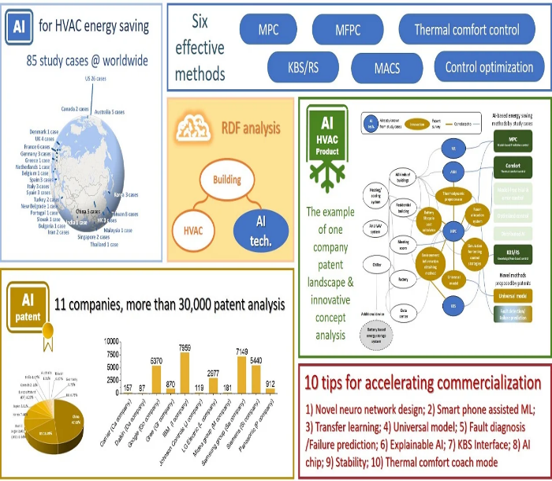
Fig-1: Framework of various AI methods used for HAVAC energy conservation [13]

This study reviewed 12 review papers and selected 85 specific cases of applications of AI for HVAC energy usage reduction. In addition to academic studies, 31,221 patents related to HVAC energy-saving equipment filed by 11 companies were investigated. In order to analyze the large amount of data, this study developed a resource description framework (RDF) as an analysis tool. This tool was used with a natural language processing (NLP) program to compare the contents of academic papers and patents. With the automated analysis program, this study aimed to link academic research and corporate research and development, mainly the enterprise patent applications, to analyze the reasons why AI can effectively save energy.
This represents a complete analysis of the current status of academic and industrial development. Six methods were identified to save energy effectively, including model-based predictive control (MPC), thermal comfort control, model-free predictive control, control optimization, multi-agent control (MAC), and knowledge-based system/rule set (KBS/RS)-based control. The energy savings of these methods were quantified to be 8.8–25.5%.
These methods are widely covered by the examined corporate patent applications. After using NLP to retrieve patent keywords, the landscapes of enterprise patents were constructed and the future research directions were identified. It is concluded that 10 topics, including novel neural network designs, smartphone-assisted machine learning, and transfer learning, can be used to increase the energy-saving effects of AI and enable sustainable air-conditioning systems.

Case Study 2: AI-Based Energy Optimization in Multi-Factory Environments [14]

Description
A large-scale study titled “Universal Artificial Intelligence Workflow for Factory Energy Saving: Ten Case Studies” examined AI implementation across 10 different factories (steel, food, semiconductor, etc.).
AI Approach Used
- Artificial Neural Networks (ANN)
- Predictive modeling + optimization
- Standardized AI workflow (Learning → Modeling → Control)
Key Results
- Average AI energy savings: ~106,124 kWh/year per factory
- ROI: < 1 year (0.46 years)
- Applicable across multiple industrial sectors
- AI enabled standardized and scalable energy management

AI provided lower absolute savings than hardware upgrades but much faster ROI.

Here majority of processes are having 5 stages of work flow.
1. Industrial Process
2. Data Acquisition (IIoT)
3. Data Processing
4. AI Model (ML/DL/RL)
5. Optimization & Control

Case Study 3: Digital Twin and AI-Based Energy Optimization in Industrial Systems
3.1 Introduction

Digital Twin technology, when integrated with Artificial Intelligence (AI), has emerged as a powerful solution for real-time monitoring, simulation, and optimization of industrial energy systems. A Digital Twin is a virtual replica of a physical system that continuously receives real-time data from sensors and Industrial Internet of Things (IIoT) devices.

This enables dynamic analysis and intelligent decision-making for improving system performance and energy efficiency.
This case study focuses on the application of AI-enabled Digital Twin frameworks in industrial plants and smart buildings for energy conservation. [15]

3.2 System Architecture

A typical Digital Twin-based energy optimization system consists of the following layers:

1. Physical Layer
- Industrial systems (HVAC, motors, compressors, production units)
- Sensors measuring:
  - Temperature
  - Power consumption
  - Pressure
  - Flow rates

2. Data Acquisition Layer

- IIoT devices and communication networks
- Real-time data transfer to cloud/edge platforms

3. Digital Twin Layer
- Virtual model of the physical system
- Simulates:
  - Energy consumption behavior
  - System dynamics
- Continuously updated using real-time data

4. AI Analytics Layer
- Machine Learning models for:
  - Energy prediction
  - Anomaly detection
  - Performance optimization
- Deep learning for complex nonlinear relationships

5. Control & Optimization Layer
- AI-driven decisions applied back to the physical system
- Adaptive control strategies for:
  - Load balancing
  - Equipment scheduling
  - Energy-efficient operation
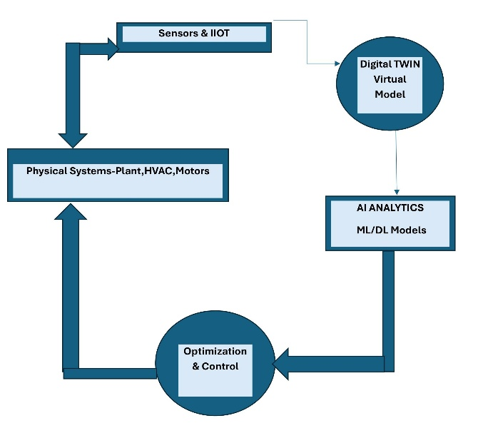

Fig:2 Digital Twin-based AI framework for real-time energy monitoring and optimization in industrial systems.
Case Study 4:- Energy Efficiency Through Industrial Automation

The conceptual framework explains how industrial automation technologies lead to improved energy efficiency through a structured relationship between inputs, mechanisms, and outcomes.

1. Core Idea of the Framework
The framework establishes that:
Automation Technologies → Enable Optimization Mechanisms → Result in Energy Efficiency

It acts as a cause–effect model, linking automation systems to measurable energy savings in industrial processes.
1. Key Components of the Framework

A. Automation Technologies (Input Layer)
These are the foundational systems that enable energy optimization:
- Programmable Logic Controllers (PLCs)
- Distributed Control Systems (DCS)
- SCADA systems
- Variable Frequency Drives (VFDs)
- Advanced Process Control (APC)
- Energy Management Systems (EMS)

These technologies provide real-time monitoring, control, and data acquisition capabilities.

B. Energy Optimization Mechanisms (Process Layer)

Automation improves energy efficiency through the following mechanisms:

- Precision Control
  - Maintains process variables within tight limits
  - Reduces energy waste (e.g., overheating, overcooling)
- Real-Time Optimization
  - Continuously adjusts process parameters
  - Matches energy usage with demand
- Equipment Sequencing
  - Optimizes start/stop operations
  - Avoids idle energy consumption
- Demand Response
  - Shifts loads to off-peak hours
  - Reduces energy cost and peak demand
- Predictive Maintenance
  - Detects inefficiencies early
  - Prevents energy losses due to faulty equipment

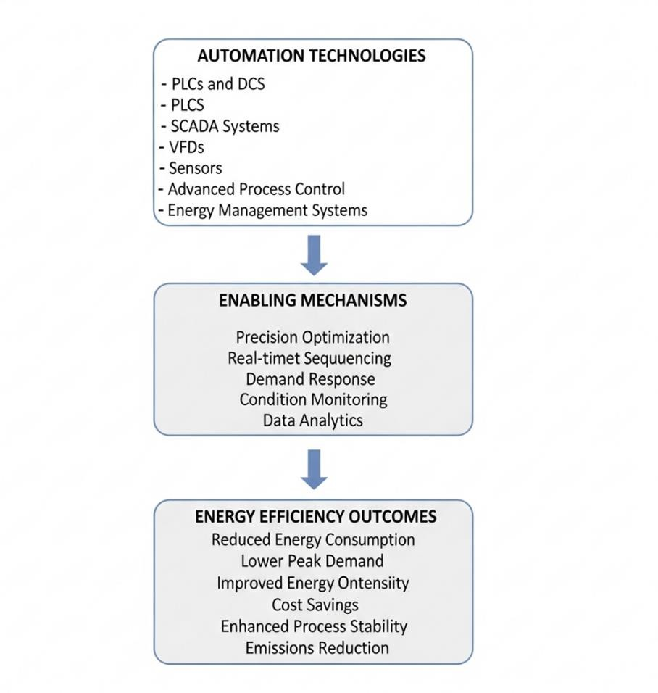

Fig:3 Conceptual Framework of Automation- Driven Energy Efficiency [16]

C. Enabling Factors (Support Layer)
These factors enhance the effectiveness of automation:
- Data availability and quality
- Integration of systems (IIoT, MES, ERP)
- Skilled workforce
- Organizational commitment
- Advanced analytics (AI/ML)

D. Outcomes (Output Layer)
The combined effect leads to:
- Energy savings (15–40%)
- Improved system efficiency
- Reduced operational costs
- Enhanced productivity and quality
- Lower environmental impact

4. Proposed AI based Framework for Energy Conservation

4.1 Framework Overview

This research proposes an integrated framework for energy conservation in industrial automation by combining Artificial Intelligence (AI), Digital Twin technology, and Industrial Internet of Things (IIoT). The framework is designed to enable real-time monitoring, predictive analysis, and adaptive control of industrial energy consumption.

Unlike conventional automation systems, which rely on fixed control strategies, the proposed framework adopts a data-driven and self-learning approach. It continuously collects operational data from industrial processes, processes this data using advanced AI techniques, and dynamically adjusts system parameters to optimize energy usage. The integration of a Digital Twin allows for real-time simulation and predictive analysis, thereby enhancing decision-making capabilities.

The framework follows a closed-loop architecture, ensuring continuous feedback between the physical system and the intelligent control system. This enables not only reactive control but also proactive and predictive energy optimization, aligning with Industry 4.0 and smart manufacturing paradigms.

4.2 Architecture of the Proposed Framework

The proposed framework is structured into five interconnected layers, each performing a specific role in achieving energy efficiency.

4.2.1 Physical System Layer

The Physical System Layer represents the actual industrial environment where energy is consumed. It includes equipment such as electric motors, HVAC systems, compressors, pumps, conveyors, and other process units. These systems are typically energy-intensive and operate under varying load conditions.
Energy consumption at this level depends on process parameters such as temperature, pressure, flow rate, and production demand. Inefficiencies often arise due to improper control, equipment degradation, and lack of real-time optimization. Therefore, this layer serves as the primary target for energy conservation.

4.2.2 Data Acquisition Layer (IIoT Integration)

The Data Acquisition Layer is responsible for collecting real-time data from the physical system using IIoT-enabled sensors and devices. Parameters such as energy consumption, temperature, pressure, and equipment status are continuously monitored.
Data is transmitted through communication protocols and integrated with automation systems such as PLCs, SCADA, and smart meters. This layer ensures high-resolution, real-time data availability, which is essential for accurate analysis and optimization.
The effectiveness of the entire framework depends on the quality, reliability, and granularity of data collected at this stage.

4.2.3 Data Processing and Digital Twin Layer

In this layer, the collected data is preprocessed and used to create a Digital Twin, which is a virtual representation of the physical system.

Data preprocessing involves:
- Removal of noise and outliers
- Handling missing values
- Normalization and feature extraction
The Digital Twin replicates the behavior of the physical system and enables:
- Simulation of different operating conditions
- Prediction of energy consumption patterns
- Identification of inefficiencies
By providing a real-time synchronized model, the Digital Twin allows for what-if analysis, enabling decision-makers to evaluate multiple scenarios before implementing control actions in the actual system.

4.2.4 AI Analytics Layer

The AI Analytics Layer forms the core of the proposed framework and is responsible for intelligent decision-making. It incorporates multiple AI techniques:
Machine Learning (ML)
Machine learning models such as Artificial Neural Networks (ANN), Support Vector Machines (SVM), and Random Forests are used for:
- Energy consumption prediction
- Load forecasting
- Pattern recognition
Deep Learning (DL)
Deep learning models, including Long Short-Term Memory (LSTM) networks, are used for:
- Time-series forecasting
- Modeling complex nonlinear relationships in industrial systems
Reinforcement Learning (RL)
Reinforcement learning enables adaptive control by learning optimal policies through interaction with the environment. It is particularly useful for:
- Real-time energy optimization
- Dynamic control of industrial processes
- Decision-making under uncertainty
Hybrid AI Models
Hybrid approaches combine multiple techniques (e.g., ML + optimization algorithms) to enhance accuracy and robustness.
This layer enables:
- Anomaly detection
- Predictive maintenance
- Energy optimization strategies
4.2.5 Optimization and Control Layer

The Optimization and Control Layer translates AI-generated insights into actionable control strategies. These include:
- Optimal equipment scheduling
- Load balancing across systems
- Adjustment of process setpoints
- Demand response strategies
Control actions are implemented through industrial control systems such as PLCs and DCS. This creates a closed-loop feedback mechanism, where system performance is continuously monitored and adjusted.

4.3 Working Principle of the Framework

The proposed framework operates through a continuous closed-loop process:
- Data Collection:
- Real-time data is collected from sensors installed in industrial systems.
- Digital Twin Update:
The virtual model is updated to reflect current system conditions.
- AI-Based Analysis:
AI models analyze data to identify inefficiencies and predict future energy demand.
- Optimization:
Optimal control strategies are generated to minimize energy consumption.
- Control Action:
These strategies are implemented in the physical system.
- Feedback and Learning:
The system continuously learns from new data, improving performance over time.

4.4 Integration of Case Studies

The proposed framework is supported by insights from multiple case studies:
- Multi-factory AI workflow demonstrates scalability and structured implementation
- HVAC optimization shows real-time adaptive control and significant energy savings
- Digital Twin applications highlight predictive and simulation capabilities
- Chiller optimization emphasizes IIoT and ML integration
- Reinforcement learning applications demonstrate adaptive decision-making
These case studies validate the effectiveness of integrating AI, IIoT, and Digital Twin technologies for energy conservation.

4.5 Expected Outcomes

The implementation of the proposed framework is expected to achieve:
- Energy savings in the range of 15–40%
- Improved operational efficiency
- Reduction in energy costs
- Enhanced predictive maintenance
- Real-time adaptive control of industrial processes
Additionally, the framework contributes to sustainability by reducing carbon emissions and improving resource utilization.

4.6 Implementation Challenges

Despite its advantages, several challenges may arise:
- Availability of high-quality data
- Integration with legacy industrial systems
- High initial implementation cost
- Cybersecurity concerns in IIoT systems
- Complexity and interpretability of AI models
Addressing these challenges is essential for successful deployment.

4.7 Novel Contribution

The proposed framework offers the following key contributions:
- Integration of AI, Digital Twin, and IIoT into a unified architecture
- Use of Reinforcement Learning for adaptive energy control
- Development of a closed-loop intelligent energy management system
- Scalable and modular design suitable for various industrial applications

5.CONCLUSION

This study presented a comprehensive investigation of AI-based approaches for energy conservation in industrial automation, emphasizing the integration of Artificial Intelligence, Industrial Internet of Things (IIoT), and Digital Twin technologies. The research systematically reviewed existing literature, analyzed multiple real-world case studies, and proposed a unified framework for intelligent energy management in industrial systems.

The findings from the literature and case studies indicate that AI-driven techniques, including machine learning, deep learning, and reinforcement learning, play a crucial role in optimizing energy consumption by enabling predictive analytics, real-time monitoring, and adaptive control. Case studies such as multi-factory AI optimization, HVAC energy management, Digital Twin-based systems, and reinforcement learning-based control demonstrate that significant energy savings—typically in the range of 15–40%—can be achieved while maintaining or improving system performance.
The proposed framework integrates physical industrial systems, IIoT-based data acquisition, Digital Twin modeling, AI analytics, and optimization control into a closed-loop architecture. This approach enables continuous learning and dynamic adjustment of operational parameters, thereby overcoming the limitations of traditional rule-based automation systems. The inclusion of reinforcement learning further enhances the framework by enabling adaptive and autonomous decision-making in complex and dynamic environments.
Despite its advantages, the implementation of AI-based energy optimization systems faces challenges such as data quality issues, integration with legacy infrastructure, high initial costs, and concerns related to cybersecurity and model interpretability. Addressing these challenges is essential for large-scale industrial adoption.
Overall, this research highlights that the convergence of AI, IIoT, and Digital Twin technologies represents a transformative approach toward achieving sustainable, energy-efficient, and intelligent industrial automation systems. The proposed framework provides a scalable and flexible foundation for future research and industrial implementation.
Future Scope
Future research can focus on:
- Development of explainable AI models for industrial applications
- Integration of edge computing for real-time decision-making
- Exploration of hybrid AI optimization techniques
- Implementation and validation using real industrial datasets
- Enhancement of cybersecurity mechanisms in IIoT-based systems
References
[1] I. Rojek, E. Dostatni, J. Kopowski, J. Lewandowski, and D. Mikołajewski,“Automation and Sustainability—The Impact of AI on Energy Consumption and Other Key Features of Industry 4.0/5.0 Technologies,” Applied Sciences, 2026.
[2] L. U. G. Gunasinghalge, A. Alazab, and M. A. Talukder,“Artificial Intelligence for Energy Optimization in Smart Buildings: A Systematic Review and Meta-Analysis,” Energy Informatics, 2025.
[3] X. (Various Authors),“Impact of Artificial Intelligence Energy Management Technologies on Commercial Multi-Energy Consumption,” Energy, 2025.
[4] R. Sehgal and R. Soryan,“Leveraging AI and IoT for Energy Efficiency in the Industrial Sector: A Comprehensive Review,” Preprints, 2025.
[5] R. Sehgal and R. Soryan,“Leveraging AI and IoT for Energy Efficiency in the Industrial Sector: A Comprehensive Review,” Preprints, 2025 (Version 1).
[6] Y. Hu et al.,“Industrial Internet of Things Intelligence Empowering Smart Manufacturing: A Literature Review,” IEEE Internet of Things Journal, 2024.
[7] H. H. K. Tin, S. Thu, and K. K. Maung, “IoT and Industrial Automation: A Review of Current Research and Emerging Trends,” FMDB Transactions on Sustainable Technoprise Letters, 2024.
[8]“Universal Artificial Intelligence Workflow for Factory Energy Saving: Ten Case Studies,” Journal of Cleaner Production, 2024.
[9] A. Pasqualetto, L. Serafini, and M. Sprocatti,“Artificial Intelligence Approaches for Energy Efficiency: A Review,” 2024.
[10] J. Chen et al.,“Towards General Industrial Intelligence: A Survey of Continual Large Models in Industrial IoT,” 2024.
[11] I. Behnke and H. Austad,“Real-Time Performance of Industrial IoT Communication Technologies: A Review,” 2023.
[12] A. S. Allahloh, M. Sarfraz, A. M. Ghaleb, and A. A. Al-Shamma’a,“Revolutionizing IC Genset Operations with IIoT and AI: A Study on Fuel Savings and Predictive Maintenance,” Sustainability, 2023.
[13] Dasheng Lee and Liyuan ChenSustainable Air-Conditioning Systems Enabled by Artificial Intelligence: Research Status, Enterprise Patent Analysis, and Future Prospects Sustainability 20 June 2022
[14] panel Dasheng Lee, Chienchieh Lin Universal artificial intelligence workflow for factory energy saving: Ten case studies.Journal of Cleaner Production Volume 468, 25 August 2024
[15] A. Fuller, Z. Fan, C. Day, and C. Barlow,“Digital Twin: Enabling Technologies, Challenges and Open Research,” IEEE Access, 2020.
[16] Y. T. Yogeshwarappa,“Energy Efficiency Through Industrial Automation,” World Journal of Advanced Research and Reviews, vol. 10, no. 2, pp. 303–313, 2021.
[17] A. Fuller, Z. Fan, C. Day, and C. Barlow, “Digital Twin: Enabling Technologies, Challenges and Open Research,” IEEE Access, vol. 8, pp. 108952–108971, 2020.
[18] J. Wan, H. Yan, H. Suo, and F. Li, “Advances in Cyber-Physical Systems Research,” KSII Transactions on Internet and Information Systems, vol. 5, no. 11, pp. 1891–1908, 2011.
[19] L. Monostori,“Cyber-physical Production Systems: Roots, Expectations and R&D Challenges,” Procedia CIRP, vol. 17, pp. 9–13, 2014.
[20] V. Mnih et al.,“Human-level Control Through Deep Reinforcement Learning,” Nature, vol. 518, pp. 529–533, 2015.
[21] S. Wang, J. Wan, D. Li, and C. Zhang, “Implementing Smart Factory of Industrie 4.0: An Outlook,” International Journal of Distributed Sensor Networks, vol. 12, no. 1, 2016.
[22] K. Bunse, M. Vodicka, P. Schönsleben, M. Brülhart, and F. O. Ernst,“Integrating Energy Efficiency Performance in Production Management,” Journ.

