Phytochemical Profiling and Evaluation of Antioxidant, Antidiabetic Potential Aegle marmelos Leaves

Abstract: Medicinal plants are an important source of natural bioactive compounds with significant therapeutic potential. Aegle marmelos is a well-known medicinal plant widely used in traditional systems of medicine for the treatment of various ailments, including diabetes and oxidative stress related disorders. The present study was undertaken to evaluate the phytochemical constituents, total phenolic content, total flavonoid content, antioxidant and antidiabetic activities of Aegle marmelos leaf extract.
Preliminary phytochemical screening was carried out using standard qualitative methods. Total phenolic content was determined using the Folin–Ciocalteu method, while total flavonoid content was estimated by the aluminium chloride colorimetric method. Antioxidant activity was evaluated using the DPPH free radical scavenging assay, and antidiabetic activity was assessed through the α-amylase inhibition assay.
The phytochemical analysis revealed the presence of important secondary metabolites such as glycosides, flavonoids and steroids. The extract showed considerable phenolic and flavonoid content along with significant antioxidant and antidiabetic activity. These findings suggest that Aegle marmelos leaves may serve as a potential natural source of bioactive compounds useful for therapeutic applications.

Keywords
Aegle marmelos, medicinal plants, phytochemical screening, total phenolic content, antioxidant activity, antidiabetic activity.

1. Introduction
Medicinal plants have been used for centuries in different traditional systems of medicine for the prevention and treatment of many diseases. They are considered an important source of natural bioactive compounds with significant therapeutic potential. These plants contain various secondary metabolites such as phenols, flavonoids, alkaloids and tannins which are responsible for several pharmacological activities. In recent years, plant-based medicines have gained considerable attention because they are relatively safer and easily accessible compared to synthetic drugs (Manzano et al.,2020).
Aegle marmelos, commonly known as Bael belongs to the family Rutaceae and is widely distributed in India. The plant has been widely used in traditional medicine and different parts of the plant such as leaves, fruits and bark are known to possess medicinal properties. Traditionally, the plant has been used in the treatment of digestive disorders, diabetes, inflammation and microbial infections. Because of its wide medicinal importance, Aegle marmelos has been extensively studied for its phytochemical constituents and pharmacological activities (Swarnkar et al., 2019). Phytochemical studies have reported that the plant is rich in bioactive constituents such as flavonoids, alkaloids, tannins, saponins, phenolic compounds. These bioactive compounds are responsible for its medicinal actions (Kokate et al. 2004).
Diabetes mellitus commonly known as diabetes is a chronic metabolic disease in which there is an increase in blood glucose level in the body. This increase in blood glucose levels is known as hyperglycemia. It occurs due to insulin deficiency, Insulin resistance or both. If the disease is not treated properly it may result into the prolonged complications like kidney failure, heart diseases, foot ulcers, damage to the eyes, weight gain, hypoglycemia, gastrointestinal disturbances, liver toxicity. Diabetes can be characterized by abnormal metabolism of carbohydrates, lipids, lipoproteins. It is one of the most common disorders emerging worldwide (Credo et. al. 2018).
Phenolic compounds and flavonoids are among the major phytochemicals present in many medicinal plants. These compounds are well known for their antioxidant properties and their ability to neutralize free radicals. By reducing oxidative stress, they help in protecting biological systems from cellular damage. In addition to antioxidant activity, phenols and flavonoids are also reported to possess several biological activities such as anti-inflammatory, antimicrobial and antidiabetic effects (Pietta, 2000).
Therefore, the present study was carried out to evaluate the phytochemical constituents of Aegle marmelos leaves extract. The study also aimed to determine the total phenolic content and total flavonoid content of the extract. Furthermore, antioxidant and antidiabetic activities were investigated in order to understand the therapeutic potential of the plant.
2. Materials and Methods
2.1 Collection of Plant Material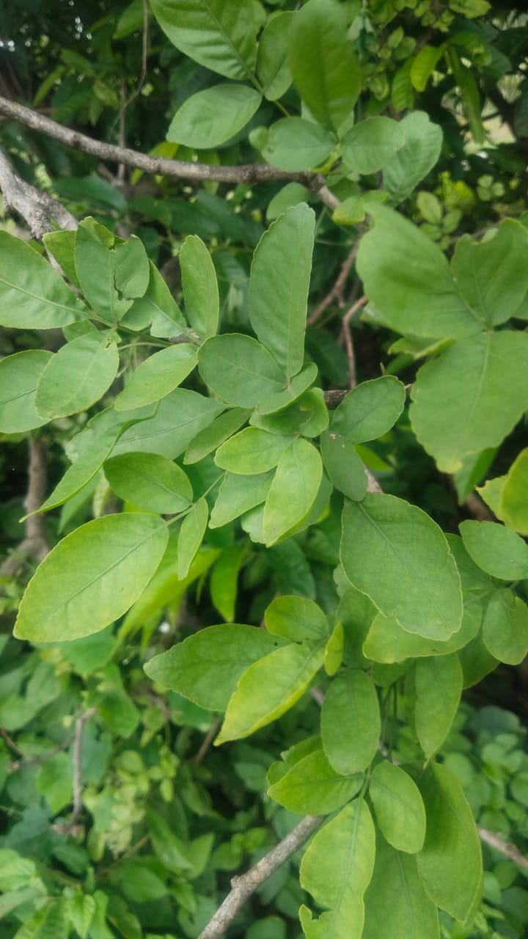
Fig. – Collection of Aegle marmelos leaves
Fresh leaves of Aegle marmelos were collected from the area of Hivra Khurd, Taluka Basmath, District Hingoli (Maharashtra, India). The site was surveyed during active growing season and only healthy plant material were selected for further study. The collected leaves were washed with water, shade dried and powdered using a mechanical grinder.
2.2 Preparation of Leaf Extract
The leaf extract was prepared by Soxhlet extraction method in the botany research laboratory, N. E. S. Science college, Nanded. The crushed leaf material of 5 gm was loaded into the thimble, which is placed inside the Soxhlet extractor. The thimble was filled with 300ml of Methanol extraction. The side arm was lagged with glass wool. The solvent was heated using the mantle and the solvent were begun to evaporate, moving through the apparatus to the condenser. The condensate then drips into the reservoir containing the thimble. Once the level of solvent reaches the siphon it pours back into the flask and the cycle begins again. The process was run for a total of 8 hours. After the successful extraction of 7 cycles the extracted plant sample were air dried and collected into the extraction collector for further use
After the preparation of extract preliminary phytochemical analysis, estimation of total phenol content, estimation of total flavonoid content was also performed in the botany research laboratory, N.E.S. Science College, Nanded.
2.3 Preliminary Phytochemical Screening:
The preliminary phytochemical analysis tests are the simple qualitative tests helps to identify the major groups of phytochemicals present in the plant extract before performing the advanced techniques.
Preliminary phytochemical screening of the Aegle marmelos leaf extract was carried out using standard qualitative methods to detect the presence of different classes of secondary metabolites. Glycosides were identified using Keller–Killiani, Raymond’s and Legal’s tests. Alkaloids were detected by Mayer’s test, while flavonoids were confirmed using ferric chloride, Shinoda and zinc hydrochloride reduction tests.
Steroids were determined by chloroform and Salkowski tests. Saponins were detected by the foam test. Carbohydrates were identified using Molisch’s and Benedict’s tests, while proteins were detected using Millon’s, xanthoproteic, biuret and ninhydrin tests. Starch was confirmed by starch reagent test. Tannins were detected using gelatin and sodium hydroxide tests. The appearance of characteristic colour changes or precipitates indicated the presence of the respective phytochemical constituents (Harborne et al., 1998).
2.4 Determination of Total Phenolic Content:
Total phenolic content of the extract was determined using the Folin–Ciocalteu reagent method. Different concentrations of the plant extract (20–100 µg/ml) were prepared. An aliquot of the extract was mixed with distilled water followed by the addition of Folin–Ciocalteu reagent. After 5 minutes, sodium carbonate solution was added to the mixture and the final volume was adjusted with distilled water.
Similarly, standard solutions of gallic acid were prepared for the calibration curve. The reaction mixture was incubated at room temperature and the absorbance was measured using a spectrophotometer at 550 nm against a reagent blank. The total phenolic content was expressed as µg of gallic acid equivalent (GAE) per g of extract, and all measurements were performed in triplicate (Chang et al., 2002).

2.5 Determination of Total Flavonoid Content
Total flavonoid content of the extract was determined using the aluminium chloride colorimetric method. The reaction mixture consisted of plant extract and distilled water followed by the addition of sodium nitrite solution. After incubation, aluminium chloride solution was added to the mixture and subsequently sodium hydroxide solution was introduced. The final volume was adjusted with distilled water.
Standard solutions of quercetin at different concentrations were prepared to obtain the calibration curve. The absorbance of both test and standard solutions was measured using a spectrophotometer at 510 nm against the reagent blank. The total flavonoid content was expressed as µg of quercetin equivalent (QE) per g of extract, and the analysis was performed in triplicate (Ashok et al., 2017).
Further assays such as antioxidant assay, antidiabetic assay was performed in the infinite biotech lab Sangli.
2.6 Antioxidant Activity:
The antioxidant activity of the plant extract was evaluated using the DPPH free radical scavenging assay. Standard used in this method is ascorbic acid.
Different concentrations of the extract (20–100 µg/ml) were prepared. An aliquot of the extract was mixed with methanolic DPPH solution and the reaction mixture was incubated in the dark for about 30 minutes.
The change in colour of the solution from purple to yellow indicated the scavenging of DPPH free radicals. The absorbance of the reaction mixture was measured using a spectrophotometer at 510 nm against the control. The percentage of DPPH radical scavenging activity was calculated using the following equation:
DPPH scavenging activity (%) = [(Absorbance of control − Absorbance of sample) / Absorbance of control] × 100
(Baliyan et al., 2022).
2.7 Antidiabetic Activity:
The antidiabetic activity of the plant extract was evaluated by in vitro α-amylase inhibition assay following the method of Bernfeld. Standard acarbose is used in this assay.
Different concentrations of the extract were prepared and mixed with phosphate buffer (pH 6.9) containing α-amylase enzyme. The reaction mixture was incubated for a short period at room temperature.
After incubation, starch solution was added as a substrate and the mixture was further incubated. The reaction was terminated by adding dinitro salicylic acid (DNSA) reagent and the mixture was heated in a boiling water bath. After cooling, the absorbance was measured using a spectrophotometer at 540 nm.
The percentage inhibition of α-amylase activity was calculated using the following equation:
Inhibition (%) = [(Absorbance of control − Absorbance of sample) / Absorbance of control] × 100
(Zephy et al., 2015; Maritim et al., 2003)

3. Results and Discussion
3.1 Preliminary Phytochemical Analysis
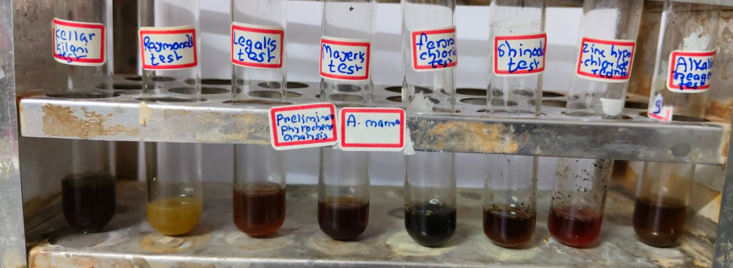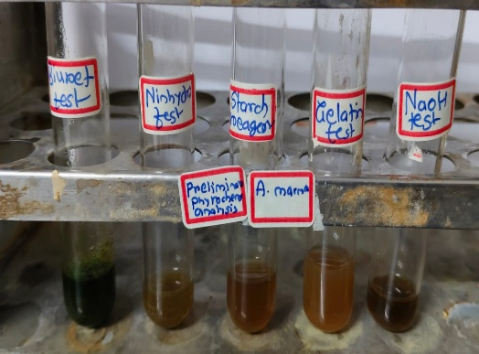
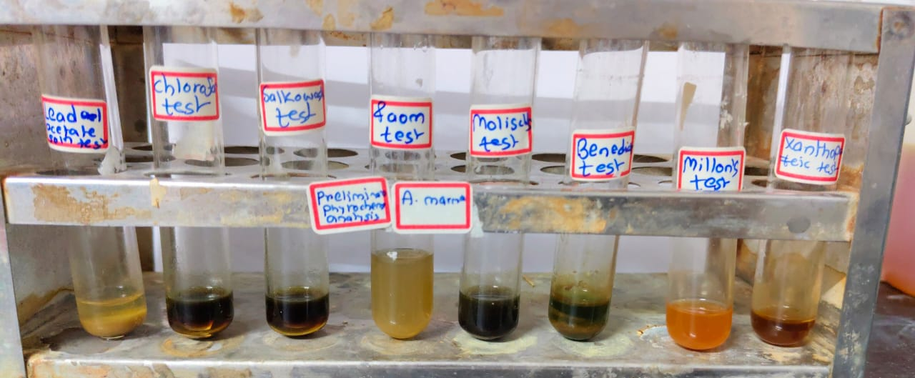
Fig.- Preliminary Phytochemical Analysis of Aegle marmelos

Test for Glycosides | Result
- Kellar Killani test | Positive
- Raymond’s test | Negative
- Legal’s test | Positive
Test for Alkaloids
1.Mayer’s test | Negative
Test for Flavonoids
- Ferric chloride test | Positive
- Shinoda test | Positive
- Zinc hydrochloric acid reduction test | Negative
- Alkaline reagent test | Negative
- Lead acetate solution test | Positive
Test for Steroids
- Chloroform test | Positive
- Sakowaski test | Positive
Test for Phenols
- Ferric chloride test | Negative
Test for Saponins
- Foam test | Negative
Test for Carbohydrates
- Molisch’s test | Negative
- Benedict’s test | Positive
Test for Proteins
- Millon’s test | Positive
- Xanthoproteic test | Negative
- Biuret test | Positive
- Ninhydrin test | Negative
Test for Starch
- Starch reagent test | Negative
Test for Tannins
- Gelatin test | Negative
- NaOH test | Negative
The preliminary phytochemical screening of the plant extract revealed the presence of several bioactive compounds. Glycosides were detected by Keller–Killani and Legal’s tests, while Raymond’s test showed a negative result. Alkaloids were not detected in the extract as indicated by Mayer’s test.
Among flavonoids, ferric chloride and Shinoda tests showed positive results, whereas zinc hydrochloride reduction and alkaline reagent tests were negative. The lead acetate test also confirmed the presence of flavonoids. Steroids were found to be present as both chloroform test and Salkowski test showed positive results.
Phenols and saponins were not detected as indicated by ferric chloride and foam tests respectively. In the case of carbohydrates, Benedict’s test showed a positive result while Molisch’s test was negative. Protein analysis revealed positive results for Millon’s test and Biuret test, whereas xanthoproteic and ninhydrin tests were negative. Starch and tannins were not detected in the extract as both starch reagent test and tannin tests showed negative results.
3.2 Total Phenolic Content
Fig.- Estimation of Total Phenolic Content by FCR method
The standard gallic acid solutions in the concentration range of 20–100 µg/ml showed a gradual increase in absorbance values from 0.102 to 0.520 at 550 nm, indicating a linear relationship between concentration and absorbance.
Similarly, the plant extract was analysed at different concentrations and the absorbance values were recorded in triplicate. The mean absorbance values increased with increasing concentration of the extract. Based on the calibration curve of gallic acid, the total phenolic content of the extract was calculated and expressed as µg gallic acid equivalent per gram (µg GAE/g) of extract.
The results showed that the phenolic content increased from 7.9 to 41.6 µg GAE/g with increasing concentration, indicating the presence of phenolic compounds in the extract.
3.3 Total Flavonoid Content
Fig. – Total Flavonoid Content by Aluminium Chloride method
The standard quercetin solutions in the concentration range of 20–100 µg/ml showed a gradual increase in absorbance values from 0.343 to 0.677 at 510 nm, indicating a linear relationship between concentration and absorbance.
Similarly, the plant extract was analysed at different concentrations and the absorbance values were recorded in triplicate. The mean absorbance values increased with increasing concentration of the extract. Based on the calibration curve of quercetin, the total flavonoid content of the extract was calculated and expressed as µg quercetin equivalent per gram (µg QE/g) of extract.
The results showed that the flavonoid content increased from 7.9 to 41.6 µg QE/g with increasing concentration, indicating the presence of flavonoids in the plant extract. The results indicated the presence of flavonoids in the plant extract, which may contribute to its biological activities.
3.4 Antioxidant assay
The results showed that the percentage inhibition increased with increasing concentration of the extract. The standard ascorbic acid exhibited percentage inhibition ranging from 26.42% to 76.16% at concentrations of 20–100 µg/ml, with an IC₅₀ value of 58.30 µg/ml.
Similarly, the Aegle marmelos extract showed concentration-dependent antioxidant activity with percentage inhibition ranging from 12.43% to 59.06% at concentrations of 20–100 µg/ml. The IC₅₀ value of the extract was found to be 86.32 µg/ml. These results indicate that the plant extract possesses considerable antioxidant activity.

Graph showing concentration dependent increase in antioxidant activity
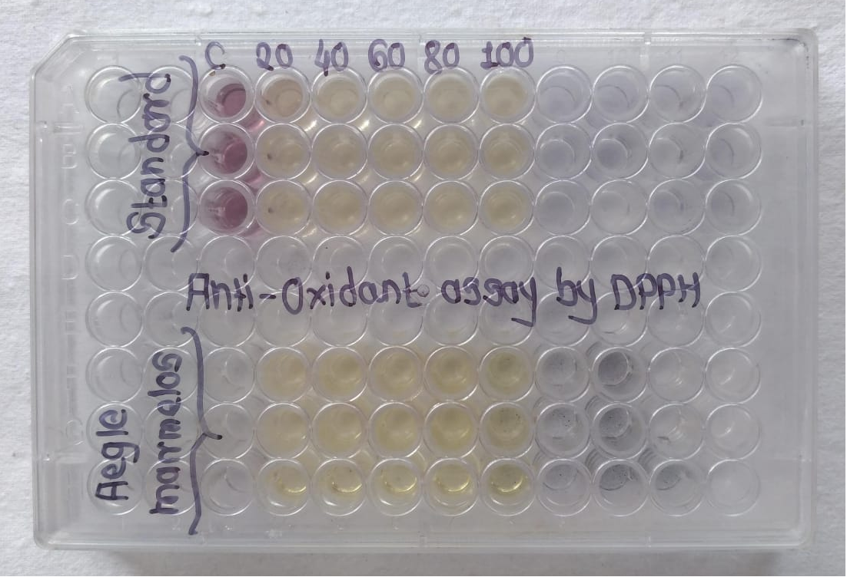
Fig.- 96 wells ELISA plate showing colour change from purple to yellow at different concentrations
3.5 Antidiabetic assay
The results showed that the percentage inhibition increased with increasing concentration of the extract.
The standard drug acarbose exhibited percentage inhibition ranging from 6.89% to 75.86% at concentrations of 20–100 µg/ml, with an IC₅₀ value of 62.13 µg/ml.
Similarly, the Aegle marmelos extract showed concentration-dependent inhibition of the α-amylase enzyme with percentage inhibition ranging from 12.06% to 55.74% at concentrations of 20–100 µg/ml. The IC₅₀ value of the extract was found to be 94.26 µg/ml, indicating its potential antidiabetic activity.

Graph showing dose dependent increase in antidiabetic activity
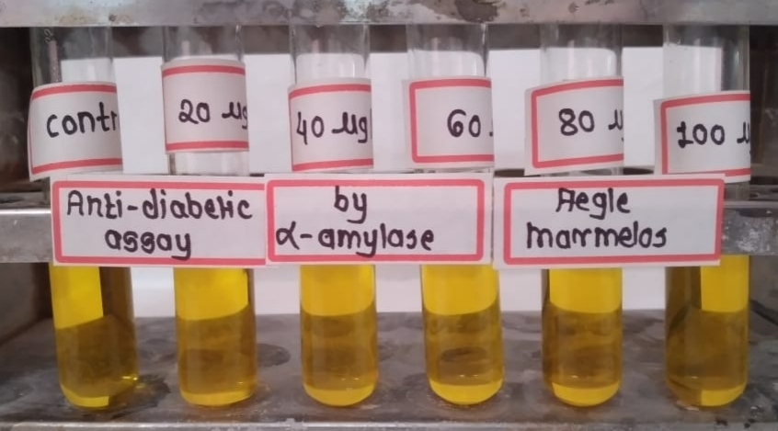
α-amylase inhibition assay showing antidiabetic activity of Aegle marmelos extract at different concentrations (20–100 µg/ml)
4. Conclusion
The present study revealed that Aegle marmelos leaf extract contains various phytochemical constituents including flavonoids, glycosides and steroids, proteins, carbohydrates. The extract showed considerable total phenolic and flavonoid content. The antioxidant study demonstrated concentration-dependent free radical scavenging activity, while the α-amylase inhibition assay indicated its potential antidiabetic activity. These findings suggest that Aegle marmelos may serve as a promising source of bioactive compounds with therapeutic potential.

References:
1. Salmeron-Manzano E., Garrido-Cardenas J. A., & Manzano-Agugliaro F. (2020). Worldwide research trends on medicinal plants. International Journal of Environmental Research and Public Health, 17(10), 3376.
2. Swarnkar R., Singh D., Choudhary A., Anand S., Rathore a., Jediya H. K. (2019). Pharmacological Properties of Aegle marmelos: A Review International Journal of Current Microbiology and Applied Sciences (2019) 8(5): 1600-1608.
3. Pietta, P. (2000). Flavonoids as antioxidants. Journal of Natural Products, 63, 1035–1042.
4. Harborne, J.B. (1998). Phytochemical Methods: A Guide to Modern Techniques of Plant Analysis. 3rd Edition, Chapman and Hall, London.
5. Chang CC, Yang MH, Wen HM (2002) Estimation of total flavonoids content in propolis by two complementary colorimetric methods. Journal of Food and Drug Analysis 23: 77-85.
6. Ashok A. Muchandi and Shashikant C. Dhawale, Estimation of Total Phenolic Contents, Total Flavonoid Contents and Muscle Co-Ordination Activity of Ethanolic Extract Stereospermum Suaveolens Dc, International Journal of Research in Pharmaceutical and Nano Sciences. 6(3), 2017, 118 - 124.
7. Siddartha Baliyan, Determination of Antioxidants by DPPH Radical Scavenging Activity and quantitative Phytochemical Analysis of Ficus religiosa, Molecules 2022.
8. Zephy D, Ahmad J. Type 2 diabetes mellitus: role of melatonin and oxidative stress. Diabetes MetabSyndr: Clinical Research & Reviews. 2015;9(2):127–131.
9. Maritim AC, Sanders A, Watkins Iii JB. Diabetes, oxidative stress, and antioxidants: a review. J Biochem Mol Toxic. 2003;17(1):24–38.
10. David Credo, Francis Machumi, Pax J. Masimba, Phytochemical screening and evaluation of antidiabetic potential of selected medicinal plants used traditionally for diabetes management in Tanzania, IJRPC 2018, 8(3), 405-411.
11. C. K. Kokate, A. P. Purohit, S. B. Gokhle (2004). Pharmacognosy 22nd ed. Pune; Nirali Prakashan

