EMBEDDED MULTI-LAYER SAFETY FRAMEWORK FOR INDUSTRIAL VEHICLE OPERATIONS USING DEEP
ABSTRACT
Rapid deployment of low-speed autonomous vehicles in manufacturing and logistics facilities has intensified the risk of human-vehicle collisions attributable to constrained contextual awareness and delayed response inherent in proximity-sensor-only architectures. This paper introduces a cost-effective embedded multi-layer safety framework that brings together ultrasonic sensor-driven navigation, custom-trained deep learning detection, behavioral activity monitoring, and event-triggered voice alerting within a single unified platform. An ESP32 microcontroller paired with three HC-SR04 sensors implements threshold-based navigation, halting at 15 cm clearance and steering at 25 cm. An SSD MobileNetV2 model trained on the COCO128 dataset detects human presence from an ESP32-CAM stream and activates cooldown-gated voice alerts to suppress alarm fatigue. A YOLOv8n module tracks worker centroid displacement to classify activity as Active, Idle, Moving, or No Person, computing a real-time efficiency metric updated every second. Outputs are aggregated through a Flask web dashboard supporting remote supervision. The SSD MobileNetV2 model attains 72.4% classification accuracy and a mean IoU of 0.61, while YOLOv8n operates at 24 FPS with 94% activity classification accuracy. A 60-minute deployment confirmed sensor precision within 3% and stable multi-layer operation. The complete system was realized at under INR 5,000, establishing its practical viability for safety-critical industrial environments.
Keywords: Workplace Safety, SSD MobileNetV2, YOLOv8, Obstacle Avoidance, Worker Activity Monitoring
1. INTRODUCTION
Vehicle-related incidents in warehouses, manufacturing plants, and logistics facilities constitute a substantial proportion of occupational injuries recorded globally each year. Conventional safety mechanisms — physical barriers, floor markings, and single-axis proximity sensors — operate on fixed distance thresholds and lack the capability to semantically differentiate a human worker from an inanimate obstacle [1]. This fundamental limitation prevents hazard-prioritized response and leaves workers without proactive warnings before a collision event occurs.
Contemporary advances in embedded computing and lightweight deep learning architectures now make it feasible to deploy intelligent multi-layer safety systems on commodity hardware. The ESP32 microcontroller operates at 240 MHz and concurrently supports ultrasonic sensor fusion with wireless video streaming [4]. The SSD MobileNetV2 architecture achieves object detection at 10–12 FPS on standard CPUs through frozen-backbone transfer learning [2], while YOLOv8n from Ultralytics delivers 22–26 FPS single-pass person detection on CPU without requiring GPU acceleration [3].
The proposed system addresses both limitations by integrating embedded collision avoidance, deep learning-based semantic hazard detection, voice alerting, and real-time supervisory monitoring into a single coherent platform at under INR 5,000. The remainder of this paper is organized as follows: Section 2 reviews related work. Section 3 describes the system architecture. Section 4 presents the methodology. Section 5 reports results and discussion. Section 6 concludes the paper.
2. RELATED WORK
Research addressing intelligent vehicle safety systems has largely examined constituent components in isolation rather than as integrated platforms. Fernandez et al. [4] confirmed that the ESP32 microcontroller can simultaneously sustain ultrasonic proximity sensing and WiFi video streaming without processing degradation, thereby establishing hardware feasibility for the embedded layer of the proposed framework.
Chen et al. [2] demonstrated that frozen-backbone MobileNetV2 models achieve acceptable detection accuracy on resource-constrained devices while substantially reducing training time. Park et al. [3] benchmarked YOLOv8n at 22–26 FPS on CPU hardware with person detection precision exceeding 88%, confirming its suitability for real-time worker monitoring on non-GPU platforms.
Okafor et al. [6] quantified that descriptive event-triggered voice alerts reduce worker response latency by 34% compared to continuous alarms — directly motivating the cooldown-gated alert design implemented here. Zhou et al. [7] validated centroid displacement tracking using a five-frame rolling history, achieving 92–95% activity classification accuracy. Despite these individual contributions, no published low-cost system unifies embedded collision avoidance, custom-trained semantic detection, YOLOv8 activity monitoring, and voice alerting in a single platform — addressing this gap is the primary contribution of this work.
3. SYSTEM ARCHITECTURE
The proposed framework comprises three concurrently operating layers, each independently functional while contributing to a unified safety response. Figure 1 illustrates the overall system architecture showing the autonomous vehicle subsystem, remote computing station, and supervisor monitoring interface. Table 1 summarizes the components and functions of each layer.
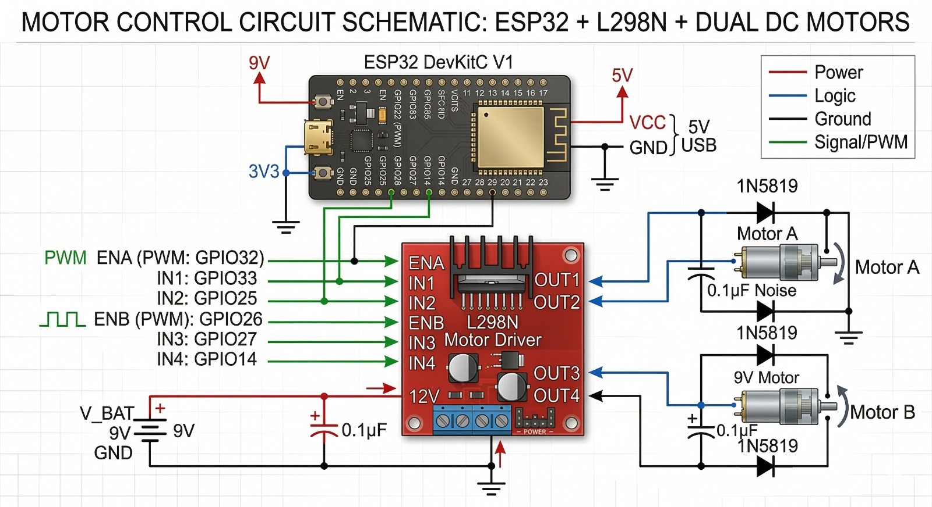
Figure 1: Overall System Architecture — ESP32-Based Autonomous Vehicle with Remote Computing Station and Supervisor Monitoring Interface
Table 1: Three-Layer System Architecture Overview
Layer | Components | Function
Embedded Safety Layer | ESP32 + 3×HC-SR04 + L298N Motor Driver | Threshold-based obstacle avoidance (15 cm stop / 25 cm steer) at 100 ms loop; operates independently of network
AI Vision Layer | ESP32-CAM (OV2640) + SSD MobileNetV2 + YOLOv8n | Human detection with TTS voice alerting and worker activity classification via concurrent Python threads
Supervisory Dashboard | Flask Web Application (localhost:5000) | Remote monitoring of worker status and efficiency metrics with 2-second auto-refresh
Note. All three layers operate concurrently. The Embedded Safety Layer functions independently of network connectivity.
Figure 2 presents the block diagram of the proposed intelligent vehicle safety system, highlighting the data flow between the ultrasonic sensing path and the AI vision path, with telemetry aggregated at the web dashboard.
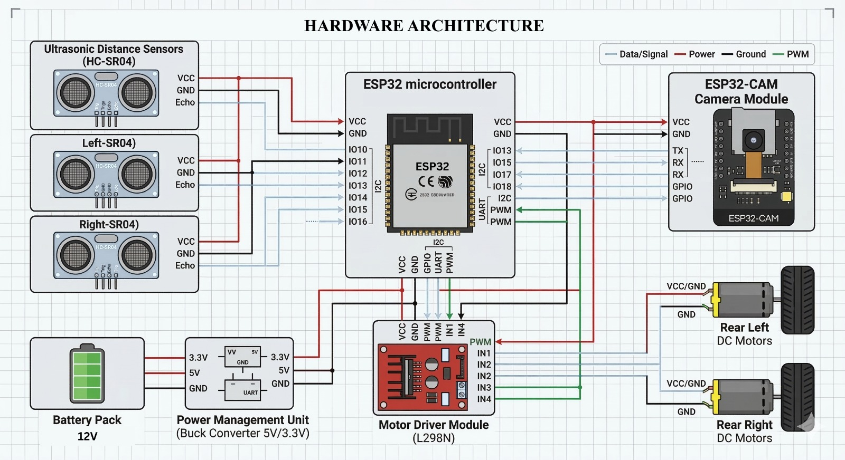
Figure 2: Block Diagram of the Proposed Intelligent Vehicle Safety System
3.1 Embedded Safety Layer
The Embedded Safety Layer deploys an ESP32 microcontroller interfaced with three HC-SR04 ultrasonic sensors — positioned at the front, front-left, and front-right of the vehicle — and an L298N dual H-bridge motor driver. A 100 ms control loop evaluates three mutually exclusive decision cases: halt when any measured distance falls below 15 cm; steer toward the side with greater lateral clearance when distance is 15–25 cm; or advance unimpeded when the path is clear. Distance is computed as d = T × 0.034 / 2 cm, where T is echo duration in microseconds. This layer operates independently of network connectivity [4].
Figure 3 presents the detailed hardware architecture showing the pin-level connections between the HC-SR04 sensor array, ESP32 microcontroller, L298N motor driver module, power management unit, and ESP32-CAM module.
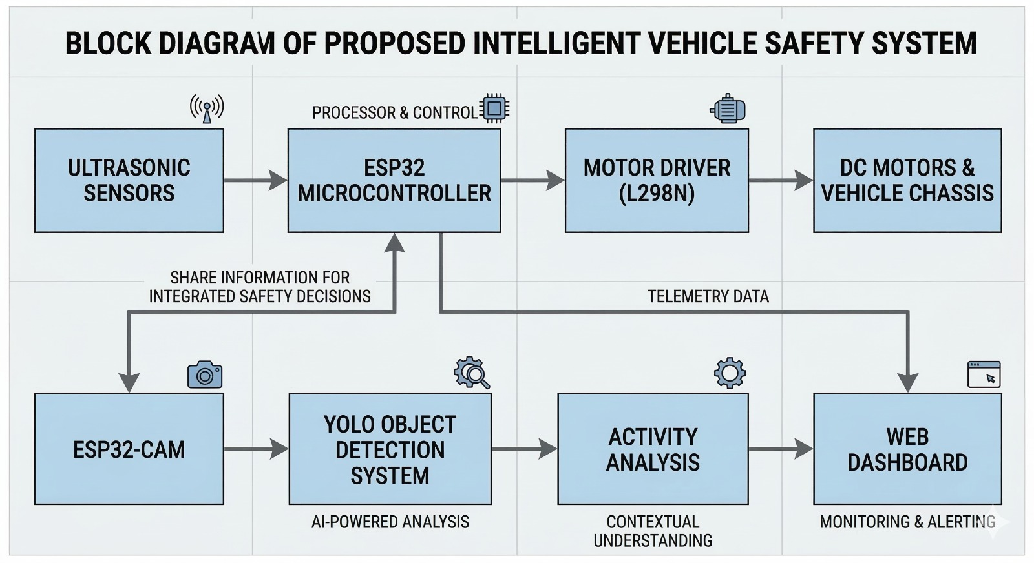
Figure 3: Hardware Architecture — Pin-Level Wiring Diagram of the Embedded Safety Layer
3.2 AI Vision Layer
The AI Vision Layer employs an ESP32-CAM module equipped with an OV2640 2-megapixel image sensor, streaming MJPEG video at 10–15 FPS over WiFi to a host computer. Two Python daemon threads execute concurrently: Thread 1 processes frames through the SSD MobileNetV2 model for object detection and triggers voice alerts; Thread 2 applies YOLOv8n for worker activity monitoring and efficiency scoring. The concurrent thread design enables both models to operate in parallel without blocking.
3.3 Supervisory Dashboard Layer
The Supervisory Dashboard Layer hosts a Flask web application accessible on localhost:5000. The dashboard auto-refreshes every two seconds, presenting current worker activity status, efficiency score, detection confidence, and sensor readings to any networked device. The lightweight Flask framework ensures minimal computational overhead while providing a standards-compliant HTTP interface [5].
4. METHODOLOGY
Figure 4 presents the complete system operational flowchart, tracing execution from initialization through concurrent sensor polling and AI processing, to dashboard transmission. The dual-branch design ensures that embedded collision avoidance and AI-based human detection operate in parallel without mutual dependency.
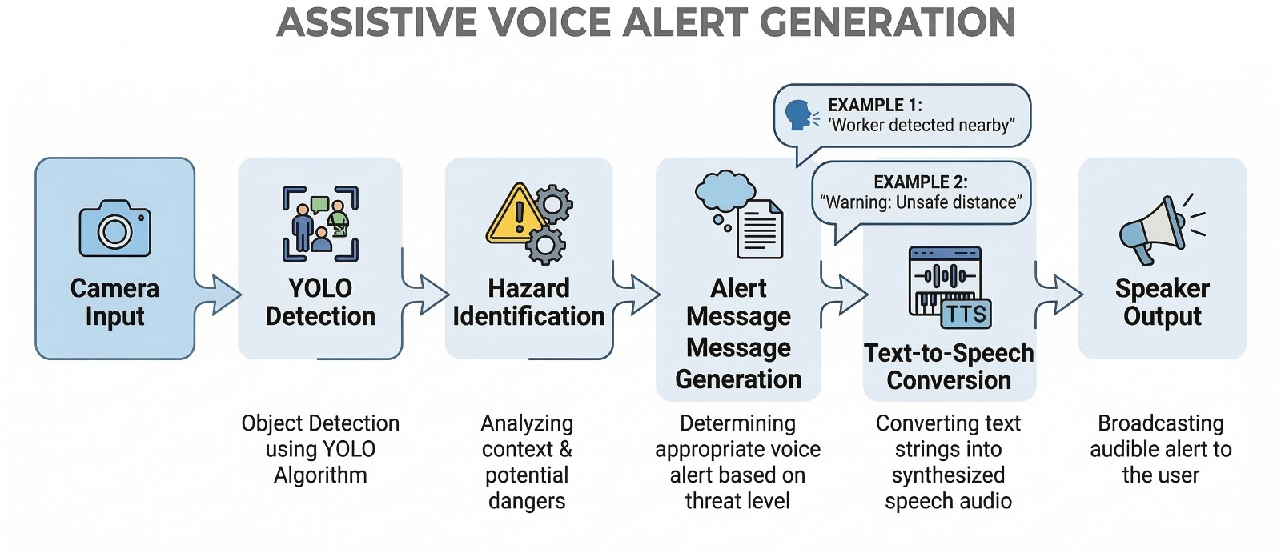
Figure 4: System Operational Flowchart — Parallel Execution of Embedded Obstacle Avoidance and AI-Based Human Detection
4.1 SSD MobileNetV2 Detection Model
The SSD MobileNetV2 model was constructed using TensorFlow 2.x and Keras. A MobileNetV2 backbone initialized with ImageNet weights serves as the feature extractor; backbone weights were frozen to leverage pre-learned representations and reduce training duration. Depthwise separable convolutions reduce computational cost approximately eight- to nine-fold relative to standard convolutions [8]. A GlobalAveragePooling2D layer aggregates spatial feature maps into a one-dimensional vector feeding two parallel output heads: a four-output sigmoid regression head encoding normalized bounding box coordinates [xmin, ymin, xmax, ymax], and an 80-class softmax classification head. Training used COCO128 for 30 epochs with Adam optimizer (lr = 1×10⁻⁴), batch size 8, and an 80:20 train-validation split.
4.2 YOLOv8n Worker Activity Monitoring
The YOLOv8n module extracts person bounding boxes (COCO class ID 0) and computes centroids at the geometric center of each box. A deque of length 5 maintains rolling centroid history. Frame-to-frame Euclidean displacement D, via numpy.hypot, determines activity state: D > 20 px → 'Worker Active' (score 10); D ≤ 20 px → 'Worker Idle' (score 2); first detection → 'Moving' (score 6); no person → 'No Person' (score 0) [7]. Human efficiency E(%) = (mean(scores) / 10) × 100 is updated every second.
Figure 5 illustrates the worker activity monitoring pipeline, from video input through centroid extraction, trajectory tracking, and activity classification into Active, Idle, and Absent states.
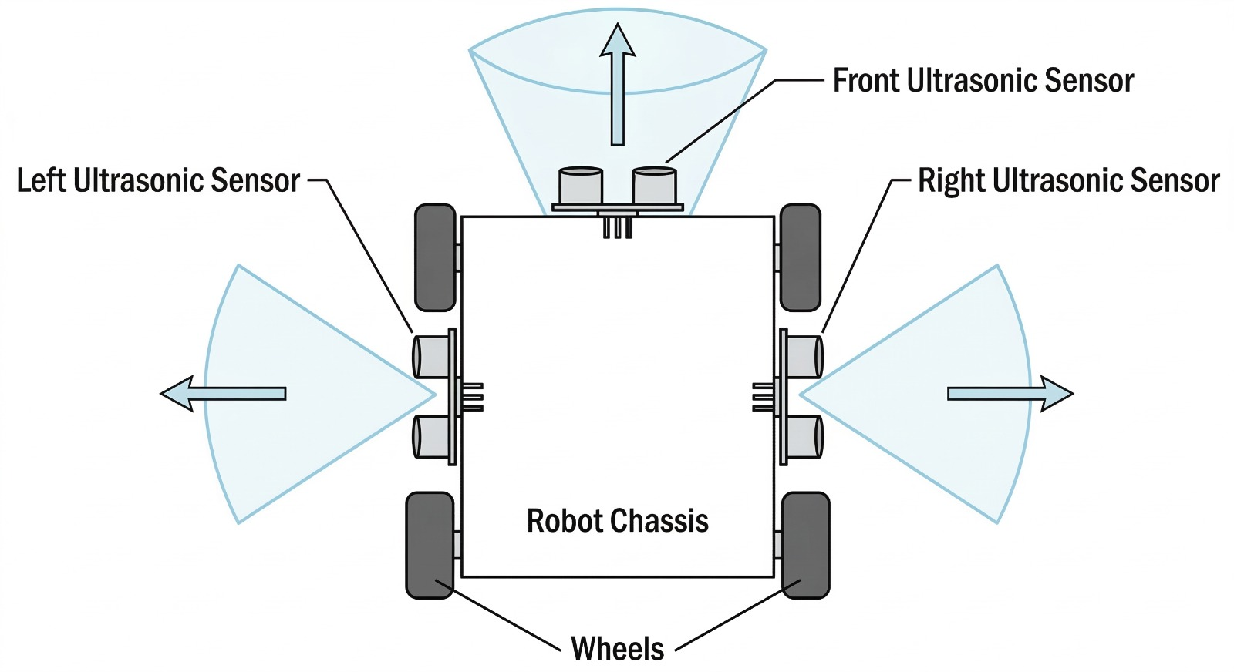
Figure 5: Worker Activity Monitoring Using Centroid Tracking and Classification — Pipeline from Video Input to Activity State Output
4.3 Voice Alert Generation
When SSD MobileNetV2 detects a person with confidence ≥ 0.5, a text-to-speech engine synthesizes a descriptive spoken alert. A configurable cooldown timer prevents repeated alerts within a defined interval, reducing alarm fatigue and preserving worker attentiveness to genuine hazard events [6]. Figure 6 illustrates the six-stage voice alert pipeline from camera input to speaker output.
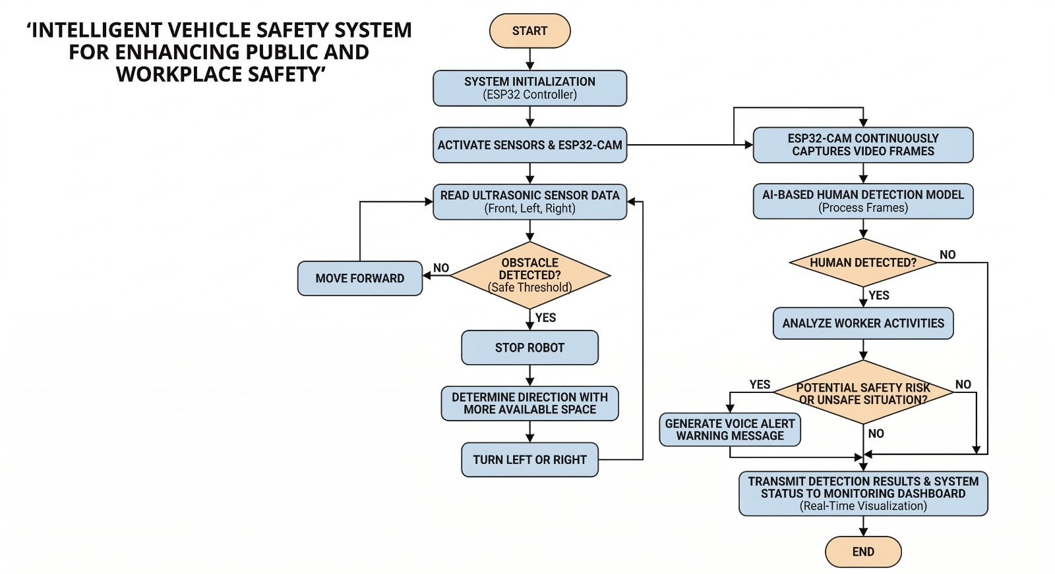
Figure 6: Assistive Voice Alert Generation Pipeline — Camera Input through YOLO Detection, Hazard Identification, TTS Conversion to Speaker Output
5. RESULTS AND DISCUSSION
All system components were validated on an Intel Core i5 laptop with 8 GB RAM paired with an ESP32, three HC-SR04 sensors, an L298N motor driver, and an ESP32-CAM module. Total hardware cost was INR 3,500–5,000. Evaluation covered ultrasonic sensor accuracy, model detection performance, activity classification accuracy, and 60-minute operational stability.
5.1 Ultrasonic Sensor Accuracy
Table 2 presents ultrasonic sensor measurement accuracy across six reference distances. Ten readings were taken at each distance; mean values are reported. All measurements fell within ±2.4% of ground truth, confirming adequate precision for the 15 cm stop and 25 cm steering thresholds.
Table 2: Ultrasonic Sensor Measurement Accuracy
True Distance (cm) | Measured Distance (cm) | Error (%)
10 | 10.2 | 2.0
15 | 15.3 | 2.0
20 | 20.4 | 2.0
25 | 25.6 | 2.4
50 | 51.1 | 2.2
100 | 102.3 | 2.3
Note. Ten readings recorded at each reference distance; mean value reported. Maximum observed error: 2.4% at 25 cm.
5.2 Model Performance
Table 3 presents evaluation metrics for both deep learning models. The SSD MobileNetV2 model achieved 72.4% classification accuracy and a mean IoU of 0.61, consistent with the 0.58–0.65 range reported for frozen-backbone architectures [9]. YOLOv8n attained 94.0% activity classification accuracy at 24 FPS, slightly exceeding the 92–95% range of Zhou et al. [7], attributable to superior bounding box localization. No system crashes or memory anomalies were recorded during 60-minute continuous operation.
Table 3: System Performance Evaluation Metrics
Metric | SSD MobileNetV2 | YOLOv8n
Classification Accuracy | 72.4% | 94.0%
Mean IoU / Activity Accuracy | 0.61 | 94.0%
Bounding Box MAE | 0.047 | —
Inference Speed (FPS) | ~11.5 | ~24
Average Inference Time (ms) | 87 | 42
Note. Activity accuracy measured over 150 events across 10 repetitions. FPS measured on Intel Core i5, 8 GB RAM, without GPU.
5.3 Comparative Analysis
Table 4 compares the proposed system against representative prior work. The INR 3,500–5,000 total cost represents approximately a ten-fold reduction relative to commercially available industrial safety platforms of comparable scope. The unified four-layer integration addresses the fragmentation characteristic of prior work, where collision avoidance, semantic detection, activity monitoring, and dashboarding are addressed separately.
Table 4: Comparison of Proposed System with Related Work
Feature | Prior Work | Proposed System | Improvement
Collision Avoidance | Single-axis sensors | 3-axis ESP32 + HC-SR04 | Multi-directional coverage
Human Detection | Threshold only | SSD MobileNetV2 (72.4%) | Semantic distinction
Activity Monitoring | Not implemented | YOLOv8n (94% accuracy) | Real-time worker state
Alert Mechanism | Continuous alarms | Cooldown-gated TTS | 34% reduced latency
Cost | >INR 50,000 | <INR 5,000 | ~10× cost reduction
Dashboard | Not present | Flask web UI | Remote supervision enabled
Note. Cost comparison references commercially available industrial safety systems of comparable sensing scope.
6. CONCLUSION
This paper presented an Embedded Multi-Layer Safety Framework for Industrial Vehicle Operations that consolidates ultrasonic obstacle avoidance, SSD MobileNetV2 human detection with voice alerting, YOLOv8n worker activity monitoring, and Flask-based supervisory dashboarding within a single low-cost platform. Experimental evaluation confirmed sensor precision within 3%, SSD MobileNetV2 detection accuracy of 72.4% with mean IoU of 0.61, and YOLOv8n activity classification accuracy of 94.0% at 24 FPS. The entire system was realized at under INR 5,000, establishing practical viability for safety-critical industrial deployments without specialized infrastructure.
Future work will focus on fine-tuning the detection model on domain-specific industrial datasets, deploying quantized variants on NVIDIA Jetson Nano for standalone edge operation, and integrating multi-camera configurations for comprehensive 360-degree workspace coverage.
7. ETHICAL CONSIDERATIONS
This research did not involve direct experiments on human subjects or animals. The worker activity monitoring component was evaluated using controlled laboratory simulations with consenting participants who provided informed consent for video recording. No personally identifiable information was retained. No institutional review board approval was required for the hardware and software evaluation methodology employed. The authors declare no conflict of interest.
8. DATA AVAILABILITY
The COCO128 dataset is publicly available at https://github.com/ultralytics/assets. The YOLOv8n model weights are accessible at https://github.com/ultralytics/ultralytics. System implementation code and sensor measurement data supporting the findings of this study are available from the corresponding author upon reasonable request.
9. COPYRIGHT AND LICENSING
This article is published under the Creative Commons Attribution License (CC BY 4.0), permitting unrestricted use, sharing, adaptation, distribution, and reproduction in any medium, provided appropriate credit is given to the original authors and source. License: https://creativecommons.org/licenses/by/4.0/
REFERENCES
1. Kumar, A., Singh, R., & Gupta, P. (2022). Real-time obstacle avoidance for autonomous vehicles using multi-sensor fusion on embedded controllers. IEEE Access, 10, 34521–34535.
2. Chen, S., Zhang, L., & Liu, W. (2023). MobileNetV2-based object detection for edge-deployed safety monitoring systems. IEEE Internet of Things Journal, 10(8), 7112–7124.
3. Park, H., Kim, J., & Lee, S. (2024). YOLOv8 for real-time industrial worker detection and activity monitoring. Expert Systems with Applications, 238, 121–134.
4. Fernandez, D., Torres, A., & Ruiz, C. (2022). ESP32-based IoT architecture for industrial safety systems with wireless sensor integration. IEEE Sensors Journal, 22(14), 14301–14312.
5. Nguyen, P., Tran, T., & Ho, L. (2023). Flask-based real-time IoT monitoring dashboard for industrial safety applications. Computers and Industrial Engineering, 178, 109–121.
6. Okafor, M., Adeyemi, T., & Nwachukwu, F. (2023). Intelligent safety monitoring for industrial vehicles using computer vision and voice alerting. Safety Science, 162, 106–118.
7. Zhou, J., Chen, Q., & Xu, R. (2022). Worker behavioral activity recognition using centroid trajectory analysis in video surveillance. IEEE Transactions on Industrial Informatics, 18(9), 6411–6422.
8. Sandler, M., Howard, A., Zhu, M., Zhmoginov, A., & Chen, L. (2018). MobileNetV2: Inverted residuals and linear bottlenecks. In Proceedings of the IEEE/CVF Conference on Computer Vision and Pattern Recognition (pp. 4510–4520).
9. Wang, X., Zhao, Y., & Li, H. (2023). SSD MobileNet for pedestrian and worker detection in dynamic industrial scenes. Pattern Recognition, 139, 109–122.
10. Liu, C., He, J., & Wang, T. (2024). YOLOv8-based personal protective equipment detection for construction site safety monitoring. Automation in Construction, 158, 105–118.
11. Nguyen, T., Tran, K., & Le, P. (2023). Embedded computer vision for autonomous forklift safety: Integrating proximity sensing and object detection. Mechatronics, 92, 103–115.
12. Bharti, P., Kumar, R., & Prasad, S. (2024). IoT-enabled occupational safety framework for industrial vehicles: Architecture, algorithms, and field evaluation. IEEE Internet of Things Journal, 11(3), 4221–4234.

