Study on Determinants of Trust, Data Sharing Attitudes, and User Preferences toward AI-Based Dietary Recommendation Systems

ABSTRACT

This research examines the integration of artificial intelligence (AI) in the healthcare industry, with specific reference to AI-based dietary recommendation systems. This research seeks to establish the key factors that affect user trust, attitudes toward information sharing, and user preferences. A questionnaire-based research method is adopted to collect data from the participants, who are asked about their engagement with mobile health applications, their willingness to share information, their level of trust in traditional dieticians, and their perceptions about AI-based dietary recommendation systems. The research results show that the level of user familiarity with diet application software varies. Familiarity with the application software is positively correlated with the frequency of application usage. Moreover, the results show that increased application usage is associated with increased user trust in AI-based dietary recommendation systems. Although the participants showed comfort with information sharing, they showed reluctance in sharing information about their dietary history. The results show that the level of trust in traditional dieticians is relatively high, indicating the significant role played by traditional dieticians in dietary recommendation. The results show that the cost-effectiveness of AI-based dietary recommendation systems is an important motivational factor, with the majority showing willingness to adopt AI-based dietary recommendation systems, irrespective of professional counselling, if the costs are reduced. Moreover, the results show that the participants show a preference for flexible dietary plans over rigid dietary plans.

Keywords: Artificial Intelligence, Dietary Recommendation Systems, User Trust, Health Data Sharing, Mobile Health Applications

INTRODUCTION
The application of Artificial Intelligence in the health sector has been rising dramatically over the past few years, specifically in areas such as nutrition and diet planning, which need to be individualized for each and every individual. For instance, the application of Artificial Intelligence in the development of diet recommendation systems utilizes individual parameters such as age and lifestyle to develop individualized diet plans for users of such systems. Such systems are now being contemplated as viable options to consult and seek recommendations for diet planning and other related issues due to their ease of availability and the potential to reduce costs. The rising prevalence of non-communicable health conditions such as Obesity and Type 2 Diabetes also necessitates effective and individualized interventions for diet and nutrition (Ordovas et al., 2018).
Digital health technologies such as mobile-based applications have also been identified as having the potential to influence and encourage users to make healthier lifestyle choices through continuous interaction and engagement mechanisms. Rather than relying on periodic consultations to seek recommendations and guidance for health and related issues, such applications have been identified as having the potential to encourage continuous interaction and engagement to promote and encourage users to make healthier lifestyle choices and adhere to recommendations and guidance provided for diet and other related issues. Research indicates that such applications have the potential to encourage and assist users to manage their health in a more active manner; however, the effectiveness of such applications is also subject to individual perceptions of such applications (Wang et al., 2022). On the other hand, individualized interventions for nutrition and diet planning through the application of Artificial Intelligence have also been identified as having a positive impact when compared to general recommendations and guidance (Ordovas et al., 2018).

However, despite these potential benefits of AI-based dietary systems, it has also been recognized that their adoption is not dependent on the capabilities of these systems alone. One of the most important factors affecting the acceptance of AI-based dietary systems is trust. Since AI-based dietary systems are dependent on computerized processes for decision-making, it has also been recognized that users may have difficulty trusting such systems compared to human dietitians who make recommendations based on their expertise and knowledge. Trust has also been related to the transparency, accuracy, and consistency of these dietary systems. Users who perceive these systems as untrustworthy or vague may be less inclined to use these systems for a longer period of time (Beldad & Hegner, 2018).

Another important aspect of AI-based dietary systems is related to the sharing of personal information. Since AI-based dietary systems require access to personal information to function optimally, it has also been recognized that users may have difficulty sharing such information. Even though users may be willing to share some information with AI-based dietary systems, they may be hesitant when it comes to more personal information such as their health condition and dietary habits. Such attitudes have also been recognized as potential factors affecting user acceptance of AI-based dietary systems (Beldad & Hegner, 2018).

In addition to these factors, user preferences and economics also play a significant role in affecting user attitudes toward AI-based dietary systems. Since AI-based dietary systems are considered to be more affordable than human consultations for dietary recommendations, it has also been recognized that such factors may play a significant role in user acceptance of these systems. Users may also have a preference for more flexible dietary plans that are capable of being adapted to their daily routines rather than more rigid plans that require strict adherence to a set of dietary principles.

Furthermore, individual characteristics and experience with technology also play a significant role in influencing the attitude of the users toward AI-based dietary systems. Individual characteristics include age and experience with mobile health applications and frequency of usage of such applications. It has been found that users who are more experienced with mobile health applications are likely to show higher attitude toward AI-based dietary systems. On the contrary, users who are not experienced with mobile health applications are likely to show a negative attitude toward AI-based dietary systems. Furthermore, users who are more frequent users of mobile health applications are likely to show higher attitude toward AI-based dietary systems.

Apart from individual characteristics and experience with technology, user preference and influence of others also play a significant role in influencing the attitude of the users toward AI-based dietary systems. It has been found that users are likely to show a positive attitude toward AI-based dietary systems based on their perceived usefulness and convenience of use. Furthermore, users who are likely to recommend AI-based diet applications to others are likely to show a higher attitude toward AI-based dietary systems. In addition, users who are likely to recommend AI-based diet applications to others are likely to show a higher attitude toward AI-based dietary systems.

Although previous studies have focused on the adoption of digital health technologies, it has also been recognized that there is a lack of research on the attitudes of users toward AI-based dietary recommendation systems in terms of trust, attitudes toward sharing personal information, and user preferences. Thus, the present study seeks to identify the determinants of trust, attitudes toward data sharing, and user preferences pertaining to AI-based dietary recommendation systems. The results of the present study are expected to offer valuable insights for the improvement of AI-based dietary recommendation technologies.
REVIEW OF LITERATURE

Artificial intelligence (AI) has recently become a major player in healthcare, especially in areas like nutrition that require personalized approaches. AI-driven nutritional recommendation systems aim to provide customized dietary advice, considering a person's lifestyle, health, and eating habits, among other factors. These AI-based technologies have been shown to improve healthcare services by increasing their accuracy and effectiveness (Jiang et al., 2017; Mehta et al., 2019).

The emergence of precision nutrition has amplified the significance of artificial intelligence within this domain. This methodology centers on tailoring dietary guidance to the unique biological and lifestyle characteristics of each individual. Studies indicate that AI-driven systems possess the capacity to dynamically refine and modify recommendations by leveraging real-time data, thereby facilitating more effective adherence to dietary plans and promoting improved health results (Agrawal, 2025; Wang, 2025).

However, the emergence of precision nutrition has led to an increase in the importance of AI in this field. This methodology is mainly concerned with personalizing the dietary recommendations in line with the specific biological and lifestyle factors of the individual. Literature has confirmed the potential of AI systems to dynamically modify and improve the personalization of the recommendations through the incorporation of real-time data, thus promoting effective compliance and health outcomes (Agrawal, 2025; Wang, 2025).

One of the major factors in the uptake of AI in healthcare is the concept of trust. People are likely to be drawn to AI systems when they feel that the recommendations offered are not only trustworthy but also beneficial to their health. Kauttonen (2025) asserts that the creation of trust is largely through the ability of the individual to comprehend the working mechanisms of the system and be confident in its accuracy.

Another important factor is transparency. This is because, when users are aware of how and why a recommendation is being done, they will be able to trust the system. This is supported by Zhang and Chen (2020), who state that, through the help of explainable AI, users are able to understand the process of recommendation. This is also supported by Kaplan and Haenlein (2019), who state that systems need to be clear and understandable for them to be accepted.

Another factor is the familiarity of people with technology. For instance, people who are used to using mobile applications are likely to be comfortable around AI systems. This is supported by Kim and Park (2012), who state that ease of use and user intention are factors that influence the adoption of health technologies.
Mobile health apps have helped users to easily access AI-based dietary recommendations. The apps enable users to monitor their dietary habits and health. Lupton (2014) argues that such technologies have helped users to change their interactions with healthcare services by making them more easily accessible.
However, data privacy is a significant concern for users. This is because AI technologies require users to provide personal and health-related data. Ema (2023) argues that data handling is crucial in addressing users' concerns to help them gain confidence in AI-based technologies.
The willingness of users to share the information also depends upon the nature of the information that is to be shared. Users are often not willing to share their health and diet information. This aspect has been identified in the research related to digital health technologies (Bickmore & Giorgino, 2006).
Understanding user behavior is also essential in the study of AI adoption. Consumer behavior theories have identified that the decision-making process is influenced by both psychological and technological factors. Fogg (2003) has mentioned that technology helps in the direction of user behavior and promotes healthier behavior.
Another factor to be considered is cost, which is associated with AI-based systems. It is cheaper than consulting a dietitian. This is because, as highlighted by Miller and Brown (2018), AI is cost-effective and still effective in its application.
Despite the rise of AI, traditional dietitians are still viewed as very reliable. This is because people prefer to interact with them, as they are empathetic. This, as highlighted by Rho et al. (2015), is an indication that AI is meant to be used alongside other health professionals.
Culture and society are other factors that can influence the response of users to the recommendations provided by AI systems. The eating culture of people varies from region to region, and this is something that AI systems need to consider for effective functioning. According to Wang (2025), this can lead to increased satisfaction for the users of the AI systems.
The other reason for the increased user engagement through AI systems is that they can provide users with interactive features. This can motivate the users of the systems, who can thereby adhere to their diets. According to ResearchGate (2025), this can lead to increased commitment from the users.

In conclusion, the implementation of dietary recommendations using AI technology will depend on various critical factors such as trust, privacy, cost, personalization, and technology familiarity. These factors will help in ensuring the effective implementation of AI technology in healthcare and nutrition (Amadeh et al., 2025).

METHODOLOGY

Survey development

Data collection

Data analysis

SURVEY DEVELOPMENT

The survey questionnaire aimed to assess how participants perceive, trust, and accept Artificial Intelligence in dietary planning and nutrition advice. It was created after reviewing key concepts related to AI-based nutrition tools and the role of dietitians in offering dietary guidance. The survey included structured and close-ended questions to ensure consistent responses and ease of analysis. The questions explored various aspects, such as how often participants used mobile health applications, their comfort level in sharing personal health data with AI platforms, their willingness to share dietary history, their trust in AI-generated dietary advice, their trust in professional dietitians, their willingness to pay for AI-based recommendations, their preference for flexible or strict diet plans, and their likelihood of recommending AI-based diet applications to others. The questionnaire underwent careful review to ensure clarity, relevance, and alignment with the study's objectives. The final version was prepared in a simple and easy-to-understand format to encourage maximum participation and accurate responses.

DATA COLLECTION

The data were collected using Google Forms, which made it easy to share the questionnaire. The survey link was shared on social media and messaging apps to reach a variety of participants.
Participation in the survey was voluntary. Respondents were informed about the study's purpose and assured that their answers would remain confidential, used only for academic research. No personal identification information was collected to keep responses anonymous.
A total of 126 participants completed the survey. The responses were automatically recorded and organized using Google Forms. The collected data included demographic information and independent responses that focused on participants' views, preferences, and trust levels regarding AI-based diet platforms and dietitians.
Using an online method for data collection allowed for quick and efficient responses while reducing data entry errors. The responses were then exported into a spreadsheet for further statistical analysis.

DATA ANALYSIS

The collected data were exported from Google Forms and analyzed using statistical techniques. Descriptive statistics, such as frequency distribution and percentage analysis, summarized the responses for each question. These methods helped identify trends, patterns, and participant preferences related to AI-based dietary tools.
Alongside descriptive analysis, Analysis of Variance (ANOVA) was conducted to see if there were significant differences among participants' responses. ANOVA compared multiple groups and helped understand variations in attitudes toward AI-based dietary advice and dietitian services.
The results were presented in percentages, tables, and interpretations. The analysis highlighted participants' trust levels, willingness to use AI-based dietary tools, and preference for guidance from professional dietitians.
The findings from the analysis were used to draw important conclusions about the acceptance of artificial intelligence in nutrition and dietary planning.

FINDINGS AND DISCUSSION

This chapter presents the findings from a survey of 126 participants. The survey assessed their views on AI-based dietary recommendations and professional dietitian guidance. We analyzed the data using descriptive statistics, bar charts, and One-Way ANOVA. This helped us understand participants' preferences, trust levels, and their willingness to use AI-based dietary platforms.

DESCRIPTIVE ANALYSIS
Table 1: Usage of mobile health or diet-related applications

Particulars | No Of Participants | Percentage
Never | 38 | 30.4%
Occasionally | 57 | 45.6%
Often | 21 | 16.8%
Always | 9 | 7.2%
USAGE OF MOBILE HEALTH OR DIET-RELATED APPLICATIONS
Most participants use mobile health or diet-related applications occasionally. About 45.6% reported occasional usage, while 30.4% said they never use such applications. A smaller group, 16.8%, reported frequent usage, and only 7.2% stated they always use these applications. These findings suggest that while mobile health applications are available, regular use among respondents is low, indicating moderate adoption of these digital health tools.
Table 2: Comfort in sharing personal data with AI-based diet platforms

Particulars | No Of Participants | Percentage
Very comfortable | 18 | 14.4%
Some what comfortable | 35 | 28%
Neutral | 44 | 35.2%
Uncomfortable | 22 | 17.6%
Very uncomfortable | 6 | 4.8%

COMFORT IN SHARING PERSONAL DATA WITH AI-BASED DIET PLATFORMS
The results show different levels of comfort among participants when it comes to sharing personal data with AI-based diet platforms. A majority, 35.2%, reported a neutral stance, followed by 28% who felt somewhat comfortable sharing their data. Additionally, 14.4% indicated they were very comfortable. However, 17.6% were uncomfortable sharing, and 4.8% were very uncomfortable. These findings highlight that while some respondents are willing to share personal data, concerns about privacy and data security still exist.
Table 3: Willingness to share full dietary history with AI tool

Particulars | No Of Participants | Percentage
Definitely not | 34 | 27.2%
Probably not | 56 | 44.8%
Definitely yes | 17 | 13.6%
Probably yes | 18 | 14.4%

WILLINGNESS TO SHARE FULL DIETARY HISTORY WITH AI TOOL
Most participants were hesitant to share their full dietary history with AI tools. A significant portion, 44.8%, said they would probably not share their dietary history, while 27.2% stated they would definitely not share this information. In contrast, only 14.4% reported they would probably share, and 13.6% indicated they would definitely share. This suggests that participants are careful about providing detailed dietary information to AI platforms, likely due to trust and privacy concerns.
Table 4: Trust in dietitian for accurate diet advice

Particulars | No Of Participants | Percentage
Completely trust | 49 | 39.2%
Mostly trust | 44 | 35.2%
Neutral | 25 | 20%
Slightly trust | 7 | 5.6%
Not trust | 0 | 0%

TRUST IN DIETITIAN FOR ACCURATE DIET ADVICE
The results show a high level of trust in dietitians among respondents. A majority, 39.2%, reported that they completely trust dietitians, while 35.2% mostly trust them for dietary advice. Additionally, 20% remained neutral, and only 5.6% slightly trust dietitians. None of the participants reported not trusting dietitians. These findings indicate that dietitians are a highly trusted source of dietary guidance among respondents.
Table 5: Willingness to pay for AI-generated dietary recommendations

Particulars | No Of Participants | Percentage
Definitely not | 52 | 41.6%
Probably not | 48 | 38.4%
Definitely yes | 10 | 8%
Probably yes | 15 | 12%

WILLINGNESS TO PAY FOR AI-GENERATED DIETARY RECOMMENDATIONS
Most participants were unwilling to pay for AI-generated dietary recommendations. About 41.6% said they would definitely not pay, while 38.4% indicated they would probably not pay. In contrast, only 12% reported they would probably pay, and 8% stated they would definitely pay for AI-generated dietary advice. These findings suggest limited willingness to invest in AI-based dietary services.
Table 6: Use of AI-based plans if cheaper without counselling
Particulars | No Of Participants | Percentage
Yes | 19 | 15.2%
No | 74 | 59.2%
Maybe | 32 | 25.6%
USE OF AI-BASED PLANS IF CHEAPER WITHOUT COUNSELLING
A majority of respondents, 59.2%, stated they would not use AI-based diet plans even if they were 50% cheaper and lacked counselling support. Meanwhile, 25.6% said they might consider using such plans, and only 15.2% indicated they would use AI-based plans without counselling. These findings emphasize the importance of human interaction and professional counselling in dietary guidance.
Table 7: PREFERENCE FOR STRICT VS. FLEXIBLE DIET PLAN
Particulars | No Of Participants | Percentage
Strict | 20 | 16%
Flexible | 89 | 71%
Not sure | 16 | 12.8%
PREFERENCE FOR STRICT VS. FLEXIBLE DIET PLAN
Most respondents prefer flexible diet plans. A majority, 71.2%, reported a preference for flexible plans, while 16% preferred strict plans. Additionally, 12.8% were unsure about their preference. These findings indicate that flexibility and adaptability in dietary planning are highly valued.
Table 8: Recommendation of AI-based diet APPS
Particulars | No Of Participants | Percentage
Definitely yes | 8 | 6.4%
Probably yes | 33 | 26.4%
Not sure | 54 | 43.2%
Definitely no | 26 | 20.8%
Probably no | 4 | 3.2%

RECOMMENDATION OF AI-BASED DIET APPS
The results show mixed opinions on recommending AI-based diet applications. A majority, 43.2%, were unsure about recommending such applications. Meanwhile, 26.4% said they would probably recommend them, and 6.4% reported they would definitely recommend AI-based diet apps. Conversely, 20.8% stated they would definitely not recommend these applications, and 3.2% indicated they would probably not recommend them. These findings suggest that respondents are cautious about recommending AI-based dietary tools to others.
DIAGRAMMATIC REPRESENTATIVE
- USE AI PLAN IF CHEAPER BUT WITHOUT COUNSELLING
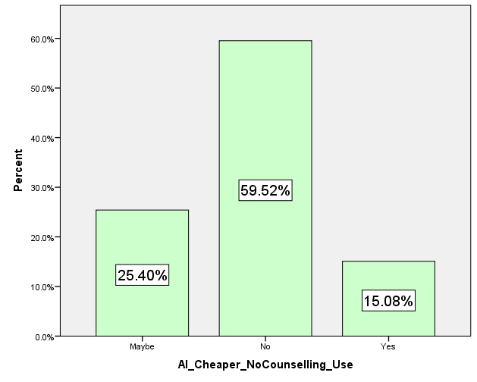
INTERPRETATION:
The bar chart shows how willing respondents are to use AI-based diet platforms if they are cheaper and do not involve counselling. The results reveal that most respondents, 59.52%, said they would not use these AI platforms without counselling. This suggests that many people still value professional guidance when getting dietary advice. Meanwhile, 25.40% selected “Maybe,” indicating some uncertainty depending on factors like reliability, cost, or effectiveness. Only 15.08% reported being willing to use AI-based diet services without counselling. Overall, these findings suggest that while cost-effective AI solutions may interest some, most respondents prefer to have professional counselling instead of relying only on AI-generated dietary advice. The findings also indicate that dietitians are still the most trusted sources of dietary guidance among respondents.
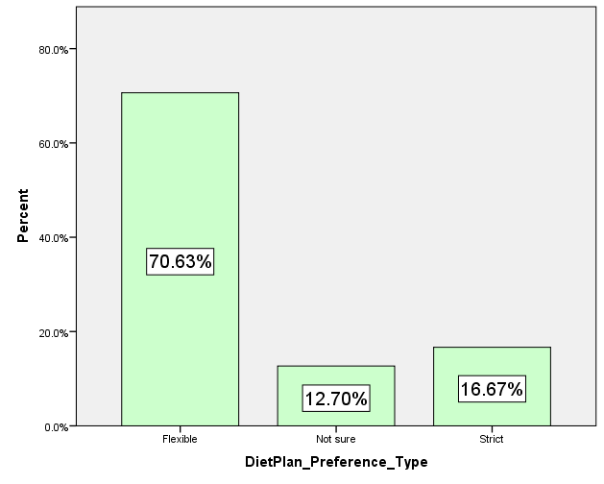
- PREFERENCE FOR STRICT VS FLEXIBLE DIET PLAN

INTERPRETATION:
The bar chart presents respondents’ preferences for diet plans. The results show that a significant majority, 70.63%, prefer flexible diet plans. This indicates that most people favor dietary approaches that allow for personal choice and adaptability over strict guidelines. In comparison, 16.67% prefer strict diet plans, meaning a smaller group is comfortable with highly regulated dietary regimes. Additionally, 12.70% reported being unsure about their preference, highlighting some uncertainty about the diet plan that best fits their needs. Overall, the findings show that flexibility in dietary planning is highly valued, emphasizing the need for adaptable and personalized diet recommendations.
- WILLINGNESS TO RECOMMEND AI DIET APPS
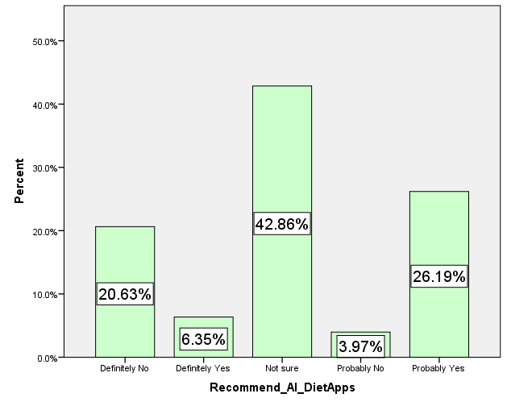
INTERPRETATION:
The bar chart illustrates how likely respondents are to recommend AI-based diet applications to others. The findings show that the largest group, 42.86%, indicated they are not sure whether they would recommend AI diet apps. This reflects considerable uncertainty about the reliability, effectiveness, or trustworthiness of these technologies. Meanwhile, 26.19% reported that they would probably recommend AI diet apps, indicating a moderate level of acceptance toward these tools. In contrast, 20.63% stated they would definitely not recommend them, while 3.97% said they would probably not recommend AI diet apps. Only a small group, 6.35%, indicated they would definitely recommend AI-based diet applications. Overall, the results suggest that while some respondents are open to recommending AI diet apps, a large portion remains uncertain. This highlights the need for greater trust and confidence in AI-driven dietary solutions.
STATISTICAL ANALYSIS
- One-Way ANOVA
Differences in Frequency of using health/diet apps across different age groups
Hypotheses
H₀: There is no significant difference in the frequency of using mobile health or diet-related apps among respondents of different age groups.
H₁: There is a significant difference in the frequency of using mobile health or diet-related apps among respondents of different age groups.
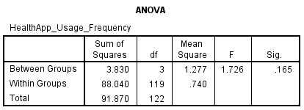
INTERPRETATION
A one-way ANOVA was conducted to see if there was a significant difference in how often respondents from different age groups used mobile health or diet-related applications. The analysis showed that the p-value (0.165) was higher than the significance level of 0.05. As a result, the null hypothesis was not rejected. This means there is no statistically significant difference in the use of mobile health or diet-related applications among respondents of different age groups. The findings suggest that age does not greatly affect the usage of mobile health or diet-related applications among the participants in this study
CONCLUSION
This study evaluated how participants view dietary recommendations based on Artificial Intelligence and the services of professional dietitians. The findings showed that while AI-based diet apps are attracting interest, most respondents still prefer advice from professional dietitians. Many participants raised concerns about privacy, accuracy, and the lack of human interaction in AI-based platforms. The results also indicated that respondents favor flexible diet plans over strict ones, emphasizing the need for personalized and adaptable dietary guidance. Additionally, the One-Way ANOVA analysis revealed no significant differences in mobile health app usage among different age groups. Overall, the study concludes that even though Artificial Intelligence can help with dietary planning, professional dietitians remain the most trusted source for nutrition advice. AI should be seen as a supportive tool, not a replacement for professional dietitians.
REFERNCES
- Agrawal, K. (2025). Artificial intelligence applications in personalized nutrition. Frontiers in Nutrition.
- Ajzen, I. (1991). The theory of planned behavior. Organizational Behavior and Human Decision Processes, 50(2), 179–211. https://doi.org/10.1016/0749-5978(91)90020-T
- Amadeh, T., Rafie, M., Radmanesh, S., Azizi, A., Ahangarian, A., Fathollahi, P., & Ahmadloo, H. (2025). Intelligent diet recommendation system powered by artificial intelligence for personalized nutritional solutions. Clinical Nutrition ESPEN. https://doi.org/10.1016/j.clnesp.2025.09.002
- Beldad, A., & Hegner, S. (2018). Expanding the technology acceptance model with the inclusion of trust, social influence, and health valuation to determine the predictors of German users’ willingness to use m-health apps. International Journal of Human–Computer Interaction, 34(9), 882–893.
- Beldad, A., de Jong, M., & Steehouder, M. (2010). How shall I trust the faceless and the intangible? A literature review on the antecedents of online trust. Computers in Human Behavior, 26(5), 857–869. https://doi.org/10.1016/j.chb.2010.03.013
- Bickmore, T. W., & Giorgino, T. (2006). Health dialog systems for patients and consumers. Journal of Biomedical Informatics, 39(5), 556–571. https://doi.org/10.1016/j.jbi.2005.12.004
- Burke, R. (2002). Hybrid recommender systems: Survey and experiments. User Modeling and User-Adapted Interaction, 12(4), 331–370.
- Castells, P., Hurley, N. J., & Vargas, S. (2015). Recommender systems handbook. Springer.
- Creswell, J. W. (2014). Research design: Qualitative, quantitative, and mixed methods approaches (4th ed.). SAGE Publications.
- Davis, F. D. (1989). Perceived usefulness, perceived ease of use, and user acceptance of information technology. MIS Quarterly, 13(3), 319–340. https://doi.org/10.2307/249008
- Dennison, L., Morrison, L., Conway, G., & Yardley, L. (2013). Opportunities and challenges for smartphone applications in supporting health behavior change. Journal of Medical Internet Research, 15(4), e86. https://doi.org/10.2196/jmir.2583
- Ema, A. (2023). AI-based diet improvement systems and ethical concerns. In Human-centered AI (pp. 145–162). Springer. https://doi.org/10.1007/978-3-031-34804-4_10
- Fogg, B. J. (2003). Persuasive technology: Using computers to change what we think and do. Morgan Kaufmann.
- Jiang, F., Jiang, Y., Zhi, H., Dong, Y., Li, H., Ma, S., Wang, Y., Dong, Q., Shen, H., & Wang, Y. (2017). Artificial intelligence in healthcare: Past, present and future. Stroke and Vascular Neurology, 2(4), 230–243.
- Kaplan, A. M., & Haenlein, M. (2019). Siri, Siri, in my hand: Who’s the fairest in the land? On the interpretations, illustrations, and implications of artificial intelligence. Business Horizons, 62(1), 15–25.
- Kauttonen, J. (2025). Trust and acceptance challenges in AI-based healthcare systems. Journal of Medical Internet Research.
- Kim, J., & Park, H. A. (2012). Development of a health information technology acceptance model using consumers’ health behavior intention. Journal of Medical Internet Research, 14(5), e133.
- Kothari, C. R. (2004). Research methodology: Methods and techniques (2nd ed.). New Age International Publishers.
- Krebs, P., & Duncan, D. T. (2015). Health app use among US mobile phone owners: A national survey. JMIR mHealth and uHealth, 3(4), e101. https://doi.org/10.2196/mhealth.4924
- Lops, P., de Gemmis, M., & Semeraro, G. (2011). Content-based recommender systems: State of the art and trends. In Recommender systems handbook (pp. 73–105). Springer.
- Lupton, D. (2014). Health promotion in the digital era: A critical commentary. Health Promotion International, 30(1), 174–183. https://doi.org/10.1093/heapro/dau091
- McKnight, D. H., Choudhury, V., & Kacmar, C. (2002). Developing and validating trust measures for e-commerce: An integrative typology. Information Systems Research, 13(3), 334–359. https://doi.org/10.1287/isre.13.3.334.81
- Mehta, N., Pandit, A., & Shukla, S. (2019). Transforming healthcare with big data analytics and artificial intelligence: A systematic review. Journal of Biomedical Informatics, 100, 103311.
- Miller, D. D., & Brown, E. W. (2018). Artificial intelligence in medical practice: The question to the answer? The American Journal of Medicine, 131(2), 129–133.
- Ordovas, J. M., Ferguson, L. R., Tai, E. S., & Mathers, J. C. (2018). Personalised nutrition and health. Nutrients, 10(7), 839.
- ResearchGate. (2025). AI-powered recipe recommendation systems and their role in personalized nutrition.
- Rho, M. J., Kim, H. S., & Chung, K. (2015). Predictors of telemedicine service acceptance and behavioral intention of physicians. International Journal of Medical Informatics, 84(8), 559–571.
- Smith, H. J., Dinev, T., & Xu, H. (2011). Information privacy research: An interdisciplinary review. MIS Quarterly, 35(4), 989–1015. https://doi.org/10.2307/41409970
- Topol, E. (2019). Deep medicine: How artificial intelligence can make healthcare human again. Basic Books.
- Venkatesh, V., Morris, M. G., Davis, G. B., & Davis, F. D. (2003). User acceptance of information technology: Toward a unified view. MIS Quarterly, 27(3), 425–478. https://doi.org/10.2307/30036540
- Wang, W. (2025). Understanding consumer behavior in AI-driven recommendation systems. Foods, 14(6), 976. https://doi.org/10.3390/foods14060976
- Wang, X. (2025). Artificial intelligence applications to personalized dietary interventions: A systematic review. Nutrients.
- Wang, Y., Min, J., Khuri, J., & Xue, H. (2022). Effectiveness of mobile health interventions on diabetes and obesity treatment and management: Systematic review of systematic reviews. Journal of Medical Internet Research, 24(1), e27343.
- Zhang, Y., & Chen, X. (2020). Explainable recommendation: A survey and new perspectives. Foundations and Trends in Information Retrieval, 14(1), 1–101.

