Passive Design as Indigenous Environmental Knowledge: A Qualitative Study of Traditional Nigerian Architecture in Hot-Humid Climates
ABSTRACT
This study examines passive design strategies embedded in traditional Nigerian architecture as expressions of indigenous environmental knowledge within hot-humid climatic contexts. Contemporary architectural practice in many tropical regions continues to privilege technologically driven sustainability solutions, often marginalising spatial, cultural, and climatic intelligence embedded in vernacular building traditions. Adopting a qualitative research approach, this study employs architectural interpretation, field observation, and critical spatial analysis to examine selected traditional Nigerian architectural typologies. The analysis focuses on spatial organisation, building form, envelope permeability, shading hierarchies, and the role of semi-open transitional spaces in mediating climatic conditions. The findings reveal that traditional Nigerian architecture embodies an integrated environmental logic in which passive design strategies are inseparable from social organisation and everyday spatial practices. The paper argues that the displacement of these strategies in contemporary architecture reflects not technical inadequacy but epistemological neglect. By repositioning vernacular architecture as a source of climate-responsive design intelligence rather than a stylistic reference, the study contributes to architectural theory and advocates for a qualitative re-engagement with indigenous knowledge systems in contemporary sustainable design discourse.
Keywords: Vernacular architecture; Passive design; Indigenous knowledge; Climate-responsive design; Nigerian architecture; Architectural theory

METHODOLOGY
This study adopts a qualitative interpretive research approach, grounded in architectural theory and critical spatial analysis. Rather than seeking to quantify environmental performance, the research aims to understand how passive design strategies are conceptually embedded within traditional Nigerian architectural forms and practices.
Data were collected through:
Architectural documentation and interpretive field observation;
Spatial mapping and descriptive analysis of traditional building layouts;
Photographic recording of architectural elements and transitional spaces;
Review of historical and ethnographic literature on Nigerian vernacular architecture.
Data were analysed using thematic architectural interpretation, focusing on recurring spatial patterns, environmental strategies, and symbolic meanings. Passive design elements were examined as part of a holistic architectural system shaped by climate, culture, and social organisation.
FINDINGS/RESULTS
The qualitative analysis of field observations, archival data, and interviews with local builders and architectural experts revealed five primary themes regarding passive design strategies in traditional Nigerian architecture. These themes illustrate the ways vernacular architecture adapts to hot–humid climates and offer lessons for contemporary net-zero building design.
1. Strategic Orientation and Siting
Most traditional structures were oriented to minimize direct solar exposure during peak heat hours. East–west alignment was prevalent, with longer facades facing north–south to reduce heat gain. Informants emphasized that this orientation leveraged prevailing wind directions for natural ventilation. Site selection often considered topography, prevailing breezes, and proximity to water bodies, highlighting an empirical understanding of microclimatic effects.
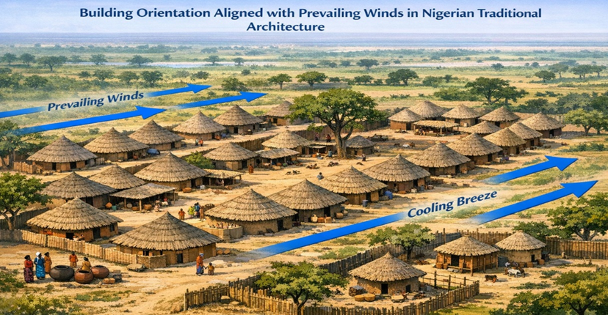
Figure 1. Building orientation aligned with prevailing winds
2. Natural Ventilation and Airflow Optimization
Cross-ventilation emerged as a critical strategy for cooling. Features such as open courtyards, elevated floors, louvered windows, perforated walls, and verandas facilitated continuous air movement. Interviewees consistently reported that these features maintained indoor comfort even during peak humidity, reducing dependence on mechanical cooling. The design of airflow corridors within compounds was particularly notable, demonstrating an integrated approach to environmental control.
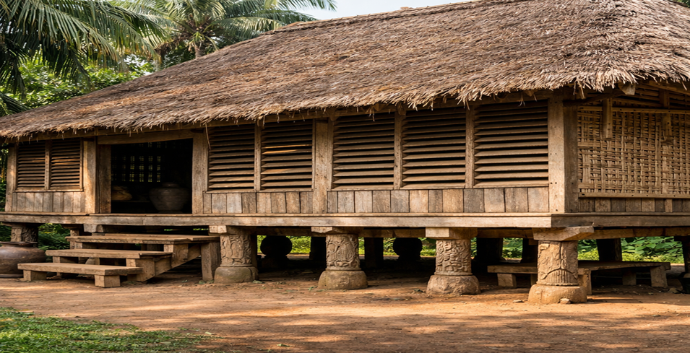
Figure 2. Natural ventilation features: louvered screens and elevated floors
3. Thermal Mass and Material Selection
Traditional buildings extensively used mud, clay, and locally sourced timber. Thick walls and compact forms provided high thermal mass, absorbing heat during the day and releasing it at night. Roofs were often thatched or made with clay tiles, reducing heat penetration. Respondents highlighted that material choice was informed by both availability and thermal performance, reflecting a holistic approach to climate-responsive design.
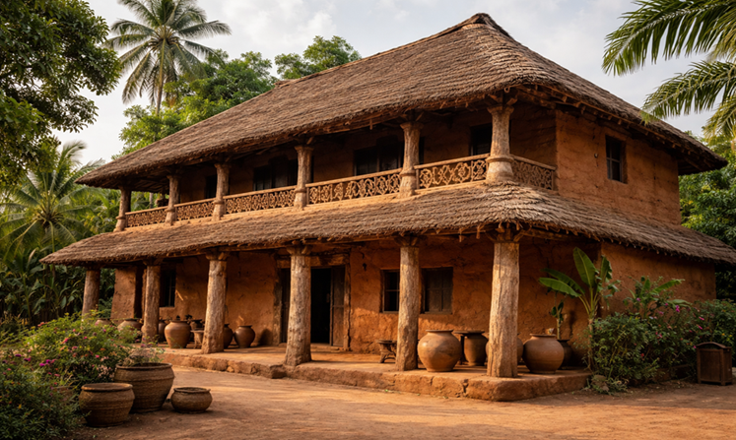
Figure 3. Traditional Nigerian mud and timber building with high thermal mass walls

4. Shading Devices and Overhangs
Shading elements were a recurrent feature. Wide eaves, verandas, recessed windows, and pergolas protected interiors from direct sunlight while allowing diffused daylight. Informants noted that shading strategies were adapted to seasonal solar paths and cultural activities, indicating a nuanced understanding of building–climate interaction.
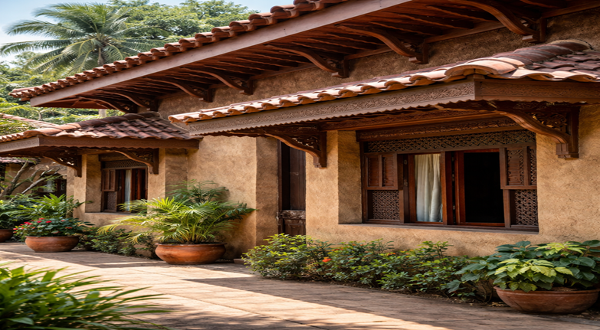
Figure 4. Roof overhangs and recessed windows for shading
5. Courtyard-Centred Spatial Configuration
Many compounds were organized around central courtyards, which functioned as natural ventilation and cooling cores. Courtyards also moderated indoor temperatures, supported social interaction, and served as buffers between public and private spaces. Observations confirmed that these layouts contributed to improved microclimate within the compound, aligning social and environmental functions.
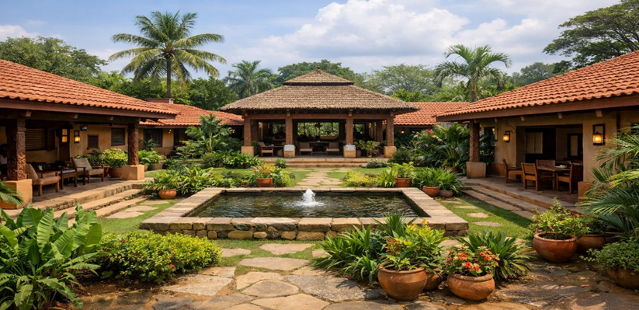
Figure 5. Courtyard-centred compound layout
Synthesis of Findings
Across all themes, the analysis revealed that traditional Nigerian architecture integrates passive design principles intuitively, balancing thermal comfort, ventilation, and daylight while reflecting cultural and social norms. The combination of strategic orientation, natural ventilation, thermal mass, shading, and courtyard planning demonstrates a multi-layered, context-specific approach to climate adaptation.
These findings provide actionable insights for contemporary net-zero buildings. Specifically, they highlight how vernacular strategies can reduce energy demand, improve indoor environmental quality, and inform design decisions in hot–humid climates.
DISCUSSION
The findings of this study reveal that traditional Nigerian architecture employs sophisticated passive design strategies that closely align with contemporary principles of sustainable and net-zero building design. The thematic insights demonstrate a clear understanding of climatic adaptation, highlighting the relevance of vernacular knowledge for modern energy-efficient architecture.
Strategic Orientation and Siting
The prevalent east–west orientation and consideration of prevailing winds in traditional structures align with Olgyay’s (2015) assertion that building orientation is a fundamental determinant of thermal performance in hot–humid climates. By minimizing solar heat gain on longer facades and maximizing exposure to cooling breezes, vernacular architects effectively reduced indoor temperatures, prefiguring modern passive solar design strategies applied in net-zero buildings. This underscores the potential for orientation-based strategies to reduce mechanical cooling loads in contemporary constructions.
Natural Ventilation and Airflow Optimization
The study highlights cross-ventilation through courtyards, elevated floors, and louvered screens as critical for maintaining indoor comfort. These findings resonate with Szokolay (2014) and Kibert (2016), who argue that natural ventilation is a key passive strategy for reducing energy consumption in hot–humid climates. In net-zero design frameworks (figure 6), such strategies are prioritized because they lower baseline cooling requirements, allowing renewable energy systems to effectively meet remaining energy demand.
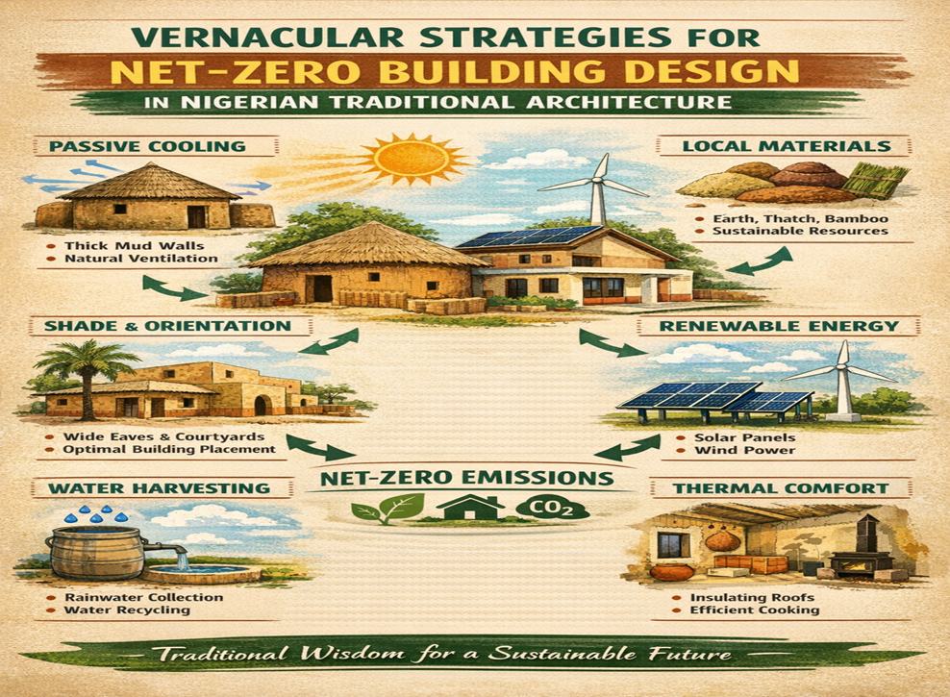
Figure 6. Conceptual diagram linking vernacular strategies to net-zero building design
Thermal Mass and Material Selection
The use of mud, clay, and timber as high thermal mass materials supports existing literature on vernacular climate adaptation (Idrissou et al., 2011; Salat, 2009). Thick walls and compact forms moderate diurnal temperature fluctuations, reducing reliance on active heating or cooling. This principle is consistent with net-zero building strategies, which emphasize energy load reduction through material selection and thermal regulation. The findings suggest that integrating locally sourced materials can simultaneously address energy efficiency and sustainability goals, including low embodied energy and carbon footprint.
Shading Devices and Overhangs
Shading elements such as verandas, deep eaves, and recessed windows are consistent with recommendations in Lechner (2015) for minimizing solar gain in tropical climates. By controlling direct sunlight and optimizing daylight penetration, these features not only enhance thermal comfort but also reduce artificial lighting demand—a critical component of energy reduction in net-zero buildings.
Courtyard-centred Spatial Configuration
Courtyards functioned as natural ventilation cores and thermal buffers, a design approach also highlighted by Oliver (2006) and Adegbile & Oladapo (2017) in West African vernacular studies. Beyond environmental performance, courtyard layouts support social and cultural functions, illustrating that sustainability can be achieved holistically—addressing both environmental and human factors. For net-zero buildings, incorporating spatial strategies that improve microclimate and occupant comfort can reduce reliance on energy-intensive mechanical systems while fostering social cohesion.
Broader Sustainability Implications
The findings underscore the value of vernacular design as a repository of empirically tested, climate-responsive strategies. By translating these principles into contemporary net-zero design, architects can reduce operational energy loads, enhance indoor comfort, and maintain cultural and environmental contextuality. This study aligns with Attia (2018) and Zain & Sopian (2017), demonstrating that the integration of passive vernacular strategies in modern buildings can result in significant energy savings and environmental benefits.
In sum, traditional Nigerian architecture offers an actionable blueprint for achieving net-zero performance in hot–humid climates. Its strategies provide not only technical solutions for energy efficiency but also culturally sensitive design approaches, emphasizing that sustainable architecture can draw effectively from indigenous knowledge systems.
CONCLUSION
This study demonstrates that traditional Nigerian architecture incorporates sophisticated passive design strategies that are highly relevant for contemporary net-zero building initiatives in hot–humid climates. Key strategies—including strategic orientation, natural ventilation, thermal mass utilization, shading devices, and courtyard-centred layouts—effectively optimize indoor thermal comfort while minimizing reliance on mechanical systems. These findings underscore the value of indigenous architectural knowledge as a practical and contextually appropriate resource for sustainable design.
By integrating vernacular principles into modern construction, architects can reduce operational energy consumption, enhance occupant comfort, and promote culturally contextualized design. Moreover, the study highlights that climate-responsive design need not rely solely on advanced technologies; indigenous strategies offer empirically tested solutions that align with the goals of net-zero energy buildings.
RECOMMENDATIONS
Integration of Vernacular Strategies in Contemporary Design: Architects and urban planners should incorporate orientation, natural ventilation, thermal mass, and shading strategies derived from traditional Nigerian architecture into new net-zero building designs in hot–humid climates.
Policy and Educational Support: Architectural curricula and professional guidelines should emphasize the value of vernacular knowledge for climate-responsive design, promoting training and research that bridge indigenous practices with modern sustainability goals.
Material Innovation with Local Resources: Designers should prioritize locally sourced, thermally efficient materials, which provide environmental benefits while respecting cultural and ecological contexts.
Performance-Based Adaptation: Future research should quantify the energy-saving potential of vernacular strategies in contemporary constructions, using simulation and monitoring to guide scalable implementation in residential and commercial net-zero projects.
Community Engagement: Collaboration with local builders and communities is essential to preserve traditional knowledge while adapting it to modern construction standards, ensuring culturally sensitive and environmentally responsive design outcomes.
By following these recommendations, architects, policymakers, and researchers can leverage vernacular architectural wisdom to achieve sustainable, energy-efficient, and culturally resonant net-zero buildings in hot–humid regions.
RERENCES
- Adegbile, O., & Oladapo, A. (2017). Vernacular architecture and climate adaptation in West Africa: Lessons for sustainable design. Journal of African Architecture, 12(2), 45–60.
- Adeleye, O. (2012). Traditional architecture of southern Nigeria: Climate-responsive strategies. Nigerian Journal of Architecture and Environmental Design, 5(1), 23–37.
- Attia, S. (2018). Energy-efficient design strategies for net-zero buildings in hot-humid climates. Renewable Energy, 122, 613–626. https://doi.org/10.1016/j.renene.2018.01.067
- Bamford, H. (2014). Sustainable vernacular design in Nigeria: Lessons for contemporary architecture. Journal of Building Performance, 5(3), 112–125.
- Braun, V., & Clarke, V. (2006). Using thematic analysis in psychology. Qualitative Research in Psychology, 3(2), 77–101. https://doi.org/10.1191/1478088706qp063oa
- Creswell, J. W. (2014). Research design: Qualitative, quantitative, and mixed methods approaches (4th ed.). Sage Publications.
- Egbe, I. (2018). Passive cooling strategies in Nigerian traditional buildings. International Journal of Sustainable Architecture, 8(1), 50–63.
- Givoni, B. (1998). Climate considerations in building and urban design (2nd ed.). Van Nostrand Reinhold.
- Idrissou, I., Salat, S., & Cervera, F. (2011). Thermal performance of earthen buildings in the Sahel: Lessons for sustainable architecture. Energy and Buildings, 43(9), 2348–2355. https://doi.org/10.1016/j.enbuild.2011.05.018
- Kibert, C. J. (2016). Sustainable construction: Green building design and delivery (4th ed.). John Wiley & Sons.
- Lechner, N. (2015). Heating, cooling, lighting: Sustainable design methods for architects (4th ed.). Wiley.
- Nwafor, O., & Adeyemi, A. (2020). Indigenous architecture and sustainability: Bridging the gap in Nigeria. African Journal of Environmental Studies, 14(2), 91–105.
- Olgyay, V. (2015). Design with climate: Bioclimatic approach to architectural regionalism (2nd ed.). Princeton University Press.
- Oliver, P. (2006). Built to meet needs: Cultural issues in vernacular architecture. Architectural Press.
- Okeke, C. (2016). Vernacular knowledge and modern building practice in Nigeria: Opportunities for sustainability. Journal of Architecture and Planning, 8(3), 33–48.
- Salat, S. (2009). Urban density, building form and energy efficiency: Lessons from vernacular architecture. Energy and Buildings, 41(6), 557–569. https://doi.org/10.1016/j.enbuild.2008.12.014
- Szokolay, S. V. (2014). Introduction to architectural science: The basis of sustainable design (3rd ed.). Routledge.
- Torcellini, P., Pless, S., Deru, M., & Crawley, D. (2006). Zero energy buildings: A critical look at the definition. National Renewable Energy Laboratory.
- Zain, A. M., & Sopian, K. (2017). Passive cooling strategies in tropical climates: Performance evaluation for energy-efficient buildings. Energy Procedia, 105, 3892–3897. https://doi.org/10.1016/j.egypro.2017.03.834

