Design and Implementation of an IoT-Based Community Delivery Robot for Secure Last-Mile Logistics
___________________________________________________________________________
Abstract
The rapid growth of e-commerce and smart logistics systems has increased the demand for efficient and contactless package delivery solutions. This paper presents the design and development of an Internet of Things (IoT) based community package delivery robot using the ESP8266 microcontroller. The proposed system is capable of wireless navigation, real-time monitoring, and secure package handling. The robot is controlled through Wi-Fi communication, enabling users to operate it remotely using a mobile device or web interface. A motor driver module (L298N / L293D) is used to control the movement of DC motors for directional navigation. An IP webcam is integrated into the system to provide live video streaming, assisting the user in monitoring the robot’s surroundings during delivery operations. To ensure package safety, a solenoid lock mechanism is implemented for secure storage and controlled access. The system is designed to be low-cost, energy-efficient, and suitable for applications such as campus delivery, residential communities, and industrial environments. Experimental implementation demonstrates reliable movement control, effective wireless communication, and enhanced delivery security. The proposed robot contributes to the advancement of smart delivery technologies by offering a practical and scalable solution for last-mile delivery challenges.
Key words: IOT, Community, Delivery Robot, ESP8266, IP Webcam, Solenoid Lock, Motor Driver, Wireless Control, Last-mile Delivery.
- INTRODUCTION
Autonomous robots are gaining widespread adoption in various industries, households, military operations, and disaster management globally. Examples include Roomba cleaning robots, delivery robots, and autonomous vehicles capable of navigating physical spaces without human guidance. [1] These robots are designed to operate with little or no human intervention and can deliver packages directly to customers. The adoption of delivery robots is driven by the increasing demand for fast, reliable, and cost-effective delivery services.[2] A control server monitors and control the robot remotely in its way to delivery of packages. It is electrically powered motorized vehicle which can deliver item or packages to customers without interaction or interference of a delivery person.[3]The hardware includes sensors to gather information about the surroundings, actuators to manipulate objects or move the robot itself, and a computational system to process data and make decisions. The software encompasses the algorithms and programming that govern the robot's behaviour and control its actions.[2]The growth in ecommerce, specifically with regards to last-mile delivery and the end-consumer preference for cheap and fast shipping, has led to businesses and academia focusing on various improvement strategies to lower last-mile delivery costs and provide more value to end users.[4]Autonomous delivery robots are increasingly used to perform logistics tasks efficiently with minimal human intervention. The growing demand for fast, low-cost, and contactless last-mile delivery solutions has encouraged the development of IoT-based robotic systems for real-time monitoring and secure package transportation. Autonomy can be scaled to various prospects depending on the usage. In our project, our initial step is to introduce a robot capable of carrying out minimalistic jobs mentioned earlier. Teaching, specifically training the robot to travel is the most challenging section of the project.[5]In India, most deliveries are performed by human beings. The main idea of the self-driving system is to have a robot which can transport physical objects from one place to the other. The objective of the robotics field is to create intelligent machines that can assist humans in a variety of ways. The model uses artificial intelligence technology to navigate the waypoint and reach the destination successfully. This technology has the capability of a computer-controlled robot to do the tasks commonly associated with intelligent humans.[6]Although the use of autonomous robots is not a new advance in the field of delivery as multinationals companies such as Amazon and DHL have been known to use such robots for the purpose to handling packages in their warehouses, it seemed quite favourable to propose something of such equivalence particularly in the eye of such firms and companies.[5]

LITERATURE REVIEW
Previous studies have focused on Wi-Fi controlled robots using microcontrollers such as NodeMCU and ESP8266 for real-time communication and control. Researchers have also implemented live video monitoring using IP cameras to help users track robot movement remotely. In addition, security mechanisms like solenoid locks have been integrated into delivery boxes to ensure safe package handling. Motor drivers and DC motors are commonly used for robot mobility due to their simplicity and cost-effectiveness.
Autonomous Indoor Delivery Robot using ROS (Journal of Robotics, 2020): This study presents the design and implementation of an autonomous indoor delivery robot that utilizes the Robot Operating System (ROS) in combination with LIDAR sensors for indoor navigation and obstacle detection. The system uses Simultaneous Localization and Mapping (SLAM) for generating maps of the environment and relies on QR code-based docking stations for precise drop-off points.[7]This automation is carried out by identifying the road, alerting about the approaching obstacles, stop signs, responding and making decisions, which include changing the direction route of the vehicle and the vehicle is capable of identifying green signals with the help of Neural Network. Autonomous vehicle analysis the input, tracks the path and sends commands to the actuators that manage acceleration, braking, and steering.[8]This project includes the usage of picture processing concept, the facing camera, where in which the camera will seize the pictures from the actual world also it uses to detect the obstacles, it uses convolutional neural network, ESP8266 microcontroller.[9]In this way it needs to quickly and accurately produce a high-quality understanding of where the vehicle is, in order to be able to transfer data alongside managing algorithms.[10]The robot's ability to detect a path, detect obstacles, and navigate close to one another to avoid collisions. It also shows that the robot was successfully following very tight curves and blocking any obstacles that appeared in its path. An action plan that allows the robot to reach its goal without colliding with any possible obstacles in its path. To avoid collisions in the portable robot area, provide route-generating & line- based techniques. Line tracking, route planning, collision avoidance, back spread, improved memory, long-distance obstacles. It is cheaper and less expensive.[11]This paper mainly deals with image processing strategies to locate lane boundary strains. Video sensors represent a remarkable innovation within automation sector and traffic safety, as they make a contribution to the event of driver help systems.These video structures use image processing strategies to alert the drivers about approaching dangers.[12]
- RELATED WORK

Recent advancements in autonomous delivery systems have significantly influenced the development of community-based package delivery robots. Researchers have explored the use of mobile robotic platforms integrated with Internet of Things (IoT) technologies to enable real-time tracking and efficient navigation. Many existing systems utilize GPS-based localization combined with obstacle detection techniques using ultrasonic sensors and computer vision for safe movement in dynamic environments.Several studies focus on last-mile delivery solutions, where robots operate within residential or campus environments to reduce human effort and delivery time. Machine learning algorithms have been incorporated to improve route optimization and object recognition, allowing robots to adapt to changing surroundings. Additionally, cloud-based communication systems have been implemented to facilitate user interaction, remote monitoring, and data storage.Some research also highlights the importance of security features such as password-protected compartments and OTP-based access to ensure safe package handling. However, challenges such as limited battery life, navigation accuracy in crowded areas, and high implementation costs still persist.The proposed system builds upon these existing approaches by integrating cost-effective hardware, improved navigation techniques, and community-focused delivery models to enhance accessibility and reliability.
- PROPOSED METHODOLOGY
Delivery robots have emerged as a promising solution for efficient and convenient last-mile deliveries. These robots operate autonomously to navigate through various urban environments.[1] The main hardware components of the package delivery robot include the chassis, motors, wheels, batteries, sensors, and microcontrollers The batteries provide the necessary power for the motors and other components. The sensors detect obstacles, measure distance, and provide feedback for the robot's movements. The microcontrollers process the sensor data and control the motors and other components.[2]
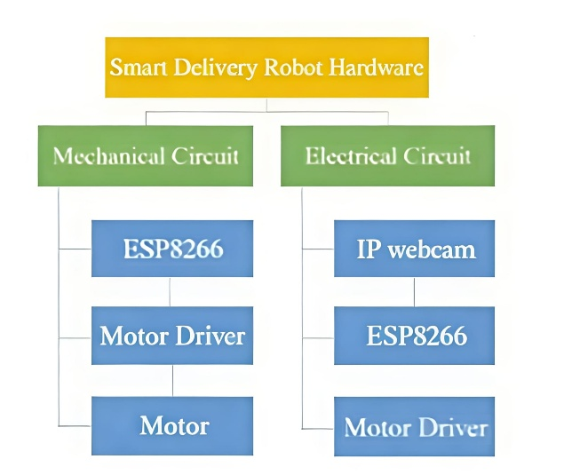
Fig 1. Robot Hardware Divisions
The diagram represents the hardware architecture of the smart delivery robot, which is divided into two main sections: the Mechanical Circuit and the Electrical Circuit. The mechanical circuit consists of components responsible for the physical movement of the robot, including the ESP8266 controller, motor driver, and DC motors. In this section, the ESP8266 sends control signals to the motor driver, which in turn drives the motors to enable forward, backward, left, and right movement of the robot.The electrical circuit section includes components used for monitoring and control functions such as the IP webcam, ESP8266 module, and motor driver. The IP webcam provides real-time video streaming for remote navigation and surveillance, while the ESP8266 handles wireless communication and command processing. Together, these circuits ensure proper coordination between robot mobility, remote monitoring, and overall system operation for efficient package delivery.
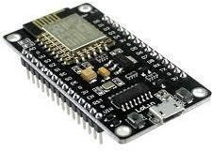
Fig 2. ESP8266 Controller
ESP8266 Controller:The ESP8266 controller is a low-cost Wi-Fi enabled microcontroller widely used in Internet of Things (IoT) applications. In the delivery robot system, it acts as the main control unit that receives commands from a mobile device or web server through wireless communication. The controller processes these commands and generates appropriate signals to control the motor driver and other connected components. It also enables real-time data transmission and remote monitoring, improving the efficiency of robot operation. Due to its compact size, low power consumption, and built-in networking capability, the ESP8266 is suitable for smart automation and robotic control systems.
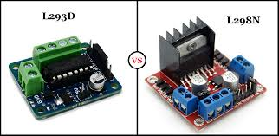
Fig 3. L298N/L293D Motor Driver
L298N/L293D Motor Driver:The L298N or L293D motor driver is an interface module used to control the speed and direction of DC motors in robotic applications. It receives low-power control signals from the microcontroller and amplifies them to drive motors that require higher current and voltage. This motor driver enables the robot to perform movements such as forward, backward, left, and right by controlling the rotation of the motors.
DC Motors: DC motors are electromechanical devices that convert electrical energy into mechanical rotational motion. In the delivery robot, they are used to drive the wheels and enable movement in different directions based on control signals from the motor driver.
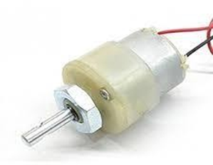
Fig 4. DC Motor
Their simple construction, easy speed control, and compatibility with battery power make them suitable for mobile robotic applications.
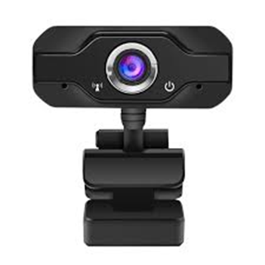
Fig 5. IP Web Camera
IP Web Camera:An IP web camera is a network-based camera used to capture and transmit real-time video over a Wi-Fi connection. In the delivery robot, it provides live visual feedback to the user for remote monitoring and navigation control. This helps in observing obstacles, guiding robot movement, and improving delivery safety and efficiency.
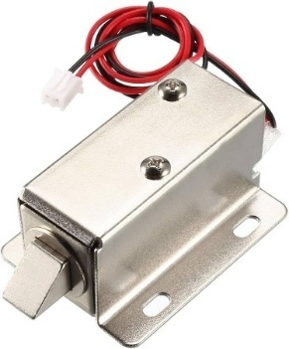
Fig 6. Solenoid Lock
Solenoid Lock:A solenoid lock is an electromagnetic locking device used to secure the delivery box in the robot. It operates by converting electrical energy into linear motion to lock or unlock the mechanism when a control signal is applied. This ensures safe and authorized access to the package during the delivery process.
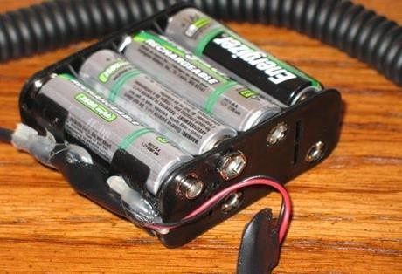
Fig 7. Lithium Batteries
Lithium Batteries:Lithium batteries are rechargeable energy storage devices widely used in portable electronics and robotic systems due to their high energy density and lightweight design. In the delivery robot, they provide a stable power supply to the microcontroller, motor drivers, motors, and other electronic components. Their long-life cycle, fast charging capability, and efficient performance make them suitable for mobile and IoT-based robotic applications.
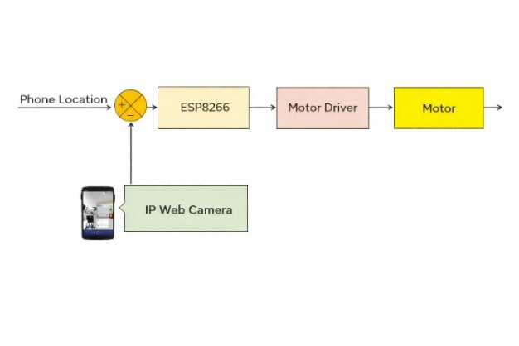Fig 8. Block Diagram of Mechanical Circuit
The block diagram illustrates the working principle of the smart package delivery robot controlled through a mobile device. The phone location or user command acts as the input to the system, which is processed by the central controller. Along with this input, live visual feedback from the IP web camera is also provided to assist in navigation and monitoring of the robot’s surroundings.The processed control signals are then sent to the ESP8266 controller, which acts as the brain of the system. Based on the received commands, the ESP8266 generates appropriate control signals and forwards them to the motor driver module. The motor driver amplifies these signals to drive the DC motors, enabling the robot to move in different directions such as forward, backward, left, and right. This integrated system allows real-time wireless control, visual monitoring, and efficient package delivery in controlled environments.
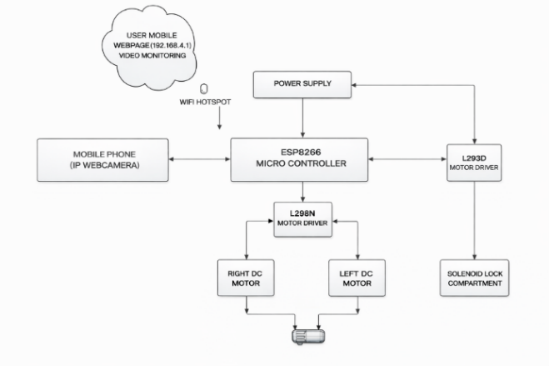
Fig 9. Implementation of Block Diagram
The implantation block diagram explains the overall system architecture of an IoT-based package delivery robot controlled through wireless communication. The user mobile webpage is connected to the robot using a Wi-Fi hotspot network, allowing the user to monitor live video and send movement commands. A mobile phone functioning as an IP web camera streams real-time video to help the user observe the robot’s surroundings and guide its navigation safely.A regulated power supply provides the necessary electrical energy to the controller and motor driver modules for proper operation. Based on the received instructions, the ESP8266 sends control signals to the L298N motor driver, which controls the left and right DC motors to enable directional movement of the robot such as forward, backward, and turning. Additionally, the system includes an L293D motor driver connected to a solenoid lock compartment for secure package handling. This locking mechanism ensures that the delivery box can be electronically opened or closed only when authorized commands are given. The coordinated operation of wireless communication, motor control, real-time monitoring, and secure locking enables the robot to perform efficient and contactless package delivery in controlled environments.
- RESULTS AND DISCUSSION
The developed community-based package delivery robot was successfully implemented and tested in a controlled environment. The system demonstrated reliable movement using the ESP8266 controller integrated with motor drivers, enabling smooth navigation across predefined paths. The IP web camera provided real-time visual feedback, allowing users to monitor the robot remotely. Obstacle detection and basic navigation ensured safe operation, while the delivery mechanism functioned effectively for small packages. The overall performance indicated that the robot could complete delivery tasks within a short time frame, reducing manual effort and improving operational efficiency.
However, challenges were observed in terms of battery life, limited range, and navigation accuracy in complex or crowded environments. Environmental factors like uneven surfaces also affected performance. Despite these limitations, the system provides a strong foundation for future improvements, including advanced path planning, AI-based decision-making, and enhanced power management, making it a promising solution for automated delivery applications.
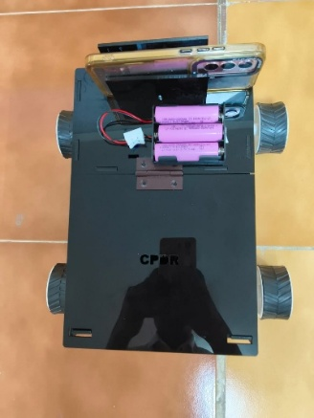
Fig10. The IP web camera is mounted on the robot to provide continuous live video monitoring of its surroundings during operation. This enables users to remotely observe the robot’s movement and delivery process in real time, improving control and transparency. The camera also supports obstacle detection by capturing visual data, which helps the system identify and respond to objects in its path. By integrating visual feedback with the control system, the robot can navigate more safely in dynamic environments. Overall, the inclusion of the IP web camera enhances both monitoring capabilities and operational safety of the delivery robot. Fig11. Shows the robot is capable of moving in forward, backward, left, and right directions to navigate efficiently within its environment.

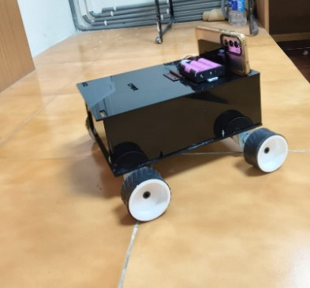

Fig11. The robot
It continuously monitors for obstacles using sensors and adjusts its movement accordingly to avoid collisions. When an obstacle is detected, the robot intelligently changes its direction and selects an alternative clear path. This adaptive movement ensures smooth and uninterrupted navigation during the delivery process. As a result, the system enhances safety, reliability, and efficiency while operating in dynamic and unpredictable surroundings.
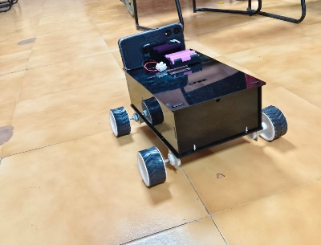
Fig12. The developed robot
Fig 12 shows the developed robot enhances efficiency by enabling fast and reliable package delivery within community environments while minimizing human intervention. It ensures a completely contactless delivery process, which improves safety and hygiene for both users and service providers. The integration of an IP web camera allows real-time monitoring and verification of the recipient, ensuring that packages are handed over only to authorized individuals. The system is capable of reaching the exact delivery location using predefined navigation paths, reducing errors and delays. Overall, the combination of automation, location accuracy, and user verification makes the robot a secure and practical solution for modern community-based delivery systems.
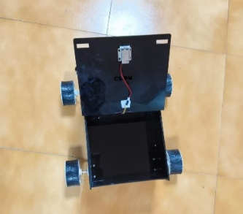
Fig13. The solenoid compartment
Fig 13 shows the solenoid compartment is unlocked only after successful verification of the user’s face and associated details, ensuring secure access to the delivered package. The system uses camera-based recognition to match the person with stored data before granting permission. Once authentication is confirmed, the solenoid lock is activated to open the compartment automatically. This approach prevents unauthorized access and enhances the safety of the delivery process. Additionally, the verification mechanism improves user trust and ensures that packages are received only by the intended recipient.
Once Delivery attempted then locked the compartment go to next delivery.
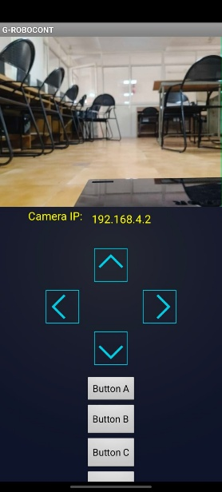
Fig14. Automatic lock compartment of robot
Fig14. Once the delivery is attempted, the robot automatically locks the compartment to ensure the safety and security of the package. This locking mechanism prevents unauthorized access after the package has been placed or delivered. After securing the compartment, the system updates the delivery status and prepares for the next task in the queue. The robot then navigates to the next delivery location using its predefined path or routing algorithm. This sequential delivery process improves efficiency and allows the robot to handle multiple deliveries in a single operation without human intervention.

- CONCLUSION
The community-based package delivery robot presents an efficient and innovative solution for last-mile delivery challenges. By integrating autonomous navigation, real-time communication, and secure delivery mechanisms, the system reduces human effort and enhances delivery speed within localized environments. The use of cost-effective components and smart technologies makes the system suitable for residential communities, campuses, and small-scale logistics applications.This approach not only improves convenience for users but also contributes to reducing traffic congestion and environmental impact associated with traditional delivery methods. Despite certain limitations such as battery constraints and navigation accuracy in complex surroundings, the system demonstrates strong potential for future development.Further improvements can include advanced artificial intelligence for better decision-making, longer battery life, and enhanced security features. Overall, the proposed model provides a scalable and reliable framework for modern delivery systems, aligning with the growing demand for automation and smart city solutions.
In future developments, the delivery robot can be enhanced by integrating advanced obstacle detection and avoidance sensors such as ultrasonic sensors, infrared sensors, or LiDAR modules. This will enable the robot to perform semi-autonomous or fully autonomous navigation without continuous human control. The implementation of intelligent path planning algorithms and machine learning techniques can further improve navigation accuracy, efficiency, and adaptability in dynamic environments. Another important improvement area is the communication and monitoring system. The robot can be upgraded with GPS or GSM modules to support long-distance tracking and operation beyond Wi-Fi range
REFERENCES
[1] ‘’Ditto: The delivery robot’’ Siddarth D1, Dennis Mcleoard1, Atish Anand Kumar1, Chevula Haarvish1, Mamatha G N2 (Ijert)-2023.
[2] ‘’Design and Development of a Package Delivery Robot’’ David Etim Udoh1, Dominic David Ekpo2, Imo Edwin Nkan3 (ISSN)-2024.
[3] ‘’Autonomous Delivery Robot’’ Dr. Vilas Ubale1, Mr. Sanket Bhor2, Mr. Sanket Kasar3, Miss. Sakshi Khule4, Miss. Vaishnavi Umbarkar5 (IJARSCT)-2023.
[4] ‘’Exploring the Impact of Delivery Robots on Last-Mile Delivery Capacity Planning Using Simulation’’ Raghavan Srinivasan 1, and Joseph Szmerekovsky 2 (MDPI)-2025.
[5] ‘’Autonomous Delivery Robot’’ Devang Dave1, Parth Parsana 2, Aarjav Ajmera3 (IRJET)-2020.
[6] ‘’Community based E-commerce package delivery robot’’ P. Ravikiran1, B. Saiprasad2, K. Venu madhav3, T. Venkatesh4 (IJRES)-2023.
[7] ‘’Autonomous Delivery Robot’’ Avantika Santosh Sawant, Prerana Dattatray Channe, Vaishnavi Dipak Patil, Dr. A.U. Mohite (Ass. Prof.) (IJCRT)-2025 ISSN: 2320-2882.
[8] Tej kurani, Nidhip kathiriya, Uday Mistry, Proff.Lukesh Kadu, Proff. Harish Motekar, "Self-driving Car using Machine Learning", International Journal of Engineering Research & Technology (IJERT), 2020.
[9] Hema C, Moksha S, Impana B, Nithin S, Pavana S, " Self –Driving Car Using Raspberry Pi, Convolutional Neural Network Arduino Microcontroller", International Journal of Engineering Research & Technology (IJERT), 2020.
[10] Sean Campbell, Niall O’ Mahony, Lenka Krpalcova, Daniel Riordan, Joseph Walsh, "Sensor Technology in Autonomous Vehicles", IEEE – 978-1-5386 6046-1, 2018.
[11] V. Keerthana, C. Kiruthiga, P. Kiruthika, V. Sowmiya, R. Manikadan "Navigation of Mobile Robot-Algorithm for Path Planning and Collision Avoidance", International Journal of Research-Granthaalayh,2017.
[12] Jamel Baili, Mehrez Marzougui, Samer Lahouar, M. Hergli, "Lane Departure detection using image processing techniques”, IEEE-978-1-5090-5814 3, 2017.

