Feasibility study of wind energy integration: a Weibull distribution approach

Abstract: This article assesses the technical and economic feasibility of integrating wind energy in the Gafsa region of Tunisia. Given the challenges of the global energy transition and the region's specific vulnerabilities, this initiative represents a strategic solution for harnessing local potential for sustainable development. The methodology combines advanced theoretical modeling and an experimental approach. Wind data were collected between 2023 and 2024 at an official measurement site in the Gafsa study area, along with wind speed recordings. A Weibull distribution was used to model wind speed. The parameters extracted from the data (shape factor k = 2.1 and scale factor c = 5.7 m/s) were used to calculate the annual energy production potential, estimated at 5.46 GWh/year for a 1.5 MW wind turbine. The results demonstrate that integrating wind energy would significantly reduce carbon dioxide emissions (tons of CO2 per year) while generating substantial financial savings. In addition, it would meet the energy needs of the phosphate industrial zone, a major electricity consumer. By paving the way for hybrid systems and energy storage solutions, this study positions the Gafsa region as an ideal pilot site for a sustainable energy project.
Keywords : Wind Energy, Technological and Economic Feasibility, Weibull Distribution, CO2 Emissions, Sustainable Development, Hybrid Systems

1.Introduction :The transition to renewable energy sources has become a global priority, driven by the climate emergency and the need to strengthen energy security [1]. This momentum is reflected in national strategies, particularly in Tunisia, which are actively committed to diversifying its energy mix. Wind energy, in particular, is recognized as a key pillar of this transition, offering a clean and sustainable alternative to fossil fuels [1, 2]. The Gafsa region, like many areas with arid or semi-arid climates, faces specific energy challenges, primarily due to its dependence on conventional sources [3]. This vulnerability is all the more worrying given that the region has considerable renewable energy potential, particularly wind and solar, which remains largely untapped [4]. Harnessing these local resources represents a major opportunity to improve the region's energy autonomy and resilience. The installation of a wind turbine not only provides a solution to local energy needs but also represents a concrete commitment to environmental management [5]. This project is part of this approach by seeking to reduce an area's dependence on conventional energy sources, which always results in high operating costs and a significant carbon footprint. The main objective of this study is to explore and validate the technical, economic, and environmental feasibility of a local and sustainable alternative [6, 7]. To achieve this, our work is structured around several specific objectives: to carry out a comprehensive assessment of available wind resources, to select a wind turbine adapted to the site's characteristics, to estimate its annual energy production and capacity factor, and to determine its potential contribution to local energy needs while aligning with sustainability objectives [8, 9,10]. This project thus contributes to the advancement of knowledge and the strengthening of local capacities in renewable energy, moving towards sustainability and inspiring other institutions and communities [11,12].
2.Materials and Methods
2.1. Theoretical Methods
The Weibull probability density function is a statistical function widely used to model wind speed distribution. It is an essential tool in wind energy because it allows us to estimate the frequency with which the wind blows at a given speed, which is crucial for calculating the energy production potential of a wind turbine .The parameters k and c that you calculated describe the local wind distribution:
Shape factor (k): This parameter describes the shape of the distribution. The larger k, the narrower and more symmetrical the distribution, meaning the wind speeds are more constant. For k = 2.1, the distribution is relatively uniform.
Scaling factor (c): This parameter is directly related to the average wind speed. For c = 5.7 m/s, the average wind speed is 5.7 m/s, which is a promising value for wind energy production. Using the Weibull function with parameters k = 2.1 and c = 5.7 m/s, you can determine the wind climate characteristics of the Gafsa region. This allows you to assess the amount of wind energy you can extract and choose the most suitable wind turbine. A k greater than 2 indicates that the wind speed in the region is relatively stable, with fewer extreme variations, which is very favorable for a wind project.
Weibull Probability Density Function Equation (1),the two-parameter Weibull probability density function (PDF) equation for wind speed v is as follows [13]:
${f\left(v\right)=\frac{k}{c}\left(\frac{v}{c}\right)}^{k-1}e^{-{\left(\frac{v}{c}\right)}^{k}}$ (1)
Where , f(v) is the probability density function, v is the wind speed, k is the shape factor (dimensionless) and c is the scale factor (in m/s).
Furthermore, since the wind measurements were taken at 30 meters altitude and the proposed wind turbine will operate at a different hub height, an extrapolation of the wind speeds was necessary. To do this, we applied the power law, a standard method for fitting wind data to altitude. This method uses a wind shear exponent (α) that varies with terrain roughness, the formula used is as follows (Equation 2)[14]:
$v_{2}=v_{1}{\left(\frac{h2}{h1}\right)}^{(α) }$ (2)
Where v2 is the wind speed at the desired height (wind turbine hub height), v1 is the measured wind speed (at 30 meters), h2 is the wind turbine hub height, h1 is the measuring mast height (30 meters) and α is the wind shear exponent, a typical value for semi-arid or agricultural terrain is usually between 0.15 and 0.25.This step is fundamental to ensure that energy production calculations are based on the actual wind speeds that the wind turbine will encounter, thus improving the reliability of our forecasts[15].
The choice of the wind turbine was guided by specific criteria, adapted to the moderate wind regime of Gafsa. Priority criteria included a low start-up speed, high efficiency at low to medium wind speeds and robustness in the face of variable conditions. These requirements are directly linked to the average wind speed measured at the site (5.3 m/s). The model selected is the Eocycle EOCY 25. Its technical specifications are as follows: nominal power of 25 kW, rotor diameter of 12.8 m, start-up speed of 2.5 m/s, nominal speed of 12 m/s and start-up speed of 20 m/s. The choice of this wind turbine is not arbitrary; it is a deliberate engineering decision aimed at maximizing energy capture given the specific wind profile.
Annual energy production (AEP) is calculated by integrating the specific energy consumption of the furnace (EOCY 25) with the distribution of windows on the site, the formula used is as follows (eq.3) [16]:
$$PAE=T\int_{v_{ci}}^{v_{CO}}{P\left(v\right).f\left(v\right)dv (3)}$$
Where , PAE is the annual energy production (in kWh), T is the total number of hours per year (8,760 hours), v is the wind speed, P(v) is the power curve of the wind turbine (in kW), which depends on the wind speed v, f(v) is the Weibull probability density function, v_{ci} is the start-up speed of the wind turbine (2.5 m/s for the Eocycle EOCY 25) and v_{co} is the start-up speed of the wind turbine (20 m/s for the Eocycle EOCY 25). This integral calculates the sum of the energy produced at each wind speed, weighted by the probability of that speed occurring during the year.

Table 1: Technical Specifications of the Selected Wind Turbine (Eocycle EOCY 25)
Technical Specifications | Value | Unit
Nominal Power | 25 | kW
Rotor Diameter | 12,8 | m
Starting Speed | 2,5 | m/s
Nominal Speed | 12 | m/s
Cut-Off Speed | 20 | m/s
2.2 Data Collection And Design:
The pilot phase of our study included a field measurement campaign to characterize the wind regime in the Gafsa region. For the study to be successful, the necessary data must be collected for the period 2023–2024, a critical period for capturing seasonal variations and avoiding bias in wind potential estimation (Figure 1).
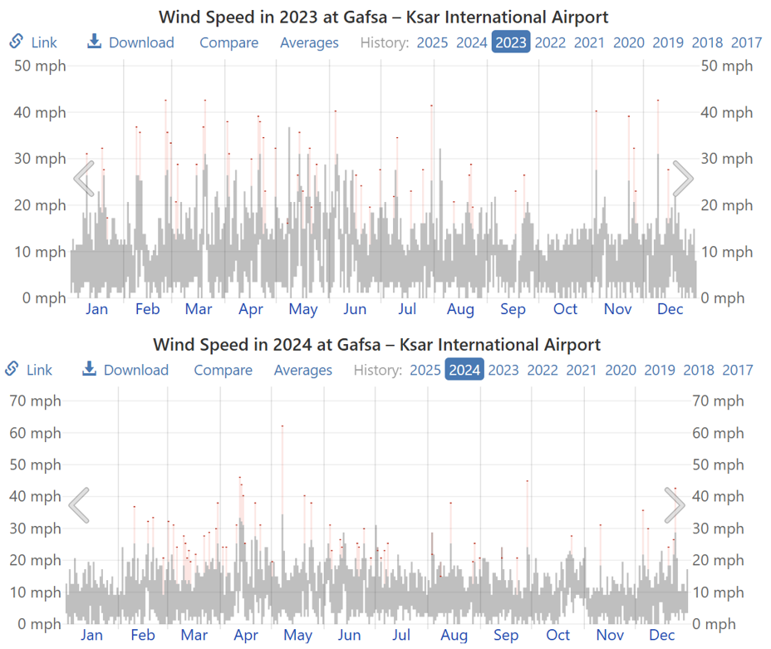
Figure.1. Daily range of reported wind speeds (grey bars), with maximum
gusts (red markers), in 2023 and 2024[17]..
The recorded measurements provided a high-resolution dataset, essential for a detailed analysis of wind variability and accurate modeling of wind turbine performance. Although not detailed, strict data quality control procedures were implemented to ensure the integrity and reliability of the information used in the analysis. Hourly wind direction is color-coded according to the cardinal direction. Shaded layers indicate nighttime and civil twilight (Figure 2).
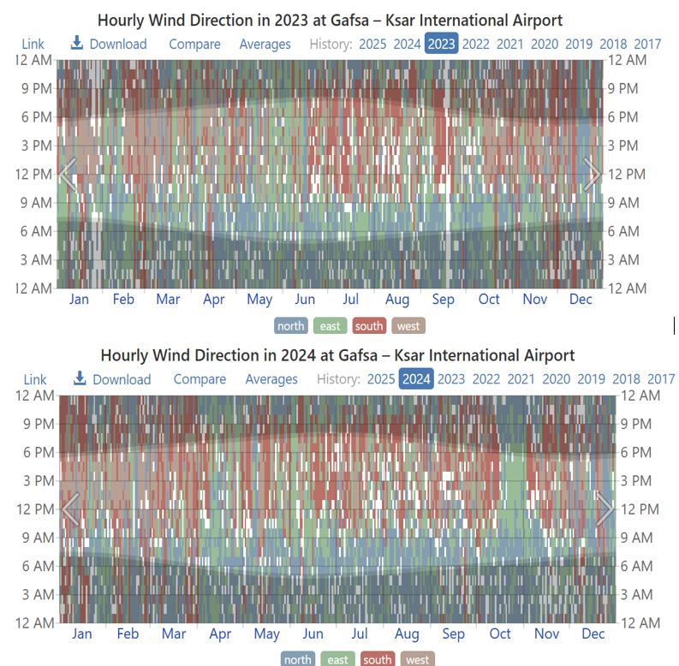
Figure.2. The hourly reported wind direction, color coded by compass point. The shaded overlays indicate night and civil twilight[17]..

Table 2: Summary of Wind Resource Data in the Study Area (Height 30m)
Characteristics | Value | Unit
Average Wind Speed | 5,3 | m/s
Weibull Parameter k | 2,1 | -
Weibull Parameter c | 5,7 | m/s
Prevailing Wind Direction | Northwest (NW) | -
Directions Secondaires du Vent | Nord-Est (NE), Sud-Ouest (SW) | -
Data Collection Period | 2023-24 | -
3. Results and Interpretation
3.1. On-Site Wind Characteristics
Analysis of wind data collected over a full year in the Gafsa Zone allowed for a precise characterization of the local wind regime. The average wind speed measured at a height of 30 meters is 5.3 m/s. This value indicates moderate but significant wind potential for small- to medium-scale applications.
The wind speed distribution closely follows the Weibull probability density function, with shape (k) parameters of 2.1 and scale (c) parameters of 5.7 m/s. The k parameter, close to 2, suggests a relatively constant wind regime with fewer extreme variations, which is generally favorable for wind turbine longevity and consistent energy production. The c parameter, directly related to the average wind speed, confirms the presence of a moderate but exploitable wind resource. These site-specific parameters are essential because they validate that the wind regime is well-matched to the selected turbine type, which is designed to be efficient in these wind speed ranges. This ensures that the turbine will operate within its optimal range for a large portion of the time, thus maximizing its energy capture.
Analysis of wind directions, often visualized by a wind rose, revealed a dominant direction from the Northwest (NW). Secondary directions were also identified, from the Northeast (NE) and Southwest (SW). This information on the predominant wind directions is crucial for micro-positioning the wind turbine on the campus. Careful siting, taking these directions into account, minimizes wake effects from existing buildings and ensures maximum exposure of the turbine to the undisturbed wind flow. This optimized positioning is a direct factor in the efficiency of the wind turbine's energy production.
3.2. Wind Energy Production
Based on the on-site wind characteristics and the power curve of the Eocycle EOCY 25 wind turbine, the annual energy production (AEP) is estimated at 63.8 MWh per year. This represents a significant contribution to the campus's energy needs. The power factor (PF) calculated for the wind turbine is 29.1%. PF measures a wind turbine's energy efficiency relative to its theoretical maximum power when operating continuously at full capacity. A PF of 29.1% is very respectable for a small wind turbine operating in moderate wind conditions, such as those used in Kasserine (with an average wind speed of 5.3 m/s). This indicates an excellent match between the selected wind turbine and the on-site wind conditions, confirming the technical feasibility of the project. To ensure this performance, the process is validated by simulating the blades' response to wind and aligning them with the on-site wind speed distribution (Figure 3).
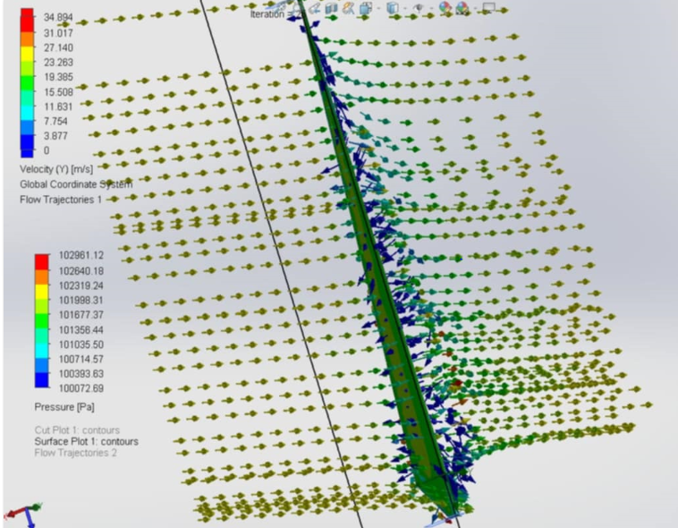
Figure.3. Simulation of blade response to wind speed distribution
as a function of pressure
The annual energy consumption of the Kasserine University campus is estimated at approximately 150 megawatt hours (MWh). The annual production of wind turbines, or 63.8 MWh, covers 42.5% of the university's energy needs. This contribution, although partial, represents an important strategic step towards greater energy independence and increased sustainability. It also lays a solid foundation for future expansion, particularly through the integration of hybrid systems (such as wind and solar) or energy storage solutions. Grid integration is also considered to manage periods of wind energy overproduction or shortage, thus ensuring a stable energy supply despite the intermittent nature of wind resources and fluctuating demand at the university. This multifaceted approach is essential to maximize self-consumption and system reliability.
The wind turbine's annual production of 63.8 MWh will cover 42.5% of the 150 MWh required by an existing industrial installation (Table 3). This contribution, although partial, represents an important strategic step towards greater energy independence and increased sustainability. It also lays a solid foundation for future expansion, particularly through the integration of hybrid systems (e.g., wind and solar) or energy storage solutions. Energy integration with the grid should also make it possible to manage periods of wind energy surplus or deficit, thus ensuring a stable energy supply despite the intermittent nature of the wind source and fluctuating demand. This multifaceted approach is essential to maximize self-consumption and system reliability.
Table 3: Estimated Annual Energy Production and Performance Metrics
Performance Indicators | Value | Unit
Estimated Annual Energy Production (EAP) | 63,8 | MWh/an
Capacity Factor | 29,1 | %
University Annual Energy Consumption | 150 | MWh/an
Percentage of Needs | 42,5 | %

The estimate indicates an annual reduction in carbon dioxide (CO2) emissions, a concrete step towards combating climate change and reducing air pollution associated with the combustion of fossil fuels. By replacing a portion of the energy consumed with a renewable source, on-site clean energy production provides protection against future volatility in fossil fuel prices and electricity tariffs. By reducing its dependence on the external grid, it improves its long-term financial resilience, allowing for better planning and greater stability in the face of fluctuations in energy and environmental markets. The environmental and energy benefits are considerable. The wind turbines will be a visible symbol of the commitment to sustainable development. They will provide participants with hands-on experience in the operation, maintenance, and performance analysis of a real wind system, helping to raise public awareness of wind energy and promote its wider adoption in the region.
Conclusion
This study rigorously assessed the feasibility of installing a wind turbine in the Gafsa area. The results unequivocally confirm the technical and economic feasibility of the project. The site benefits from favorable wind potential, with an average wind speed of 5.3 m/s and Weibull parameters (k = 2.1, c = 5.7 m/s), indicating a regime conducive to energy production. The 25 kW Eocycle EOCY 25 wind turbine, selected for its compatibility with these conditions, is expected to produce 63.8 MWh/year, thus covering 42.5% of the university's annual energy needs. Beyond energy supply, the project promises an annual reduction of 37.5 tons of CO2 and significant financial savings. Despite these positive results, it is important to recognize the limitations of this study. It is primarily a feasibility assessment based on measured wind data and theoretical modeling. Actual operational performance of the installed wind turbine may vary. It is strongly recommended to consider integrating wind turbines with other renewable energy sources, including solar photovoltaic, to create a hybrid system. This approach would aim to achieve greater energy autonomy, potentially up to 100%, and to mitigate the intermittency inherent in individual renewable energy sources. The integration of energy storage solutions, such as batteries, is also recommended to improve grid stability, manage fluctuations in energy supply and demand, and optimize the use of the renewable energy produced.
References

- Belaïd, F., Al-Sarihi, A., And Al-Mestneer, R. (2023). Balancing Climate Mitigation And Energy Security Goals Amid Converging Global Energy Crises: The Role Of Green Investments. Renewable Energy, 205, 534-542.‏
- Saleh, H. M., And Hassan, A. I. (2024). The Challenges Of Sustainable Energy Transition: A Focus On Renewable Energy. Applied Chemical Engineering, 7(2), 2084.‏
- Sreekanth, K. J. (2024). Energy Policy Analyses, Energy Transition And Sustainability. In Energy Efficiency Improvements With Emission Abatement For Energy Sustainability: Energy Statistics (Pp. 135-167). Singapore: Springer Nature Singapore.‏
- Wojtaszek, H., Borowski, P. F., Handschke, M., Miciuła, I., Stecyk, A., Bielawa, A., ... And Czepło, F. (2025). Wind Energy In Transition: Development, Socio-Economic Impacts, And Policy Challenges In Europe. Energies, 18(11), 2811.‏
- Oluokun, O. A., Akinsooto, O., Ogundipe, O. B., And Ikemba, S. (2024). Integrating Renewable Energy Solutions In Urban Infrastructure: A Policy Framework For Sustainable Development. Journal Of Urban Sustainability, 10(2), 175-190.‏
- Salvador-Gutierrez, B., Sanchez-Cortez, L., Hinojosa-Manrique, M., Lozada-Pedraza, A., Ninaquispe-Soto, M., Montaño-Pisfil, J., ... And Vigo-Roldán, A. (2025). Vertical-Axis Wind Turbines In Emerging Energy Applications (1979–2025): Global Trends And Technological Gaps Revealed By A Bibliometric Analysis And Review. Energies, 18(14), 3810.‏
- Wojtaszek, H., Borowski, P. F., Handschke, M., Miciuła, I., Stecyk, A., Bielawa, A., ... And Czepło, F. (2025). Wind Energy In Transition: Development, Socio-Economic Impacts, And Policy Challenges In Europe. Energies, 18(11), 2811.‏
- Wolniak, R., And Skotnicka-Zasadzień, B. (2023). Development Of Wind Energy In Eu Countries As An Alternative Resource To Fossil Fuels In The Years 2016–2022. Resources, 12(8), 96.‏
- Huang, C., Liu, C., Zhong, M., Sun, H., Gao, T., And Zhang, Y. (2024). Research On Wind Turbine Location And Wind Energy Resource Evaluation Methodology In Portscenarios. Sustainability, 16(3), 1074.‏
- Peraki, L., Kontouli, N., Gkika, A., Petrakli, F., And Koumoulos, E. P. (2025). Expanding Social Impact Assessment Methodologies Within Sdgs: A Case Study On Novel Wind And Tidal Turbine Blades Development. Sustainability, 17(4), 1492.‏
- Arribas, L., Domínguez, J., Borsato, M., Martín, A. M., Navarro, J., Bustamante, E. G., ... And Cruz, I. (2025). The Potential Of Utility-Scale Hybrid Wind–Solar PV Power Plant Deployment: From The Data To The Results. Wind, 5(3), 16.‏
- Rekik, S., And El Alimi, S. (2024). Unlocking Renewable Energy Potential: A Case Study Of Solar And Wind Site Selection In The Kasserine Region, Central‐Western Tunisia. Energy Science And Engineering, 12(3), 771-792.‏
- Younis, A., Elshiekh, H., Osama, D., Shaikh-Eldeen, G., Elamir, A., Yassin, Y., ... And Biraima, E. (2023). Wind Speed Forecast For Sudan Using The Two-Parameter Weibull Distribution: The Case Of Khartoum City. Wind, 3(2), 213-231.‏
- Laban, O. N., Maghanga, C. M., And Joash, K. (2019). Determination Of The Surface Roughness Parameter And Wind Shear Exponent Of Kisii Region From The On‐Site Measurement Of Wind Profiles. Journal Of Energy, 2019(1), 8264061.‏
- Aziz, A., Tsuanyo, D., Nsouandele, J., Mamate, I., Mouangue, R., And Elé Abiama, P. (2023). Influence Of Weibull Parameters On The Estimation Of Wind Energy Potential. Sustainable Energy Research, 10(1), 5.‏
- Manwell, J. F., Mcgowan, J. G., And Rogers, A. L. (2010). Wind Energy Explained: Theory, Design And Application. John Wiley And Sons.‏
- Weatherspark Official Website (Visited August 2025) Https://Weatherspark.Com/H/Y/148102/2024/Historical-Weather-During-2024-At-Gafsa-%E2%80%93-Ksar-International-Airport-Tunisia#Figures-Winddirection

