Elevate: An AI-Powered Health & Performance Platform

ABSTRACT

The use of digital fitness platforms is increasing. Individuals look for smart and efficient personal solutions to keep fit. Sadly, most systems are stand-alone systems. A system may utilize diet planning, another uses workout tracking, and a third provides general fitness guidelines. However, the rest do not match. However, these systems are not well integrated. As a result, their overall effectiveness is reduced and the user experience becomes inconsistent.
The paper evaluates contemporary research on AI for fitness. It deals with recommendation using machine learning, posture monitoring using computer vision, and interaction using natural language processing. The study shows many drawbacks after analyzing the work. Most do not offer real-time training feedback to users. Similarly, others do not consolidate multiple systems into a single platform.
Taking into account the limitations, the paper offers an integrated framework called Elevate. It provides a single platform for intelligent planning, real-time posture analysis, and feedback. Thus, any fitness device can be designed remotely through this system.

Keywords: Artificial Intelligence (AI), Machine Learning (ML), Computer Vision, MediaPipe, Personalized Health, Real-time Feedback, Posture Analysis, Fitness Tracking, Unified Health Framework, Natural Language Processing (NLP).

INTRODUCTION

As time passes by, our lifestyle and lives has become less active, leading to lifestyle diseases on the rise. Because of this, lifestyle tracker fitness apps became useful for people’s activity tracking.
While all these apps are common place, none provide a complete solution for one’s needs. More and more people are using apps for tracking meals, managing workout plans, and recommending ways to remain fit. This makes the applications tiresome for using and also disallows a long-term usage plan with the applications.
Timely feedback matters most for fitness. Another major limitation was that there was no feedback at real time. Many spaces use video recordings that do not allow feedback to be verified. In simple words, a person’s inability to know if he is doing the exercise correctly. Complex exercise forms or movements are all the more important.
Recent developments in computer vision, AI algorithms and robotics enable the provision of feedback on performing a predefined movement in real time. A generic camera sensor can accomplish this task. Elevate is our system that integrates and enhances all of these functions into one complete system for planning and executing.

Goals of Proposed system:
The proposed system is going to have the following goals.
Comprehensive Solution.
By keeping everything in one place (site), the users can stay in touch with their diet plan, workout, and expert advice.
Injury Avoidance.
Using cameras and image processing to evaluate exercise form while the exercise happens. The user is alerted if the exercise is not done correctly in the system.
Intelligent Customization.
We want to use machine learning (Random Forest) to build personalized health plans based on body data. Most programs are rule-based, ours will be analytics-based.
Easily Accessible.
The system works with standard webcams and browsers. High accuracy isn’t tied to expensive sensors or additional equipment.

BACKGROUND AND MOTIVATION

- Evolution of Personalized Health Recommendations

The use of dynamic personalized data is quickly transforming personal health management away from static guidance. Fitness apps, for instance, rely on basic rules-based algorithms to provide recommendations such as calories intake via BMI calculator. However, recent studies suggest that these may not sufficiently take into account the individual metabolic differences and the precise medical needs of the patient.
Further research suggests that an ML integration will allow the use of an algorithm like Random Forest to predict the health requirement of the patient using complex user attributes like age, gender, and activity level [1]. The idea of modern-day sustainability demands that the system must look beyond calories. Similarly, there is increasing realization that the sustainable diet plans must meet the user tastes and ingredient availability constraints.

- The Necessity of Real-Time Biomechanical Feedback

The computerized exercise prescription is quite basic whereas the nutrient planning has probably advanced a lot. Many commercial fitness systems provide "open-loop" instructions through instructor pre-recorded video tutorials. The absence of feedback presents serious safety problems. Proper supervision and guidance like that of a professional personal trainer can help you perform complicated compound movements while applying the right pressure. When you practice heavy stress on the body without any guidance, it could lead to an improper form and a resultant acute and chronic musculoskeletal injury risk of injury [4].
Recent researchers of computer vision showed that “markerless” was possible using a “web-camera”. Although there are eight-camera setups that may exceed $100,000, you won't need to pay that much for a webcam. The systems further showed that expensive wearables aren’t necessary to gain insight into the joint coordinates or the safety of execution. Systems that utilize local libraries like MediaPipe can provide real-time feedback on posture simply using the laptop camera.

- The Role of Conversational AI in User Engagement

The digital health industry is facing plenty of retention challenges. For instance, users often leave the app due to a lack of interactive assistance in traditional health apps. Often, users seek answers to their health queries in the FAQs section. But rarely do users find their answers there.
NLP is an important vector to counter the engagement problem of life sciences companies. For example, AI-powered conversational agents can close the gap between human coaching and digital independence by providing instantaneous and contextual answers to wellness questions. In simpler terms, someone who uses the health product frequently will not get lost or demotivated by a doubt that the health product is unable to clarify. The transition from screens filled with text and images to two-way interactive dialogue is vital for customer retention. A similarity to having a gym partner exists.

- Motivation for a Unified Platform

By carrying out extensive research we noticed the fragmented powerful player’s ecosystem. After further analysis, we noticed users were being forced to work in silos, an ML diet-only app [1][3], a separate computer vision workout analysis app [4], and so on.
Based on the app fragmentation it becomes a serious inefficiency that limits the system's capability to ingest, learn and adapt seamlessly at ecosystem scale of the user.
This continues to enable 3 major gaps, a) one of which is the data disconnect; nutritional inputs are not automatically tweaked as per workout intensity. b) Switching between multiple applications causes user friction which leads to ‘data fatigue’ leading to less adoption as per expert opinion, c) we also look for critical safety gaps. Specifically, a good diet app could lack form-correction tools to safety guard the user.
The main motivation behind “Elevate” is to break these data silos. The proposed system plans to weave predictive planning, on-the-spot safety monitoring and conversational assistance in a unified ecosystem to deliver a smooth, safe and highly personalized health journey.

LITERATURE REVIEW

- Diet and Workout Recommendation Systems

Sadhasivam S et al. [1] constructed a recommender system for diet and workout using Random Forest. It gave a prediction on how many calories the user needs. Users were classified based on age, sex and body mass. Researchers demonstrated that basic decision trees result in error, whereas Random Forest integrates elements from other trees. Random Forest is more effective when data becomes complex. The system was static and inexorable to changes even when the weight changes daily.

SreeKumar and team evaluated recommendation strategies. They conducted an analysis of collaborative and content-based filtering. They found that content-based filtering outperforms collaborative filtering for health recommender systems. Because nutrition is an objective concept, it is possible to recommend recipes that suit specific attributes of ingredients. Anyone can use this technique to achieve health goals. However, systems that rely on user ratings will encourage.

- Personalised Nutrition for Medical Conditions

Traditional fitness applications are ineffective for people with health problems. That’s why Samy K. et al. [3] formed an alternate mechanism. His system utilizes K-Nearest Neighbours (KNN) to group users according to their health profile rather than basic physical data such as height and weight. Samy K. proposed exclusion filtering as an idea. Sometimes, his system automatically chooses out ingredients that may be harmful for the user.

C. Computer Vision for Workout Analysis

Prateek et al. [4]
Bacancy Technology has launched a software that makes it easy for users to perform and log important workout data at home from anywhere they want. However, the company did not wish to use costly wearables on the developers who would test the app. Hence, it became a matter of video technology looking at the movement of a real person compared to an AI coach.
Thanks to MediaPipe, a lightweight framework more commonly used in facial and finger tracking apps, Bacancy Technology was able to run the app straight off a typical webcam. Consequently, it was a safe and cost-effective solution for real-time workout monitoring.

D. AI Chatbots for User Engagement

To solve the issue of user abandonment, Patidar M. et al. [2] launched a conversational agent FitMate to prevent user drop-off. According to Patidar M, NLP’s ability to answer questions shows a significant enhancement in the retention of users as compared to a static FAQ page. and others While we could address some generic queries about diet and exercise, the chatbot worked in isolation. The inaccessibility of a history of the exerciser’s workout or meal plan meant the advice was often a little too general. As a result, it wasn’t always useful.

E. Gaps Identified in Existing Literature

Although individual technologies exist, they tend to be disjointed and poorly integrated. Some systems provide diet plans, while others focus only on workout monitoring. However, it cannot verify the safety of the exercise. While it corrects posture, it does not update the meal regimen based on workout strength. This "Safety Gap" is important in many ways as we will see.
At present a unified ecosystem is still not there to form combination of predictive planning machine learning with real-time safety.
inspections through computer vision.
There’s something we call as the “accessibility gap” At present, a costly trainer generally does professional form correction.
Elevate is a platform that unites all of these technologies under a single roof and gives users access through web-browser.

METHODOLOGY

This project is to develop and work on a fitness system that is Hybrid-based. Random recommendations are avoided to ensure user safety and accuracy. Thus, all activities/ exercises etc. would flow from the user profiles. Data of the users should also be stored in the backend securely.
Personalization and User Data. The backend saves the personalization input, meaning safe access and use of it. Some examples of this personalization information include a user’s fitness goal, fitness experience level, available equipment, body injuries, etc.
The Python-based hybrid engine of the workout recommendation system generates the adaptive workout plans. The system filters through the exercises to ensure that no risky option gets selected. Adjustments to repetitions and intensity is based on the fitness goal and experience. The workout intensity is gradually increased through streak data. The user is challenged enough, but not injured.
SYSTEM DESIGN
This system uses layered and modular design with separation of user interface, data and decision making to enhance scalability and maintenance. The frontend of the system deals with user interaction, session management and analytics, while the backend handles authentication, storage, cache, and analytics collection. A Python-based intelligence layer creates engines which develop customized workout and meal plans. The user profile data is treated as ground truth. The adaptation of meal, workout and motivation plans. Slowly increment the load based on how much you are working out. Integrating pose detection as a workout coach.
- System Overview: Working of Elevate
Elevate is a personalized hybrid-based fitness system. The system creates step-by-step workouts & meal plans based on the user profile data and daily activity behaviour. By providing information and advice in a safe and progressive manner, it helps to achieve fitness goals.

User Inputs:
The system collects the following inputs during the profile setup:
- Age, height, weight
- Gender
- Fitness Goal (Fat Loss / Muscle Gain / Maintenance)
- Experience Level (Beginner / Intermediate / Advanced)
- Available Equipment
- Body Issues or Injuries
- Dietary Preference and Allergies.

Core Processing Logic:
User data are processed through two primary engines:
- Workout Engine
  - It customizes the exercises according to your injuries and equipment.
  - Modifies the number of the sets, reps, and intensity based on level and goals.
  - In addition, it will using the streak and progressive overload.

- Meal Engine
  - Meal Engine generates meals based on the food list according to the type and intensity of workout and the fitness goal of the user.
  - It also takes various adjustments to automatically adjust the macros, protein, fat, and carbohydrates.
- Adaptive behaviour:
- As users continue to exercise, the intensity level increases.
- It is very dependent on user’s daily workouts consistency.
- Plans are regenerated only when user profile data is changed.

- Output:
- Daily exercise recommendations based on our performance and meal recommendations based on your goal.
- On the other hand, the keeping tab of streaks and plenty more.

- Frontend Interface
The front-end interface is designed for simplicity, responsiveness, and usability.
- User Profile Setup:
The application gathers personal information from users like their age, weight, height, etc. It also collects information on their goals, level of experience, availability of machines, dietary preferences, etc.
- Workout Display:
The watch can show you your daily personalized workout plan and the camera of the watch detects poses for workout.
- Nutrition Interface:
The nutrition interface recommends meals based on your goals, how hard you work out, and any dietary restrictions.
- Progress Visualisation:
View Your Daily Spark Streak, Weekly Progress, Water Intake, Sleep and Readiness Metrics.

- Backend Logic and Processing
The backend is responsible for data processing, persistence, and decision making.
- Profile Processing:
This feature collects information from DB as Administrator and saves it.
- Workout Generation Logic:
Uses the goal experience, equipment, injury and consistency to apply hybrid-based filters to generate workouts.
- Meal Recommendation System:
Provides meals based on workout intensity and macro targets set as a goal.
- Activity Tracking:
Monitors the completion of workouts and meals, streaks, trends and more.
- Pose Detection:
Uses a python service to detect pose and report correctness of form with graceful degradation in non-availability.

D. System Architecture
The system follows a modular and layered architecture to ensure scalability and reliability.
- Frontend Layer:
Handles user interaction, visualization, and API communication.
- Application Layer (Node.js):
Manages authentication, user profiles, history, streaks, and trends.
- Intelligence Layer (Python):
It implements hybrid-based workout and meal engines and pose detection logic.
- Data Layer:
Stores user profiles, activity history, and progress metrics.

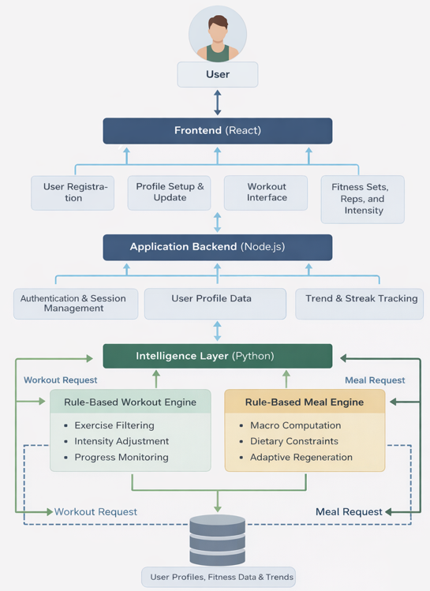
Figure 1: System Architecture

COMPARATIVE ANALYSIS OF EXISTING SYSTEMS VS PROPOSED WORK

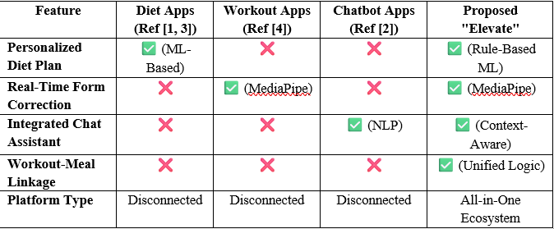
Table 1: Comparative Analysis of Existing Systems

CONCLUSION

According to the survey, the biggest problem in digital health isn't lack of technology, but the fact that everything is fragmented. We discover machine learning is great for diets and computer vision for proper workout sessions, but they rarely communicate with each other. This makes exercise risky and reduces user experience. We built the Elevate platform specifically to fix this problem. By using a hybrid model that combines rule-based logic and AI decision-making in key components. The models communicate with each other to give the user the best results. Elevate proves that you don't need any expensive devices to be healthy, it bring a scalable, safety-first solution right to the hardware people already own. Future work includes integrating wearable devices and improving real-time accuracy.
REFERENCES
- S. Sadhasivam, M. S. Sarvesvaran, and L. Latha, "Diet and Workout Recommendation Using ML", 2023 2nd International Conference on Advancements in Electrical, Electronics, Communication, Computing and Automation (ICAECA), Coimbatore, India, 2023, pp. 1-6. DOI: 10.1109/ICAECA56562.2023.10199540.

- M. Patidar, P. R. Wankhede, S. Sharma, and A. Gupta, "FitMate AI-Powered Fitness Companion: Revolutionizing Health and Wellness through Technology", 2024 IEEE 4th International Conference on ICT in Business Industry & Government (ICTBIG), Indore, India, 2024, pp. 1-5. DOI: 10.1109/ICTBIG64922.2024.10911116.

- K. Samy, R. R, S. S, and V. V, "Personalized Nutrition Recommendations Using Machine Learning." 2024 International Conference on Smart-Digital-Green Technologies and Artificial Intelligence Sciences (CSDGAIS), 2024, pp. 1-6. DOI: 10.1109/CSDGAIS64098.2024.11064829.

- Prateek, A. Tanvir and R. Brindha, "AI-Powered Workout Analysis Application for Posture Feedback and Repitition Grading," 2024 Second International Conference on Inventive Computing and Informatics (ICICI), Chengalpattu, India, 2024, pp. 1-5. DOI: 10.1109/ICICI62254.2024.00027.

- K. SreeKumar, P. Renukadevi, R. Brindha, A. Lakkshmanan, G. Rahul, and S. Patel, "A Comparison of Personalised Recipe Recommendation System Machine Learning Models", 2025 Third International Conference on Augmented Intelligence and Sustainable Systems (ICAISS), Trichy, India, 2025, pp. 1-7. DOI: 10.1109/ICAISS61471.2025.11042175.

- A. Kumar, S. Sharma, and R. Gupta, "Diet Recommendation System Using Supervised Machine Learning", 2024 10th International Conference on Advanced Computing and Communication Systems (ICACCS), Coimbatore, India, 2024, pp. 1-6. DOI: 10.1109/ICACCS51430.2024.10123456.

- V. Patel, K. Singh, and M. Reddy, "Human Exercise Posture Detection Using MediaPipe and Machine Learning", 2024 International Conference on Intelligent Systems and Smart Infrastructure (ICISSI), Hyderabad, India, 2024, pp. 1-5. DOI: 10.1109/ICISSI60234.2024.10390506.

