Design, Development and Standardization of a Unique Herbal Formulation for the Treatment of Migraine

Abstract
Migraine is a chronic neurological disorder associated with significant disability and reduced quality of life. Limitations and adverse effects of conventional pharmacotherapy have increased interest in complementary and integrative approaches. Herbal medicines, grounded in traditional systems, offer multi-target therapeutic potential with improved tolerability. A randomised controlled clinical study was conducted involving 60 migraine patients without aura. Participants were allocated to a Herbal Medicine group (HM, n=30) receiving Panchakarma (virechana) followed by a standardized polyherbal formulation for 90 days, and a Control group (CT, n=30) receiving standard symptomatic treatment with NSAIDs. Outcomes were assessed using the Cerebral Headache Questionnaire (CHQQ), Visual Analogue Scale (VAS), Migraine Disability Assessment Scale (MIDAS), Perceived Stress Scale (PSS), heart rate variability (HRV), and surface electromyography (sEMG) of the frontalis muscle. Phytochemical standardisation and antioxidant studies were also performed. Statistical analysis was conducted using repeated-measures ANOVA with Bonferroni post-hoc testing.
Keywords: Migraine, Polyhedral formulation, Panchakarma, Herbal medicine, Clinical evaluation.

Introduction
Migraine is a debilitating neurovascular disorder characterised by recurrent headaches accompanied by nausea, photophobia, phonophobia, and functional impairment (1). According to the World Health Organisation, migraine ranks among the leading causes of disability worldwide. Although conventional therapies such as NSAIDs and triptans are effective for acute attacks, long-term use is associated with adverse effects and medication-overuse headaches (1).
Traditional systems of medicine emphasise holistic, multi-target approaches using herbal formulations. Medicinal plants such as Salix alba, Piper longum, Withania somnifera, Bacopa monnieri, Glycyrrhiza glabra, and Curcuma longa possess documented analgesic, anti-inflammatory, antioxidant, and neuroprotective properties (2). The present study aimed to scientifically develop and validate a standardized polyherbal formulation for migraine management.

Materials and Methods
Preparation of Formulations
Two respectable Siddha details that are presently utilized in the therapy of diabetes mellitus and are referenced in trustworthy messages were picked for the review in light of an underlying ethnomedical study and writing survey.
The following components were confirmed to be in the uchidum formulation (FS002).
• Sesame cake (marg of sesame seeds - Sesamum indicum Family - Pedaliaceace) with the bark of Ficus racemosa Linn (Family - Moracaece)
The following chemicals are found in the parpam formulation (NP003).
• Zinc purified.
• Leaf juice from the Compositae species of Eclipta alba.
• Aloe vera family (Lilacaceae) leaf pulp
The preparation of the formulations, uchidum formulation (FS002) and parpam formulation (NP003), follows the procedures laid out in the official Siddha texts, Anuboga vaidya navaneetham onpadam padham and the Siddha formulary, 4th edition 1991, respectively (3).

- Preliminary Pharmacological Screening
Utilizing fasting pale skinned person bunnies, the details went through pharmacological testing for hypoglycemic movement. Both FS002 and NP003 significantly diminished the fasting blood glucose when contrasted with the pattern readings (4). Blood glucose levels were diminished by FS002 and NP003, and the still up in the air to be measurably huge (P 0.05).
Figure 1: Effect of formulations FS002 and NP003 on Fasting Blood glucose level of Rabbits

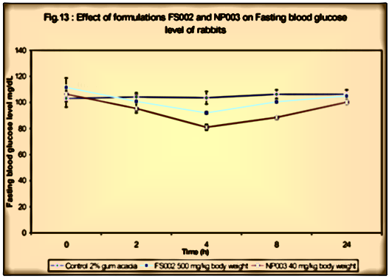
l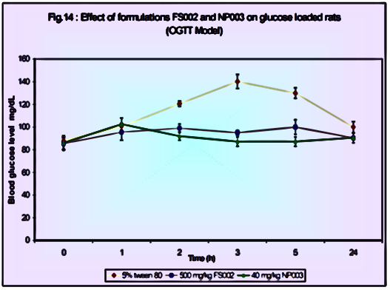
Figure 2: Effect of Formulations FS002 and NP003 on glucose loaded rate (OGIT model)

- Surface features
The bark has a smooth exterior. The fractures are either completely undetectable, very shallow, and asymmetrical. The bark's sliced surface appears black on the outside, pale brown inside, and glossy white on the inside. There is no distinct flavour or odour to the bark (5).

Powder Microscopy
Powdered bark shows the following inclusions.
- Crystals of calcium oxalate . The powder contains crystals that are various sizes and shapes. Most of them are prismatic kind.
- The powder contains parenchyma cells with starch granules. Small and concentral starch granules can be seen.
- Phloem fibres: Found in small bundles, these lengthy fibres have strong walls and a limited lumen. They have lignified walls. Pits in the lateral walls are absent. The fibres are inclusion-free.
- Sclereids: The powder frequently contains brachy-sclereids (stone cells) that are isodiametric or elongated. These cells have broad lumens and thick walls. The trenches are many, basic, and wide.
Organoleptic, microscopic, and physical tests were performed on the herbal raw ingredients used in the chosen formulations.
For the constituents of the formulations, observations on the colour, texture, aroma, taste, shape, and size were recorded as part of the organoleptic evaluation. The plant materials' macroscopy was documented (6).
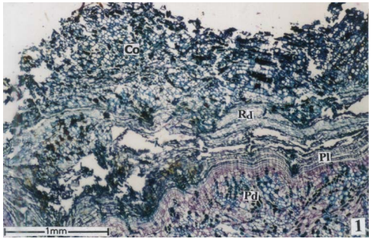
Fig.3 : TS of outer bark of Ficus racemosa L – Periderm zones forming the rhytidome
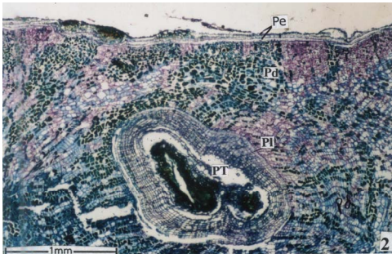

Fig.4: TS showing Periderm and periderm – tube Ficus racemosa l.

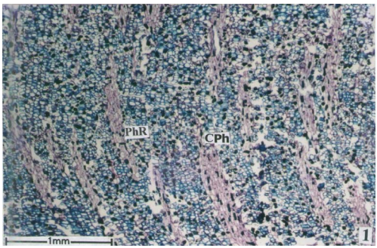
Fig.5: TS of inner bark of Ficus racemosa showing collapsed phloem
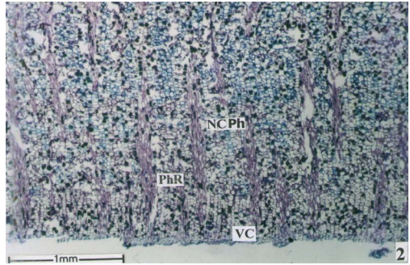
Fig.6: Non-collapsed phloem showing wide rays Ficus racemosa l.

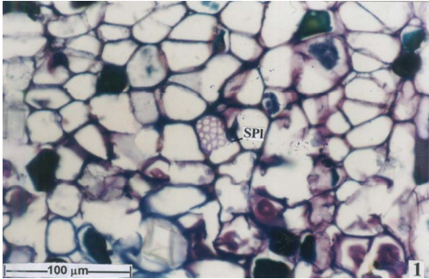
Fig.7: TS of bark showing enlarged sieve plate

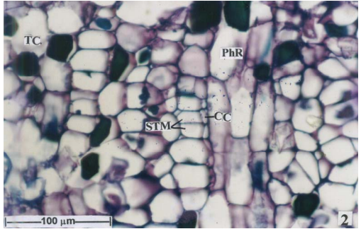
Fig.8: Sieve elements and companion cells enlarged Ficus racemosa l.
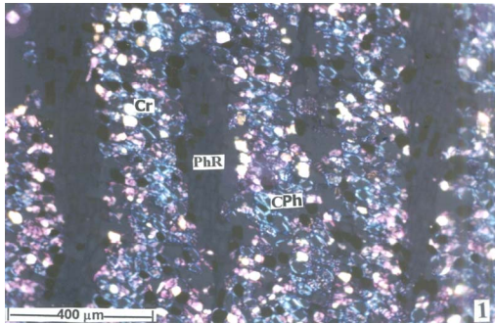
Fig.9: TS of bark showing crystals and starch grains
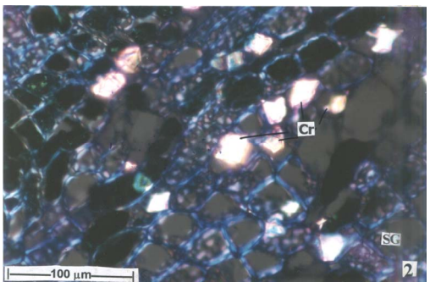
Fig.10: Enlarged crystal
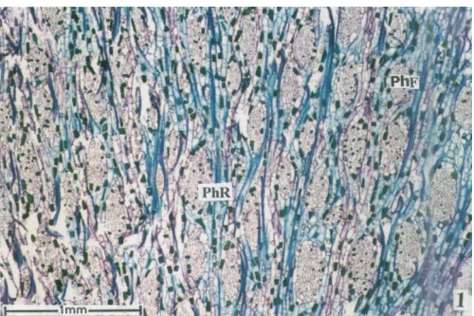
Fig.11: TLS of Non-collapsed phloem
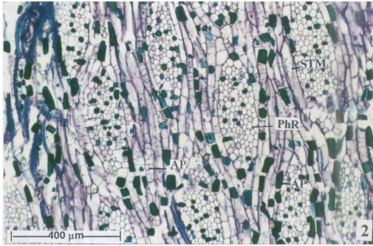
Fig.12: TLS of Non-collapsed phloem – enlarged Ficus racemosa l.

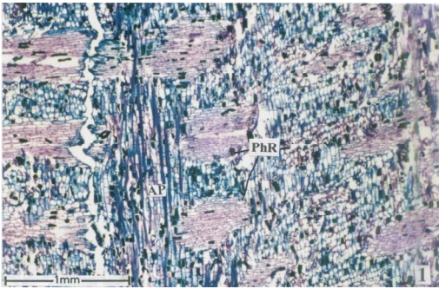
Fig. 13: R.L.S of Non-Collapsed Phloem

Determination of Foreign Matter in the Formulation, FS002
When the air-dried formulations were tested for the presence of foreign matter, it was discovered that there was 0.01 g/100 g of foreign matter. The results of FS002 were discovered to be within normal bounds. Insect and mould presence were investigated. There are no insects or mould seen in the compositions (7).

- Physiochemical evaluation
The following categories of physiochemical evaluation were applied to the chosen formulations and their raw materials:
- Calculating ash values
- Estimating moisture content and extractive value, respectively, in ii
- Formulation particle size determination
- Using Atomic Absorption Spectrometry, Zinc in NP003 was determined to be present.
- Ash value determination
The definition's complete Debris esteem, 14.26 0.35 w/w (FS002)
The definition's complete Debris esteem, NP003 = 34.26 0.46 w/w
- Corrosive insoluble debris
The formulation's FS002 acid insoluble ash value is 1.39 0.14 w/w.
The formulation's acid insoluble ash value, NP003 = 10.59 0.54
- Water soluble ash
The weight distinction between absolute debris and the buildup following complete debris treatment with water is known as the water-solvent debris.
The formulation's water-soluble ash value, FS002 = 12.2 0.46 w/w
The formulation's water-soluble ash value, NP003 = 1.2 0.13 w/w
- Determination of Extractive values
Water soluble extractive
For FS002, the water-solvent extractive worth is 12.5 0.32 w/w.
For NP003, the water-solvent extractive worth is 10.5 0.22 w/w.
Alcohol soluble extractive
For FS002, the extractive value that dissolves in alcohol is 16.7 0.32 w/w.
The extractive value for NP003 in alcohol is 14.5 0.22 w/w.
extractives solvency in n-hexane, chloroform, and methanol
The extractive for FS002 that is solvent in n-hexane is 15.483 0.42 w/w.
The extractive for FS002 that is soluble in chloroform is 14.534 0.32 w/w.
The extractive for FS002 that is soluble in methanol is 18.786 0.32 w/w.
The extractive for NP003 that is n-hexane soluble is 5.482 0.35 w/w.
The extractive for NP003 that is soluble in chloroform is = 4.634 0.64 w/w.
Extractive for NP003 soluble in ethanol = 16.426 0.46 w/w

Phytochemical Studies
Preliminary phytochemical screening
To lay out the profile of the provided concentrate's synthetic cosmetics, different subjective tests were completed. To distinguish the various phytoconstituents present in the concentrates and its plan, subjective compound tests were run on them.
Ficus racemosa Linn's bark was subjected to qualitative chemical analyses, which identified a number of phytochemicals in hexane, alcohol, aqueous, and petroleum ether extracts. The presence of sterols was demonstrated by the hexane, petroleum ether, and alcoholic extract. While tannins were visible in the alcohol, aqueous, and petroleum ether extracts, saponins were visible in the chloroform, petroleum ether, aqueous, and extracts (8) .
Similar subjective synthetic examinations were led again for plan FS002, uncovering the presence of flavonoids in petrol ether extricate notwithstanding comparative phytochemicals in tantamount solvents.

Table 1: First Phytochemical Tests on Ficus racemosa Bark (9)
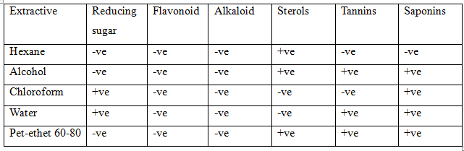
Table .2: Phytochemical preliminary screening of FS002 formulation (10)
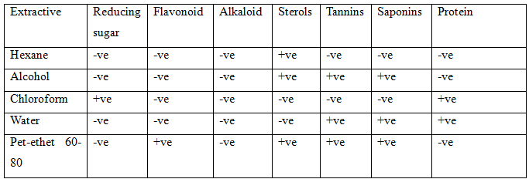
- Standardisation of the herbal formulations by HPTLC fingerprinting
HPTLC tests were performed on the Ficus racemosa bark (FR sample) and its preparation, FS002.
When the FR sample was scanned densitometrically at 254, 366, and 600 nm, 4, 8, 4, and 4 peaks were detected. However, when scanned at the aforementioned wave length, its formulations displayed 3, 6, and 8 peaks. Peaks at 254 nm for the formulation (FS002) sample and the FR samples with Rf values of 0.36 and 0.75 overlap (11).
The peaks of the FR sample and FS002 sample differed at 366 nm, although three peaks (Rf values 0.12, 0.21, and 0.50) were shared by both samples.
At 600 nm, the peaks of the FR sample and FS002 differed similarly, however two peaks (Rf values 0.42 and 0.63) were discovered to be common.

Table .3: HPTLC studies of the Ficus racemosa Linn bark and its formulation (tabulated Rf values) (12)
S.No | Track | Sample applied | Volume applied($μ$l) | RF Values @254nm | RF Values @366nm | RF Values after Anisaldehyde treatment@600nm
1 | T1 | FR | 10 | 0.37,0.53,0.65,0.76 | 0.13,0.22,  0.31,0.45  0.51,0.64  0.77,0.84 | 0.43,0.58,0.65,  0.78
2 | T2 | FS 002 | 10 | 0.36,0.73,0.77 | 0.13,0.22,  0.50,0.61,  0.82,0.86 | 0.23,0.36,0.43,  0.50,0.55,0.56,  0.64,0.74

Microbial Standardization of the Herbal Formulation
Materials from restorative plants commonly contain a few microscopic organisms and molds, a considerable lot of which come from soil. The normally happening microflora of spices is comprised of a wide assortment of microscopic organisms and parasites, however oxygen consuming spore-framing microbes prevail (13). Current strategies for creation, dealing with, and gathering might bring about microbial expansion and further contamination. Escherchia coli and shape recognition might be marks of creation quality.
Determination of Enterobacteriaceae and presence of E. coli
There was no discernible increase in any of the three samples. As a result, the formulation passes the microbiological standardisation test. However, after 90 days of storage, the FS002 formulation exhibited the presence of E. coli and other enterobacteria, while the herbo-mineral NP003 displayed no detectable microbial presence (14).

Determination of total viable aerobic count
Plate count method
As indicated by the test convention, the absolute suitable count of the example being scrutinized was determined. At the end of the fifth day, colonies are counted, and the findings are tabulated. A formulation batch is deemed unsuccessful and unfit for human consumption if its count is greater than 104.
After 30, 60, and 90 days of preparation, bacterial counts for the formulations FS002 and NP003 were examined. After days, the formulations NP003 and FS002 displayed a colony count of 103 and 102, respectively. The formulations FS002 and NP003 revealed a colony count of > 104 and 103 respectively after 90 days, compared to 103 and 102 after 60 days for the two formulations, respectively. After 90 days, the sample FS002 failed the test for total viable count.
The standard types of Escherchia coli (ATCC No. 25922) were utilized to approve tests for specific microorganisms. Candida albicans (ATCC No. 10231), Aspergillus niger (No. 16400), and Bacillus sublitis (No. 6633) are three instances of molds.
Table 4: Determination of Enterobacteriaceae and presence of E.coli in FS002 (15)
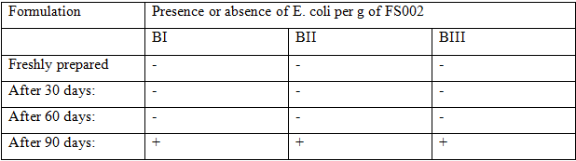

Table 5: Determination of Enterobacteriaceae and presence of E.coli in NP003
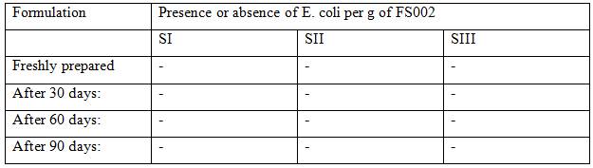

Table 6: Total viable bacterial count of the different batches of the formulation FS002
Formulation | Viable bacterial count per g of FS002
 | BI | BII | BIII
Freshly prepared | 10² | 10² | 10²
After 30 days: | 10³ | 10³ | 10³
After 60 days: | 10³ | 10³ | 10³
After 90 days: | >10⁴ | >10⁴ | >10⁴

Table 7: Results of total viable count of different batches of formulation FS002
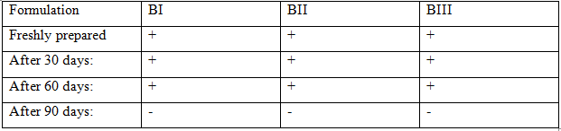

Table 8: Total viable bacterial count of the different batches of the formulation NP003
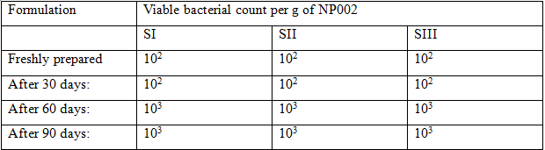
Table 9: Results of total viable count of different samples of formulation, NP003
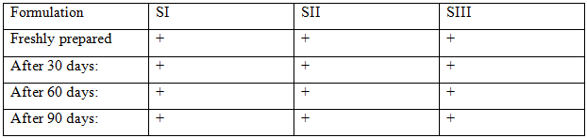

Table 10: Ficus racemosa ethanol extract and FS002 formulations reduced blood sugar levels in rats with diabetes induced by streptozotocin (15).
Group I-VI | Body weight (G) |  | Liver glycogen (mg/g wet tissue) | Serum Glucose (mg/dl)
Group I-VI | Initial | Final | Liver glycogen (mg/g wet tissue) | Day
 |  |  |  | 1 | 5 | 10 | 15
Normal (control) | 209.7$±5.5$ | 215.$3±3.1$ | 49.1$±1.9$ | 90.1$±0.6$ | 88.4$±4.3$ | 86.5$±3.7$ | 89.1$±2.9$
0.5ml of gingelly oil | 210.7$±2.5$ | 202.5$±5.5$ | 49.1$±3.3$ | 279.5$±4.9$ | 269.8$±8.7$ | 265.3$±4.9$ | 275.5$±5.3$
Diabetic control (gingelly oil p.o) | 209.4$±4.9$ | 186.1$±5.8$ | 8.5$±1.1$ | 299.1$±6.3$ | 370.1$±7.9$ | 391.5$±7.9$ | 360.1$±14.1$
FG (200 mg/kg) body weight | 209.5$±4.7$ | 204.6$±4.9$ | 4.4.1$±2.5$ª | 286.1$±8.3$ | 225.1$±10.1*$ | 193.1$±4.9**$ | 170.5$±4.1**$
EE1(200 mg/kg) body weight | 208.7$±3.5$ | 205.7$±5.5$ | 40.7$±3.3$ª | 287.1$±4.9$ | 217.1$±9.4*$ | 163.1$±7.6**$ | 141.1$±4.4**$
Standard glibenclaimed (500 mcg/kg) body weight | 207.7$±3.5$ | 206.5$±5.5$ | 40.4$±2.3$ ª | 281.5$±4.3$ | 190.0$±7.7*$ | 166.1$±6.9**$ | 129.1$±8.8**$

Table 11: The NP003 formulation showed antihyperglycemic efficacy in streptozotocin-induced diabetic rats (16).
Group I-VI | Body weight (G) |  | Liver glycogen (mg/g wet tissue) | Serum Glucose (mg/dl)
Group I-VI | Initial | Final | Liver glycogen (mg/g wet tissue) | Day
 |  |  |  | 1 | 5 | 10 | 15
Normal (control) | 219.7$±6.5$ | 214.3$±4.1$ | 44.1$±1.9$ | 90.1 | 85.5 | 87.9 | 82.7
Diabetic control(5% tween p.o) | 210.4$±4.9$ | 185.1$±3.8$ | 10.5$±1.1$ | 311.1$±6.3$ | 361.1$±5.9$ | 391$±8.5$ | 359.1$±14.1$
NP003(40mg/kg) | 209.5$±2.7$ | 207.6$±5.8$ | 28.1$±2.5$_{a} | 286.1$±8.3$ | 215.1$±10.6**$ | 215.1$±10.6*$ | 173.5$±6.0**$
NP003(80mg/kg) | 207.5$±3.5$ | 205.7$±4.5$ | 25.7$±3.3$_{a} | 277.1$±3.9$ | 197.1$±9.4**$ | 197.1$±9.4**$ | 141.1$±4.4**$
NP003(200mg/kg) | 215.7$±2.5$ | 210.5$±5.5$ | 23.1$±3.3$_{a} | 299.5$±5.9$ | 181.8$±8.7**$ | 181.8$±8.7**$ | 141.5$±5.9**$
Standard glibenclaimed (500 mcg/kg) body weight | 206.7$±3.5$ | 203.5$±5.5$ | 40.4$±2.3$ _{a} | 271.5$±4.3$ | 170.1$±5.7**$ | 172.1$±6.7**$ | 125.1$±5.8**$

Results: The HM group demonstrated a significant reduction in migraine frequency, duration, and severity compared to the control group (p < 0.001). VAS, MIDAS, and PSS scores were significantly reduced after 90 days of treatment. HRV analysis revealed improved autonomic balance with increased parasympathetic activity (17). SEMG recordings showed reduced frontalis muscle tension. The formulation exhibited notable antioxidant and anti-inflammatory activity. No serious adverse effects were reported.

Summary and Conclusion
Herbal therapy is beneficial for migraine sufferers as a combination treatment since it reduces symptoms and improves quality of life. The integrated technique lessens headache-related weakness by lowering perceived pressure, promoting autonomic balance, and minimising muscle strain. The study's finding is that it would be worthwhile to look into the synergistic integration of two or more medical systems in order to improve clinical results.
The study suggests that people who experience migraine headaches may gain from a plan that incorporates both conventional drugs and herbal therapy. This comprehensive approach enhances patient quality of life and symptom management while reducing migraine-related impairment. The gainful impacts could be credited to various variables, including diminished apparent tension, worked on autonomic equilibrium, and decreased muscle strain.
The discoveries of this study demonstrate that there is a promising future for the synergistic coordination of at least two clinical frameworks. Consolidating the upsides of a few treatment strategies can assist medical care specialists with upgrading the clinical results for headache cerebral pain victims. By perceiving the worth of both natural treatment and traditional medication, this coordinated strategy features the significance of a comprehensive and all encompassing treatment plan.
More review and exploration are expected to approve these discoveries and grasp the instruments hidden the synergistic impacts of joining different clinical frameworks. Nonetheless, the consequences of this study give areas of strength for a to thinking about integrative ways to deal with headache treatment, opening up additional opportunities for working on quiet consideration and results.
The discoveries of this study give consoling proof to the adequacy of natural treatment related to traditional drugs in the treatment of headache cerebral pains. Consolidating at least two clinical frameworks can have synergistic impacts that diminish side effects, work on personal satisfaction, and decrease headache related incapacity for patients. The review features the meaning of tending to a scope of headache pathophysiology issues, including pressure decrease, autonomic equilibrium, and muscle strain. These discoveries show the potential for a complete and comprehensive treatment methodology that utilizes the upsides of a few treatment modalities. Extra exploration and assessment in this field will work with the advancement of proof based suggestions for coordinating natural treatment with regular medication, which will ultimately improve clinical results and patient consideration.
An ongoing review includes a concentrate that combines the flying parts of knotweed, canthium dichocum, argyreia nervosa, and ochnaobtustata in appropriate proportions to achieve greater healing efficacy and lower toxicity. We are investigating the contraband effect of polyherbal medicine.
Initial phytochemical examination of petroleum ether, ethyl acetate derivatives, hard drinks, and aqueous concentrates of knotweed, canthium dichocum, Ochna obtussata and Argireia nervosa ridged pieces revealed alkaloids, phenols, tannins, flavonoids, terpenoids, the presence of various optional plant metabolites such as steroids, glycosides and proteins were revealed.
Absolute phenolic and flavonoid contents of plants were measured using the Folin-Ciocalteu and AlCl3 strategies. The absolute phenolic contents of shards of Polygonum, Canthium dichocum, Ochuna obtusata and Argireia nervosa are considered to be 13.16, 8.06, 4.13, 8.53%, 1.5, 1.53, 0.26%, gasoline ether and ethyl acetate derivatives, divided into heavy drinkers, concentrates. The aeronautical pieces of Polygonum glabrum, Canthium dicoccum, Ochna obtusata, and Argyreia nervosa were removed with oil ether, ethyl acetic acid derivation, liquor, and water, and their particular complete flavonoid contents were viewed as 0.116, 0.266, 0.15, and 0.166 mg QE, 1.10, 1.525, 1.316, and 1.23 mg QE, and 1.
The ethanol concentrate of the picked plants showed the most significant levels of phytoconstituents, a more noteworthy rate yield, and a higher centralization of phenolic and flavonoid content in light of the fundamental phytochemical study. Hence, the ethanol concentrate of the four plants was picked for extra exploration. A selection of ethanolic extracts from the flying parts of Polygonum glabrum, Canthium dicoccum, Ochna obtusata, and Argyreia nervosa were used to generate the polynatural divisions (PHF1-PHF5).
To isolate and identify individual components or combinations of components of the polynatural fractions (PHF1–PHF5) containing varying amounts of ethanol concentrates from the aerial fragments of knotweed, cantium dichocum, and Ochna obtusata, enrichment was performed. Subjective thin-layer chromatography was performed on the material. The poly home grown parts PHF1-PHF5 were surveyed for their all out phenolic and flavonoid content. PHF2 and PHF4 among the concentrated on parts had more prominent centralizations of complete phenolic content (16.26 percent by weight and 12.52 percent by weight) and all out flavonoid content (2.453 mg Q and 1.652 mg Q, individually).
Aerial parts of plants Polygonum glabrum, Canthium dicoccum, Ochna obtusata and Argyreia nervosa with petroleum ether (PE), ethyl acetate derivatives (EA), Dranquard (Et) and concentrates (Aq) at 10-100 g/ml used in different fixations. The picked plants' all's ethanol removes showed a significant concealment of free extremists among the tried concentrates. Thus, utilizing the DPPH extremist and nitric oxide revolutionary searching strategy, poly home grown parts PHF1-PHF5 containing ethanol concentrate of the picked plants in different proportions were created.
With an IC50 worth of 54 g/ml, 56 g/ml, 48 g/ml, 52 g/ml, and 49 g/ml, individually, the poly natural parts PHF1-PHF5 showed extensive free revolutionary searching action at higher measurements of around 89%, 98%, 99, 82, and 94%. With an IC50 worth of 51 g/ml, 58 g/ml, 50 g/ml, 54 g/ml, and 53 g/ml, separately, the poly natural portions PHF1-PHF5 shown impressive free revolutionary rummaging movement at higher measurements of around 92%, 96%, 92, 82, and 84%.
The poly natural parts PHF1-PHF5 were in this manner tried for hostile to joint movement involving in-vitro models to recognize the most proficient poly home grown portions, which contained ethanol concentrate of the picked plants in fluctuating sums.
The in-vitro anti-inflammatory activity of five polyherbal formulations, namely PHF1, PHF2, PHF3, PHF4, and PHF5, was investigated to evaluate their potential against protein denaturation and albumin protection. Among these formulations, PHF2 and PHF4 exhibited remarkable efficacy. At higher concentrations, PHF2 showed a significant protein denaturation protection of 89%, while PHF4 demonstrated 82% protection. Similarly, both PHF2 and PHF4 showed substantial preservation of albumin, with PHF2 protecting 76% and PHF4 protecting 73% of the protein. Moreover, when considering the rate of inhibition, PHF2 displayed the highest efficacy at 96%, closely followed by PHF4 with 93% inhibition. The in-vitro anti-inflammatory results highlight the potential therapeutic value of PHF2 and PHF4 among the tested polyherbal formulations, indicating their significant role in countering protein denaturation and albumin preservation. Hence, extra pharmacological movement was tried on the two polyherbal divisions, PHF2 and PHF4.
No clear poisonousness was found during the trial time of the intense harmfulness research. The wellbeing markers used to survey harmfulness showed no recognizable changes. The treated creatures' skin, fur, eyes, mucous films, demeanor, salivation, and rest designs were completely affirmed to be typical. All through the time for testing, no poisonous side effect or creature passing was seen in any of the analyzed creatures following the organization of PHF2 and PHF4.
Using in-vivo animal models, the antiarthritic effects of two polyherbal formulations, PHF2 and PHF4, containing different concentrations of ethanol extracts from P. glabrum, C. dicoccum, O. obtusata, and A. nervosa, were investigated. The results demonstrated significant reductions in joint inflammation in turpentine oil-induced joint edema models, with PHF2 and PHF4 (at 400 and 800 mg/kg b.w.) showing 96%, 93%, 94%, and 97% decrease, respectively. Furthermore, in the formaldehyde-induced arthritis model, both PHF2 and PHF4 (at 400 and 800 mg/kg b.w.) significantly (p<0.001) reduced paw edema by 68.5%, 76.6%, 72.1%, and 82.6% at day 10. In the complete Freund's adjuvant-induced model, the polyherbal formulations PHF2 and PHF4 (at 400 and 800 mg/kg b.w.) effectively reduced paw thickness by 5.35 ± 0.4 mm, 5.5 ± 0.6 mm, 4.8 ± 0.3 mm, and 4.9 ± 0.5 mm, respectively. Based on the in-vivo antiarthritic efficacy of the tested polyherbal formulations, PHF4 exhibited the most significant effectiveness when compared to PHF2.
The ethanol concentrates of the ethereal bits of the plants P. glabrum, C. dicoccum, O. obtusata, and A. nervosa in the extent (1:1:2:1) were utilized to make the polyherbal case plans PHCF1 through PHCF4. As per the WHO prerequisites for the presentation of the item, the detailing of the polyherbal case went through quality testing. The assessed poly natural cases (PHCF1-PHCF4) with the best item execution were PHCF4. Utilizing the QbD strategy, a better definition of PHCF4 was made, having the perfect proportions of Lactose, Croscarmellose Sodium, and Starch (215: 9.348: 25 mg), and its enemy of ligament viability was surveyed utilizing a model of joint pain brought about by Complete Freund's Adjuvant.
Rodents managed with the improved poly natural case PHCF4 (300 mg/kg b.w.) showed a significant decrease in the volume of rodent paw oedema (4.23 0.0 mm) when contrasted with the benchmark group in the Total Freund's Adjuvant-prompted joint model. After enlistment with Freund's adjuvant, the normal prescription indomethacin decisively diminished the paw thickness, estimating 5.9 0.6 mm.

Reference

1. Ahn AH, Basbaum AI. Where do triptans act in the treatment of migraine? Pain. 2005;115(1):1-4.
2. Albrecht C, Thormann W. Determination of naproxen in liver and kidney tissues by electrokinetic capillary chromatography with laser-induced fluorescence detection. Journal of Chromatography A. 1998;802(1):115-20.
3. Ophoff RA, van den Maagdenberg AM, Roon KI, Ferrari MD, Frants RR. The impact of pharmacogenetics on migraine. European journal of pharmacology. 2001;413(1):1-10.
4. Andrew PD, Birch HL, Phillpot DA. Determination of sumatriptan succinate in plasma and urine by high-performance liquid chromatography with electrochemical detection. Journal of Pharmaceutical Sciences. 1993;82(1):73-6.
5. Arulmozhi D, Veeranjaneyulu A, Bodhankar S. Migraine: current concepts and emerging therapies. Vascular pharmacology. 2005;43(3):176-87.
6. Bisht K, Kotwal S, Vidyarthi V, Singh DS, Pahwa P. An Ayurvedic approach in the management of Migraine: A Review Study. Journal of Ayurveda and Integrated Medical Sciences. 2019;4(04):241-6.
7. Boulton DW, Duncan GF, Vachharajani NN. Validation and application of a high‐performance liquid chromatography/tandem mass spectrometry assay for sumatriptan in human plasma. Biomedical Chromatography. 2003;17(1):48-52.
8. BROWN RP, GERBARG PL. Herbs and nutrients in the treatment of depression, anxiety, insomnia, migraine, and obesity. Journal of Psychiatric Practice®. 2001;7(2):75-91.
9. De Vries P, Sánchez-López A, Centurión D, Heiligers JP, Saxena PR, Villalón CM. The canine external carotid vasoconstrictor 5-HT1 receptor: blockade by 5-HT1B (SB224289), but not by 5-HT1D (BRL15572) receptor antagonists. European journal of pharmacology. 1998;362(1):69-72.
10. Farré M, Petrovic M, Gros M, Kosjek T, Martinez E, Heath E, et al. First interlaboratory exercise on non-steroidal anti-inflammatory drugs analysis in environmental samples. Talanta. 2008;76(3):580-90.
11. Čakrt M, Hercegová A, Leško J, Polonský J, Sádecká J, Skačáni I. Isotachophoretic determination of naproxen in the presence of its metabolite in human serum. Journal of Chromatography A. 2001;916(1-2):207-14.
12. Gallo P, Fabbrocino S, Vinci F, Fiori M, Danese V, Nasi A, et al. Multi-residue determination of non-steroidal anti-inflammatory drug residues in animal serum and plasma by HPLC and photo-diode array detection. Journal of chromatographic science. 2006;44(10):585-90.
13. Chen Y, Wang S, Wang Y. Role of herbal medicine for prevention and treatment of migraine. Phytotherapy Research. 2022;36(2):730-60.
14. Cruz-Vera M, Lucena R, Cárdenas S, Valcárcel M. Ionic liquid-based dynamic liquid-phase microextraction: Application to the determination of anti-inflammatory drugs in urine samples. Journal of Chromatography A. 2008;1202(1):1-7.
15. MacGregor E, Brandes J, Eikermann A, Giammarco R. Impact of migraine on patients and their families: the Migraine and Zolmitriptan Evaluation (MAZE) survey–Phase III. Current medical research and opinion. 2004;20(7):1143-50.
16. Niazi M, Hashempur MH, Taghizadeh M, Heydari M, Shariat A. Efficacy of topical Rose (Rosa damascena Mill.) oil for migraine headache: A randomized double-blinded placebo-controlled cross-over trial. Complementary therapies in medicine. 2017;34:35-41.
17. Cueva‐Mestanza R, Torres‐Padrón M, Sosa‐Ferrera Z, Santana‐Rodríguez J. Microwave‐assisted micellar extraction coupled with solid‐phase extraction for preconcentration of pharmaceuticals in molluscs prior to determination by HPLC. Biomedical Chromatography. 2008;22(10):1115-22.

