CampusBites: Food Ordering System for the Faculty and Staff of Pangasinan State University Alaminos City Campus

ABSTRACT
CampusBites An Food Ordering System Mobile Application for Faculty and Staff of Pangasinan State University Alaminos City Campus addresses the challenges face by vendors, faculty and staff in managing food orders by providing a centralized platform for them to operate in, enhancing communication and overall ordering experience within the campus. The existing manual ordering process trough facebook messenger often leads to miscommunication, delayed transaction and difficulty in tracking orders, highlighting the need for a more organized and efficient digital solution. Using the Agile Methodology, the study aims to design and develop a mobile application that provides a centralized platform for food ordering and order management. Data were collected through interviews observations and online research providing the researchers with the existing ordering process and challenges the customers face. These methods allowed the team to gather firsthand information from vendor and faculty members, there ensures that the system addresses real pain points such as order accuracy, response time and ease of use Purposive Sampling was used to select the participants with a total of 91 responses from a combination of vendors, faculty and staff. System performance and user acceptance were evaluated using a Likert-scale surveys, which measured key indicators such as functionality, reliability and user satisfaction. By digitizing and streamlining the food ordering process and improving communication between vendors and faculty, this study contributes to enhanced service at Pangasinan State University Alaminos City Campus. The findings are expected to support the adoption of digital solutions in academic settings, promoting efficiency and convenience within the university community while also serving as a reference model for similar campus-based food ordering systems.
Keywords: Food Ordering System, Ordering, Mobile Application
INTRODUCTION
Online food ordering applications are web- or mobile based platforms used by restaurants and other food services providers to expand their reach and improve operational efficiency. With the rapid advancement of technology, food ordering practices have evolved from traditional in-person transactions to digital platforms, allowing consumers to conveniently access meals without physical presence. In the Online Food Delivery Services Market Report of 2026, the online food delivery market size has reached a to $177.9 Billion in 2025 and is expected to grow to $314.84 billion by 2030 with a compound annual growth rate (CAGR) of 12.2%, the growth can all be attributed to increasing demand and the overall benefit of ordering online.
Food services within educational institutions play an important role in providing accessible and convenient meals to students, faculty, and staff, contributing to their daily needs and overall well-being. However existing ordering process at the Pangasinan State University Alaminos City Campus - Mini Forest Area, relies heavily on Facebook Messenger to receive and process orders, while customer must manually browse menu and screenshots and send their orders trough group chats. This informal approach often results in delayed response, miscommunication, and difficulty tracking order statuses, while also compromising user privacy, as orders are visible to all members within the group chat. Ultimately disrupting the efficiency of food service operations on campus. The CampusBites system addresses the current ordering challenges with an appropriate approach to provide customers with better ordering experience and greater convenience compared to in-person ordering.
CampusBites provides customers with a simple all in one application that allows them to order conveniently from their phone.Through the app, customer can place order, check their order status and receive notifications all in real time. The system was designed to be straightforward, accommodating users who are not highly familiar with technology. Trough this service the system enhances the ordering experience by reducing steps typically required to complete a transaction.
CampusBites provide a alternative digital order service for the Pangasinan State University Alaminos City Campus, offering faculty and staff a more structured and efficient way to order meals. According to Peng et al. (2024), online food ordering is largely driven by consumer demand for convenience and ease of transaction. In line with this, CampusBites brings comfort, convenience, and consistency to the customer's dining experience through its centralized mobile platform.
Objectives of the Study
The objective of this study is to design and implement an ordering system for faculty and staff at Pangasinan State University – Alaminos City Campus. Specifically the study aims to:
- To identify the existing food ordering and tracking practices used by PSU ACC Faculty, staff and vendors.
- To Identify challenges and inefficiencies in the Ordering system.
- To design and develop the CampusBites food ordering system.
- To identify the systems usability and effectiveness of the developed system.
METHODOLOGY
The system developed utilized a Agile Methodology and Descriptive research design as a research framework. Surveys, Interviews, and Observation serve as a way to obtain user feedback for system effectiveness evaluations. Agile methodology is a set of principles and values, and for the ability to respond agilely to uncertainty, change and unpredictability. Agile Methodology has six phases: Requirements, Design, Development, Testing, Deployment, and Review. During the Requirement phase the proponents conducted interviews to identify the the process and handed out questionnaires for the customer to asses their experience to the existing ordering process. Next the design phase where the researchers defined the CampusBites Mobile applications identity such as its Color scheme, typography and logo. Wire frames were done in Figma, the logo designed in Krita and technology stack were also finalized by selecting Flutter for fast development and firebase for the back end. Development Phase is done in Visual Studio Code and Android Studio. A Minimum Viable Product (MVP) was developed first to ensure that the core requirements and features was completed first and met the user needs. Testing for the Testing Phase was first completed by the developers to ensure that the mobile application is working as intended, the Application was then introduced to a small user group for feedback. Any Bug identified through testing was quickly fixed. After the successful testing and debugging the CampusBites application the system was made accessible to selected vendors and faculty/staff within the mini-forest area. The phase allowed the researchers to see any pain points in the system and validate if the user requirements are met. Feedback was then gathered as part of the Review Phase trough the use of ISO/IEC 25010 Acceptability Questionnaire where the researchers measured the systems Acceptability. The researchers then reviewed user comments and identified areas for further improvements and adjustments in the system. The Development method of the mobile application strictly followed the Agile model as shown in Figure 1.
Figure 1. Agile Methodology
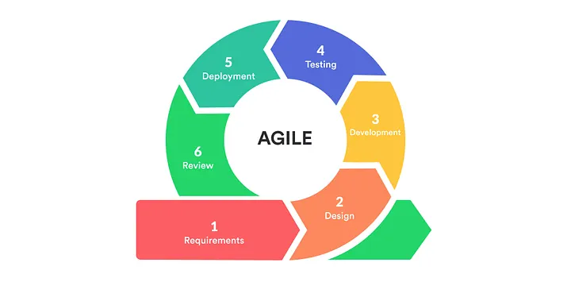
The study was conducted at Pangasinan State University Alaminos City Campus Mini Forest Area, where the proponents examined the food ordering process and challenges faced by faculty, staff and vendors. Data were gathered through interviews with the the Income Generating Project Coordinator of the Campus, Ms. Danielle B. Madero who provided them with valuable insights and suggested features for the system. In addition, Observations were conducted to understand how vendors operate and how orders are placed by customers, allowing the researchers to identify issues in the current process. These findings helped the researchers refine their ideas and guide the development of the system. Purposive sampling was employed to select participants who are directly involved in the ordering process, ensuring that relevant and meaningful data were collected to assess user needs and interest in the proposed system. Table 1 presents a list of those who took part in the research investigation.
Table 1. Respondents of Study
Respondents | Number of Respondents
Vendors | 10
Faculty and Staff | 80
IGP Coordinator | 1
Total Respondents | 91

A ISO/IEC 25010 Questionnaire was used to measure the systems acceptability. The researchers measured system assesment and improvemint using the Likert Scale where the 5 is the highest and 1 is lowest value. Average Weighted Mean is used for the data. The CampusBites system scored a 4.22 in Functional Sustainability, 4.15 in Performance Efficiency, 4.17 in Usability, 3.97 in Reliability, 3.88 in Security, 4.01 in Maintanability, 3.93 in Portability, with a Average Weighted mean of 4.05, which means the system is highly rated by the users and is within the acceptable range. The data is illustrated in Table 2.
Table 2. Acceptability Test
Acceptability | Weighted Mean | Description
Functional Sustainability | 4.22 | Very Good
Performance Efficiency | 4.15 | Very Good
Usability | 4.17 | Very Good
Reliability | 3.97 | Very Good
Security | 3.88 | Very Good
Maintainability | 4.01 | Very Good
Portability | 3.93 | Very Good
Average Weighted Mean | 4.05 | Very Good

The analysis of the ISO/IEC 25010 Acceptability Test response allowed the researchers to derive meaningful insights, and finding to the campus population. A review of existing Food Ordering Platforms such as UberEats and Food Panda revealed effective strategies, while studies on food service operations with similarities to CampusBites served as a guide to the Development of the system to better meet the requirements and needs of the Faculty, staff and vendors of the Pangasinan State University Alaminos Ctiy Campus.
The development team used Flutter within Android Studio and Visual Studio Code to implement the ordering workflows and in-real time ordering features. The UI was designed in Figma to identify how the system will look like and the proper Typhography, Color Scheme and Components. Firebase enabled live data exchange between the application and the vendors, ensuring that customers received accurate and up-to-date information about their orders.
A Fishbone Diagram is a tool that assist in analyzing and identifying the root food of related problems[5]. The use of the Fishbone diagram highlighted several issues in the existing food ordering system.These Include Inventory & Menu Management where they are unable to track orders and stock in real time, order tracking and visibility where updates are slow and delays if the order is accepted or rejected, Communication and Coordination for missin or unclear order details, operational limitations such as internet connect and difficulty in managing menu, and customer experience problems such as long queue times or slow service due to a lack of man power or ineffiecient system. All this identified problems leads to a conclusion that the existing ordering process is unstructured and inefficient which cause the delays and frustration when ordering
Figure 2. Fishbone Diagram
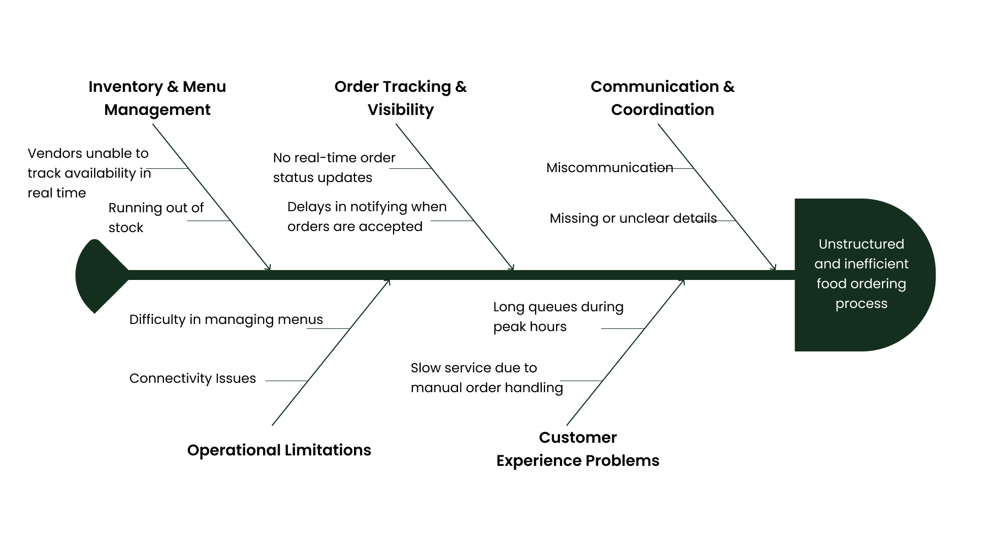
As a result of these multiple factors, the development of CampusBites produced a mobile application that meets all user requirements and improves the ordering experience on campus. By addressing the key challenges in the existing ordering process, the system aims to enhance the ordering experience for faculty, staff, and vendors at the Pangasinan State University Alaminos City Campus.
RESULTS AND DISCUSSION
The Three Tier architecture is a well known and effective architecture model, it consists of a presentation tier for graphical user interface, application tier that handles logic and data tier to store data. The CampusBites food ordering system utilized a three-tier system architecture, which separates an application into presentation, logic, and data tiers that operate independently to enhance scalability and maintainability (Chiaramonte, 2024). Users can access the CampusBites application trough their mobile phones as shown in the Figure 3, within the Presentation Tier. The Data Tier uses Firebase to store and retrieve user profiles, menus and order statuses in real-time, ensuring consistency within the system. The application tier handles business logic such as user authentication, order validation and role based access using Firebase Authentication.
Figure 3. CampusBites Food Ordering Mobile Application Three-Tier Architecture
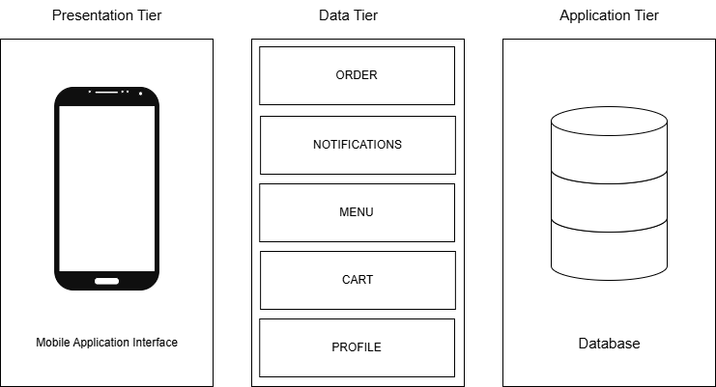
Inside the CampusBites application's Presentation Tier, the system user interface serves as the gateway for faculty, staff, and vendors to interact with the system. Faculty and staff can order from any store registered in the system and view their order status in real time, while vendors can add items to their store, update item stock and prices, and manage order status. This tier also contains necessary functions such as user login, order follow-up, order cancellation, and order notifications, serving as the main interaction medium for the system.
User inputs such as menu browsing, order placement, and status updates generate request that are processed by the application tier via Google Firebase Services.The application tier handles business logic. Firebase Authentication Manages secure, role based access. Cloud Firestore services serve as the Data tier that accesses user profiles, menus, and order statuses in real time.
The Data tier serves as the most important part of the system, storing and managing user profiles, menu items, order histories, and vendor records.Firestore ensures data remains consistent, immediately showing changes whenever an order is placed or an item is updated. This allows the Application tier to retrieve real-time information without delay, supporting the overall reliability and scalability of the CampusBites application.
By utilizing the Three-Tier Architecture the CampusBites application became an efficient and highly scalable framework for creating a Food Ordering application. Future Enhancements for the app can include further improvements in the mobile application UI and more Quality of Life (QoL) feature within the system. Communication with the locale is necessary for any future improvements to stay within the necessary user requirements and user expectations.
CONCLUSION
CampusBites is a mobile application designed to improve the existing food ordering process at the Pangasinan State University Alaminos City Campus. The combination of multiple features within the application, such as real-time ordering, order management, and order notifications. This serves as the foundation of a well-made ordering platform designed to improve the ordering experience. The application serves as the centralized solution to address the challenges identified by the researchers. The Agile Methodology ensured that the development of the application stayed within scope and continuously improved based on real feedback and user requirements, while the Three-Tier Architecture served as a guide to make the system scalable. By providing an alternative to the current process, CampusBites aims to make ordering more organized and enjoyable for faculty, staff, and vendors. The CampusBites application achieved a "Very Good" overall acceptability rating, with an average weighted mean of 4.05, based on the ISO/IEC 25010 software quality standard evaluation. Vendors can now manage orders, update item availability, and monitor sales more efficiently. Overall, the mobile application digitalizes the existing ordering process, streamlines daily operations, and ensures a more reliable and organized campus food service experience.
ACKNOWLEDGEMENT
The completion of this study would not have been possible without the support and contributions of several individuals who played important roles trough its development. The proponents would like to give their gratitude to all those who helped bring this project to fruition.
To the proponents Capstone adviser, Sir Carlo Genster P. Camposagrado who provided direction and clarity, which allowed the researchers to better understand and improve their work his support and patience serves as a successful completion of this study.
To the proponents adviser, Sir Christian Paul O. Cruz who gave us invaluable advice and helped us trough every stage of the project.
To the chairman and panelist of the project, who assisted in further improving and refining their system.
To their parents, who gave us the strength and courage to persevere and complete their research; and to the almighty God for granting strength , and wisdom to overcome challenges and successfully complete this study.
REFERENCE
- Asghar, M. (2023). Cafe Politics: How Food Service Operators Influence University Students' Satisfaction and Dining Frequency. Politica, 1(1), 42–53. https://doi.org/10.5281/zenodo.7747564
- Chathmini. (2020, July 30). Agile methodology. Medium. https://medium.com/@chathmini96/agile-methodology-30ec4cdf3fc
- Chiaramonte, M. (2024, May 13). Understanding the architecture of a 3-tier application. vFunction. https://vfunction.com/blog/3-tier-application/
- Kumah, A., Nwogu, C. N., Issah, A. R., Obot, E., Kanamitie, D. T., Sifa, J. S., & Aidoo, L. A. (2024). Cause-and-effect (fishbone) diagram: A tool for generating and organizing quality improvement ideas. Journal of Quality in Healthcare, 7(2), 85–xx. https://innovationsjournals-jqsh.kglmeridian.com/view/journals/jqsh/7/2/article-p85.xml
- Peng, B., Erkoc, M., & Omachonu, V. K. (2024). Online food ordering and delivery: A study on the use of customer service data and quality function deployment. Journal of Food Distribution Research, 55(2), 65–95. https://www.researchgate.net/publication/384884974_Online_Food_Ordering_and_Delivery_A_Study_on_the_Use_of_Customer_Service_Data_and_Quality_Function_Deployment
- The Business Research Company (2026). Online Food Delivery Services Global Market Report 2026. https://www.thebusinessresearchcompany.com/report/online-food-delivery-services-global-market-report
- Ulemu Mponela, Dr. Kadar Shereef, & Dr. Tawarish. (2024). Online Food Ordering System. International Journal of Information Technology & Computer Engineering, 4(02), 43–52. https://doi.org/10.55529/ijitc.42.43.52
- Cheena. (2024, October 24). Why Agile methodology is crucial for mobile app development. Medium. https://medium.com/@cheenawrites/why-agile-methodology-is-crucial-for-mobile-app-development-854120040950

