“DEVELOPMENT AND VALIDATION OF STABILITY-INDICATING
RP-HPLC METHOD FOR THE SIMULTANEOUS ESTIMATION OF RELUGOLIX, ESTRADIOL HEMIHYDRATE AND NORETHINDRONE ACETATE IN ITS SYNTHETIC MIXTURE”
Abstract: A stability-indicating Reverse Phase High Performance Liquid Chromatography (RP-HPLC) method was developed and validated for the simultaneous estimation of Relugolix, Estradiol hemihydrate, and Norethindrone in their synthetic mixture. These drugs are commonly used in combination therapy for hormonal disorders, and accurate analytical methods are required to ensure their quality, safety, and efficacy. The chromatographic separation was attained using a suitable C18 column with an optimized mobile phase under gradient conditions. The flow rate and detection wavelength were selected to acquire well-resolved peaks with acceptable retention times. The method was found to be specific, as no interference from excipients or degradation products was observed. Forced degradation studies were performed under various stress conditions such as acidic, alkaline, oxidative, thermal, and photolytic environments to indicated the stability-indicating capability of the method. The developed method effectively separated the drugs from their degradation products, confirming its suitable for stability studies.
Keywords: Relugolix, Estradiol Hemihydrate, Norethindrone Acetate, RP-HPLC, Method Development, Method Validation, Simultaneous Estimation, Stability-Indicating Method, ICH Guidelines, Forced Degradation Studies.

- Introduction:
Uterine fibroids are common estrogen-dependent gynecological disorders characterized by chronic pelvic pain, abnormal uterine bleeding, and severe vasomotor symptoms that affect the quality of life in women of reproductive age. Relugolix, a GnRH receptor antagonist, which suppresses ovarian hormone production to manage symptoms associated with uterine fibroids and endometriosis. Estradiol Hemihydrate is incorporated as estrogen add-back therapy to alleivate hypoestrogenic side effects, while Norethindrone Acetate, a synthetic progestogen, provides endometrial protection against estrogen-induced hyperplasia. The combination of in a mixture is essential to ensure quality and effectiveness.

A stability-indicating RP-HPLC method helps in detecting the drugs even in the presence of degradation products. Therefore, this study focuses on developing and validating a simple, precise, and reliable method according to ICH guidelines. Reverse Phase High Performance Liquid Chromatography (RP-HPLC) is a widely used analytical technique for the simultaneous estimation of multiple drugs due to its accuracy and reliability.

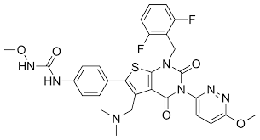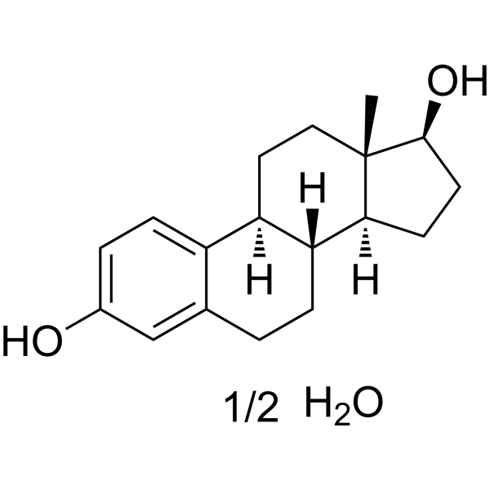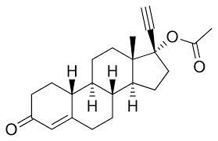

Fig 1 Structure of Relugolix Fig 2 Structure of Estradiol hemihydrate Fig 3 Structure of Norethindrone Aceta

2. MATERIAL AND METHODS:

2.1 Chemical and Reagents
Methanol, acetonitrile, orthophosphoric acid, potassium dihydrogen phosphate buffer, and HPLC grade water were used for the RP-HPLC method development.
- Analytical grade reagents Buffer Preparation:
A 0.02 M Potassium Dihydrogen Phosphate buffer was prepared by dissolving 2.72 g of potassium dihydrogen orthophosphate in 1 L of Milli-Q water using sonication. The pH was adjusted to 3 with diluted orthophosphoric acid.
2.2 Instrumentation
The analysis was carried out using a UV–Visible double-beam spectrophotometer (Shimadzu UV-1800, UV Probe software), HPLC system (Shimadzu LC-2010 CHT with UV detector, 100 µL fixed loop injector, LC Solution software), analytical balance (Sartorius), USP Type II dissolution apparatus (Lab India DS 8000), digital pH meter (Lab India), ultrasonic bath (Athena Technology), hot air oven (Patel Scientific), and calibrated micropipettes (Eppendorf).

2.3 Standard Solution Preparation:

Relugolix stock solution (4000 µg/ml): About 80 mg of Relugolix working standard was accurately weighed and transferred into 20 ml volumetric flask. To this, 10 mL methanol was added and dissolved by sonication. The solution was then diluted up to the mark with methanol and used as a stock solution.

Estradiol stock solution (100 µg/ml): About 10 mg of estradiol working standard was accurately weighed and transferred into 100 ml volumetric flask. To this, 50 ml of methanol was added and dissolved by sonication. The solution was diluted up to the mark with methanol and used as a stock solution.

Norethindrone stock solution (50 µg/ml): About 10 mg of norethindrone acetate working standard was accurately weighed and transferred into 200 ml volumetric flask. To this, 100 ml of methanol was added and dissolved by sonication. The solution was diluted up to the mark with methanol and used as a stock solution.

Mix standard solution (400 µg/ml relugolix + 10 µg/ml Estradiol + 5 µg/ml Norethindrone): Pipetted out 1 ml of relugolix, 1 ml of estradiol and 1 ml of norethindrone stock solution in 10 ml volumetric flask. Volume was made upto the mark with diluent and used as a standard solution.

2.3.1 Sample Preparation
Sample Stock: Synthetic mixture 100 mg (equivalent 40 mg Relugolix, 1 mg Estradiol, and 0.5 mg Norethindrone Acetate)) was weighed on butter paper. Powder was then transferred to 10 mL volumetric flask. To this 8 mL methanol was added and active contents were extracted in sonication for 15 minutes. The flask was allowed to cool down on room temperature and then the volume was made with methanol. The solution was then filtered through 0.45 µ Whatman PVDF syringe filter.
Sample (400 µg/ml Relugolix + 10 µg/ml Estradiol + 5 µg/ml Norethindrone Acetate):1 mL of clear filtrate was then further diluted to 10 ml with diluent and used as a sample solution.

  - Chromatographic Condition
Separation was achieved on a YMC Triart C18 column (250 mm × 4.6 mm, 5 µm particle size). using a mobile phase of Buffer: ACN (60:40 % v/v) (Gradient Mode) at a flow rate of 1.0 mL/min. Detection was performed at 238 nm, the injection volume was 10 µL, and the column temperature was maintained at 25 °C.

Time  (min) | Buffer | ACN
0.01 | 60 | 40
5.0 | 25 | 75
15.0 | 25 | 75
15.1 | 60 | 40
20.0 | 60 | 40

2.5 Method Validation:
This method was validated according to ICH validation parameters which gives acceptable results

3. RESULT AND DISCUSSION

3.1 FT-IR Spectroscopic Analysis
A small quantity of the API was analyzed using ATR-FTIR over the range of 4000–400 cm⁻¹. The obtained spectrum was evaluated for characteristic functional group peaks and compared with reference spectra to confirm the identity of the API.

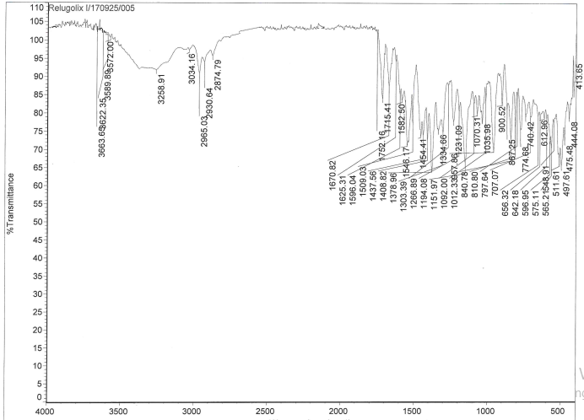
Functional Group | Observed Wavenumber (cm⁻¹) | Reference Range (cm⁻¹)
N–H Stretch | 3258.91 | 3300–3200
C–H Stretch Aliphatic | 2965.03, 2930.74, 2874.09 | 2970–2850
C=O Stretch | 1670.82 | 1720–1640
C–N Stretch | 1378.96 | 1380–1250
C–O Stretch (ether) | 1303.39 | 1320–1210
C–F Stretch (aryl fluoride) | 1151.97 | 1200–1000

Fig 4: IR spectrum of Relugolix (API) Table 1: FTIR Interpretation Relugolix

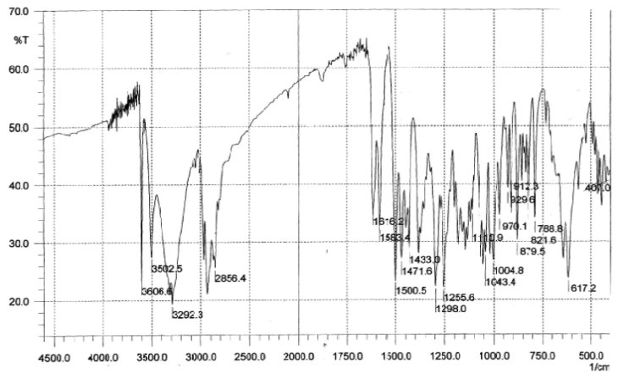

Functional Group | Observed (cm⁻¹) | Reference Range (cm⁻¹)
O-H stretch | 3606.6, 3502.5, 3292.3 | 3600-3200
C-H stretch | 2856.4 | 2900-2700
C-H bending1,2,4-trisubstituted | 879.5 | 880 ± 20

Table 2: FTIR Interpretation Estradiol Hemihydrate (API) Fig 5: FTIR Interpretation Estradiol Hemihydrate

Functional Group | Observed (cm⁻¹) | Reference Range (cm⁻¹)
O-H stretch | 3344.57 | 3500-3200
C–H stretching (aliphatic) | 2899.01 | 2700-2950
C=O stretch | 1654.92 | 1750-1650
C–H bending (aromatic) | 1419.61, 1348.42 | 1450-1350
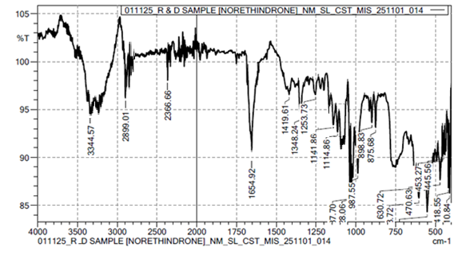

Fig 6: FTIR Interpretation Norethindrone acetate (API) Table 3: FTIR Interpretation Norethindrone acetate

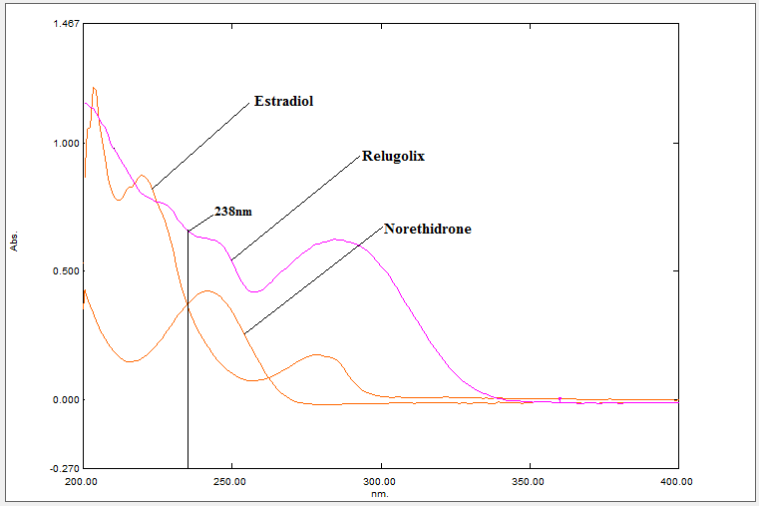

Fig 7: Determination of wavelength maximum (238nm)

3.2 METHOD DEVELOPMENT:

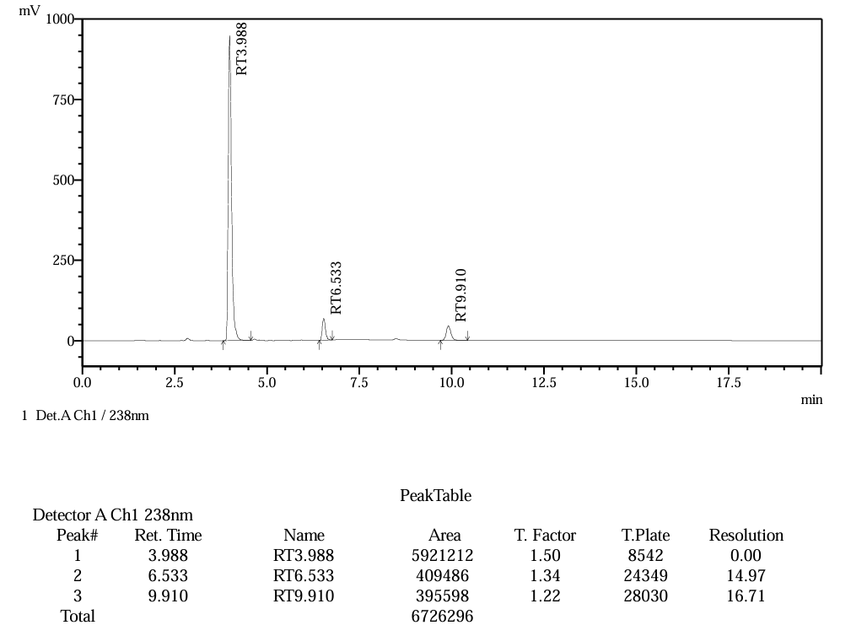

Fig 8 :- Final HPLC Chromatogram of (400 µg/mL Relugolix + 10 µg/mL Estradiol + 5 µg/mL Norethindrone Acetate)

3.3 VALIDATION PARAMETER

System Suitability Study
A mixed standard solution containing Relugolix (400 µg/mL), Estradiol Hemihydrate (10 µg/mL), and Norethindrone Acetate (5 µg/mL) was injected six times (n = 6) into the HPLC system.
Table 4: System Suitability Study

Sr.  No. | System Suitability Parameter | Relugolix  Mean ± SD | %RSD | Estradiol  Mean ± SD | %RSD | Norethindrone  Acetate  Mean ± SD | %RSD
1. | Retention Time (min) | 3.988 ± 0.0022 | 0.06 | 6.532 ± 0.0031 | 0.05 | 9.910 ± 0.0033 | 0.03
2. | Tailing Factor | 1.50 ± 0.0075 | 0.50 | 1.34 ± 0.0075 | 0.56 | 1.22 ± 0.0075 | 0.61
3. | Theoretical Plates (N) | 8543 ± 14.4 | 0.17 | 24349 ± 27.3 | 0.11 | 28028 ± 27.3 | 0.10
4. | Resolution | — | — | 15.0 ± 0.07 | 0.47 | 16.7 ± 0.07 | 0.42

Specificity
Specificity of the developed method for Relugolix, Estradiol Hemihydrate, and Norethindrone Acetate was evaluated by: Injecting a blank solution to confirm absence of interference. Injecting a standard and Sample solutions.
No interfering peaks were observed at the respective retention times of Relugolix, Estradiol Hemihydrate, and Norethindrone Acetate, confirming the specificity of the method.
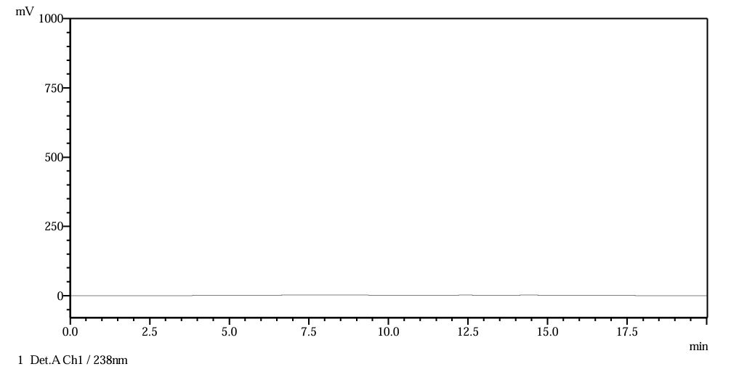
Fig 9: Diluent Chromatogram
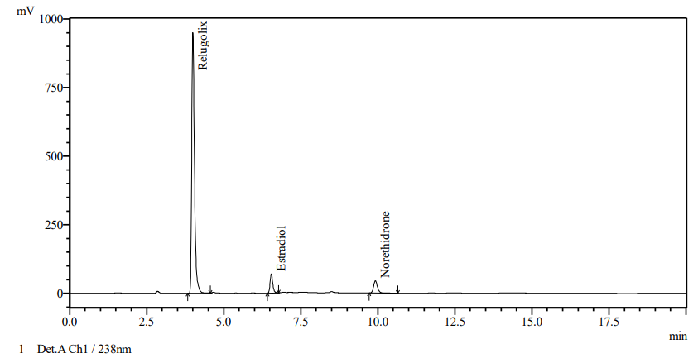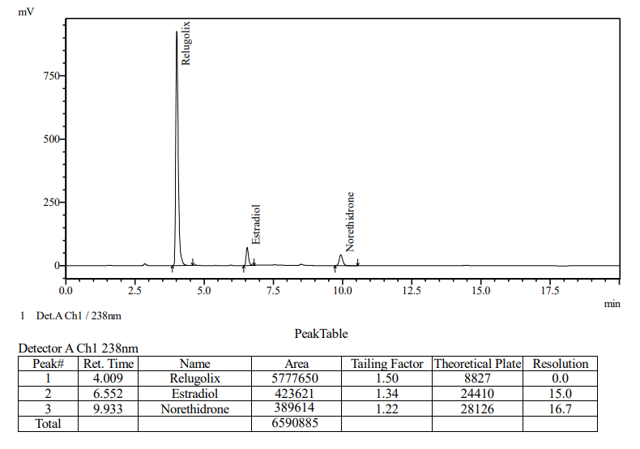
Fig 10: Standard Chromatogram Fig 11: Sample Chromatogram

Linearity
Linearity was evaluated by preparing calibration curves at five concentration levels using least squares regression analysis.
Linearity Ranges:
- Relugolix: 200 – 600 µg/mL
- Estradiol Hemihydrate: 5 – 15 µg/mL
- Norethindrone Acetate: 2.5 – 7.5 µg/mL
Appropriate aliquots from stock solutions were transferred into 10 mL volumetric flasks and diluted to volume with mobile phase. Calibration curves were constructed by plotting:
Peak Area vs. Concentration
The following parameters were calculated:
- Slope
- Y-intercept
- Correlation coefficient (R²)
The method demonstrated good linearity with R² values ≥ 0.999 for Relugolix, Estradiol Hemihydrate, and Norethindrone Acetate

Sr. No. | Conc. (µg/mL) | Mean Area | SD | % RSD
1 | 200.00 | 3067797 | 5856 | 0.19
2 | 300.00 | 4480543 | 9938 | 0.22
3 | 400.00 | 6017193 | 12746 | 0.21
4 | 500.00 | 7460741 | 18424 | 0.24
5 | 600.00 | 8981514 | 16954 | 0.18

Fig 12: Calibration Curve of Relugolix Table 5: Linearity Data for Relugolix

Sr. No. | Conc. (µg/mL) | Mean Area | SD | % RSD
1. | 5.00 | 202237 | 518 | 0.25
2. | 7.50 | 299807 | 220 | 0.07
3. | 10.00 | 407879 | 103 | 0.02
4. | 12.50 | 508515 | 654 | 0.12
5. | 15.00 | 606373 | 76 | 0.01

Table 6: Linearity Data for Estradiol Hemihydrate Fig 13: Calibration Curve of Estradiol Hemihydrate

Sr. No. | Conc. (µg/mL) | Mean Area | SD | % RSD
1 | 2.50 | 196040 | 172 | 0.08
2 | 3.75 | 289512 | 412 | 0.14
3 | 5.00 | 396017 | 615 | 0.15
4 | 6.25 | 488591 | 465 | 0.09
5 | 7.50 | 585633 | 74 | 0.01

Fig 14: Calibration Curve of Norethindrone Acetate Table 7: Linearity Data for Norethindrone Acetate
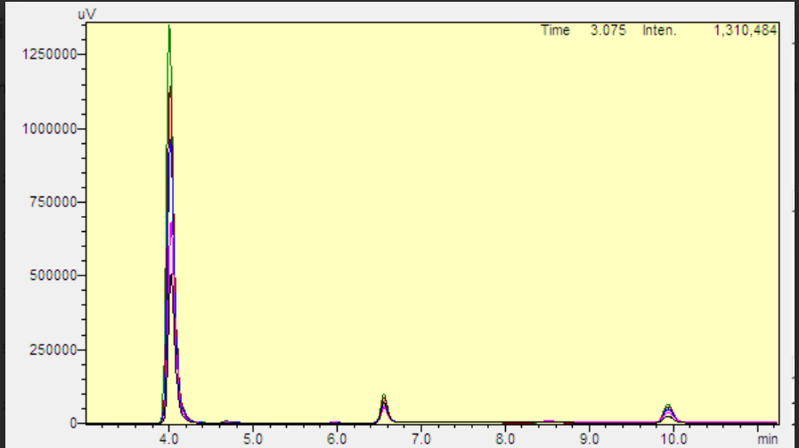
Fig 15: Linearity Overlay

Precision
Results were expressed as %RSD.

Repeatability
A standard solution containing Relugolix (400 µg/mL), Estradiol Hemihydrate (10 µg/mL), and Norethindrone Acetate (5 µg/mL) was injected six times (n = 6).
%RSD of peak areas was calculated.
Acceptance Criteria: %RSD ≤ 2.0%

Table 8: Repeatability Data of Relugolix, Estradiol Hemihydrate, and Norethindrone Acetate

Conc. of Relugolix | Peak area | Conc. of Estradiol Hemihydrate | Peak area | Conc. of Norethindrone Acetate | Peak area
400 µg/ml | 5921212 | 10 µg/ml | 409486 | 5 µg/ml | 395598
400 µg/ml | 5925531 | 10 µg/ml | 410290 | 5 µg/ml | 395695
400 µg/ml | 5930306 | 10 µg/ml | 409946 | 5 µg/ml | 395634
400 µg/ml | 5935343 | 10 µg/ml | 409738 | 5 µg/ml | 395932
400 µg/ml | 5937540 | 10 µg/ml | 409976 | 5 µg/ml | 395585
400 µg/ml | 5942335 | 10 µg/ml | 409735 | 5 µg/ml | 396021
Mean | 5932045 | Mean | 409862 | Mean | 395744
SD | 7871.037206 | SD | 274.2687854 | SD | 186.1025703
%RSD | 0.13 | %RSD | 0.06 | %RSD | 0.04

- Intraday and Interday Precision:
For intraday precision, standard solutions containing Relugolix (200, 400, 600 µg/mL), Estradiol Hemihydrate (5, 10, 15 µg/mL), and Norethindrone Acetate (2.5, 5, 7.5 µg/mL) were analyzed on the same day, while for interday precision the same three concentration levels were analyzed on three successive days, and %RSD was calculated for each level.
Table 9: Inter day and Intraday Precision

Intraday Precision |  |  |  | Inter day Precision
Relugolix |  |  |  | Relugolix
Conc. (µg/ml) | Mean Peak Area ± SD (n=3) |  | % RSD | Conc. (µg/ml) | Mean Peak Area ± SD (n=3) | % RSD
200 | 3069544 ± 10830.66 |  | 0.35 | 200 | 3223436 ± 54034.60 | 1.68
400 | 5970522 ± 16716.39 |  | 0.28 | 400 | 6196038 ± 14956.09 | 0.24
600 | 8910925 ± 26211.06 |  | 0.29 | 600 | 9078422 ± 145453.32 | 1.60
Estradiol Hemihydrate
5 |  | 201440 ± 1589.30 | 0.79 | 5 | 202367 ± 1987.50 | 0.98
10 |  | 406838 ± 391.94 | 0.10 | 10 | 418540 ± 1423.81 | 0.34
15 |  | 588270 ± 1567.54 | 0.27 | 15 | 610382 ± 10066.70 | 1.65
Norethindrone Acetate
2.5 |  | 199445 ± 474.22 | 0.24 | 2.5 | 202102 ± 2518.69 | 1.25
5 |  | 395129 ± 808.77 | 0.20 | 5 | 403960 ± 1162.00 | 0.29
7.5 |  | 589841 ± 1334.63 | 0.23 | 7.5 | 586052 ± 4156.43 | 0.71

Limit of Detection (LOD) and Limit of Quantitation (LOQ)
LOD and LOQ for Relugolix, Estradiol Hemihydrate, and Norethindrone Acetate were determined from calibration curve data.Calibration curves were prepared in triplicate, and the standard deviation (σ) of the Y-intercepts and mean slope (S) were calculated.
The following equations were used:
LOD = 3.3 × (σ / S)
LOQ = 10 × (σ / S)
Where:
σ = Standard deviation of intercept
S = Mean slope of calibration curve
Table 10: Limit of Detection and Limit of Quantitation data
Sr. No. | Drug | LOD (µg/mL) | LOQ (µg/mL)
1 | Relugolix | 22.6 | 68.6
2 | Estradiol Hemihydrate | 0.74 | 2.26
3 | Norethindrone Acetate | 0.46 | 1.40

Accuracy
Accuracy of the method was determined by the placebo recovery (standard addition) method at three levels (50%, 100%, and 150%) with three replicates (n = 3).A placebo equivalent to formulation excipients was accurately weighed and transferred into a 100 mL volumetric flask. Known amounts of Relugolix, Estradiol Hemihydrate, and Norethindrone Acetate corresponding to 50%, 100%, and 150% of the target concentration were added. % Recovery was calculated for each level.
Acceptance Criteria:
% Recovery should be between 98–102% and %RSD should be ≤ 2.0%.
Table 11: Accuracy Data for Relugolix
Levels | Sets | mcg added | Mcg Found | % Recovery | Mean % Recovery | % RSD
50% | 1 | 200.000 | 201.870 | 100.90 | 100.5 | 0.4
50% | 2 | 200.000 | 200.850 | 100.40 | 100.5 | 0.4
50% | 3 | 200.000 | 200.170 | 100.10 | 100.5 | 0.4
100% | 1 | 400.000 | 405.880 | 101.50 | 101.1 | 0.5
100% | 2 | 400.000 | 404.640 | 101.20 | 101.1 | 0.5
100% | 3 | 400.000 | 402.000 | 100.50 | 101.1 | 0.5
150% | 1 | 600.000 | 603.280 | 100.50 | 101.3 | 0.7
150% | 2 | 600.000 | 609.630 | 101.60 | 101.3 | 0.7
150% | 3 | 600.000 | 610.470 | 101.70 | 101.3 | 0.7

Table 12: Accuracy Data for Estradiol Hemihydrate & Norethindrone Acetate

Level% | Set | Estradiol Hemihydrate |  |  |  |  | Norethindrone Acetate
Level% | Set | Mcg  Added | Mcg  Found | %Recovery | Mean %  Recovery | %RSD | Mcg  Added | Mcg  Found | %Recovery | Mean %  Recovery | %RSD
50% | 1 | 5.000 | 4.910 | 98.20 | 99.6 | 1.3 | 2.500 | 2.540 | 101.60 | 100.9 | 0.6
50% | 2 | 5.000 | 5.040 | 100.80 | 99.6 | 1.3 | 2.500 | 2.520 | 100.80 | 100.9 | 0.6
50% | 3 | 5.000 | 4.990 | 99.80 | 99.6 | 1.3 | 2.500 | 2.510 | 100.40 | 100.9 | 0.6
100% | 1 | 10.000 | 10.120 | 101.20 | 101.6 | 0.3 | 5.000 | 5.090 | 101.80 | 101.7 | 0.1
100% | 2 | 10.000 | 10.170 | 101.70 | 101.6 | 0.3 | 5.000 | 5.090 | 101.80 | 101.7 | 0.1
100% | 3 | 10.000 | 10.180 | 101.80 | 101.6 | 0.3 | 5.000 | 5.080 | 101.60 | 101.7 | 0.1
150% | 1 | 15.000 | 14.840 | 98.90 | 99.4 | 0.4 | 7.500 | 7.470 | 99.60 | 100.0 | 0.4
150% | 2 | 15.000 | 14.920 | 99.50 | 99.4 | 0.4 | 7.500 | 7.510 | 100.10 | 100.0 | 0.4
150% | 3 | 15.000 | 14.960 | 99.70 | 99.4 | 0.4 | 7.500 | 7.530 | 100.40 | 100.0 | 0.4

Robustness
Robustness of the RP-HPLC method for Relugolix, Estradiol Hemihydrate, and Norethindrone Acetate was evaluated (n = 3) by introducing small deliberate variations in chromatographic conditions:
Flow rate: ± 0.2 mL/min
Column temperature: ± 5°C
Mobile phase composition: ± 2% organic phase
The effect of these changes on peak area, retention time, and resolution was studied
Acceptance Criteria:
%RSD ≤ 2.0%
No significant change in retention time or resolution
The results demonstrated that the developed RP-HPLC method is robust and reliable under small variations in analytical conditions.
Table 13: Robustness Data of Relugolix, Estradiol Hemihydrate, and Norethindrone Acetate

 | Drug | Area at Tem.  (-5°C) | Area at Tem.  (+5°C) | Area at Flow  (-1%) | Area at Flow (+1%ml/min) | Area at Organic Phase -2% | Area at Organic Phase+2%
Mean Peak Area | Relugolix | 5935794 | 5965565 | 6858978 | 5383639 | 6024360 | 6155138
Mean Peak Area | Estradiol Hemihydrate | 404388 | 411368 | 467521 | 377598 | 406596 | 394971
Mean Peak Area | Norethindrone Acetate | 387380 | 389018 | 447866 | 365128 | 387610 | 385372
% RSD | Relugolix | 1.30 | 0.63 | 0.26 | 0.51 | 1.74 | 0.53
% RSD | Estradiol Hemihydrate | 1.26 | 0.60 | 0.21 | 1.68 | 1.64 | 0.47
% RSD | Norethindro-ne Acetate | 0.61 | 0.67 | 0.23 | 0.92 | 0.38 | 0.94
Theoretical Plates | Relugolix | 8423 | 8030 | 6180 | 6456 | 7153 | 5895
Theoretical Plates | Estradiol Hemihydrate | 25071 | 23840 | 26085 | 23077 | 26395 | 22569
Theoretical Plates | Norethindrone Acetate | 27034 | 28691 | 27738 | 28426 | 28549 | 27390
Tailing Factor | Relugolix | 1.47 | 1.53 | 1.54 | 1.50 | 1.56 | 1.53
Tailing Factor | Estradiol Hemihydrate | 1.36 | 1.32 | 1.37 | 1.34 | 1.36 | 1.35
Tailing Factor | Norethindrone Acetate | 1.22 | 1.24 | 1.23 | 1.22 | 1.22 | 1.22

3.4 FORCE DEGRADATION STUDIES

3.4.1 Acid Degradation
An aliquot (1 mL) of standard/sample solution was treated with 1 mL of 1 N hydrochloric acid in a 10 mL volumetric flask and kept at room temperature for 4 hours to induce acid degradation.
After the specified time, the solution was neutralized with 1 N sodium hydroxide, diluted to volume with diluent, mixed thoroughly, and analyzed by HPLC.
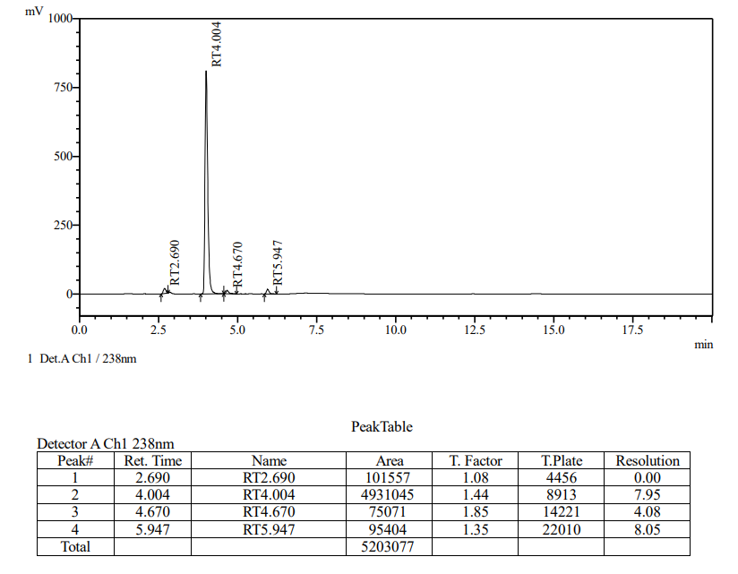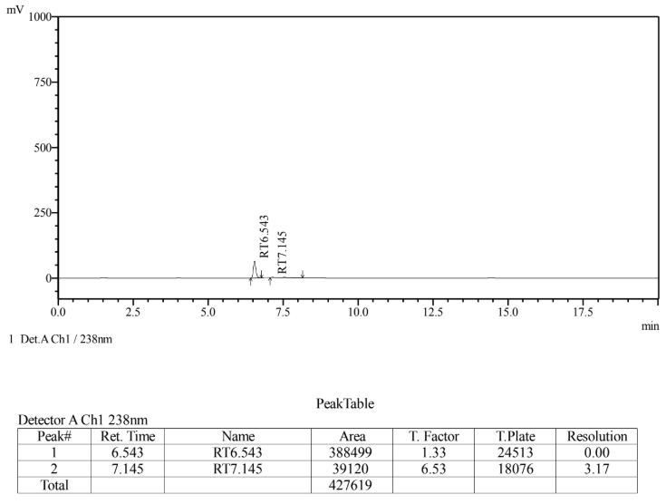
Fig 16-A: API Acid Degradation (Relugolix) Fig 16-B: API Acid Degradation (Estradiol)

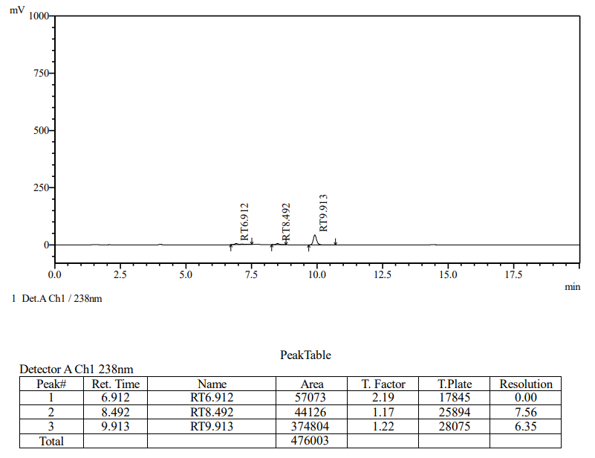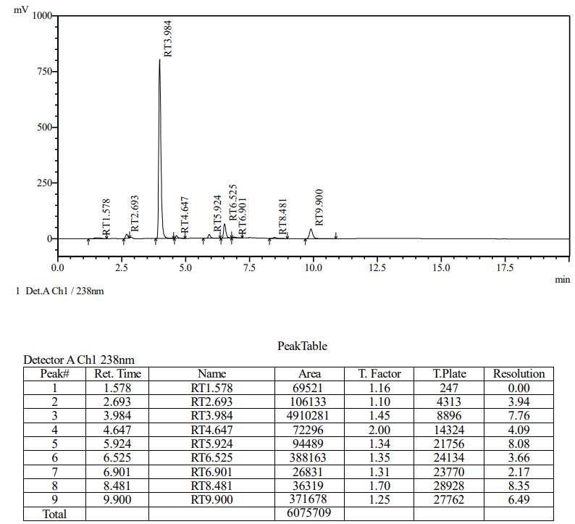

Fig 16-C: API Acid Degradation (Norethindrone Acetate) Fig 16-D: Sample Acid Degradation

3.4.2 Base Degradation
An aliquot (1 mL) of the standard/sample solution was transferred into a 10 mL volumetric flask and treated with 1 mL of 1 N sodium hydroxide for alkaline degradation, followed by standing at room temperature for 4 hours. After the degradation period, the solution was neutralized with 1 N hydrochloric acid, diluted to volume with diluent, mixed well, and subjected to HPLC analysis.

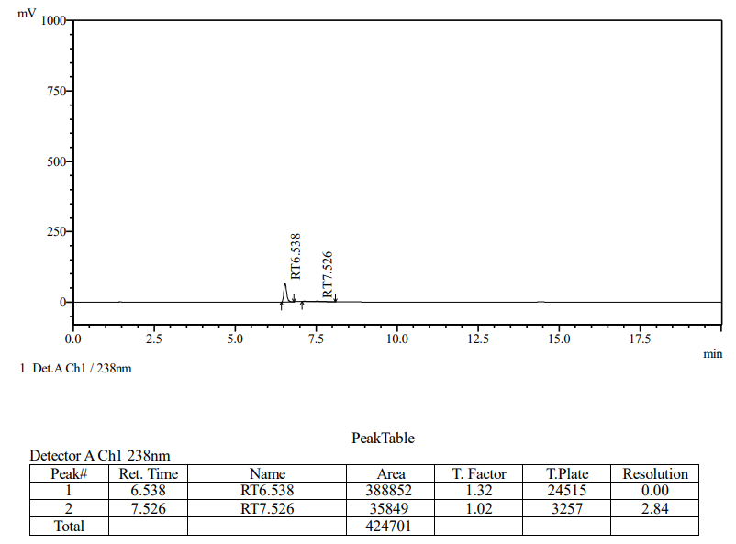
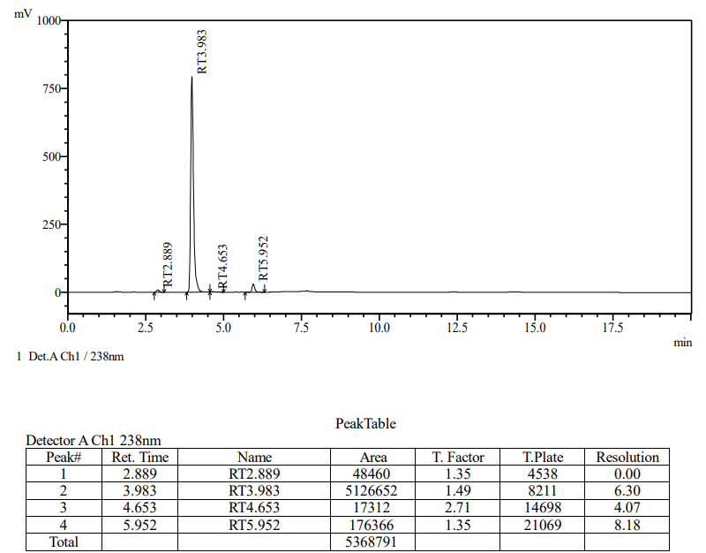
Fig 17-A: API Base Degradation (Relugolix) Fig 17-B: API Base Degradation (Estradiol)

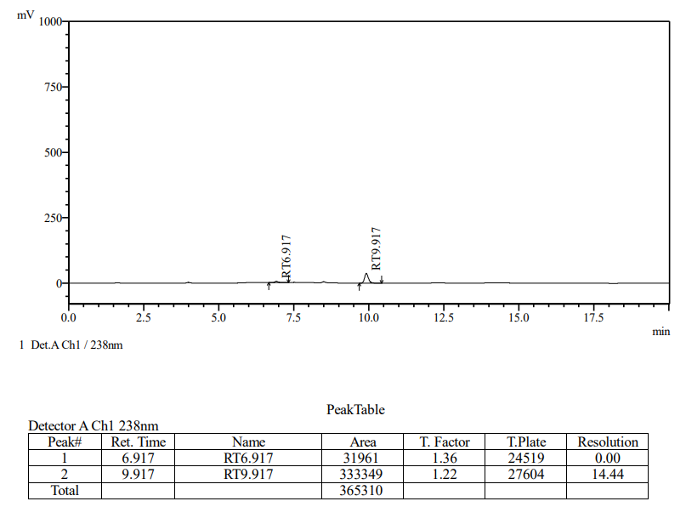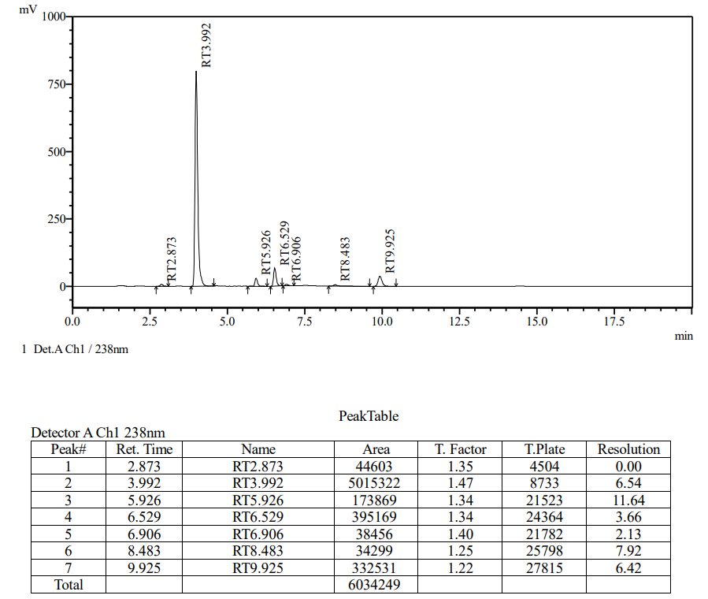
Fig 17-C: API Base Degradation (Norethindrone Acetate) Fig 17-D: Sample Base Degradation

3.4.3 Oxidative Degradation
An aliquot (1 mL) of the standard/sample solution was treated with 1 mL of 3% hydrogen peroxide and kept at room temperature for 4 hours to induce oxidative degradation. The solution was then diluted to volume with diluent, mixed well, and analyzed by HPLC.
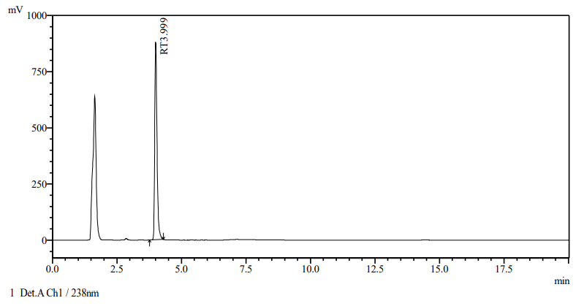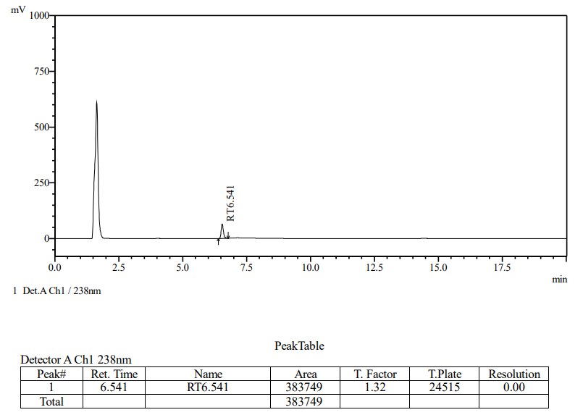
Fig 18-A: API Oxidation Degradation (Relugolix) Fig 18-B: API Oxidation Degradation (Estradiol)
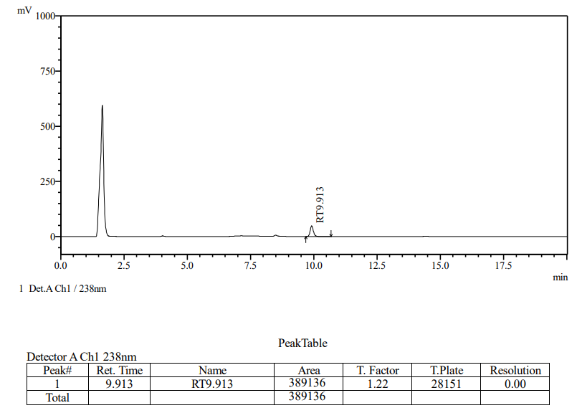 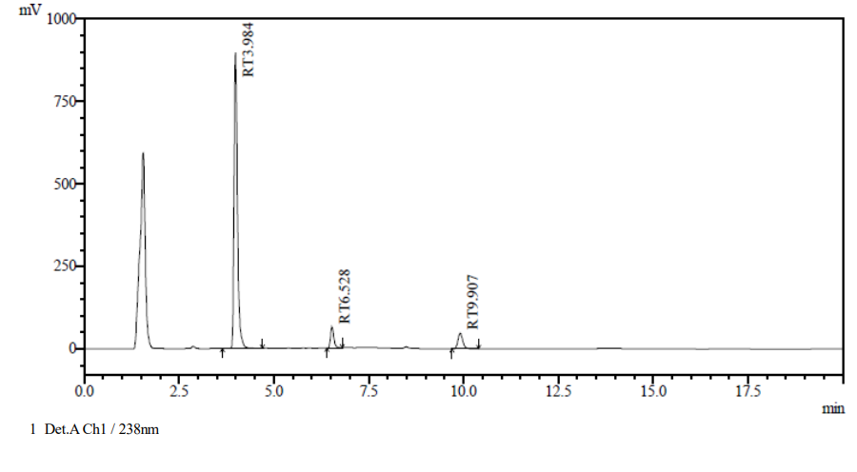Fig 18-C: API Oxidation Degradation (Norethindrone Acetate) Fig 18-D: Sample Oxidation Degradation

3.4.5 Photolytic Degradation
The standard/sample solution was exposed to direct sunlight for 24 hours in a clear container, then suitably diluted with diluent and analyzed by HPLC.

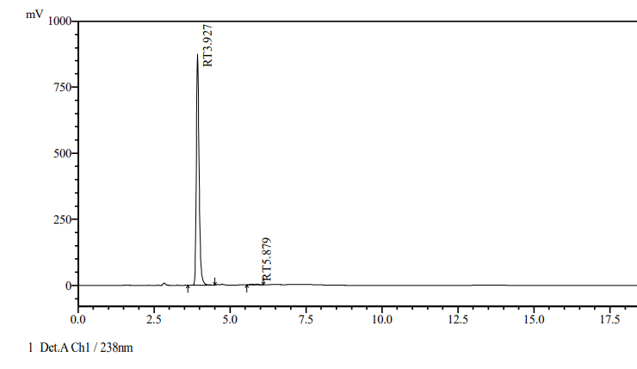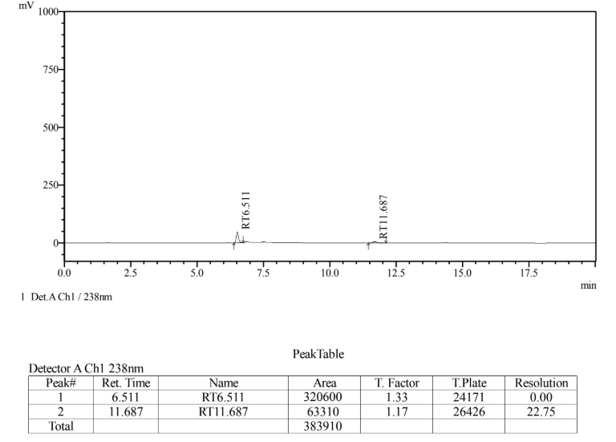
Fig 19-A: API Photolytic Degradation (Relugolix) Fig 19-B: API Photolytic Degradation (Estradiol)

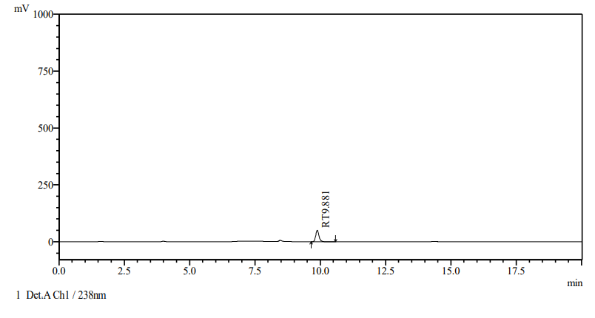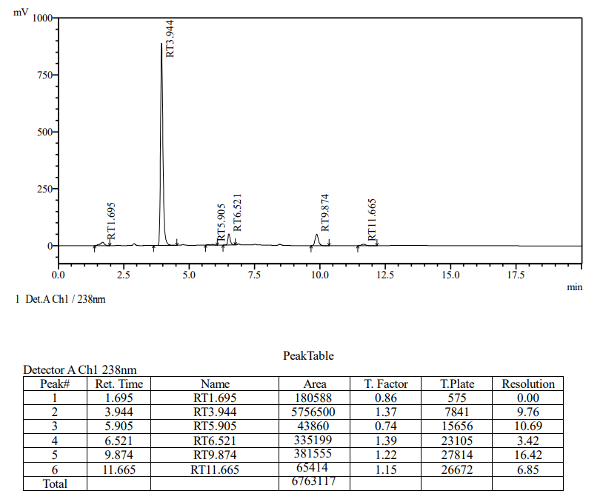
Fig 19-C: API Photolytic Degradation (Norethindrone Acetate) Fig 19-D: Sample Photolytic Degradation

Table 7.1 Forced Degradation result for Relugolix

Parameter | Sample Area | API Area
As such | 5760265 | 5921212

Condition | Sample Area | % Degradation (Sample) | API Area | % Degradation (API)
Acid | 4910281 | 14.8 | 4931045 | 16.7
Base | 5015322 | 12.9 | 5126652 | 13.4
Peroxide | 5641490 | 2.1 | 5473689 | 7.6
Photolytic | 5756500 | 0.1 | 5585219 | 5.7
Thermal | 5679327 | 1.4 | 5703957 | 3.7

Table 7.2 Forced Degradation result for Estradiol

Parameter | Sample Area | API Area
As such | 421678 | 409486

Condition | Sample Area | % Degradation (Sample) | API Area | % Degradation (API)
Acid | 388163 | 7.9 | 388499 | 5.1
Base | 395169 | 6.3 | 388852 | 5.0
Peroxide | 387199 | 8.2 | 383749 | 6.3
Photolytic | 335199 | 20.5 | 320600 | 21.7
Thermal | 398801 | 5.4 | 390833 | 4.6

Table 7.3 Forced Degradation result for Norethindrone Acetate

Parameter | Sample Area | API Area
As such | 378945 | 395598

Condition | Sample Area | % Degradation (Sample) | API Area | % Degradation (API)
Acid | 371678 | 6.8 | 374804 | 5.3
Base | 332531 | 16.6 | 333349 | 15.7
Peroxide | 388578 | 2.6 | 389136 | 1.6
Photolytic | 381555 | 4.4 | 388678 | 1.7
Thermal | 370281 | 7.2 | 372375 | 5.9

- CONCLUSION:
A simple, precise, accurate, robust, and stability-indicating RP-HPLC method was successfully developed and validated for the simultaneous estimation of Relugolix, Estradiol Hemihydrate, and Norethindrone Acetate in a synthetic mixture. The optimized chromatographic conditions resulted in well-resolved peaks with satisfactory system suitability parameters and low %RSD values, demonstrating the reliability and reproducibility of the method. The validation studies confirmed that the method complies with analytical performance requirements in terms of linearity, precision, accuracy, robustness, and sensitivity across the selected concentration ranges. Therefore, the proposed method can be reliably employed for routine quality control analysis and simultaneous quantification of these three drugs in pharmaceutical dosage forms.

- REFERENCE

- Stewart EA, Laughlin-Tommaso SK, Catherino WH, Lalitkumar S, Gupta D, Vollenhoven B. Uterine fibroids. Nat Rev Dis Primers. 2016;2:16043.
- Markham A. Relugolix: First Approval. Drugs. 2020;80(7):675–681.
- Al-Hendy A, Lukes AS, Poindexter AN, Venturella R, Villarroel C, Critchley HOD. Treatment of uterine fibroid symptoms with relugolix combination therapy. N Engl J Med. 2021;384(7):630–642.
- Snyder LR, Kirkland JJ, Dolan JW. Introduction to Modern Liquid Chromatography. 3rd ed. Hoboken: John Wiley & Sons; 2010.
- International Council for Harmonisation (ICH). Q2(R1): Validation of Analytical Procedures: Text and Methodology. Geneva: ICH; 200
- P.S Kalsi spectroscopy of organic compounds 2010 pp 2.55.

