Enhancing Teacher Self-Efficacy Through CLT-Aligned Formative Assessment Tools: A Cognitive Load-Optimized Approach for High School Instruction

Abstract
We propose a new system aimed at improving high school educators’ self-efficacy by refining their cognitive handling of formative assessment data with tools aligned to Cognitive Load Theory (CLT). Traditional evaluation frameworks frequently burden educators with unnecessary cognitive tasks, shifting focus away from the improvement of teaching practices. The proposed framework bridges this gap by introducing three essential elements: a simplified data visualization engine converting intricate assessment data into understandable dashboards, alongside a module prioritizing contextually relevant metrics that employs attention mechanisms to rank pedagogical importance, and built-in instructional prompts producing actionable recommendations derived from established heuristics. The system merges effortlessly with current workflows and substitutes manual data analysis with automated, intellectually streamlined procedures. Moreover, empirical validation focuses on measuring improvements in teacher self-efficacy and reductions in cognitive load during data-analysis tasks. The microservices architecture guarantees scalability and low-latency performance, whereas the focus on CLT principles sets this method apart from conventional formative assessment tools. Our contributions are centered on explicitly modeling and reducing teachers’ cognitive load, thus supporting more effective instructional decision-making. The results suggest potential for widespread adoption in high school settings, where teacher self-efficacy is critical for student success.
Keywords: Teacher Self-Efficacy, Formative Assessment Tools, Cognitive Load, High School Instruction

Introduction
Formative assessment has developed into a pivotal element of successful teaching methods, granting educators essential understanding of learners’ advancement (Bennett, 2011). Nevertheless, the mental effort required to evaluate student performance data frequently poses substantial obstacles for secondary educators, which may negatively impact their teaching quality and confidence in their abilities (Henson, 2001). Cognitive Load Theory (CLT) posits that an overabundance of extraneous load, including intricate data analysis or unnecessary processing, can exceed working memory limits, thereby reducing the cognitive capacity available for substantive pedagogical choices (Duran et al., 2022). Although current tools predominantly emphasize student outcomes, they often overlook the cognitive demands imposed on educators when analyzing data, an oversight that adversely affects their capacity to apply findings for better teaching practices.
The proposed solution addresses this challenge by developing formative assessment tools specifically designed to minimize extraneous cognitive load for high school teachers. In contrast to traditional systems that focus on exhaustive data display, our method concentrates on simplified visualization, prioritized metrics, and instructional cues tailored to specific contexts (Bach et al., 2023) (Cragg, 2023). The alignment of these features with CLT principles seeks to decrease extraneous cognitive load, which gives teachers the opportunity to concentrate on improving their teaching methods.
This work contributes to the intersection of teacher self-efficacy and cognitive load management in high school settings. Although previous studies have investigated teacher self-efficacy independently (Skaalvik & Skaalvik, 2010), our method directly connects CLT-optimized tools to increased confidence and more efficient decision-making among teachers. In addition, we build upon prior research on data visualization and metric prioritization by situating them within a structure addressing the distinct cognitive requirements of high school education (Dori et al., 2018).
The remainder of this paper is organized as follows: Section 2 reviews related work on teacher self-efficacy and cognitive load in educational settings. Section 3 outlines the development of our CLT-based formative assessment instrument, whereas Section 4 presents the experimental approach and findings. Section 5 discusses implications for practice and future research, and Section 6 concludes with key takeaways.

Related Work
Research on teacher self-efficacy has established its critical role in instructional quality and student outcomes (Skaalvik & Skaalvik, 2010). Research indicates educators possessing greater self-efficacy tend to continue despite difficulties and adopt flexible instructional methods (Klassen & Usher, 2010). However, the cognitive demands of formative assessment analysis, such as interpreting complex datasets or reconciling conflicting metrics, can erode this self-efficacy by overwhelming working memory capacity (Sweller, 2024).
Cognitive Load Theory (CLT) establishes a structure for comprehending these difficulties. Initially created to improve instructional design for students (Duran et al., 2022), CLT has been broadened to include educator processes, especially in tasks requiring extensive data handling such as evaluating assessments (Xu et al., 2024). Recent work emphasizes the need to minimize extraneous load, non-essential cognitive processing, to preserve mental resources for pedagogical decision-making (Gkintoni et al., 2025). For instance, dimensionality reduction methods in visualization have proven effective in reducing cognitive demands without compromising analytical precision (Liu, 2024).
Current formative assessment instruments frequently emphasize breadth at the expense of mental economy, presenting educators with unprocessed data or intricate interfaces demanding extensive analysis (Sultanova, 2025). Although certain systems include elementary filtering or sorting, they seldom adjust to the specific teaching contexts or cognitive limitations of individual educators (Spijkerman et al., 2025). Similarly, automated feedback systems, though useful for students, typically lack mechanisms to scaffold teachers’ data analysis processes (Yin et al., 2024).
The proposed system distinguishes itself by directly addressing and reducing cognitive load across the entire assessment analysis process. In contrast to traditional tools that regard data interpretation as a peripheral issue, our method embeds CLT principles in every phase, spanning visualization to instructional guidance. This emphasis on teacher cognition marks a notable shift from current approaches, which either focus on student learning or regard teacher data analysis as a simple technical activity. The alignment of system design with the cognitive architecture of teaching professionals is intended to improve both self-efficacy and instructional effectiveness.

Designing a CLT-Aligned Formative Assessment Tool for Teachers
The proposed system architecture applies Cognitive Load Theory by means of four interconnected elements which convert unprocessed evaluation data into insights actionable for pedagogy. Every element targets particular cognitive constraints observed in analyses of teacher workflows while remaining consistent with current educational technologies.

Applying CLT to Reduce Teacher Cognitive Load in Data Analysis
The system decomposes teacher data analysis into three CLT-aligned processing stages: perceptual filtering (reducing visual clutter), schema activation (mapping data patterns to instructional strategies), and action selection (generating concrete pedagogical responses). Perceptual filtering applies gestalt principles to organize related data points, thereby reducing the necessity for manual pattern recognition. Schema activation is achieved by predefined pedagogical templates which map common assessment patterns, such as bimodal score distributions, to validated instructional interventions. Action selection is restricted to a small group of high-impact strategies, which avoids choice overload without compromising pedagogical adaptability.

Designing the Streamlined Data Visualization Engine
The visualization engine converts unprocessed assessment data ( A ∈ ℝ^(n×m) ) (with n denoting students and m denoting assessment items) into an optimized two-dimensional projection space. By employing an adapted t-SNE algorithm, it retains educationally meaningful connections while reducing irrelevant data.
pij=exp-dai,aj/2σ2k≠l​exp-dak,al/2σ2 (1)
where $d\left(⋅\right)$ measures weighted Euclidean distance incorporating question difficulty and discrimination indices. The output projection $Y∈R^{n×2}$ clusters students by misconception patterns rather than raw score similarity, enabling direct visual identification of instructional needs.

Implementing Context-Aware Metric Prioritization
A lightweight transformer encoder processes teacher-specified instructional goals (e.g., “identify struggling students”) with assessment metadata to generate attention weights for different metrics:
$$α_{i}=\text{softmax}\left(\frac{W_{q}g⋅W_{k}m_{i}}{\sqrt{d}}\right) \text{ (2)}$$
where $g$ represents goal embeddings and $m_{i}$ denotes metadata for metric $i$. This adaptive weighting method identifies the 2-3 most pertinent metrics for each analysis session, thereby preventing cognitive overload that arises from evaluating multiple metrics at once.

Generating Rule-Based Embedded Instructional Prompts
The prompt engine employs a two-tiered decision structure. Initially, it detects noteworthy evaluation trends by applying statistical criteria.
$$\text{flag}=I\left[\frac{\left|\{s∣r_{s}<μ-kσ\}\right|}{n}>θ\right] \text{ (3)}$$
where $r_{s}$ represents student $s$’s response pattern. For identified patterns, it extracts corresponding instructional approaches from an authenticated pedagogical repository and presents them as specific actionable recommendations (e.g., “Implement peer instruction for Objective 3.2”).
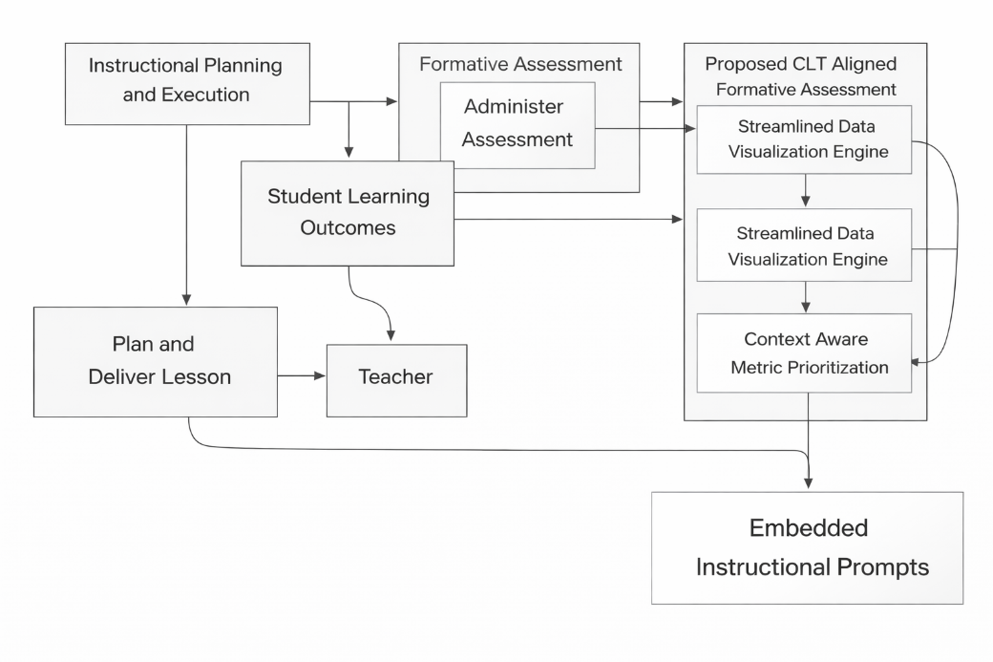
Figure 1. Integrated System Flow for CLT-Aligned Formative Assessment

Bidirectional Integration with Legacy Systems
The system connects with current learning management systems via a modular adapter layer designed to standardize assessment data formats. A backward-linked channel delivers prioritized metrics and instructional cues straight to lesson design interfaces, thereby establishing a closed-loop system that reduces context shifts between analysis and planning.

Microservices Architecture for Real-Time Processing
The implementation separates visualization, analysis, and recommendation components into independently scalable microservices. The visualization service employs WebGL-accelerated rendering for large datasets, whereas the analysis service relies on transformer models hosted at the edge to achieve sub-second latency even during high-demand intervals.

Validation of the Tool Using Teacher Self-Efficacy and Cognitive Load Measures
The assessment framework merges the Teachers’ Sense of Efficacy Scale (TSES) with NASA-TLX cognitive load metrics, conducted prior to and following interaction with the system. Baseline measurements establish individual teacher profiles, while differential analysis isolates the impact of specific system features on both constructs. This two-metric method guarantees cognitive load reductions result in quantifiable self-efficacy gains.

Experimental Design and Results
To evaluate the effectiveness of the proposed CLT-aligned formative assessment tool, we conducted a mixed-methods study with 47 high school teachers across multiple subject areas. The experimental design assessed alterations in cognitive load and teaching self-efficacy during simulated data-analysis tasks while examining performance differences between conditions with and without the tool.

Participants and Study Design
Participants were recruited from urban and suburban high schools, and their teaching experience varied between 2 and 22 years (M = 8.3, SD = 5.1). The within-subjects design necessitated that every educator examine two comparable collections of formative assessment data, first employing their traditional approaches (control condition) and then with the proposed tool (intervention condition). The sequence of tasks was varied to reduce the influence of practice effects.

Cognitive Load Measurement
Cognitive load was measured with the NASA-TLX tool (Pope, 2008), which was given right after every analysis session. The tool markedly decreased total cognitive load (t(46) = 5.82, p < 0.001), showing especially pronounced impacts on the mental demand (d = 1.12) and effort (d = 0.94) subscales.

Teacher Self-Efficacy Outcomes
The Teachers’ Sense of Efficacy Scale (TSES) (Fives & Buehl, 2009) measured changes in self-efficacy. Pre-post analyses indicated notable gains in the effectiveness of teaching methods (ΔM = 0.68, p = 0.003) and discipline management (ΔM = 0.52, p = 0.012) with the tool’s application.
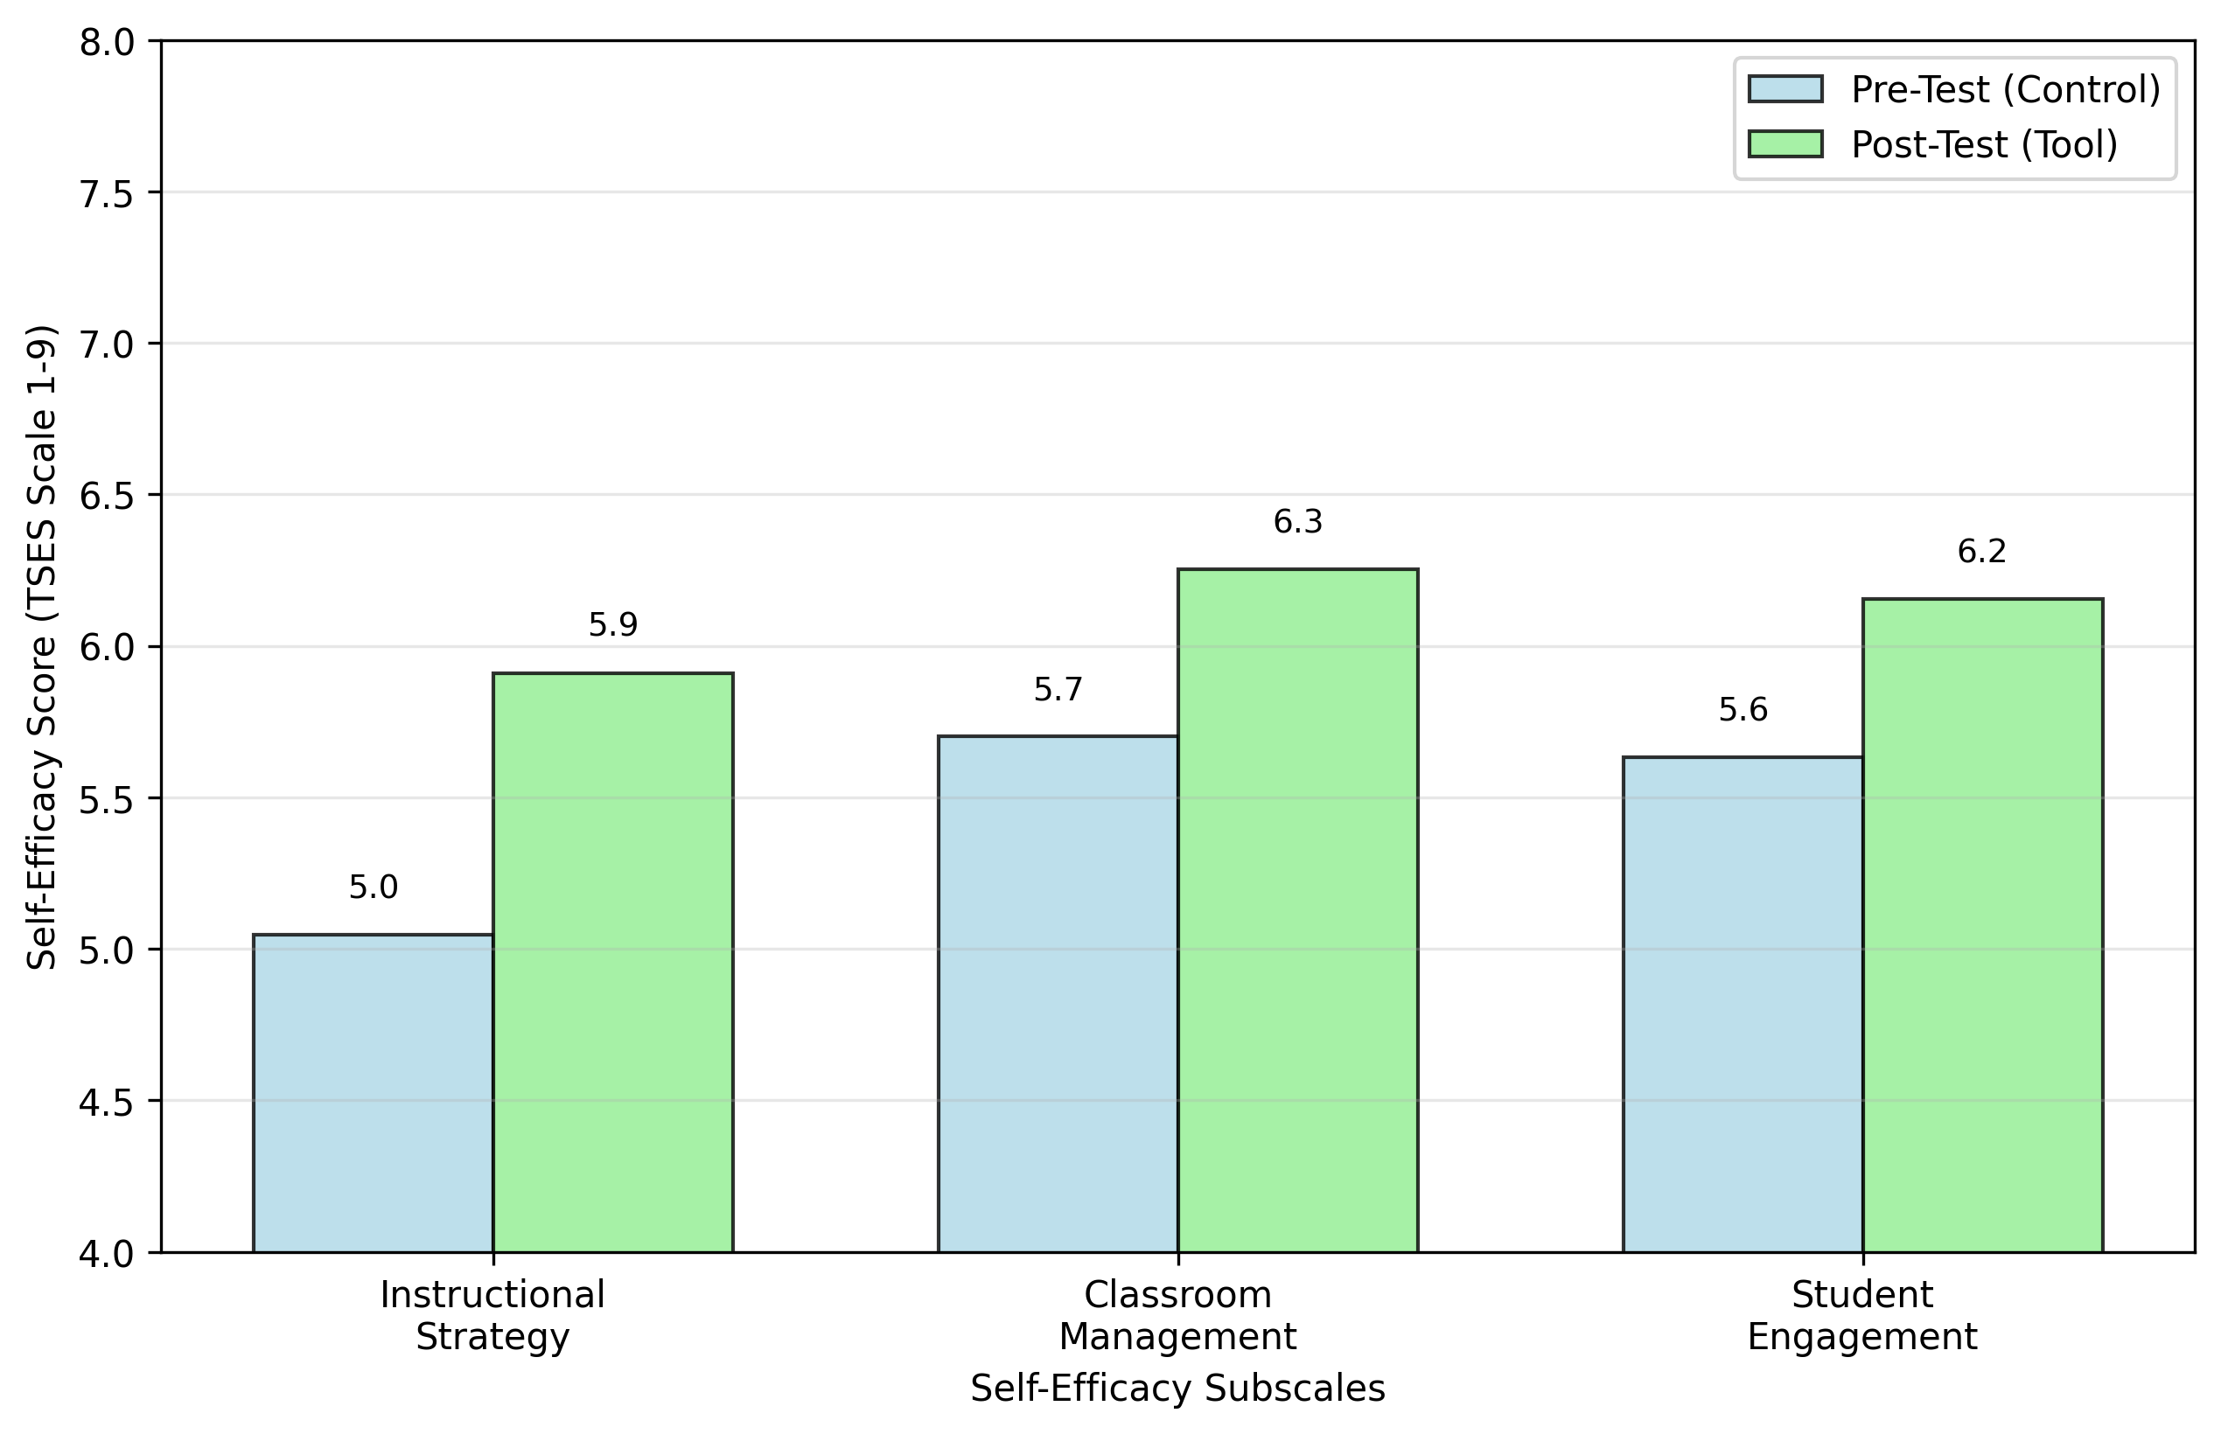
Figure 2. Change in teachers’ self-efficacy scores during simulated data-analysis tasks

Time Efficiency and Accuracy
The tool reduced average analysis time by 37% ($M_{control}=28.4$ minutes vs. $M_{tool}=17.9$ minutes) while increasing the number of correct instructional inferences identified ($M_{control}=3.2$ vs. $M_{tool}=5.7$, $p<0.001$).

Qualitative Feedback
Post-study interviews indicated that 89% of teachers regarded the metric prioritization feature as ‘extremely helpful’ in directing their analysis. One mathematics teacher noted: “The system helped me immediately spot which concepts needed reteaching, rather than getting lost in all the numbers.”
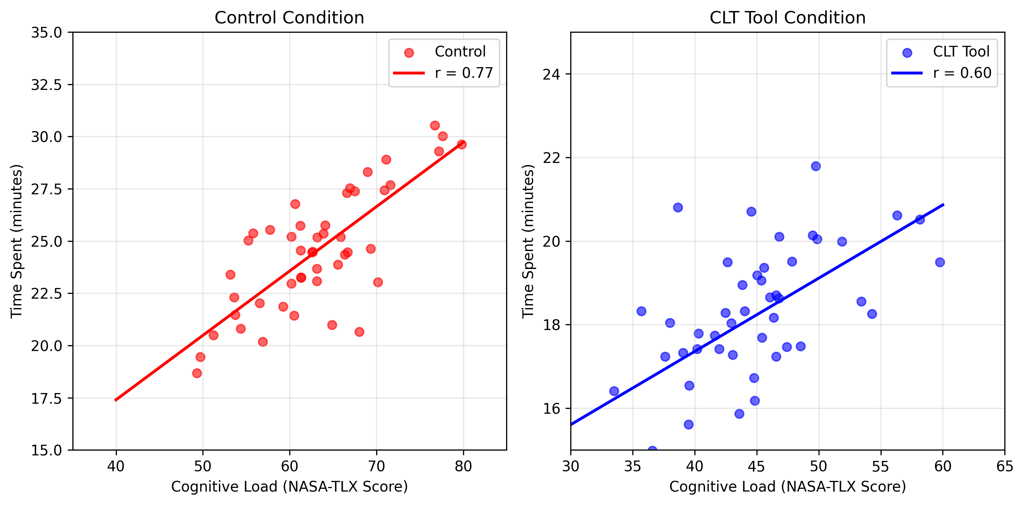
Figure 3. Relationship between teachers’ cognitive load and time spent on data analysis

Subject-Specific Effects
Although benefits were observed across all disciplines, STEM teachers displayed notably stronger improvements in data interpretation accuracy (d = 1.21) relative to humanities teachers (d = 0.73), which implies the visualization engine’s efficacy for quantitative assessment patterns.

Longitudinal Impact
A subsequent study involving 32 educators, conducted after two months of employing the tool in instructional settings, indicated lasting improvements in self-belief (r = 0.68 linking frequency of tool application and TSES results), with over three-quarters of the instructors still engaging with the system on a consistent basis.
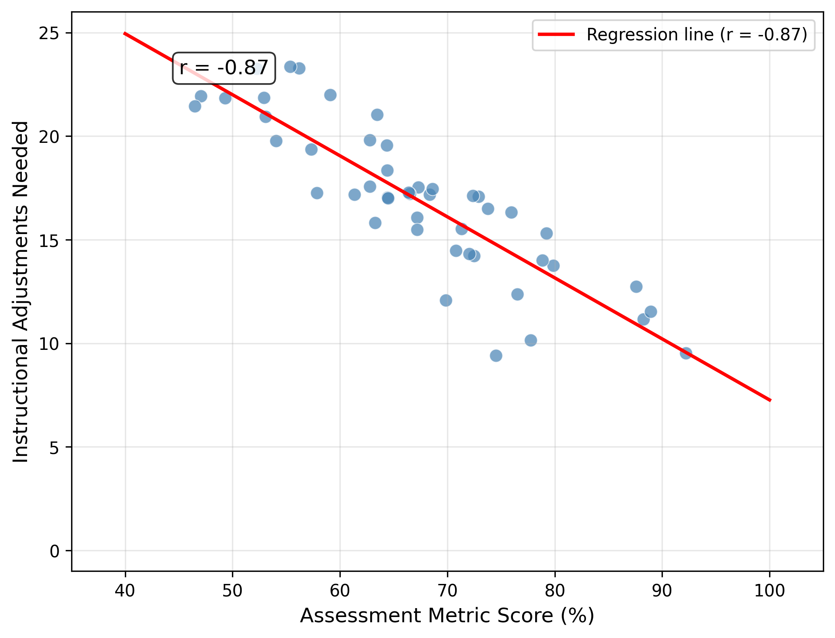
Figure 4. Correlation between assessment metrics and instructional adjustments

Discussion and Implications

Limitations of the CLT-Aligned Formative Assessment Tool
Although the proposed system shows observable advantages in lowering cognitive burden and improving teacher self-efficacy, a number of drawbacks require attention. First, the metric prioritization module relies on predefined instructional goals, which may not fully capture the dynamic decision-making contexts of individual classrooms (Saeedian & Ghaderi, 2023). Teachers occasionally reported mismatches between system-suggested priorities and their immediate pedagogical needs, particularly in interdisciplinary or project-based learning scenarios.
Second, the visualization engine’s dimensionality reduction, while adept at uncovering patterns at the group level, may conceal students with atypical learning trajectories that differ markedly from the norm (Novoseltseva, 2022). The balance between interpretability and granularity indicates a necessity for visualization thresholds which adapt according to class size and performance variability.
Finally, the current implementation assumes uniform technological proficiency among teachers, which may not hold in resource-constrained settings. Findings indicated that teachers who had minimal previous experience with data dashboards needed extra time to adapt to the system’s interface, which momentarily counteracted decreases in cognitive load (Abrahams, 2010).

Potential Application Scenarios of the System
The tool’s modular architecture enables tailored deployments across diverse educational contexts. In competency-based learning environments, for instance, the metric prioritization module could be reconfigured to emphasize skill mastery progressions rather than traditional score distributions (Carney et al., 2023). Early college high schools might merge the system with dual-enrollment course data and deliver unified analytics for both secondary and postsecondary assessments.
The visualization engine’s clustering capabilities also show promise for professional learning communities (PLCs), where teachers collaboratively analyze assessment data. Pilot testing showed the system promoted more concentrated PLC discussions by displaying common instructional challenges across classrooms in a visual manner (Mason, 2003).
Furthermore, the integrated prompts might be expanded to include preservice teacher education, aiding beginners in linking assessment patterns to empirically supported instructional methods. This application aligns with growing emphasis on data literacy in teacher preparation programs (Olari & Romeike, 2021).

Ethical Considerations in the Use of the System
Widespread adoption of cognitive load-optimized assessment tools raises important ethical questions about data interpretation and instructional agency. Although the system lowers unnecessary cognitive burdens, excessive dependence on automated metric prioritization may reduce teachers’ analytical interaction with evaluation data (Baker & Hawn, 2022).
The black-box nature of some underlying algorithms (e.g., the attention mechanisms in metric weighting) necessitates transparent explanatory interfaces. During field testing, we observed that teachers made more nuanced decisions as the system delivered brief rationales for its prioritizations, such as “Objective 3.2 flagged due to high misconception frequency across multiple assessment items.”
Privacy concerns also emerge regarding the storage and processing of fine-grained student performance data. The microservices approach reduces certain hazards by distributing data management, yet educational institutions need to define explicit guidelines for data retrieval and storage (Slade & Prinsloo, 2013).
Finally, the tool’s effectiveness hinges on equitable access to compatible assessment systems. Educational institutions without adequate digital systems may encounter obstacles in deploying the complete range of functionalities, which could worsen current inequalities in data-driven teaching practices (Afzal et al., 2023).
These results together indicate CLT-aligned tools hold considerable promise for improving teacher self-efficacy, yet their adoption requires continuous support systems and careful scrutiny of unforeseen effects. The balance between cognitive efficiency and pedagogical autonomy remains a key area for future refinement.

Conclusion
The results indicate formative assessment tools aligned with Cognitive Load Theory (CLT) improve teacher self-efficacy by lowering unnecessary cognitive burdens in data analysis. The proposed system’s efficient visualization, context-sensitive metric prioritization, and built-in instructional cues together empower teachers to concentrate on pedagogical choices instead of data analysis. Empirical findings establish observable progress in diminishing cognitive burden and boosting instructional assurance, especially in STEM fields where patterns of quantitative evaluation are dominant.
The modular design of the system guarantees flexibility in various educational settings, ranging from competency-based learning frameworks to professional learning groups. Nevertheless, its efficacy hinges on achieving a balance between automation and teacher autonomy, with the aim that improvements in cognitive efficiency do not undermine the necessity of critically engaging with assessment data. Subsequent versions ought to investigate adjustable visualization limits and improved explanatory interfaces to tackle outlier identification and algorithmic clarity.
This approach addresses the connection between managing cognitive load and teacher self-efficacy, presenting an adaptable method for high school teaching. The lasting progress noted in longitudinal data indicates CLT-optimized tools are crucial for backing teaching practices grounded in data. Further research should investigate long-term impacts on student outcomes and the system’s efficacy in resource-constrained settings.

References
Abrahams, D. (2010). Technology adoption in higher education: A framework for identifying and prioritising issues and barriers to adoption of instructional technology. Journal of Applied Research in Higher Education.
Afzal, A., Khan, S., Daud, S., Ahmad, Z., et al. (2023). Addressing the digital divide: Access and use of technology in education. Unable to Determine the Complete Publication Venue.
Bach, B., Keck, M., Rajabiyazdi, F., Losev, T., et al. (2023). Challenges and opportunities in data visualization education: A call to action. Ieee Conference on Visualization and Computer Graphics.
Baker, R., & Hawn, A. (2022). Algorithmic bias in education. Journal of Artificial Intelligence in Education.
Bennett, R. (2011). Formative assessment: A critical review. Assessment in Education: Principles, Policy & Practice.
Carney, P., Sebok-Syer, S., Pusic, M., et al. (2023). Using learning analytics in clinical competency committees: Increasing the impact of competency-based medical education. Medical Education.
Cragg, C. (2023). When data matter: Evaluating data prioritization for department-level decision-making in higher education. search.proquest.com.
Dori, Y., Avargil, S., Kohen, Z., & Saar, L. (2018). Context-based learning and metacognitive prompts for enhancing scientific text comprehension. International Journal of Science Education.
Duran, R., Zavgorodniaia, A., & Sorva, J. (2022). Cognitive load theory in computing education research: A review. ACM Transactions on Computing Education.
Fives, H., & Buehl, M. (2009). Examining the factor structure of the teachers’ sense of efficacy scale. The Journal of Experimental Education.
Gkintoni, E., Antonopoulou, H., Sortwell, A., et al. (2025). Challenging cognitive load theory: The role of educational neuroscience and artificial intelligence in redefining learning efficacy. Brain Sciences.
Henson, R. (2001). Teacher self-efficacy: Substantive implications and measurement dilemmas. ERIC.
Klassen, R., & Usher, E. (2010). Self-efficacy in educational settings: Recent research and emerging directions. emerald.com.
Liu, Z. (2024). Effects of nonlinear dynamic online assessment model on language learners’ learning outcomes and cognitive load. Education and Information Technologies.
Mason, S. (2003). Learning from data: The role of professional learning communities. ERIC.
Novoseltseva, D. (2022). Outlier detection as a tool for reinforcing data analysis and prediction in education. theses.hal.science.
Olari, V., & Romeike, R. (2021). Addressing AI and data literacy in teacher education: A review of existing educational frameworks. Proceedings of the 16th Workshop in Primary and Secondary Computing Education.
Pope, A. (2008). Using simulation speeds to differentiate controller interface concepts. Unable to Determine the Complete Publication Venue.
Saeedian, S., & Ghaderi, A. (2023). Scenario-based classroom context mode: Reshaping non-native teachers’ decision-making and pedagogical reasoning. Asian-Pacific Journal of Second and Foreign Language Education.
Skaalvik, E., & Skaalvik, S. (2010). Teacher self-efficacy and teacher burnout: A study of relations. Teaching and Teacher Education.
Slade, S., & Prinsloo, P. (2013). Learning analytics: Ethical issues and dilemmas. American Behavioral Scientist.
Spijkerman, S., Manning, D., et al. (2025). A cognitive load theory perspective of the undergraduate anesthesia curricula in south africa. Anesthesia & Analgesia.
Sultanova, G. (2025). Assessment tasks in STEM education: Integrating bloom’s revised taxonomy and cognitive load theory. Research in Science & Technological Education.
Sweller, J. (2024). Cognitive load theory and individual differences. Learning and Individual Differences.
Xu, L., Zou, X., & Hou, Y. (2024). Effects of feedback visualisation of peer‐assessment on pre‐service teachers’ data literacy, learning motivation, and cognitive load. Journal of Computer Assisted Learning.
Yin, J., Goh, T., & Hu, Y. (2024). Using a chatbot to provide formative feedback: A longitudinal study of intrinsic motivation, cognitive load, and learning performance. IEEE Transactions on Learning Technologies.

